**EX.N0. IMPLEMENT DECISION TREE BASED ID3 ALGORITHM USING THE**

**DATE: DIABETES DATA SET FOR BUILDING THE DECISION TREE AND APPLY THIS**

**KNOWLEDGE TO CLASSIFY A NEW SAMPLE**

**AIM:**

To implement decision tree based id3 algorithm using the diabetes data set for building the decision tree and apply this knowledge to classify a new sample.

**ALGORITHM:**

**STEP-1:** Prepare Data:Import libraries and load the dataset, Separate the feature columns (x) and target column (y), where y is the "Diabetes_binary" column.

**STEP-2:** Train-Test Split: Split data into training and testing sets (80-20 split). Set a random state to ensure reproducibility of results.

**STEP-3:** Train Model:Initialize a DecisionTreeClassifier with the Gini index as the criterion and set the maximum depth of the tree to 3.Fit the classifier to the training data using .fit().

**STEP-4:** Evaluate Model:Predict with test data and calculate accuracy. Calculate the accuracy using accuracy_score() by comparing the predicted and actual values.

**STEP-5**: Visualize Tree: Plot the decision tree using plot_tree(), setting parameters like feature names, class names, and Gini impurity values and display it.

**CODE :**

import pandas as pd

import matplotlib.pyplot as plt

from sklearn.tree import DecisionTreeClassifier,plot_tree

df=pd.read_csv("diabetes.csv")

x=df.drop("Diabetes_binary",axis=1)

y=df["Diabetes_binary"]

from sklearn.model_selection import train_test_split

from sklearn.metrics import accuracy_score

xtrain,xtest,ytrain,ytest=train_test_split(x,y,test_size=0.2,random_state=42)

clf=DecisionTreeClassifier(criterion='gini',max_depth=3, random_state=42)

clf.fit(xtrain,ytrain)

y_pred=clf.predict(xtest)

acc=accuracy_score(ytest,y_pred)

print(“accuracy:”,acc)

plt.figure(figsize=(20, 12))

plot_tree(

clf,

feature_names=x.columns,

class_names=['0','1'],

filled=True,

rounded=True,

impurity=True, # show gini value

label='all', # show class + impurity + samples

precision=2

)

plt.title("Decision Tree (Gini)")

plt.show()

**OUTPUT:**



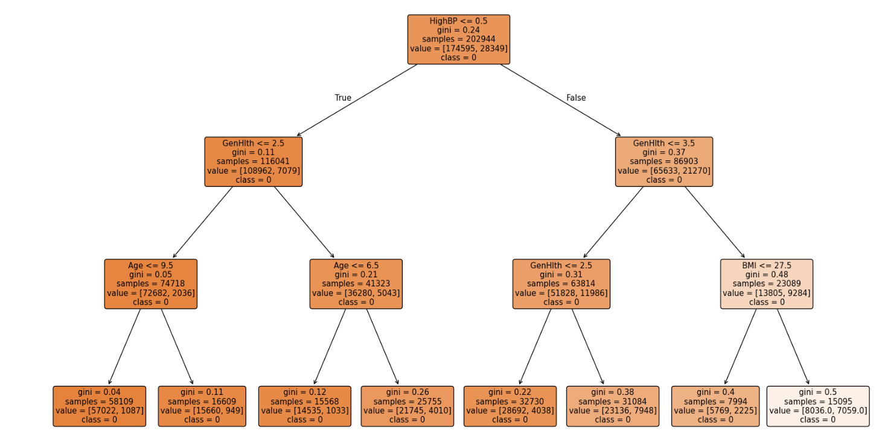

**RESULT:**

Thus the program to implement decision tree based id3 algorithm using the diabetes data set for building the decision tree and apply this knowledge to classify a new sample has been executed and output is verified successfully.

**EX.N0. IMPLEMENT XGBOOST REGRESSION TO PREDICT THE CAR PRICES**

**DATE: ANALYZE THE PERFORMANCE OF THE MODEL BY APPLYING VARIOUS**

**METRICS**

**AIM:**

To implement xgboost regression to predict the car prices analyze the performance of the model by applying various metrics.

**ALGORITHM:**

**STEP-1**: Load and preprocess data Read the CSV file, calculate car age, and apply one-hot encoding

to categorical columns.

**STEP-2:** Create binary labels, Define the target as 1 if Selling_Price > 15, else 0.

**STEP-3:** Split the dataset, Use train_test_split to divide features and labels into training and test sets.

**STEP-4:** Train base models, Fit Logistic Regression and SVM models, then get their predicted

probabilities.

**STEP-5:** Stack and evaluate, Combine predictions, train an XGBoost classifier, predict on the test set,

and print accuracy and classification report.

**CODE :**

import pandas as pd

from sklearn.model_selection import train_test_split

from sklearn.metrics import classification_report

from sklearn.linear_model import LogisticRegression

from sklearn.svm import SVC

from xgboost import XGBClassifier

df=pd.read_csv("cardata.csv")

df["age"]=2025-df["Year"]

x=df.drop(columns=['Selling_Price','Car_Name','Year'])

y=df['Selling_Price']

x=pd.get_dummies(x,columns=['Fuel_Type','Seller_Type' ,'Transmission'],drop_first=True)

threshold = 15

y_binary = (df['Selling_Price'] > threshold).astype(int)

x_train, x_test, y_train, y_test = train_test_split(x, y_binary, test_size=0.2, random_state=42)

logreg_model=LogisticRegression()

logreg_model.fit(x_train, y_train)

svc_model=SVC(probability=True)

svc_model.fit(x_train, y_train)

x_train_logreg_pred=pd.DataFrame(logreg_model.predict_proba(x_train)[:, 1], columns=['logreg_pred'])

x_test_logreg_pred=pd.DataFrame(logreg_model.predict_proba(x_test)[:, 1], columns=['logreg_pred'])

x_train_combined=pd.concat([x_train_logreg_pred, pd.DataFrame(svc_model.predict_proba(x_train)[:, 1], columns=['svc_pred'])], axis=1)

x_test_combined=pd.concat([x_test_logreg_pred, pd.DataFrame(svc_model.predict_proba(x_test)[:, 1], columns=['svc_pred'])], axis=1)

xgb_clf=XGBClassifier()

xgb_clf.fit(x_train_combined, y_train)

y_pred=xgb_clf.predict(x_test_combined)

accuracy=(y_pred==y_test).mean()

print("Accuracy=", accuracy)

print(classification_report(y_test,y_pred))

**OUTPUT:**



Classification report:

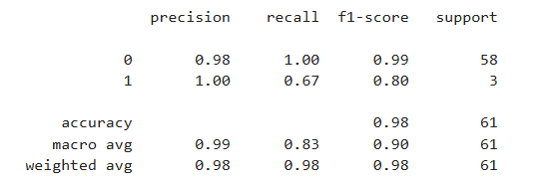

**RESULT:**

Thus the program to implement xgboost regression to predict the car prices analyze the performance of the model by applying various metrics has been executed and output is verified successfully.