Readme
Authoring Tool
Users
Lecturers
Interface
The interface can be generally divided into four parts (Shown as below):
- Video Canvas: Source videos captured or created by the lecturers are played in Video Canvas.
- Control Panel: Auxiliary functionalities are mainly positioned on Control Panel.
- Subtitle Display Board: Captions or subtitles are displayed with time on Subtitle Display Board.
- Concept Map Generator: Concept maps are designed in Concept Map Generator automatically or manually with keywords.

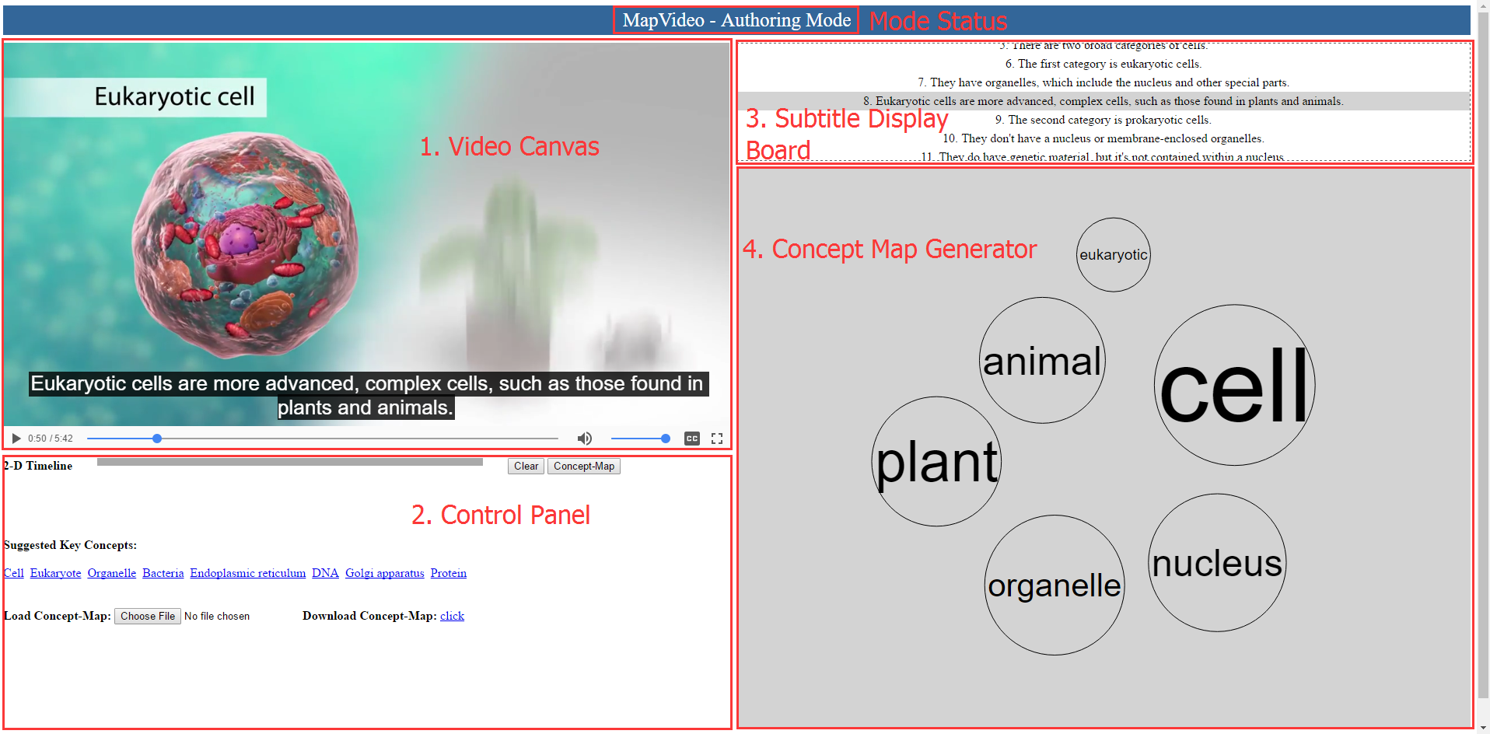

Video Canvas Functionalities
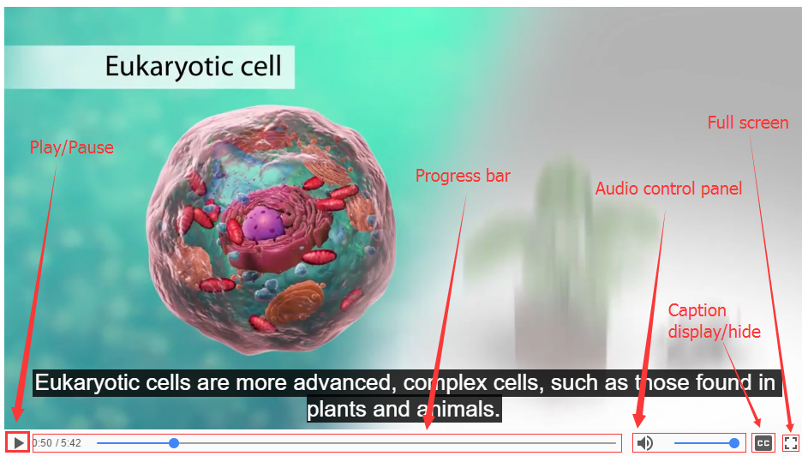
Video Canvas is basically an embedded video player (as shown above) for playing source video streams.
- Play/Pause: Play or Pause the source video at a specific position.
- Progress bar: Locate a specific position of the source video.
- Audio control panel: Control the volume of the audio.
- Caption display/hide button: Turn on/off the subtitle.
- Full screen button: Play the source video in full screen mode.

Control Panel Functionalities
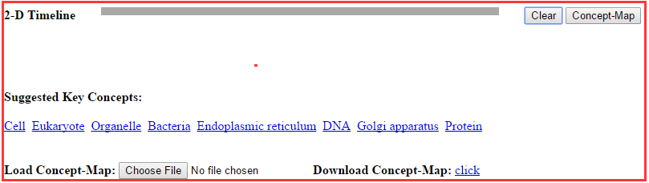
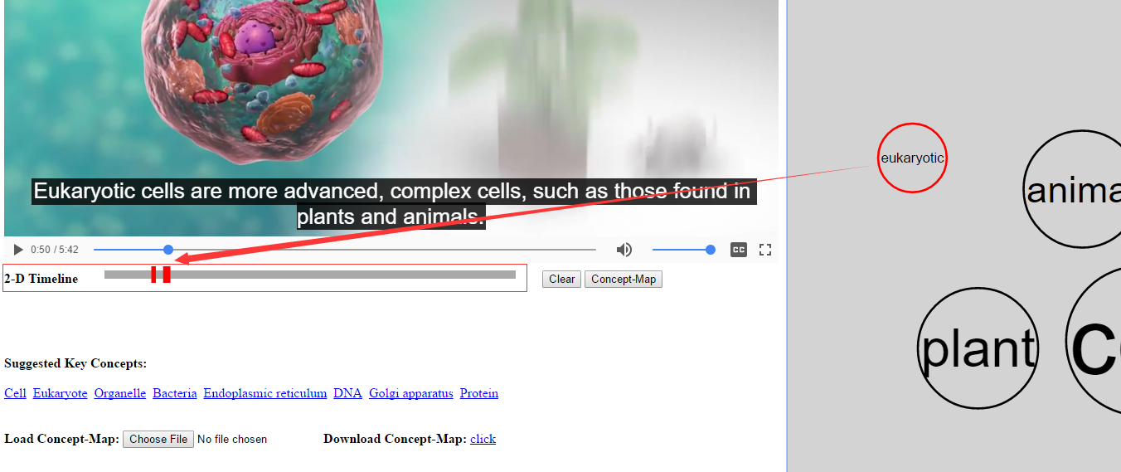
- 2-D Timeline: Highlight the corresponding timestamps when one or more concept bubbles are selected in the Concept Map Generator.

- Clear button (): Clear all the marked timestamps on the 2-D Timeline.
- Concept-Map button (): Automatically generate concept bubbles according to current displayed subtitle sentences.
- Suggested Key Concepts: Automatically generate key words with their corresponding explanation links based on the entire subtitle text.
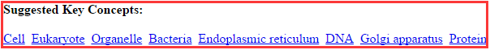
- Load/Download Concept-Map buttons: Load existing concept map into Concept Map Generator or download a designed concept map from Concept Map Generator and save it on a local disk.

Subtitle Display Board Functionalities
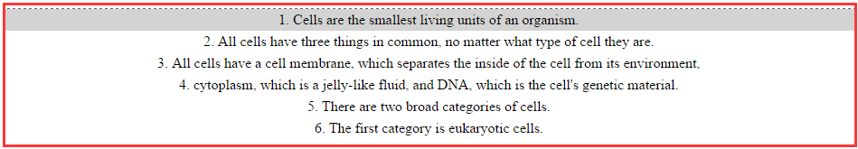
The Subtitle Display Board is for displaying the subtitle with time.
- Sentences of the entire subtitle text are separately displayed according to the timestamps.
- Keywords can be automatically detected from the subtitle sentences and then represented as concept bubbles in the Concept Map Generator (as shown below).
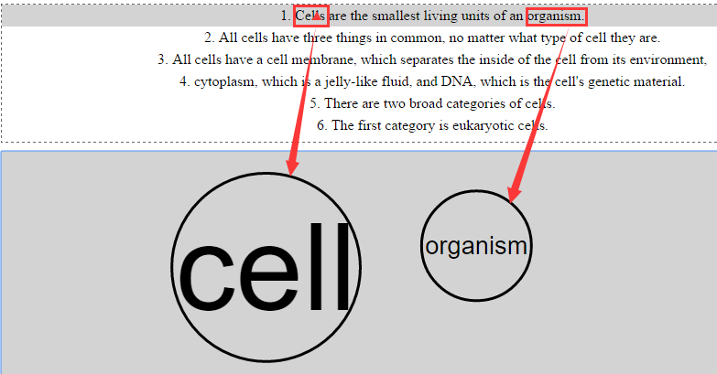

- Customized keyword can be dragged directly from the subtitle sentences.
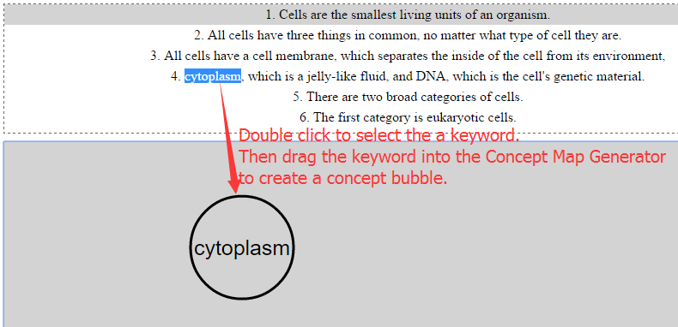
Concept Map Generator
Concept Map Generator is the main panel for designing a concept map.
- Selection: Left click on a concept bubble. The contour is turned red. All the corresponding keywords are highlighted in the subtitle display board and all the corresponding timestamps are highlighted in the 2-D Timeline.
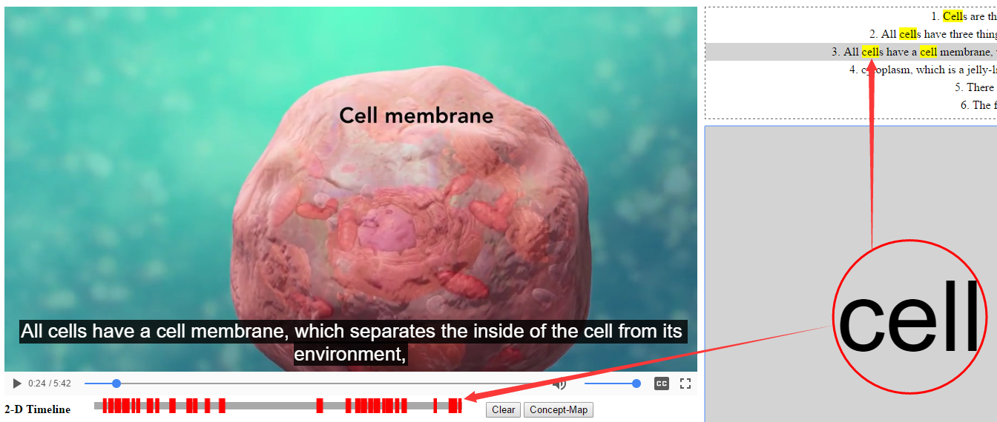
- Move (drag): Select a concept bubble and keep left mouse button pressed. Then the selected concept bubble can be moved.
- Edit: Select a concept bubble and press “E” on the keyboard. There would be an editing interface shown on the video canvas for modifying specific attributes of the concept bubble.
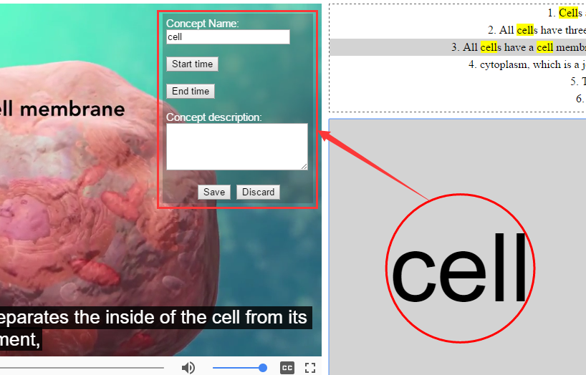
- Delete: Select a concept bubble and press “Delete” on the keyboard.
- Create an empty concept bubble: Double click left mouse button and an empty bubble would be created.
- Connection: keep pressing “Ctrl” on the keyboard, click one concept bubble as an origin and click the target concept bubble. There would be a line connector shown with an arrow heading. The connection can be selected by left click, edited by press “E” on the keyboard and deleted by press “Delete” on the keyboard.
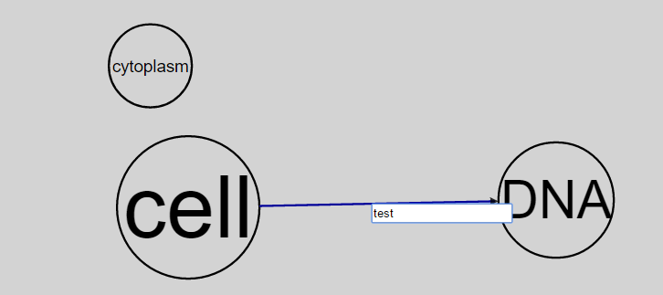
- Concept bubble’s size is displayed based on the keyword’s frequency in the entire subtitle text. Each concept bubble’s size can be enlarged by manually drag more keywords from Subtitle Display Board.
- Using mouse wheel to zoom in and out of the entire concept map.

