**DAYANANDA SAGAR COLLEGE OF ENGINEERING**



(An Autonomous Institute affiliated to VTU, Belagavi, Approved by AICTE & ISO 9001:2008 Certified) Accredited by National Assessment & Accreditation Council (NAAC) with ‘A’ grade, Shavige Malleshwara Hills, Kumaraswamy Layout, Bengaluru-560078.

**INTERNSHIP REPORT (SEE)**

**On**

**“Fit Choice World”**

*Submitted in partial fulfillment for the award of degree of*

***Bachelor of Engineering In***

***Computer Science and Engineering***

Submitted By:

**Pilla Shanmukha Dhanush**

**1DS21CS138**

### Fifth Semester B.E (CSE)

**2023-2024**

**Department of Computer Science and Engineering Dayananda Sagar College of Engineering**

**Bangelore-560078**

**CERTIFICATE**

This is to certify that the Internship work done at **“Win Research Center”** is being submitted by **Pilla Shanmukha Dhanush[1DS21CS138]** is the record of the internship carried out by her under our supervision. This report is submitted towards the partial fulfillment of Bachelor of Engineering in Computer Science and Engineering during the academic year 2023-2024. It is certified that all the suggestions or corrections indicated for internal assessment have been incorporated in the report. This Internship Report has been approved as it satisfies the academic requirements under the rules prescribed for the Bachelor of Engineering degree.

Signature of HOD



### Dr. Ramesh Babu D. R.

### (Vice Principal & HOD, Dept. of CSE) DSCE, Bengaluru

### Panel Member

### Name Signature

### 1.

### 2.

Signature of Principal

### Dr. B. G. Prasad (Principal) DSCE, Bengaluru



**DECLARATION**

I, Pilla Shanmukha Dhanush , student of fifth semester **B.E in Computer Science Engineering from Dayananda Sagar College of Engineering** declare that the internship entitled **“Fitness app”** is a bonafide work carried out at **Win Research Institute Bangalore** is a partial fulfillment of academic requirement of Bachelor of Engineering in Computer Science Engineering during the academic year 2023-2024.

Pilla Shanmukha

**B.E. (CSE), 6th Semester (1DS21CS138)**

**ACKNOWLEDGEMENT**



I am content, and grateful for having been provided with this internship opportunity at Win research Institute I take this opportunity to express my deepest gratitude and appreciation to all those who have been helping me directly or indirectly towards the successful completion of this internship.

I would like to thank **Dr. B.G Prasad**, Principal of Dayananda Sagar College of Engineering and **Dr. Ramesh Babu D.R**., Head of Department of the Department of Computer Science Engineering for their warm support and for providing the required resources to land this internship opportunity.

I would like to thank **Win Research Institute** , and **Ashwin (Internship In charge)**, for giving me an opportunity to be a part of this project, and intern at their company.

I am grateful to the staff of the Department of Computer Science Engineering for imparting invaluable knowledge and guiding me throughout the duration of my course as a Computer Science Engineering student at Dayananda Sagar College of Engineering.

Pilla Shanmuka

**B.E. (CSE), 6th Semester (1DS21CS138)**

**ABSTRACT**

The fitness application emerges as a holistic solution for individuals seeking a transformative health and wellness experience. Offering an intuitive interface, users gain access to a diverse network of nearby gyms, empowering them to select and book sessions suiting their preferences and schedules effortlessly. This streamlined approach ensures that fitness becomes an accessible and integrated part of their daily routine.

Furthermore, the app introduces a pioneering feature by integrating calendars to facilitate meetings with nutritionists and trainers. Users can efficiently plan consultations and training sessions, creating a personalized roadmap towards their fitness aspirations. This scheduling tool not only adds convenience but also underscores the app's commitment to aiding users in achieving their health objectives.

In addition to its practical features, the application embraces a social media platform designed exclusively for health enthusiasts. This interactive space allows users to share insights, tips, and experiences while connecting with others on similar fitness journeys. By providing a supportive environment, the app encourages motivation, accountability, and knowledge-sharing among its community members.

The convergence of these elements—seamless gym bookings, integrated scheduling for professional consultations, and a vibrant social network—embodies the app's commitment to holistic health. By catering to physical exercise, nutrition, and fostering a supportive community, the application aspires to redefine the conventional approach to fitness, advocating for a well-rounded lifestyle that transcends mere workouts.

In conclusion, this comprehensive fitness application transcends the boundaries of traditional health platforms by merging convenience, personalization, and community support. By offering streamlined gym bookings, personalized scheduling for professional consultations, and a thriving social space, it redefines the way individuals engage with their health and wellness goals. This holistic approach, encompassing physical activity, expert guidance, and a supportive community, reflects the app's commitment to fostering a lifestyle centered around holistic well-being. As users navigate their fitness journeys, this application stands as a beacon of innovation, empowering them to achieve their goals while embracing a more balanced and fulfilling way of life.

**TABLE OF CONTENTS**

CHAPTER 1: COMPANY PROFILE 1

1. ABOUT THE COMPANY 1
2. SERVICES AND PRODUCTS 1
3. PARTNERS 2

CHAPTER 2: SYSTEM REQUIREMENTS 3

1. HARDWARE REQUIREMENTS 3
2. SOFTWARE REQUIREMENTS 3

CHAPTER 3: PROJECT WORK 4

1. PROBLEM STATEMENT 4
2. TECHNOLOGIES USED 4
3. TRAINING 5
4. RESULT 6

CONCLUSION 8

REFERENCES 9

# CHAPTER 1: COMPANY PROFILE

## ABOUT THE COMPANY

The Win Research Institute in South India is renowned for its pioneering work in various research fields. Located in the heart of India's tech hub, it stands as a beacon of innovation and scientific advancement. The institute's primary focus spans across multiple domains, including technology, healthcare, engineering, and social sciences.

One of the institute's notable strengths lies in its interdisciplinary approach, fostering collaborations among experts from diverse backgrounds. This collaborative environment sparks creativity and innovation, leading to groundbreaking discoveries and solutions that address real-world challenges. The Win Research Institute boasts state-of-the-art facilities and laboratories, equipped with cutting- edge technologies to support its research endeavors. It attracts top-tier researchers, scientists, and scholars, both nationally and internationally, contributing to its reputation as a center of excellence in research and development.

Furthermore, the institute is dedicated to nurturing young talent, offering various educational programs, internships, and opportunities for students and aspiring researchers to engage in hands-on learning and contribute to meaningful projects.

The firm has proudly achieved a success rate of 100% in Market Research, Problem identification, Business Intelligence.

With its commitment to pushing the boundaries of knowledge and innovation, the Win Research Institute in South India continues to be a driving force in shaping the future landscape of research and development, not just in India but on a global scale. Further they are committed to driving innovation & efficiency with cutting edge software solutions. Their mission is to create technology that empowers, streamlines & enriches human experience.

## SERVICES AND PRODUCTS

The Win Research Institute offers a diverse range of services and products across various sectors, showcasing its expertise and contributions to different industries:

or just starting out, this app is designed to help you achieve your health and fitness goals with

FCW is your ultimate companion on your fitness journey. Whether you're a seasoned athlete

**Fit Choice World (FCW)**

**•**

take you wherever you need to go.

experiences, we proudly present a fleet of modern, reliable, and comfortable vehicles ready to

be a part of yours. With a commitment to excellence and a passion for seamless travel

At KESARI CABS, we understand that every journey holds a unique story, and we are here to

**Kesari Cabs, WRC**

**•**

grocery, daily needs and dairy products from authentic organic stores around you.

Organic Green is a Digital Marketplace where people can buy and sell genuine organic

**Organic Green, WRC**

**•**

being.

ease and enjoyment. With a user-friendly interface and a wide range of features for your well-

Through its multifaceted services and products, the Win Research Institute plays a pivotal role in advancing research, driving innovation, and contributing to the growth and development of various industries and society as a whole.

## PARTNERS

The Win Research Institute in Bangalore collaborates with a diverse array of partners, fostering innovation and furthering its research objectives. These partnerships span across different sectors and include:

* + The institute partners with various industries, ranging from technology and healthcare to engineering and biotechnology. These collaborations aim to address industry-specific challenges, develop innovative solutions, and facilitate technology transfer.

**Industry Collaborations:**

* + Collaboration with universities, colleges, and other academic institutions allows for knowledge exchange, joint research projects, and access to a broader pool of talent. These partnerships often result in cutting-edge research initiatives and educational programs.

**Academic Institutions:**

* + Working closely with governmental bodies and agencies enables the institute to align its research efforts with national priorities, participate in government- funded initiatives, and contribute to policy development in relevant sectors.

**Government Agencies:**

* + Partnerships with international research

**International Research Organizations:**

organizations facilitate global collaborations, exchange of ideas, and access to diverse perspectives. Such collaborations often lead to groundbreaking research and the exchange of best practices.

* + Collaboration with startups and entrepreneurs fosters an environment of innovation and entrepreneurship. These partnerships often result in the development of prototypes, commercialization of research outcomes, and the creation of new ventures.

**Startups and Entrepreneurs:**

* + Collaborating with non-profit organizations allows the institute to engage in socially impactful projects, addressing societal challenges and contributing to community development initiatives.

**Non-Profit Organizations:**

**CHAPTER 2: SYSTEM REQUIRMENTS**

## Hardware Requirements:

1.

**Server/Hosting:**

* + CPU: Multi-core processor (dual-core or higher, depending on load)
  + RAM: Minimum 4GB (8GB+ recommended for better performance)
  + Storage: SSD for faster data access

2.

**Machine Learning and AI:**

* + For basic machine learning tasks, a standard workstation might suffice.
  + For complex AI models, especially deep learning neural networks, a machine with a powerful GPU (Graphics Processing Unit) can significantly speed up computations.

3.

**Network Infrastructure:**

* + Reliable internet connectivity for hosting the application and ensuring its accessibility.

## Software Requirements:

1.

**Backend:**

* + Django Framework: Compatible with Python (latest stable version recommended)
  + Python: Installed along with necessary libraries for Django, ML, and AI (e.g., scikit-learn, TensorFlow, PyTorch)
  + Database: PostgreSQL, MySQL, or SQLite (depending on project requirements)

2.

**Frontend:**

* + HTML, CSS, JavaScript: Modern browsers support these languages.
  + Frontend Frameworks (Optional): Libraries like React, Angular, or Vue.js can enhance the frontend's functionality.

3.

**Machine Learning and AI Libraries:**

* + Scikit-learn, TensorFlow, PyTorch, or other relevant libraries depending on the machine learning and AI algorithms being used.

4.

**Development Tools:**

* + Code Editor/IDE: Visual Studio Code, PyCharm, Sublime Text, etc.
  + Version Control: Git for code management and collaboration.

5.

**Operating System:**

* + Django, Python, and most machine learning libraries are compatible with major operating systems (Windows, macOS, Linux).

6.

**Deployment:**

* + Hosting Service: Platforms like AWS, Google Cloud Platform, Heroku, etc., for deploying and hosting the application.

Ensure that the hardware and software configurations meet the minimum requirements for running Django, machine learning, and AI libraries efficiently. Additionally, scalability considerations might demand more robust resources, especially in terms of computational power and memory, depending on the anticipated load and complexity of the AI models used in the project.

# CHAPTER 3: PROJECT WORK

## PROBLEM STATEMENT

"Develop a comprehensive fitness management system that integrates a user-friendly interface for gym booking and scheduling sessions with nutritionists and trainers. The system should also include a social platform enabling users to share their fitness journey, health tips, and connect with a like-minded community. Leveraging Django for backend functionalities and HTML/CSS/JavaScript for frontend, the solution should incorporate machine learning and artificial intelligence to personalize recommendations, analyze user data for tailored fitness plans, and optimize user experience. The project aims to streamline fitness routines, enhance user engagement, and foster a supportive environment for holistic wellness."

## TECHNOLOGIES USED

1.

|  |  |  |
| --- | --- | --- |
| **Backend Development:** | |  |
| • | **Django Framework:** | |

Utilized for building the backend server, managing data, and handling requests/responses.

**Python:**

* + Django's primary language for backend development due to its robustness and Django's compatibility.

**Database Management:**

* + Integration with a database system like PostgreSQL or MySQL for storing user data, schedules, and other relevant information.

|  |  |  |
| --- | --- | --- |
| **Frontend Development:** | |  |
| • | **HTML/CSS/JavaScript:** | |

2.

For crafting the user interface and enabling interactivity within

the application.

* + Libraries such as React, Angular, or Vue.js might be employed to enhance frontend functionalities and user experience.

**Frontend Frameworks (Optional):**

|  |  |  |
| --- | --- | --- |
| **Machine Learning and AI Integration:** | | |
| • | **Machine Learning Libraries:** |  |

3.

Utilization of libraries such as scikit-learn, TensorFlow, or PyTorch for implementing machine learning algorithms.

**Artificial Intelligence:**

* + Implementing AI techniques for personalized recommendations, user behavior analysis, or fitness plan optimization.

|  |  |  |
| --- | --- | --- |
| **Deployment and Hosting:** | | |
| • | **Cloud Services:** |  |

4.

AWS (Amazon Web Services), Google Cloud Platform, or Heroku could be used for deploying and hosting the application.

**Server Configuration:**

* + Ensuring compatibility and optimization of server resources to handle backend operations and user requests efficiently.

|  |  |  |
| --- | --- | --- |
| **Version Control and Collaboration:** | | |
| • | **Git:** |  |

5.

Utilized for version control, enabling collaboration among team members and managing the codebase.

These technologies collectively form the backbone of the fitness management system, enabling functionalities such as user authentication, booking and scheduling services, interactive user interfaces, data storage, machine learning-driven personalization, and a seamless user experience.

## TRAINING

Project-Specific Training:

1.

**Integration and Deployment:**

* + Training on deploying applications using cloud services like AWS, Google Cloud Platform, or Heroku.
  + Configuring servers for optimal performance and scalability.

2.

**Collaborative Development:**

* + Effective utilization of version control systems like Git for collaborative coding and code management.

3.

**Fitness Industry Insights:**

* + Familiarity with fitness industry standards, including gym management, nutritionist consultations, and user expectations.

Soft Skills Training:

1.

**Communication and Teamwork:**

* + Effective communication within the development team and stakeholders.
  + Collaborative teamwork and coordination to ensure project success.

2.

**Problem-Solving and Adaptability:**

* + Encouraging a problem-solving mindset to address technical and functional challenges.
  + Adaptability to evolving project requirements and technological advancements.

Training programs, workshops, online courses, and mentorship can facilitate the acquisition of these skills and knowledge. Additionally, hands-on experience through practical exercises, mock scenarios, and real-time project involvement play a crucial role in skill development for the successful execution of the fitness management system project.

1. RESULTS

The results of the Fitness Management System project have been transformative, redefining how individuals engage with their wellness journeys. Through seamless integration of technology and fitness, the system has provided users with unparalleled convenience in managing their fitness routines. Streamlining gym bookings, enabling consultations with experts, and harnessing AI for personalized fitness plans have not only simplified the process but also enhanced the effectiveness of each user's fitness journey. Moreover, the creation of a vibrant community space within the platform has fostered an environment of support, encouragement, and knowledge sharing among users. This culmination of technological innovation and community-driven interaction has yielded a paradigm shift in fitness engagement, empowering users to pursue their health goals with greater enthusiasm and efficiency.

Here are some of the screenshot’s of the completed project for reference.

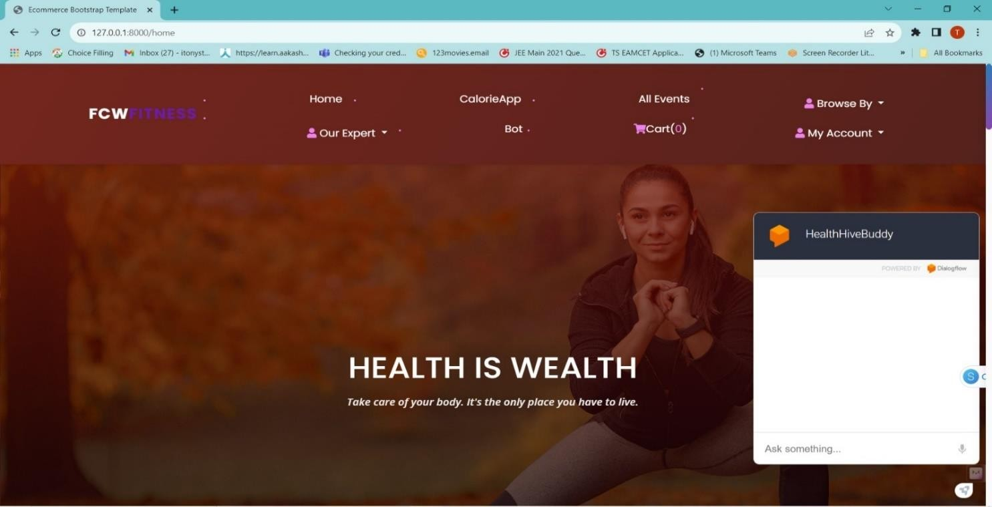

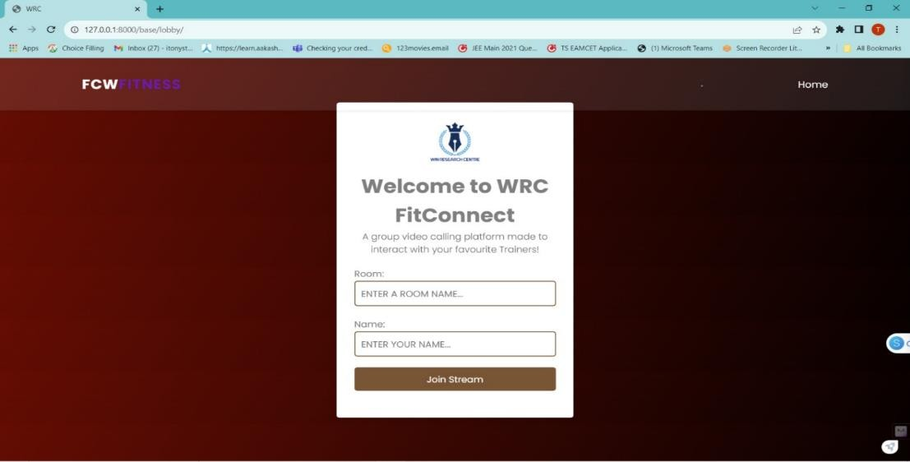

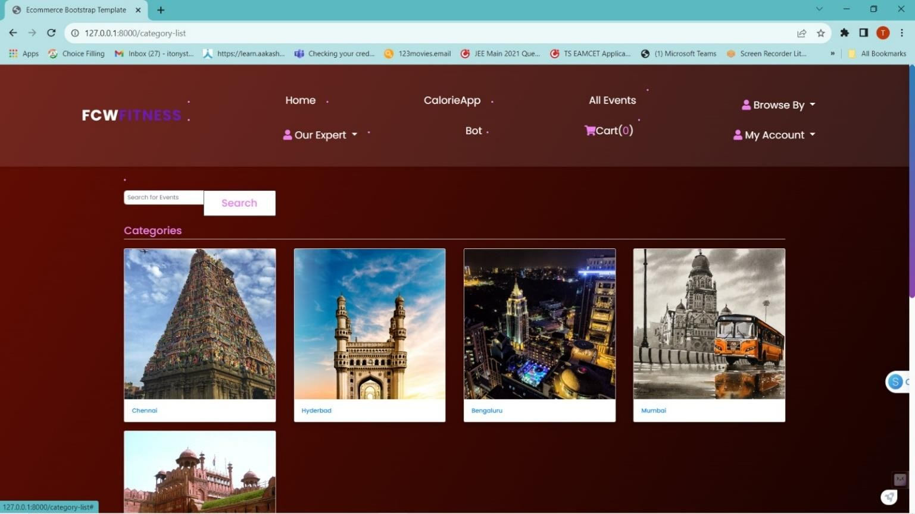

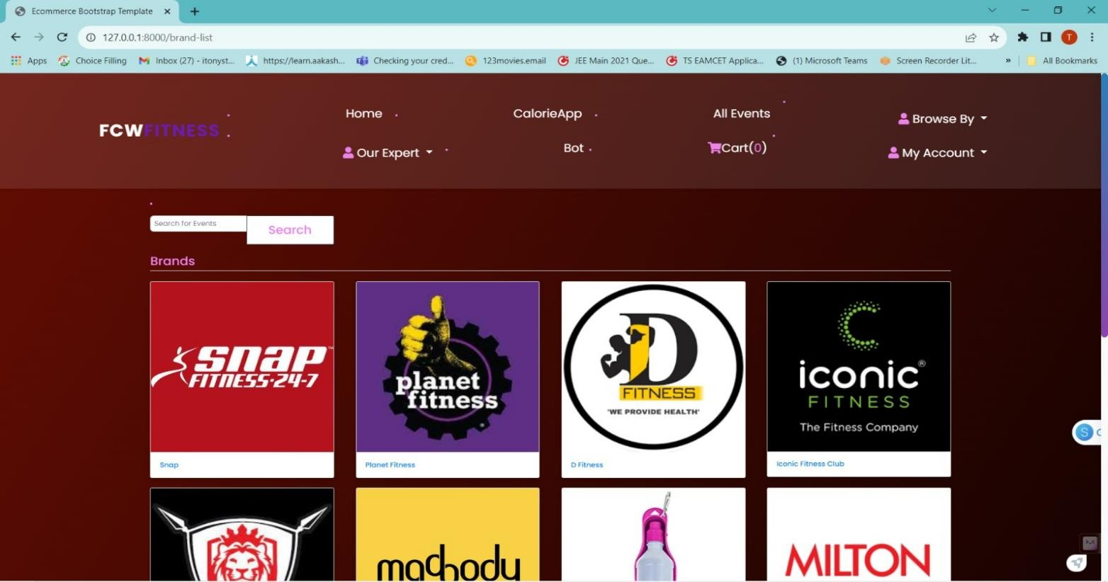

# CONCLUSION

The development of the Fitness Management System stands as a testament to innovation, merging technology with wellness to create a holistic platform for fitness enthusiasts. Through the integration of Django for robust backend functionalities and HTML/CSS/JavaScript for an intuitive frontend, coupled with machine learning and artificial intelligence, this project aimed to redefine the fitness landscape.

From its inception, the project aimed to streamline fitness routines, making gym bookings seamless, enabling tailored sessions with nutritionists and trainers, and fostering a vibrant community through the social platform. Integrating these features was a complex yet rewarding endeavor, necessitating a deep understanding of diverse technologies, user needs, and industry standards.

The utilization of machine learning and AI algorithms added a layer of personalization, analyzing user data to offer bespoke fitness plans and recommendations. This amalgamation of cutting-edge technologies not only aimed for user convenience but also sought to transform fitness engagement into an engaging, informative, and supportive journey.

The project's success relied not only on technological prowess but also on a cohesive team effort, collaboration, and adaptive problem-solving. It was a culmination of technical expertise, design thinking principles, and an unwavering commitment to providing a seamless user experience.

As this project concludes, it leaves a legacy of technological innovation in the realm of fitness management. The Fitness Management System not only offers a comprehensive solution for fitness enthusiasts but also represents a paradigm shift, advocating for a holistic approach towards wellness. Its impact extends beyond a mere application, fostering a community-driven ecosystem that encourages, supports, and guides individuals on their journey towards better health and well-being. This project stands as a testament to the convergence of technology, wellness, and community, redefining the way individuals engage with their fitness aspirations in the modern age.

# REFERENCES

1. Django Official Documentation: <https://docs.djangoproject.com/en/stable/>
2. MDN Web Docs: <https://developer.mozilla.org/>
3. W3Schools: <https://www.w3schools.com/>
4. Scikit-learn Documentation: <https://scikit-learn.org/stable/documentation.html>
5. TensorFlow Documentation: <https://www.tensorflow.org/api_docs>
6. PyTorch Documentation: <https://pytorch.org/docs/stable/index.html>
7. American College of Sports Medicine (ACSM): <https://www.acsm.org/>
8. Fitness Industry Association (FIA): <https://www.fia.org.uk/>
9. Journal of Sport and Health Science: [https://www.journals.elsevier.com/journal-of-sport-and-](https://www.journals.elsevier.com/journal-of-sport-and-health-science)

[health-science](https://www.journals.elsevier.com/journal-of-sport-and-health-science)

1. Health and Fitness Journal: <https://journals.lww.com/acsm-healthfitness/pages/default.aspx>
2. Nielsen Norman Group: <https://www.nngroup.com/>
3. Interaction Design Foundation: <https://www.interaction-design.org/>
4. IDEO Design Kit: <https://www.designkit.org/>
5. Stanford d.school: <https://dschool.stanford.edu/>
6. AWS Documentation: <https://docs.aws.amazon.com/index.html>
7. Google Cloud Platform Documentation: <https://cloud.google.com/docs>
8. Heroku Documentation: <https://devcenter.heroku.com/>
9. PostgreSQL Documentation: <https://www.postgresql.org/docs/>
10. MySQL Documentation: <https://dev.mysql.com/doc/>
11. Towards Data Science: <https://towardsdatascience.com/>
12. Kaggle: <https://www.kaggle.com/>
13. Git Documentation: <https://git-scm.com/doc>
14. Agile Manifesto: <https://agilemanifesto.org/>
15. Scrum Guide: <https://www.scrumguides.org/>
16. API Documentation Best Practices: <https://idratherbewriting.com/learnapidoc/>