Tech stack

Data analysis

* Excel

Data visualisation

* Excel

Skills showcased

Demonstrated 6 key skills through this micro experience

1. Data Visualization
2. Data analysis
3. Power Pivots
4. Power Query
5. Problem solving and critical thinking
6. Communication and storytelling

Problem scenario

Situation

SAPL - (Strent AH Pvt Limited) is an accommodation company started in various mega cities of India. As a SAPL Data analyst, the task was to understand the sales funnel (Fig a) equipped with the process from lead generation to onboarding the clients and analysing the areas where there is a scope for improvement. In the current scenario we were asked to focus on the phase of company’s customer care involvement in the sales funnel, that is a crucial bridge between the number of clients who verified their credentials online to the number of clients who actually visited the site.

Different datasets were provided enlightening information on the different cities the accommodations are provided, various status and sub status phases included in the sales funnel and specific information like hostel id’s, leads data consisting of the city and the hostel he chose, the status he is in and many more.

Fig a: Sales funnel

Complication

The process starts by leads signing up for SAPL through various marketing portals such as social media, various landing pages, social media platforms and many more. The signup count was given for the months May and June, which was a significantly high number. This shows that the marketing department of the company had performed very well in the given months. Whereas, the problem faced by SAPL was the low number of leads who actually onboarded SAPL, compared to the number of leads generated. The complication in this process was analysed and found that the low participation of Customer Care services in the sales funnel, is significantly affecting the success rate in major cities. Customer care services play a crucial role in encouraging the verified leads to undergo the next process. But, only an average of 42.73% of verified leads are contacted by the customer care team, which results in many leads getting stuck only at the verification phase. The other factor that is affecting the sales of SAPL can be the verification phase in the sales funnel where only an average of 52% leads. Factors like email, OTP and Id proof verification can affect the verification process which can in-turn affect the participation of customer care.

Note: It is also observed that many leads who have signed up the agreement have not started the onboarding process. Refer to Fig b

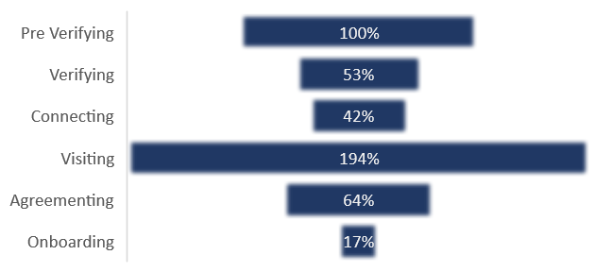

Fig b: Conversion rate at each phase for all cities

Business impact

Due to the complications in customer care services and verification processes the number of students who successful joined SAPL has reduced significantly, when compared with number of students who have applied online. As a result, SAPL faces loss in potential leads, leading to loss in revenue, which may lead to shutting down of the company. This can be identified by observing the conversion rates at each stage from signup to student getting successfully shifted. Metrics like conversion rate at each stage and overall conversion rate, that is students onboarded to total leads in all phases, help us understand the sales funnel better. Although the marketing company has performed very well in generating the leads, there can be two reasons attributed to this problem. One reason can be no response from the leads even after tries from the sales department and the other can be lagging or no proper interaction from the sales department.

This can be overcome by focussing on training the sales department, take up more calls, convincing clients or by understanding the on what time to contact according to the convenience of the leads.

Objectives

* To contact the lead as per lead’s convenient time
* To improve efficiency of the sales department
* To try contacting the leads more than once

Approach

1. Problem approach
   1. Start by understanding how the sales funnel works in SAPL.
   2. Interpret the problem statement with a real time example.
   3. Understanding how each phase works step by step.
2. Analytical approach
   1. SAPL sales process complete dataset was provided from the bluetick micro experiences. It contained four different datasets status, city, hostel and lead are provided for clear and vivid understanding.
   2. All these different datasets are related to each other and using proper cardinality they are uploaded into the data model.
   3. Using power pivots, State vs Status, Status vs Number of leads at a particular phase were analysed. Using appropriate visual aids from excel, better data visualization are used.
   4. Key metrics like conversion rates, overall conversion rate, total number of enrolments, comparing conversion rate between different sub statuses, between different states were included.
3. Insights and recommendations
   1. Apart from the improvement in customer services, an improvement in verification also helps in better sales
   2. An additional assist from payment received to student successfully shifted, would help the company, providing better marketing.
4. Solution implementation and monitoring
   1. This can be overcome by focussing on training the sales department better
   2. Taking up more calls, convincing clients or by understanding the on what time to contact according to the convenience of the leads.
   3. Regular follow up for unanswered leads.

Impact created

<<What was the business impact if we used the commercial calculator for partners in Ahmedabad cluster >>

Project deliverables

The complete analysis and visualization of all the deliverables is present in the 3 different sheets and can be accessed with the help of the link below.

Link: <https://github.com/shan4smiles/SAPL-Analysis>

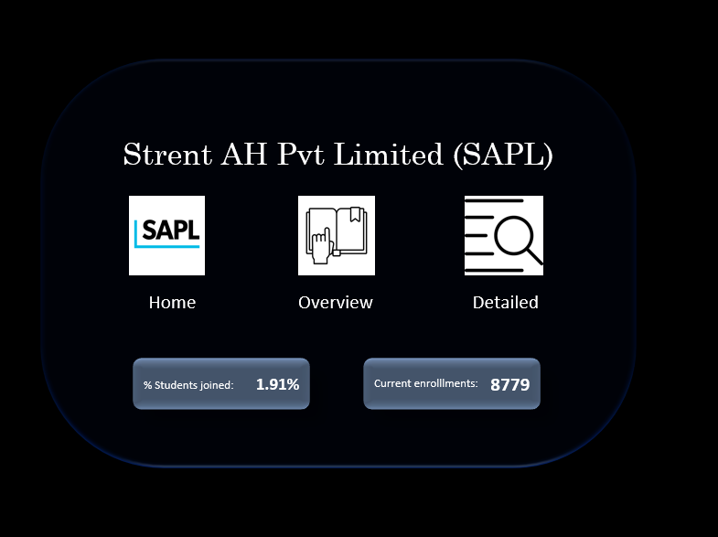

Fig c: The dashboard index page which details the total leads overall, percentage of leads successfully turned clients

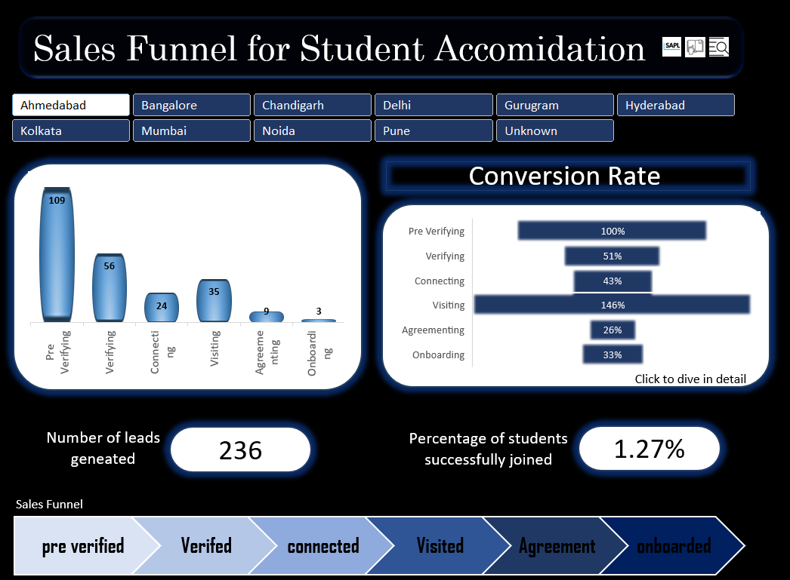

Fig d: The Overview page which details the process map that visually represents the various stages of the sales funnel, number of leads at each phase, conversion at each phase, total number of leads generated, percentage of leads successfully onboarded out of total leads for different states.

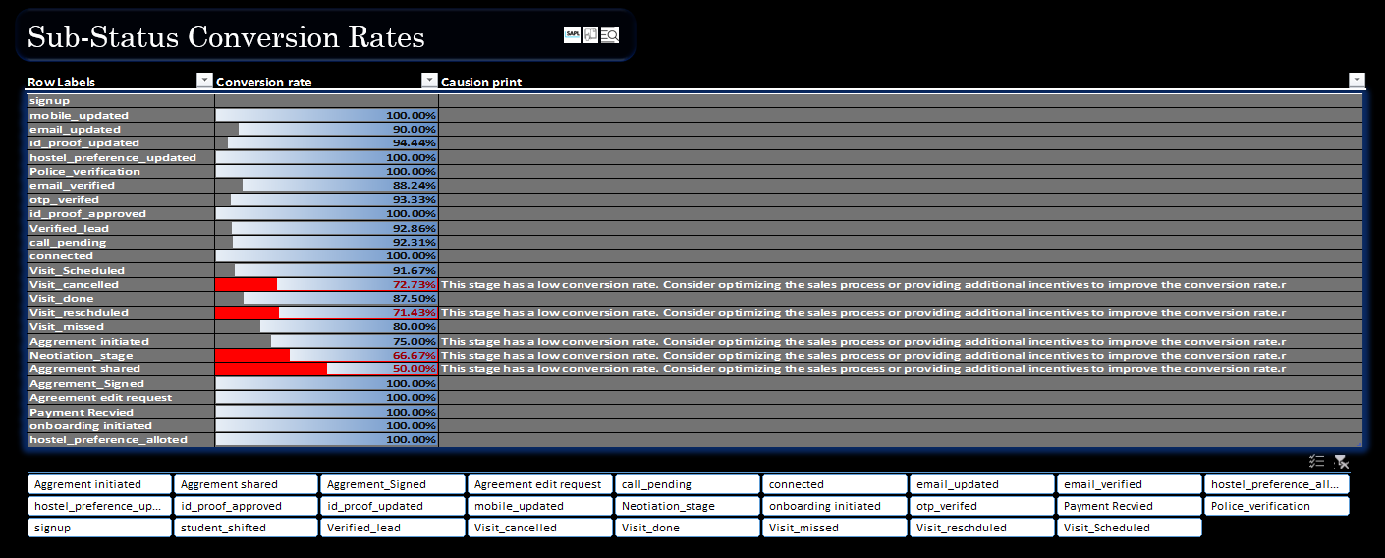

Fig e: The detailed page, details the conversion rate at each substage of a status phase, giving a visual aid to understand how the conversion rate change from its previous stage. It also finds the stage where development is required to enhance the process funnel and returns a disclaimer message.

Scope of improvement

More additional analysis and visualization can be made to understand the count of leads generated for each hostel, percentage students successfully enrolled in each hostel, finding the best hostel branch and similar data analysis related to hostel Id’s.

Feedback

Time and date addition in the dataset helps analyse exactly at what period could a specific hostel generate more revenue.