Repo Memory
Project Summary
Date: 2026-05-20 | Version: 1.0
Audience: Engineering Team, Architects, Stakeholders

Table of Contents
1. Executive Summary
2. Architecture Overview
3. Processing Pipeline
4. Core Components
4.1 Normative Documents
4.2 Reference Documents (`references/`)
4.3 Platform Adapters (`agents/`)
4.4 Python Utility Scripts (`scripts/`)
4.5 Examples (`examples/`)
5. API Contracts and Document Schema
5.1 Required Baseline Docs
5.2 Standard Metadata Fields
5.3 Feature Registry Queue Schema
6. Infrastructure and Deployment
6.1 Repository Structure
6.2 CI/CD Workflows
6.3 Versioning
6.4 Installation
7. Extension Patterns
Adding a New Reference Document
Adding a New Platform Adapter
Adding a New Example
Extending scaffold-docs.py
8. Rules and Anti-Patterns
Do
Do Not
9. Dependencies
Python Scripts
CI Actions
Installation (npx skills)
10. Code Structure

1. Executive Summary
Repo Memory is a portable, repo-native project memory and handoff standard for AI-assisted software projects. It defines a structured set of Markdown documentation files, metadata conventions, status values, and evidence rules that help humans and coding agents understand, resume, and safely change any software project from shared repository docs. The skill is installed via npx skills add and works with GitHub Copilot, OpenAI Codex, Claude Code, and the OpenAI Agents SDK. Repo Memory keeps project context — architecture, requirements, decisions, feature state, and handoff notes — close to the code rather than locked in chat history or one-tool memory. At version 1.8, the standard supports four conformance levels (Baseline through Integrated), a ranked next-work queue for autonomous cloud agents, intake-to-canonical promotion for raw brainstorms, and full continuity governance including provenance, conflict resolution, and multi-agent handoff protocols.

2. Architecture Overview
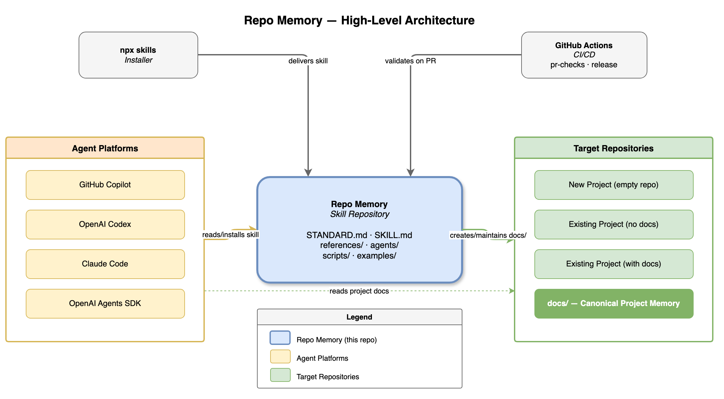
High-Level Architecture
Repo Memory sits at the centre of a three-party relationship:
Party | Role
Repo Memory (this repo) | Provides the portable standard (STANDARD.md), the agent-facing skill workflow (SKILL.md), reference docs, platform adapters, Python utility scripts, and adoption examples.
Agent Platforms | GitHub Copilot, OpenAI Codex, Claude Code, and the OpenAI Agents SDK install the skill via npx skills add and use its workflow to create or maintain docs/ in target repositories.
Target Repositories | Any software project that adopts the standard. Agents apply the skill to scaffold, audit, and maintain a docs/ tree in the target repo.

The npx skills installer delivers the skill package to agent tool directories. GitHub Actions CI (pr-checks.yml, release.yml) validates the skill repo itself — checking Markdown lint, relative links, doc-structure rules, SKILL.md version format, and changelog alignment on every pull request.
Agent platforms consume the skill definition and read project docs from the target repo. Once docs exist, agents read them on every session start so they can orient, resume, and hand off without relying on chat history.

3. Processing Pipeline
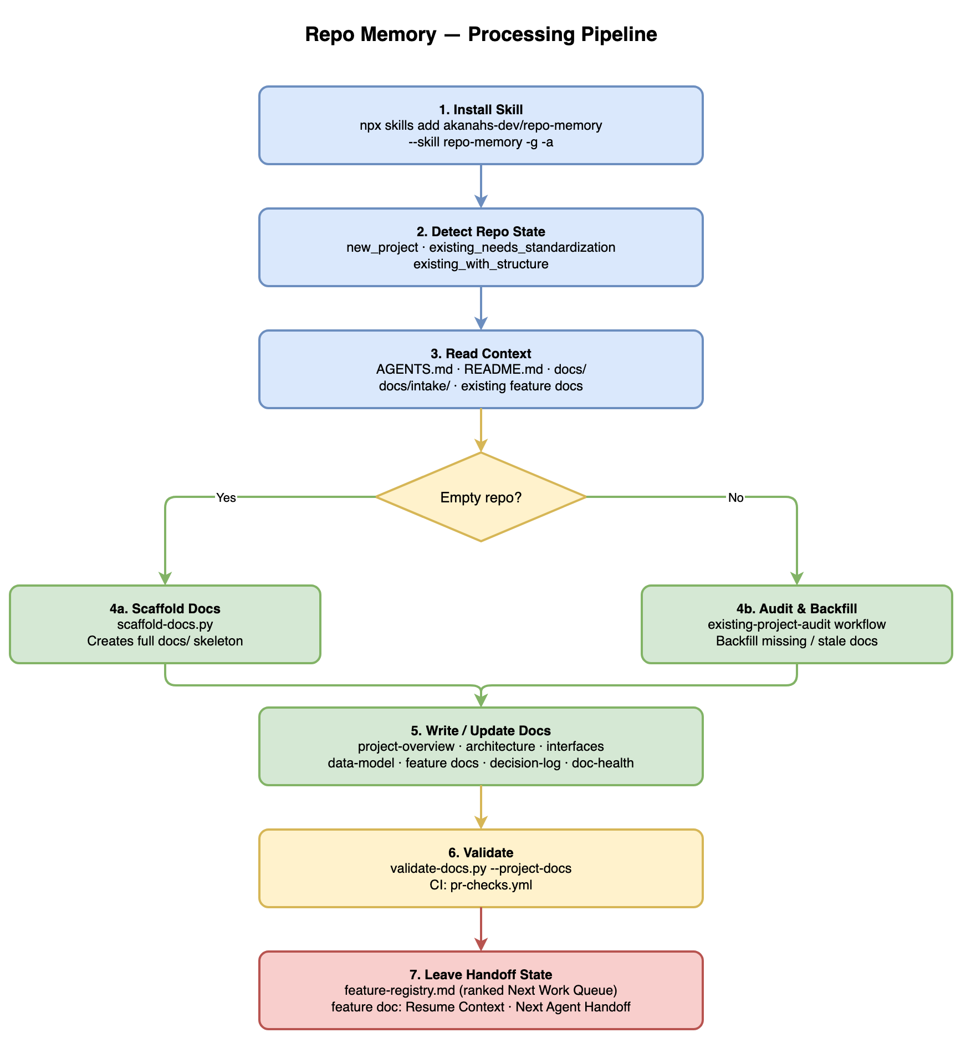
Processing Pipeline
When an agent applies the Repo Memory skill to a target repository, it follows a seven-step pipeline:
Step | Action | Key Artefacts
1. Install Skill | npx skills add akanahs-dev/repo-memory --skill repo-memory -g -a <agent> installs the skill payload globally or per-project. | Installed skills/repo-memory/ directory
2. Detect Repo State | The agent classifies the repo as new_project, existing_project_needs_standardization, or existing_project_with_structure. | Classification decision
3. Read Context | Reads AGENTS.md, README.md, .github/copilot-instructions.md, docs/, and docs/intake/ raw brainstorms. | Source evidence inventory
4a. Scaffold (empty repo) | Runs scaffold-docs.py to create the complete docs/ skeleton including docs/intake/README.md for raw brainstorm capture. | Full docs/ tree
4b. Audit & Backfill (existing repo) | Follows existing-project-audit.md to identify missing or stale baseline docs and backfill them from code evidence. | Gap analysis + filled docs
5. Write / Update Docs | Creates or refreshes the standard doc set: project overview, architecture, interfaces, data model, feature registry, decision log, implementation log, doc health, and more. | 15+ canonical Markdown docs
6. Validate | Runs validate-docs.py --project-docs <repo> locally; CI enforces Markdown lint, relative-link checks, structure rules, and version validation. | Validation report
7. Leave Handoff State | Updates feature-registry.md (ranked Next Work Queue), active feature doc (Resume Context, Next Agent Handoff), and doc-health.md. | Resumable session artefacts

4. Core Components
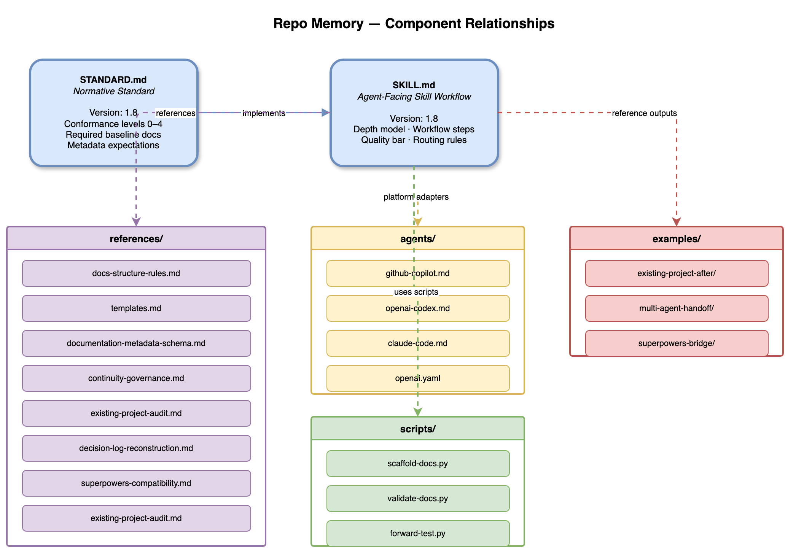
Component Relationships
The Repo Memory skill package lives in skills/repo-memory/ and contains four functional groups:

4.1 Normative Documents
File | Purpose
STANDARD.md | Portable Repo Memory standard: conformance levels 0–4, required baseline docs, metadata expectations, and non-goals. This is the normative entrypoint.
SKILL.md | Agent-facing implementation of the standard. Defines the workflow, depth model, quality bar, and routing rules for how agents apply the standard. Version-tracked; every change must bump the version and add a CHANGELOG.md entry.

SKILL.md implements STANDARD.md. The two files share the same Version: number (currently 1.8).

4.2 Reference Documents (`references/`)
File | Purpose
docs-structure-rules.md | Strict kebab-case naming rules, placement rules, and enforcement checklist.
templates.md | Copy-paste templates for every standard doc type, each with a usage note.
documentation-metadata-schema.md | Standard metadata fields, required fields by doc type, allowed status values, and examples.
continuity-governance.md | Freshness protocols, conflict resolution, rename procedures, feature closure, and multi-agent coordination rules.
existing-project-audit.md | Step-by-step audit workflow for backfilling docs in repos that already have code.
decision-log-reconstruction.md | Comprehensive guidance for reconstructing durable technical decisions from code evidence and project history.
superpowers-compatibility.md | Bridge guidance for linking Obra Superpowers specs/plans as evidence without replacing canonical Repo Memory docs.

4.3 Platform Adapters (`agents/`)
File | Target Platform
github-copilot.md | GitHub Copilot Coding Agent — session workflow, instruction-file alignment, CI integration tips.
openai-codex.md | OpenAI Codex — skill activation, workflow routing, and session-end checklist.
claude-code.md | Claude Code — context window strategy, file-reading order, and handoff conventions.
openai.yaml | OpenAI Agents SDK — interface block with display_name, short_description, and default_prompt.

Adapters are intentionally thin. They describe how a specific agent should use the standard, not what the standard says. Durable project facts live in docs/, not in adapter files.

4.4 Python Utility Scripts (`scripts/`)
Script | Purpose
scaffold-docs.py | Creates the full docs/ skeleton in an empty or nearly-empty repo. Supports --with-agents (generates AGENTS.md), --project-name, --include-user-stories, and --force.
validate-docs.py | Lightweight local and CI validator. Checks required files, naming rules, metadata fields, feature registry structure, and orphaned docs. Add --strict to treat warnings as failures.
forward-test.py | Manual blind forward-testing harness. Creates disposable fixture repositories for skill behaviour testing. Supports --fixture-only (no live agent), --scenario, and --keep.

4.5 Examples (`examples/`)
Directory | What It Shows
existing-project-after/ | A compact target repo after adopting the standard, including all baseline docs, a feature registry with a ranked Next Work Queue, and an example feature doc.
multi-agent-handoff/ | How one agent leaves Resume Context and Next Agent Handoff state that lets another agent continue without chat history.
superpowers-bridge/ | Linking docs/superpowers/specs/ and docs/superpowers/plans/ artifacts as evidence while keeping canonical handoff in Repo Memory docs.

5. API Contracts and Document Schema

5.1 Required Baseline Docs
Every target repo adopting the standard must keep these files under docs/:
File | Doc Type | Description
docs/README.md | index | Documentation map and agent startup order.
docs/project-overview.md | project-overview | Goal, problem, users, success criteria, scope, and non-goals.
docs/architecture.md | architecture | System shape, components, data flow, key design decisions.
docs/interfaces-and-contracts.md | interfaces | Public interfaces, contracts, APIs, and integration points.
docs/data-model.md | data-model | Entities, relationships, ownership, and storage decisions.
docs/local-development.md | local-development | Setup, scripts, tooling, codegen, fixtures, contributor workflows.
docs/doc-health.md | doc-health | Freshness, verification state, known drift, conflicts, renames.
docs/observability-and-instrumentation.md | observability | Logs, metrics, traces, analytics, audit events, dashboards, alerts.
docs/testing-strategy.md | testing-strategy | Test approach, coverage expectations, test types, and gaps.
docs/operations-runbook.md | operations-runbook | Deployment, incident response, and operational procedures.
docs/security-and-privacy.md | security | Threat model, data handling, auth, secrets management.
docs/decision-log.md | decision-log | Lasting technical choices from project start to current state.
docs/implementation-log.md | implementation-log | What actually landed, when, and by whom.
docs/feature-registry.md | feature-registry | Feature status table + ranked Next Work Queue.
docs/requirements/functional-requirements.md | requirements | Functional behaviour the system must implement.
docs/requirements/non-functional-requirements.md | requirements | Performance, reliability, scalability, and maintainability constraints.

5.2 Standard Metadata Fields
Every canonical doc must include these metadata fields at the top:
Field | Allowed Values | Notes
Doc type | project-overview, architecture, feature, decision-log, etc. | Matches the doc-type vocabulary in documentation-metadata-schema.md.
Owner | Agent handle or team name | Who is responsible for keeping this doc current.
Status | draft, active, verified, stale, superseded | Current reliability of the doc's content.
Last updated | ISO date | When the doc was last changed.
Last verified | ISO date or unknown | When the doc was last checked against code.
Confidence | low, medium, high | How trustworthy the content is relative to code truth.
Canonical source | File path | The single authoritative location for this information.
Related docs | Comma-separated file paths | Linked artefacts that depend on or complement this doc.

5.3 Feature Registry Queue Schema
feature-registry.md contains a ranked Next Work Queue table:
Column | Description
Rank | Numeric priority — lower is higher priority.
Feature | Human-readable feature name.
Status | ready, verify-first, needs-human, blocked.
Pickup note | One-line instruction for the next agent picking up this task.

6. Infrastructure and Deployment

6.1 Repository Structure
This repository follows the common multi-skill layout:
repo-memory/
├── README.md # overview and quick-start guide
├── AGENTS.md # AI agent instructions
├── CHANGELOG.md # version history
├── LICENSE # MIT license
├── CONTRIBUTING.md # contribution guidelines
├── CODE_OF_CONDUCT.md # community behaviour expectations
├── SUPPORT.md # support and issue guidance
├── ROADMAP.md # directional project roadmap
├── .gitignore # local generated-file ignores
├── .gitattributes # source archive export rules
├── .markdownlint.json # Markdown lint configuration
├── .github/
│ ├── ISSUE_TEMPLATE/ # bug, feature, docs-adoption templates
│ ├── pull_request_template.md # PR checklist
│ └── workflows/
│ ├── pr-checks.yml # lint, link-check, validate, version-check on PRs
│ └── release.yml # auto-tag and GitHub Release on main
└── skills/
└── repo-memory/ # installable skill payload
├── SKILL.md
├── STANDARD.md
├── LICENSE.txt
├── agents/
├── examples/
├── scripts/
└── references/

6.2 CI/CD Workflows
Workflow | Trigger | Checks
pr-checks.yml | Pull request to main | Markdown lint (markdownlint-cli2), relative-link validation (Python), validate-docs.py --skill-repo ., SKILL.md version format + bump check, CHANGELOG.md alignment.
release.yml | Push to main | Auto-tag vMAJOR.MINOR and publish a GitHub Release; release body pulled from CHANGELOG.md.

6.3 Versioning
The standard and skill share the same two-number version (MAJOR.MINOR):
Change type | Action
New content or non-breaking additions | Increment minor version
Required baseline changes or structural workflow changes | Increment major version

The CI version-check enforces that SKILL.md version strictly increases on every PR that modifies the file, and that CHANGELOG.md contains a matching ## [X.Y] entry.

6.4 Installation
# Install globally for a specific agent
npx skills add akanahs-dev/repo-memory --skill repo-memory -g -a codex -y

# Install from the skill subfolder directly
npx skills add https://github.com/akanahs-dev/repo-memory/tree/main/skills/repo-memory -g -a codex -y

# Scaffold an empty target repo
python3 skills/repo-memory/scripts/scaffold-docs.py /path/to/repo --with-agents

# Validate a target repo
python3 skills/repo-memory/scripts/validate-docs.py --project-docs /path/to/repo

# Validate this skill repo
python3 skills/repo-memory/scripts/validate-docs.py --skill-repo .

7. Extension Patterns

Adding a New Reference Document
1. Create the file in skills/repo-memory/references/ using kebab-case naming (my-topic.md).
2. Add standard metadata at the top of the file (doc type, owner, status, dates, confidence, canonical source, related docs).
3. Link the new file from README.md (under "Related Docs") and from this AGENTS.md (under "Entry Points").
4. Add a template block for the new doc type to skills/repo-memory/references/templates.md with a usage note.
5. Update validate-docs.py if the new doc type should be required or checked.
6. Bump SKILL.md minor version and add a CHANGELOG.md entry.

Adding a New Platform Adapter
1. Create skills/repo-memory/agents/<platform>.md (or .yaml for SDK configs).
2. Add a comment or front-matter describing the target platform and usage.
3. Keep the adapter thin — describe how the agent uses the standard; do not duplicate durable project facts.
4. Add a row to the Agent-Specific Guides table in AGENTS.md.
5. Link it from README.md.

Adding a New Example
1. Create a directory under skills/repo-memory/examples/<example-slug>/.
2. Populate it with realistic doc artefacts that demonstrate the specific pattern.
3. Add a description to skills/repo-memory/examples/README.md.
4. Link from README.md under "Examples".

Extending scaffold-docs.py
1. Open skills/repo-memory/scripts/scaffold-docs.py.
2. Add a new ScaffoldFile entry to the files list with the file path and content.
3. Document the new scaffold output in README.md under "Empty Repository Scaffold".

8. Rules and Anti-Patterns

Do
• One docs layer per project. Avoid overlapping documentation systems when one maintained docs/ tree is sufficient.
• Markdown first. All docs are plain Markdown — readable without any specific AI provider, editor, or plugin.
• Evidence before assumption. Document confirmed facts before inferred ones; mark inferences clearly with low confidence.
• Keep handoff current. Always close a session with updated Resume Context and Next Agent Handoff in the active feature doc.
• Promote intake before building. Accept raw brainstorms in docs/intake/, then promote accepted facts into canonical docs before depending on them.
• Increment the version. Every change to SKILL.md must bump the version number and add a CHANGELOG.md entry.

Do Not
• Do not let AGENTS.md become a second source of truth for mutable project facts. Keep agent instruction files concise and pointing into docs/.
• Do not create empty optional deep-dive folders just to fill out the docs tree. Create docs/diagrams/, docs/designs/, etc., only when there is real content.
• Do not orphan deep-dive docs. Every deep-dive doc must be linked from an owning baseline doc, feature doc, or index file.
• Do not skip metadata. Every canonical doc needs doc type, owner, status, dates, confidence, and related docs.
• Do not leave resume state in chat history. Put resumable state in docs/features/<feature-slug>.md and linked docs.
• Do not change a slug after registration without updating every reference (registry, file name, folder name).

9. Dependencies
The skill itself is pure Markdown plus Python scripts — no runtime dependencies for the standard itself.

Python Scripts
Script | Python Version | Standard Library Only? | Notes
scaffold-docs.py | 3.8+ | Yes | Uses argparse, dataclasses, datetime, pathlib, textwrap.
validate-docs.py | 3.8+ | Yes | Uses argparse, re, sys, pathlib.
forward-test.py | 3.8+ | Yes | Uses subprocess, pathlib, argparse, tempfile.

CI Actions
Action | Version | Purpose
actions/checkout | v4 | Check out repository.
DavidAnson/markdownlint-cli2-action | v17 | Markdown lint on all .md files.

Installation (npx skills)
Tool | Purpose
npx skills | Skill installer — fetches and installs the skills/repo-memory/ payload into agent tool directories.

10. Code Structure
Annotated directory tree (2 levels deep):
repo-memory/
├── README.md # Project overview, quick-start, philosophy, key principles
├── AGENTS.md # AI agent entry point: reading order, workflow rules, quality checklist
├── CHANGELOG.md # Version history; format: ## [X.Y] - YYYY-MM-DD
├── ROADMAP.md # Directional roadmap: current focus, near-term, later, non-goals
├── CONTRIBUTING.md # Contribution guidelines
├── CODE_OF_CONDUCT.md # Community behaviour expectations
├── SECURITY.md # Security policy and vulnerability reporting
├── SUPPORT.md # Support channels and issue guidance
├── LICENSE # MIT license (repository root)
├── .markdownlint.json # Markdown lint rules for CI
├── .gitignore # Generated file exclusions
├── .gitattributes # Archive export exclusions
├── assets/
│ └── project-logo.png # Repo Memory project logo
├── .github/
│ ├── ISSUE_TEMPLATE/ # Bug report, feature request, docs-adoption-help templates
│ ├── pull_request_template.md # PR checklist (version, changelog, link, lint)
│ └── workflows/
│ ├── pr-checks.yml # 4-job CI: lint, links, docs validate, version check
│ └── release.yml # Auto-release on push to main
└── skills/
└── repo-memory/ # Installable skill payload (all agent-facing content)
├── SKILL.md # Skill definition, workflow, depth model — version-tracked
├── STANDARD.md # Portable standard — same version as SKILL.md
├── LICENSE.txt # Package-local MIT license
├── agents/ # Thin platform adapters (4 files)
├── examples/ # Reference adoption outputs (3 examples)
├── scripts/ # Python utilities (scaffold, validate, forward-test)
└── references/ # Rules, templates, metadata, governance (7 files)

