GEOSPATIAL ANALYTICS ASSESSMENT
Location-Specific Landslide Risk Scoring Index for Haldummulla, Sri Lanka
Haldummulla Divisional Secretariat Division, Badulla District, Sri Lanka
I propose a Location-Specific Landslide Risk Scoring Index (LS-LRSI) for Haldummulla Divisional Secretariat Division (DSD), Badulla District, Sri Lanka.
Module: Geospatial Analytics
Assessment: Location-Specific Landslide Risk Scoring Index
Prepared for academic assessment submission
Revision date: 23 August 2026
Evidence-based report synchronized with the verified reproducible project outputs

Abstract
This project develops a transparent and reusable landslide risk index for Haldummulla DSD. The method separates physical susceptibility from social exposure. Seven physical indicators were processed on a common 30 m grid: slope, mean annual rainfall, land cover, local relief, topsoil clay content, proximity to roads and proximity to streams. Susceptibility was calculated by a weighted linear combination and summarized for each Grama Niladhari (GN) division using 60% of the mean and 40% of the 90th percentile. Exposure combined population density, occupied housing density, the share of children and older people, and mapped critical amenities. The final GN-level risk score used a weighted geometric mean with 70% emphasis on susceptibility and 30% on exposure. The official 2024 Census of Population and Housing data identified 39 GN divisions, 38,778 residents and 10,970 occupied housing units within approximately 408.87 km2. The 30 m susceptibility surface had a mean score of 37.47 and ranged from 3.48 to 89.77. Haldummulla, Beragala, Watagamuwa, Koslanda and Poonagala received the five highest relative risk scores. A 500-run weight sensitivity test produced a median Spearman rank correlation of 0.997. However, the NASA catalogue provided only two keyword-matched events inside the DSD, including one with 10 km stated accuracy. The result is therefore a screening and prioritization index, not an engineering hazard map or early-warning product.

1. Location selection, scope and final solution
Haldummulla DSD is an appropriate location because its northern and north-eastern sections form part of the steep central highlands, while Koslanda within the DSD has a documented history of major slope failures. Ranasinghe et al. (2019) describe Koslanda as a hilly area where climatic conditions, thick colluvium, weathered material and poorly maintained drainage have contributed to instability. Their study also refers to the Naketiya and Meeriyabedda landslides and shows that terrain, rainfall, land use, hydrology and soil conditions must be considered together. The importance of this setting is supported by wider Badulla District research. Hemasinghe et al. (2018) used slope, aspect, lithology, land cover and distance from roads and rivers in a logistic regression model, while Jayasinghe, Wijekoon and Gunatilake (2017) found that a geographically weighted logistic model performed better than a non-spatial logistic model for district-level susceptibility. These studies confirm the relevance of Badulla but also show why a local and socially informed assessment is useful.
The elements at risk include residents, houses, roads, schools, health facilities, police and fire services, and agricultural livelihoods. The official 2024 census records 38,778 people and 10,970 occupied housing units across the 39 GN divisions used in this project. Exposure is uneven. For example, a small GN division with dense settlement may require attention even when its average physical susceptibility is not the highest. Conversely, a large sparsely settled division may contain steep and unstable slopes but produce a lower present-day risk score because fewer mapped people and assets are exposed. This distinction follows the international guidance that susceptibility describes where slope failure is more likely, while risk additionally considers the exposed elements and their vulnerability (Fell et al., 2008; Corominas et al., 2014).
The spatial design has two connected levels. Physical susceptibility is calculated on a 30 m raster because terrain and land-cover conditions vary within each GN division. The final decision unit is the GN division because census population, housing and age data are available at that level and local authorities can use GN-based results for communication and prioritisation. The continuous 30 m layer should support field targeting, while the GN score provides a practical summary. Risk classes are quartiles relative to Haldummulla's 39 GN divisions. They are not national thresholds and must not be interpreted as legal building zones or evacuation warnings.
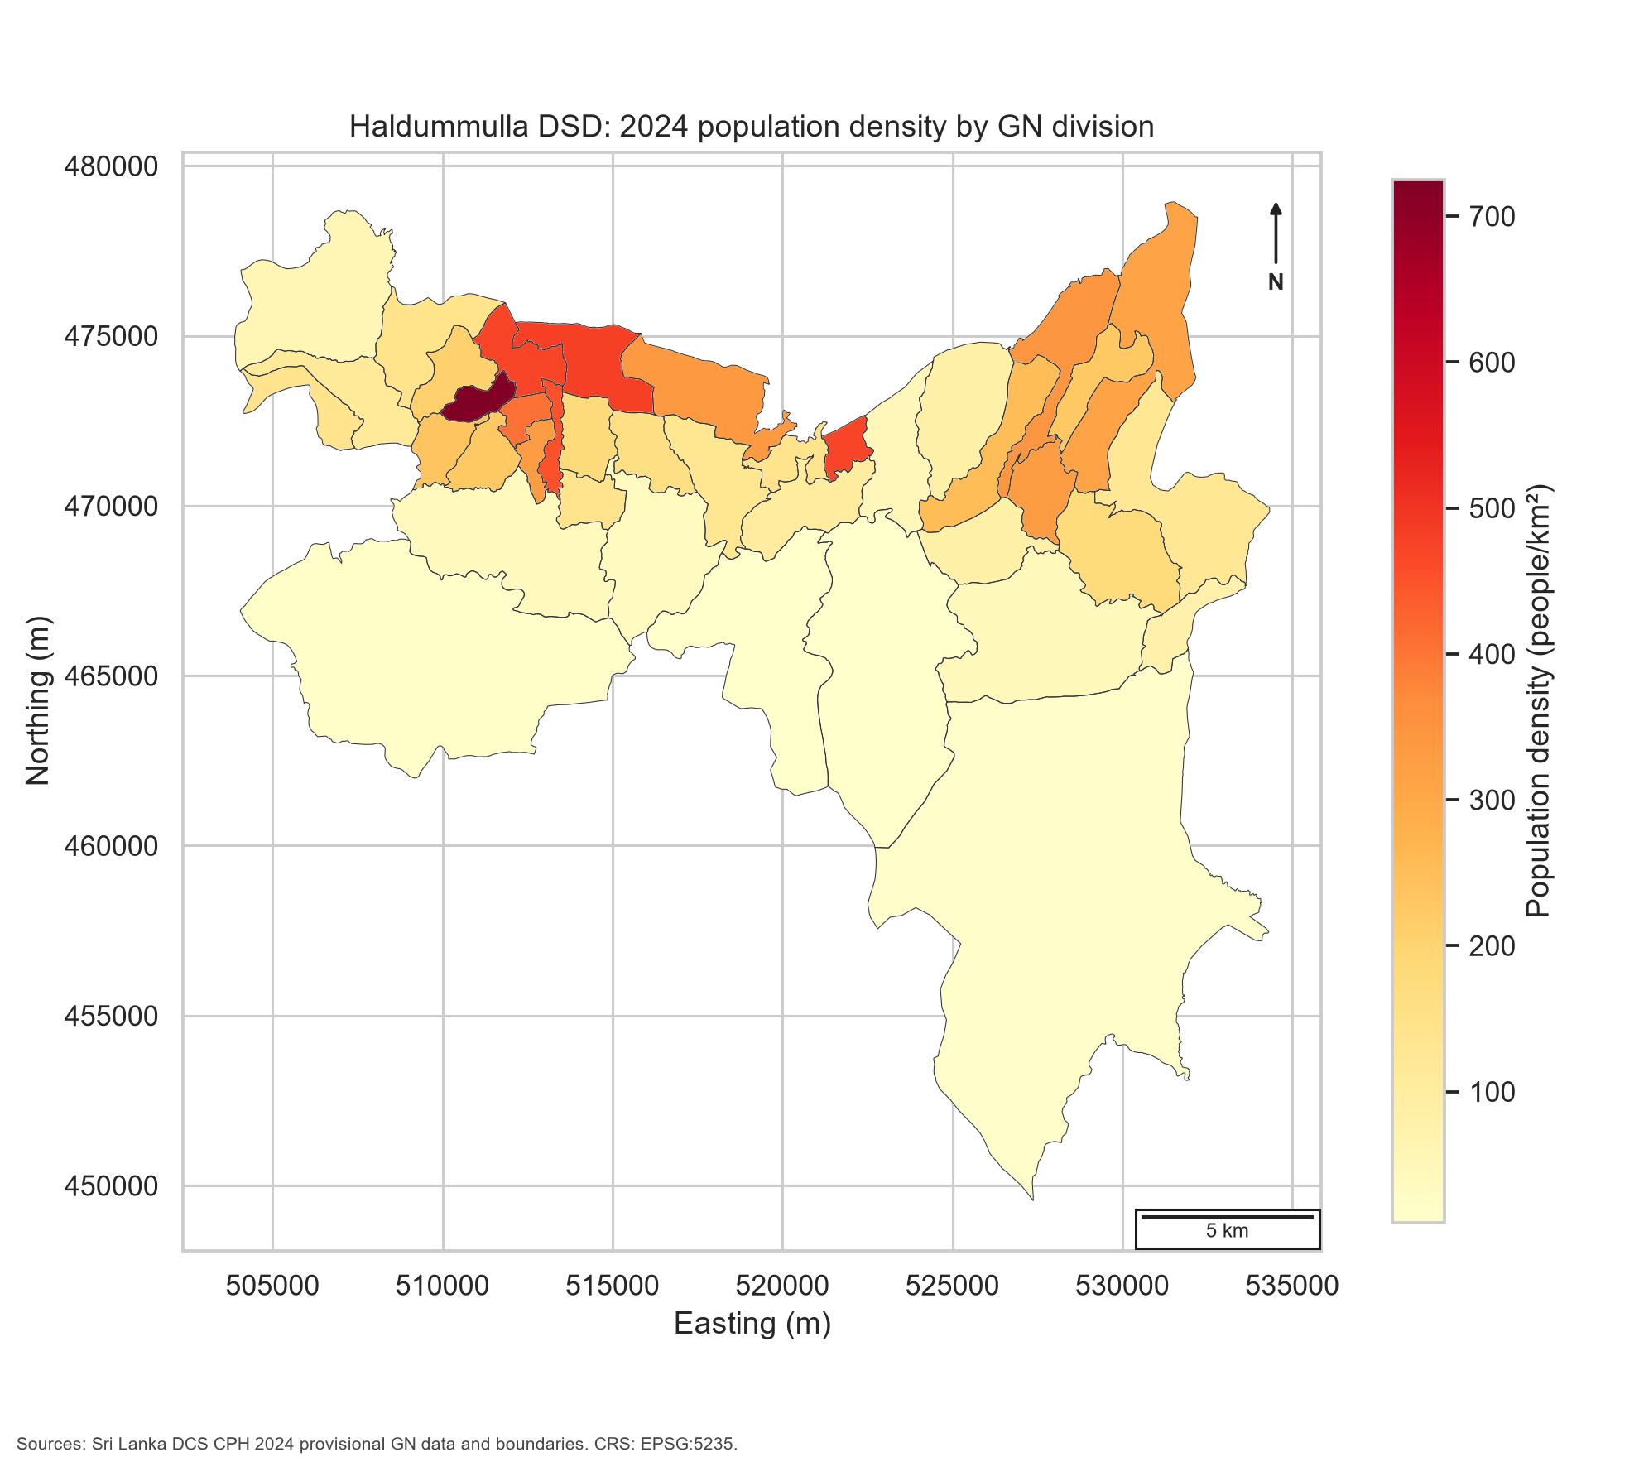
Figure 1. Haldummulla DSD and 2024 population density by GN division. Population values and boundaries are from the Sri Lanka Department of Census and Statistics.

2. Background research and literature review

2.1 Causes, conditioning factors and triggers
A landslide occurs when driving forces on a slope exceed the resisting strength of the material. The process is influenced by several connected factors rather than one variable. Slope angle controls the gravitational component acting downslope. Local relief represents the broader energy and terrain contrast around a location. Soil and weathered material affect permeability, water storage and shear strength. Rainfall can raise pore-water pressure, reduce effective stress and trigger failure, especially after prolonged wet conditions. Streams may erode the foot of a slope or indicate drainage convergence, while road cuts can remove support, change drainage and disturb the natural slope. Land-cover change may remove root reinforcement or alter infiltration and runoff.
The importance of these factors is location dependent. Van Westen, Castellanos and Kuriakose (2008) explain that susceptibility, hazard and vulnerability assessments need different spatial datasets and that scale influences which data are suitable. Reichenbach et al. (2018), after reviewing 565 statistically based studies, found substantial differences in thematic data, scale, modelling choices and evaluation practice. They also observed that conditioning factors were sometimes included without a clear geomorphological reason. Therefore, a long list of variables does not automatically produce a better model. The present index uses a smaller set of indicators that have a direct interpretation and can be refreshed from open sources.
Sri Lankan research gives stronger local justification. Ranasinghe et al. (2019) used 15 factors in Koslanda, including elevation, slope, curvature, topographic wetness, land use, geology, rainfall, distance to water bodies, soil moisture, surface roughness and forest biomass. Their radar-enhanced models improved the separation of high- and very-low-susceptibility areas, showing the value of moisture and surface information. However, several inputs, including a 7 m DEM and a field-checked inventory, were not released as open project data. At Badulla District scale, Hemasinghe et al. (2018) reported that 20.5% of the area fell into high or extremely high susceptibility categories using logistic regression. Jayasinghe, Wijekoon and Gunatilake (2017) compared ordinary and geographically weighted logistic regression and selected the geographically weighted method based on ROC-AUC performance. These studies support the use of spatially varying relationships, but both depend on inventories that are more complete than the open catalogue available for this assessment.

2.2 Modelling approaches and their suitability
Landslide susceptibility methods can be grouped broadly into expert or index-based approaches, statistical methods, machine learning, and physically based models. GIS-based multi-criteria decision analysis (MCDA) is widely used when factors come from different units and a clear weighted structure is required (Malczewski, 2006). Its strengths are transparency, modest computing requirements and the ability to operate where training data are limited. Its main weakness is that weights and class scores include judgement. Feizizadeh and Blaschke (2014) show that this uncertainty can materially affect a landslide susceptibility map and recommend Monte Carlo sensitivity analysis. This recommendation directly influenced the 500-run weight test used here.
Statistical methods such as frequency ratio, weights of evidence and logistic regression estimate relationships from mapped landslides. They can reduce reliance on expert judgement, but their reliability depends on inventory quality, representative absence or background samples, consistent mapping scale and appropriate validation. Reichenbach et al. (2018) found logistic regression, neural networks, data overlay, index methods and weights of evidence among the most common methods. They also found that uncertainty analysis remained uncommon. Local research by Hemasinghe et al. (2018) and Jayasinghe, Wijekoon and Gunatilake (2017) demonstrates the value of logistic and geographically weighted models in Badulla. Nevertheless, transferring their fitted relationships to a different data stack would not be defensible without the original inventory and harmonised variables.
Machine-learning methods can identify non-linear interactions. Merghadi et al. (2020) reviewed algorithm performance and noted the strong performance of tree-based ensembles, especially random forests. However, good predictive accuracy is not guaranteed by algorithm complexity. A model can learn mapping bias, spatial autocorrelation or errors in the inventory. Random train-test splits may also overstate performance when nearby pixels from the same terrain appear in both sets. The available NASA legacy catalogue contains only 75 Sri Lankan reports and only three text-matched Haldummulla, Koslanda or Nikapotha candidates. Two candidate points fall inside the DSD, and their stated accuracy is 1 km and 10 km. This evidence is inadequate for training a supervised 30 m classifier. Reporting an ROC-AUC value from such a sample would give false confidence.
Physically based models estimate slope stability using material strength, groundwater, slope geometry and rainfall inputs. They can support scenario analysis, but they require detailed geotechnical parameters that are not available consistently across the DSD. Advanced methods named in the brief, including InSAR, deep learning, graph neural networks and geo-foundation models, may be valuable in later research. InSAR could detect slow deformation, while Sentinel imagery could support land-cover or moisture updating. However, adding an advanced method without suitable ground observations would increase technical complexity without solving the main evidence gap. The current design therefore favours an interpretable screening index and clearly records what it cannot establish.

2.3 Research gap and contribution
The main gap is not the absence of a physical susceptibility study near Koslanda. Ranasinghe et al. (2019) already provide a strong local example. The gap addressed here is a reproducible, openly sourced workflow that extends across the full Haldummulla DSD, links 30 m physical conditions to current GN-level population and housing exposure, and quantifies the sensitivity of the ranking to the selected weights. Previous Badulla studies mainly map susceptibility. The present project adds exposure and a reusable data pipeline with file hashes, documented transformations and exportable raster, vector and tabular outputs.
This contribution has limits. The index does not include a detailed lithology layer, rainfall intensity thresholds, field-mapped landslide polygons or building footprints. Topsoil clay is a broad proxy and cannot replace site-specific geotechnical testing. Mean annual rainfall shows long-term spatial wetness rather than the rainfall intensity of a particular storm. These gaps are made visible instead of being hidden behind a high-performing but unsupported model.
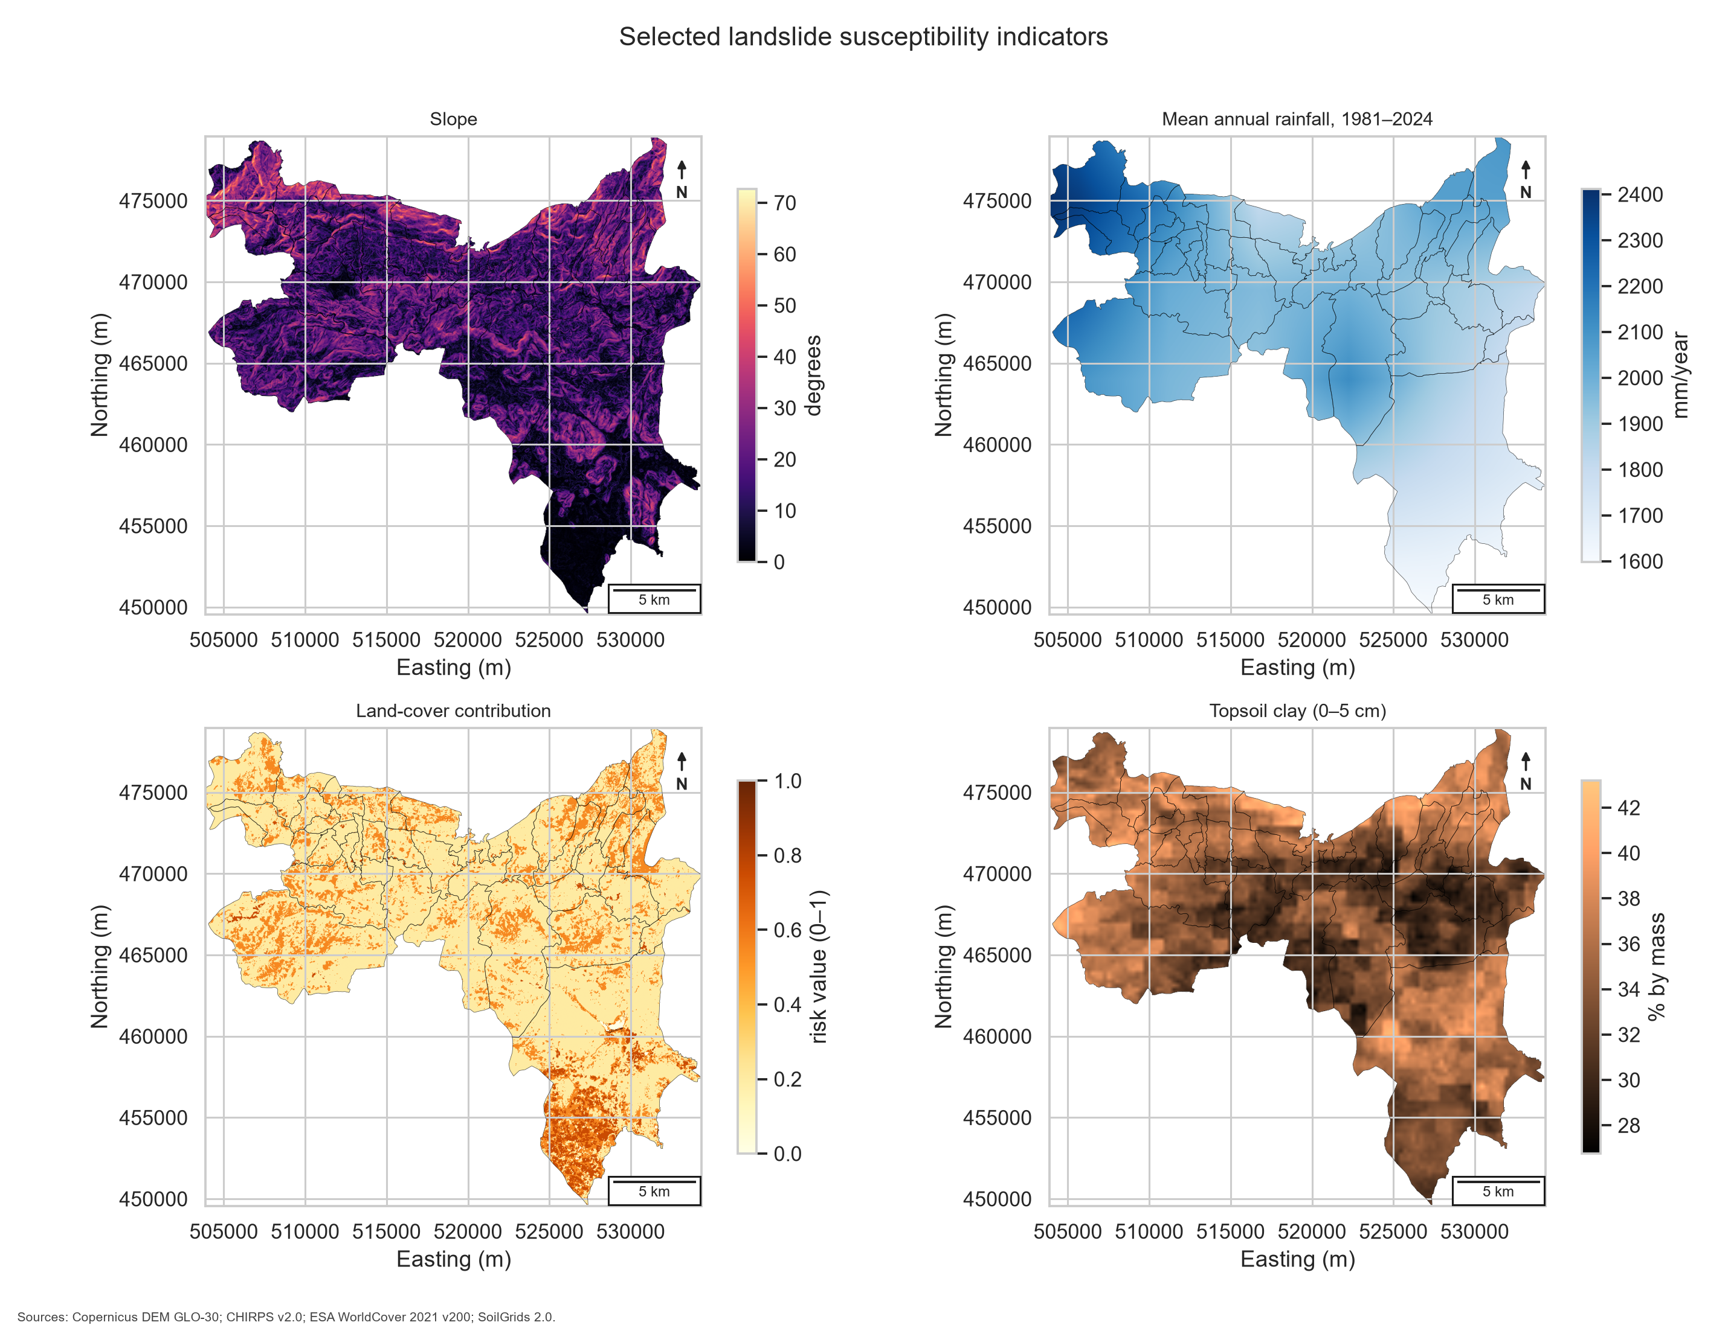
Figure 2. Selected physical susceptibility indicators after harmonisation. Units are shown on each colour bar.

3. Dataset selection, acquisition and verification
All core datasets were downloaded from official or recognised providers. The downloader records the file size, source and SHA-256 hash in data/raw/download_manifest.json. This supports reproducibility and allows later users to confirm whether an input has changed. The DCS ArcGIS feature service returned 39 Haldummulla GN polygons with 2024 population, sex and age fields. These totals were cross-checked against the official DCS Excel structure. Occupied housing was joined by GN code, and the workflow stops if any GN record fails to join.
Table 1. Verified datasets, roles and principal limitations
Dataset | Resolution / unit | Time coverage | Source CRS | Use in the index | Main limitation
DCS CPH 2024 GN boundaries and population | GN division | Census moment: 19 Dec. 2024; provisional GN tables | EPSG:4326 | Boundaries, population density, age vulnerability | Provisional values; exposure varies within each GN
DCS occupied housing units | GN division | 2024 provisional | Tabular | Housing density | Does not describe construction quality or replacement value
Copernicus DEM GLO-30 | Approx. 30 m | Source acquisition mainly 2010-2015; product release later | EPSG:4326; elevations in metres | Elevation, slope and 1 km local relief | Digital surface model; errors and vegetation/building effects remain
CHIRPS v2.0 annual mean | 0.05 degrees, about 5 km | 1981-2024 mean annual precipitation | EPSG:4326 | Long-term rainfall indicator | Too coarse for local storm intensity or threshold modelling
ESA WorldCover 2021 v200 | 10 m | 2021 | EPSG:4326 | Land-cover contribution | Global overall accuracy is 76.7%; local class errors are possible
SoilGrids 2.0 clay, 0-5 cm | 250 m | Static modelled soil property | EPSG:4326 service output | Topsoil clay percentage | Model prediction, not a field geotechnical layer; only surface depth
OpenStreetMap roads, waterways and amenities | Vector features; variable mapping detail | Retrieved for this project | EPSG:4326 | Road/stream proximity and critical amenity exposure | Volunteer coverage and tagging are incomplete in some areas
NASA Global Landslide Catalog legacy export | Event points; stated accuracy varies | Compiled from 2007; export current to 7 Mar. 2016 | EPSG:4326 | Limited independent reasonableness check | Media/report bias, old export and only two matched points inside DSD
Source: project data register and official provider documentation. Full URLs and SHA-256 hashes are retained in the repository.

Copernicus describes GLO-30 as a global digital surface model at 30 m with WGS 84 horizontal coordinates and metre-based elevations. CHIRPS combines satellite estimates and stations at 0.05-degree resolution and provides a long record from 1981 (Funk et al., 2015). ESA WorldCover provides 10 m global land cover, but its reported overall validation accuracy of 76.7% means that local categories must not be treated as error-free. SoilGrids uses machine learning and global soil profiles to predict properties at 250 m and six standard depths (Poggio et al., 2021). OpenStreetMap is useful for infrastructure but is community maintained, so a missing amenity is not proof that no facility exists. NASA states that the legacy Global Landslide Catalog was built mainly from media, disaster databases and reports, and that the selected export is a one-time snapshot current to March 2016 (Kirschbaum et al., 2010; NASA, 2025a).

4. Data cleaning, preprocessing and exploratory analysis

4.1 Preprocessing
The 39 GN geometries were checked and repaired where necessary before reprojection. All spatial data were transformed to Sri Lanka Kandawala / Sri Lanka Grid 1999 (EPSG:5235), which uses metres and supports meaningful area and distance calculations. The target raster contained 1,016 columns and 980 rows at 30 m. A union of the GN polygons created the analysis mask. Cells outside the DSD were stored as NoData.
The two Copernicus DEM tiles were mosaicked during reprojection and resampled bilinearly. Slope in degrees was derived from the horizontal and vertical elevation gradients. Local relief was calculated as the maximum minus minimum elevation in an approximately 1 km moving window. CHIRPS rainfall, SoilGrids clay and the DEM-derived continuous variables were resampled bilinearly. ESA WorldCover was resampled using nearest neighbour so class codes were preserved. SoilGrids clay values in grams per kilogram were divided by ten to produce percentage by mass. OSM road and stream lines were clipped to the DSD, rasterised and converted to Euclidean distance surfaces. Proximity contributions used exponential decay with 500 m for roads and 300 m for streams.
Continuous physical indicators were normalized using committed 2nd and 98th percentile baseline bounds. Values below the lower bound became zero, values above the upper bound became one, and intermediate values were linearly scaled. Raw rasters were retained so the clipped index can be audited. The automated preprocessing audit recorded no missing study-area cells for the DEM, CHIRPS or WorldCover inputs and 187 missing SoilGrids cells (0.041%), which were below the 0.5% rejection threshold and filled from the nearest valid cell. Approximately 4% of the valid cells in each continuous indicator fell outside the P2-P98 scaling interval, as expected from two-tail robust clipping. The audit is exported as outputs/tables/preprocessing_quality_audit.csv. Land cover used a documented class-to-risk lookup. Bare land received the maximum contribution, cropland and built-up land received relatively high values, grassland and shrubland received moderate values, tree cover received a lower value, and open water received zero. These are index assumptions, not measured failure probabilities.

4.2 Exploratory findings
Elevation ranged from 117.36 m to 2,208.06 m. Mean slope was 15.87 degrees, with a 98th percentile of 39.92 degrees and a maximum of 72.68 degrees. The mean 1 km local relief was 235.70 m. Mean annual rainfall ranged from about 1,598.57 to 2,411.64 mm/year, with a study-area mean of 1,956.15 mm/year. Topsoil clay averaged 34.42%. These results show a strong north-south physical contrast. The north and north-west contain steeper, wetter and more locally rugged terrain, while much of the southern area has lower index values.
WorldCover classified 76.54% of the 30 m analysis cells as tree cover, 19.54% as grassland and 3.53% as cropland. Built-up, bare and open-water classes together formed less than 0.4% of the area. The dominance of tree cover lowers the land-cover contribution over a large part of the DSD, but it does not remove terrain and rainfall effects. A random sample of 30,000 valid cells was used for Spearman correlation. Slope and local relief had the strongest relationship (rho = 0.616), which is expected because both describe terrain form. Rainfall and local relief had a moderate correlation (rho = 0.400). Road and stream proximity had a correlation of 0.310. No pair approached a level that required removing an indicator, but the overlap between slope and relief supports giving relief a smaller weight.
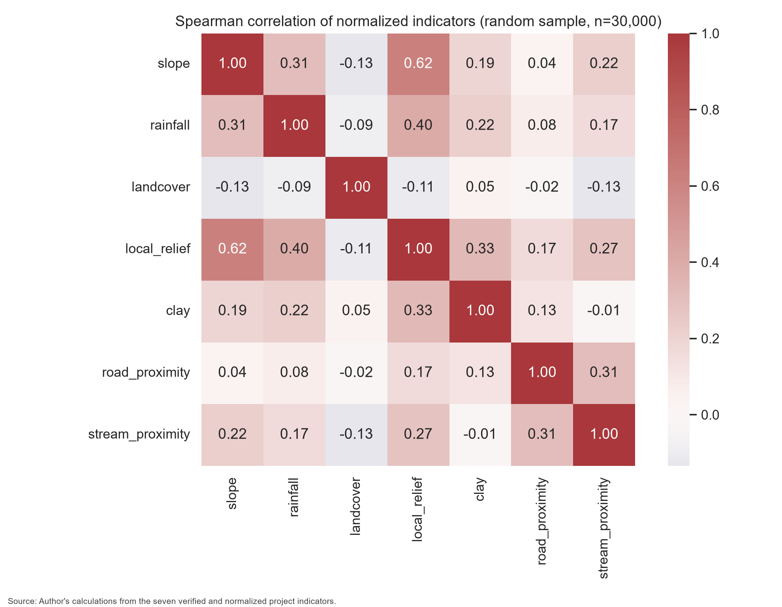
Figure 3. Spearman correlations between the seven normalised susceptibility indicators using a fixed random sample of 30,000 cells.
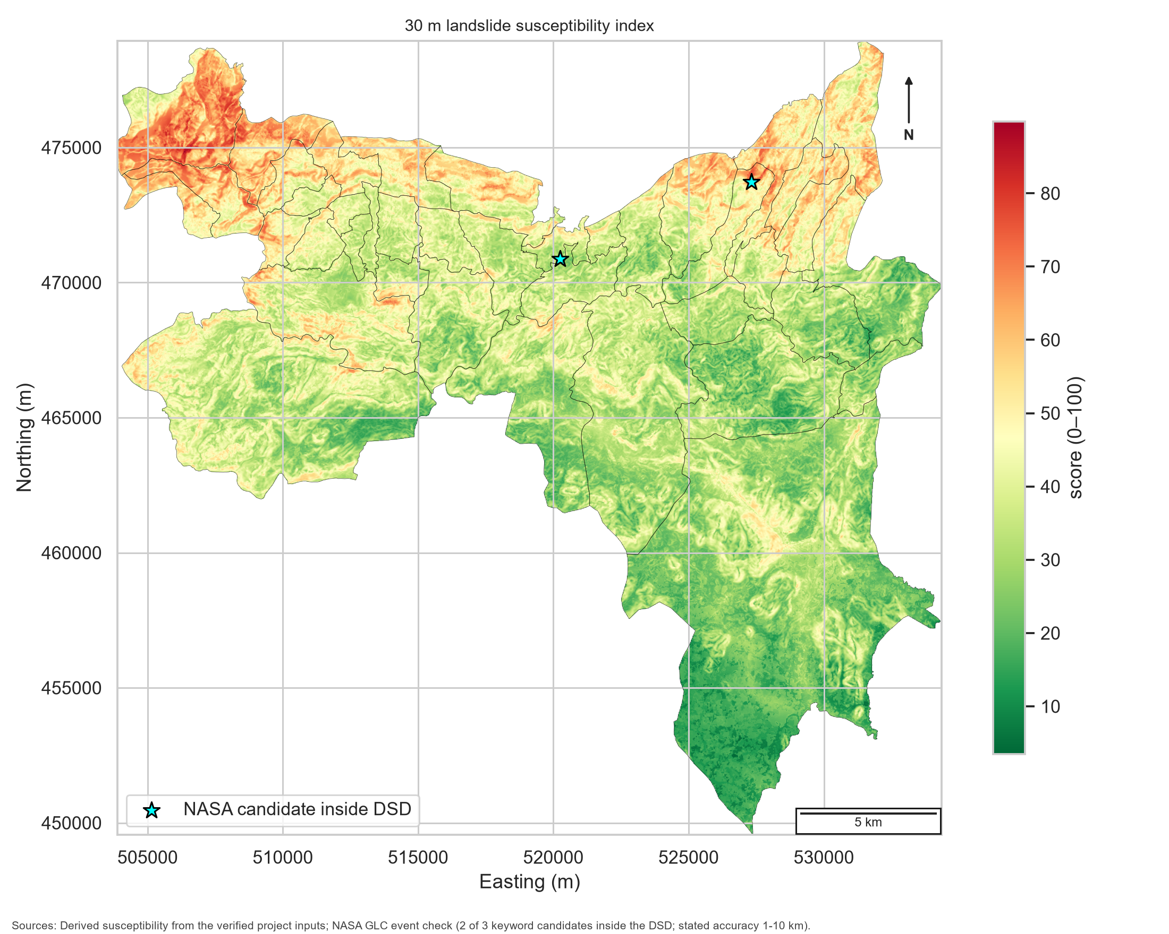
Figure 4. The 30 m susceptibility index with the two keyword-matched NASA catalogue candidates located inside the DSD.

5. Indexing algorithm

5.1 Normalisation and physical susceptibility
For a continuous indicator x, robust min-max scaling is applied within the Haldummulla mask:
Equation 1: z = clip[(x - P2(x)) / (P98(x) - P2(x)), 0, 1]
where P2 and P98 are the 2nd and 98th percentiles. Larger values represent a larger susceptibility contribution. Road and stream indicators are already bounded from zero to one after exponential distance decay. The 30 m physical susceptibility score for cell c is:
Equation 2: S(c) = 100 x [0.30z_slope + 0.20z_rainfall + 0.15z_landcover + 0.05z_relief + 0.10z_clay + 0.10z_road + 0.10z_stream]
Slope receives the highest weight (0.30) because it directly controls the downslope gravitational component. Rainfall receives 0.20 because prolonged and intense rainfall are important triggers in the Koslanda literature, although the present mean-annual layer represents broad climatological wetness rather than individual storms. Land cover receives 0.15 because vegetation, agriculture and exposed surfaces affect root reinforcement, drainage and disturbance. Clay, road proximity and stream proximity each receive 0.10. Local relief receives 0.05 because its sampled Spearman correlation with slope is 0.616; the smaller weight limits double counting while retaining broader terrain contrast. These weights, lookup scores and decay distances are transparent provisional expert-judgement assumptions, not calibrated failure probabilities.
The cell values are aggregated to GN division g using both central tendency and upper-tail conditions:
Equation 3: SGN(g) = 0.60 x mean[S(c) in g] + 0.40 x P90[S(c) in g]
Using only the mean would reduce the influence of small hazardous slopes within a large GN division. Using only the maximum would be unstable because one noisy cell could control the result. The mean-plus-90th-percentile rule provides a practical balance.

5.2 Exposure and final risk
Population density, occupied housing density, vulnerable population share and critical amenity density are calculated for every GN. Vulnerable population is defined as residents aged 0-14 plus residents aged 65 and over, divided by total population. Each exposure indicator is robustly normalised across the 39 GNs. The exposure score is:
Equation 4: E(g) = 100 x [0.45z_population + 0.25z_housing + 0.15z_vulnerability + 0.15z_amenities]
Population and housing receive 70% of the exposure weight because they directly represent people and occupied structures. Age structure represents potential assistance needs, while amenity density represents disruption to important services. The final LS-LRSI is a weighted geometric mean:
Equation 5: R(g) = 100 x [SGN(g)/100]^0.70 x [E(g)/100]^0.30
The geometric form reduces the ability of an extremely high value in one component to fully compensate for a very low value in the other. Susceptibility receives 70% because exposure cannot create landslide risk without an unstable physical setting, while the 30% exposure term ensures that risk is not treated as susceptibility alone.
The 39 continuous risk scores are ranked and divided into four quartile classes: Low, Moderate, High and Very High. These labels describe priority relative to Haldummulla only. The continuous score and component scores should always be retained because class boundaries simplify gradual differences.

5.3 Pseudo-code
INPUT: official GN polygons and census tables; DEM; rainfall; land cover;
clay; OSM roads, streams and amenities; NASA catalogue

1. Verify files and write SHA-256 manifest.
2. Repair GN geometry; join population and housing by GN code.
3. Reproject all spatial inputs to EPSG:5235.
4. Create a 30 m grid and mask it to Haldummulla DSD.
5. Derive slope, 1 km local relief, road distance and stream distance.
6. Resample continuous layers bilinearly and land cover by nearest neighbour.
7. Write the missing-coverage and clipping audit; convert continuous factors to 0-1 using the fixed P2-P98 baseline.
8. Apply the land-cover lookup and distance-decay functions.
9. Calculate the weighted 30 m susceptibility score.
10. For each GN, combine mean susceptibility and its 90th percentile.
11. Calculate and normalise the four exposure indicators.
12. Calculate exposure and the final geometric LS-LRSI score.
13. Rank GN divisions; assign relative quartile classes.
14. Perturb weights 500 times; report rank and class stability.
15. Compare catalogue points only as a limited reasonableness check.
OUTPUT: GeoTIFFs, GeoPackages, CSV tables, figures and report evidence.
Future updates should retain the target CRS, grid origin, 30 m alignment, indicator direction, committed normalization baseline and output schema. A new rainfall period, land-cover year, census table or edited OSM extract can then replace the old source, after which checksums and the preprocessing audit must be regenerated and the full workflow rerun. The 0.05-degree CHIRPS layer has an effective resolution of approximately 5 km around Haldummulla; aligning it to 30 m does not create local rainfall observations. A future dynamic version should derive one coherent rainfall sub-index from dated daily rainfall, such as maximum 1-day, 3-day or 7-day accumulation and antecedent 7-day or 30-day rainfall, while checking correlation to avoid double weighting. If a reliable dated polygon inventory becomes available, the fixed weights should be re-estimated or compared against logistic regression, random forest and spatially separated cross-validation.

6. Results, validation and interpretation
The cell-level susceptibility surface had a mean of 37.47, a median of 36.22 and a 98th percentile of 68.17. Scores ranged from 3.48 to 89.77. The highest values form connected bands across steeper northern and north-eastern terrain rather than isolated cells. This pattern agrees with the physical gradients in slope, relief and rainfall. However, a high cell score means that mapped conditions resemble the index definition of susceptibility; it is not a probability that a landslide will occur during a stated period.
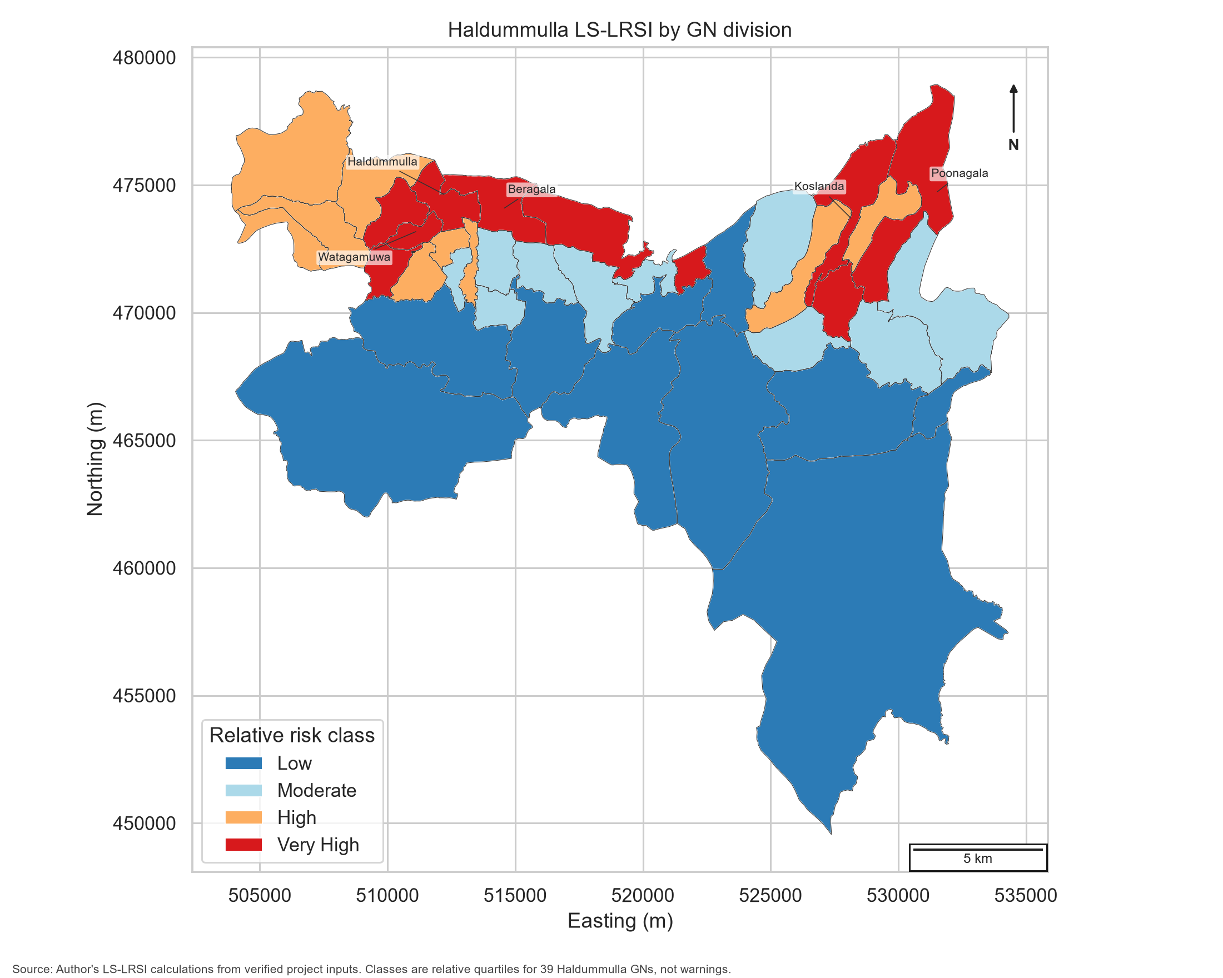
Figure 5. Final GN-level LS-LRSI classes. The classes are quartiles relative to the 39 Haldummulla GN divisions.
At GN level, Haldummulla ranked first with a risk score of 59.51, followed by Beragala at 58.97, Watagamuwa at 56.24, Koslanda at 55.67 and Poonagala at 54.01. The reasons differ. Haldummulla combines susceptibility of 56.89 with exposure of 66.10, while Beragala combines susceptibility of 54.55 with exposure of 70.73. Watagamuwa has a lower susceptibility score of 48.37 but its third-ranked outcome is driven by exposure of 79.97 and population density of approximately 724.86 people per km2. Koslanda has susceptibility of 57.38 and exposure of 51.86. Poonagala combines susceptibility of 55.38 and exposure of 50.95 with 4,050 residents and three mapped critical amenities.
Ten GNs were classified Very High, nine High, ten Moderate and ten Low. The Very High group ranged from 50.87 to 59.51. High ranged from 43.68 to 48.53, Moderate from 32.86 to 43.26, and Low from 5.97 to 32.23. The gaps between ranges result from the observed continuous scores and deterministic quartile assignment. They must not be converted into universal thresholds.
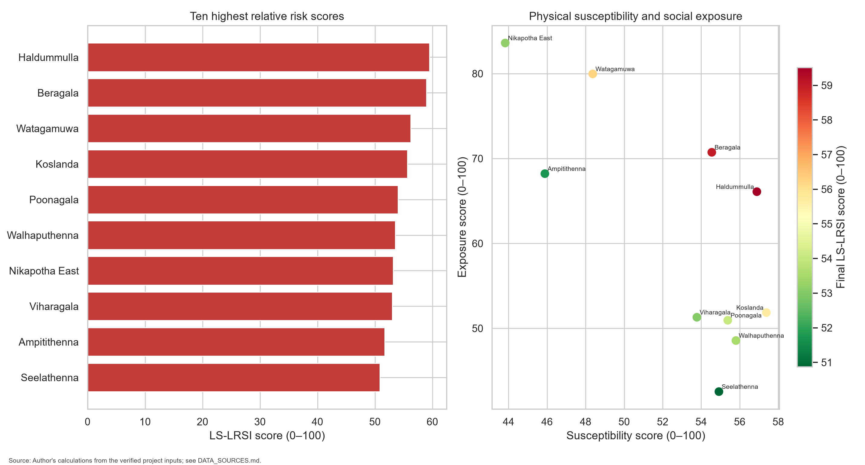
Figure 6. Ten highest GN scores and the balance between physical susceptibility and social exposure.
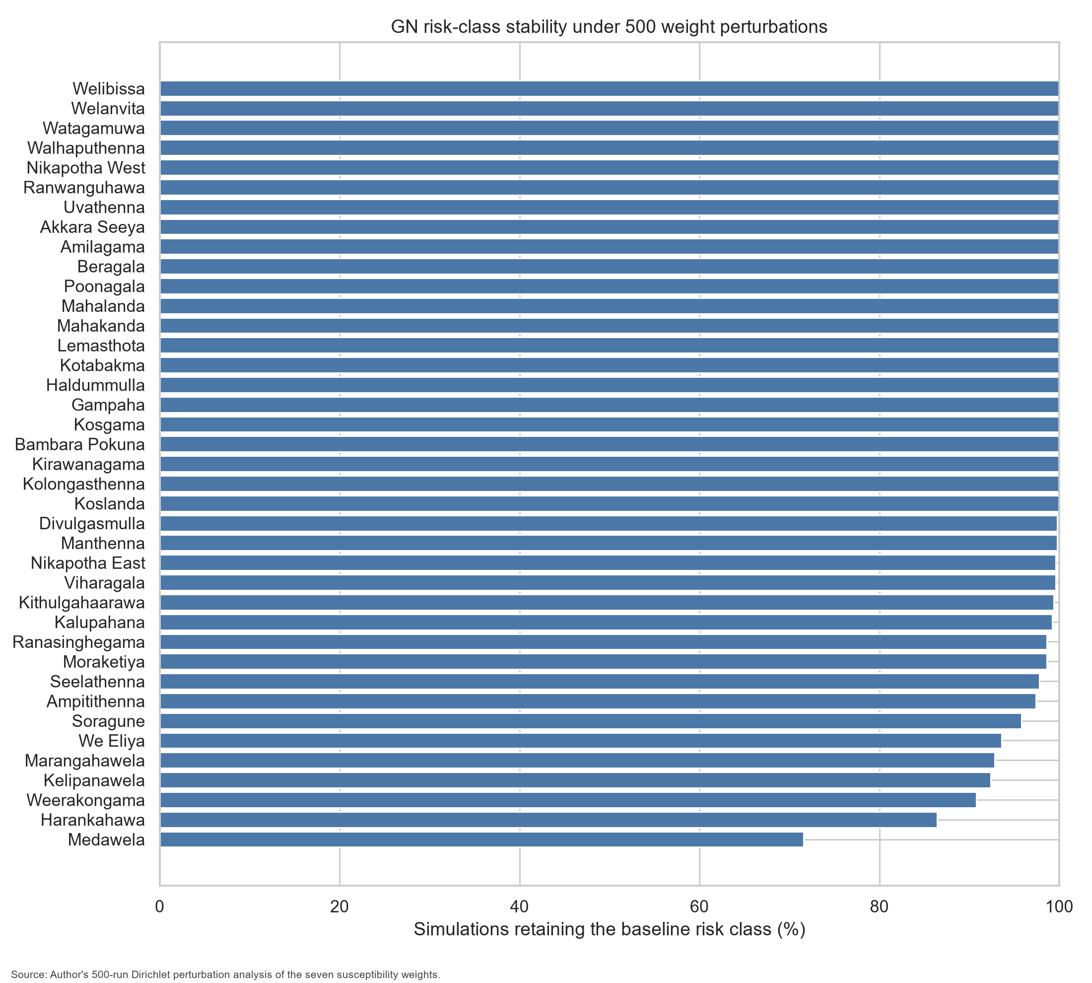
Figure 7. Percentage of weight simulations in which each GN division retained its baseline class.
The 500-run Dirichlet test varied all seven susceptibility weights while preserving a sum of one. Spearman rank correlation between each simulated ranking and the baseline had a 5th percentile of 0.993, a median of 0.997 and a 95th percentile of 0.999. Thirty-three of 39 GN divisions retained their baseline class in at least 94% of simulations, and 37 retained it in at least 90%. Medawela was least stable at 71.6%, followed by Harankahawa at 86.4% and Weerakongama at 90.8%. These GNs lie near relative class boundaries, so their continuous scores should receive more emphasis than their class labels. The sensitivity test addresses moderate susceptibility-weight uncertainty only; it does not validate indicator relationships or vary exposure weights, class scores or distance-decay choices.
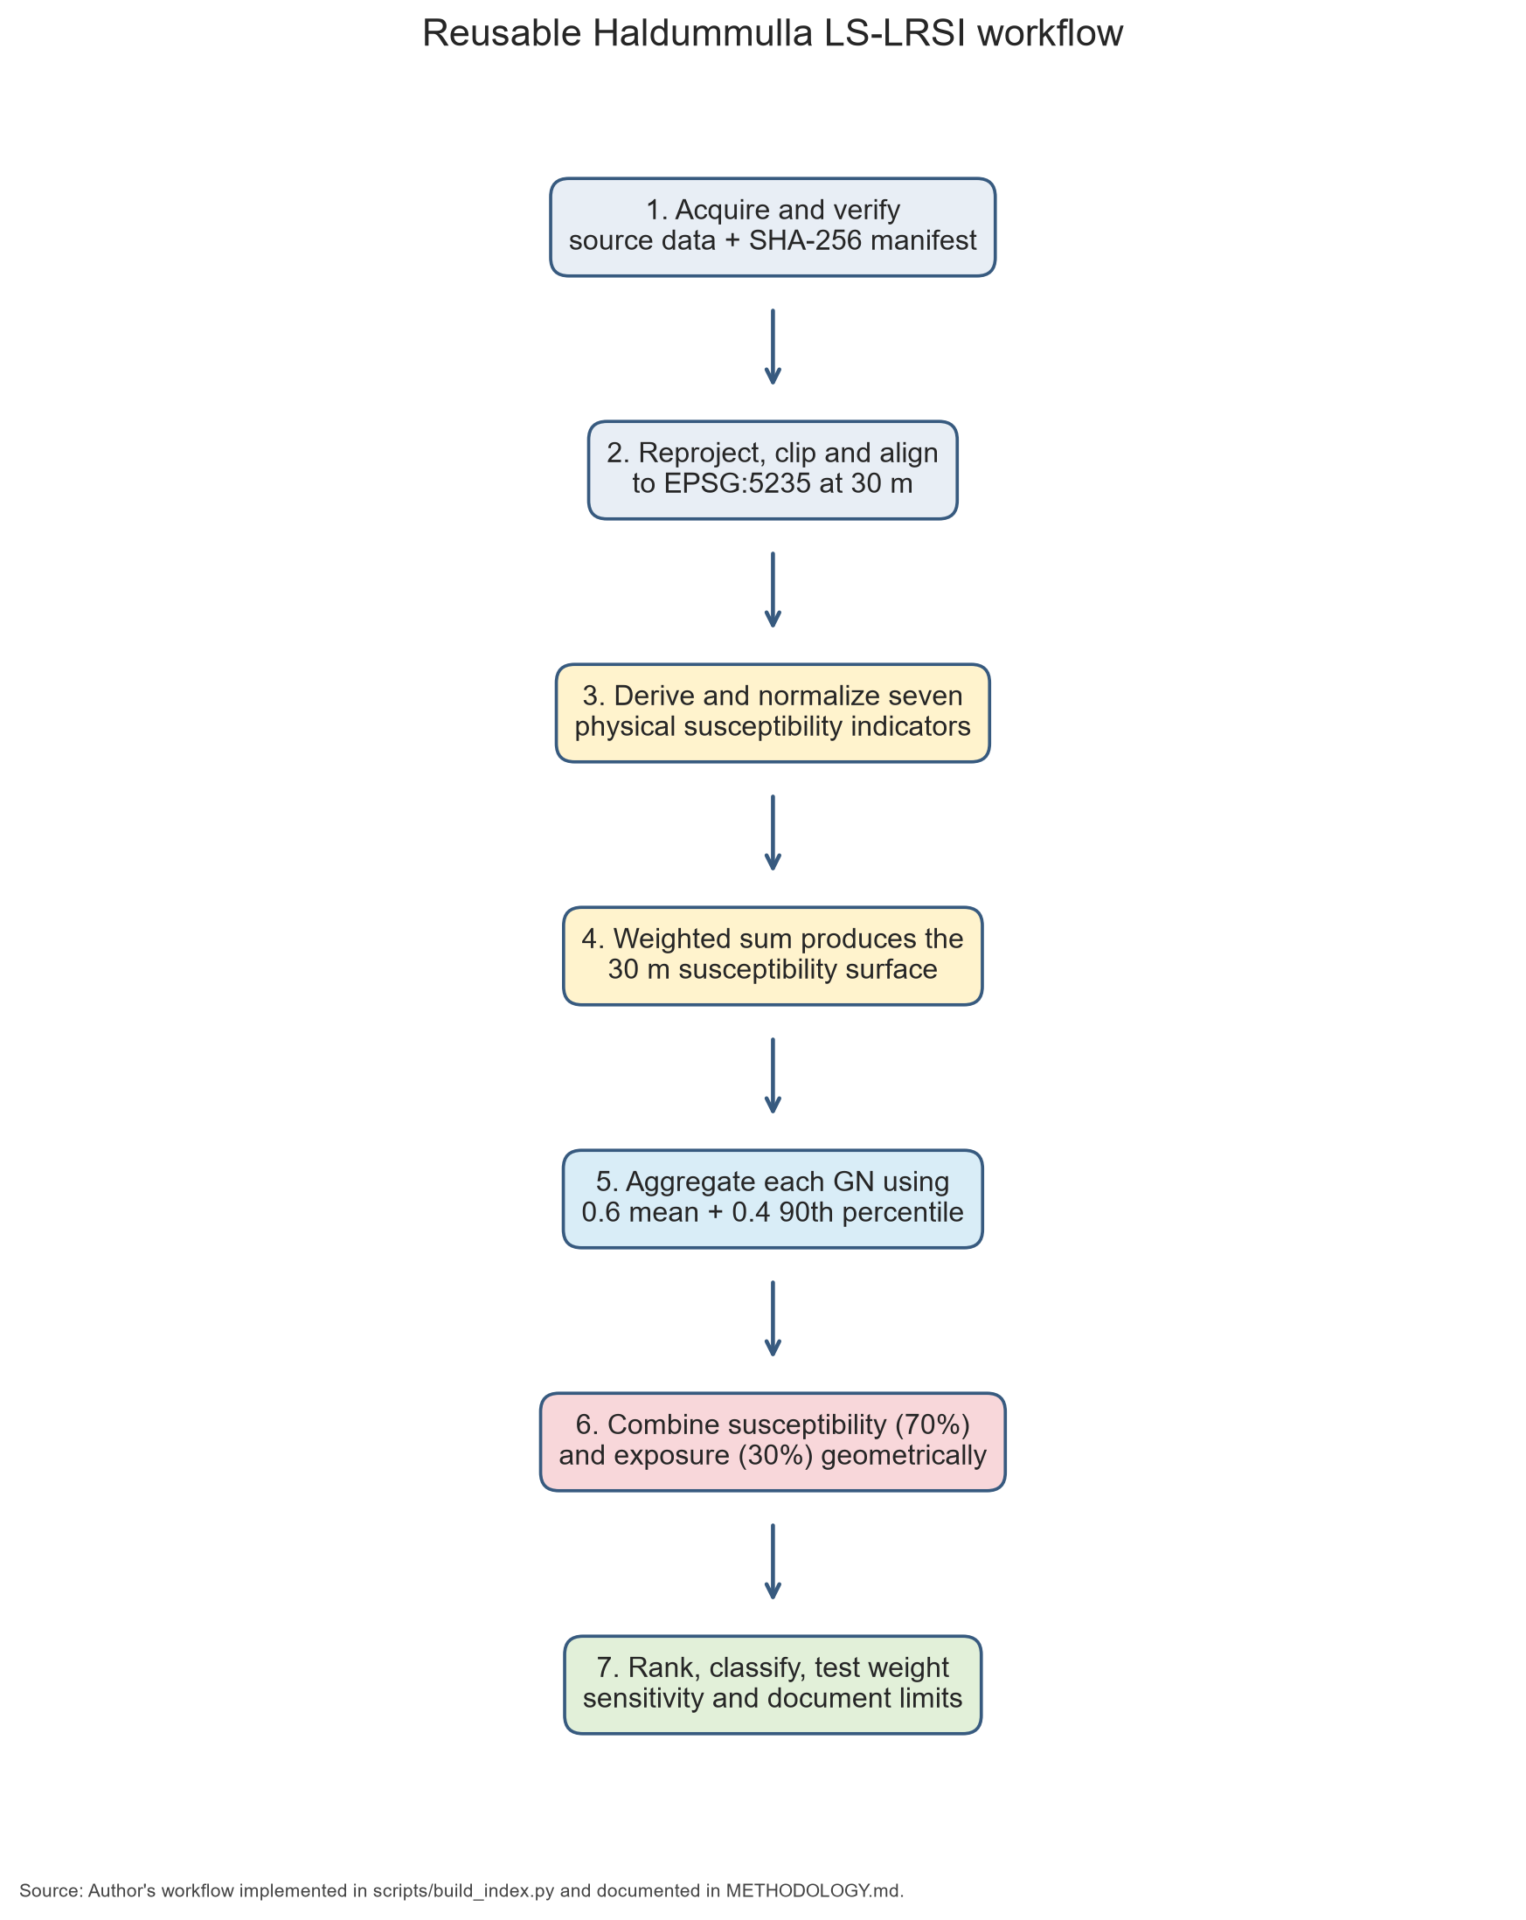
Figure 8. Reusable workflow for calculating the Haldummulla LS-LRSI with future datasets.
NASA catalogue validation was deliberately limited. Three Sri Lankan records matched Haldummulla, Koslanda or Nikapotha, but one reported Haldummulla event plotted outside the DSD. The Koslanda tea plantation point, with 1 km stated accuracy, fell on a susceptibility score of 66.70 at the 97.44th study-area percentile. The Nikapotha event, with 10 km accuracy, fell on 34.06 at the 43.25th percentile. A 10 km uncertainty radius covers many terrain conditions, so this cannot be treated as a failed prediction. Two usable points are insufficient for ROC-AUC, confusion matrices or a train-test split. The catalogue therefore provides only a reasonableness check and confirms the need for a field-verified NBRO or locally compiled inventory.

7. Conclusion, limitations and recommendations
This project demonstrates that an interpretable LS-LRSI can be produced for Haldummulla from verified public data. The final ranking identifies Haldummulla, Beragala, Watagamuwa, Koslanda and Poonagala as the five highest relative priorities. The result is not driven by one type of evidence. Haldummulla, Beragala and Koslanda combine strong physical susceptibility with meaningful exposure, while Watagamuwa shows how dense settlement can raise risk despite a lower susceptibility component. The 500-run sensitivity test suggests that the broad ranking is robust to moderate weight changes.
Several limitations affect interpretation. First, the CHIRPS input has a 0.05-degree native grid, approximately 5 km around Haldummulla. Bilinear alignment to 30 m creates a smooth calculation grid but not new local observations, and the layer represents 1981-2024 mean annual rainfall rather than event intensity, duration or antecedent wetness. Second, SoilGrids is a 250 m global prediction of 0-5 cm topsoil clay. It does not represent deeper colluvium, rock structure, groundwater or shear-strength parameters. Third, no detailed lithology or lineament layer was included, even though local geology influences failure mechanisms. Fourth, OSM completeness is uneven, and the 17 mapped critical amenities are a minimum count rather than a complete government inventory. Fifth, census values are aggregated by GN and do not locate people within each polygon or describe building vulnerability. The most important limitation is the landslide inventory: the legacy NASA export is media based, old and spatially uncertain, so it cannot support supervised 30 m training or formal predictive accuracy. The index also uses judgement-based weights, land-cover scores and distance-decay assumptions. Sensitivity testing measures moderate susceptibility-weight perturbations but does not prove that the relationships are correct. Finally, quartile classes always place approximately one-quarter of GNs in the highest class; they support relative prioritization, not warning levels.

Three improvements are recommended. First, obtain a field-checked polygon inventory from NBRO or create one through multi-date Sentinel-2 interpretation, local records and field verification. Use spatially separated cross-validation when comparing logistic regression, random forest and the current index. Second, add local geology, regolith depth, road-cut condition, drainage condition and event-based rainfall. A dynamic layer could use daily CHIRPS or GPM rainfall and antecedent rainfall indices, but operational warning thresholds must be calibrated against dated local events. Third, improve exposure mapping with building footprints, building use and construction type, road criticality, school enrolment, health-facility capacity and daytime population.
For immediate use, the map should guide screening. Very High and High GNs can be reviewed alongside NBRO hazard maps, road-cut inspections and community knowledge. Field teams should focus on steep inhabited slopes, drainage failures, recent land-cover disturbance and infrastructure serving vulnerable groups. No planning refusal, relocation or evacuation decision should be based on this index alone.

References
Corominas, J., van Westen, C.J., Frattini, P., Cascini, L., Malet, J.-P., Fotopoulou, S. et al. (2014) 'Recommendations for the quantitative analysis of landslide risk', Bulletin of Engineering Geology and the Environment, 73(2), pp. 209-263. https://doi.org/10.1007/s10064-013-0538-8
European Space Agency (2022) ESA WorldCover 10 m 2021 v200. https://doi.org/10.5281/zenodo.7254221
Feizizadeh, B. and Blaschke, T. (2014) 'An uncertainty and sensitivity analysis approach for GIS-based multicriteria landslide susceptibility mapping', International Journal of Geographical Information Science, 28(3), pp. 610-638. https://doi.org/10.1080/13658816.2013.869821
Fell, R., Corominas, J., Bonnard, C., Cascini, L., Leroi, E. and Savage, W.Z. (2008) 'Guidelines for landslide susceptibility, hazard and risk zoning for land use planning', Engineering Geology, 102(3-4), pp. 85-98. https://doi.org/10.1016/j.enggeo.2008.03.022
Funk, C., Peterson, P., Landsfeld, M., Pedreros, D., Verdin, J., Shukla, S. et al. (2015) 'The climate hazards infrared precipitation with stations - a new environmental record for monitoring extremes', Scientific Data, 2, 150066. https://doi.org/10.1038/sdata.2015.66
Hemasinghe, H., Rangali, R.S.S., Deshapriya, N.L. and Samarakoon, L. (2018) 'Landslide susceptibility mapping using logistic regression model: a case study in Badulla District, Sri Lanka', Procedia Engineering, 212, pp. 1046-1053. https://doi.org/10.1016/j.proeng.2018.01.135
Jayasinghe, G.J.M.S.R., Wijekoon, P. and Gunatilake, J. (2017) 'Landslide susceptibility assessment using statistical models: a case study in Badulla district, Sri Lanka', Ceylon Journal of Science, 46(4), pp. 27-41. https://doi.org/10.4038/cjs.v46i4.7466
Kirschbaum, D.B., Adler, R., Hong, Y., Hill, S. and Lerner-Lam, A. (2010) 'A global landslide catalog for hazard applications: method, results, and limitations', Natural Hazards, 52(3), pp. 561-575. https://doi.org/10.1007/s11069-009-9401-4
Malczewski, J. (2006) 'GIS-based multicriteria decision analysis: a survey of the literature', International Journal of Geographical Information Science, 20(7), pp. 703-726. https://doi.org/10.1080/13658810600661508
Merghadi, A., Yunus, A.P., Dou, J., Whiteley, J., ThaiPham, B., Bui, D.T., Avtar, R. and Boumezbeur, A. (2020) 'Machine learning methods for landslide susceptibility studies: a comparative overview of algorithm performance', Earth-Science Reviews, 207, 103225. https://doi.org/10.1016/j.earscirev.2020.103225
NASA (2025a) Global Landslide Catalog Export. Available at: https://data.nasa.gov/dataset/global-landslide-catalog-export (Accessed: 16 August 2026).
NASA (2025b) Cooperative Open Online Landslide Repository (COOLR). Available at: https://gpm.nasa.gov/applications/landslides/coolr (Accessed: 16 August 2026).
OpenStreetMap contributors (2026) OpenStreetMap data. Available at: https://www.openstreetmap.org/copyright (Accessed: 16 August 2026).
Poggio, L., de Sousa, L.M., Batjes, N.H., Heuvelink, G.B.M., Kempen, B., Ribeiro, E. and Rossiter, D. (2021) 'SoilGrids 2.0: producing soil information for the globe with quantified spatial uncertainty', SOIL, 7, pp. 217-240. https://doi.org/10.5194/soil-7-217-2021
Ranasinghe, A.K.R.N., Bandara, R., Puswewala, U.G.A. and Dammalage, T.L. (2019) 'Efficacy of using radar-derived factors in landslide susceptibility analysis: case study of Koslanda, Sri Lanka', Natural Hazards and Earth System Sciences, 19, pp. 1881-1893. https://doi.org/10.5194/nhess-19-1881-2019
Reichenbach, P., Rossi, M., Malamud, B.D., Mihir, M. and Guzzetti, F. (2018) 'A review of statistically-based landslide susceptibility models', Earth-Science Reviews, 180, pp. 60-91. https://doi.org/10.1016/j.earscirev.2018.03.001
Sri Lanka Department of Census and Statistics (2026) Census of Population and Housing 2024: GN-level population and occupied housing information. Available at: https://www.statistics.gov.lk/Population/StaticalInformation/CPH2024/ (Accessed: 16 August 2026).
van Westen, C.J., Castellanos, E. and Kuriakose, S.L. (2008) 'Spatial data for landslide susceptibility, hazard, and vulnerability assessment: an overview', Engineering Geology, 102(3-4), pp. 112-131. https://doi.org/10.1016/j.enggeo.2008.03.010

Academic integrity and responsible use note
This revised report is written in original language from the documented analysis and cited sources. It does not copy source passages. Before submission, the student should confirm institutional cover-sheet and identification requirements, verify the required referencing style, review every claim against the cited paper, add personal reflection where appropriate, and retain the code, checksums, preprocessing audit and intermediate outputs as evidence of authorship. Similarity software may still identify titles, dataset names, equations and reference entries; those legitimate matches should not be removed by weakening correct citation.

