**Executive Tour: Murree, Bhurban, Ayubia, NathiaGali, Patriata 4D/3N**

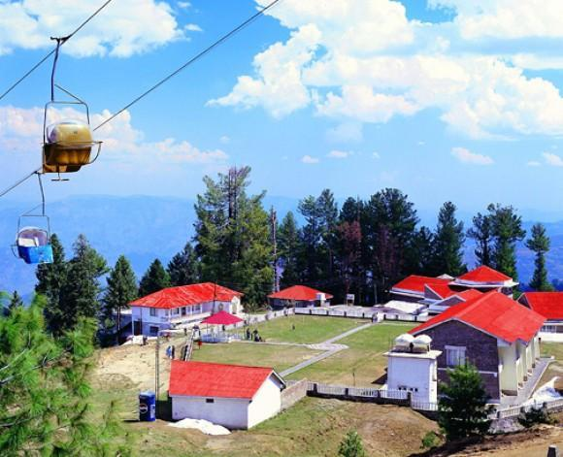

**No Planning, . No Worrying, .  &  No Driving. . .** Just fun & have a good time. Enjoy the Royal Treatment we provide, ! Once you take a Pleasantvacant with Pleasantvacant.com, you’ll understand why people love to **” Go with Pleasantvacant.com”** 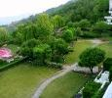

**(online travel & tours).** **.**

**General Information:** Its the tours of MURREE, AYUBIA, NATHIAGALI, PATRIATA & BHURBAN…. The most beautiful hill stations of  Pakistan. You can enjoy the coldest atmosphere here and the beautiful, attractive, picturesque natural scenes.

**Tour Type:** Private Tour for Couples, Families or Group of Fellows or Friends .

**Duration:** 4 Days & 3 Nights

**Destinations:** Murree, Ayubia, Nathiagali, Patriata & Bhurban.

**Overnight stay: For Deluxe & Standard Tour:** Overnight stay at Hotel in Murree.

**For Royal Tour:** 1st & 2nd Overnight stay at Pearl Continental Hotel in Bhurban. 3rd Overnight stay at Jawa International Hotel in Murree.

**Tour Categories:**

**Standard Tour -** Standard Tour includes the Accommodation (3*-4* Star Hotel/Standard Rooms), Breakfast along with Good Condition Transport, (Cultus, Santro, Suzuki APV, Hi-Roof  & Coaster) Fuel and Driver.

**Delux Hotel -** Deluxe Tour includes the Accommodation (3*-4* Star Hotel/Deluxe Rooms), Breakfast along with Deluxe Transport, (Corolla XLI, Corolla GLI, Corolla Se Saloon, Honda City, Suzuki APV, Hi-Roof & Coaster (New Model) Fuel and Driver.

**Royal Tour –** Royal Tour includes the Accommodation (4*-5* Star Hotel/Executive Rooms), Breakfast along with Deluxe Transport, (Corolla XLI, Corolla GLI, Corolla Se Saloon, Honda City, Suzuki APV, Hi-Roof & Coaster (New Model) Fuel and Driver.

**The Services includes:**

**1. Transportation:**

* Round Pleasantvacant from Lahore or Islamabad to Murree & Galiyat.
* **DELUXE** Transportation along with fuel, parking and toll taxes will be provided by Pleasant Vacant.com.
* Transportation will be provided from Islamabad or Tourist City. If you want to pick/drop from your desired city at you doorstep than extra mileage and fuel charges will be applicable.

**2. Hotel Accommodation:**

* **3*-5\*** star hotel as per the tour category.
* Rooms on twin sharing basis.
* **Children:** (3-10 years age) 50 % charges apply.
* **Note:** Children will share room with their parents.
* **Infants:** 0 to 3 years **FREE….**

**3. Meals: (Breakfast)**

* Meal (Breakfast) will be provided by Pleasantvacant.com during hotel stay.
* Lunch & Dinner meals are not included.
* If you want to avail the Lunch & Dinner facility than it can be arranged as per your requirement, extra charges will be applicable.

Important Note:

▪NET price of the tour (No Hidden Charges)

▪10% deposit to be made within 3 days at booking to confirm reservation.

▪Remaining 90% payment at or before the tour departure (start).

**Murree:** Murree you can visit the Kashmir point or Pindi point and enjoy the ride of chairlift. Also you can enjoy the busy life of Mall Road. Murree is said the Queen of Mountains and Mall Road is a jewel in this crown. .   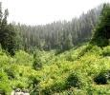

**Nathia Gali & Ayubia:** It is known for its scenic beauty, hiking tracks and pleasant weather, which is much cooler than the rest of the Galiyat due to it being greater altitude.The wildlife of Nathiagali contains various species of birds, insects, butterflies and animals, here you can also find lush green hills and mountains with wonderful Pine, Walnut, Oak and Maple trees. After visiting the Nathiagali drive to Ayubia. Ayubia is famous for its wild life, the wild life over here is very good. Here you can visit the Ayubia National Forest Park locate with the majestic. There is no place in this area where you won’t find monkeys. You can also enjoy the ride of cable car of Ayubia. 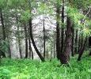

**Patriata:** Murree enjoy the ride of chair lift which takes you up 10,000 meters high. You can watch the adventurous scenes while sitting over the chair lift and after that you ride a Cabin Box lift which takes you up highest point of the Patriata.  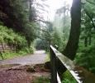

**For Royal Tour:** Murree enjoy the ride of chair lift which takes you up 10,000 meters high. You can watch the adventurous scenes while sitting over the chair lift and after that you ride a Cabin Box lift which takes you up highest point of the Patriata.

**Bhurban:** Bhurban,  take Hi-Tea in Pearl Continental Hotel and enjoy the golf club as well in the sight of evening. Have walk on the paved pathway through pure jungle in a secure environment, maintained by PC.

**For Royal Tour:** Bhurban,  take Hi-Tea in Pearl Continental Hotel and enjoy the golf club as well in the sight of evening. Have walk on the paved pathway through pure jungle in a secure environment, maintained by PC.

**Terms & Conditions:**

* **The above price includes:**
* Hotel Accommodation on twin sharing basis
* Breakfast will be provided by Pleasantvacant.com during Hotel stay.
* One Mattress per room for children (optional)
* AC/Non-AC Transportation for managed tours as per itinerary

**The above price does not include:** Guide services Any other service not mentioned above

**Child Policy:** Infants<3yrs are free.

**Children:** 3  to 10 years age 50% charges apply. Child above 10 years will be treated as adult. The price does not include breakfast charges for children.

**Get Free Quote or Request Booking Online – 24hours(recommended):** Submit the Free Quotation/Booking Form given below. No Credit Card or Payment required to request Quote. After submission, you will receive a Tour QUOTE within 3-12 hours via Email from Pleasantvacant.com. For help, question, query regarding tour or tariff, please don’t hesitate to call helpline 0332-3515830(9am-9pm).