**PCA and K-Means Segmentation**

Nexus Logistics Solutions (NLS) has implemented an Employee Development Program to support its workforce. Our analysis of employee feedback is gathered from the recent survey conducted by NLS, with the aim of identifying key motivational **themes**, determining distinct employee **segments**, and exploring variations in **engagement across different locations**.

We will use Principal Component Analysis (PCA) to identify key motivational themes, K-means clustering to segment employees based on their motivations and Location-based analysis to examine geographical differences in employee engagement.

**Key Themes Reflected in Employee Feedback:**

Through Principal Component Analysis (PCA), we have identified three main themes driving employee engagement in the EDP:

**PC1 - Skill Development:**

PC1 theme captures motivations related to improving job-specific skills, training, and gaining new competencies.

**PC2 - Operational Focus:**

PC2 reflects the importance of day-to-day responsibilities and routine work tasks. Employees aligned with this theme may value clear operational goals and efficiency in their daily roles.

**PC3 - Career Advancement:**

PC3 theme represents employees’ aspirations for career growth, leadership opportunities, and promotions.

**Scree Plot: - Appendix**

The above scree plot shows the cumulative explained variance by the number of principal components, which show the number of components necessary to capture most of the variance in the data.

This scree plot guided the selection of principal components for further analysis. The first three components account for approximately 80% of the variance, which indicates that they capture the most important factors underlying employee motivations. Beyond the third component, the curve flattens, showing that additional components add minimal value. Therefore, we chose to focus on the top three components to identify the primary themes of Skill Development, Team Engagement, and Career Advancement.

**Heatmap:**

This heatmap illustrates the contribution of each survey question to the top three themes (Skill Development, Team Engagement, and Career Advancement) identified through PCA. Each cell's color and value indicate the strength and direction of a survey question's relationship with a particular theme. For example, questions Q1, Q3, Q6, Q7, Q9 and Q11 show strong positive loadings on PC1, aligning with the theme of Skill Development. Similarly, questions Q4, Q10 and Q12 have high loadings on PC2, which we interpret as Operational Focus. Lastly, questions Q2, Q5, Q6, Q7, Q8 and Q9 have higher loadings on PC3, highlighting their connection to career growth and advancement.

This heatmap helps us understand which survey questions are most relevant to each theme, providing targeted insights into employee motivations.

**Groups based on Employee Responses:**

We have segmented the employees by using K-means clustering. As shown below, we have categorized employees into distinct segments based on their survey responses. These clusters reveal groups of employees with similar motivations, such as a focus on skill development, operational focus, or career advancement.

**Radar Charts:**

The below radar charts depict the profiles of each employee cluster based on the identified themes: Skill Development, Operational Focus, and Career Advancement. They illustrate the profiles of each cluster based on the three identified themes, represented by the principal components (PC1, PC2, and PC3). Each chart shows the average scores for each principal component within a specific cluster, providing insight into the dominant motivations for the employees in each group.

• **Cluster 0**:

Career Advancement (PC3) is the strongest motivator, with a score above 1.25, indicating a high interest in career growth opportunities.

Operational Focus (PC2) has a slight positive score, suggesting that employees in this cluster value some level of operational focus, but it’s not a primary driver.

Skill Development (PC1) shows a negative score of -0.75, meaning that employees in Cluster 0 are less interested in skill-building or training programs.

This profile indicates that employees in Cluster 0 are primarily focused on career advancement and may be less engaged by skill development initiatives. Programs aimed at this group should emphasize career pathways, growth opportunities, and leadership roles to align with their motivations.

• **Cluster 1**:

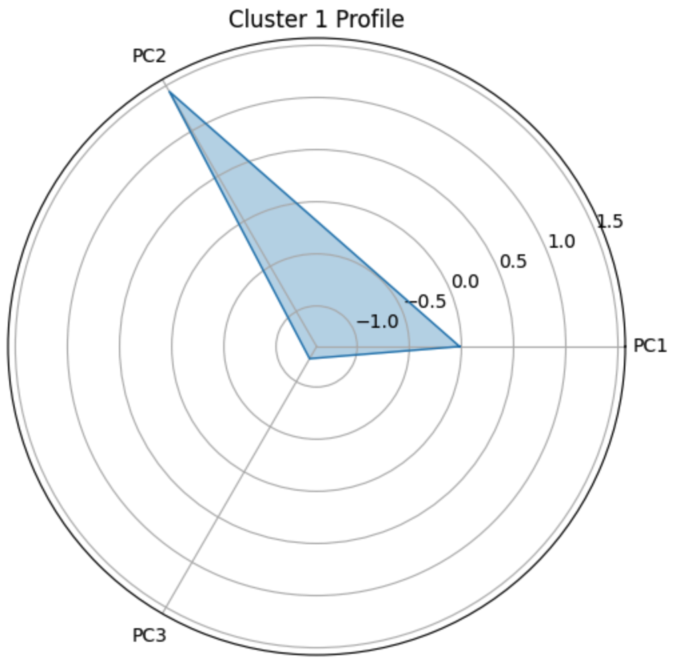

Operational Focus (PC2) is the most significant motivator, with a strong positive score close to 1.5. Employees in Cluster 1 value day-to-day responsibilities and routine work tasks.

Skill Development (PC1) has a neutral score, indicating that training and skill-building do not strongly influence this group.

Career Advancement (PC3) has a strong negative score below -1, showing that this group is less interested in career progression or leadership opportunities.

This profile suggests that Cluster 1 employees would benefit from initiatives that enhance structure, clarity, and efficiency in their day-to-day tasks. Career advancement-focused programs may not resonate well with this group, as they prioritize operational focus over individual career growth.

• **Cluster 2**:

Skill Development (PC1) is the strongest motivator for this cluster, with a high positive score above 3. Employees in Cluster 2 are focused on enhancing their skills and gaining expertise.

Operational Focus (PC2) has a strong negative score near -2, indicating that this group is not motivated by routine, structured tasks or operational efficiency.

Career Advancement (PC3) has a neutral score around 0, suggesting that career growth and promotion opportunities are not a primary focus for this group.

This profile suggests that Cluster 2 employees would benefit most from individualized skill development programs and training opportunities, rather than operational or career advancement initiatives."

• **Cluster 3**:

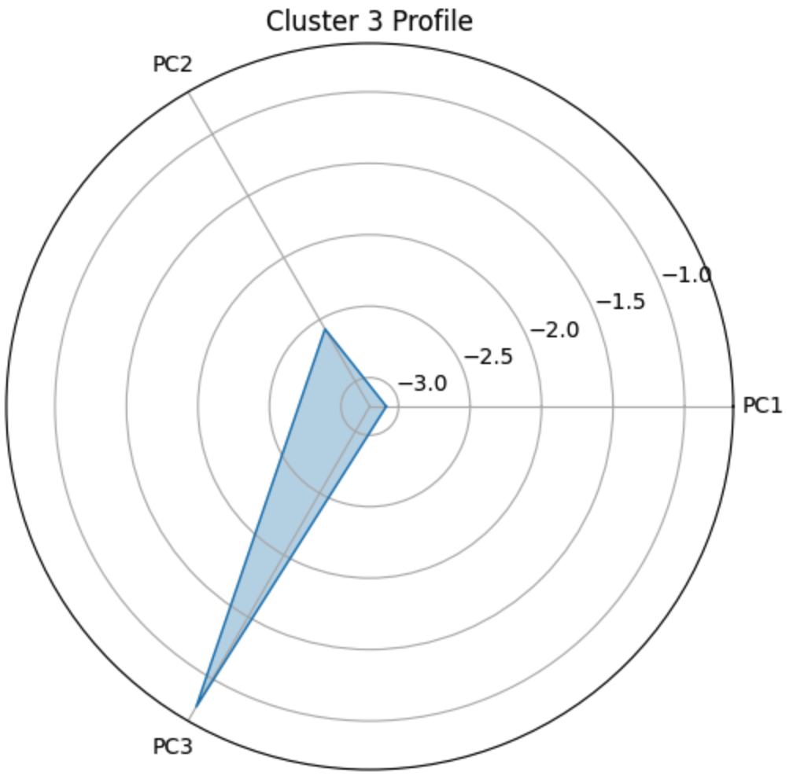

"Skill Development (PC1): Strongly negative, close to -3, indicating very low interest in training and professional growth.

Operational Focus (PC2): Strongly negative, close to -2.5, suggesting a lack of motivation toward routine, structured tasks and operational efficiency.

Career Advancement (PC3): Negative, close to -1, indicating a lower priority on career progression.

This profile suggests that employees in Cluster 3 are generally disengaged from traditional motivators such as skill development, operational efficiency, and career advancement. Programs aimed at this group might need to explore alternative forms of engagement, as conventional development and career-focused initiatives may not resonate with them."

.

**Differences in Groups across Locations:**

We have analyzed the results as per the location of the respondents, and by examining the distribution of employee segments across cities, we have identified geographical variations in engagement and motivations. This information can support targeted strategies for promoting the EDP in specific locations.

**Heatmap:**

The above heatmap shows city-wise variations in employee motivations based on the three identified themes: PC1 (Skill Development), PC2 (Operational Focus), and PC3 (Career Advancement). Each cell contains the average score for a particular theme in a specific city, with colors indicating the strength and direction of association (positive or negative).

**Overview:**

High Skill Development Motivation: Los Angeles has a strong positive association with Skill Development (PC1), suggesting employees there are highly interested in training opportunities. Other cities do not show a strong interest in skill development.

High Operational Focus Motivation: Denver has a positive association with Operational Focus (PC2), indicating that employees in Denver value structured, routine tasks and operational efficiency in their roles.

Overall Neutral to Negative Career Advancement: Most cities have low or neutral scores for Career Advancement (PC3), with a slight positive association in Denver and New York but low or negative in Los Angeles and Toronto.

**Suggestions:**

Targeting Skill Development in Los Angeles would be effective, given the strong interest in training and professional growth.

Focusing on Operational Efficiency in Denver may resonate well with employees, as they value clear and structured workflows.

Career Advancement Programs might not be as effective across these cities, given the generally neutral or negative association with career progression.

Using these insights, NLS can tailor their Employee Development Program to better address motivational differences across cities.

**Interpretation by City**

**Denver:**

PC1 (Skill Development): Average score of -0.48, indicating a negative association. Employees in Denver show less interest in skill development.

PC2 (Operational Focus): Average score of 0.4, indicating a positive association. Operational focus is a motivating factor for Denver employees, suggesting they value structured tasks and routine efficiency.

PC3 (Career Advancement): Average score of 0.15, indicating a slight positive association with career advancement. While career growth is somewhat valued, it is not as strong a motivator as operational focus.

**Los Angeles:**

PC1 (Skill Development): Average score of 0.75, showing a strong positive association. Employees in Los Angeles are highly motivated by skill development and value opportunities for training and skill-building.

PC2 (Operational Focus): Average score of 0.029, close to neutral, suggesting that operational tasks and routine efficiency are neither strong motivators nor detractors.

PC3 (Career Advancement): Average score of 0.0061, also near zero, indicating a neutral stance on career advancement.

**New York:**

PC1 (Skill Development): Average score of -0.058, close to neutral, showing a slight negative association. Skill development is not a strong motivator in New York but is not strongly opposed either.

PC2 (Operational Focus): Average score of 0.17, indicating a mild positive association with operational focus. Employees in New York may value structured work processes, though not as strongly as Denver.

PC3 (Career Advancement): Average score of 0.091, indicating a slight positive association. Career advancement has some appeal but is not a dominant motivator.

**Toronto:**

PC1 (Skill Development): Average score of -0.5, showing a negative association. Employees in Toronto are generally not motivated by skill development.

PC2 (Operational Focus): Average score of -0.49, also showing a negative association, suggesting a lack of interest in operational tasks and routine efficiency.

PC3 (Career Advancement): Average score of -0.12, indicating a slight negative association with career advancement. Career progression is not a key motivator for employees in Toronto.

**Pie Charts:**

The below set of pie charts illustrates the cluster composition of employees in each city: Denver, Los Angeles, New York, and Toronto. Each pie chart shows the percentage of employees in each cluster, providing insights into the dominant motivational profiles within each city.

**Overview:**

**Cluster 0** (Low Skill Development & Career Advancement, Neutral Operational Focus): This cluster is consistently the largest across all cities, especially in Denver and New York, suggesting that a significant portion of employees in each city is not strongly motivated by traditional development themes.

**Cluster 1** (High Operational Focus): This cluster is a substantial segment in all cities, indicating that operational focus, such as structured tasks and routine efficiency, is a prominent motivator, particularly in Denver, Los Angeles, and New York.

**Cluster 2** (High Skill Development): Los Angeles has a higher proportion of employees in Cluster 2, indicating a stronger interest in skill development compared to other cities.

**Cluster 3** (Disengaged Across Themes): Toronto has the largest percentage of Cluster 3, indicating a higher presence of employees who are generally disengaged.

**Suggestions:** These insights reveal the motivational trends within each city, suggesting that programs in Los Angeles might emphasize skill development, while initiatives in Denver could focus on enhancing operational efficiency. Toronto’s higher proportion of disengaged employees (Cluster 3) may require different engagement strategies to improve motivation.

**Interpretation by City**

**Denver:**

Cluster 0 (50.0%): The largest group in Denver, indicating that half of the employees have low interest in skill development and career advancement, with a slight positive inclination toward operational focus.

Cluster 1 (37.7%): The second-largest cluster, motivated primarily by operational focus, with little interest in skill development or career advancement.

Cluster 2 (7.2%): A smaller group in Denver, focused strongly on skill development with a negative association with operational tasks.

Cluster 3 (5.1%): A minimal presence, generally disengaged from all three themes (skill development, operational focus, and career advancement).

**Los Angeles:**

Cluster 0 (34.4%): A significant portion of employees in Los Angeles falls into this cluster, which has low interest in skill development and career advancement.

Cluster 1 (34.9%): Another large group, highly motivated by operational focus.

Cluster 2 (27.4%): A substantial proportion in Cluster 2, indicating a strong focus on skill development.

Cluster 3 (3.2%): A minimal representation, showing disengagement across all three themes.

**New York:**

Cluster 0 (37.8%): Similar to other cities, Cluster 0 is the largest segment in New York, indicating a lack of strong motivation in skill development and career advancement.

Cluster 1 (34.6%): Also prominent in New York, with employees in this cluster mainly motivated by operational focus.

Cluster 2 (13.4%): A smaller group that values skill development.

Cluster 3 (14.2%): Notably higher than in Denver and Los Angeles, showing a higher proportion of employees in New York who are disengaged across all themes.

**Toronto:**

Cluster 0 (32.9%): The largest cluster in Toronto, showing a lack of motivation in skill development and career advancement.

Cluster 1 (26.2%): A sizable group motivated primarily by operational focus.

Cluster 2 (16.8%): A moderate portion focused on skill development.

Cluster 3 (24.2%): The highest proportion of Cluster 3 across all cities, suggesting a relatively larger group in Toronto that is generally disengaged.

**Appendix**

* **PCA Loadings Table**

The below table shows the loading values for each question, indicating their relationship with each principal component.



* **PCA – Explained Variance**

Below table shows Explained Variance for each Principal Component:



The first three components capture a total of 76.3% of the variance, making them the primary themes in the data.

* **Cluster Centers Table**

The below table provides insight into the primary motivations for each cluster:



The above table displays the average scores on each principal component for each cluster, highlighting the dominant themes and motivational profiles of each group:

PC1 (Skill Development): Positive values suggest a motivation for training and skill enhancement, while negative values indicate a lack of interest.

PC2 (Operational Focus): Positive values reflect a focus on structured tasks and operational efficiency, while negative values suggest less interest in routine or task-oriented work.

PC3 (Career Advancement): Positive values indicate a desire for career growth and advancement, while negative values imply a lack of focus on career progression.