Up to Fall 2017


BRAC University
Degree Application Form

The Controller of Examinations
BRAC University
66 Mohakhali, Dhaka 1212

Please attach two

attested copy of your
recent color

photograph
(Passport size)

Subject: Conferment of the degree: Undergraduate/Graduate
Sir,

I was admitted as a regular/transfer student in the _____________________________
Program of BRAC University under _________________________________________
Department in __________ Semester in the year ______. I have completed all the
requirements for the degree of ________________________ on ____________. I am now
applying for the conferment of the degree.

APPLICANT INFORMATION

 |  | Name (in block letters) as it should appear in your certificate |  |  |  |  |  |  |  |  |  |  |  |  |  |  |  |  | ID
Name of the degree: |  |  |  |  |  |  |  |  |  |  | Major:
Second Major (if any): |  |  |  |  |  |  |  |  |  |  | Minor (if any):
 |  | =======================================================
Guardian(s): 1. |  |  |  |  |  |  |  |  | 2.
 |  |  |  |  |  |  |  | Father |  |  |  |  |  |  |  |  |  | Mother
OR
Guest(s): |  | 1. |  |  |  |  |  |  | 2.
 |  |  |  |  |  |  |  | Guest 1 |  |  |  |  |  |  |  |  |  | Guest 2
Postal Address:
Phone: (Residence) |  |  |  |  |  |  |  |  |  |  | Mobile:
Email address of applicant:

Note: Submit the completed application to the Controller’s office.
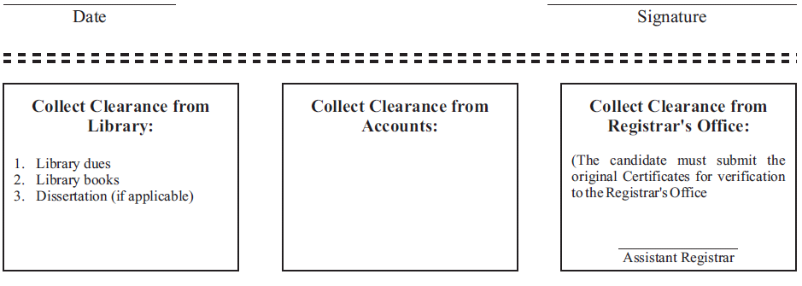

Signature Signature

Please Turn Over >>>

Name: ________________________________________________ID: _______________

Program: CSE (Students admitted in Spring 2005 or later) |  |  |  |  | Department: CSE
Humanities Courses (12 credits):
Course ID | Course Name | Credits | Grade | GPA | Comments (if any)
ENG 091 | Basic English | 0.0
ENG 101 | English Fundamentals | 3.0
ENG 102 | English Composition I | 3.0
DEV 101 | Bangladesh Studies | 3.0
HUM 103 | Ethics and Culture | 3.0

Mathematical and Natural Science Courses (18 credits):

 | Course ID |  | Course Name |  | Credits |  | Grade |  | GPA |  | Comments (if any)
 | MAT 110 |  | Mathematics I |  | 3.0
 | MAT 120 |  | Mathematics II |  | 3.0
 | MAT 215 |  | Mathematics III |  | 3.0
 | MAT 216 |  | Mathematics IV |  | 3.0
 | PHY 111 |  | Principles of Physics I |  | 3.0
 | PHY 112 |  | Principles of Physics II |  | 3.0
 | Core Courses (78 credits):

 | Course ID | Course Name | Credits | Grade | GPA | Comments (if any)
 | CSE 110 | Programming Language I | 3.0
 | CSE 111 | Programming Language II | 3.0
 | CSE 220 | Data Structures | 3.0
 | CSE 221 | Algorithms | 3.0
 | CSE 230 | Discrete Mathematics | 3.0
 | CSE 250 | Circuits and Electronics | 3.0
 | CSE 251 | Electronic Devices and Circuits | 3.0
 | CSE 260 | Digital Logic Design | 3.0
 | CSE 320 | Data Communications | 3.0
 | CSE 321 | Operating System | 3.0
 | CSE 330 | Numerical Methods | 3.0
 | CSE 331 | Automata and Computability | 3.0
 | CSE 340 | Computer Architecture | 3.0
 | CSE 341 | Microprocessors | 3.0
 | CSE 350 | Digital Electronics and Pulse Techniques | 3.0
 | CSE 360 | Computer Interfacing | 3.0
 | CSE 370 | Database Systems | 3.0
 | CSE 420 | Compiler Design | 3.0
 | CSE 421 | Computer Networks | 3.0
 | CSE 422 | Artificial Intelligence | 3.0
 | CSE 423 | Computer Graphics | 3.0
 | CSE 460 | VLSI Design | 3.0
 | CSE 461 | Digital System Design | 3.0
 | CSE 470 | Software Engineering | 3.0
 | CSE 471 | Systems Analysis and Design | 3.0
 | CSE ___ | ______________________________ | 3.0

Courses Outside the Department (24 credits):

Course ID

Course Name

Credits Grade

GPA

Comments (if any)

Internship and Thesis (4 credits):

Course ID | Course Name | Credits | Grade | GPA | Comments (if any)
CSE 400 | Internship and Thesis | 4.0

MINOR AREA (If Any)

Minor in ……………………………………………………………

For Minor declaration, fill up the relevant Minor Form, get the approval for respective department and attach it with the main form.

Total Credits Completed:

CGPA:

Total Credits Transferred/Wavered (if any):

Institute:

Signature of the Applicant

Date

For Office Use only

Requirement | Comments | Signature

Attend of Residential Semester

Requirement of Major/Double Major

Requirement of Minor (if any)

Signature of the Authorized Chairperson’s Signature, Controller’s Office
Person and Name Seal & Date

______________________________

Controller of Examinations

