**Topics: Normal distribution, Functions of Random Variables**

1. The time required for servicing transmissions is normally distributed with *m* = 45 minutes and *s* = 8 minutes. The service manager plans to have work begin on the transmission of a customer’s car 10 minutes after the car is dropped off and the customer is told that the car will be ready within 1 hour from drop-off. What is the probability that the service manager cannot meet his commitment?
2. 0.3875
3. 0.2676
4. 0.5
5. 0.6987

**Ans**: Normal Distribution with µ= 45 and SD = 8. Let X be the time taken to complete the repair, hence, the probability of repair to be complete in one hour is P (X ≤ 50). The question asks us to find the probability of not being able to complete in one hour is P (X > 50).

P(X>50) = 1 – P(X≤50)

Z = (X - µ) / SD

= (50 – 45) / 8

= 0.625

P (X ≤ 50) = P (Z ≤ 0.625) = 0.7324

P (X > 50) = P (Z > 0.625) = 1 – P (Z ≤ 0.625)

= 1 – 0.7324

= 0.2676

**B. 0.2676**

1. The current age (in years) of 400 clerical employees at an insurance claims processing center is normally distributed with mean *m* = 38 and Standard deviation *s* =6. For each statement below, please specify True/False. If false, briefly explain why.
2. More employees at the processing center are older than 44 than between 38 and 44.

**Ans:** µ = 38 and SD = 6

The probability of more employees being older than 44 is P (X > 44) = 1 - P (X ≤ 44)

Z = (X - µ)/ SD

= (44 – 38)/ 6

= 1

P (X ≤ 44) = P (Z ≤ 1) = 0.8413 = 84.13%

P (X > 44) = P (Z > 1) = 1 - P (X ≤ 1)

= 100 – 83.14%

= 16.86%

The probability of employees being between 38 and 44 is P (X < 44) - 0.5

= 0.8314 - 0.5 = 0.3413 = 34.13%

Hence, the statement is false.

1. A training program for employees under the age of 30 at the center would be expected to attract about 36 employees.

**Ans:** µ = 38 and SD = 6

Z = (X - µ)/ SD

Z = (30 – 38)/ 6

= - 1.3333

P (X ≤ 30) = P (X ≤ - 1.3333) = 0.0918

Number of employees under the age of 30 = 0.0918 * 400 = 36.72 (approx. 36 employees).

Hence, the statement is true.

1. If *X1* ~ *N*(μ, σ2) and *X*2 ~ *N*(μ, σ2) are *iid* normal random variables, then what is the difference between 2 *X*1 and *X*1 + *X*2? Discuss both their distributions and parameters.

**Ans:** 2X1 is twice of random variable of X1. If X1 is normally distributed the 2X1 is also normally distributed.

X1 and X2 is normally distributed, hence, the associated sums and sample along with their parameters are also normal.

1. Let X ~ N(100, 202). Find two values, *a* and *b*, symmetric about the mean, such that the probability of the random variable taking a value between them is 0.99.
2. 90.5, 105.9
3. 80.2, 119.8
4. 22, 78
5. 48.5, 151.5
6. 90.1, 109.9

**Ans:** The value of a and b is symmetric about mean and lie within the probability random variable between 0.99

The probability of going wrong, or probability of a and b being outside the area is 0.01

The probability towards the left for a = 0.01/2 = -0.005

The probability towards the right for b = 0.01/2 = +0.005

For calculating the Standard Normal Variable Z (Z value), we can find X value

Z = (X - µ)/ SD

For probability of 0.005 the Z value is –2.57 (from Z table)

Z * SD + µ = X

(-2.57) * 20 + 100 = 48.6

(2.57) * 20 + 100 = 151.4

**D. 48.5, 151.5**

1. Consider a company that has two different divisions. The annual profits from the two divisions are independent and have distributions Profit1 ~ N(5, 32) and Profit2 ~ N(7, 42) respectively. Both the profits are in $ Million. Answer the following questions about the total profit of the company in Rupees. Assume that $1 = Rs. 45
2. Specify a Rupee range (centered on the mean) such that it contains 95% probability for the annual profit of the company.

**Ans:** Mean profit from two different divisions of a company = (µ1 + µ2) * 45 = (5 + 7) *45

= 12 * 45 = 540 million.

Variance of profits from two different divisions of a company = (SD1 + SD2) * 45

= (3 + 2) * 45 = 225 million.

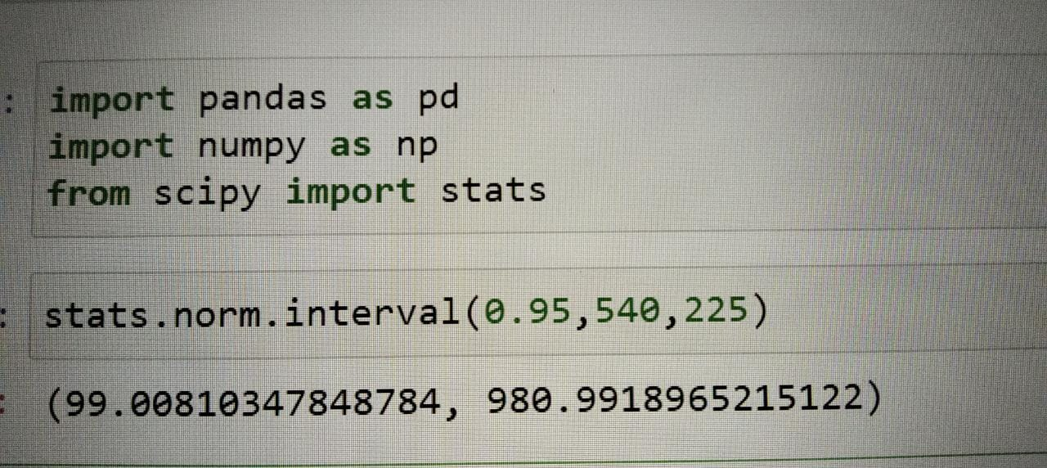

1. Specify the 5th percentile of profit (in Rupees) for the company

**Ans:** The formula used to compute percentiles of a normal distribution is

X = µ + Z(SD)

Where, µ = 540 and SD = 225 of the variable X and Z value of 5th percentile = -1.645

X = 540 + (-1.645) * (225)

= 169.875 = 170 (approx.)

1. Which of the two divisions has a larger probability of making a loss in a given year?

**Ans:**

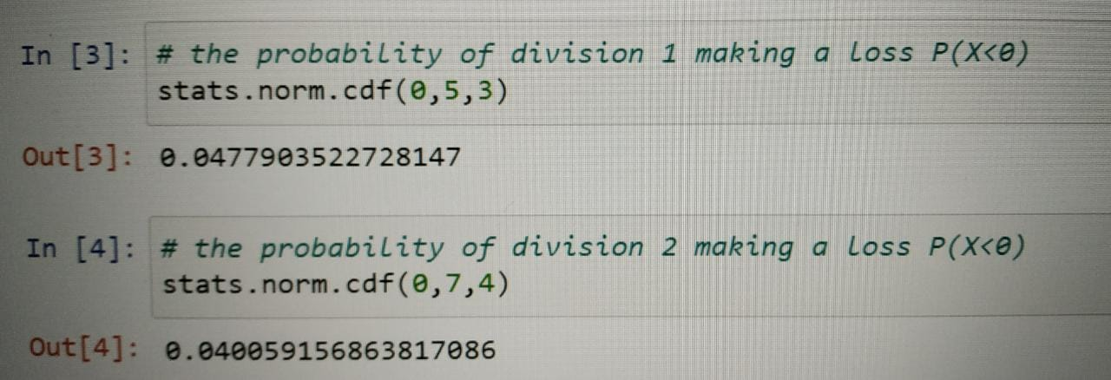

Therefore, the probability of division 1 making a loss in a year is more than division 2.