PROJECT REPORT
Student Marketplace
A Web-Based Platform for Buying and Selling Second-Hand Academic Books

Submitted in partial fulfillment of the requirements for the
Bachelor of Computer Applications (BCA)

Academic Year 2024–2025

Submitted by
Shashank Bhat
Government Degree College Nagrota

GOVERNMENT DEGREE COLLEGE NAGROTA
BCA Department
CERTIFICATE OF AUTHORSHIP

This is to certify that the project entitled "Student Marketplace – A Web-Based Platform for Buying and Selling Second-Hand Academic Books" has been designed, developed, and documented by Shashank Bhat, a student of Government Degree College Nagrota, in partial fulfillment of the requirements for the Bachelor of Computer Applications (BCA) degree.

This project is the original and independent work of the author. All ideas, designs, code, and written content contained in this report are the intellectual property of Shashank Bhat, unless otherwise cited. No part of this project report may be reproduced, distributed, or used in any form without the prior written permission of the author.

The project has been completed under the supervision of the faculty of the BCA Department and is submitted in accordance with the academic guidelines of Government Degree College Nagrota.

Author: Shashank Bhat
Institution: Government Degree College Nagrota
Academic Year: 2024–2025

Signature of Author: ___________________________
Signature of Guide: ___________________________
Date: ___________________________

Acknowledgement
I would like to express my sincere gratitude to my project guide and the faculty members of Government Degree College Nagrota for their valuable guidance, encouragement, and support throughout the development of this project. Their insights helped me understand both the theoretical and practical aspects of software development and shaped the final outcome in meaningful ways.

I am also thankful to my friends and classmates for their honest feedback during testing and for their constant motivation. A special thanks to my family for their unwavering support and patience throughout this journey.

Finally, I am grateful to the open-source community — the developers behind React, Node.js, Express, and MongoDB — whose freely available tools and documentation made this project possible.

Shashank Bhat
Government Degree College Nagrota

Table of Contents
1. Introduction 4
1.1 Goal 4
1.2 Need of the Application 5
1.3 Scope 6
1.4 Platform Specifications 7
2. System Requirement Analysis 9
2.1 Information Gathering 9
2.2 System Feasibility 10
3. System Analysis 13
3.1 ER Diagram 13
3.2 Data Flow Diagram 15
3.3 Use Case Diagram 17
3.4 Class Diagram 19
4. Design 21
4.1 Design Goals 21
4.2 Architectural Design 22
4.3 Modular Approach 24
5. Implementation 26
5.1 Database Design 26
5.2 User Interface Design 28
5.3 Technical Discussions 29
6. Testing 31
7. Results & Challenges 34

Chapter 1: Introduction
Education is one of the most important investments a person can make in their life. However, the rising cost of academic materials — especially textbooks — continues to create financial hurdles for students across the country. In many colleges and universities, a single semester can require students to purchase five or more books, each costing anywhere between a few hundred to several thousand rupees. For students who come from middle-income or lower-income families, this expense can be a genuine hardship.

At the same time, many students who have completed a semester find themselves with stacks of books they no longer need. These books often end up collecting dust in storage, or get sold in informal markets at very low prices simply because there is no organized channel for resale. This mismatch between demand and supply of affordable second-hand books is a problem that affects nearly every educational institution.

The Student Marketplace project was conceived as a direct solution to this problem. It is a web-based application that creates a digital platform where students can list the books they want to sell and browse books that others have listed. The platform is designed to be simple, clean, and easy to use — so that even students with minimal technical experience can navigate it without difficulty.

1.1 Goal
The primary goal of this project is to design and develop a fully functional, web-based application called Student Marketplace. This platform is specifically built to help students within a college or university buy and sell second-hand academic books at affordable prices.

The system is designed with the following specific goals in mind:
- To create a centralized, easily accessible platform where students can list books they wish to sell along with all relevant details such as title, author, subject, semester, condition, and price.
- To allow students who are looking to buy books to search, browse, and filter available listings quickly and efficiently.
- To enable seamless communication between buyers and sellers using email-based notifications, so that the transaction process remains straightforward and reliable.
- To ensure that user data and credentials are stored securely, using modern encryption standards so that users can trust the platform with their personal information.
- To build a responsive web application that can be accessed from any device — whether a desktop, laptop, or smartphone — without any degradation in experience.
- To provide a foundation that can be expanded in the future with additional features such as online payments and a rating and review system.

In essence, the goal is to make the process of buying and selling second-hand books as simple and transparent as possible — removing the inefficiencies of informal trading and replacing them with a reliable, trustworthy digital system.

1.2 Need of the Application
To fully appreciate why this application is needed, it is helpful to understand the current situation that students face in most educational institutions.

Every semester, students are required to purchase a set of prescribed textbooks. In many cases, these books are used for just one semester and are then no longer needed. A student in their third semester has no use for a book prescribed for the second semester, and vice versa. This creates a natural opportunity for students to pass books along to junior students at reduced prices — but the lack of a proper system means this rarely happens in an organized way.

The challenges that currently exist without a platform like Student Marketplace include:

Financial Burden
New academic books are expensive. Students who cannot afford them either skip the book entirely — which affects their academic performance — or stretch their finances significantly. A platform that makes second-hand books easily available at lower prices directly addresses this financial burden.

Wastage of Usable Books
Thousands of books are discarded or left unused each year simply because their previous owners have no efficient way to sell them. This is a waste of both money and resources. A marketplace that connects sellers with buyers ensures these books are put to good use.

Lack of Organized Communication
Currently, if a student wants to sell a book, they might put up a notice on a bulletin board, send messages through WhatsApp groups, or rely on word of mouth. These methods are unreliable, time-consuming, and often result in missed connections. A digital platform centralizes all of this communication and makes it much more efficient.

No Quality or Price Transparency
In informal transactions, it is hard for buyers to compare prices or assess the condition of a book before meeting in person. A well-structured listing page with detailed information — including the condition of the book (new, good, worn), price, and seller contact details — gives buyers all the information they need upfront.

The Student Marketplace application directly addresses all of these problems. It creates a structured, digital environment where students can connect with each other for the purpose of buying and selling books — saving money, reducing waste, and making academic resources more accessible for everyone.

1.3 Scope
The scope of this project defines the boundaries of what the system is intended to do in its current version, as well as what could be added in future iterations.

Current Scope
The Student Marketplace, in its current form, is focused on providing a solid and functional base platform. The following features are included in the current scope:

- User Registration and Login: Any student can create an account on the platform by providing their name, email address, and a password. Registered users can log in securely to access all features of the platform.
- Book Listing: Registered users can add books they wish to sell. Each listing includes the book's title, author, price, subject, semester, and condition. Users can also upload an image of the book.
- Browse and Search: All users can browse the list of available books. Filters allow users to narrow down results by subject, semester, price range, or condition.
- Book Details Page: Each book has a dedicated page that shows all the details of the listing, including the seller's contact information (email), so that interested buyers can reach out directly.
- Purchase Request via Email: When a buyer is interested in a book, they can initiate a purchase request. The system automatically sends an email to the seller with the buyer's contact details, allowing them to coordinate the transaction offline.
- Secure Authentication: User passwords are encrypted using industry-standard hashing algorithms before being stored in the database, ensuring user security.

1.3.3 Already Implemented (Beyond Original Scope)
During development, several features that were originally planned as 'future enhancements' were successfully implemented in the current version:
- Real-Time Chat System: Buyers and sellers can now message each other directly within the platform using a built-in chat feature powered by Socket.IO. Conversations are organised by book listing.
- Admin Panel: A dedicated admin interface allows authorised administrators to view, edit, and delete any book listing on the platform.
- Order History: When a buyer contacts a seller, an order record is created and stored. Both buyers and sellers can view their order history on their dashboard.
- Wishlist: Users can add books to a personal wishlist and view them on their dashboard for easy access later.
- User Dashboard: A personal dashboard showing the user's listed books, order history, and wishlist in one place.
- Dark/Light Theme: The application supports both a dark and a light theme, automatically respecting the user's system preferences while allowing manual switching.
- Image Upload: Sellers can upload a photo of their book when creating a listing, helping buyers assess the condition of the book before contacting the seller.
- Notification System: The platform generates in-app notifications to keep users informed about relevant activity.

1.3.4 Future Scope
The following features remain planned for future versions:
- Online Payment Integration: Integrating a payment gateway (such as Razorpay or PayPal) would allow buyers to pay for books directly through the platform, making the transaction fully digital.
- Rating and Review System: After a transaction, buyers and sellers could rate each other, building a community trust system that encourages honest listings and reliable transactions.
- Mobile Application: A native mobile app for Android and iOS to make the platform even more accessible to students who primarily use smartphones.

1.4 Platform Specifications – Deployment
This section outlines the hardware and software requirements needed to run the Student Marketplace application, both for development and deployment purposes.

1.4.1 Hardware Specifications
The application is designed to be lightweight and efficient. The minimum hardware requirements for running the application are as follows:

Hardware Component | Minimum Requirement | Recommended
Processor | Intel Core i3 or equivalent | Intel Core i5 / i7 or AMD Ryzen 5
RAM | 4 GB | 8 GB or more
Storage | 20 GB free disk space | 50 GB or more (SSD preferred)
Internet Connection | Required (broadband) | High-speed broadband
Display | 1280 x 720 resolution | 1920 x 1080 Full HD

These hardware specifications are sufficient for development, testing, and small-scale deployment. For production deployment serving a large number of users simultaneously, a cloud-based server infrastructure (such as AWS, Google Cloud, or Azure) would be recommended.

1.4.2 Software Specifications
The Student Marketplace is built using a modern, open-source technology stack. The key software components used in the development and deployment of the application are:

Category | Technology / Tool | Version / Notes
Frontend Framework | React (with Vite) | React 18+, Vite for fast bundling
Backend Framework | Node.js with Express | Node.js v18+, Express v4
Database | MongoDB | MongoDB Atlas (cloud) or local
Real-Time Communication | Socket.IO | WebSocket-based real-time chat
Programming Languages | JavaScript, HTML5, CSS3 | ES6+ JavaScript
API Communication | REST APIs using Axios | Axios for HTTP requests
Email Service | Nodemailer | SMTP-based email sending
File Upload | Multer | For uploading book images
Development IDE | Visual Studio Code | With ESLint, Prettier plugins
API Testing Tool | Postman | For testing REST endpoints
Version Control | Git / GitHub | For source code management

All of the technologies used in this project are open-source and freely available, making this a cost-effective solution. The use of widely-adopted frameworks and libraries also means that the project can easily be maintained and extended by developers familiar with the JavaScript ecosystem.

Chapter 2: System Requirement Analysis
System requirement analysis is a critical phase in the software development lifecycle. It involves identifying, documenting, and validating the requirements of the system before actual development begins. This phase ensures that the final product aligns with user needs and business goals, and helps prevent costly changes during later stages of development.

For the Student Marketplace project, the requirement analysis involved gathering information from potential users (students), studying existing solutions, and assessing the feasibility of the proposed system.

2.1 Information Gathering
The requirements for this project were gathered through a variety of methods to ensure a comprehensive understanding of what the system should do and how it should behave.

2.1.1 Discussions with Students
Informal discussions were conducted with students from various semesters and departments. These conversations focused on understanding:
- How students currently source second-hand books (if at all).
- What price range they typically expect for second-hand academic books.
- What features they would find most useful in a book marketplace.
- Their comfort level with technology and web applications.

The feedback from these discussions was invaluable. Most students expressed frustration at not having a centralized place to find affordable books. Many mentioned that they had previously resorted to social media groups or asking seniors directly, both of which they found unreliable and time-consuming.

2.1.2 Observation of Current Problems
In addition to speaking with students, the current informal methods of book trading were observed. Bulletin boards in college corridors often have handwritten notices for book sales. WhatsApp groups are used, but messages get buried quickly. These observations confirmed the need for a more structured and persistent platform.

2.1.3 Research on Existing Marketplace Applications
Existing general-purpose marketplace applications such as OLX and Facebook Marketplace were studied to understand best practices in listing management, search functionality, and user experience. The key insight from this research was that a student-focused platform should be simpler and more specifically tailored to academic needs — students don't need the complexity of a general marketplace.

2.1.4 Functional Requirements
Based on the information gathered, the following functional requirements were identified:
- The system must allow new users to register with their name, email, and password.
- Registered users must be able to log in and log out securely.
- Logged-in users must be able to add a new book listing with complete details.
- All users (registered or not) must be able to browse available book listings.
- Users must be able to filter books by subject, semester, price, and condition.
- Each book listing must display all relevant details including seller contact information.
- Buyers must be able to express interest in a book, triggering an email notification to the seller.

2.1.5 Non-Functional Requirements
In addition to the functional requirements, several non-functional requirements were also identified:
- Performance: The system should load pages within 3 seconds under normal conditions.
- Security: All passwords must be hashed before storage. The system must be protected against common web vulnerabilities such as SQL injection and cross-site scripting (XSS).
- Usability: The user interface must be simple and intuitive enough for first-time users to navigate without any training.
- Scalability: The architecture should allow the system to scale to accommodate a growing number of users and listings.
- Availability: The system should be available 24/7 with minimal downtime.
- Maintainability: The codebase must be well-organized and documented to allow easy future modifications.

2.2 System Feasibility
Feasibility analysis is conducted to determine whether the proposed system is practical and worthwhile to develop. The Student Marketplace was evaluated across three key dimensions: economic feasibility, technical feasibility, and behavioral feasibility.

2.2.1 Economic Feasibility
Economic feasibility assesses whether the benefits of the system outweigh its development and operational costs.

Development Costs:
- All technologies used in this project — React, Node.js, Express, and MongoDB — are open-source and completely free to use. There are no licensing fees involved.
- Development tools such as Visual Studio Code and Postman are also available free of charge.
- Cloud hosting can be done on free tiers initially (e.g., MongoDB Atlas free tier, Render or Vercel for deployment), keeping initial costs at zero.

Benefits:
- Students save money by accessing affordable second-hand books.
- Students earn money by selling books they no longer need.
- The institution benefits from a reputation for innovation and student support.

The economic feasibility analysis confirms that the project is highly cost-effective. The total development cost is essentially the time invested by the developer, with no software licensing or infrastructure costs during the development phase.

2.2.2 Technical Feasibility
Technical feasibility evaluates whether the technology and expertise required to build the system are available.

Technology Availability:
- All required frameworks and libraries (React, Node.js, Express, MongoDB) are mature, well-documented, and have large communities of developers. This means that help and resources are readily available.
- The application can run on any standard computer with a modern web browser — no special hardware or software is required by end users.
- Deployment platforms like Vercel (for the frontend) and Render or Railway (for the backend) offer free hosting options that are suitable for this type of project.

Developer Capability:
- The developer has knowledge and prior experience in JavaScript, React, Node.js, and MongoDB — which are the core technologies used in this project.
- Familiarity with REST API design, database design, and user authentication means that the technical challenges of this project are well within scope.

The technical feasibility analysis concludes that the project is well within the technical capabilities available and can be successfully implemented using the chosen technology stack.

2.2.3 Behavioral Feasibility
Behavioral feasibility — sometimes called operational feasibility — assesses whether the system will actually be used and accepted by its intended users.

User Familiarity with Technology:
Today's college students are digital natives. They are comfortable using smartphones, web browsers, and online platforms in their daily lives. Apps like Instagram, OLX, and Amazon have familiarized them with the concept of product listings, browsing, and online transactions. This means that adapting to the Student Marketplace interface should be natural and require little to no training.

User Interface Design Philosophy:
The UI of the Student Marketplace is designed to be clean, minimal, and intuitive. The navigation is straightforward: users can register, log in, browse books, and add listings with very few steps. Attention was paid to mobile responsiveness, ensuring that the experience on a smartphone is as smooth as on a desktop.

Trust and Adoption:
One concern in behavioral feasibility is whether users will trust the platform enough to list their personal contact information. To address this, the platform is designed to be transparent about how information is used. Seller email addresses are only shown to logged-in users, reducing the risk of spam or misuse.

The behavioral feasibility analysis concludes that the system is likely to be well-received and actively used by students, provided it is promoted effectively within the institution.

Chapter 3: System Analysis
System analysis involves understanding the structure and behavior of the system through various modeling techniques. These models help visualize how data flows through the system, how entities relate to each other, and how users interact with the system. This chapter describes the key diagrams used in the analysis of the Student Marketplace application.

3.1 Entity-Relationship (ER) Diagram
An Entity-Relationship (ER) diagram is a visual representation of the data model of a system. It shows the entities (objects or concepts) in the system, their attributes (properties), and the relationships between them. The ER diagram forms the foundation of the database design.

3.1.1 Entities and Attributes
The Student Marketplace has five primary entities:

Entity 1: User — stores user credentials, wishlist references, and account details.
Entity 2: Book — stores listing details including title, author, price, semester, course (BCA/BBA), condition, image URL, sold status, and the owner reference.
Entity 3: Order — records a purchase request linking a buyer, seller, and book.
Entity 4: Conversation — represents a chat thread between two users about a specific book.
Entity 5: Message — stores individual chat messages within a conversation.
Entity 6: Notification — stores in-app notifications for users.

3.1.2 Relationships
The key relationships between entities are:
- One User can add multiple Books (one-to-many).
- One User can have many Orders as a buyer, and many Orders as a seller.
- One Conversation links two Users and one Book.
- One Conversation can have many Messages.
- One User can have many Notifications.
- One User can have many Books in their Wishlist (many-to-many via array of references).

[ IMAGE PLACEHOLDER ]
Figure 3.1 – ER Diagram showing User and Book entities with their attributes and relationship

Entity | Attribute | Data Type | Constraints
User | user_id | ObjectId | Primary Key, Auto-generated
User | name | String | Required
User | email | String | Required, Unique
User | password | String | Required, Hashed (bcrypt)
User | wishlist | ObjectId[] | Array of references to Book
Book | book_id | ObjectId | Primary Key, Auto-generated
Book | title | String | Required
Book | author | String | Required
Book | price | Number | Required, Min 0
Book | semester | Number | Required
Book | course | String | Required — BCA or BBA
Book | condition | String | Required — New or Used
Book | imageUrl | String | Optional — uploaded photo
Book | contactEmail | String | Optional
Book | isSold | Boolean | Default: false
Book | owner | ObjectId | Foreign Key → User
Order | buyer | ObjectId | Foreign Key → User
Order | seller | ObjectId | Foreign Key → User
Order | book | ObjectId | Foreign Key → Book
Conversation | participants | ObjectId[] | Two User references
Conversation | book | ObjectId | Foreign Key → Book
Message | conversationId | ObjectId | Foreign Key → Conversation
Message | sender | ObjectId | Foreign Key → User
Message | text | String | Required

3.2 Data Flow Diagram (DFD)
A Data Flow Diagram (DFD) is a graphical representation of how data moves through a system. It shows the inputs, outputs, processes, and data stores involved. DFDs are drawn at different levels of detail: Level 0 (also called the Context Diagram) gives a high-level overview, while Level 1 breaks the system down into its main processes.

3.2.1 Level 0 DFD – Context Diagram
The Level 0 DFD shows the Student Marketplace as a single process that interacts with external entities.

External Entities:
- Student/User: The primary actor who interacts with the system. Students register, log in, list books, browse books, chat with sellers, and track orders.
- Email Server: An external service (SMTP server via Nodemailer) that handles email notifications when a buyer contacts a seller.

Data Flows:
- From User to System: Registration details, login credentials, book listing data (including image), chat messages, and purchase requests.
- From System to User: Authentication tokens, book listings, chat messages (real-time via Socket.IO), notifications, and order history.
- From System to Email Server: Email content including buyer details and book information.
- From Email Server to Seller: Email notification about a buyer's interest.

[ IMAGE PLACEHOLDER ]
Figure 3.2 – Level 0 DFD (Context Diagram) showing system interactions with external entities

3.2.2 Level 1 DFD
The Level 1 DFD breaks the system down into its main processes:

Process 1: User Registration / Login
- Input: Name, email, password (for registration); email, password (for login).
- Process: Validate inputs, hash password, store user, or compare credentials and issue JWT token.
- Output: Success/failure message; authentication token for logged-in users.
- Data Store: Users Collection.

Process 2: Add / Manage Book Listing
- Input: Book title, author, price, semester, course, condition, image file.
- Process: Validate inputs, save image via Multer, associate listing with logged-in user. Save to database.
- Output: Confirmation message; updated book listings.
- Data Store: Books Collection.

Process 3: Browse / Search Books
- Input: Search keywords, filter parameters (semester, course, condition).
- Process: Query database with filters. Return matching results.
- Output: Filtered list of book listings.
- Data Store: Books Collection.

Process 4: Real-Time Chat
- Input: Buyer initiates chat from a book listing; messages typed in the chat window.
- Process: Create or retrieve Conversation document. Send/receive messages via Socket.IO in real time. Persist messages to database.
- Output: Real-time messages delivered to both participants.
- Data Store: Conversations Collection, Messages Collection.

Process 5: Order & Notification
- Input: Buyer confirms interest in a book.
- Process: Create Order record. Generate Notification for seller. Send email via Nodemailer.
- Output: Order stored; notification created; email sent.
- Data Store: Orders Collection, Notifications Collection.

[ IMAGE PLACEHOLDER ]
Figure 3.3 – Level 1 DFD showing the four main processes: Registration/Login, Add Book, Browse Books, and Contact Seller

3.3 Use Case Diagram
A Use Case Diagram shows the interactions between users (called 'actors') and the system. Each 'use case' represents a specific function that the system performs for the user. This diagram provides a high-level view of the system's functionality from the user's perspective.

3.3.1 Actor
The Student Marketplace currently has one primary actor: the User (Student). In future versions, an Admin actor could be added to manage the platform.

3.3.2 Use Cases
The following use cases have been identified for the Student Marketplace:

Use Case | Actor | Description | Pre-condition
Register | User | New user creates an account | User has not registered before
Login | User | Existing user logs into the system | User is registered
Logout | User | Logged-in user ends their session | User is logged in
Add Book Listing | User | User lists a book for sale | User is logged in
Edit Listing | User | User modifies their book listing | User is logged in; owns the listing
Delete Listing | User | User removes their book listing | User is logged in; owns the listing
Browse Books | User | User views all available listings | None (accessible to all)
Search/Filter Books | User | User filters listings by criteria | None (accessible to all)
View Book Details | User | User views full details of a listing | None (accessible to all)
Contact Seller | User | Buyer sends interest to seller via email | User is logged in; book is available

[ IMAGE PLACEHOLDER ]
Figure 3.4 – Use Case Diagram showing the User actor and all use cases (Register, Login, Add Book, Browse Books, Contact Seller, etc.)

3.4 Class Diagram
A Class Diagram is used in object-oriented design to describe the structure of the system. It shows the classes (which correspond to the data models in the system), their attributes (fields), and their methods (functions). The class diagram for the Student Marketplace maps directly to the MongoDB data models used in the backend.

3.4.1 User Class
The User class represents the structure of a user document in the MongoDB users collection.

Attribute / Method | Type | Description
_id | ObjectId | Unique identifier (auto-generated by MongoDB)
name | String | Full name of the user
email | String | Email address (unique, used for login)
password | String | Hashed password (bcrypt)
createdAt | Date | Timestamp of account creation
register() | Method | Creates a new user document
login() | Method | Validates credentials and returns token
getProfile() | Method | Returns user profile information

3.4.2 Book Class
The Book class represents the structure of a book listing document in the MongoDB books collection.

Attribute / Method | Type | Description
_id | ObjectId | Unique identifier (auto-generated)
title | String | Title of the book
author | String | Author of the book
price | Number | Asking price in rupees
semester | String | Target semester (e.g., Sem 3)
subject | String | Subject the book covers
condition | String | New / Good / Worn
description | String | Optional additional details
owner | ObjectId | Reference to User who listed the book
createdAt | Date | Timestamp of listing creation
addListing() | Method | Creates a new book listing
editListing() | Method | Updates an existing listing
deleteListing() | Method | Removes a listing
getAll() | Method | Returns all active listings
filterBy() | Method | Returns listings matching filter criteria

[ IMAGE PLACEHOLDER ]
Figure 3.5 – Class Diagram showing the User and Book classes with attributes and methods

Chapter 4: Design
The design phase translates the requirements and analysis models into a blueprint for the actual system. Good design is what separates a system that merely works from one that is genuinely useful, maintainable, and scalable. This chapter describes the design goals, architectural choices, and modular structure of the Student Marketplace.

4.1 Design Goals
The Student Marketplace was designed with a clear set of principles to guide every decision made during the development process. These design goals ensure that the final product is not just functional, but also pleasant to use and easy to maintain.

- Simplicity: The interface should be clean and free of unnecessary clutter. Users should be able to accomplish their goals — browsing books, listing a book, or contacting a seller — in as few steps as possible.
- Responsiveness: The application must work equally well on desktops, tablets, and smartphones. With mobile internet usage at an all-time high, a non-responsive design would exclude a large portion of potential users.
- Speed: Pages should load quickly. This is especially important for the book listing page, which may contain many entries. Efficient API calls and optimized database queries are used to keep response times low.
- Security: User data, especially passwords and contact information, must be protected at all times. The application uses industry-standard security practices including password hashing and JWT-based authentication.
- Modularity: The codebase is organized into well-defined modules — frontend components, backend routes, and database models — so that each part of the system can be developed, tested, and modified independently.
- Scalability: While the current version is designed for use within a single institution, the architecture is built in a way that allows it to scale to multiple institutions or a larger user base with minimal changes.
- Accessibility: Text sizes, color contrast ratios, and button sizes are chosen to be accessible to users with visual impairments or motor difficulties.

4.2 Architectural Design
The architecture of the Student Marketplace follows the well-established three-tier architecture pattern, which separates the system into three distinct layers: the Presentation Layer, the Application Layer, and the Data Layer.

4.2.1 Architectural Context Diagram
The three-tier architecture consists of:

Layer | Technology | Responsibility
Presentation Layer (Frontend) | React with Vite | Renders the UI, handles user interactions, communicates with backend via API calls
Application Layer (Backend) | Node.js with Express | Processes business logic, handles API requests, manages authentication, sends emails
Data Layer (Database) | MongoDB | Stores all persistent data including users and book listings

4.2.2 Communication Flow
The communication between layers works as follows:
- The user opens the Student Marketplace website in their browser. The React frontend is loaded.
- When the user performs an action (e.g., searching for a book), the React frontend sends an HTTP request to the Node.js/Express backend via a REST API endpoint (e.g., GET /api/books?semester=3).
- The Express backend receives the request, validates it (checking authentication if needed), and processes the business logic.
- If data needs to be read or written, the backend communicates with the MongoDB database using Mongoose — a library that provides a clean interface for database operations.
- MongoDB returns the requested data to the backend.
- The backend formats the data as a JSON response and sends it back to the frontend.
- The React frontend receives the response and updates the UI to display the new information to the user.

This separation of concerns makes the system much easier to maintain and extend. For example, the frontend can be completely redesigned without changing the backend, or the database can be migrated to a different system without affecting the frontend.

4.2.3 API Design
The Student Marketplace uses a RESTful API design. REST (Representational State Transfer) is an architectural style for designing networked applications. It uses standard HTTP methods to perform operations on resources.

Method | Endpoint | Description | Auth Required
POST | /api/auth/register | Register a new user | No
POST | /api/auth/login | Login and get JWT token | No
GET | /api/auth/wishlist/:userId | Get user's wishlist | Yes
POST | /api/auth/wishlist/add | Add book to wishlist | Yes
DELETE | /api/auth/wishlist/remove/:bookId | Remove from wishlist | Yes
GET | /api/books | Get all book listings | No
GET | /api/books/:id | Get a specific book by ID | No
GET | /api/books/mine/:userId | Get books listed by user | Yes
POST | /api/books | Create a new book listing (with image) | Yes
PUT | /api/books/:id | Update a book listing | Yes
DELETE | /api/books/:id | Delete a book listing | Yes
DELETE | /api/books/admin/:id | Admin delete any listing | Admin
POST | /api/orders | Create a new order | Yes
GET | /api/orders/mine/:userId | Get user's orders | Yes
GET | /api/notifications/:userId | Get user notifications | Yes
GET | /api/messages/conversations/:userId | Get all conversations | Yes
POST | /api/messages | Send a message | Yes
GET | /api/messages/:conversationId | Get messages in conversation | Yes

4.3 Procedural/Modular Approach
The Student Marketplace is built using a modular approach, where the system is divided into self-contained modules, each responsible for a specific set of features. This makes the code easier to understand, test, and maintain.

4.3.1 Shop Products Module
The Shop Products Module is the heart of the Student Marketplace. It is responsible for displaying all the available book listings to the user in an organized and visually appealing manner.

Key features of this module:
- Fetches all active book listings from the backend via the GET /api/books endpoint.
- Displays each listing as a card with the book's title, author, price, semester, and condition.
- Provides filtering options: users can filter books by semester, subject, price range, and condition.
- Provides a search bar that allows users to search for books by title or author name.
- Implements pagination to manage large numbers of listings without overwhelming the page.
- Each card has a 'View Details' button that navigates to the Product Description Module.

4.3.2 Product Description Module
The Product Description Module provides a detailed view of a single book listing. It gives the buyer all the information they need to make a decision about purchasing the book.

Key features of this module:
- Displays the full details of the book: title, author, price, semester, subject, condition, and description.
- Shows the seller's name and contact information (email address) — visible only to logged-in users.
- Provides a 'Contact Seller' button that triggers the Cart Details Module.
- Displays a 'Back to Listings' button to navigate easily back to the main list.

4.3.3 Cart Details / Purchase Module
The Cart Details Module handles the process by which a buyer expresses interest in purchasing a book. In the current version of the platform, this does not involve an actual financial transaction — instead, it facilitates a connection between the buyer and seller so they can arrange the exchange offline.

Key features of this module:
- When a logged-in user clicks 'Contact Seller', the system sends an email to the seller.
- The email contains the buyer's name, email address, and the details of the book they are interested in.
- The system uses Nodemailer with an SMTP configuration to send this email.
- After the email is sent, the buyer sees a confirmation message on the screen.

4.3.4 Authentication Module
The Authentication Module manages user registration, login, and session management. This module is critical for ensuring that only authorized users can add listings or contact sellers.

- Registration: Accepts user details, validates inputs, hashes the password using bcrypt, and stores the user in the database.
- Login: Validates the entered email and password against stored credentials, and issues a JSON Web Token (JWT) upon successful authentication.
- Session Management: The JWT is stored in the browser's local storage and sent with every subsequent API request that requires authentication.
- Logout: The JWT is removed from local storage, effectively ending the session.

Chapter 5: Implementation
The implementation phase is where the designs and plans made in earlier phases are translated into actual, working code. This chapter describes the key aspects of how the Student Marketplace was built, including the database design, the user interface, and the important technical decisions made during development.

5.1 Database Design and Implementation
MongoDB was chosen as the database for this project because of its flexibility, ease of use with JavaScript applications, and its document-based data model which maps naturally to the JSON data used throughout the application.

5.1.1 Why MongoDB?
Unlike traditional relational databases (like MySQL or PostgreSQL) that store data in fixed rows and columns, MongoDB stores data as flexible JSON-like documents. This is advantageous for this project because:
- The data structure of a book listing can vary slightly from one listing to another (e.g., some listings may have a description, others may not), and MongoDB handles this naturally.
- MongoDB integrates seamlessly with the Node.js/JavaScript ecosystem through the Mongoose library.
- MongoDB Atlas provides a free cloud-hosted database, which is ideal for a project of this scale.

5.1.2 Database Schema
The database consists of six collections: Users, Books, Orders, Conversations, Messages, and Notifications.

Users Collection — key fields:
- name, email (unique), password (hashed), wishlist (array of Book references), createdAt.

Books Collection — key fields:
- title, author, price, semester (Number), course (BCA/BBA), condition (New/Used), imageUrl, contactEmail, isSold (Boolean, default false), owner (User reference), createdAt.

Orders Collection — key fields:
- buyer (User reference), seller (User reference), book (Book reference), bookTitle, bookAuthor, price, sellerEmail, createdAt.

Conversations Collection — key fields:
- participants (array of two User references), book (Book reference), lastMessage (text + sender), timestamps.

Messages Collection — key fields:
- conversationId (Conversation reference), sender (User reference), text, timestamps.

Notifications Collection — key fields:
- user (User reference), message (String), isRead (Boolean, default false), createdAt.

5.1.3 Data Validation
Mongoose, the library used to interact with MongoDB from Node.js, provides built-in data validation. All required fields are enforced at the model level, meaning that if a request to create a book listing is missing the title or price, Mongoose will reject it before it even reaches the database. This ensures data integrity throughout the application.

5.2 User Interface Design and Implementation
The frontend of the Student Marketplace is built using React — a JavaScript library developed by Facebook for building user interfaces. React allows the UI to be broken down into small, reusable components, each responsible for a specific part of the page.

5.2.1 Why React?
React was chosen for the frontend for several reasons:
- Component-Based Architecture: The UI is broken down into small, reusable components (e.g., BookCard, SearchBar, FilterPanel, Navbar), making the code organized and easy to maintain.
- Virtual DOM: React uses a virtual DOM to efficiently update only the parts of the page that have changed, resulting in fast and smooth user experiences.
- Large Ecosystem: React has a huge ecosystem of libraries and tools that speed up development.
- Vite: Using Vite as the build tool instead of the older Create React App gives much faster development server startup and hot module replacement.

5.2.2 Pages and Components
The Student Marketplace frontend consists of the following pages:

Page | Route | Description
Landing / Auth Page | /auth | Login and registration forms combined on one page
Home / Book Listings | / | Main browsing page showing all available book listings with filters
Add Book | /add-book | Form for logged-in users to add a new book listing with image upload
Chat | /chat | Real-time messaging interface between buyers and sellers
Dashboard | /dashboard | Personal dashboard showing order history, wishlist, and own listings
Admin Panel | /admin | Admin interface for managing all listings (password protected)

[ IMAGE PLACEHOLDER ]
Figure 5.1 – Screenshot: Home Page showing book listings with filter options

[ IMAGE PLACEHOLDER ]
Figure 5.2 – Screenshot: Add Book page with image upload form

[ IMAGE PLACEHOLDER ]
Figure 5.3 – Screenshot: Real-Time Chat interface

[ IMAGE PLACEHOLDER ]
Figure 5.4 – Screenshot: User Dashboard showing orders, wishlist, and listings

5.2.2 Frontend Screenshots
The following screenshots show the actual working Student Marketplace web application, demonstrating the key pages and user interface elements developed during this project.

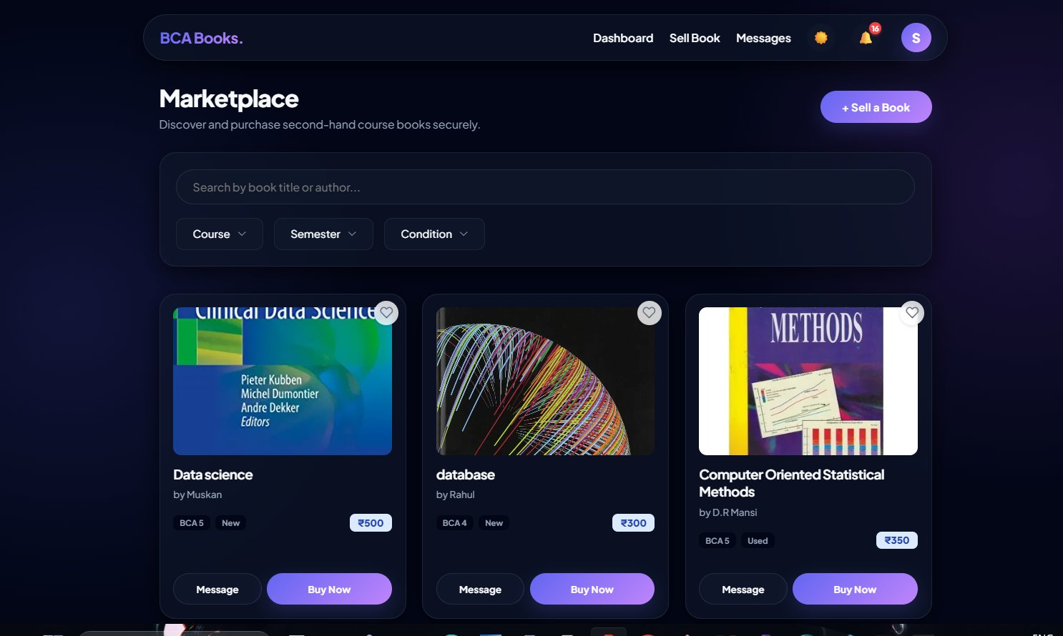
Figure 5.5 – Screenshot: Home Page – Book listings with semester filter

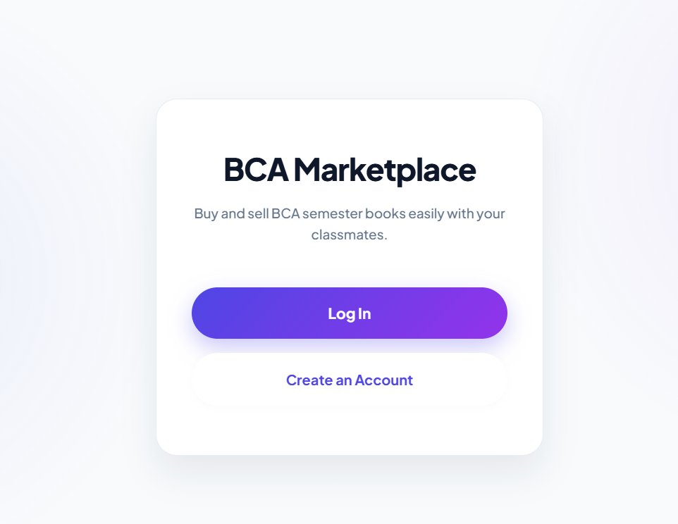
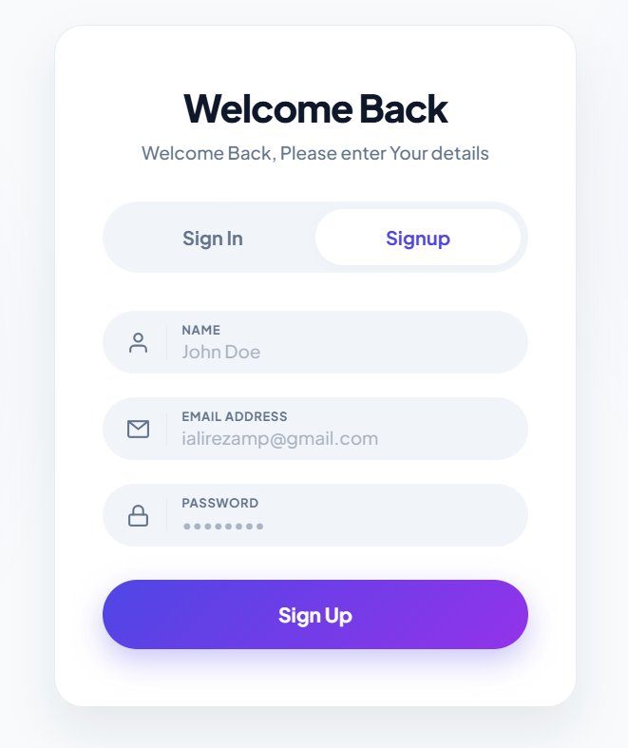
Figure 5.6 – Screenshot: Login / Sign Up Page

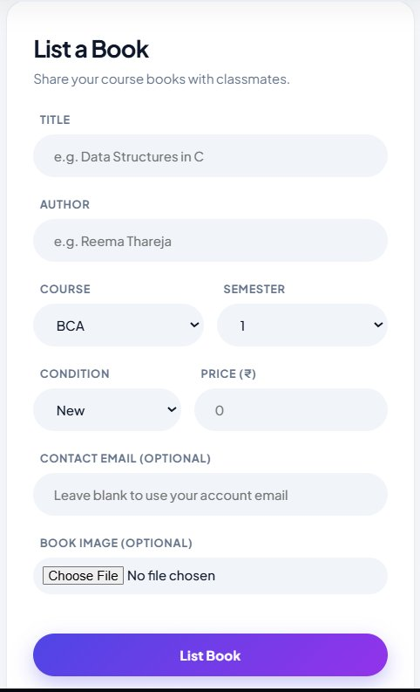
Figure 5.7 – Screenshot: Add Book / List Book Page

[ IMAGE PLACEHOLDER ]
Figure 5.8 – Screenshot: Book Detail Page

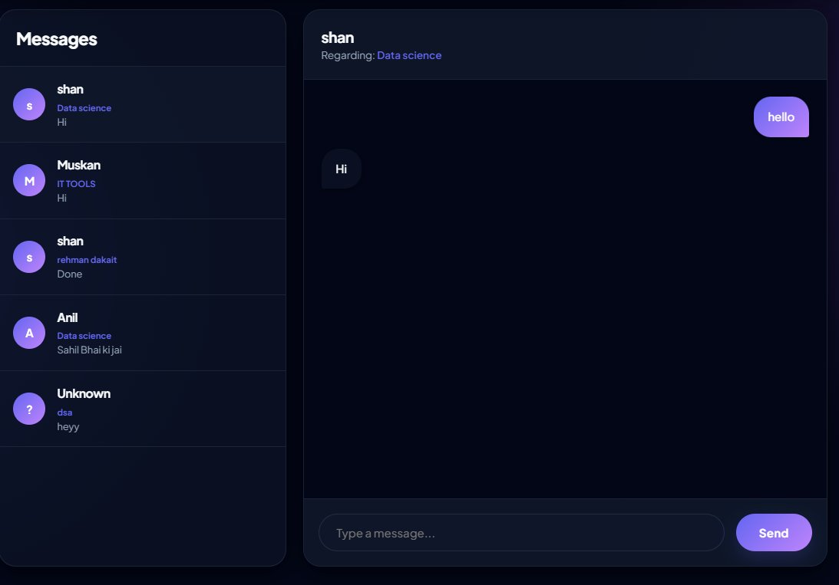
Figure 5.9 – Screenshot: Real-Time Chat Interface

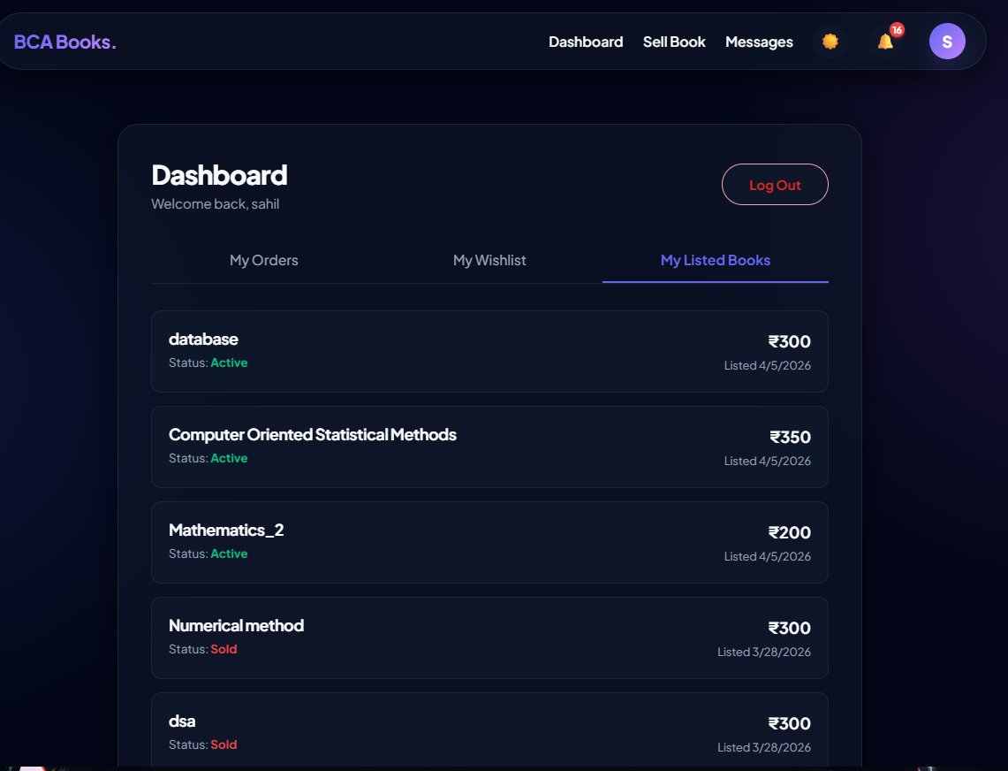
Figure 5.10 – Screenshot: User Profile / Dashboard Page

5.2.3 Code Screenshots
The following screenshots show key portions of the source code, illustrating the backend API routes, frontend React components, database models, and authentication logic used in the Student Marketplace application.

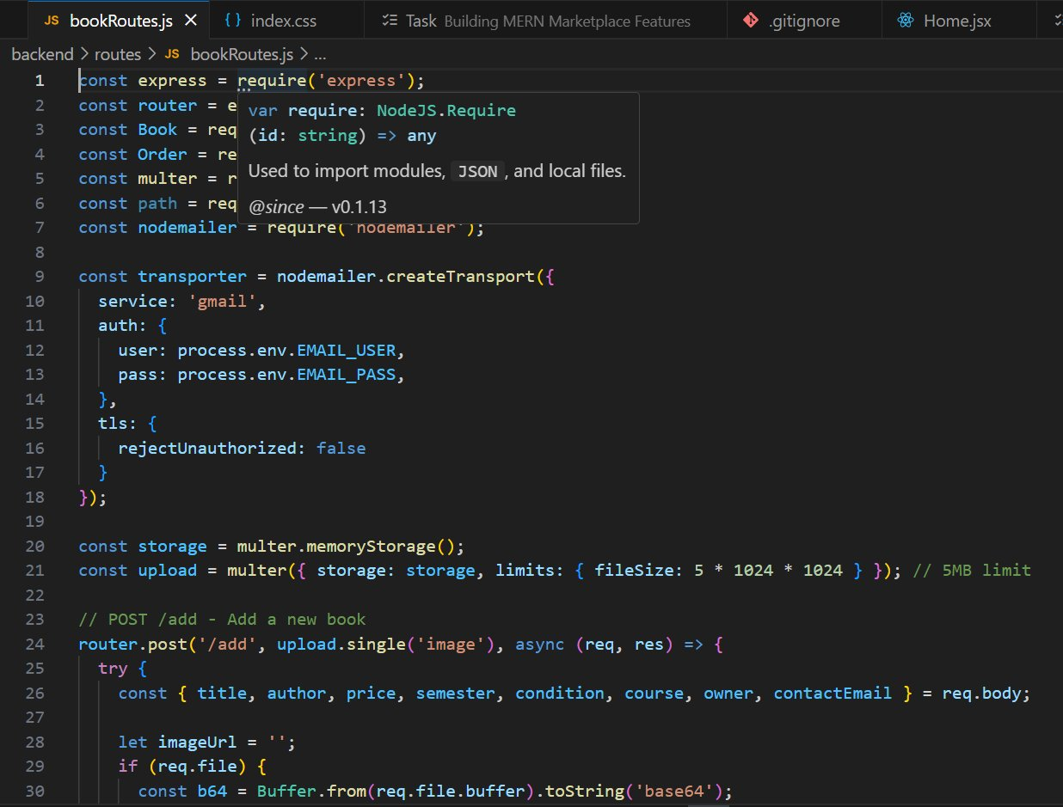
Figure 5.11 – Code: Backend – Express API route for book listings

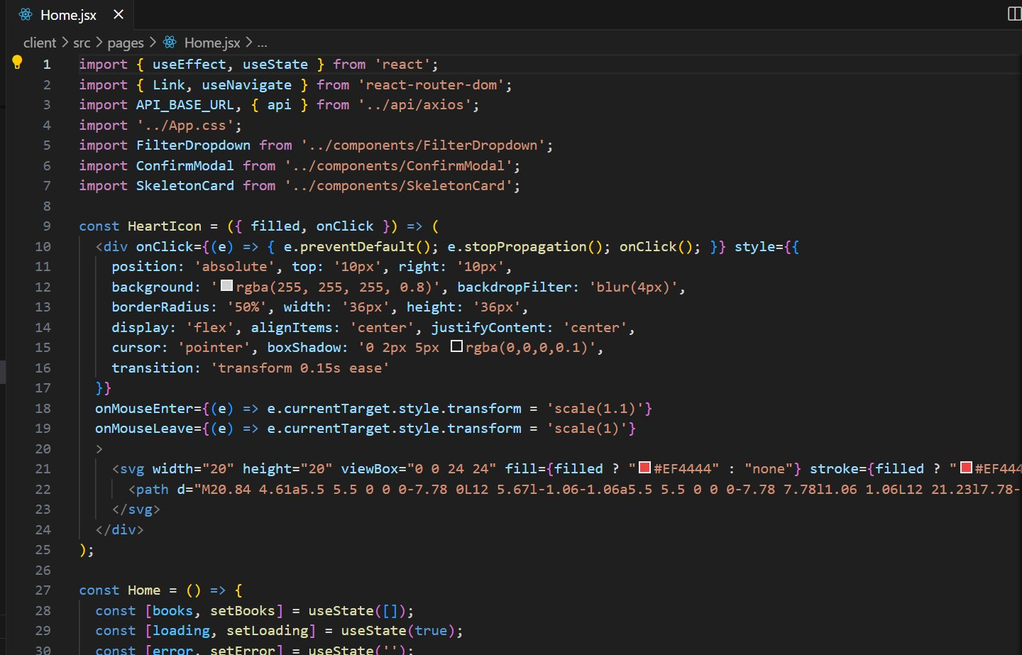
Figure 5.12 – Code: Frontend – React component for Home Page

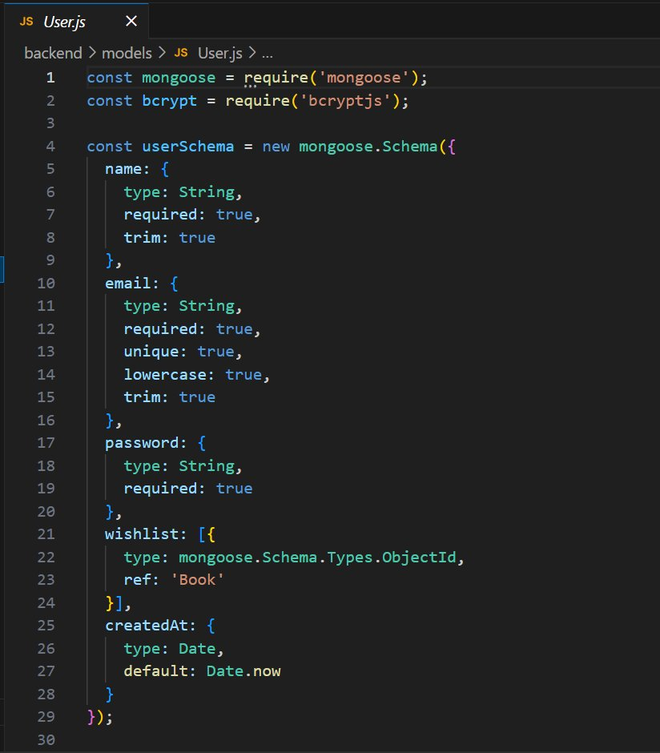
Figure 5.13 – Code: Database – MongoDB User and Book models

[ CODE SCREENSHOT PLACEHOLDER ]
Figure 5.14 – Code: Authentication – JWT login and registration logic

[ CODE SCREENSHOT PLACEHOLDER ]
Figure 5.15 – Code: Real-Time Chat – Socket.IO implementation

5.2.3 Responsive Design
The application uses CSS Flexbox and Grid for layout, combined with media queries, to ensure that the interface adapts seamlessly to different screen sizes. On mobile screens, the navigation bar collapses into a hamburger menu, and book cards are displayed in a single column. On larger screens, a multi-column grid layout is used to display more listings at once.

5.3 Technical Discussions
This section covers the key technical decisions and implementations that make the Student Marketplace work securely and efficiently.

5.3.1 Password Security with bcrypt
User passwords are one of the most sensitive pieces of data in any application. The Student Marketplace uses bcrypt — a widely trusted password hashing algorithm — to ensure that passwords are never stored in plain text.

When a user registers, their password goes through the following process:
- The plain text password is received from the registration form.
- bcrypt generates a unique 'salt' — a random string of characters — for this specific user.
- The password and salt are combined and processed through the bcrypt hashing function.
- The resulting hash (which looks like a random string of characters) is stored in the database.
- The original plain text password is never stored anywhere.

When a user logs in, bcrypt compares the entered password against the stored hash. Even if an attacker gained access to the database, they would not be able to reverse the hash to obtain the original password.

5.3.2 JWT-Based Authentication
After a user successfully logs in, the server issues a JSON Web Token (JWT). A JWT is a compact, self-contained string that securely encodes information about the user. It consists of three parts:
- Header: Specifies the type of token and the signing algorithm used.
- Payload: Contains the user's ID and any other relevant claims (e.g., the expiry time of the token).
- Signature: A cryptographic signature that ensures the token has not been tampered with.

The token is sent back to the client and stored in the browser's local storage. For every subsequent API request that requires authentication (like adding a book listing or contacting a seller), the frontend includes the JWT in the request header. The backend verifies the token before processing the request.

5.3.3 REST APIs and Axios
The communication between the React frontend and the Node.js backend is done through REST APIs. Axios — a popular JavaScript library — is used on the frontend to make these HTTP requests. Axios was chosen over the native Fetch API because it provides a cleaner syntax, automatic JSON parsing, and better error handling.

For example, when the user visits the book listings page, the React component makes a GET request using Axios to the /api/books endpoint on the backend. The backend processes the request, fetches the data from MongoDB, and returns it as a JSON response. Axios receives this response and the React component updates the state to display the listings.

5.3.4 Real-Time Chat with Socket.IO
One of the major new features in this version of the Student Marketplace is the real-time chat system. Instead of relying on email for communication between buyers and sellers, users can now message each other directly within the platform.

This is powered by Socket.IO — a library that enables real-time, bidirectional communication between the browser and the server using WebSockets. Here is how it works:
- is how it works:
- When a user opens the Chat page, the frontend establishes a WebSocket connection with the backend server.
- Each conversation has a unique room ID. When a user opens a conversation, they 'join' that room using socket.emit('join_room', roomId).
- When a message is sent, the frontend emits a 'send_message' event with the message data.
- The backend server receives the event and broadcasts it to all other users in the same room using socket.to(roomId).emit('receive_message', data).
- The message is also saved to the MongoDB database via a REST API call, so conversation history is persisted.

5.3.5 Image Upload with Multer
Sellers can now upload a photo of their book when creating a listing. This is handled using Multer — a Node.js middleware for handling multipart/form-data, which is the format used for file uploads.

When a seller submits the Add Book form with an image, the image file is sent to the backend as part of a multipart form request. Multer receives the file, saves it to the uploads/ directory on the server, and the image's path is stored in the book's database record. The frontend then retrieves and displays the image using the server's static file endpoint.

5.3.6 Theme Support (Dark/Light Mode)
The application supports both a dark theme and a light theme. A ThemeContext provider (using React's Context API) manages the current theme state globally. Users can toggle between themes using a button in the navigation bar. The chosen theme is stored in the browser's local storage so that the user's preference is remembered across sessions. CSS variables are used throughout the application to make switching themes seamless — when the theme changes, all colors update automatically without requiring any component to re-render.

Chapter 6: Testing
Testing is a critical phase of the software development lifecycle. Its purpose is to identify defects, verify that the system behaves as expected, and ensure that the final product meets the requirements defined during the analysis phase. A comprehensive testing strategy was followed for the Student Marketplace, covering multiple levels and types of testing.

6.1 Unit Testing
Unit testing involves testing individual components or functions of the system in isolation, without any dependencies on other parts of the system. The goal is to verify that each unit of code performs exactly as it is supposed to.

For the Student Marketplace, unit testing was performed on the following components:

Backend Unit Tests
- User Registration Function: Tested to ensure that it correctly hashes the password, stores the user in the database, and returns an appropriate success response. It was also tested with invalid inputs (missing fields, invalid email format, weak password) to verify that validation errors are handled gracefully.
- User Login Function: Tested to verify that valid credentials result in a JWT being issued, and that invalid credentials (wrong password, non-existent email) result in a clear error message.
- Add Book Function: Tested with valid data to ensure a listing is correctly created and associated with the logged-in user. Tested with missing required fields to verify that validation errors prevent incomplete listings from being saved.
- Email Sending Function: Tested in a development environment using a test SMTP server (Mailtrap) to verify that emails are correctly formatted and dispatched without errors.

Frontend Unit Tests
- Input Validation: Form inputs on the registration, login, and add-book pages were tested to ensure that appropriate error messages are shown when fields are left empty or contain invalid data.
- Component Rendering: Key components such as the BookCard, Navbar, and FilterPanel were tested to verify that they render correctly with different sets of props.

Test Case | Input | Expected Output | Status
Register – valid data | Name, email, password | User created successfully | PASS
Register – missing email | Name, password only | Validation error shown | PASS
Register – duplicate email | Existing email | Error: Email already in use | PASS
Login – valid credentials | Correct email & password | JWT token issued | PASS
Login – wrong password | Correct email, wrong password | Error: Invalid credentials | PASS
Add Book – all fields + image | Complete book details + photo | Book listing created with image | PASS
Add Book – missing price | Book without price | Validation error | PASS
Chat – send message | Message text in open conversation | Message delivered in real time | PASS
Order creation | Buyer clicks Message Seller | Order record created, notification generated | PASS
Wishlist – add book | Book ID + User ID | Book added to wishlist | PASS
Admin delete – valid secret | Admin secret + Book ID | Book deleted successfully | PASS

6.2 Integration Testing
Integration testing checks that different parts of the system work correctly when combined. After unit testing each component individually, integration testing ensures that they interact with each other as expected.

Key integration tests performed for the Student Marketplace:

- Frontend to Backend Communication: The React frontend was tested together with the Node.js backend to ensure that all API calls return the correct responses and the UI updates accordingly.
- Backend to Database Communication: All Mongoose queries were tested to ensure data is read and written correctly across all six collections.
- Authentication Flow: The complete login flow — entering credentials, receiving a JWT, and using it for authenticated requests — was tested end-to-end.
- Book Listing Flow: The complete flow of adding a book with an image upload was tested — from the form submission, to Multer saving the file, to the listing appearing in the home page.
- Real-Time Chat Flow: The Socket.IO chat system was tested with two browser windows open simultaneously to verify that messages delivered in real time, the conversation sidebar updated without a page refresh, and messages were correctly persisted to the database.
- Order & Notification Flow: Clicking 'Message Seller' was tested to verify an order record is created, a notification is generated for the seller, and the buyer is navigated to the chat page with the conversation already open.

6.3 Validation Testing
Validation testing ensures that the application correctly handles user input and prevents invalid or malicious data from being processed. This is important both for data integrity and for security.

Input validation was tested at two levels:

Client-Side Validation (Frontend)
The React forms include real-time validation that gives users immediate feedback. Tests were performed to verify:
- Required fields cannot be submitted empty.
- Email fields reject invalid email formats (e.g., 'notanemail').
- Password fields enforce a minimum length.
- Price fields accept only positive numerical values.

Server-Side Validation (Backend)
Even with client-side validation in place, server-side validation is essential because malicious users can bypass the frontend and send requests directly to the API. Tests were performed to verify:
- API endpoints reject requests with missing required fields, even if they bypass the frontend.
- The database schema enforces data types and required fields at the model level.
- Duplicate email registration is rejected at the database level (unique constraint on the email field).

6.4 White Box Testing
White box testing (also known as structural testing or glass-box testing) involves testing the internal logic of the code, as opposed to just testing its external behavior. The tester has full visibility into the code and designs test cases based on the code's internal structure.

White box testing was applied to the following areas of the Student Marketplace:
- Authentication Middleware: The middleware function that verifies JWTs was tested to cover all code paths — including the path for a valid token, the path for an expired token, and the path for a missing or malformed token.
- Password Hashing Logic: The bcrypt hashing and comparison logic was tested to ensure that hashing always produces different results (due to salting) and that comparison always correctly identifies matching and non-matching passwords.
- Error Handling: Every try-catch block in the backend was tested to ensure that errors are caught and handled gracefully rather than causing the server to crash.
- Database Query Logic: The Mongoose queries used to filter books were tested with various filter combinations to ensure all code branches are executed and produce correct results.

6.5 Performance Testing
Performance testing evaluates how the system behaves under different load conditions. It helps identify bottlenecks and ensures the system can handle the expected number of users without degradation in performance.

The following performance tests were conducted:

Load Testing
Multiple simultaneous users were simulated to test how the server handles concurrent requests. The results showed that the application maintained acceptable response times (under 2 seconds for most operations) with up to 50 concurrent users, which is well within the expected usage for a single-institution deployment.

Database Query Performance
The performance of MongoDB queries was tested with a database containing several hundred book listings. Queries with and without filters were measured. The results confirmed that response times were fast even with filters applied, largely due to MongoDB's efficient indexing.

Frontend Rendering Performance
The React frontend was tested to ensure that the book listings page renders smoothly even with a large number of entries. React's virtual DOM and the use of pagination (showing a limited number of listings per page) ensure that rendering remains fast and the page does not become sluggish.

Test Scenario | Response Time | Status
Load home page (50 listings) | < 1.2 seconds | PASS
Filter books by semester + course | < 0.8 seconds | PASS
User login | < 0.5 seconds | PASS
Add new book listing with image | < 1.5 seconds | PASS
Send chat message (Socket.IO) | < 0.1 seconds (real-time) | PASS
Load chat conversation history | < 0.7 seconds | PASS
Load dashboard (orders + wishlist) | < 1.0 seconds | PASS
50 concurrent users browsing | < 2 seconds average | PASS

Chapter 7: Results and Challenges
This chapter presents the final outcome of the Student Marketplace project, including a summary of what was successfully achieved, and an honest account of the challenges that were encountered during development.

7.1 Results
The Student Marketplace was successfully developed, tested, and deployed as a fully functional web application. All the core features identified during the requirement analysis phase were implemented and verified through testing.

The following is a summary of what was achieved:

Feature | Status | Notes
User Registration & Login | Completed | With input validation and password hashing
Add Book Listing with Image | Completed | With Multer image upload
Browse & Filter Book Listings | Completed | Filter by semester, course, condition
Real-Time Chat (Socket.IO) | Completed | Conversations organised by book
Order History | Completed | Tracks all buy requests
User Dashboard | Completed | Orders, wishlist, and listings in one place
Wishlist | Completed | Save books for later
Admin Panel | Completed | Edit and delete any listing
In-App Notifications | Completed | Triggered on key actions
Dark/Light Theme | Completed | Persisted in local storage
Responsive Design | Completed | Works on desktop and mobile
Secure Authentication | Completed | bcrypt + JWT implementation

The final application provides a smooth and intuitive experience for students looking to buy or sell second-hand books. The registration and login process is quick and straightforward. The book listings page is well-organized and the filters make it easy to find exactly what you are looking for. Adding a new listing is a simple process that takes less than a minute.

The email-based contact system, while simple, proved to be highly effective. When a buyer expresses interest in a book, the seller receives a clear, informative email with all the details they need to follow up.

From an academic standpoint, this project successfully demonstrates the application of modern full-stack web development techniques — including RESTful API design, component-based UI development, document-based database design, and secure user authentication — in a practical, real-world context.

7.2 Challenges
Software development is rarely straightforward, and this project was no exception. The following challenges were encountered during development, along with the approaches used to overcome them.

Challenge 1: Implementing Secure Authentication
Building a secure authentication system from scratch was one of the more complex parts of this project. The challenge was not just in implementing JWT-based login, but also in understanding the security implications of every decision — such as token expiry, storage strategy, and how to handle expired tokens gracefully on the frontend.

The solution involved careful study of authentication best practices, implementing middleware on the backend to verify tokens on every protected route, and handling authentication errors on the frontend by redirecting users to the login page when their token expires.

Challenge 2: Managing Cross-Origin Resource Sharing (CORS)
During development, when the React frontend (running on port 5173) tried to communicate with the Node.js backend (running on port 5000), the browser blocked the requests due to CORS policy. This is a security feature of web browsers that prevents websites from making requests to a different domain or port without explicit permission.

The solution was to configure the CORS middleware in the Express backend to explicitly allow requests from the frontend's origin during development, and to configure it appropriately for the production domain once deployed.

Challenge 3: Designing an Effective Responsive UI
Creating a user interface that looks and works well on both large desktop screens and small mobile screens required significant thought and iteration. The challenge was to use a layout that was flexible enough to reflow gracefully at different screen widths without breaking.

This was addressed by using CSS Grid for the book listings layout (which automatically adjusts the number of columns based on screen width) and Flexbox for smaller components. Media queries were used for specific adjustments, such as hiding the sidebar filter panel on small screens and replacing it with a collapsible dropdown.

Challenge 4: Handling Asynchronous Operations
A lot of the operations in a web application — API calls, database queries, email sending — are asynchronous, meaning they take time to complete and the rest of the code should not wait for them. Managing this correctly using async/await in JavaScript, and ensuring that errors in asynchronous operations are caught and handled properly, required careful attention to detail.

Every async operation in both the frontend and backend was wrapped in try-catch blocks to handle errors gracefully and provide meaningful error messages to the user rather than letting the application crash silently.

Challenge 5: Configuring Nodemailer for Email Sending
Configuring Nodemailer to correctly send emails through an SMTP server was initially tricky. Different email providers have different SMTP settings, and some (like Gmail) require additional security configuration (such as enabling 'Less secure apps' or using App Passwords) to allow applications to send emails programmatically.

The solution was to use a dedicated test email service (Mailtrap) during development, which provides a safe sandbox environment for testing email functionality without actually sending emails to real addresses. For production, proper SMTP credentials were configured with appropriate security settings.

7.3 Future Enhancements
While the current version of the Student Marketplace is fully functional, there are several enhancements that would significantly improve the platform's utility and user experience:

- Online Payment Gateway: Integrating a payment gateway like Razorpay would allow the entire transaction — from browsing to payment — to happen within the platform, making it truly end-to-end.
- Rating and Review System: After a completed transaction, both parties could rate and review each other, building a community trust system.
- Multi-Institution Support: Expanding the platform to support multiple colleges or universities, with each institution having its own isolated marketplace.
- Mobile Application: Native apps for Android and iOS would make the platform even more accessible to the majority of students who primarily use smartphones.

Each of these enhancements represents a meaningful improvement that would increase the value of the Student Marketplace. They are planned for future development phases.

7.4 Conclusion
The Student Marketplace project set out to solve a real and tangible problem faced by students — the lack of an organized digital platform for buying and selling second-hand academic books. What started as a simple listing platform has grown into a full-featured web application with real-time chat, order tracking, wishlist management, an admin panel, image uploads, in-app notifications, and a polished dark/light theme.

The project demonstrates strong practical application of modern full-stack web development using React, Node.js, Express, MongoDB, and Socket.IO. Every feature — from JWT-based secure authentication to real-time bidirectional messaging — reflects industry-standard practices that are directly relevant to professional software development.

Beyond the technical achievements, this project reflects a genuine desire to make academic life a little easier and more affordable for students at Government Degree College Nagrota and beyond. By creating a structured, digital environment for buying and selling books, the Student Marketplace helps students save money, reduce waste, and support each other — which is ultimately what a campus community is all about.

It is hoped that this project serves as a strong foundation for future development and perhaps one day becomes a platform that benefits students across many institutions.

