Project JXTA 2.0 Super-Peer Virtual Network（Partly）
Bernard Traversat, Ahkil Arora, Mohamed Abdelaziz,
Mike Duigou, Carl Haywood, Jean-Christophe Hugly, Eric Pouyoul, Bill Yeager
Bernard.Traversat@Sun.Com
Project JXTA
Sun Microsystems, Inc.

Abstract

The Project JXTA protocols establish a virtual network overlay on top of the Internet, allowing peers to directly interact and self-organize independently of their network connectivity and domain topology (firewalls or NATs). Project JXTA enables application developers, not just network administrators to design network topology that best match their application requirements. Multiple ad hoc virtual networks can be created and dynamically mapped into one physical network unleashing a richer multi-dimensional virtual network world. Project JXTA is looking ahead where billion of network services, all addressable on the network will be able to discover and interact with each other in an ad doc and decentralized manner through the formation of a multitude of virtual networks. The following paper describes the Project JXTA 2.0 implementation that was recently released by the JXTA community. The JXTA 2.0 implementation introduces a number of new features for improving overall functionality, performance, and scalability of the JXTA network. The JXTA 2.0 release is making a stronger differentiation in the way JXTA super-peers (relay and rendezvous) behave and interact with edge peers. The JXTA 2.0 implementation introduces the concept of a rendezvous peer view to connect rendezvous within a peergroup. Resolver queries are no more propagated to edge peers as in JXTA 1.0 reducing overall network traffic. Edge peers use a loosely-coupled distributed hash index to locate advertisements on the rendezvous peer view for efficient query lookups. The JXTA 2.0 implementation provides better resource management (threads and queues), and implements resource usage limits to fairly allocate resource between platform services. The JXTA 2.0 release also introduces new implementations of the TCP/IP and HTTP transports. The TCP/IP transport now takes advantage of bi-directional physical connections to limit the number of connections. Finally, the JXTA 2.0 implementation supports TCP/IP relay for
efficient traversal of NATs.

- 1. Introduction

The open-source Project JXTA [1,2,3] is the industry leading peer-to-peer (P2P) platform originally conceived by Sun Microsystems Inc. and designed with the participation of a small but growing number of experts from academic institutions and industry. The Project JXTA protocols establish a virtual network overlay on top of the Internet and non-IP networks, allowing peers to directly interact and self-organize independently of their network connectivity. Today more than 90 projects are hosted on the JXTA open-source website. More than 1 million downloads of the technology have been made. ISVs are developing and shipping JXTA technology-based applications to a variety of markets including knowledge management, content sharing, and collaborative applications. Enterprises, government agencies, and educational institutions are making plans to adopt the technology as their primary P2P technology solution. Project JXTA standardizes a common set of protocols for building P2P virtual networks. The JXTA protocols defines the minimum required network semantic for peers to form and join a virtual network. The Project JXTA protocols define a generic network substrate usable to build a wide variety of P2P networks. Project JXTA enables application developers, not just network administrators to design network topology that best match their application requirements. Multiple ad hoc virtual networks can be created and dynamically mapped into one single physical network. Project JXTA envisions a world where each peer, independent of software and hardware platform, can benefit and profit from being connected to millions of other peers through the formation of a multitude of virtual networks. Project JXTA is designed to be independent of programming languages (such as C or the Java™programming language), system platforms (such as the MicrosoftWindows and UNIX® operating systems), service definitions (such as RMI and WSDL), and network protocols (such as TCP/IP or Bluetooth). The Project JXTA protocols have been designed to be implementable on any device with a network heartbeat, including sensors, consumer electronics, PDAs, appliances, network routers, desktop computers, data-center servers, and storage systems. The initial reference implementation of the JXTA 1.0 protocols was released on April 2001, the following paper describes the JXTA 2.0 reference implementation that was recently released by the JXTA community. The Project JXTA 2.0 reference implementation introduces a number of new features to improve overall performance and scalability of the JXTA network. The JXTA 2.0 release is making a stronger differentiation in the way super-peers such as relay and rendezvous behave and interact with edge peers. The JXTA 2.0 release introduces the concept of a rendezvous peer view (RPV) to propagate resolver queries, and a shared resource distributed index (SRDI) to index advertisements on the rendezvous peer view for efficient advertisement query lookups. The JXTA 2.0 implementation introduces the concept of pluggable walkers to propagate queries within the rendezvous RPV network. The JXTA 2.0 implementation is adding better resource management (threads and message queues), and implements resource usage limits to fairly allocate resource between platform services. The JXTA 2.0 implementation is creating thread pools, and thread limits to control thread usage on a per-service based. The JXTA 2.0 implementation is also adding optimizations for reducing extra message buffering and copying when sending messages. The endpoint service minimizes the number of active connection threads required to support large number of peers connecting to a single peer. Peers establish a connection, get their addressed messages, and then remain quiescent until another message is available or the connection is closed. The Project JXTA 2.0 implementation adds support for TCP/IP relays to enable efficient NAT traversals. Finally, the JXTA 2.0 implementation provides dynamic failover from rendezvous and relay super-peers to recover from super-peer failures, or roam for improving connectivity or functionality.

Section 2. gives an overview of Project JXTA virtual network. Section 3. discusses the rendezvous super-peer network, the rendezvous peer view, the shared resource distributed index service, and resolver query propagation. Section 4. covers the relay super-peers, routing, firewall and NAT traversals. Section 5. discusses peergroups, and virtual secure domains. Section 6. describes the JXTA pipe abstraction. Section 7. outlines JXTA security model. Section 8. discusses the JXTA core specification and standard service protocols. Section 9. describes the JXTA 2.0 reference implementation overall architecture. Finally, section 10. concludes on the state of the JXTA 2.0 implementation and future directions.

2. Project JXTA Virtual Network

The Project JXTA protocols create a virtual network overlay on top the existing physical network infrastructure. The Project JXTA virtual network allows a peer to exchange messages with any other peers independently of its network location (firewalls, NATs or non-IP networks[6]). Messages are transparently routed, potentially traversing firewalls or NATs, and using different transport/transfer protocols (TCP/IP, HTTP) to reach the receiving peers (see figure 1). The Project JXTA network allows peers to communicate without needing to understand or manage complex and changing physical network topologies allowing mobile peers to move transparently from on location to another. The Project JXTA virtual network standardizes the manner in which peers discover each other, self-organize into peergroups, discover peer resources, and communicate with each other. The Project JXTA 2.0 implementation builds upon the 5 virtual network abstractions introduced in JXTA 1.0 [1]. First, a logical peer addressing model that spans the entire JXTA network. Second, peergroups that let peers dynamically self-organize into protected virtual domains. Third, advertisements to publish peer resources (peer, peergroup, endpoint, service, content). Fourth, a universal binding mechanism, called the resolver, to perform all binding operations required in a distributed system. Finally, pipes as virtual communication channels enabling applications to communicate between each other. In the following sections, we discuss these abstractions and enhancements made in JXTA 2.0.

2.1 JXTA IDs

The Project JXTA addressing model is based on an uniform and location independent logical addressing model. Every network resource (peer, pipe, data, peergroup, etc.) is assigned a unique JXTA ID. JXTA IDs are abstract objects enabling multiple ID representations (IPv6, MAC) to coexist within the same JXTA network. The reference implementation is using 128-bit random UUIDs allowing each peer to self-generate its own IDs. A peer in the JXTA network is uniquely identified by its peer ID allowing the peer to be addressed independently of its physical address (see figure 1). For instance, a laptop booting via DHCP, and therefore having many different IP addresses overtime, will always have the same peer ID. Similarly, a peer supporting multiple network interfaces (Ethernet, Wi-Fi, etc.) will be addressed as a single peer independently on the interface used. The peer ID abstraction allows a peer to encapsulate not just physical transports, but also “logical” transport protocols such as HTTP or TLS. JXTA logical addressing model introduces a fundamental indirection separating the identification of a resource and the location of a resource allowing a variety of virtual mappings to be used to determine the physical location of a resource.

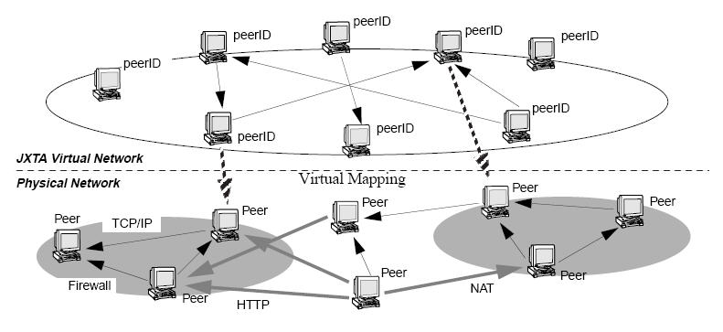
Figure 1: The Project JXTA Virtual Network

A peer endpoint is associated with each Peer ID encapsulating all available physical network addresses for a peer. Peer endpoints are very much like business cards, listing the many ways to contact a person (phone, fax, email address, etc.). When receiving a peer endpoint advertisement, another peer can select the most efficient way to communicate with that peer from the list of available peer endpoint addresses (using TCP/IP directly when possible, or HTTP over TCP/IP if one must traverse firewall).

2.2 Advertisements
All network resources in the Project JXTA network, such as peers, peergroups, pipes, and services are represented by advertisements. Advertisements are language-neutral metadata structures resource descriptors represented as XML documents. Project JXTA standardizes advertisements for the following core JXTA resource: peer, peergroup, pipe, service, metering, route, content, rendezvous, peer endpoint, transport. Developers can subtype these advertisements to create their own subtypes to add an unlimited amount of additional and richer metadata information to each resource description. For example a Web service advertisement will contain the associated WSDL document associated with the service. Advertisements can be used to virtually describe anything: source code, script, binary, classes, compiled JIT code, Java objects, EJB, J2EE containers.

Figure 2 shows an example of a PeerGroup Advertisement (jxta:PGA) that describes a peergroup via a unique peergroup ID (GID), a module specification ID (MSID) that points to an advertisement that describes all of the peergroup services available in this peergroup, a peergroup name (Name), and a description of the peergroup (Desc). Peers cache, publish, and exchange advertisements to discover and find available network resources. Peers discover resources by searching for their associated advertisements. All advertisements are published with a lifetime that specifies the duration of that advertisement in the network. An advertisement can be republished at anytime to extend its lifetime before it expires. Peers exchange advertisements, but maintain their expiration date during exchanges. Lifetimes permit to purge expired advertisements without centralized management.:

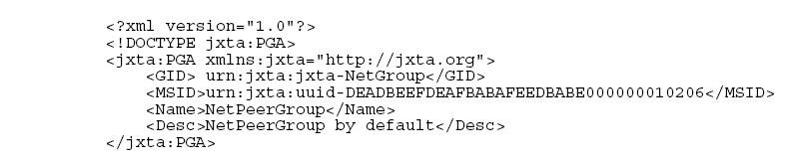
Figure 2: Example of a Peergroup Advertisement

3. Rendezvous Super-Peers
The Project JXTA network uses an universal resource binding mechanism called the resolver to perform all resolution operations found in traditional distributed systems, such as resolving a peer name into an IP address (DNS), binding a socket to a port, locating a service via a Directory service (LDAP), or searching for content in a distributed filesystem (NFS). In Project JXTA, all resolution operations are unified under the simple discovery of one or more advertisements. The Project JXTA protocols do not specify how the search of advertisements is performed, but provide a generic resolver protocol framework with a default policy that can be overwritten. Developers can tailor their resolver implementations to use a decentralized, centralized, or hybrid approach to match their application domain requirements. The core resolver infrastructure provides the ability to send and propagate queries, and receive responses. The resolver performs authentication and verification of credentials, and drops invalid messages.

The Project JXTA network provides a default resolver policy based on Rendezvous super-peers. Rendezvous are peers that have agreed to cache advertisement indices (i.e. pointers to edge peers that cache the corresponding advertisement). Rendezvous conceptually corresponds to well known locations used for indexing and locating advertisements. The default rendezvous policy provides the minimum infrastructure for efficiently bootstrapping high-level advertisement search policies.

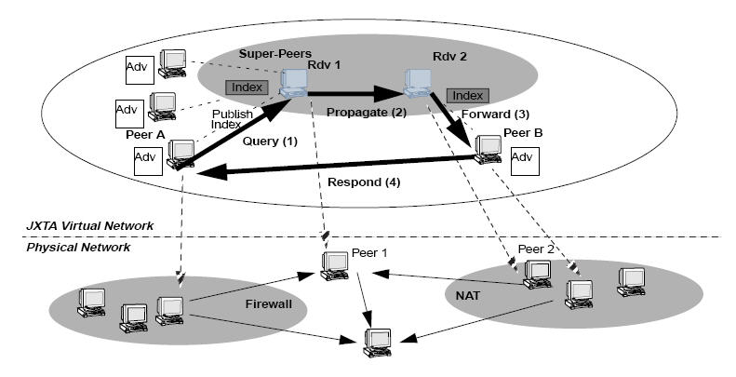
Figure 3: Project JXTA Rendezvous super-peers

For instance, via rendezvous, a peer can find enough peers to bootstrap a more advanced search policy. Highlevel search services are expected to provide more efficient search mechanisms, because they may have a better knowledge of the content topology distribution (CAN[4] or Chord[5], Semantic Web[7]). The default rendezvous peer infrastructure provides a low-level discovery mechanism to discover advertisements while providing hooks to allow high-level discovery services to participate in the advertisement search process.

Edge peers maintain special relationship with their rendezvous peers. Any peer can become a rendezvous peer assuming it has the right credentials. Secure peergroups may restrict which edge peers can act as rendezvous. A fundamental change made in JXTA 2.0 is rendezvous do no cache edge peer advertisements. Rendezvous just maintain an index of advertisements published by their edge peers. Not caching advertisements make the rendezvous architecture more scalable, and reduce the problem of caching out-of-date advertisements. The Shared- Resource Distributed Index (SRDI) service is used by edge peers to index their advertisements on rendezvous. Edge peers use SRDI to push advertisement indices to their rendezvous when publishing new advertisements. Indices can be pushed synchronously when a new advertisement is published, or asynchronously by the SRDI daemon that runs at fixed intervals. For example in figure 3, both Peer A and Peer B are pushing indices of their advertisements to their respective rendezvous Rdv1, and Rdv2. When an advertisement query is issued from Peer A for an advertisement stored on Peer B, the query is sent to Peer A’s rendezvous Rdv1 (1), Rdv1 looks if it has an index of that advertisement. If it does not find an index, it propagates the query (2) to the next rendezvous Rdv2. We will discuss shortly the propagation policy used by rendezvous to forward queries between themselves. When the query reaches Rdv2, Rdv2 finds the index for the advertisement and forwards the query to Peer B (3). This is done to ensure that the latest copy of the advertisement on Peer B will be sent to Peer A. When Peer B receives the query, it sends the advertisement to Peer A (4). It is important point out that any peers independently of its physical location can act as a rendezvous. In figure 3, the physical Peer2 is behind NAT and acting as a rendezvous.

Another significant improvement made in JXTA 2.0 is advertisement queries are no more propagated to edge peers. Only rendezvous peers are involved in the propagation of advertisement queries. A query is only forwarded to an edge peer when a matching index has been found. This is significantly reducing network traffic when looking for an advertisement. The next section discusses how queries are propagated between rendezvous super-peers.

