Copyright

© Ericsson AB 2009 – All Rights Reserved
Disclaimer
No part of this document may be reproduced in any form without the written permission of the copyright owner.
The contents of this document are subject to revision without notice due to continued progress in methodology, design and manufacturing. Ericsson shall have no liability for any error or damage of any kind resulting from the use of this document.
Trademark List
JAVA™ is a trademark of SUN Microsystems inc.
SUN™ is a trademark of SUN Microsystems inc.
Windows® is a registered trademark of the Microsoft Corporation.
Apache™ is a trademark of The Apache Software Foundation.
Abstract
This document describes how to build, deploy and use the Web Call Example Application. This document also describes the design of Web Call Example Application.

Contents
1 Introduction 5
1.1 Background 5
1.2 Overview 5
1.2.1 Network overview 6
1.2.2 Basic Use cases 6
1.2.3 Content of package 7
1.3 Target group 7
1.4 Terminology 7
2 Getting started 9
2.1 Development environment 9
2.1.1 Download and install Web Call Example Application (this kit) 9
2.1.2 Third-party product information 9
2.1.3 SIP account 10
2.2 Operating system (OS) environment variables 10
2.2.1 Required OS environment variables 10
2.2.2 How to set OS environment variables 11
2.2.3 Configure Ant properties file 12
2.2.4 Configure Application deployment descriptor file 13
2.2.5 Configure database resource 13
2.2.6 Configure SSL connection 14
2.2.7 Deploy the web application 17
3 Use Cases Demonstration 18
3.1 Overview 18
3.2 Desktop browser view demonstration 18
3.2.1 User Registration 18
3.2.2 User panel 19
3.2.3 VoIP provider account 20
3.2.4 Click-to-Call Service 20
3.2.5 Phone-to-Phone call 21
3.2.6 User/Administrator management 23
3.3 Mobile browser view demonstration 24
3.4 Java ME client application demonstration 26
3.4.1 VoIP call form 26
3.4.2 Call method 26
3.4.3 VoIP call form menu 27
3.4.4 Synchronize 29
3.4.5 Phone call 29
3.5 Test with SDS 30
3.5.1 Configure SIP network environment 30
3.5.2 Prepare SIP Client Endpoint 34
3.5.3 Test Web Call Example Application 36
4 Design description 38
4.1 SIP Call Component 39
4.2 Relay Call and Third Party Call 39
4.2.1 Relay Call 40
4.2.2 Third Party Call 40
4.3 Relay Call Controller 41
4.3.1 Session Control Call Flows 43
4.3.2 Internal design outlines 46
4.4 Third Party Call Controller 52
4.4.1 Five layers architecture 52
4.4.2 Architecture of Third Party Call Controller 53
4.4.3 Call transfer implementation of third party call control 54
4.4.4 SDP swap implementation of third party call control 55
4.4.5 Re-invite implementation of third party call control 55
4.4.6 Web client implementation of third party call control 56
4.5 Conclusion 57
4.6 Design of the Web Application 58
4.6.1 Architecture of Mobile Front Controller 58
4.6.2 Desktop Browser view of Web Application 60
4.6.3 Mobile browser view of Web Application 60
4.6.4 Site structure 61
4.6.5 Validation mechanism 62
4.6.6 Web Service interface of Web Application 62
4.6.7 Security feature – SSL certificate 66
4.6.8 Security feature – Form-based Authentication 68
4.7 Designs of Java ME Client 70
4.7.1 Design of Java ME web service client application 70
5 Future Work 75
6 References 76

Introduction

Background
IP telephone (VoIP) technology enables the communications between Internet users and the endpoints in PSTN circuit switched (CS) networks. As we know, Session Initiation Protocol (SIP) [1] is widely adopted as a signaling protocol for VoIP communications. Because of its simplicity, power and extensibility, it has also been selected by the Third Generation Partnership Project (3GPP) as a major component of IP Multimedia Subsystem (IMS) for the evolved UMTS core network.
Based on IMS/SIP network technology, Web Call Example Application integrated call functions into Web containers. This presents a simple way to implement the communication convergence of Web, IMS/SIP network, and CS networks. It does not require the installation of the plug-in clients on the browser or other special client software as most VoIP services.
Compare to other customer-oriented VoIP products, Web Call Example Application offers solutions for developers. It integrated the SIP call function into Web container as Java EE components, providing the example of the convergences between SIP/IMS and the Web with existing Internet Web technology on Java EE Web container.

Overview
The Web Call Kit is a software development kit (SDK) consists of Sip Call Component, an Integrated Web Application and a Java ME - Web Service Client application. The purpose of Web Call Controller Kit is to provide high level API to implement SIP call control, and demonstrate how to integrate SIP call component in web container as Java Beans and web services. It also includes a java ME application examples to access web service making phone-to-phone SIP calls. This SDK can help Java application developers to understand how SIP call component Library works and how Java EE and Java ME applications can be developed upon it. This SDK can be used for connecting to a SIP based network such as IMS core network.
- Sip Call Component. It provides high-level API to developers to implement a phone-to-phone SIP call function. The component is built with the open source MJSIP library. The main functions include establishing SIP sessions between two endpoints, controlling the session states, and managing the audio proxy. The Sip Call Component is a SIP call-controlling component, connecting SIP endpoints though the SIP network selected by users.
- Integrated Web Application. It contains a set of examples for developers, showing how to integrate the Sip control Component as Java Beans and web services into a web container. The web application uses the Mobile Front Controller architecture and provides examples on how to develop efficient and secure web application for both web users and mobile users.
- Java ME client application. It is a related project to the web application. It is a client-side java ME application, using SOAP to access the phone-to-phone web service integrated in the web container.

Network overview
Figure 1 Network overview shows the general network architecture for a service provider with the integrated web application. The application runs on a Java EE web container and resides outside the operator’s mobile network.
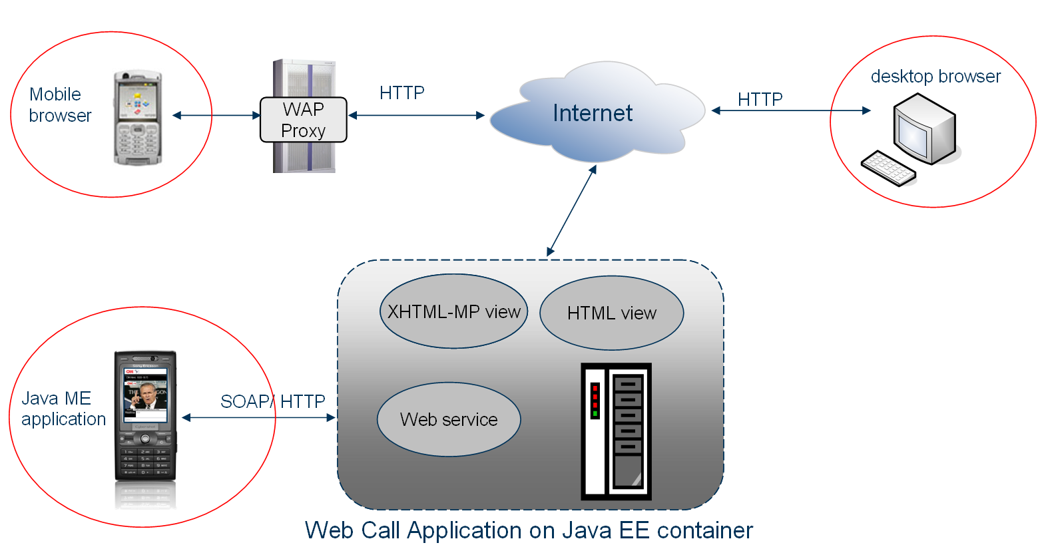
Figure 1 Network overview
In the front-end of the application, there are three types of access.
- Web users can use desktop browsers to visit the web site via the ISP on the internet. The web application provides XHTML version for web users (desktop browser view).
- Mobile users can use mobile browsers to visit the web site via the mobile operator’s network. The web application provides XHTML-MP versions for mobile users (mobile browser view).
- More advanced mobile user, with JSR 172 [11] support, can download and install the Java ME client application, and access the web services via mobile operator’s network.

Basic Use cases
The Web Call Example Application has implemented the following basic use cases:
- Sample application with VoIP call function (VoIP call API).
- Click-to-Call business service.
- Thin client phone-to-phone call services.
- Java ME client initialed VoIP call services

Content of package
The package contains;
- Complete source code with code comments
- Configuration files
- Ant script
- developer’s guide

Target group
Web Call Example Application is primarily for Java developers, who have experience in the filed of Java EE, and have a basic concept of VoIP network. Java developers can learn the example set in the kit, and use the Sip Call Component to build different Java EE components. Developers can also modify and extend this kit for more application functionalities.
The web call example application uses Ericsson Mobile Front Controller as a front controller in web application. If you need more information Mobile Front Controller, please refer to Ericsson Developer Connection at http://www.ericsson.com/developer
The demo application should be regarded as educational and research material only. It can be used to copy certain ideas or bits of code for new applications, but it should not be mistaken for a commercially deployable application.

Terminology
SIP: Session Initiation Protocol, an application-layer control (signaling) protocol for creating, modifying, and terminating sessions with one or more participants.
RTP: Real-time Transport Protocol, a carrier for audio/video communications.
Java EE: Java Platform, Enterprise Edition, is the industry standard for developing server-side Java applications.
SSL: Secure Sockets Layer, is a commonly-used protocol for managing the security of a message transmission on the Internet.
Custom Tag: A custom tag is a user-defined JSP language element.
Web service: Web services are web-based enterprise applications that use open, XML-based standards and transport protocols to exchange data with calling clients.
SOAP: Simple Object Access Protocol is a XML-based protocol that lets applications exchange information over computer networks, normally using HTTP/HTTPS.
WSDL: Web Service Description Language is a XML-based language that provides a model for describing web services.
JAX-WS: The Java API for XML Web Services is a programming language API for creating web services and is a part of the Java EE platform.
Java ME: Java Platform, Micro Edition, provides a robust, flexible environment for applications running on mobile and other embedded devices.
JSR 172: J2ME Web Services Specification, defines an optional package that provides standard access from J2ME to web services.
JAD: Java Application Descriptor file. It describes the MIDlets (Java ME applications) that are distributed as JAR files.

Getting started

Development environment

Download and install Web Call Example Application (this kit)
Extract the kit to <WebCall>, for example, c:\WebCall

Third-party product information
The Web Call Example Application requires a series of freely downloadable third-party products (3PPs). Download and install the following 3PPs:
- Java SE Development Kit (JDK) 6 update 12. The JDK installation directory will from now on be referred to as <jdk>. Download from: http://java.sun.com/javase/downloads/index.jsp
- Ant 1.7.0.The Ant installation directory will from now on be referred to as <ant>. Download from: http://ant.apache.org/.
- Cygwin 1.5.25. Make sure to include the source for the Open SSL package when installing. The Cygwin installation directory will from now on be referred to as <cygwin>. Download from http://www.cygwin.com/.
- Tomcat 6.0.18. The Tomcat installation directory will from now on be referred to as <tomcat>. Download from: http://tomcat.apache.org/download-60.cgi.
- Metro 1.4. The Metro installation directory will from now on be referred to as <metro>. Download from https://metro.dev.java.net/1.4/. Install Metro by following the instruction.
- MySQL 5.1 Download from http://dev.mysql.com/downloads/ install MySQL by follow the instruction.
- MySQL Connector/J 5.1.7 Download from http://www.mysql.com/products/connector/j/ Extract the package and copy mysql-connector-java-5.1.7-bin.jar to <tomcat>/lib.
- Sun Java Wireless Toolkit 2.5.2_01 Download from http://java.sun.com/products/sjwtoolkit/download.html The Sun Java Wireless Toolkit installation directory will now be referred to as <WTK>. Install it by following the instruction.

SIP account
SIP accounts are used in connecting to the SIP network, which is offered by SIP providers. Apply a SIP account from a SIP provider. For example, voipstunt, http://www.voipstunt.com, Nonoh, http://www.nonoh.net/en/index.html.
The configuration information of the SIP account should contain the follow elements:
- SIP server/proxy address and port number
- Domain name
- User name
- Password

Operating system (OS) environment variables

Required OS environment variables
The environment variables that have to be set in order to perform different steps in this guide are shown in Table 1. See section 2.2.2 for information on how to set up environment variables.

Variable | Set to | Description
JAVA_HOME | <jdk> | Set JAVA_HOME operating system environment variable to the JDK installation directory. Required for Ant tasks.
TOMCAT_HOME | <tomcat> | Set TOMCAT_HOME operating system environment variable to the Tomcat installation directory.
CYGWIN_HOME | <cygwin> | Set CYGWIN_HOME operating system environment variable to the Cygwin installation directory.
WTK_HOME | <wtk> | Set WTK_HOME operating system environment variable to the Java Wireless Toolkit installation directory.
PATH | %PATH%;%ANT_HOME%/bin | Add the bin directory of the Ant installation to the system path so that the Ant command can be executed in any directory. Note that %PATH%; in the “Set to” column means that the old value should not be overwritten, but instead be appended to.
PATH | %PATH%;%JAVA_HOME%/bin | Add the bin directory of the JDK installation to the system path. Note that %PATH%; in the “Set to” column means that the old value should not be overwritten, but instead be appended to.
PATH | %PATH%;%CYGWIN_HOME%/bin | Add the bin directory of the Cygwin installation to the system path. Note that %PATH%; in the “Set to” column means that the old value should not be overwritten, but instead be appended to.
Table 1 Environment variables.

How to set OS environment variables
This section describes the steps involved in setting environment variables in Windows.
- Open the System Properties dialog. This is done by opening the Control Panel and double-clicking the System icon.
- Choose the Advanced tab.
- Click Environment Variables to edit the system’s environment variables.
- In the list, choose the variable to add/change and click New/Edit.
- Enter the new variable value and click OK.
- Adding directories to the %PATH% environment variable is done by appending a new entry to the existing one. For example, the new result can be: %JAVA_HOME\bin;%PATH%
Figure 2 shows an example of what this can look like.

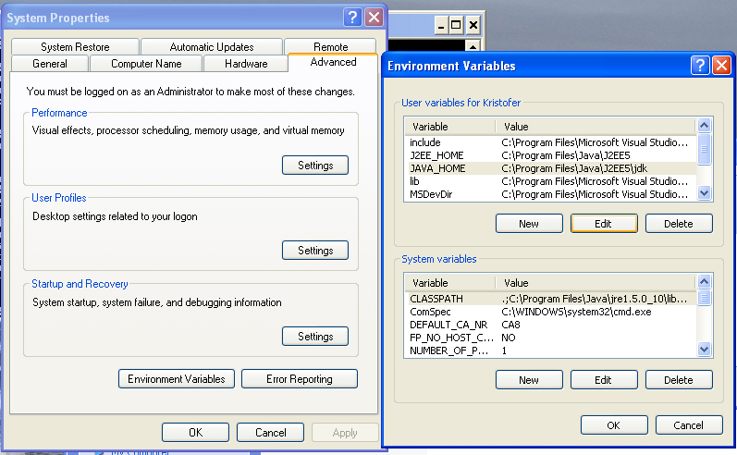
Figure 2 Setting environment variables in Windows.

Configure Ant properties file
This Ant properties file is located under application root directory, for example,
<WebCall>/build.properties.
The structure and setup properties are described below.
jdk.home.1.6=${env.JAVA_HOME}
jdk.home.sun_java(tm)_wireless_toolkit_2.5.2_for_cldc=${env.WTK_HOME}
metro.home=${env.METRO_HOME}

# Settings for Tomcat
tomcat.url=http\://127.0.0.1\:8080/manager
tomcat.user=admin
tomcat.pass=admin

contextroot.path=WebCall
Change the username and password of tomcat on the highlight lines above. This is used for deploy the web call project.

Configure Application deployment descriptor file
Web.xml is an XML file describing the servlets and other components that make up this application, along with all initialization parameters and container-managed security constraints that the server enforce. Only the values of context-param and init-param need to be modified. This file is located in the project development directory in the WEB-INF folder, for example: <WebCall>\SIPComponentWebApp\web\WEB-INF\web.xml

<context-param>
<description>Public account user name</description>
<param-name>publicUsername</param-name>
<param-value>u3ername</param-value>
</context-param>
<context-param>
<description>Public account password</description>
<param-name>publicPassword</param-name>
<param-value>pa33w0rd</param-value>
</context-param>
<context-param>
<description>Public account SIP server</description>
<param-name>publicServer</param-name>
<param-value>sip.voipstunt.com:5060</param-value>
</context-param>
<context-param>
<description>Public account realm</description>
<param-name>publicRealm</param-name>
<param-value>sip.voipstunt.com</param-value>
</context-param>
<context-param>
<description>Administrator number</description>
<param-name>adminNumber</param-name>
<param-value>004687573902</param-value>
</context-param>
<context-param>
<description>Local Port</description>
<param-name>publicLocalPort</param-name>
<param-value>5099</param-value>
</context-param>
Figure 3 parameters for click to call service
Figure 3 shows the parameters in web.xml that need to be changed in order to make “click to call”. For more details about click to call please refer to 3.2.4 Click-to-Call Service.

Configure database resource
Create a database named webcalldb in MySQL database.
The context.xml is an XML document that defines the database resource and the parameters to access the database. It is located in the web folder under the project development directory, for example, <WebCall>\web\META-INF\context.xml.

<?xml version="1.0" encoding="UTF-8"?>
<Context>
<Resource name="jdbc/webcalldb"
type="javax.sql.DataSource"
auth="Container"
driverClassName="com.mysql.jdbc.Driver"
maxActive="100"
maxIdle="30"
username="localuser"
password="localpwd"
url="jdbc:mysql://localhost:3306/webcalldb?autoReconnect=true"/>

<!--user login control-->
<!--the digest here used should be the same as "web.xml/digest"
do NOT change this after deployed.
see "/WEB-INF/web.xml" -->
<Realm className="org.apache.catalina.realm.DataSourceRealm"
debug="99"
dataSourceName="jdbc/webcalldb"
localDataSource="true"
userTable="user"
userNameCol="username"
userCredCol="password"
digest="SHA-1"
userRoleTable="username_role_view"
roleNameCol="role"/>
</Context>
Figure 4 context.xml of SIPComponentWebApp
The parameters with highlight are for database resources. The username and password are should be changed according your database configuration.
The tables will be automatically created at the first time when web call application deploys.

Configure SSL connection
The integrated web application uses Java EE form based authentication with SSL/TLS. To setup SSL in Tomcat server, you need generate a SSL certificate at first, and then configure Tomcat server.
In the SIPComponentWebApp project, the SSL Certificate Authority is implemented in a sub project, named certificate generator, which is located in the <WebCall>/SIPComponentWebApp/certificate directory. You can also find the configuration files and ant script there.
Generate SSL certificate:
1. Go to <WebCall>/SIPComponentWebApp/certificate Open the build.properties file there. Edit as follows:

Files and path properties
# Open SSL src-directory
# # The Open SSL source directory that exists inside Cygwin.
# IF %CYGWIN_HOME%/usr/src/openssl-0.9.8i-1 THEN openssl.src.dir=openssl-0.9.8i-1
openssl.src.dir=openssl-0.9.8i-1
##### Tomcat keystore file #####
# e.g. mobilesecurity.keystore -> %TOMCAT_HOME%/conf/mobilesecurity.keystore
tomcat.keystore=conf/mobilesecurity.keystore

Note: Make sure that the property openssl.src.dir is set to the name of the Open SSL source directory that exists in the Cygwin directory.

Server keystore properties
# Keystore alias
keystore.alias=MobileSecurity

# Keystore password
keystore.pass=changeit

# Organization
keystore.o=Ericsson

# Organizational Unit
keystore.ou=MobilityWorld

# Company Name or Server name
keystore.cn=localhost

# Country 2 letter internet code
keystore.c=SE

# Validation day
keystore.day=365

Root certificate properties
# Organization
ca.o=Ericsson

# Organizational Unit
ca.ou=MobilityWorld

# Company Name or Server name
ca.cn=Ericsson

# Country 2 letter internet code
ca.c=SE

# State
ca.st=Stockholm

# Location
ca.location=Stockholm

# Name
ca.name=ERICSSON.WAP.CA

# E-mail
ca.email=test@email.com

# Password
ca.pass=changeit

# Validation day
ca.day=365

# Alias
ca.alias=ericsson.root.ca
Note: The properties keystore.pass and ca.pass have to be identical.
Generate certificate by running ant target gen_certificate_tomcat.

Configure https port:

Configure connectors for HTTP and HTTPS (SSL) by making sure <tomcat>/conf/server.xml contains the following connector elements:

<Connector port="8080" protocol="HTTP/1.1"
connectionTimeout="20000"
redirectPort="443" />
<Connector port="443" protocol="HTTP/1.1" SSLEnabled="true"
maxThreads="150" scheme="https" secure="true"
clientAuth="false" sslProtocol="TLS"
keystoreFile="conf/mobilesecurity.keystore"
keystorePass="changeit" />

Deploy the web application
After all these installations and configurations, we can deploy the web application to Tomcat server now.
Start Tomcat server by running Ant task startTomcat.
Deploy application to Tomcat by running Ant task deploy_tomcat

Use Cases Demonstration

Overview
Web Call Example Application is a functionally integrated implementation. Before we go to the detailed development solution, let’s generalize the use cases and main functionalities at first. This section can also be considered as End-user’s guide.
Besides integrating SIP call control function and architecture of Mobile Front Controller, the integrated web application also features other functionalities, such as user account management, SSL certificate security, form-based login, and web service interface and web services.

Desktop browser view demonstration
Web use cases have been tested with Microsoft Internet Explorer, Mozilla Firefox and Opera browser. We use Mozilla Firefox in the web user demonstration.

User Registration
To use the Web Call Example Application, a user must register him on the web site. We take a quick look at the use flow.
1. Navigate to the web site url, for example, http://localhost:8080/WebCall/.
2. Figure 5 is the welcome page. Click the link to New User Registration.
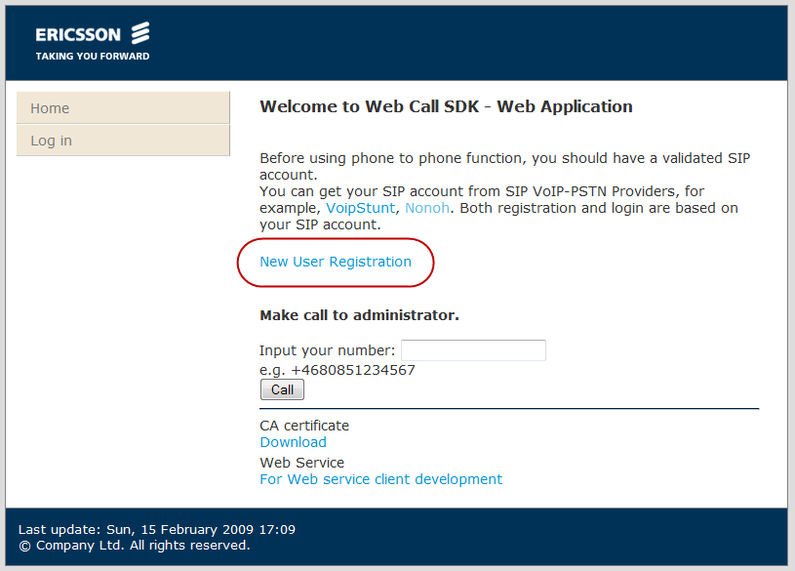
Figure 5 Welcome page of desktop browser view.

User panel
The user profile information menu is shown in Figure 6. User can edit his phone number, contact book, password, VoIP provider accounts and recent calls log.
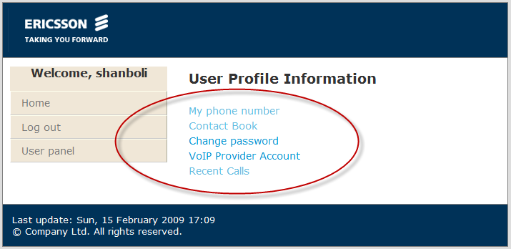
Figure 6 User Profile

VoIP provider account
To make a VoIP call, the user must have a VoIP Provider Account first. Figure 7 shows how to register a VoIP provider account. To get the view of adding VoIP provider account, user should go to user panel -> User Profile Information -> VoIP Provider Account -> add new VoIP provider account.
Follow the example in Figure 7 and input the VoIP account information. The outbound proxy should in a format of SIP_PROVIDER_URL:PORT_NUMBER. If no port number specified, the port 5060 will be used as defined in RFC3261 [1].
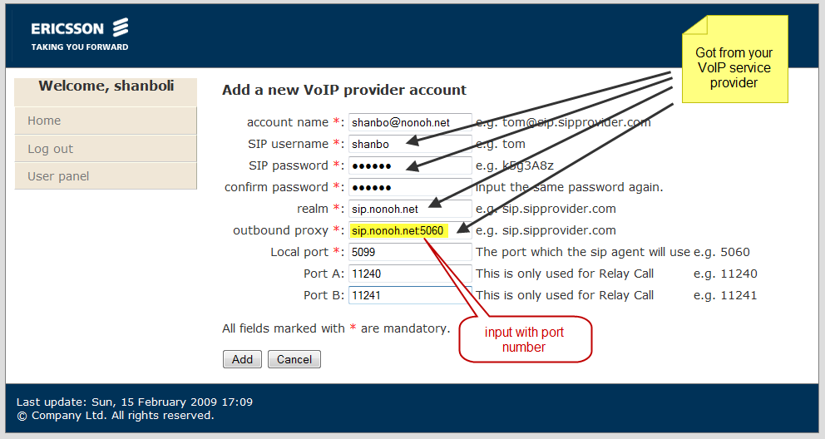
Figure 7 Register VoIP provider account
Web Call Example Application supports multi-account. This means as a user, you can have more than one account and choose a cheaper one when you make VoIP calls.

Click-to-Call Service
"Click-to-call" service allows users to dial a phone number, and directly talk with an administrator or a customer service reprehensive of an entity.
Both registered user and anonymous can access this service.
1. Navigate to the main page. You will see a form: make call to administrator
2. Input your phone number, and click the call button, see Error: Reference source not found.
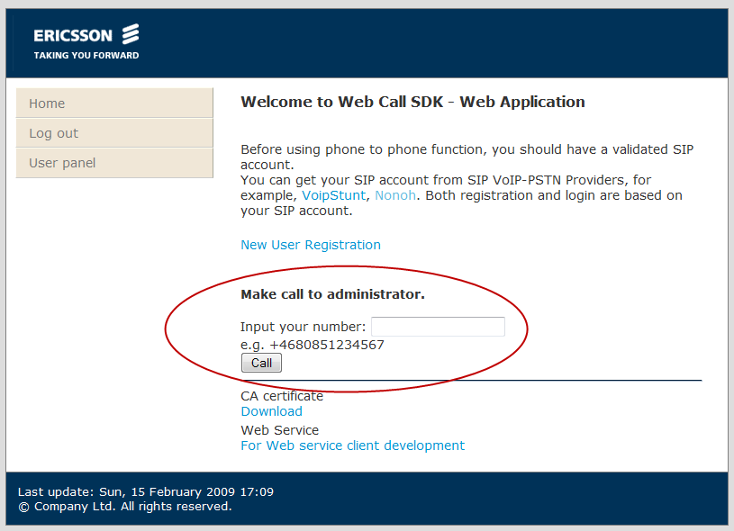
Figure 8 Click to call use case
3. Then the web application will try to setup the phone-to-phone connection between the user and the administration.

The VoIP account that used to call the administrator could be setup in web.xml. For the configuration of click to call service, refer to section 2.2.5 Configure

Phone-to-Phone call
The integrated web application offers phone-to-phone function for registered users.
1. Figure 9 is the user panel. You can either go to user profile Information page or the phone-to-phone dialing page. To make VoIP calls, the user just need click the link of Phone to phone call.
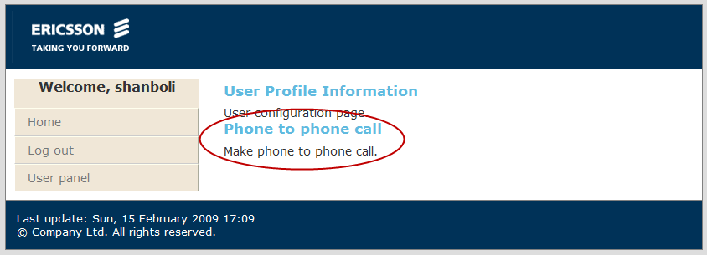
Figure 9 User panel
2. In the phone-to-phone dialing page, you can input your own number, or use the default numbers, which is set in “my phone number” of user profiles information. And input the destination phone number, or select from recent calls or the contact list. The client number could either be SIP address or a complete phone number. If you have more than one VoIP provider account, you can use the drop down list of VoIP provider account and choose an account as you wish. Different VoIP service provider may supply different rate for different destination. So the multi-account function can help user save money by choosing a cheapest provider. The view of phone to phone call is shown in Figure 10. This page uses the technology of Ajax to dynamically show the information of VoIP account.
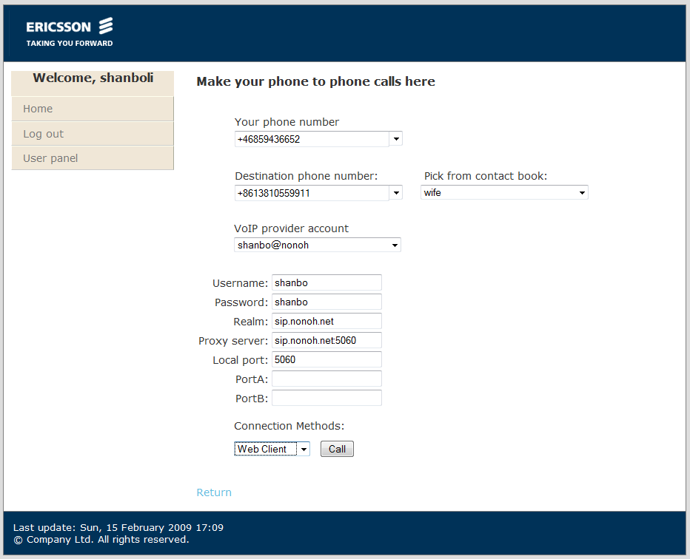
Figure 10 view of phone to phone call
3. The connection methods. There are five different implementations of connection methods. These are Relay Call, Call transfer, Re-invite, SDP swap and Web client. The last four methods are so called third party call control (3PCC) [2]. The differences of connection methods will be discussed in section 4 Design description. It is recommend that by default user use the method of Web client.
4. Then your request is being processed. The page will direct to the calling stage page.

User/Administrator management
The functionalities concerning user profile management include all of user relevant information.
Figure 11 is the user list page. The administrator can use the button of edit to change the user information as well as user roles.
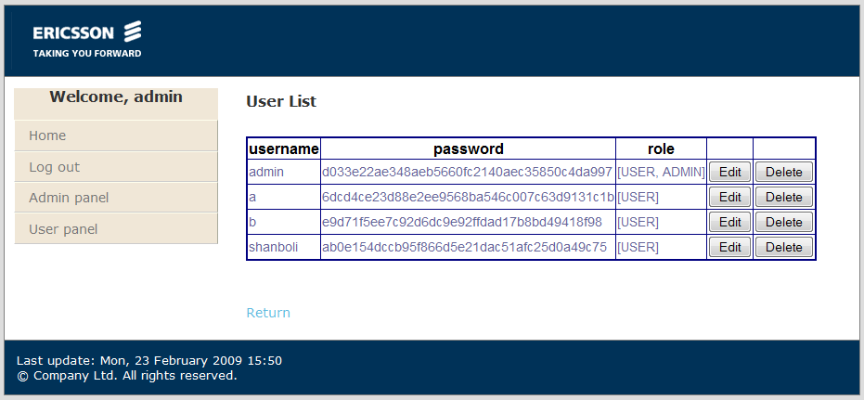
Figure 11 User list
Figure 12 shows the administrator view of user info. The administrator can update user’s basic info, e.g. password and roles. Or administrator client “show” button in the SIP relevant info section and change SIP relevant information, such as user’s phone number, user’s contact list and user’s VoIP account info.
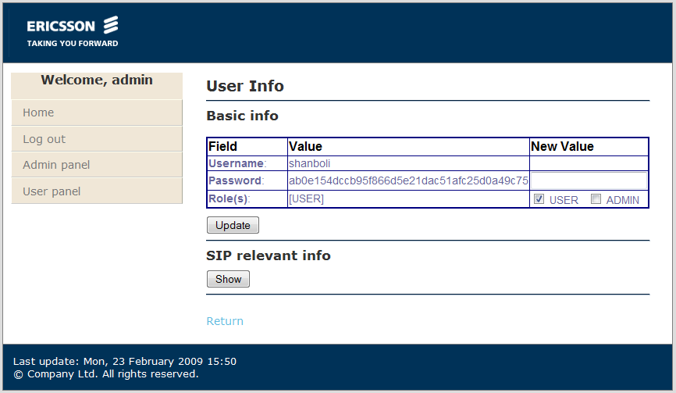
Figure 12 administrator view of user info

Mobile browser view demonstration
Users can also visit the XHTML-MP version of the web application to access the same functionalities as desktop browser view. The working flow is exactly the same as described in section 3.2 Desktop browser view demonstration.
In addition, there is a function of download Java ME client on the mobile browser view.
1. If user visit the web application via a browser on a mobile device, the application will response the mobile browser view to user, shown in Figure 13.
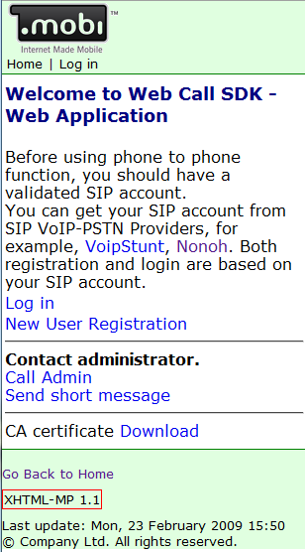
Figure 13 Welcome page of mobile browser view
2. After login, go to the user profile page, you will see “Download your JAD file”, as shown in Error: Reference source not found. Click the link to download and install the Java ME client.
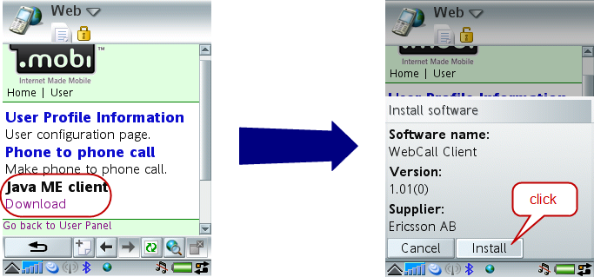
Figure 14 Download and install Java ME client
3. The Java ME application will be downloaded and be installed to your mobile device.

Java ME client application demonstration
After downloading and installing the Java ME client application, you can access the web service by launching the Web Call Client application.
The client application requires the mobile phone support JSR172 – Java ME Web Service Specification. The test has been done with Sony Ericsson P1i and P990i.

VoIP call form
The VoIP call form is the main form in the Java Me client. It is shown in Figure 15. It contains two input items and two drop down lists. In the “Your Phone Number” field, just input your phone number. And input the destination number in the field of “Destination number”. These two numbers are just like the two clients in the 3PCC [2] . And the Web Call Example Application will try to establish a session between you and your target. The VoIP provider is used to choose a VoIP account that you wish to use. The items in the dropdown list of VoIP provider is get from the server side. See how to configure the VoIP provider account, please refer to section 3.2.3 VoIP provider account. Below that, there is a drop down list to choose call methods. There are five different methods to use. They have similar effects but not the same with of establishing connection. See section 3.4.2 Call method.
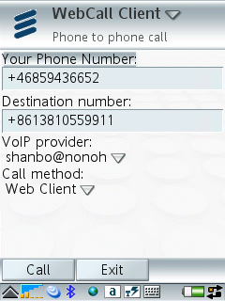
Figure 15 VoIP call form of Java ME client

Call method
The call methods here are exactly same as described in section 3.2.5 Phone-to-Phone call. The differences of connection methods will be discussed in section 4 Design description. It is recommend that by default user use the method of Web client. The Java ME client use the RMS (Record Management System) to store the last call method that user selected. When the Java ME client starts again, it will read the record from RMS and automatically set call method as the same as last time used.
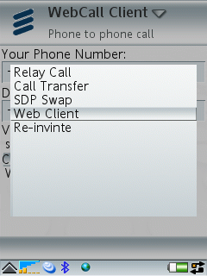
Figure 16 Call method of Java ME client

VoIP call form menu
On the VoIP call form menu, there are five items, PIM Contacts, My phone number, Contacts, Recent Call and Sync as shown in Figure 17.
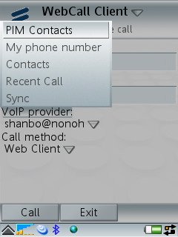
Figure 17 Call form menu of Java ME client

PIM contacts
PIM contacts supplies feature of reading contacts from Personal Information Management (PIM) data from cell phone. It uses JSR 75: PDA Optional Packages for the J2METM Platform [13] to accessing PIM data. Before load the contacts from your cell phone, there will be popup window to ask you if you want the application to read your contacts list. After that you can see your contacts book in your phone and choose one of them as your destination number. In the view of “Contacts Book in phone” there is also another command to save your contacts in contact book of web application.
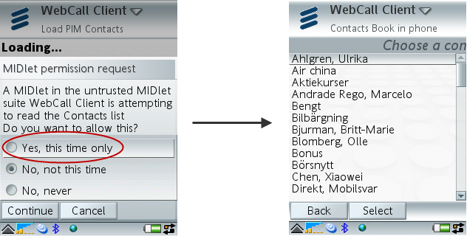
Figure 18 PIM contacts of Java ME client
Note, only the mobile which support JSR 75 can use this function.

My phone number
My phone number is the phone number you wish to call from. It could your current phone or a landline phone. You can have more than one phone number saved in the database of server side.
Click one of “my phone number”, the number will be set as your phone number in the phone to phone call form.

Contacts
The contacts here refer to the contacts book in the web application. It is not same as the PIM contact book. However, you can save contacts from contacts book in phone to contacts book in web application. The number of selected contact will be set as destination number. The view of Contact list is shown in Figure 19.
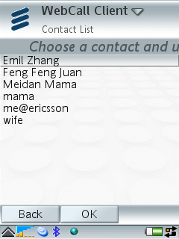
Figure 19 Contact list of Java ME client

Synchronize
The synchronize function in phone call form is used to synchronize VoIP provider account and contacts. If same name with different phone number happens, the number in client will be kept. The synchronize function is shown in Figure 20.
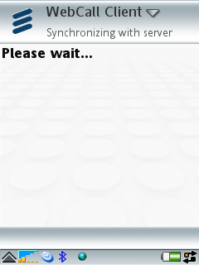
Figure 20 Synchronize with server, Java ME client

Phone call
After the user setup the phone number, destination number, VoIP provider account and Call method, just simply click “Call” button then a session will be established between the user and his friend.
The phone call function in Java ME client is easy and convenient. Every time it restarts, the configuration will be the same as last time he used. It is especially useful when the user always calls the same number. The phone call function is shown in Figure 21.

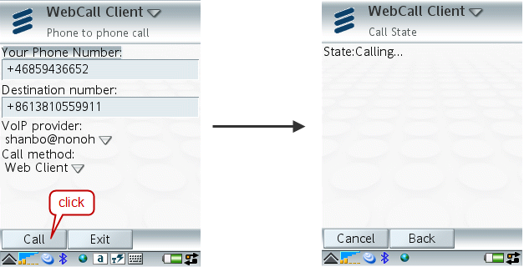
Figure 21 Phone call of Java ME client

Test with SDS
Ericsson Service Development Studio (SDS) is the tool for development and end-to-end testing of both the client and server side of new IMS-based applications. Web Call Example Application has been tested with SDS and PhonerLite SIP client software. This section will demonstrate how to configure the test environment and run the test.

Configure SIP network environment
To setup a simulative IMS Core Network, we need the CSCF(Call Session Control Function) and DNS simulators in SDS. The following steps describe the configuration of SDS for the network environment:
1. Download Ericsson SDS from http://www.ericsson.com/mobilityworld/sub/open/tools.html, install this studio following the installation instruction.
2. Launch the SDS, go to “SDS -> server -> Visual Network” to open the Visual network window, as show in Figure 22.
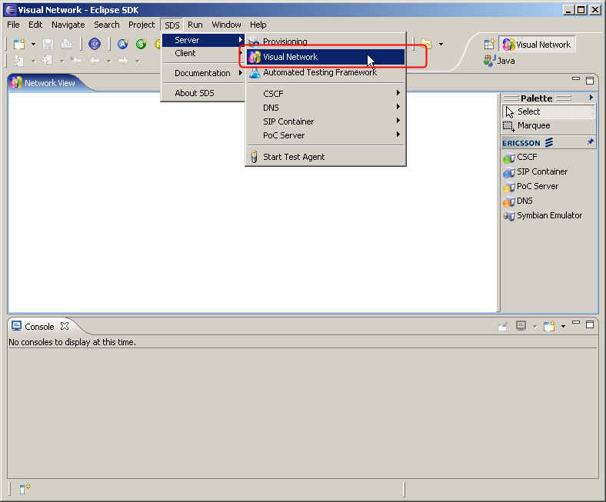
Figure 22 Visual network window in SDS
3. Drag CSCF icon and DNS icon to the blank window from the Palette on the right.
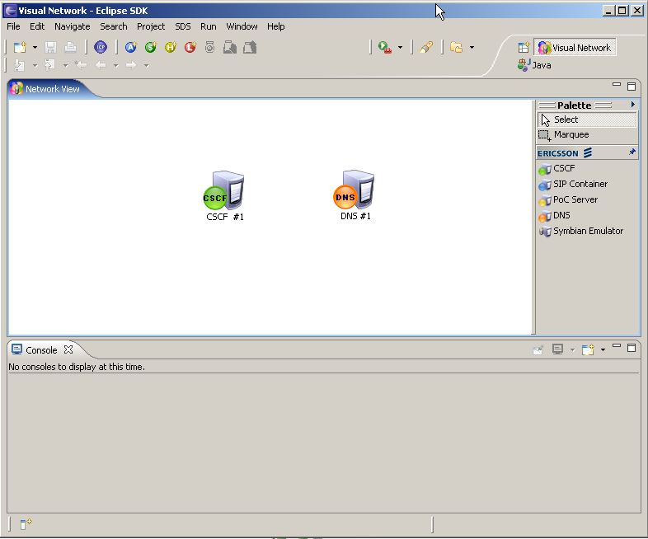
Figure 23 Select elements in visual network
4. Right click the DNS icon, and select “properties” and open the References window for DNS configuration. Then you can configure the DNS properties for your new domain.
5. Click “New”, and add the zone name, e.g. Ericsson.com. According to the documentation in SDS, the port number should use the default value. Click “OK” to confirm the setting. See example in Figure 24.
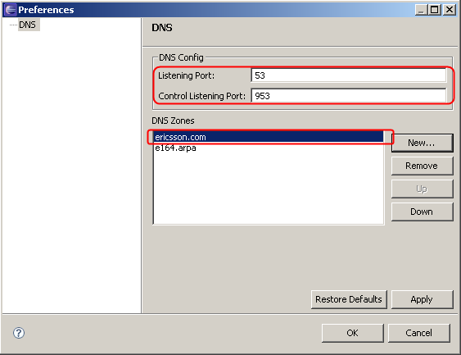
Figure 24 Configure DNS server
6. Right click the DNS icon, and select “start” to run the DNS emulator.
7. Right click the CSCF icon, and select “properties” and open the References window for CSCF configuration. Then you can configure the CSCF properties for your new domain.
8. Click “CSCF” tag in the left window, you will see the configuration properties on the right. Input you domain name, and DNS server address as shown in Figure 25. The DNS host should input the public IP address. See the developer documentation of SDS for more configuration information.
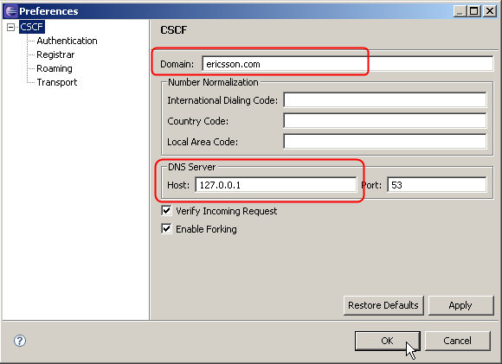
Figure 25 Configure CSCF server

9. In the CSCF Reference, click the “Transport” on the left, configure the S-CSCF and P-CSCF properties. Public addresses are preferred here according to the SDS developer documentation. Leave the “Listening port” to be the default value “5081”.
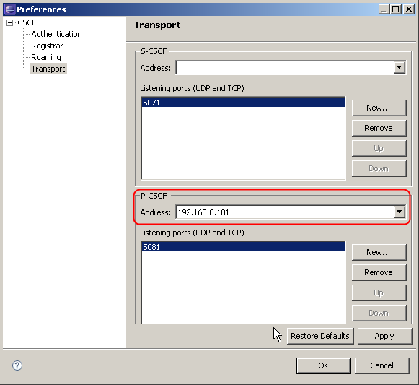
Figure 26 Configure P-CSCF server
10. Click “OK” to save the configuration. Then right click the “CSCF” icon, select “start” to run the CSCF simulator.
After these configurations, a simulative SIP network has been setup for the test environment.

Prepare SIP Client Endpoint
In this test, we used PhonerLite as the SIP client software. Download PhonerLite from http://www.phonerlite.de/download_en.htm and install it following the install wizard.
Then we need to configure the SIP account information in PhonerLite for the test with the SIP network environment that is configured with SDS.
1. Launch PhonerLite client, select “options -> configuration”. Then switch to “server” in the configuration menu, input the parameters that are defined in SDS. See Figure 27.
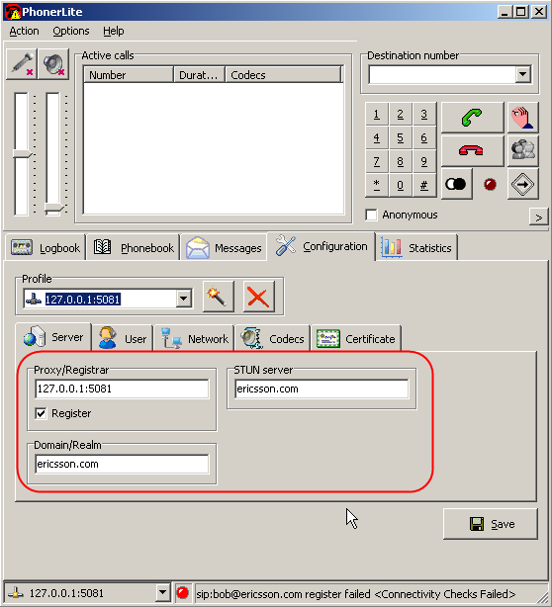
Figure 27 Configure PhonerLite (1)
2. Go to the user tag, and configure the SIP user information as shown in Figure 28. Since the CSCF server does not set the requirement for authorization, so the username and password could be anonymous.
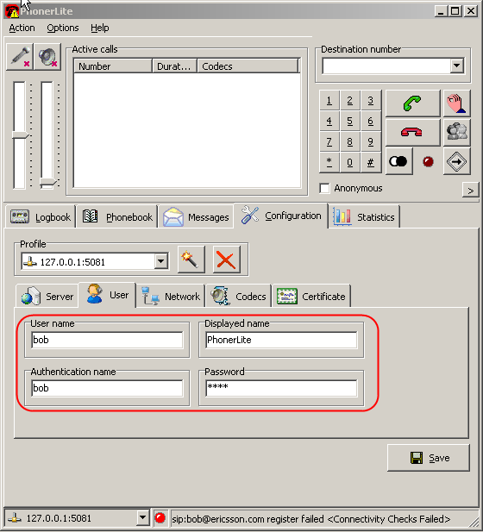
Figure 28 Configure PhonerLite (2)
3. Save the configurations, and the PhonerLite will start registration to CSCF server.
Phone-to-Phone test require two instances of SIP clients, so you can also setup another PhonerLite instance on another computer.

Test Web Call Example Application
Before made the test, please make sure there are at least three users in SDS, a, b, and c. For how to create users in SDS please refer the manual of SDS. Register a and b to SDS. In the web application, add a new VoIP provider account as shown in Figure 29. Then you can make a VoIP call test between two clients by using the phone-to-phone call function in Web Call Example Application. As shown in Figure 30.
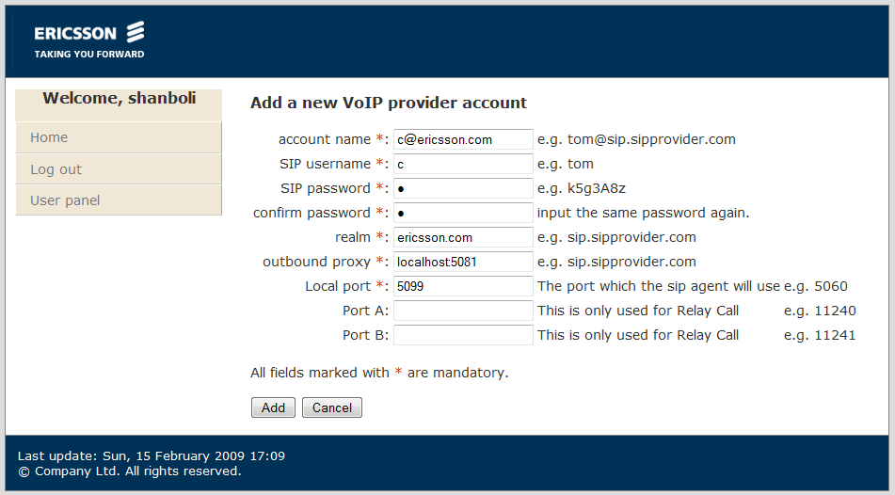
Figure 29 register a new VoIP provider account
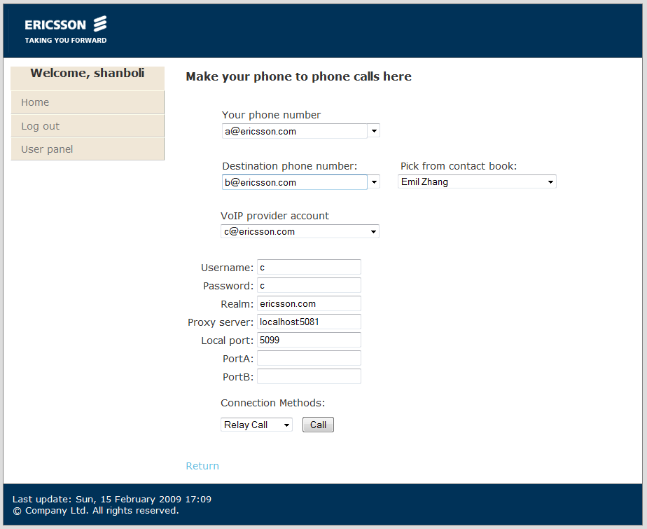
Figure 30 make a phone call test

Design description
This chapter presents a detailed solution description of Web Call Example application. The design architecture is shown in Figure 31.
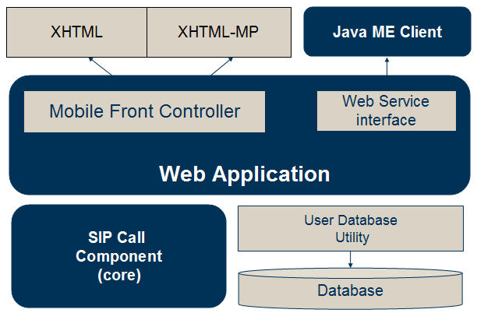
Figure 31 Design Architecture
Web Call Example Application contains three components which are SIP Call Component, Web Application and Java ME client.
Sip control Component is an SIP User Agent Client (UAC) side application in a SIP network. It implemented a relay call controller and a third party call controller. It provides high level API, so it is very convenient for developers to use and extend.
The Web Application is built on the Architecture of Mobile Front Controller. SIP Call Component integrated into the web server as Java EE components: servlet, and web service. The Mobile Front Controller is used for detecting and selecting views, i.e. applications with views for desktop and mobile browsers. So Web Call Example Application supplies both XHTML view which used by desktop browser and XHTML-MP view which used by mobile browser. The web service interface in web application supplies a common interface for using sip call function. Java ME client is one client of web service interface. The web service interface shares the same user database with mobile front controller based browser view.
The Java ME Client is a client to access the web service residing in the Integrated Web Application. It could be installed Over-the-Air (OTA). With OTA deployment, the MIDlet (Java ME application) is installed on a Web server and then downloaded to a device via the device's mobile browser.

SIP Call Component
The SIP Call Component is the core of Web Call Example Application. The design architecture of it is shown in Figure 32.
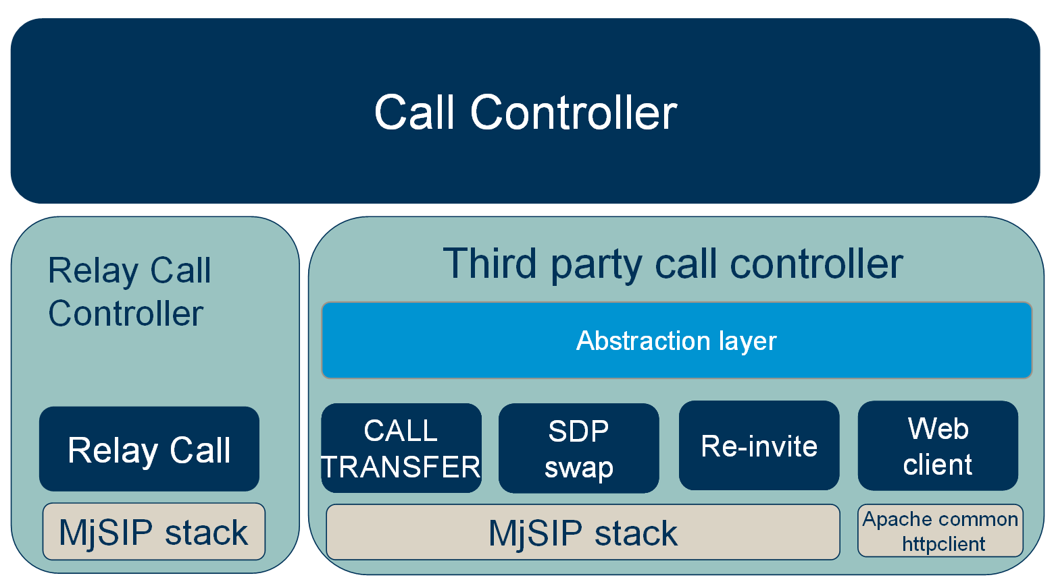
Figure 32 The design architecture of SIP Call Component
The Call Controller is an interface which supplies setters and getters for SIP call’s parameters. It also contains methods for establishing and closing connections. Relay Call Controller and Third party call controller are two implements of Call Controller.

Relay Call and Third Party Call
The Relay Call Controller works as a back-to-back agent and forwards media streams, while Third Party Call Controller only establishes connections by sending off SIP messages and it doesn’t handles any streams itself.

Relay Call
The signal and media flow of Relay Call is shown in Figure 33. In this scenario, the Web Call Example Application acts as a back-to-back user agent. It sets up the connection and forwards the media stream. It can be seen from the picture that both signal and media are handled by Web Call Server. When it starts, it try to call client A. After it establishes a session with client A, it will try to call client B and also establish a session with client B. After that, it will work as a media stream bridge and forward media stream from client A to B, as well as from client B to A.
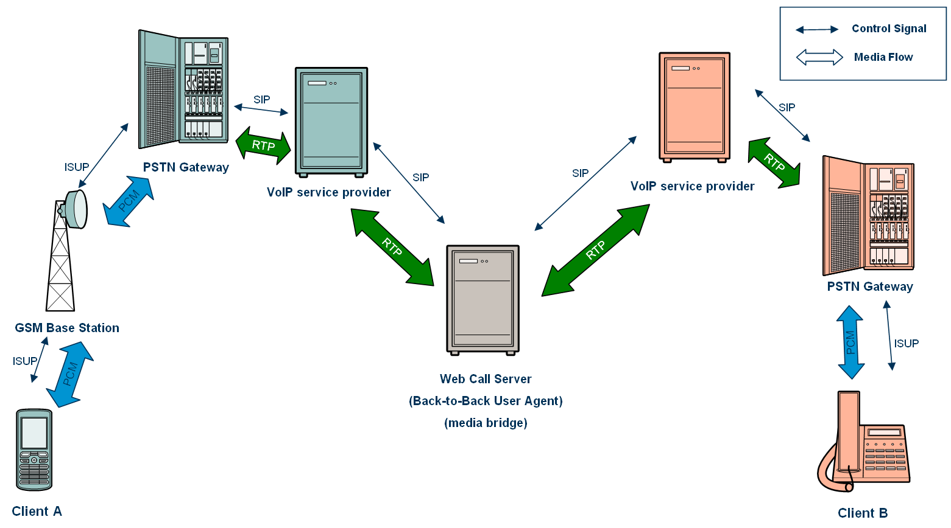
Figure 33 The signal and media flow of Relay Call

Third Party Call
In the traditional telephony context, third party call control allows one entity (which we call the controller) to set up and manage a communications relationship between two or more other parties. Third Party call control (referred as 3pcc) is often used for operator services (where an operator creates a call that connects two participants together) and for conferencing. [2] The signal and media flow in third party call is show in . The advantage of third party call in Web Call is that the controller only need to handle message transfer and leaves the media flow for the ISP.
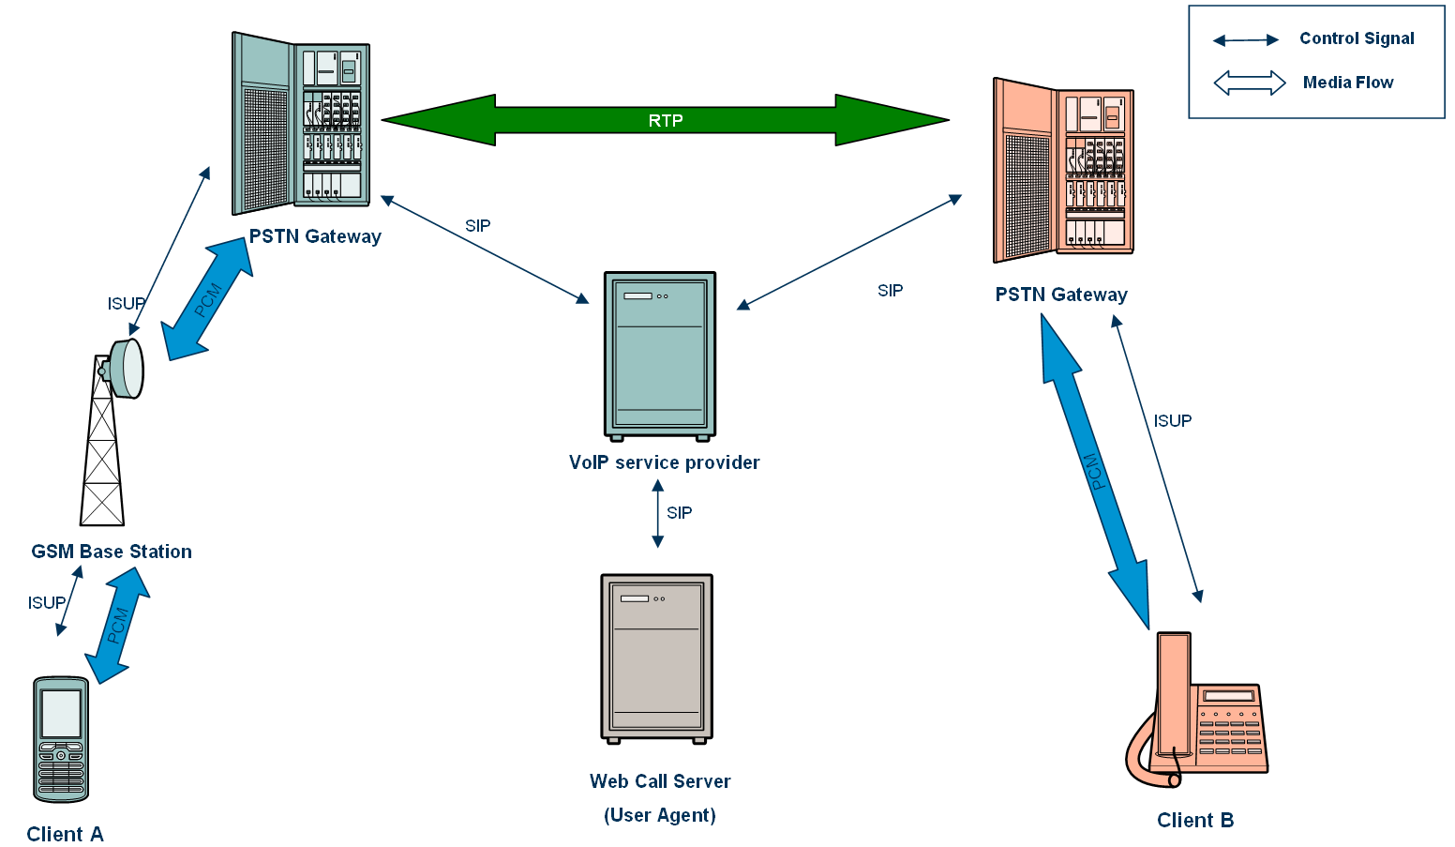

Relay Call Controller
Relay Call Controller is one implement of Call Controller. It is an SIP User Agent Client (UAC) side application in a SIP network. It uses the MjSip v1.6 toolkit as the lower level SIP stack, and implemented a phone-to-phone session control and RTP proxies.
③ RTP
① Bean
② Session
SIP Controller
SIP Controller Listener
Register Agent
Session Control
User
Account
Clients
Status
RTP Proxy
RTP Marker
Ring Tone
RTP Forward
RTP Convert
SIP Stack
System Configuration
SIP account
Client information
Subscribers

Figure 34 Design architecture of SIPComponent
As shown in , the Sip control component consists of three modules:
- SIP controller Bean
- SIP registration & session control
- RTP proxy.
SIP Controller is a Java Bean class. It consists of a constructor, several getters and setters and some business logic operations. The constructor takes key system parameters, e.g. ring tone media file, log file, port number. User can also use other setter functions to add more system parameters. After configuring the SIP account parameters and client parameters, the SIP Controller calls business logic functions to setup sessions.
SIP registration module received account parameters from SIP Controller, it create a Register Agent to handle the registration functions. Session Control module is in charge of creating, modifying, and terminating sessions with participants. Moreover, the session control also handles the coordination between different sessions. The control flow charts are in 4.3.1 - Session Control Call Flows.
The media communications are done over RTP proxy. It provides an interface of media packet proxy. Four concrete sub-proxies have been implemented: RTP marker, RTP ring tone, RTP forward, and RTP convert. The Marker is usually sent in the beginning of the RTP transfer, acting as the starting signal of the upcoming RTP packet stream. The RTP ring tone proxy is actually a ring tone sender, the ring tone media file could be customized by user. RTP forward proxy and convert proxy are handling the exchanging of RTP packets. The convert proxy is called when the participants have different media coding formats, e.g. PCMU–PCMA converting.
The session control and RTP proxy are related by the status of the clients. Session control updates the client status and notifies the proxy. This is a typical observer design pattern, which will be described in section 4.3.2 - Internal design outlines.

Session Control Call Flows
As mentioned before, the session control module handles the SIP session initiation and the coordination between sessions. Due to the time limitation, SIP control component only implemented the phone-to-phone SIP call function. Thus, the primary primitive operation of Sip control component is establishment of session between endpoints A and B. Establishment of this session is orchestrated by a third party, SIP controller.
This section documents three call flows that presents the typical three different use cases of SIP controller in a phone-to-phone logic environment.
Flow 1 - Normal case
Client A
Controller
Client B
INVITE
200 OK
ACK
INVITE
RTP ring tone
200 OK
ACK
RTP Forward
/ RTP Convert
RTP Forward
/ RTP Convert
BYE
200 OK
BYE
200 OK
ACK
ACK
Figure 35 Flow – normal case
The basic case flow is shown in Figure 35. The controller first sends an INVITE to A. A's phone rings, and A answers. This results in a 200 OK that is sent to session initiator, controller. The controller needs to send the ACK. This part is the typical SIP session setup steps.
After the session between controller and client A has been established, controller starts to send ring tone to client A, indicating that it is waiting for B to answer the phone.
Once the controller receives a 200 OK from client A, it start another session initiation with client B by sending INVITE to B.
After B answers the phone, controller receives 200 OK from client B. It will stop sending ring tone to A, and start RTP packets proxy between A and B.
Flow 2 - Cancel case
Client A
Controller
Client B
INVITE
200 OK
ACK
INVITE
RTP ring tone
BYE
200 OK
CANCEL
ACK
ACK
RINGING
487 Request Terminated
200OK
Figure 36 Flow – cancel case
In the Cancel case, the session initiation with client A is the same as normal case. While controller is waiting for client B to answer the phone, client A hangs up the phone. This results in a BYE to the controller. On receiving the BYE message, controller stops sending ring tone to A, and sends a CANCEL to B.
The CANCEL request is used to cancel the INVITE request sent by the controller.
When a SIP server receives a CANCEL request for an INVITE, but has not yet sent 200OK, would stop sending RING, and then respond to the INVITE with a specific error response – 487 Request terminated.
Flow 3 – Rejection case
Client A
Controller
Client B
INVITE
200 OK
ACK
INVITE
RTP ring tone
4XX
ACK
BYE
200 OK
Figure 37 Flow – rejection case
In the rejection case, the session initiation with client A is the same as normal case. While controller is waiting for client B to answer the phone, it receives a 4xx message from B, for example, 486 Busy Here or 404 Not Found. At this situation, the controller will send an ACK to client B, stop sending the ring tone, and try to terminate the session with client A by sending a BYE message.

Internal design outlines
With the goal of Light-weight, Extendibility and Flexibility, the SIP control component design features several important design patterns. This section describes the key design outlines of the component.
SIP controller - Java bean
On the top of the design architecture is a Java bean, SipControllerBean, providing the highest level API to users. Figure 38 is the sequence diagram of the SipController and related modules.
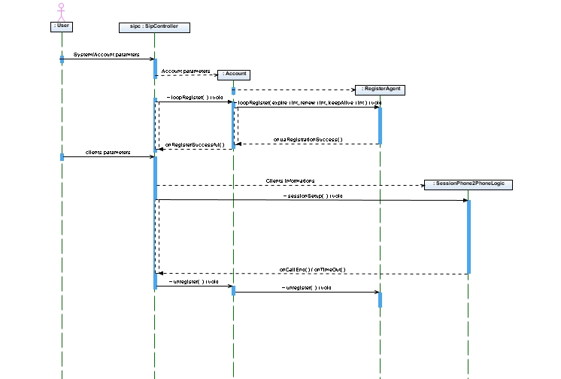
Figure 38 Sequence diagram of SIPController
On receiving the system parameters and SIP account parameters from actor, it creates an Account instance to handle the account related properties and operations. When a register function is called, the account will create a RegisterAgent instance, managing the SIP registration operations.
After the successfully registration, the SipController calls the session logic handler-SessionPhone2PhoneLogic to setup session between clients. The client parameters are set with the setter functions in controller bean.
At the end of the session, the session logic handler inform SipController about the ending status. Then the controller would perform the un-registration operation via Account and Register Agent.
The structure of SipControllerBean:
- Constructor for essential system parameters.
- Getters and setters for SIP account parameters
- Setters for other system parameters.
For example, setParam(“retransmission_time=3600”). This method is to set the MjSIP UA configurations, please refer to MjSIP toolkit documents.
- Business logic functions: registration, un-registration, session setup, etc.
The example ExampleMain.java located in com.ericsson.sipc.test package shows how to use the API in SipControllerBean. Please refer to the source code for more details.

Session logic control – Facade
The session logic control is under the SipController in the architecture of the component. It manages the session establishment and coordination. In this library, SessionInterface provides an interface to developer to implements session control sub-systems. SessionPhone2PhoneLogic is an implementation of phone-to-phone logic control sub-system. Developer can also implement other functionalities, for example, conference management.
Figure 39 is the class diagram of session logic control module. SessionPhone2PhoneLogic represent a sub-system with a set of classes. It is a Facade design pattern. A facade pattern provides a simplified interface to a larger body of code, such as sub system.
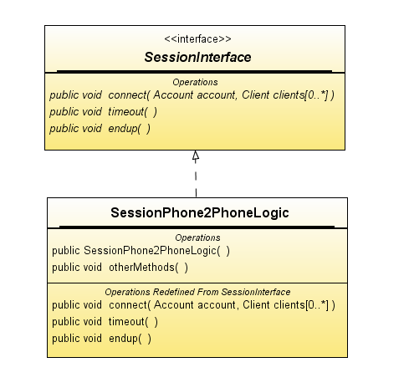
Figure 39 Class diagram - Façade pattern
The advantage of facade pattern is:
- makes a software library easier to use and understand, since the facade has convenient methods for common tasks;
- make code that uses the library more readable, for the same reason;
- reduce dependencies of outside code on the inner workings of a library, since most code uses the facade, thus allowing more flexibility in developing the system;
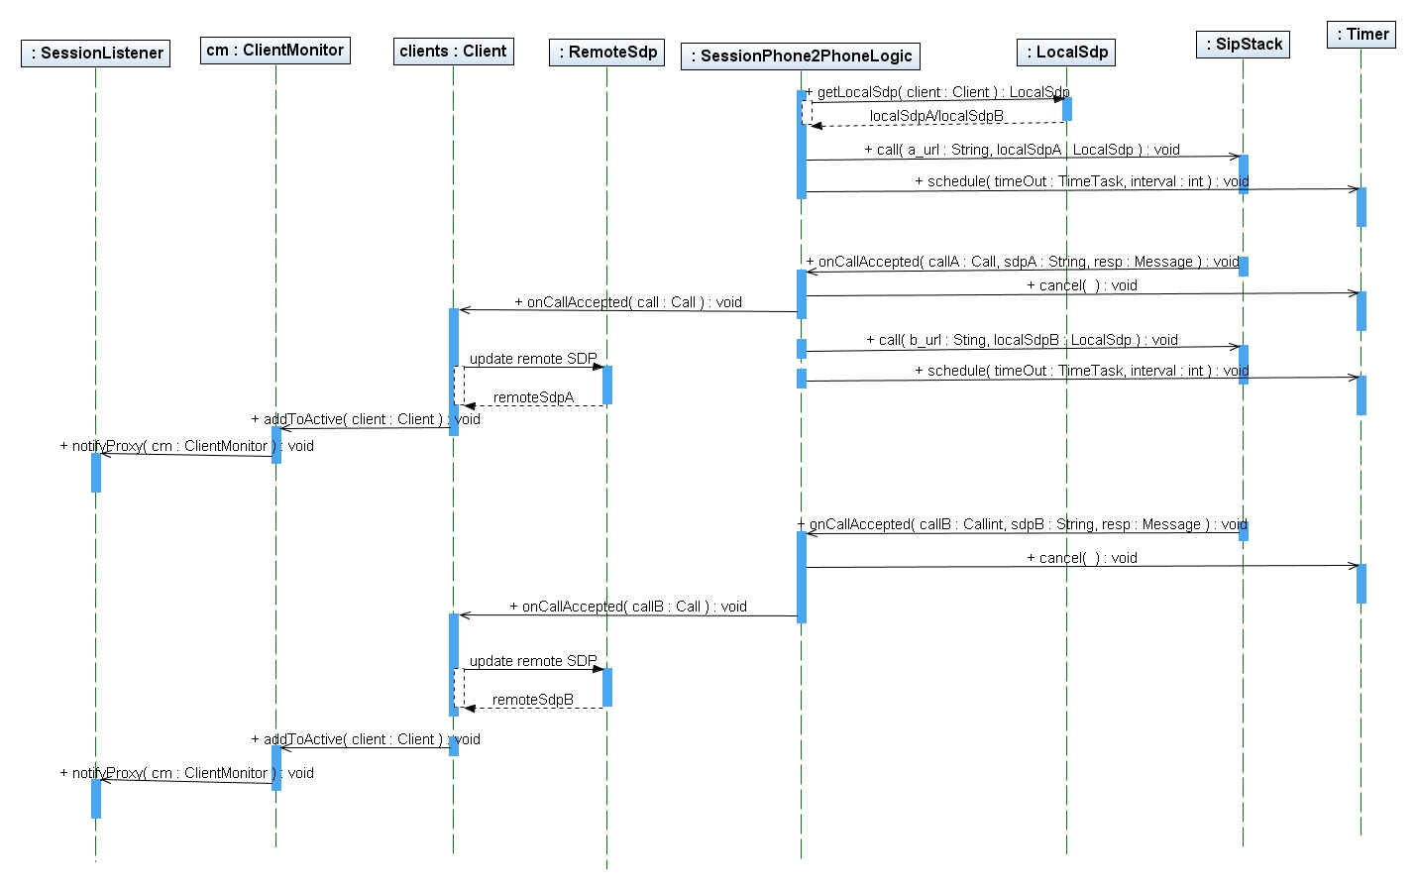
Figure 40 Sequence diagram of session control
Figure 40 shows the sequence diagram inside the session logic control module. This is the normal case, corresponding to session control call flow 1 – Normal case.
SessionPhone2phoneLogic initializes local SDP for each client, and calls SipStack to make the phone calls. The SipStack here represents the open source SIP stack library.
Client updates the remote SDP for each client with the SDP information contained in their responses from endpoints. A Client instance manages the status and data of the client.
ClientMonitor is a monitor, which listening to all the Client instances. It updates the status of the Client pool, and notifies the updating to SessionListener. ClientMonitor is an Observable object in an Observer design pattern, which is related to RTP proxies.
Timer is to handle the timeout situation. The interval value can be configured in SipControllerBean. The default value is 60 seconds. When an INVITE request is sent out, the Timer schedules a Timeout task, which will be canceled if a proper response is received, otherwise, it will call the timeout handling.
PTP proxy – Observer
The implementation of RTP proxy function is a typical Observer design pattern with Change-Manager. Figure 41 shows the structure of the RTP proxy module.
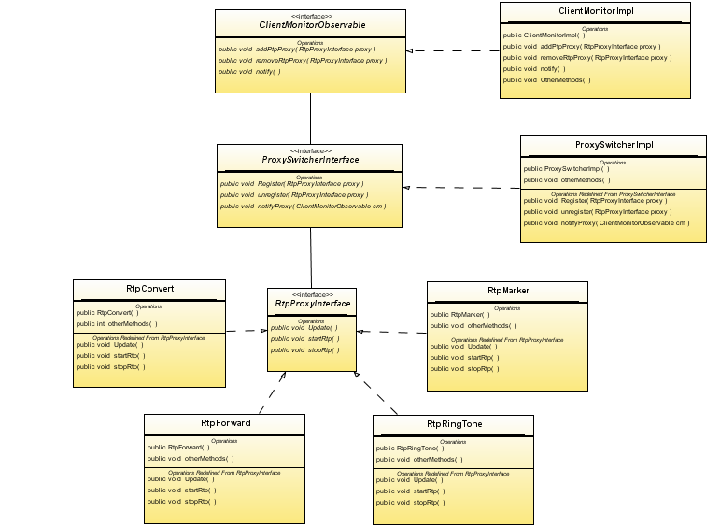
Figure 41 Class diagram – observer pattern
ClientMonitorObservable: Subject role in observer pattern. It monitors the status of the clients, for example, the change of the active client list. The main functions include: addRtpProxy(RtpProxy proxy), removeRtpProxy(RtpProxy proxy), notify() and other client related methods. It is implemented by ClientMonitorImpl.
RtpProxyInterface: Observer role in Observer pattern. It is implemented by four sub–proxies: RtpMarker, RtpRingTone, RtpForward, and RtpConvert. The RTP proxy has observer method – update().
RtpProxySwitcherInterface: Change-Manager. When the dependency relationship between subjects and observers is complex, a Change-Manager is needed to maintain these relationships. In this case, the purpose of the proxy switcher is to minimize the work required to make proxies to several interdependent subjects.
In the proxy module, the proxy switcher has three main responsibilities:
- It maps a subject to its observers and provides an interface to maintain this mapping.
- It defines a complex and particular update strategy.
- It updates all dependent observers at the request of a subject.
For example, in the phone2phone logic, when the status of client updated from one active client to two active client, the client monitor notify switcher about this change. The switcher then decides to stop RtpRingtone Proxy, and start either RtpForward or RtpConvert according to the client media format.
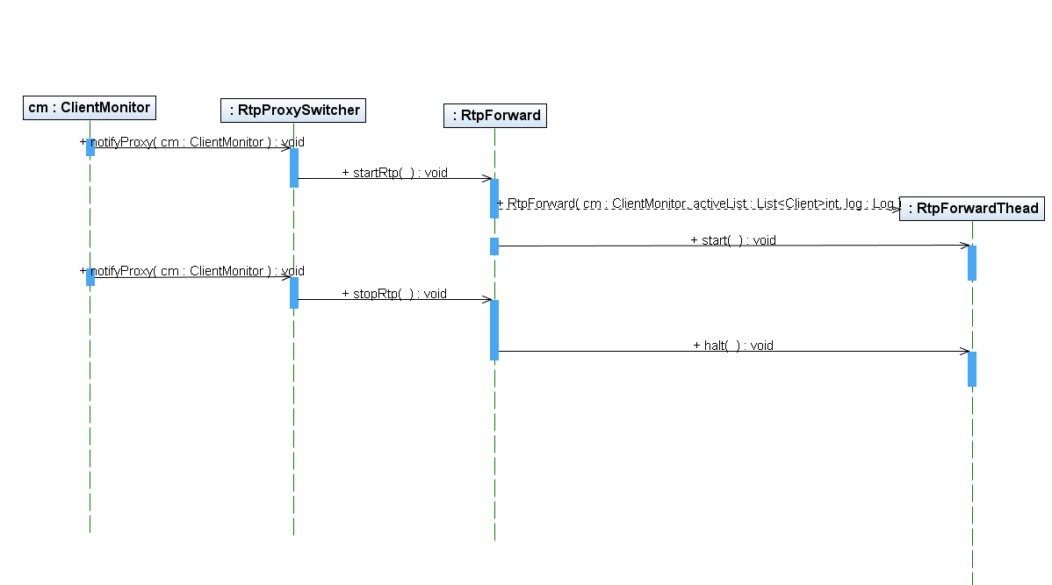
Figure 42 Sequence diagram of RTP proxy
Figure 42 is the sequence diagram of RTP proxy module. RTP forward is used as an example in this figure. When ClientMonitor notify RtpProxySwitcher the updating information from clients, it will rearrange the proxy controlling and decide whether start or stop the sub-proxies. When a RtpForward proxy is started, it will create one or more RtpForwardThread and start running them. When the stopRtp() function is called, the RtpForward proxy will halt() the running threads.
Each thread is a one-to-many distributing model:
- One receiver: one RTP socket receives all the incoming RTP packets
- Many senders: multiple RTP sockets send out the packets that are received by receiver.
- Each RTP socket corresponds to one DatagramSocket, which is connected with the remote socket address.

Third Party Call Controller
The Third Party Call Controller is another implementation of Call Controller. Third Party Call (3PCC) allows one entity (which we call the controller) to set up and manage a communications relationship between two or more other parties [1]. When the session has been setup, the media communications are transfers peer to peer between parties. Thus, the controller is very functional and light-weighted.

Five layers architecture
A five layers architecture has to be introduced before illustrate the Third Party Call Controller. The five layers architecture is shown in Figure 43.
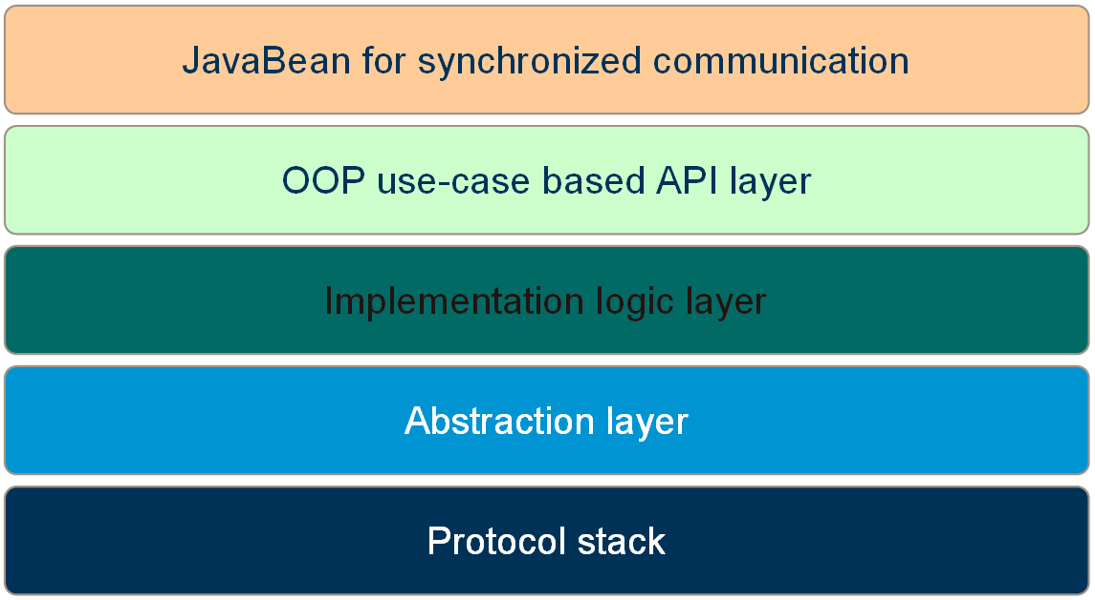
Figure 43 Five layers architecture
From bottom to top, the five layers are Protocol stack, Abstraction layer, Implementation layer, OOP use-case based API layer and JavaBean for synchronized communication.
Protocol stack:
The protocol stack is the low level API for the project. There could be several implementations of the protocol stack.
Abstraction layer:
This layer is used for abstracting low level protocol stack. So the project can be easily migrated from one protocol stack to another without modifying the logic layer.
Implementation logic layer:
This layer contains the main logic of the project.
OOP use-case Based API Layer:
This layer is used for exposing public API for end user. Design Patterns such as Abstract Factory Pattern can be used here, especially for java SE.
JavaBean for synchronized communication:
Components in Java are called beans. This layer contains
The JavaBean which special designed for synchronized communication has two pairs of constructor and business logic group. The constructor which has system parameters works with business logic which doesn’t have system parameters. The constructor which doesn’t have system parameters works with business logic which has system parameters. In addition, this kind of JavaBean only has method of getState()and no method of setState()

Architecture of Third Party Call Controller
The architecture of third party call controller is shown in
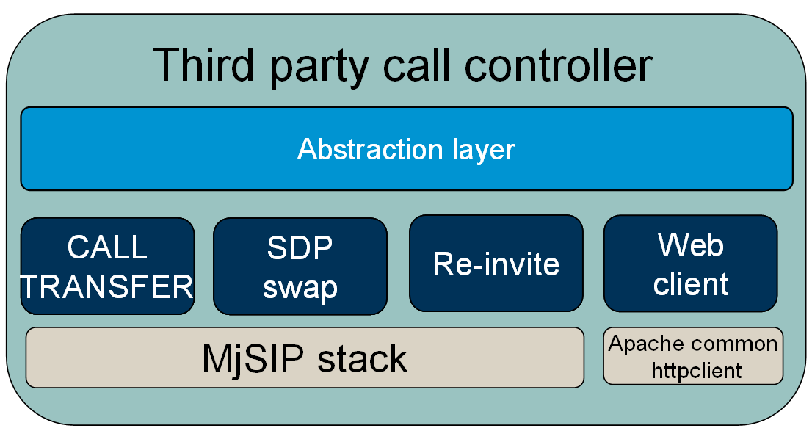
Figure 44 Architecture of Third Party Call Controller
There are four implementations of 3PCC in the example application. All of them implemented the interface in abstraction layer. Among them, Call Transfer, SDP Swap and Re-invite are based on MjSIP [3]. The Web client implementation is based on Scallope [4], a project which acts as a web client logins to sip provider's web page to makes phone calls. According to the five layers architecture, there is an abstraction layer on top of these implementations. So the protocol of Web Call Example Application can easy switch to one of them. It can be seen from the UI of the example application.

Call transfer implementation of third party call control
The call transfer implementation use a REFER method which defined in RFC3515 The Session Initiation Protocol (SIP) Refer Method [5]. The REFER method indicates that the recipient (identified by the Request-URI) should contact a third party using the contact information provided in the request [5]. 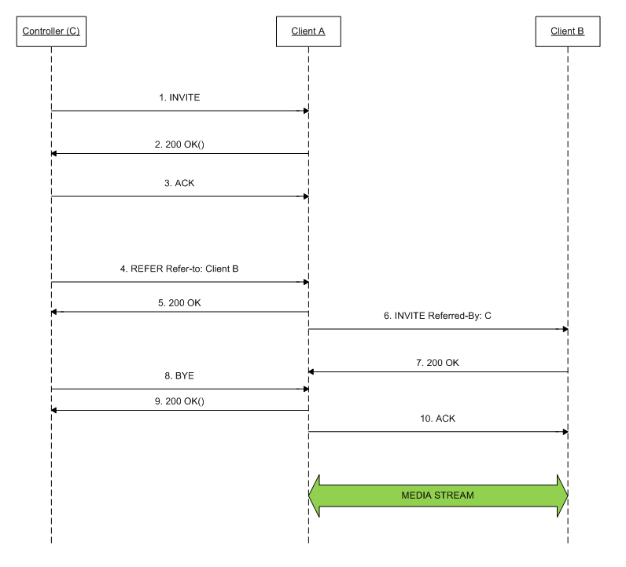

Figure 45 Call flow of call transfer implementation of third party call control
The Call flow is shown in Figure 45. The controller first sends an INVITE to client A (1). This invite is just a normal invite. A’s phone rings and answers. This results in a 200 OK (2). The controller then answer client A an ACK (3). Follow that, the controller send out a REFER refer-to: Client B (4), which means controller wish client A to make a phone call to client B. The client A understands that and returns a 200 OK to controller (5). Then client A sends an INVITE referred-By: C to client B (6). Client A and Client B can establish a session according the INVITE from A to B. The BYE (8) and 200 OK (9) means the controller cut the media stream between itself and client A.
To accomplish the whole call flow, client A must support RFC 3515 [5].

SDP swap implementation of third party call control
This implementation of third party call control swaps SDP from two clients. The prototype of SDP swap comes from RFC 3725 Best Current Practices for Third Party Call Control (3pcc) in the Session Initiation Protocol (SIP) [1]. However, the call flow in RFC 3725 is quite complicate. The concept of SDP is that controller calls to client and swaps two SDP which got from clients. These two clients seem to call controller but the media stream is connected between them.
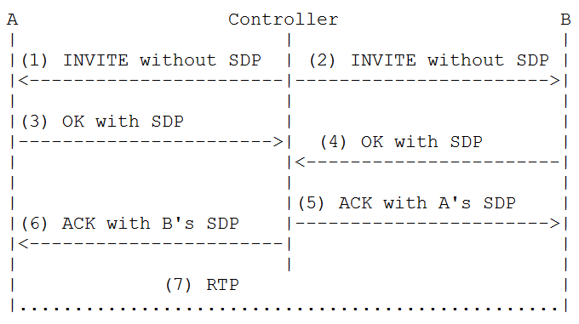
Figure 46 Call flow of SDP swap implementation of third party call control
The call flow of SDP swap implementation of third party call control is shown in Figure 46. Controller first call client A. This INVITE has no session description. Client A’s phone rings, and client A answers. It results a 200 OK (3) that contains an offer which contains client A’s SDP [1] . Meanwhile, the controller does the same to client B (2) and gets client B’s offer (4) which contains client B’s SDP. So far, controller has both client A and client B’s SDP. It just simply swaps these two SDP, then ACK client B with client A’s SDP (5) and ACK client A with client B’s SDP (6). So client A gets client B’s SDP by (6) and client B gets client A’s SDP by (5). Therefore, media flows between client A and client B (7).

Re-invite implementation of third party call control
A re-INVITE is used to change the session parameters of an existing or pending call. It uses the same Call-ID, but the CSeq is incremented because it is a new request. The Re-invite implementation send two client’s SDP to each other in the Re-invite process.
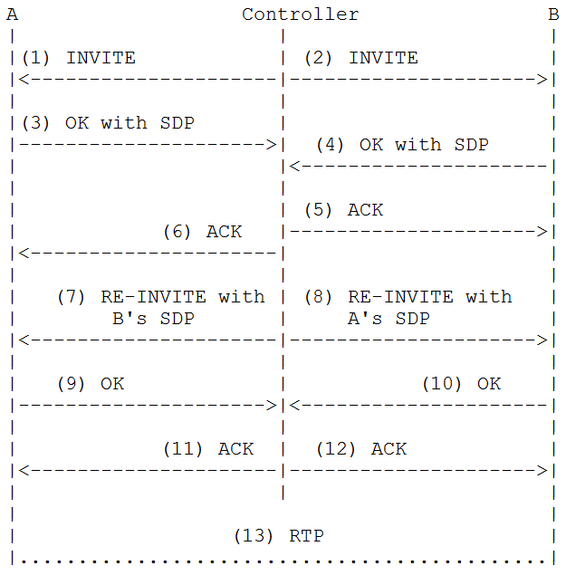
Figure 47 Call flow of Re-invite implementation of third party call control
The call flow is shown in Figure 47. From the SIP message (1) to (6), the controller uses a three way handshake to establish connections with client A and client B. In (3) and (4) the controller gets client A and client B’s SDP which are going to be used in the Re-invite phase in (7) and (8). The controller sends a Re-invite to A with B’s SDP (7), which indicates the controller changes its media port to B’s. At the moment, controller also send a Re-invite to client B with client A’s SDP, which indicates the controller change its media port to A’s. Both client A and client B gets each other’s SDP, thus a media stream could be established between A and B (13).

Web client implementation of third party call control
This implementation does manipulate SIP message. It uses a project named Scallope [4] as the lower level API. It acts as a web client login to sip provider's web page and make phone call. As a result of the abstraction layer, it can be used in the Web Call Example Application.

Conclusion
The Comparison of call methods are shown in Table 2. The PSTN (Public Switched Telephone Network) is the network of the world's public circuit-switched telephone networks. In another word, it is the traditional telephone network includes mobile as well as fixed telephones. The other methods are supported by Web Call Example Application.
 | PSTN | VoIP
 | PSTN | Relay Call | Third Party Call
 | PSTN | Relay Call | Call Transfer | SDP Swap |  | Re-Invite |  | Web Client
service provider | All PSTN switch | support by all VoIP service providers | Not support by all VoIP service providers
service provider | All PSTN switch | support by all VoIP service providers | The ones who support REFER [5] method |  | The ones who do not filter SIP message which doesn’t carry SDP |  | The ones who support  Re-Invite message | The ones who supply web site call
Client | Traditional telephone or mobile phone | All clients (traditional phone, mobile phone, software-client) | Traditional phone, mobile phone, software-client, under particular requirements of software-client / PSTN gateway |  |  |  |  | All clients (traditional phone, mobile phone, software-client)
Client | Traditional telephone or mobile phone |  | Client need support REFER [5] method | Client need implement RFC 3725 [2] |  | Client need support Re-Invite
Media stream | In PSTN network | Internet and/or PSTN, need to be handled on controller | Internet and/or PSTN.
Latency | Very short / QoS guarantee | long | Short, acceptable. But no QoS guarantee.
Fee | High (especially on international call ) | low
Table 2 Compare call method
It can be seen from Table 2, when talk about latency, the best call method is the PSTN way. But it costs a lot for international sessions. The Relay call can be used on any server and client with a low fee. But the latency is long and sometimes unacceptable. The relay call method brings media traffic to the controller so it not possible to have it on a small or personal server. The third party call is not support by all of the services. We have developed four different solutions on third party call. Each of them has its own Cons and Pros. It is recommended that when make an international or long distance call, the web client method should be choose. If it is not possible to use web client method, users can try the other third party call implementations. If none of them works, user can choose either the PSTN which supply a good quality and high cost or the relay call which supply a poor quality but with low price.

Design of the Web Application
The Integrated Web Application is built on the Architecture of Mobile Front Controller. SIP Control Component is integrated into the web server as Java EE components. This section will focus on the solution description of the SIP Call Component, database design and other Java EE design features.

Architecture of Mobile Front Controller
The Web Application is built on Mobile Front Controller. This section gives a brief introduction of the architecture of Mobile Front Controller [7]. The following is an abstract from the documentation of Mobile Front Controller SDK.
Mobile Front Controller (MFC) is a light-weight Java EE web application framework based on design patterns. MFC is used for creating internet web and mobile applications, i.e. applications with views for web browsing and mobile browsing that share UI logic. The framework is easy to use and does not require an XML file for navigation [7].
Figure 48 shows how this solution works.
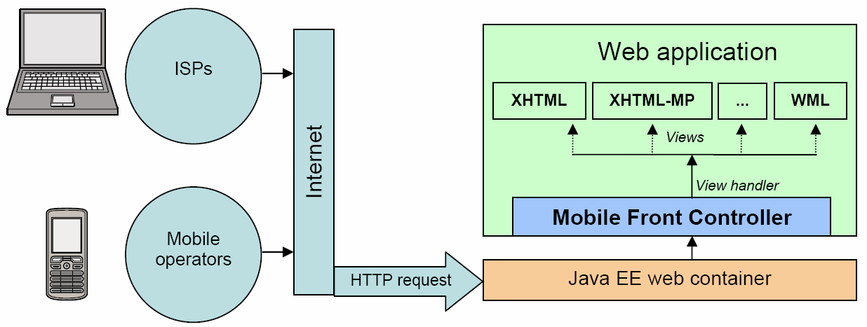
Figure 48 An overview of Mobile Front Controller used by a web application on a Java EE web container.
MFC is used on top of a Java EE web container, and does not require any other framework, such as JSF, Struts, etc.
MFC does the following:
- Detects and selects appropriate views based on HTTP request headers. A view is a subdirectory that, for example, corresponds to a markup language such as XHTML, XHTML Mobile Profile (MP) and WML (see Figure 49[7]). The way MFC detects and selects views is customizable using view handlers.
- Shares UI logic between different views, for example, web and mobile browsing. This is done using action commands, which are classes that contain an execute method that is executed when a URL with, for example, the URL pattern *.do is called (for example http://localhost:8080/mfc-basic-demo/xhtml/Print.do).
The architecture of mobile front controller is shown in Figure 49
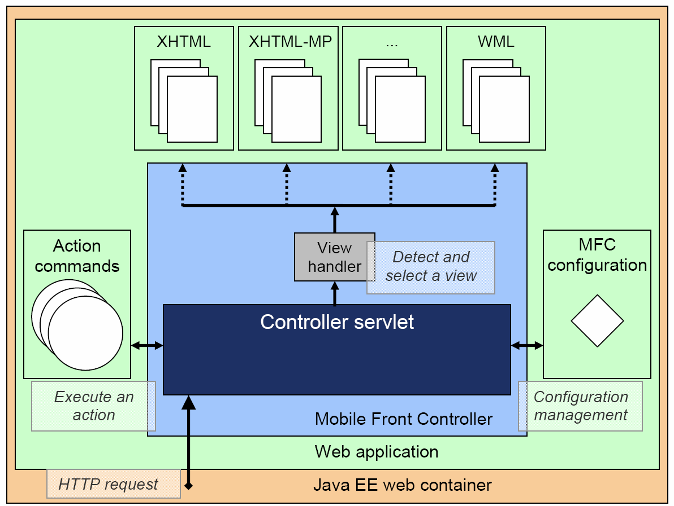
Figure 49 The architecture of mobile front controller

Desktop Browser view of Web Application
The mobile front controller supplies a function of select view. If the user access web application via a desktop browser, the desktop browser view (XHTML view) will return to user. The desktop browser view is a normal web site that follows the standard of XHTML1.0 [15]. The welcome page of desktop browser view is shown in Figure 50.

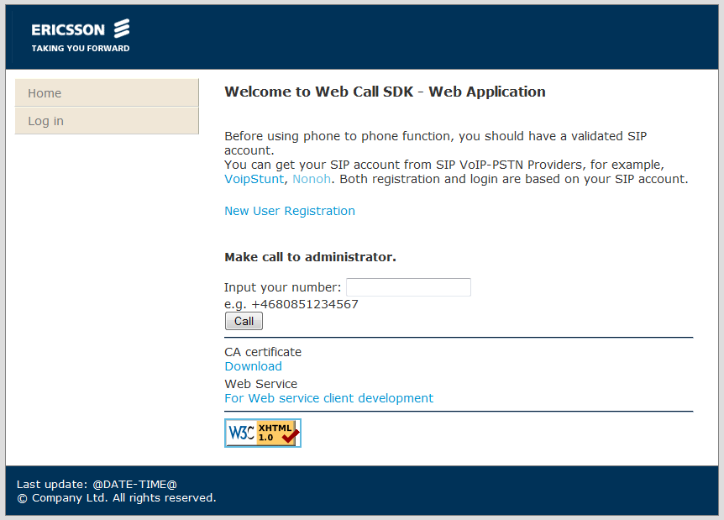
Figure 50 Welcome page of desktop browser view

Mobile browser view of Web Application
If the user access web application via a mobile browser, the mobile browser view (XHTML MP view) will return to user. The mobile browser view is a normal web site that follows the standard of XHTML MP 1.1 (eXtensible HyperText Markup Language Mobile Profile). The welcome page of desktop browser view is shown in Figure 51.
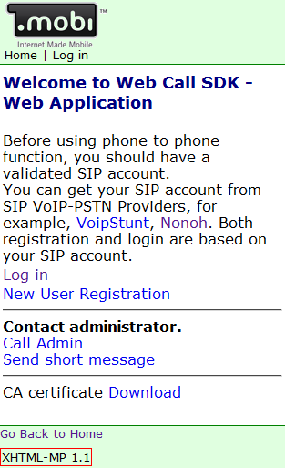
Figure 51 Welcome page of mobile browser view

Site structure
The web set structure contains three levels. Base -> Protected -> admin. Both desktop browser view and mobile browser view use the exactly same structure.
Under base directory, there is welcome page, user register page and login page. The pages on this level are public opened. There are no restrictions on requesting these pages.
All pages in protected directory are authenticated resources. To visit these pages, the user has to login first. Both user and administrator can request this kind of resources. Under user panel, user can freely edit information, e.g. user phone number, contact book, change password, VoIP provider account and recent calls. Users can make VoIP calls by clicking the link of Phone to Phone Call under user panel.
The pages under admin directory are used for managing user information. Only user who has a role of administrator can access pages under admin directory. Administrator can modify user information or even delete users.
For more details about security, please refer section 4.6.7.

Validation mechanism
The validation of web application is implemented both at presentation tier and logic tier. On presentation tier, all form are validated by javascript. The validation on presentation can save the time of communication between browser and server. However, to prevent user disables javascript, there is also a validation mechanism on logic tier.

Web Service interface of Web Application
NOTE: For security reason, all passwords in web service method are the encrypted password in database (NOT plain text).
A Web Service is a collection of functions that are brought together into a single entity and exposed to clients over a network. Web Services use XML to transfer information over standardized, open protocols ensuring that Web Services are interoperable and platform neutral. This tutorial also defines Web Service Description Language (WSDL), Extensible Markup Language (XML), Simple Object Access Protocol (SOAP) and Hyper Text Transfer Protocol (HTTP). [12]
Web service is built from an implementation class with the function of making phone2phone calls. The solution of Java EE-Java ME web service is based on the example in Java SE - Java EE web - Web service kit [8]. The following description is mostly excerpted from the developer’s guide of Java SE - Java EE web - Web service kit.
The following steps are needed to build a SOAP-based web service application from an implementation class:
- Create a Java source file for the web service implementation class and compile it.
- Generate portable artifacts (also called skeleton server classes) from the implementation class using the JAX-WS RI tool wsgen.
- Create deployment descriptors.
- Deploy the web service.

Web service implementation
The web service source file is sip.components.webapp.webserviceg.WebCallImpl. shows a fragment of the source file that calls operation in Sip Call Component.
…
import sip.components.core.controller.CallController;
…

@WebService(name = "WebCall")
public class WebCallImpl {
…
@WebMethod
@WebResult(name = "callID")
public String call(@WebParam(name = "clientA") String clientA,
@WebParam(name = "clientB") String clientB,
@WebParam(name = "sipAccountName") String sipAccountName,
@WebParam(name = "implType") String implType,
@WebParam(name = "username") String username,
@WebParam(name = "password") String password)
Throws PersistenceLayerException,
AuthenticationFailedException {

…
…
CallController controller = cf.createAudioCallController();
controller.setClientA(clientA);
controller.setClientB(clientB);
controller.register();
controller.start();
…

}
Figure 52 Web Service implementation
The implementing class uses the @WebService annotation to set the port name, service name and the target namespace. The web service methods use the @WebMethod to annotate the operation name and actions. The parameter of the method is annotated with @WebParam.
There are nine web service methods in the implementation Web Service:
- getUserURIs: Get the list of user’s URIs.
- getContacts: Get the contact list.
- getRecentCalls: Get the recent calls list.
- getSipAccounts: Get accounts for sip providers. The register of sip provider’s accounts can be done at both desktop and mobile browser views.
- getImplTypes: Get the implementation types list.
- call: Establish phone calls. In this method, the user’s phone number and destination phone number will also be stored in database. A Ring Buffer is used to store the recent calls.
- cancelCall: cancel a phone call.
- getState: get a phone call’s state.
- syncContacts: Synchronize contacts. If same name with different phone number happens, the number in client will be kept.
For details about the method please refer the source code in sip.components.webapp.webserviceg.WebCallImpl .
Generate portable artifacts
The compiling of WebCallImpl.java file is done in the ant script task: apt_webservice. Refer to the < PROJECT_HOME>/build.xml for more details. In this case, the complied class would be packed into the WAR file of the whole web application.
<!-- APT --> shows the apt_webservice ant task that generate the artifacts.

<!-- APT -->
<taskdef name="apt" classname="com.sun.tools.ws.ant.Apt">
<classpath refid="library.metro.classpath"/>
</taskdef>
<target name="apt_webservice" depends="compile.module.sipcomponentwebapp" description="Generates the portable artifacts used in JAX-WS services.">
<apt sourcedestdir="${module.sipcomponentwebapp.basedir}/SIPComponentWebApp/src"
sourcepath="${module.sipcomponentwebapp.basedir}/SIPComponentWebApp/src/sip/components/webapp/webservice"
nocompile="true"
nowarn="true">
<classpath refid="sipcomponentwebapp.runtime.module.classpath"/>
<source file="${module.sipcomponentwebapp.basedir}/SIPComponentWebApp/src/sip/components/webapp/webservice/WebCallImpl.java"/>
</apt>
</target>

Figure 53 apt_webservice ant task
More information about apt ant task can be found at JAX-WS apt page [9].
Configure Deployment descriptors
Two descriptor files are needed for deploying the web service application to Tomcat.
The deployment descriptor adds a listener and a servlet, as shown in . The listener and the servlet terminate the HTTP SOAP request for a Java EE web container. The deployment descriptor is located in <SIPComponentWebApp>\web\WEB-INF\web.xml.

<!-- BEGIN WebServers listener-->
<listener>
<listener-class>
com.sun.xml.ws.transport.http.servlet.WSServletContextListener
</listener-class>
</listener>
<!-- END WebServers listener-->

<servlet>
<description>JAX-WS endpoint</description>
<display-name>WSServlet</display-name>
<servlet-name>WSServlet</servlet-name>
<servlet-class>
com.sun.xml.ws.transport.http.servlet.WSServlet
</servlet-class>
<load-on-startup>1</load-on-startup>
</servlet>
<servlet-mapping>
<servlet-name>WSServlet</servlet-name>
<url-pattern>/services/*</url-pattern>
</servlet-mapping>
Figure 54 Configure Java Metro web service servlet
<endpoints xmlns='http://java.sun.com/xml/ns/jax-ws/ri/runtime' version='2.0'> shows a JAX-WS RI specific proprietary deployment descriptor that specifies the endpoint for the application. The endpoint defines the corresponding implementation class and URL pattern. The deployment descriptor is located in SIPComponentWebApp>\web\WEB-INF\sun-jaxws.xml.
Note: url-pattern in web.xml should match url-pattern in sun-jaxws.xml.
<endpoints xmlns='http://java.sun.com/xml/ns/jax-ws/ri/runtime' version='2.0'>
<endpoint
name='WebCall'
implementation='sip.components.webapp.webservice.WebCallImpl'
url-pattern='/services/WebCall'/>
</endpoints>
Figure 55 sun-jaxws.xml file

Security feature – SSL certificate
The security solution of the Web application includes the technique of SSL certificate. This security mechanism provides end user authentication using HTTPS. It performs mutual (client & server) certificate based authentication with a set of different cipher suites.

Generate certificates
SSL certificate generation is a sub-project in the SIPComponentWebApp project. It is located in <SIPComponentWebApp>\Certificate.
In the previous chapter, we already described how to configure the build.properties file in this sub project, as well as how to generate keys for Tomcat server and CA (Certification Authority) root certificate for applications.
2.2.6 - Configure SSL connection also describes how to configure the server.xml in Tomcat to setup SSL connection.
The generated certificate signature, ca-cert.cer, is deployed to the directory <SIPComponentWebApp>\web. This CA certificate is for Web/WAP user to download and install manually.

Security constraint
The entire standard configuration is done in the web.xml application descriptor file.
You have to specify the context-relative URL realm of the resource that is to be protected as well as the HTTP methods that the restriction applies to. You also have to specify the roles that will have the permissions to access the protected resources. In order to use SSL to protect authentication a transport guarantee for the data must be specified. The roles declared below must match exactly the role listed in the database.
Figure 56 shows the security constraint configuration in web.xml.
<security-role>
<role-name>USER</role-name>
</security-role>
<security-role>
<role-name>ADMIN</role-name>
</security-role>
<security-constraint>
<display-name>SIP registered user area</display-name>
<web-resource-collection>
<web-resource-name>UsersArea</web-resource-name>
<description>accessible by sip users</description>
<!--Define the context-relative URL(s) realm(s) to be protected -->
<url-pattern>/xhtml/protected/*</url-pattern>
<url-pattern>/xhtmlmp/protected/*</url-pattern>
<!--If you list http methods, only those methods are protected -->
<http-method>DELETE</http-method>
<http-method>GET</http-method>
<http-method>POST</http-method>
<http-method>PUT</http-method>
</web-resource-collection>
<auth-constraint>
<description>
These are the roles who can access protected area</description>
<role-name>ADMIN</role-name>
<role-name>USER</role-name>
</auth-constraint>
<!-- For setup SSL via WEB browser -->
<user-data-constraint>
<transport-guarantee>CONFIDENTIAL</transport-guarantee>
</user-data-constraint>
</security-constraint>

<security-constraint>
<display-name>SIP admin area</display-name>
<web-resource-collection>
<web-resource-name>AdminsArea</web-resource-name>
<description>accessible by SIP administrator</description>
<!--Define the context-relative URL(s) realm(s) to be protected -->
<url-pattern>/xhtml/protected/admin/*</url-pattern>
<url-pattern>/xhtmlmp/protected/admin/*</url-pattern>
<!--If you list http methods, only those methods are protected -->
<http-method>DELETE</http-method>
<http-method>GET</http-method>
<http-method>POST</http-method>
<http-method>PUT</http-method>
</web-resource-collection>
<auth-constraint>
<description>
These are the roles who can access protected area
</description>
<role-name>ADMIN</role-name>
</auth-constraint>
<!-- For setup SSL via WEB browser -->
<user-data-constraint>
<transport-guarantee>CONFIDENTIAL</transport-guarantee>
</user-data-constraint>
</security-constraint>
Figure 56 Security constraint in web.xml

Authorization – set up SSL connection
When the user has been authenticated, the container retrieves security roles for the authenticated user and checks to see if the user belongs to one of the roles defined in the <auth-constraint> tag of the deployment descriptor file web.xml.
The section in Figure 56 shows the <security-constraint> tag of the deployment descriptor file web.xml. It defines the protected web resources and a list of roles that have access to the protected resources.
The tag <transport-guarantee> will activate the SSL during the authentication.
As described in section 2.2.6, creating a SSL connector in the file <TOMCT_HOME>/conf/server.xml is needed.
See more details in http://tomcat.apache.org/tomcat-6.0-doc/ssl-howto.html.

Security feature – Form-based Authentication
According to Servlet Specification [10] , web containers have support for built-in security mechanisms for their applications. Tomcat offer three types of authentication mechanisms: basic, form-based, and mutual authentication. In this web application, form-based login is used, because it allows applications to customize the authentication user interface, and it can be associated with protection or user domains.

Configure the database resource and realm
To configure the database resource for a web application that is deployed on Tomcat, the database resource and the realm are specified in context.xml (<SipComponentWebApp>/web/META-INF/context.xml), see Figure 57.
<?xml version="1.0" encoding="UTF-8"?>
<Context>
<Resource name="jdbc/webcalldb"
type="javax.sql.DataSource"
auth="Container"
driverClassName="com.mysql.jdbc.Driver"
maxActive="100"
maxIdle="30"
username="localuser"
password="localpwd"
url="jdbc:mysql://localhost:3306/webcalldb?autoReconnect=true"/>

<!--user login control-->
<!--the digest here used should be the same as "web.xml/digest"
do NOT change this after deployed.
see "/WEB-INF/web.xml" -->
<Realm className="org.apache.catalina.realm.DataSourceRealm"
debug="99"
dataSourceName="jdbc/webcalldb"
localDataSource="true"
userTable="user"
userNameCol="username"
userCredCol="password"
digest="SHA-1"
userRoleTable="username_role_view"
roleNameCol="role"/>
</Context>
Figure 57 Specifying the database resource and the realm in context.xml.

The tables and view in database which used for user authentication are shown in Figure 58.
user
id
username
password
role
id
role
user_role
id
user_id
role_id
username_role_view
username
role

Figure 58 The tables and view which used for user authentication

Login configuration
The <login-config> of web.xml defines the type of authentication mechanism, and the URI to login and error pages. The login configuration should be set up in the web.xml file as shown in Figure 59:
<!-- Define the login configuration for this application -->
<!-- Default login configuration uses form-based authentication -->
<login-config>
<auth-method>FORM</auth-method>
<realm-name>WebCall</realm-name>
<form-login-config>
<form-login-page>/ControllerServlet?page=login.jsp</form-login-page>
<form-error-page>/ControllerServlet?page=loginFail.jsp</form-error-page>
</form-login-config>
</login-config>
Figure 59 Configure Form-based login in web.xml

Login pages
You have to create an HTML or JSP page, with the same name you specified under the <form-login-page> tag, which contains a form with these fields:
- Data must be posted to a special resource name ‘j_security_check’
- The username field must be named ‘j_username’
- The password field must be named ‘j_ password’
The following JSP code is the example of the login form in <SIPComponentWebApp>\web\html\Login.jsp.

<form action="<%=response.encodeURL("j_security_check")%>" method="post" onsubmit="return validate(this);">
<table>
<tr>
<td>
Username:
</td>
<td>
<input size="24" type="text" name="j_username" value=""/>
</td>
</tr>
<tr>
<td>
Password:
</td>
<td>
<input size="24" type="password" name="j_password"/>
</td>
</tr>
</table>

<p>
<input type="submit" name="Submit" value="Login"/>
<input type="reset" name="reset" value="Reset"/>
</p>
</form>
Figure 60 Form-based login JSP form

Designs of Java ME Client
The Java ME Client is a client to access the web service residing in the Web Application. This Section describes the design of Midlet and its communication with web application.

Design of Java ME web service client application
The client application consists of:
- web service client stub
- Web Call Client
- PIM contact helper
- graphic user interface
The architecture of Java ME web service client is shown in Figure 61.
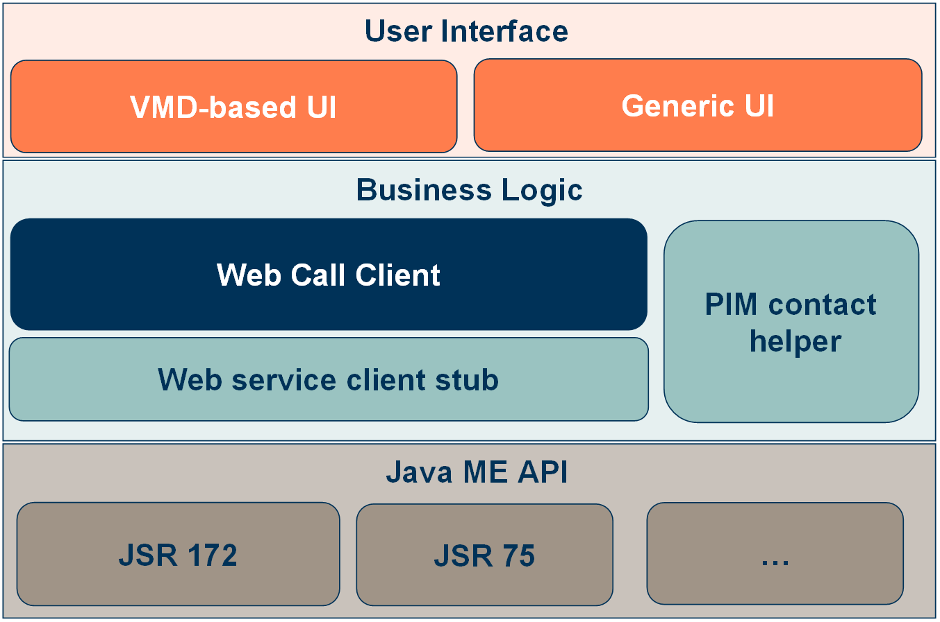
Figure 61 Architecture of Java ME web service client

Web service client stub
The web service client stub is generated by NetBeans Java ME Web Service Client Wizard. The window of wizard is shown in Figure 62.
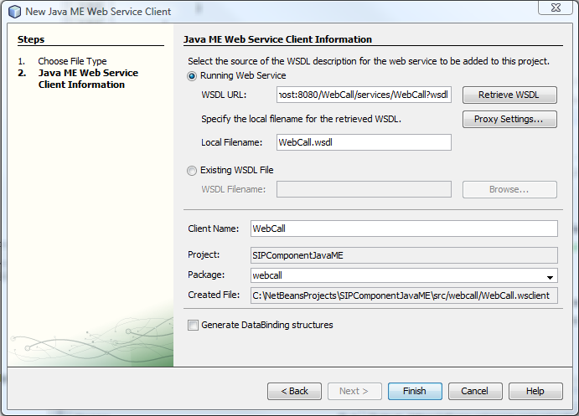
Figure 62 Netbeans Java ME Web Service Client Wizard
Only the handset which supports JSR 172: J2METM Web Services Specification [11] can run the Java ME web service client.

PIM contact helper
A good feature of Java ME web service client is that the application can read contacts from Personal Information Management (PIM) data from cell phone. It uses JSR 75: PDA Optional Packages for the J2METM Platform [13] to accessing PIM data.
The contact helper has two public methods:
- getContacts() : get a HashTable of contacts.
- getSortedNameList() : get a Vector of contact names. The name is sorted by lexicography.
Only the handset which supports JSR 75 [13] can run the Java ME web service client with full functional. But the contacts part will not affect web service can phone call functions. The PIM contact helper can also be used as a helper library in other Java ME applications.

Web Call Client
The Web Call Client bases on web service client stub. The web service client stub only implements the client interface. But the web call client manages the business logics, e.g. the user URI list, the recent call list and logic of synchronization.

User Interface
The user interface invokes methods in Web Call Client to make phone calls and get user information.

VMD-based UI
This Java ME client is first developed with Visual Mobile Designer.
The Visual Mobile Designer (VMD) is a graphical interface within NetBeans Mobility that enables you to design mobile applications using drag and drop components. The VMD allows you to define the application flow and design your GUI using the components supplied by the IDE or components you design yourself. The VMD contains many standard User Interface (UI) components that you can use to create applications such as Lists, Alerts, Forms and Images. It also includes custom components that simplify the creation of more complex features, such as Wait Screens, Splash Screens, Table Items and more. [14]
The application flow is shown in Figure 63.
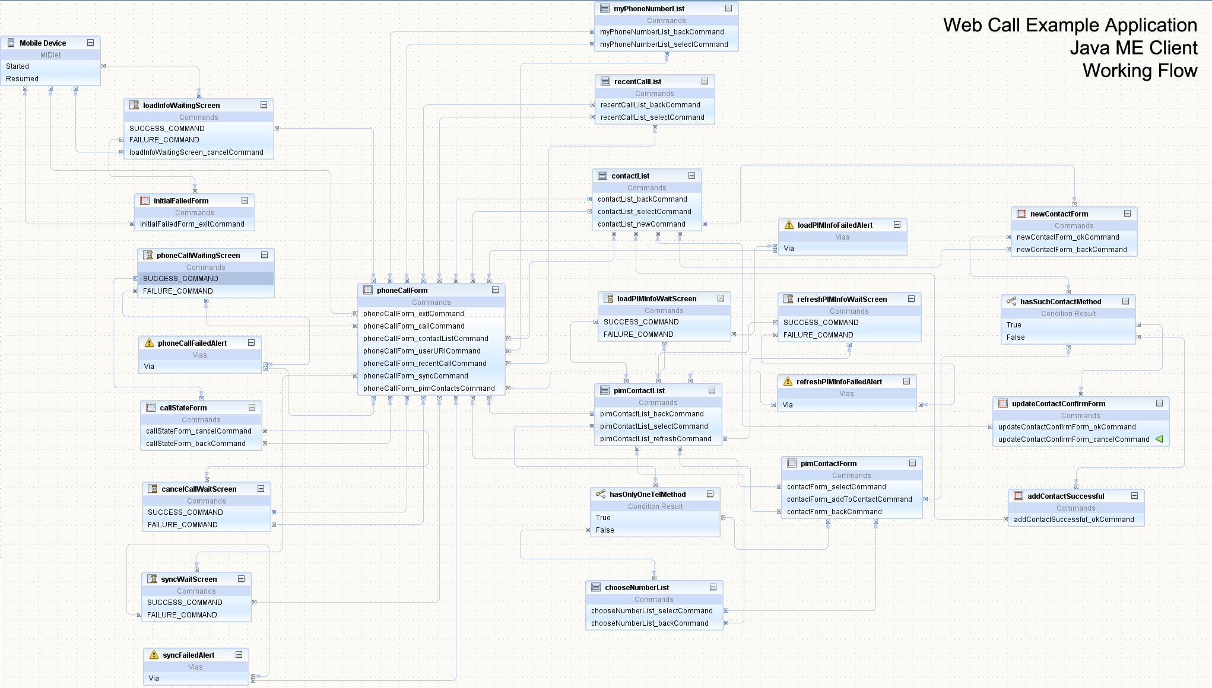
Figure 63 Working flow of Java ME Client
The drawback of VMD-based UI is that a VMD library is needed when compile and deploy.

Generic UI
To avoid using the VMD library, a generic UI is introduced. It doesn’t use any particular class from NetBeans. Change org.netbeans.microedition.lcdui.WaitScreen to Form, change org.netbeans.microedition.util.SimpleCancellableTask to normal method.
There are three sub packages in package sip.components.me.ui, nb, nb2 and general. The package nb contains the VMD-based UI. The package nb2 is a UI which doesn’t contain any NetBeans library. The UI in package general is the code copy from nb2 and refractored according the package name and Midlet name. All three UIs can be treaded as Midlets. They invoke the same logic in WebCallClient and PIMContactHelper. By default only the UI in general will be compiled.

Dynamic JAD file for WAP user
The main purpose of the dynamic JAD file is to reduce the input amount from Java ME client. As we know, most mobile input interfaces are not as convenient as computers. To access the web service, we need several parameters such as the username and password.
The web application dynamically generates the customized JAD files for Java ME when they download the JAD file. To know how to use the client application, see section 3.4. Note: only mobile phones supporting JSR172 can install this application.
The following steps describe the process flow of this design.
- Prepare the JAR file. Put the generated JAR file into web application for user downloading.
- The web application uses a Sevlet to generate the dynamic JAD file. The Sevlet locates at sip.components.webapp.controller.jmehelper
- After download and install the jar file, the clients can easily launch the Midlet application and input the destination number, making phone calls without other complicated input steps.
The security of this design is protected by the step of user login by SSL certification. And the password in web service method is encrypted.

Future Work
Base on the web service interface, follow gadget or application will be developed in the next version of release.
- iGoogle gadget
- Vista sidebar gadget
- Google desktop gadget
- Facebook application

References
- Rosenberg, J., Schulzrinne, H., Camarillo, G., Johnston, A., Peterson, J., Sparks, R., Handley, M. and E. Schooler, "SIP: Session Initiation Protocol", RFC 3261, June 2002. http://www.ietf.org/rfc/rfc3261.txt
- Rosenberg, J., Peterson, J., Schulzrinne, H. and Camarillo, G. Best Current Practices for Third Party Call Control (3pcc) in the Session Initiation Protocol (SIP), RFC 3725, April 2004. http://www.ietf.org/rfc/rfc3725.txt
- MjSIP http://www.mjsip.org/
- Scallope http://code.google.com/p/scallope/
- RFC 3515 The Session Initiation Protocol (SIP) Refer Method http://www.ietf.org/rfc/rfc3515.txt
- Rosenberg, J. and H. Schulzrinne, "An Offer/Answer Model with Session Description Protocol (SDP)", RFC 3264, June 2002.
- Mobile Front Controller, Developer Program, Ericsson Mobility World http://www.ericsson.com/mobilityworld/sub/open/technologies/mobile_browsing/tools/mobile_front_controller
- The Java SE-Java EE web – web service kit, Ericsson Mobility World http://www.ericsson.com/mobilityworld/sub/open/technologies/open_development_tips/tools/JavaSEEE_web_service
- Apt ant task https://jax-ws.dev.java.net/2.1.5/docs/apt.html
- Servlet Specification http://java.sun.com/products/servlet/download.html
- JSR 172: J2METM Web Services Specification http://jcp.org/en/jsr/detail?id=172
- Get started with new Web Services (JSR 172) tutorial http://developer.sonyericsson.com/site/global/newsandevents/latestnews/newsaugust06/p_web_services_tutorial_jsr172.jsp
- JSR 75: PDA Optional Packages for the J2METM Platform http://jcp.org/en/jsr/detail?id=75
- Visual Mobile Designer Custom Components: Creating Login Screens http://www.netbeans.org/kb/60/mobility/loginscreen.html
- XHTML 1.0 The Extensible HyperText Markup Language http://www.w3.org/TR/xhtml1/

