Use Ericsson SDS as a SIP provider and Test with Fring

Introduction
This is a guide for setup Ericsson SDS as a sip provider. And test it with SIP call via Fring

Ericsson SDS
The Ericsson SDS is the only fully comprehensive tool for development and end-to-end testing of both the client and server side of new IMS-based applications. It is based on the Eclipse Integrated Development Environment (IDE),

Fring
Fring™ is a mobile internet service & community that enables you to access & interact with your social networks on-the-go, make free calls and live chat with all your fring, Skype®, MSN® Messenger, Google Talk™, ICQ, SIP, Twitter, Yahoo!™ and AIM®* friends using your handset’s internet connection rather than costly cellular airtime minutes.

Configuration
Start your computer with a public IP address or internet connection and do as follows.
There are two reasons to do so. First, a public IP address allows Ericsson SDS works as a public SIP provider. Second,

Configure DNS

Login to DynDNS
Go to DynDNS (http://www.dyndns.com) and login with follow account:
User: webapptemplate
Pass: adminadmin

Modify DNS
After Login to DynDNS, click “My Services” which lies at top right of the page.
Click webapptemplate.homeip.net and change the IP address to your public IP address as shown below:
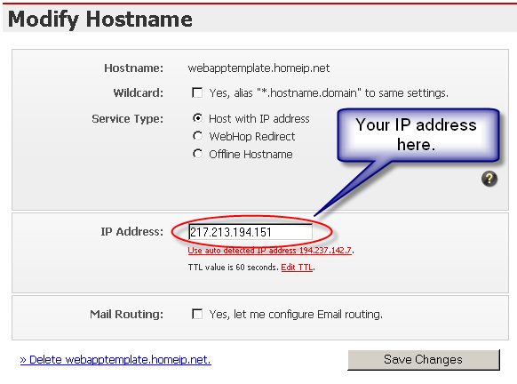
Figure 1 Modify Hostname

Click “Save Changes” and exit.

Configure Ericsson SDS

Domain and Listening port
In the preferences of CSCF in Ericsson SDS, set domain to webapptemplate.homeip.net as shown below:
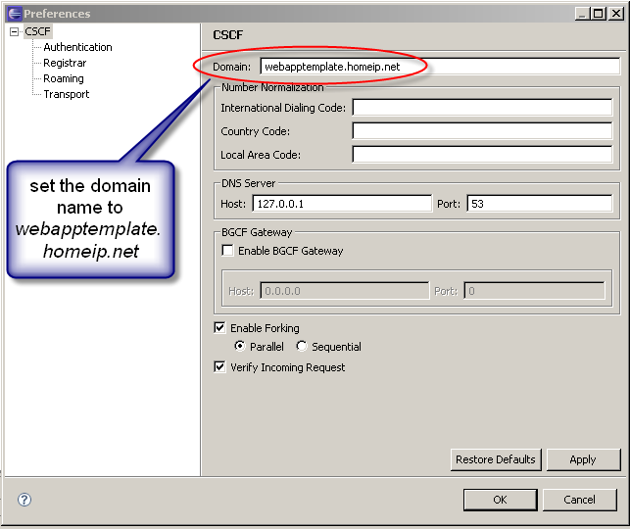
Figure 2 Modify domain of CSCF in Ericsson SDS

Go to Preferences -> CSCF -> Transport -> Listening Ports
Add listening port “5060” to the list.
Click and there will be popup window tell you SDS will change the domain of all your provisioned users. Click ok.

Configure Ericsson SDS DNS
In Ericsson SDS go to Menu -> SDS -> Server -> Provisioning -> DNS -> SIP/SIP Keys.
Add follow records as shown in highlight:
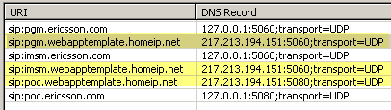
Figure 3 Customize DNS in Ericsson SDS
Click save and start CSCF and DNS.

Configure Fring

- From the Main Menu choose Manage communities…
The following screen appears:
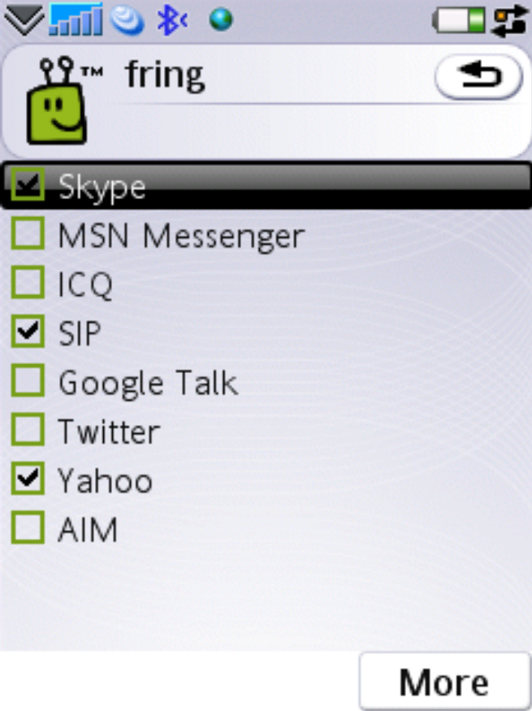
Figure 4 Fring Manage communities Screen

- Navigate between the options using the up and down arrows on your handset. Choose SIP from the list.
The following screen appears:
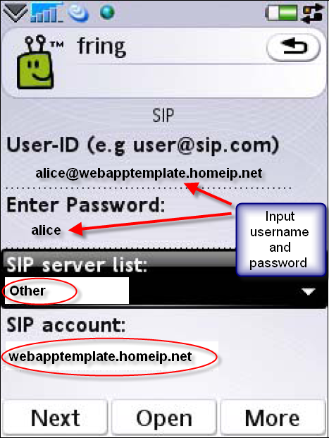
Figure 5 SIP account configuration in Fring
Input the username and password. Make sure the username has a format as name@webapptemplate.homeip.net. All username should be registered into Ericsson SDS before login.

- Choose Other from the SIP server list. And input webapptemplate.homeip.net to SIP account as shown in Figure 5.
- Click “Done” and wait for registering to Ericsson SDS.

Test
You can have several Fring client register to Ericsson SDS as shown in part 2.3 and after that you can just simply make a sip call from one client to another.
Reference to developers’ guide of Web Call SDK you can also have a sip phone software client on your computer and test it with Fring via Ericsson SDS.

