|  |  |  |  |
| --- | --- | --- | --- |
|  |  | BankAccount | BankABA |
| ClientID | FDICCert (some banks share the same) |  |  |
|  |  |  |

1. Account : 1000 is bank level; 2000 is client level; 1001 is the allocation view of the accounts.
2. Don’t forget to close the ExecuteDBQuery

String query = "SELECT * FROM exclusions WHERE clientid='"+strsBank[0]+"' AND subid='"+strsBank[1]+"' AND fdiccert='"+fdiccertBank+"'";

ResultSet rs= OperationUtilities.ExecuteDBQuery(query, this.owner.getConnection());

if(rs.next())

{

System.out.println(""+strsBank[0]+" excludes "+fdiccertBank);

OperationUtilities.CloseResultSet(rs);

continue;//

}

else

OperationUtilities.CloseResultSet(rs);

1. Data base assessment operations are in the OperationManager class.
2. Expected interest APY calculation:

Input: AverageDailyBalance (ADB), Interest, DayCount.

“C:\Falcon\src\com\scp\server\core\operationprocess\operationjob\InterestPosting.java”

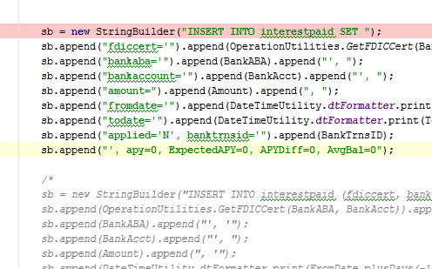

1. The config file controlling the test server or the dev server is at “C:\apache-tomcat-7.0.63\conf\server.xml”, url="jdbc:mysql://yoda:3306/devusbfica"
2. When you click the items in the picture below, an new object is created on the server except for the “Daily” one, for which only double-click will create a new object. Clicking “Daily” will retrieve the most recent usage.

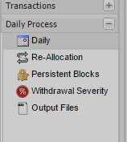

1. ICA product:
2. Create ICA daily job

Work to do:

1. Remove subacctID “-“ problem

Some ideas:

1. If the
2. Sales award rules can be improved
3. We can use some data mining method to predict the customer behavior and allocate fund to wiring account before the customer making the withdraw request.