Chai Blossom

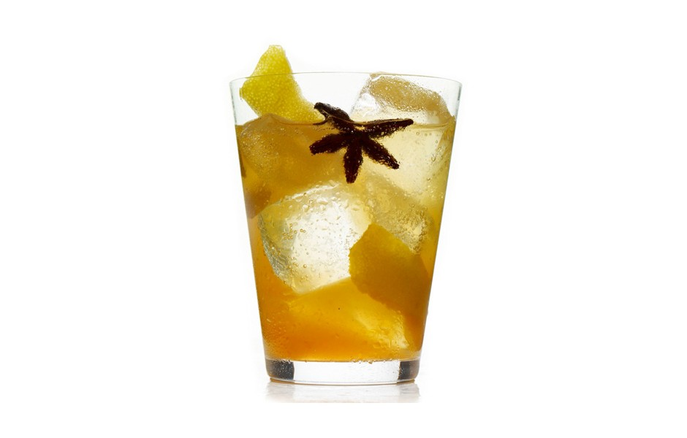Combine tea bags and 1 cup boiling water in a small bowl; cover and let sit 8–10 minutes. Add sugar; stir to dissolve. Discard tea bags and let cool. Stir chai syrup and lime juice in a pitcher to combine. Divide among 4 rocks glasses filled with ice and add 2–3 oz. club soda to each. Garnish with anise pods and lemon twists.

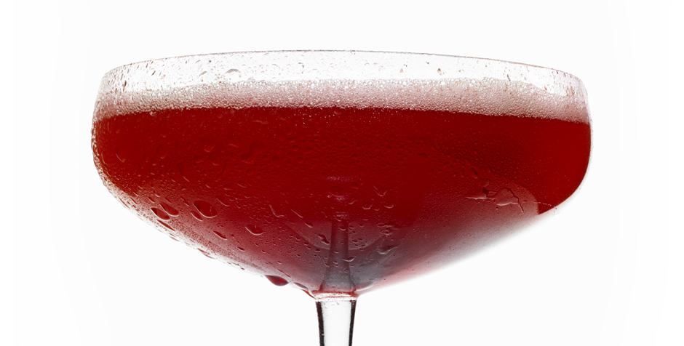

### The Rehydrator

### Ingredients

SERVINGS: MAKES 4

* 1/2 cup pitted cherries
* 3/4 cup aloe vera juice
* 1/2 cup unsweetened cranberry juice
* 1/4 cup fresh lime juice
* 1 Tbsp. honey

### Recipe Tips

### Preparation

* Muddle cherries and honey in a pitcher. Add juices and stir to combine. Place 1 cup mixture in a cocktail shaker and fill shaker with ice. Cover and shake until outside of shaker is frosty, about 30 seconds. Strain into 2 coupe glasses. Repeat with remaining mixture.

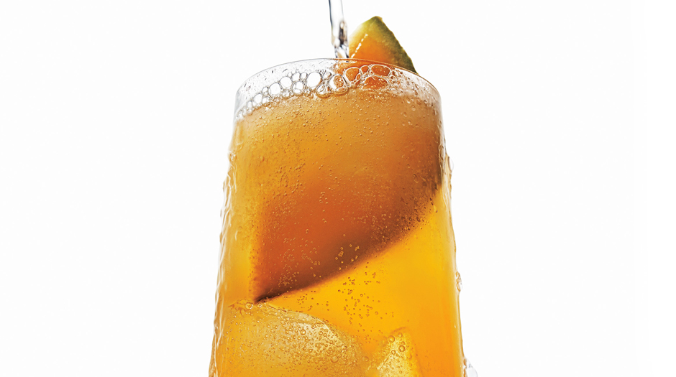

### Summer Twang

## Cantaloupe meets apple cider vinegar in this refreshing non-alcoholic cocktail.

### Ingredients

SERVINGS: MAKES 4

* 2 cups chopped cantaloupe
* 3 Tbsp. honey
* 8–12 oz. club soda
* 3 Tbsp. apple cider vinegar

### Recipe Tips

### Preparation

* Purée cantaloupe, vinegar, and honey in a blender. Strain into a measuring cup or bowl, pressing on solids; discard solids. Divide among 4 Collins glasses filled with ice and add 2–3 oz. club soda to each. Garnish with cantaloupe wedges.

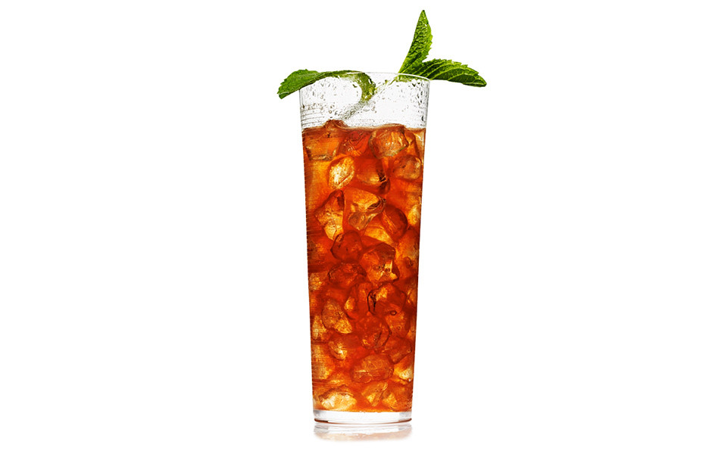

PG-13 Singapore Sling

Ingredients

SERVINGS: MAKES 4

* 1/2 cup mango juice
* 1/2 cup pineapple juice
* 2 Tbsp. fresh lime juice
* 8–12 oz. tonic water
* 4 mint sprigs
* 3/4 cup pomegranate juice

Recipe Tips

Preparation

* Combine juices in a pitcher filled with ice and stir until cold. Divide among 4 Collins glasses filled with crushed ice and add 2–3 oz. tonic water to each. Garnish with mint sprigs.