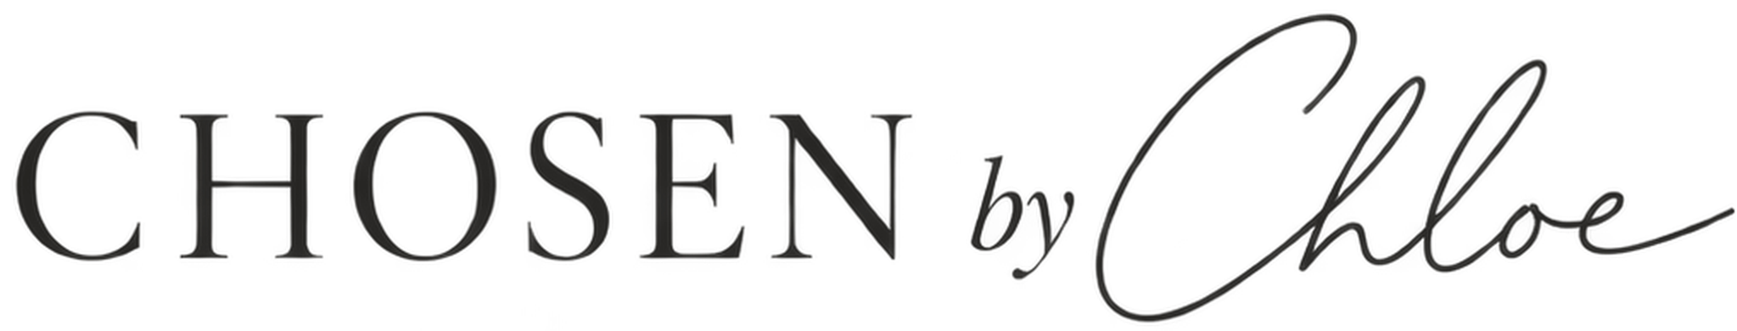 | INVOICE  Invoice No. CBC-EDU-0926-001  Invoice Date 23/09/2026
CUSTOMER  Jessica Fan  Little Lionsheart Nursery School  103 Greenford Road  Harrow, HA1 3QL  +44 7523 267405 | DELIVERY TO  Little Lionsheart Nursery School  103 Greenford Road  Harrow  HA1 3QL  United Kingdom
ITEM | SKU | QTY | PRICE | TOTAL
Khaki Puddlesuit | 2-3 years | GA104-KHAKI-STD-2/3 | 3 | £34.00 | £102.00
Khaki Puddlesuit | 18/24 months | GA104-KHAKI-STD-18/24 | 2 | £34.00 | £68.00
Khaki Puddlesuit | 12/18 months | GA104-KHAKI-STD-12/18 | 1 | £34.00 | £34.00
Rose Puddlesuit | 12/18 months | GA104-ROSE-STD-12/18 | 1 | £34.00 | £34.00
Rose Puddlesuit | 18/24 months | GA104-ROSE-STD-18/24 | 2 | £34.00 | £68.00
Rose Puddlesuit | 2-3 years | GA104-ROSE-STD-2/3 | 3 | £34.00 | £102.00
Amethyst Purple Kids Puddlesuit | 12/18 months | GA104-ICEAME-STD-12/18 | 1 | £34.00 | £34.00
Amethyst Purple Kids Puddlesuit | 18/24 months | GA104-ICEAME-STD-18/24 | 2 | £34.00 | £68.00
Amethyst Purple Kids Puddlesuit | 2-3 years | GA104-ICEAME-STD-2/3 | 3 | £34.00 | £102.00
Geothermal Grey Kids Puddlesuit | 12/18 months | GA104-GEOTHE-STD-12/18 | 1 | £34.00 | £34.00
Geothermal Grey Kids Puddlesuit | 18/24 months | GA104-GEOTHE-STD-18/24 | 2 | £34.00 | £68.00
Geothermal Grey Kids Puddlesuit | 2-3 years | GA104-GEOTHE-STD-2/3 | 3 | £34.00 | £102.00
Glacial Green Beanie | Green / 1-2 years | GA453-GLAGRE-STD-1/2 | 1 | £12.00 | £12.00
Khaki Chunky Sole Kids Shortie Welly | UK5 | GA316-KHAKI-UK5 | 1 | £27.00 | £27.00
Khaki Kids Waterproof Rain Dungarees | 18/24 months | GA105-KHAKI-STD-18/24 | 1 | £29.00 | £29.00
Amethyst Kids' Purple Joggers | 18-24m | GA014-ICEAME-STD-18/24 | 1 | £16.00 | £16.00
EDUCATION DISCOUNT  40% off standard retail pricing for education settings. | Subtotal £900.00  Education Discount (40%) -£360.00  Delivery £0.00  TOTAL £540.00
PAYMENT
Payment status: [PAID / DUE] Payment method: [Card / Bank Transfer / Other]
A LITTLE NOTE
Thank you for choosing Chosen by Chloe. Education discount applied at 40%.

