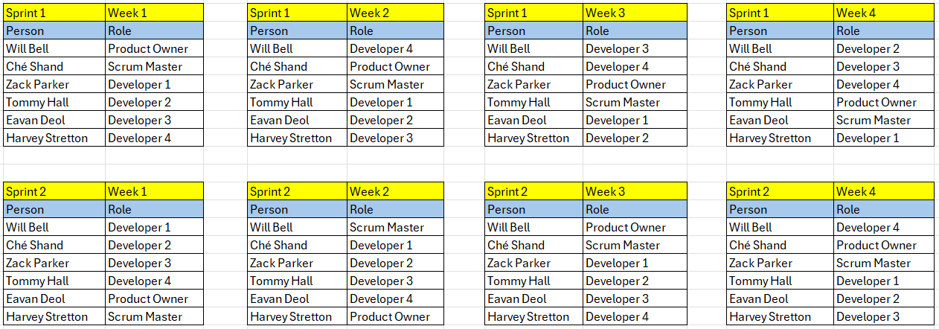

Komodo Hub Goals:
- Make people realise it’s their responsibility not just the governments to aid with endangered animals.
- develop a revolutionary digital platform for animal conservation in Indonesia.
- Allow people to explore, identify, and protect Indonesian endemic species.
- Educate people about animal conservation.
- Endorse the involvement of communities in aiding conservation.
- Be available to citizens nationwide, from remote indigenous communities to regional towns and urban areas.
- Make available (registration) for individuals and institutions (like primary schools).
- Allow users equal opportunity to access the rich knowledge base of Indonesian endangered endemic species and get involved in a broad range of conservation programs.
- Allow registered users to further extend its knowledge base by sharing their records of the species (add sightings report section).
- Easy to use, even for primary school pupils.
- Teachers be able to leave notes on students work, sightings etc…
- Allow users to see what programs they’re enrolled in.
- Account customisation for students.
- Generation and distribution of unique access code.
- Only teacher should access students’ data.
- Use ISO 9241-210:2019.
- Treat errors by following some principles. Firstly, our design should make it difficult for users to take incorrect actions using distinctive links and action buttons, clear and polite instruction language.
- Should be scalable.
- Data protection.
- Authentication methods.

Product Backlog:
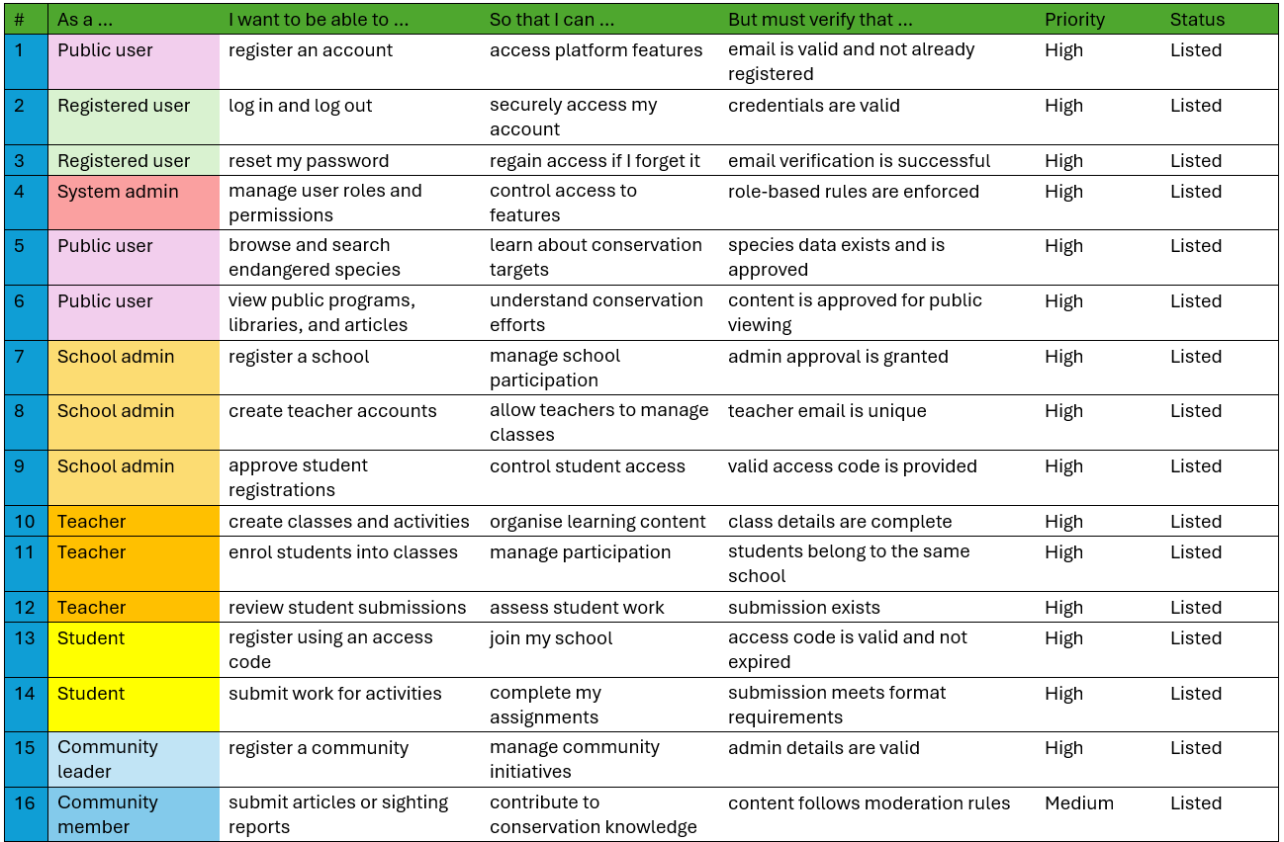

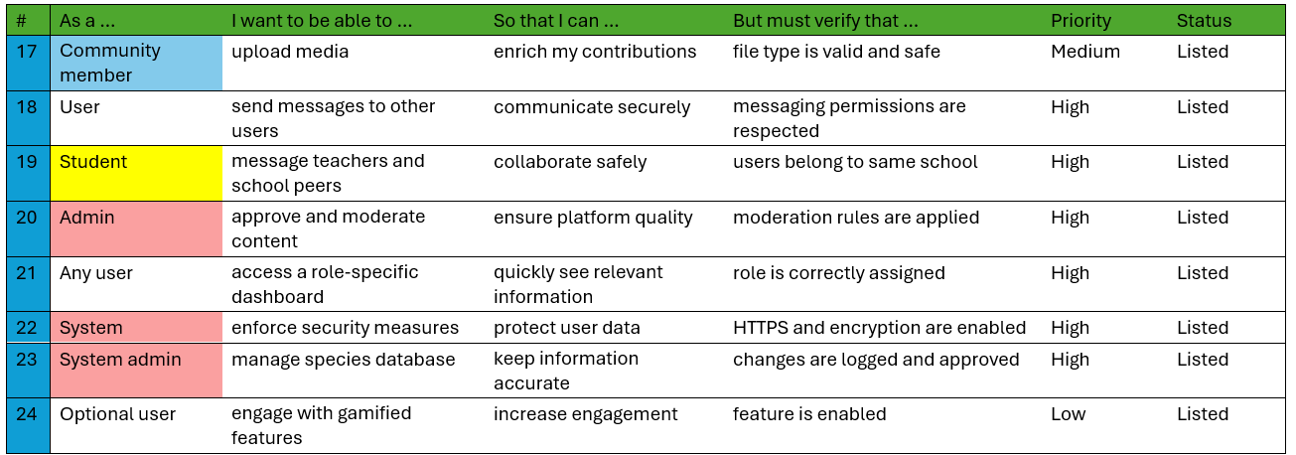

The centralized approach:

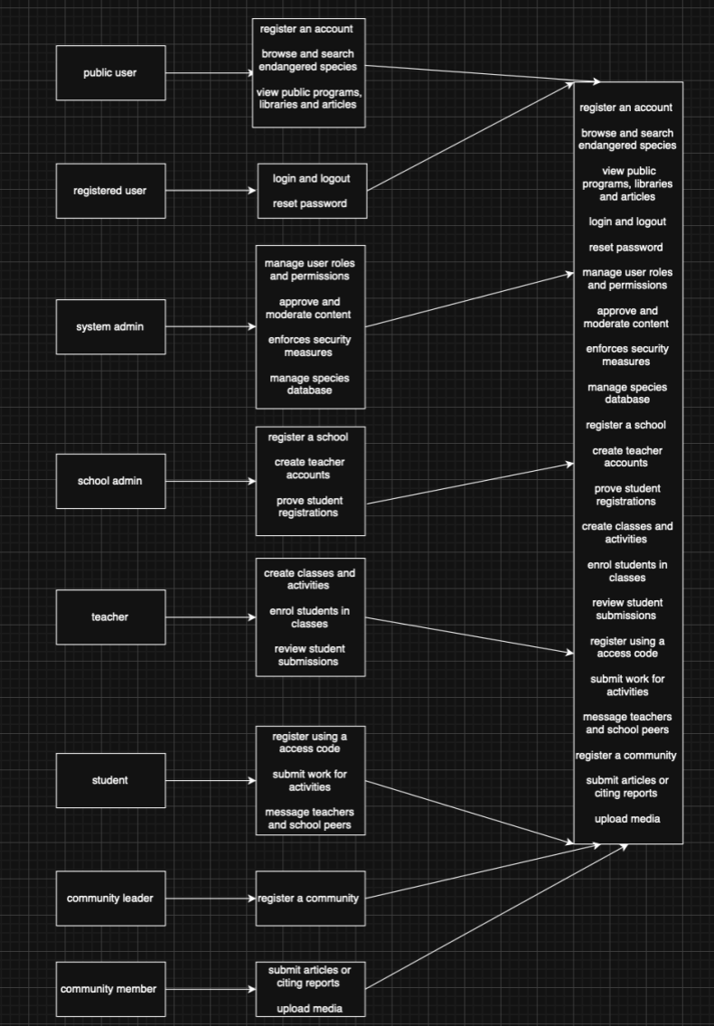

Sprint Backlog:
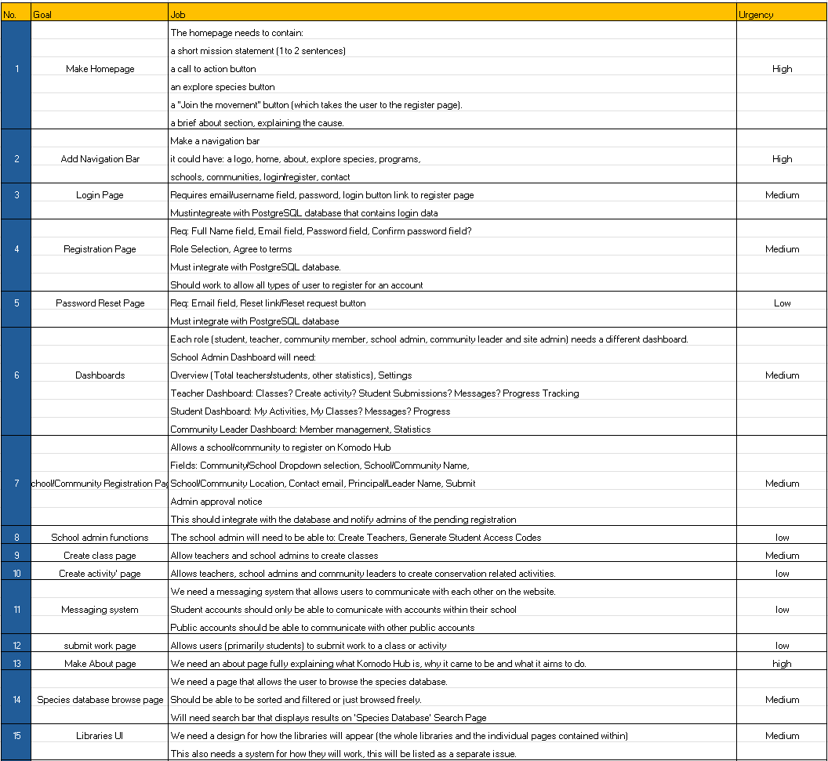

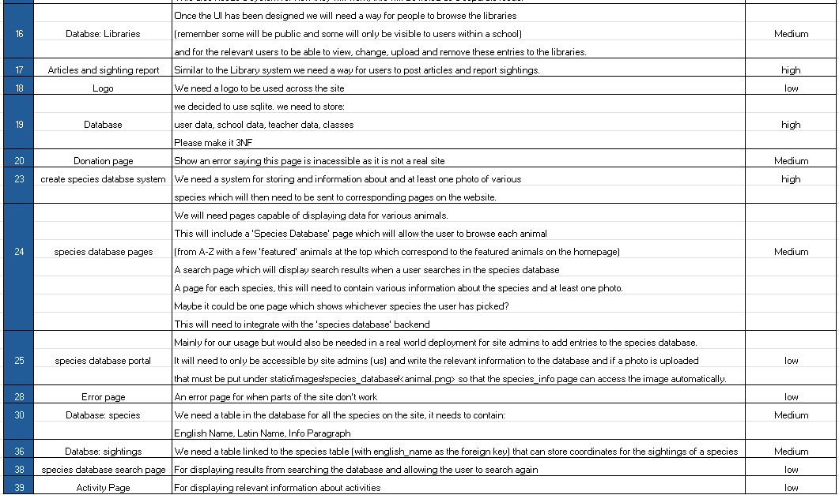

Sprint backlog also integrated in git as briefly shown below…
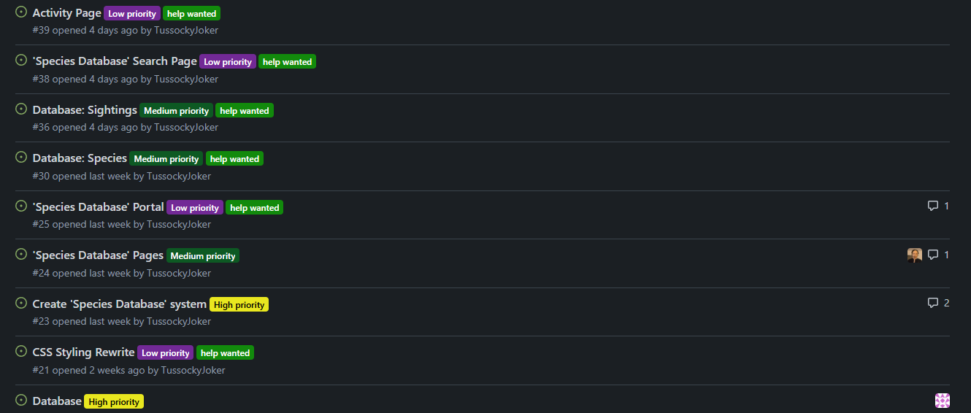

Komodo Hub Vision Statement:
Aiding a sustainable future for Indonesian wildlife where local people, communities and schools can learn about and aid the wildlife living alongside them.

Use case diagram:

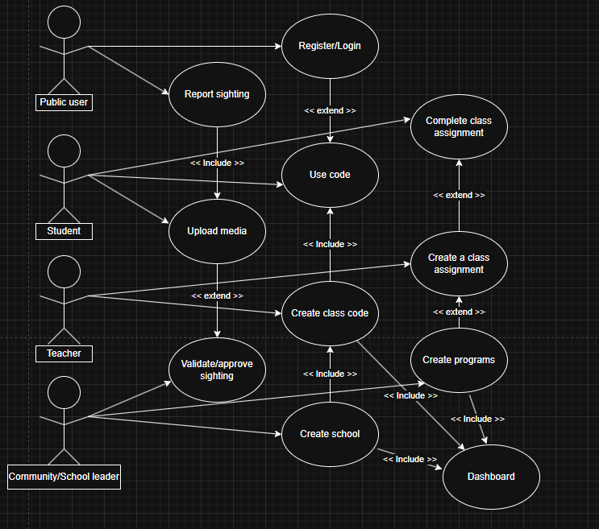

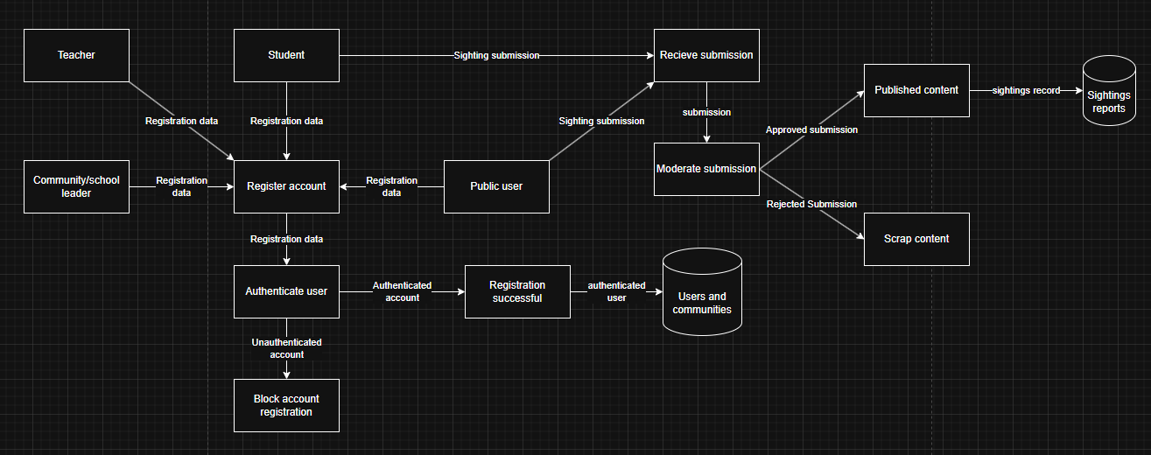
Data flow diagram:

Activity diagrams:

