# RoadMap

通过官方网站查找开发资料。

<http://msdn.microsoft.com/en-us/library/windows/hardware/ff537864(v=vs.85).aspx>

根据网站上面的资料

<http://msdn.microsoft.com/en-us/library/windows/hardware/ff537039(v=vs.85).aspx#usbaudio_class_system_driver>

The USBAudio class system driver (Usbaudio.sys) is an AVStream minidriver that provides driver support for USB Audio devices that comply with the Universal Serial Bus Device Class Definition for Audio Devices (release 1.0).

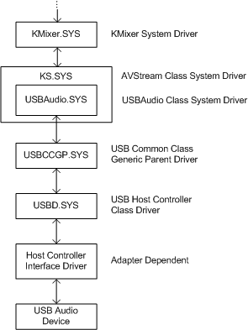

下面打算采用MSVAD来做，需要注意的是，只有在MSVAD当中的所有的.sys生成之后，才能使用。