# **Pork Shop Staffing and Sales Terminal**

Project Manager:

Jonathan Deschene

Date Submitted:

January 13, 2017

# APPROVAL

Gerald Caissy, Project Sponsor

Pork Shop Staffing and Sales Terminal

(PSST)

This document is to receive the approval of the person(s) in charge of the upcoming project, to confirm that they approve of the plans laid within this document. If signed, they take responsibility for all changes proposed within and agree that they have read them over thoroughly and fully. If the changes proposed within are accepted, please date and sign at the bottom of this document to confirm moving forward with the project as outlined.

__________________ ___________________

Client Date

__________________ ___________________

Project Manager Date

# Document Tracking

|  |  |  |  |  |
| --- | --- | --- | --- | --- |
| Version | Document Name | Date | Authors | Comment |
| 1 | PSST Project Statement | Jan 10, 2017 | Jonathan | Initial Document creation. |
| 2 | PSST Project Statement | Jan 11, 2017 | Jonathan, Heather | Project Summary, Project Objective, Assumptions and Constraints added. |
| 3 | PSST Project Statement | Jan 12, 2017 | Jonathan, Heather, Bryan, Noah, Shane | Project Plan, Team Organization, Budget, Member Contract added. |
| 4 | PSST Project Statement | Jan 13, 2017 | Jonathan, Heather, Bryan, Noah, Shane | Document finalized. |

# Table of Contents

Contents

**Pork Shop Staffing and Sales Terminal** 1

APPROVAL 2

Document Tracking 3

Table of Contents 4

Project Summary 5

Project Objective 7

Project Deliverables 7

Assumptions 9

Constraints 9

Project Plan 11

Team Organization 11

Budget 13

Change Management 14

Progress/Status Reporting 16

Decision Making 18

Appendix A 19

# Project Summary

Client: The Pork Shop

Client Contact: Heather Watterson, Owner

Project: Pork Shop Staffing and Sales Terminal (PSST)

**Development Team:** Strangest Things Inc.

**Project Manager:** Jonathan Deschene

**Client/Creative Director:** Heather Watterson

**Analysts/Developers:** Bryan MacFarlane

Heather Watterson

Jonathan Deschene

Noah Gallant

Shane Arsenault

**Project Start Date:** Jan 9, 2017

**End Date:** February 17, 2017

**Definitions:**

User – any employee of Pork Shop who may have need to access all or part of the system.

CRA – Canada Revenue Agency

CPP – Canada Pension Plan

EI – Employment Insurance

**Resources Used:**

N/A

# Project Objective

The Pork Shop is a new BBQ Restaurant and Blues Club opening in downtown Summerside. Initial capacity will be 5 booths capable of seating 6 patrons and 15 tables that will seat 4, as well as limited individual seating at the bar. It will be open for lunch and dinner service as well as providing live music in the evenings. Staff will include the Owner (Heather) a bar manager, three bartenders, 8 waitresses and 6 kitchen staff. Employees are cross-trained to perform a variety of job duties when needed.

This project will develop a two-part system for the Pork Shop: a Point of Sale sub-system which will allow staff to place and process customer orders, track consumption of bar inventory and manage on-line reservations; and a Back Office Portal which will manage staffing and payroll functions and allow for future development of the system.

# Project Deliverables

This project will deliver:

1. Project Statement on Jan 13, 2017
2. Four Status Reports: one on January 20, January 27, February 3 and February 10, 2017.
3. Analysis and Design Document on Jan 25, 2017, which will include:
   1. System models
   2. User Interface designs
   3. Reporting Functionality
   4. Fully developed database
4. Testing deliverables on February 14, 2017, which will include:
5. User Interface Test Plan
6. Incident Report Plan
7. Test Summary Report

V. Final project application on February 17, 2017.

This project will not deliver:

1. System hardware and software. The client will be responsible for the acquisition of any new hardware and software, ensuring it meets project specifications. However, as new hardware and software are necessary to the system, their costs have been included in the budget.
2. While the system covers a large portion of the Pork Shop’s organizational processes, it will not cover kitchen inventory or accounting processes.
3. Mobile functionality.
4. An updated website (this aspect of the project is still under discussion, pending time constraints, and will proceed through the appropriate change management steps if approved).

# Assumptions

1. The Pork Shop will acquire hardware to meet the system specifications.
2. Team members will cover their own costs for business related travel unless otherwise specified.
3. Given the time constraints, team members will not schedule extended vacations during the project.
4. We will hardcode a tax rate for sample purposes.
5. Functionality to permit toggling between the point of sale and scheduling/payroll sub-systems.
6. Perfect technology and seamless project implementation.
7. Training will be minimal and relocated to the owner, manager and/or chief supervisor.
8. No outside consultants or vendors required.
9. Standard security protocols will meet the client’s needs.
10. The bar inventory report will capture total items sold per item category rather than per item brand (future programming may permit increased granularity).

# Constraints

1. The timeline for the system design and implementation is six weeks.
2. Users will have access only to those areas of the system that they have need of in their everyday work (i.e. authorization functionality should be implemented to prevent unauthorized employees from accessing scheduling or payroll).
3. The system will submit orders to be printed from a printer in the kitchen.
4. Staff requires a punch clock that will send their shift details to the database.
5. Each table will have a number identifying it to be used in the Online Registration application.
6. Employees are to be stored in the system regardless of employment status.
7. The prototypical nature of the system will constrain the design in a number of ways. For example:
   1. Staff will assign tables and booths based on online reservations (it will not be automated).
   2. The payroll application will employ 3 or 4 hard-coded levels of pay, as well as CPP and EI, but no Income Tax deductions.
   3. We will hard-code the bar into the system.

# Project Plan

See attached Gantt Chart.

# Team Organization





We have imagined a situation where our client, Heather, has acquisitioned funding for the project from a government or financial institution which intends to closely monitor the project. Gerald Caissy represents this organization and has taken on the role of Project Sponsor. Heather and Gerald will therefore both sit on the Steering Committee, though the final word ultimately rests with Gerald.

Responsibility of steering committee:

The Steering Committee is responsible for providing support for the project. They help the project manager to plan and give advice along the way. They are also responsible for setting up vision and goals for the project. They review and approve all costs, arrange funding, create policies for the project and communicate with stakeholders.

The responsibilities of project members:

Jonathan (Project Manager): Is responsible for making sure tasks are completed in a timely fashion, that quality standards are met, and that accurate cost information is forwarded to the Steering Committee. He will work closely with the Steering Committee to resolve obstacles should they arise, and act as the liaison between the Steering Committee and project members.

Heather (Member): Project Analyst

Noah (Member): Project Analyst

Shane (Member): Project Analyst

Bryan (Member): Project Analyst

# Budget

The proposed budget for the project is $17,330.00. This amount covers wages, hardware, software, and startup training and maintenance costs.

Estimated wage cost: $11,330.00 (see below charts for cost breakdown by task).

Estimated hardware and software costs: $5,000.00.

Estimated training costs on startup: $200.00.

Estimated maintenance costs for the first year: $800.00

Total estimated costs: $17,330.00

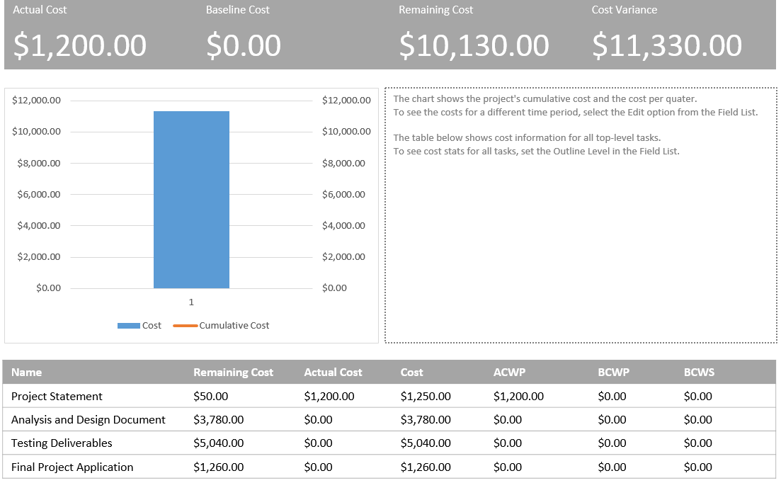

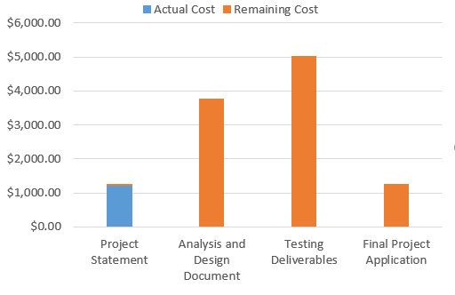

# Change Management

A change management process is to be implemented so that all changes are documented and resolved in a systematic and timely fashion.

The audience for the change management process includes the project manager, project team members, project sponsor and any stakeholders critical to implementing the proposed change.

All internal and external change requests must be funneled through the project manager, Jonathan Deschene, for approval.

Proposed changes are to proceed through the following steps:

* Change Management Request form is submitted.

* Change request is logged.

* The request is reviewed by the project manager and team members and a solution is devised.

* Authorization requires project manager signoff. Client signoff may be necessary depending on the context of the change (i.e. if the change requires additional funding or involves a change request by the client). Below are the required fields in the Change R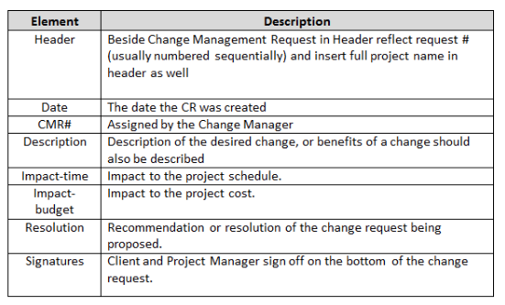equest Form.

# Progress/Status Reporting

Four status reports will be created by the project team and delivered on the following dates: January 20, January 27, February 3, February 10 of 2017. The project manager will review and forward these reports to the client and project sponsor.

The purpose of the Progress/Status Reporting is to report on project health, the dates the team is driving towards and the progress made so far. It will include, in point form, an overview of progress, budget, outstanding issues and recommended action, change requests and plans for the next period.

An example of a Progress/Status Report is included below.

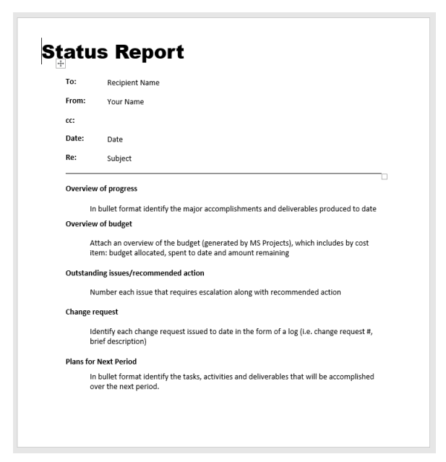

# Decision Making

Due to time constraints, decision making must be rapid. Ideally, decisions should be made as soon as team members are able to discuss the issue. In cases where research or client input is required, a twenty-four-hour maximum turn-around time is. Below are three scenarios designed to provide structure to our decision making:

* If a change requires a budget increase, the client/project sponsor will need to sign off on it.

* If the client rejects a proposed solution, appropriate team members will convene, re-evaluate the situation, devise a new or modified solution with client input and resubmit with approval from the project manager.

* In case of disagreement among team members on such matters as interpreting business rules, solution development or prioritizing workflow, the final decision will rest with the project manager, with further input from the client when applicable.

# Appendix A

**Team Charter**

|  |  |
| --- | --- |
| Section | Discussion Guidelines |
| Member Contact Information | *Bryan MacFarlane*, [bmacfarlane10169@hollandcollege.com](mailto:bmacfarlane10169@hollandcollege.com)  902-432-4219  *Heather Watterson,* [hwatterson@hollandcollege.com](mailto:hwatterson@hollandcollege.com)  902-303-2649  *Jonathan Deschene,* [jdeschene@hollandcollege.com](mailto:jdeschene@hollandcollege.com)  902-303-2702  *Noah Gallant*  [ngallant112507@hollandcollege.com](mailto:ngallant112507@hollandcollege.com)  902-439-0654  *Shane Arsenault*  [sarsenault112452@hollandcollege.com](mailto:sarsenault112452@hollandcollege.com)  902-303-2424 |
| Communication | Our primary means of communicating with each other will be through email and Google Hangouts, and in person before or after classes. |
| Goals | ➢ The quality of our work and on-time submissions represent the measure of our success.  ➢ Our goal is to achieve a grade of 100%. We would prefer not to achieve less than 85%. |
| Roles & Responsibilities | ➢ Jonathan Deschene has taken on the role of project manager.  ➢ Heather Watterson will act as creative director and as an analyst/developer.  ➢ Bryan MacFarlane, Noah Gallant and Shane Arsenault will act as analysts/developers.  ➢  ➢ The group will delegate other, more specific roles as the need arises, and as group member strengths and preferences manifest themselves. |
| Team Meetings | Members touch base daily, before or after class. More formal meetings are scheduled as the need arises.  Current scheduled meetings:  Monday 1:00 – 2:30  Tuesday 10:00 – 11:30  Wednesday 2:30 – 4:00  Thursday 10:00 – 11:30  Friday 1:00 – 2:30    ➢ Meeting agendas will be determined through email at least 24 hours prior to the meeting.  ➢ The project manager will lead the meetings.  ➢ We will keep track of our decisions and agreed upon actions through personal note taking.  ➢ Meeting attendance will be monitored by the project manager who will address attendance issues should they arise.  ➢ Valid excuses for missing or being late to a meeting include injury, illness or a family emergency.  ➢ Because team members study at the same campus, all meetings will be held in person.  ➢ If repeated absences/lateness becomes an issue, the offending member will be held accountable by the project manager. |
| Decision-Making | Ideally, decisions will be made based on consensus after constructive debate and fact-finding. In the case of unresolved disagreements, executive decision lies with the project manager.    As Heather Watterson is acting as our client, we will consult with her whenever a decision requires client input. We may also request input from our project sponsor, Gerald Caissy. |
| Team Project Contribution  &  Member Accountability | All work will be reviewed by the project manager prior to submission. Additional proof-reading/editing by other members will be provided when the need arises.  ➢ All team submission will be required prior to the deadline. If a submission is not ready, the group will convene to discuss the best course of action. This action may include assisting the team member whose work is not ready.  ➢ Individual members will be rewarded for outstanding contribution through a glowing peer-review.  ➢ A team member will be removed from the group only in the unlikely circumstance that he or she fails to contribute to the project. |
| Conflict | An effort will be made to deal with conflict within the confines of the group. |
| Revisiting & Revising the Team Charter | We will reevaluate the charter on Jan 16 2016, if revisions are required. |