# New Century Health Center

# 

# New Century Information System

Prepared By: Heather Watterson

Jonathan Deschene

Bryan MacFarlane

Date: 16 December 2016

# APPROVAL

Anita Davenport, Office Manager (aka Gerald Caissy, Client Liaison)

New Century Information System

(NCIS)

This document is to receive the approval of the person(s) in charge of the upcoming project, to confirm that they approve of the plans laid within this document. If signed, they take responsibility for all changes proposed within and agree that they have read them over thoroughly and fully. If the changes proposed within are accepted, please date and sign at the bottom of this document to confirm moving forward with the project as outlined.

__________________ ___________________

Client Date

__________________ ___________________

Project Manager Date

# Document Tracking

|  |  |  |  |  |
| --- | --- | --- | --- | --- |
| Version | Document Name | Date | Author | Comment |
| 1 | NCIS Design Document | Dec 15, 2016 | Heather Watterson | Created Design Document |
|  |  |  |  |  |
|  |  |  |  |  |
|  |  |  |  |  |
|  |  |  |  |  |
|  |  |  |  |  |
|  |  |  |  |  |

Table of Contents

New Century Health Center 1

New Century Information System 1

APPROVAL 2

Document Tracking 3

Management Summary 6

System Overview 8

System Goal Statement 8

System Deliverables/Assumptions/Constraints 9

Part 1: System Deliverables 9

Part 2: Assumptions 9

Part 3: Constraints 10

System Key Requirements 11

System Modelling 13

Part 1: System Event Table 13

Part 3: Four Use Cases 16

System Component Details 30

Program Design 30

Output Design 38

Input Design 44

Database Design 48

Support Processing Design 57

Environmental Requirements 58

Implementation Requirements 58

Appendices 61

Context Diagram 61

# Management Summary

This document outlines the purpose of the New Century Information System (NCIS) project as well as the features which shaped its design. It contains four sections following this summary: System Overview, System Component Details, Environmental Requirements and Implementation Requirements. These sections will be discussed below.

The purpose of this project is to provide a system which will enable New Century Clinic to transition from its current paper-based information system to an electronic information system. It will provide software which will allow New Century to store, retrieve, add, update and delete data about its patients, appointments, providers, services, bills, payments and insurance reporting. The system will enable the Clinic to produce patient invoices and various other reports, such as the daily Patient List. It will also provide official, as well as ad hoc, printouts when needed, in a simple and efficient way.

Following this summary, the proposed system is presented in detail. The System Overview includes a restatement of the project objectives, an outline of the requirements and constraints which shaped the design process and the assumptions that were made during our work, based on the information provided. As part of this analysis it contains models and charts which cover four essential use cases.

The System Component Details section of the document presents several other models such as a design class diagram, three-layer sequence diagrams, and report and interface mock-ups. It also contains a fully-realized entity-relationship database model and database language documentation to accompany it.

Hardware, software and staffing considerations are presented in Environmental Requirements, while the final section, Implementation Requirements, covers data conversion, security, system changeover and training requirements. An appendix is included after this section.

# System Overview

## System Goal Statement

This project will develop an electronic information system for New Century Clinic to replace the paper-based system it currently employs. In doing so, the project will combine the Clinic’s patient record, billing and scheduling systems into a unified whole. As such, it will be used primarily by the office staff, however, it will benefit all stakeholders at the Clinic through enhancing information management. The Clinic itself will benefit from improved productivity and cost savings.

The system will provide the user with a main interface through which he or she can access additional interfaces allowing the user to create, display or modify patient, appointment, billing, insurance and payment information. An onsite database will store the Clinic’s data; however, a second offsite database will be employed to ensure that no data is lost in the event of system failure. The system will provide automatic accounting calculations such as bill totals and household balances. It will also generate seven essential reports, such as an automatically generated monthly Statement, based on internal and external events.

## System Deliverables/Assumptions/Constraints

### Part 1: System Deliverables

The system must be able to produce these seven reports:

* Daily Patient List (Report 1).
* Daily Patient Call List (Report 2).
* Weekly Provider Report (Report 3).
* Monthly Statement (Report 4).
* Weekly Insurance Company Report (Report 5).
* Monthly Claim Status Summary (Report 6).
* Bi-monthly appointment Reminder Postcards (Report 7).

### Part 2: Assumptions

Assumptions made during this project include the following:

* Unique identifiers are automatically generated.
* If the provider scheduling sub-system is to be included in this system, it will be addressed in another iteration and has therefore been omitted from this document (see Session 4).
* Each appointment must, and can only, have a single provider and a single service each. Additional services, even if offered by the same provider, require additional appointments (for billing purposes). These appointments can be scheduled back-to-back, appearing to the patient as a single appointment, if necessary.
* Patient, household and Insurance Company information is taken from the application the patient filled out prior to their first appointment.
* Within this initial iteration, New Century Health Clinic does not treat patients who are not covered by medical insurance.
* A medical specialty can have many providers; however, a provider can have only one medical specialty.
* A medical specialty can have many services; however, a service can have only one medical specialty.
* The Clinic can restrict existing patients from accessing services (for instance, due to an overdue balance exceeding a pre-set Clinic maximum).
* The Clinic can have services in its system that are not currently offered (consider the possibility of the Clinic waiting to fill a position of a recently terminated provider who supplied a unique service).
* All insurance claims created by Insurance Reporting and Accounting clerk (Tom Capaletti) are automatically and immediately submitted to the appropriate insurance company.
* The reverse is not true; that is, the insurance company’s response will not update the claim status in the system automatically. Tom Capaletti must do that manually.
* The statement (report 4) is automatically generated *at the end* of every month.

### Part 3: Constraints

Below are the constraints which have shaped the proposed design:

* Services rendered to a patient are charged to that patient’s ‘household.’
* Patients belong to households in a many-to-one relationship.
* Every household must have a ‘head’ who is responsible for paying the outstanding balance.
* All patient insurance claims must be created by the Insurance Reporting and Accounting clerk (Tom Capaletti) and then submitted to the appropriate insurance company.
* A patient’s bill is applied to the household which that patient belongs to, whether the patient is the head of that household or not.
* A bill can be paid by the household a patient belongs to, by the insurance company the patient is covered by or through a combination of both.
* Because the Clinic employs providers who offer different services, it is not only true that a provider can have many patients but that a patient can have many providers.
* The system must be able to generate the seven reports outlined above.

## System Key Requirements

The system is expected to manage data (add/edit/delete/view), generate pre-defined and ad hoc reports and accept data entry. It should also support the input, output, data processes and security requirements stated below.

The system must enable the following:

* Outputs
* Produce the seven reports listed above.
* Display patient records information.
* Display billing, payment and insurance information.
* Display appointment scheduling information.
* Display provider and service information.
* Inputs, data and Processes (interfaces must enable the following):
* Enter and edit patient details.
* Enter and edit patient household details.
* Enter and edit employer details
* Enter and edit appointment details.
* Enter and edit medical provider details.
* Enter and edit medical service details.
* Enter and edit insurance company details.
* Enter and edit insurance policy details.
* Enter and edit insurance claim details.
* Enter and edit bill details.
* Enter and edit payment details.
* Calculate the household balance.
* Calculate the number of household payments.
* Calculate the bills, payments and insurance claims totals.
* Security
* Storage and transmission of data must employ HIPAA compliant encryption.
* Firewalls.
* Network- and host-based intrusion detection systems.
* A synchronized backup database located off-site.
* Access control and authentication controls.
* User account monitoring and transaction logging.
* On-site server stored in a locked room that provides the proper HVAC environment and an uninterrupted power supply.

## System Modelling

### Part 1: System Event Table

The table below provides an overview of the use cases directly related to producing the seven essential reports. Not every use case is included here. For instance, the system must be able to create, update and delete insurance companies and their insurance policies, which is not shown below. Furthermore, while the use case *Add patient* is included, *Update patient* and *Delete patient* have not been included, even though this functionality will eventually be required. These use cases have been omitted to save space and to keep initial focus on generating the seven essential reports which form the core of the design. The next iteration will see the below table flushed out further.

|  |  |  |  |  |  |
| --- | --- | --- | --- | --- | --- |
| Event | Trigger | Source | Use Case | Response | Destination |
| 1) Susan Gifford adds a new patient | Create patient | Susan Gifford | Create patient | Patient created confirmation | Susan Gifford |
| 2) Lisa Sung schedules an appointment | Create appointment | Lisa Sung | Create appointment | Appointment created confirmation | Lisa Sung |
| 3) Lisa Sung requests Calling List (Report 2) | Produce Calling List | Lisa Sung | Generate a new Calling List | Calling List | Lisa Sung |
| 4) Time to generate Appointment Reminder Postcards (Report 7) | “Twice a month” | Lisa Sung | Generate Appointment Reminder Postcards | Appointment Reminder Postcards | Lisa Sung |
| 5) Time to generate Appointment List (Report 1) | “Beginning of the day” |  | Generate Appointment List | Appointment List | A provider |
| 6) Tom Capaletti creates bill | Create bill | Tom Capaletti | Create bill | New bill created confirmation | Tom Capaletti |
| 7) Tom Capaletti creates a new insurance claim | Create insurance claim | Tom Capaletti | Create insurance claim | New insurance claim creation confirmation | Tom Capaletti |
| 8) Tom Capaletti submits insurance claim | Submit insurance claim | Tom Capaletti | Submit insurance claim | Insurance claim submission confirmation | Insurance company |
| 9) Time to generate Statement (Report 4) | “End of month” |  | Generate Statement | Statement | Tom Capaletti |
| 10 Time to generate Insurance Company Report (Report 5) | “End of week” |  | Generate Insurance Company Report | Insurance Company Report | Carla Herrara |
| 11) Time to generate Claim Status Summary (Report 6) | “End of month” |  | Generate Claim Status Summary | Claim Status Summary | Carla Herrara |
| 12) Time to generate Provider Report (Report 3) | “End of week” | Appointment summary data submitted | Generate Provider Report | Provider Report | Fred Brown |

Part 2: System Class Diagram

More detailed versions of this diagram will appear later in this document; however, the structure will remain the same. Of note is the Household entity which works well for limiting data duplication in the case of multiple patients living in the same home. The restricted field in the Patient is defaulted to false. This field safeguards against accidently scheduling an appointment for a patient who is not permitted services due, most likely, to billing issues.



### Part 3: Four Use Cases

#### A: Create patient use case

One of the chief functions of the system is to create and store new patient data. Creating a patient involves adding a patient to a household. If the patient’s household does not exist in the system, it must be created during the patient creation process. The patient’s insurance policy must also be added to the patient at this time, however, insurance policies have been added to the system prior to creating a new patient.

Use case diagram for ***Create patient***



Fully developed use case description for ***Create patient***

This table flushes out the above model and gives a step-by-step breakdown of the use case. In the Preconditions section, we see that the accepted insurance policies have already be established within the system. The clerk will simply select one of these when creating the new patient.

|  |  |  |
| --- | --- | --- |
| **Use case name:** | *Create patient*. | |
| **Scenario:** | Create a new patient. | |
| **Triggering Event:** | Patients Records clerk (Susan Gifford) wants to add a new patient. | |
| **Brief description:** | Patients Records clerk (Susan Gifford) wants to add a new patient to the system so that appointments can be scheduled and bills generated for that person. | |
| **Actors:** | Patients Records clerk (Susan Gifford). | |
| **Related use cases:** | A precondition for the *Schedule appointment* use case (Patient). | |
| **Stakeholders:** | Providers, office clerks, patients. | |
| **Preconditions:** | A patient must belong to a ‘household’ through which the patient is contacted and billed.  A patient must be covered by one of the 34 different insurance policies accepted by the Clinic. | |
| **Postconditions:** | Patients must be created and saved.  Household and insurance policy must be associated with the patient. | |
| **Flow of activities:** | **Actor** | **System** |
| 1. Clerk indicates desire to create patient and enters basic patient information.  2. Clerk enters the patient’s household or creates a new one.  3. Clerk selects the patient’s insurance policy. | 1.1 System creates a new patient.  1.2 System prompts clerk to enter the patient’s household.  2.1 System adds household to the patient.  2.2 System prompts clerk to select the patient’s insurance policy.  3.1 System adds insurance policy to the patient.  3.2 System returns valid patient account details. |
| **Exception**  **Conditions:** | 1.1 Basic patient data is incomplete.  2.1 Household data is incomplete or invalid.  3.1 Insurance policy is invalid for that patient (i.e. due to age, region, employer, etc.). | |

Activity diagram for ***Create patient*** use case

Both this and the following diagram illustrate the process of creating a new patient in different ways.

Later development (see section 3.a.) see the steps for this use case further simplified.



Sequence diagram for ***Create patient*** use case



#### B: Create appointment use case

Use case diagram for ***Create appointment***

To create a new appointment, the clerk must add basic scheduling information as well as a patient, a medical service (the ‘treatment’ to be provided), and a medical professional to provide the service. Once this information has been entered in the appointment interface, a new appointment can be scheduled.



Fully developed use case description for ***Create appointment***

Three of the Clinic’s essential reports depend directly on this use case.

|  |  |  |
| --- | --- | --- |
| **Use case name:** | *Create appointment.* | |
| **Scenario:** | Schedule a new appointment. | |
| **Triggering Event:** | Appointments clerk (Lisa Sung) wants to schedule a new appointment. | |
| **Brief description:** | Appointments clerk (Lisa Sung) wants to schedule a new appointment in the system, granting the requesting patient access to the providers and services offered by the clinic. | |
| **Actors:** | Appointments clerk (Lisa Sung). | |
| **Related use cases:** | A precondition for producing theDaily Appointment List, Call List and Reminder Postcards reports. | |
| **Stakeholders:** | Providers, office clerks, patients. | |
| **Preconditions:** | A patient must have already been successfully created in the system. | |
| **Postconditions:** | Appointments must be created and saved.  Providers and services must be associated with the appointment. | |
| **Flow of activities:** | **Actor** | **System** |
| 1. Clerk indicates desire to create appointment, adds patient and enters basic appointment information.  2. Clerk selects the patient requested service(s).  3. Clerk selects the appointment’s provider. | 1.1 System creates a new appointment and adds patient to the appointment.  1.2 System prompts clerk to select the patient requested service(s).  2.1 System adds service to the appointment.  2.2 System prompts clerk to select the appointment’s provider.  3.1 System adds provider to the patient.  3.2 System returns valid appointment account details. |
| **Exception**  **Conditions:** | 1.1 Basic appointment data is incomplete. The patient is restricted from receiving Clinic services (see Assumptions).  2.1 The service is not currently offered (see Assumptions).  3.1 The provider is not currently available. | |

Activity diagram for ***Create appointment***use case

In order to create the appointment, the clerk should be able to pull existing patient, provider and service

information from the database through intuitive search controls.



Sequence diagram for ***Create Appointment*** use case

Showing the information sent by the clerk and returned by the system.



#### C: Create bill use case

Use case diagram for ***Create bill***

A bill must be created before a statement can be sent to the patient. However, bills aren’t generated automatically by the system in the way that statements are. Rather, they must be manually created by the accounting clerk.



Fully developed use case description for ***Create bill***

|  |  |  |
| --- | --- | --- |
| **Use case name:** | *Create bill.* | |
| **Scenario:** | Create a bill for appointment service charges. | |
| **Triggering Event:** | Accounting clerk (Tom Capaletti) wants to create a bill for the service charges of an appointment. | |
| **Brief description:** | A bill must be confirmed manually by the Accounting clerk, for a patient, on or after the date of that patient’s appointment. | |
| **Actors:** | Accounting clerk (Tom Capaletti). | |
| **Related use cases:** | A precondition for the *Generate invoice* use case. | |
| **Stakeholders:** | Providers, office clerks, patients. | |
| **Preconditions:** | An appointment must have already been successfully created in the system. | |
| **Postconditions:** | Charges must be applied to the patient’s household account (a bill is created). | |
| **Flow of activities:** | **Actor** | **System** |
| 1. Clerk indicates desire to create bill based on an appointment. | 1.1 System creates bill and applies the charges to the balance on the patient’s household.  1.2 System returns bill creation confirmation. |
| **Exception**  **Conditions:** | 1.1 Appointment has been rescheduled. | |

Activity diagram for ***Create bill***use case

The following two models are quite simple, representing the simplicity, if not the importance, of this use case. The clerk should be able to search for the appointment in question and create the bill by clicking a button, reviewing the pre-populated information, and then clicking a Submit button to save the bill to the database.



Sequence diagram for ***Create bill*** use case

Because the bill is linked to the appointment to which the bill will be applied, all or most relevant

information will be prepopulated from the appointment, into the bill interface fields, when the clerk is

ready to submit the bill.



#### D: Create insurance claim use case

The ***Create insurance claim***use case is accomplished through the Bill interface on which an option exists to create a new claim. Choosing this option opens a new “Create insurance claim” interface with prepopulated patient, household, provider, service, charge, insurance company and insurance policy fields. The clerk may have to do little more than click on a “Create Insurance Claim” button to create the claim.

Use case diagram for ***Create insurance claim***



Fully developed use case description for ***Create insurance claim***

|  |  |  |
| --- | --- | --- |
| **Use case name:** | *Create insurance claim* | |
| **Scenario:** | Insurance Reporting clerk (Tom Capaletti) wants to create a new insurance claim. | |
| **Triggering Event:** | Insurance Reporting clerk (Tom Capaletti) creates a new insurance claim. | |
| **Brief description:** | Once the service charges have been confirmed and the bill generated, an insurance claim needs to be created manually. | |
| **Actors:** | Insurance Reporting clerk (Tom Capaletti). | |
| **Related use cases:** | A precondition for the *Submit insurance claim* and *Generate Claim Status Summary* use cases. | |
| **Stakeholders:** | Providers, office clerks, patients. | |
| **Preconditions:** | A bill must have already been successfully generated by the system. | |
| **Postconditions:** | Insurance claim must be created and saved.  Bill and insurance policy must be associated with the claim. | |
| **Flow of activities:** | **Actor** | **System** |
| 1. Clerk indicates desire to create a new insurance claim. | 1.1 System creates a new insurance claim.  1.2 System returns insurance claim details. |
| **Exception**  **Conditions:** | 1.1 Patient, household, insurance company or insurance policy this process draws on have become invalid since the bill was created. | |

Activity diagram for ***Create insurance claim***use case



Sequence diagram for ***Create insurance claim*** use case



# System Component Details

### Program Design

#### Part I: Design Class Diagram

This diagram presents a picture of the system only insofar as it creates the 7 essential reports. Therefore, it does not contain controllers for Providers, Services, Insurance, etcetera (features which will be added during the next iteration), but only those relevant to the use cases discussed in 2.d. of this document. Missing from the class diagram are the entities Employer, Insurance Company, Payment and Medical Specialty as they are not needed in the four use cases and their corresponding sequence diagrams below.



#### Part 2: Four use cases

1. Three-tier Sequence diagram for *Create patient* use case

The ability to create and/or add an Employer (every Household needs one) and an Insurance Company (every Employer needs one) has been left out in the interests of space. ‘Create household’ is a use case inextricably tied to the use case ‘create patient’ and therefore is included in the above diagram. ‘Create household’ cannot happen outside the ‘create patient’ use case.



2. Three-tier Sequence diagram for *Create appointment* use case

In the initial appointment interface, there is a place to put the patient’s SIN (or name). The system is used to search for the patient based on this information. It then returns the patient and the patient’s attributes (as well as all other relevant information, such as Household to which the patient belongs), populating any necessary fields, such as telephone number and street address, which the clerk can verify with the patient. The clerk repeats similar steps with provider and service. “Patient details,” “service details,” and “provider details” are used in place of the actual attribute names due to space constraints. Please see the Design Context Diagram for the fields that could be included in these details.



3. Three-tier Sequence diagram for *Create bill* use case (formerly *Confirm charges* use case)

Perhaps the easiest way to create a bill during an appointment is to go through the appointment view, as shown above. Once the clerk has picked the desired appointment, there will be several options such as ‘attended,’ ‘rescheduled,’ and ‘create bill.’ Clicking on the last of these three will do the following and create a bill. Although this is shown from the appointment view, there will also be a separate bill view, that can be accessed from the main system view, enabling the user to create a new bill or adjust the bill fields as needed.



4. Three-tier Sequence diagram for *Create claim* use case

A control on the main interface will allow the user to create a new claim. Activating the control will prompt the user to enter the bill number, houseID and other search options. The bill draws from the appointment fields which in turn draws from the service, provider, household, insurance company, insurance policy and patient fields to prepopulate most of the insurance claim fields. The user reviews this information which, if confirmed, generates a new claim that is saved to the database.

Alternatively, the user can access the claim view through the bill menu of the customer account in question. This should populate a variety of related fields, some of which are needed to create the claim, such as the patID, billNum and procdrCode. The user fills out the rest of the fields and submits the claim. A new claim is created and saved to the database.



#### Part 3: Three-layer package diagram

The below diagram separates the functionality of the previous models into the view, business and data layers. Every window has a corresponding handler and every handler has a corresponding schema. In decoupling the view layer from the data layer, we create a more robust, maintainable and scalable system.



#### Part 4: Three-layer internet architecture diagram

The diagram below illustrates the physical structure of the system. Note that two separate databases are shown in this model. Even if it is decided that we should build the application from scratch, outside cloud storage will be necessary to ensure the data is safe in the event of an onsite system catastrophe.



### Output Design

1. Daily Schedule (per provider)

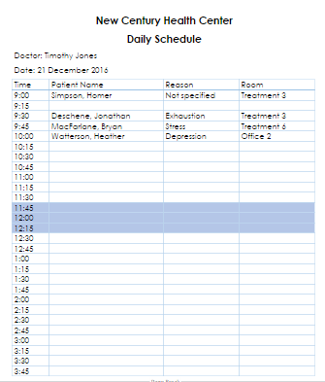

SYSTEM DOCUMENTATION

NAME OF SYSTEM                         DATE                                                 Page 1 of 1

Scheduling                                                December 15, 2016

ANALYST                                         PURPOSE OF DOCUMENTATION

            Heather Watterson                              Report of Doctor Schedule Report

                         FIELD                         FIELD TYPE             FIELD LENGTH

                        Doctor Name              Alphanumeric              30

                        Schedule Date            Date/Time                   10 (dd/mm/yyyy)

                        Patient Name             Alphanumeric              30

                        Appointment Time    Date/Time                    7 (00:00 am or pm)

                        Reason                        Alphanumeric              30

                      Room Number          Alphanumeric              10

COMMENTS:

1.      Patient Name field is derived from concatenation of First Name and Last Name

2.      Time slots where treatment provider is unavailable for appointments will be shaded out in blue (grey when printed in black & white).

SORT SEQUENCE:

Appointments will be listed in a chronological order only.

TOTALS REQUIRED:

            No totals required.

MEDIA:

            8.5 * 11 inch white paper.

FREQUENCY:

            Report generated daily for each working service provider.

DISTRIBUTION:

Printed and distributed in staff mailboxes by 8:30 am every morning.

ATTACHMENTS:

            Report mock-up attached

1. Daily Appointment Call List

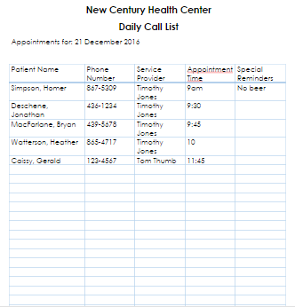

SYSTEM DOCUMENTATION

NAME OF SYSTEM                         DATE                                                 Page 1 of 1

Scheduling                                                December 15, 2016

ANALYST                                         PURPOSE OF DOCUMENTATION

            Heather Watterson                              Report of Daily Call List Report

                         FIELD                         FIELD TYPE             FIELD LENGTH

                        Schedule Date             Date/Time                   10 (dd/mm/yyyy)

                        Patient Name             Alphanumeric           30

Phone Number           Alphanumeric           10 ((xxx)xxx-xxxx)

Doctor Name              Alphanumeric             30

                     Appointment Time   Date/Time                  7 (00:00 am or pm)

                       Special Reminders    Alphanumeric            30

COMMENTS:

1.      Patient Name field is derived from concatenation of First Name and Last Name

2.      List is a concatenation of all appointments for all service providers for a given day.

3.      Special Reminders column indicates any special instructions the patient needs for the appointment

SORT SEQUENCE:

Appointments will be listed in alphabetical order by last name.  Sort by provider available.

TOTALS REQUIRED:

            No totals required.

MEDIA:

            8.5 * 11 inch white paper.

FREQUENCY:

            Report generated daily.

DISTRIBUTION:

Printed and distributed to receptionists by 8:30 am every morning.

ATTACHMENTS:

            Report mock-up attached.

1. Weekly Provider Report

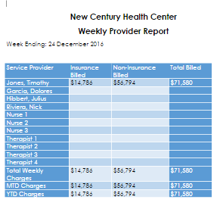

SYSTEM DOCUMENTATION

NAME OF SYSTEM                         DATE                                                 Page 1 of 1

Scheduling                                                December 15, 2016

ANALYST                                         PURPOSE OF DOCUMENTATION

            Heather Watterson                              Report of Weekly Provider Report

                         FIELD                         FIELD TYPE             FIELD LENGTH

Provider Name              Alphanumeric             30

                        Insurance Billed            Currency                      9 (2 decimal places)

                        Non-Insurance Billed    Currency                      9 (2 decimal places)

                        Total Billed                    Currency                      9 (2 decimal places)

                        Total Weekly Charges    Currency                      9 (2 decimal places)

                        MTD Charges                Currency                      9 (2 decimal places)

                        YTD Charges                 Currency                      9 (2 decimal places)

COMMENTS:

1.      Provider Name field is derived from concatenation of First Name and Last Name

2.      MTD Charges and YTD Charges are for overall clinic only.  Can be generated by provider in detailed Billing Report.

SORT SEQUENCE:

Can be sorted alphabetically, by seniority or by revenues generated.

TOTALS REQUIRED:

All fields other than name are totals.  Total Billed is calculated for each provider.  Total Weekly Charges, MTD Charges and YTD Charges are totaled for all providers.

MEDIA:

            8.5 * 11 inch white paper.

FREQUENCY:

            Report generated weekly.

DISTRIBUTION:

Printed and distributed to Owners and Office Manager by 9am Monday morning for previous week.

ATTACHMENTS:

            Report mock-up attached.

1. Monthly Statement

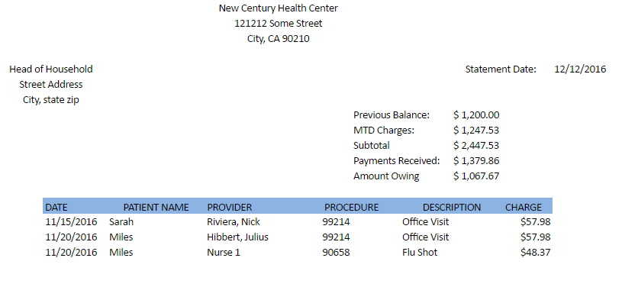

SYSTEM DOCUMENTATION

NAME OF SYSTEM DATE Page 1 of 1

Billing December 15, 2016

ANALYST PURPOSE OF DOCUMENTATION

Heather Watterson Report of Monthly Statement Report

FIELD FIELD TYPE FIELD LENGTH

Head of Household Alphanumeric 30

Street Address Alphanumeric 30

City Alphanumeric 15

State Alphanumeric 2

Zip Alphanumeric 10

Previous Balance Currency 9 (2 decimal places)

MTD Charges Currency 9 (2 decimal places)

Payments Received Currency 9 (2 decimal places)

Amount Owing Currency 9 (2 decimal places)

Date Alphanumeric 10 (mm/dd/yyyy)

Patient Name Alphanumeric 10

Provider Alphanumeric 30

Procedure Alphanumeric 5

Description Alphanumeric 50

Charge Currency 9 (2 decimal places)

COMMENTS:

1. Statement Date is generated and printed in Upper Right corner of report.

2. Head of Household field is derived from concatenation of First Name and Last Name

3. Procedure refers to CPT code

4. Description is Description of Procedure from CPT database

SORT SEQUENCE:

Individual charges are listed in chronological order.

TOTALS REQUIRED:

MTD Charges and Amount Owing are calculated.

MEDIA:

8.5 * 11 inch white paper.

FREQUENCY:

Report generated monthly.

DISTRIBUTION:

Printed and mailed to customers.

ATTACHMENTS:

Report mock-up attached.

### Input Design

1. Create/Edit Patient

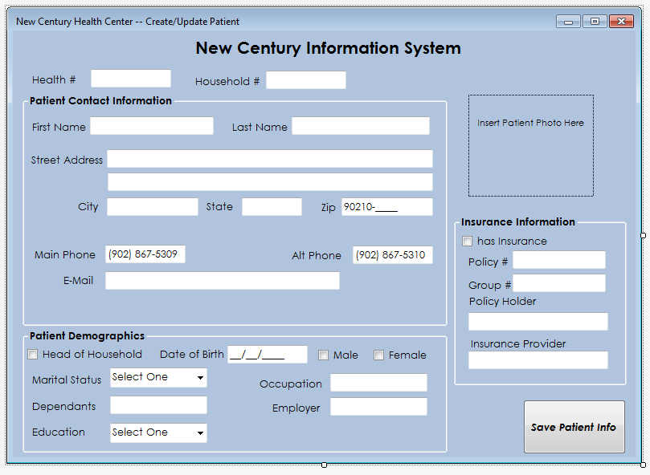

* When patient first comes to clinic, or their information changes, the Patient Records Manager will create/edit their file using this screen.
* If the patient already exists in the database a dialog window will alert the user and ask if they wish to edit the existing client or create a new one.
* Patient must provide their Health Card as verification of identity.
* Patient photo can be added to create a secondary client verification method.

1. Patient Check-In

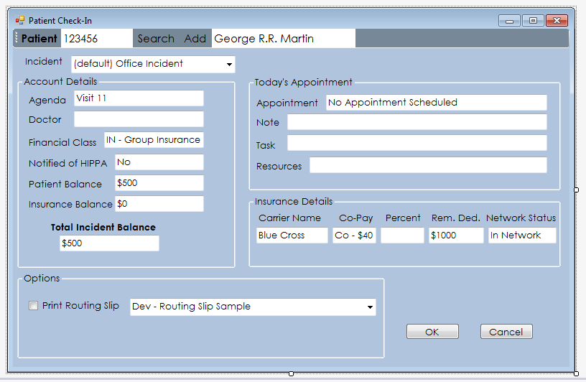

* When patient comes in for visit they must present their Health Card for identification purposes.
* The receptionist will fill out the reason for the visit, the doctor or other service provider being seen and any other pertinent details for the visit.

1. Insurance Registration

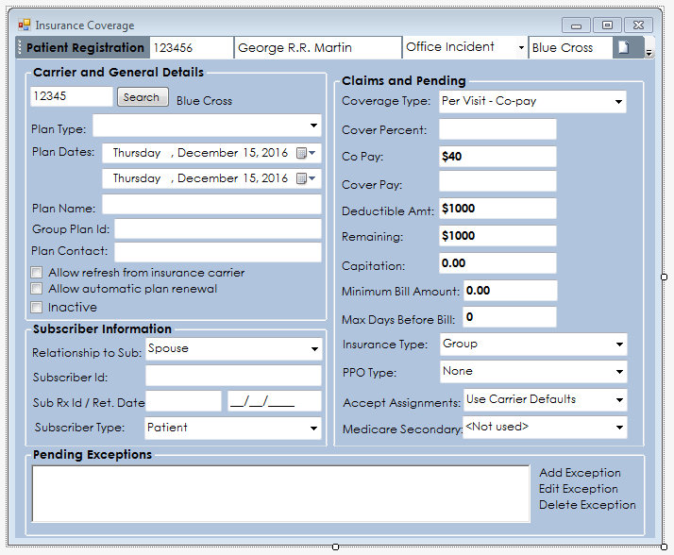

* When a patient is added to the system, or they add Insurance to their file, the basic information is added at the Create/Edit Patient Screen. The appropriate insurance company is contacted electronically and the information regarding the patient’s insurance coverage is populated into this screen.

1. Appointment Scheduling

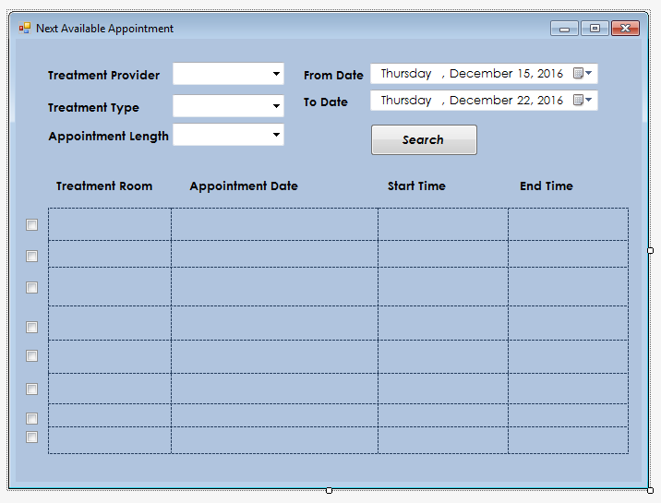

* The main scheduling window will be a calendar view. This screen will allow a second quicker option for scheduling.
* If treatment provider or treatment type is not specified, the available appointments will include all types.
* If there are no appointments available in the selected date range, a dialog window will prompt for a change of range or change of provider/type.

### Database Design

#### Part 1: Detailed ERD



In order to create a new Patient and Household, the head of the Household’s Employer, that Employer’s Insurance Company, and the Patient’s Insurance Policy all must have been created first. Once this is done, a Patient can fill out an Appointment Form (over the phone or in person). The Appointment Form creates an Appointment, to which there is always a Provider and a Service attached. The Provider and Service are linked through the associative entity Medical Specialty. An Appointment generates a Bill which in turn generates an Insurance Claim that is linked to the Patient’s Insurance Policy. The Insurance Company can submit a Payment to the Bill, based on the Insurance Claim. The Household can also submit a Payment to the Bill.

#### Part 2: Database Design Language Documentation

Database Design Language Documentation

1.

Appointment (AppntNum, ProvID, ServiceNum, AppntDate, AppntTime,

AppntRom, AppntLength, Attended, Rescheduled, BillCreated)

FK ProvID -> Provider

FK ServiceNum -> Service

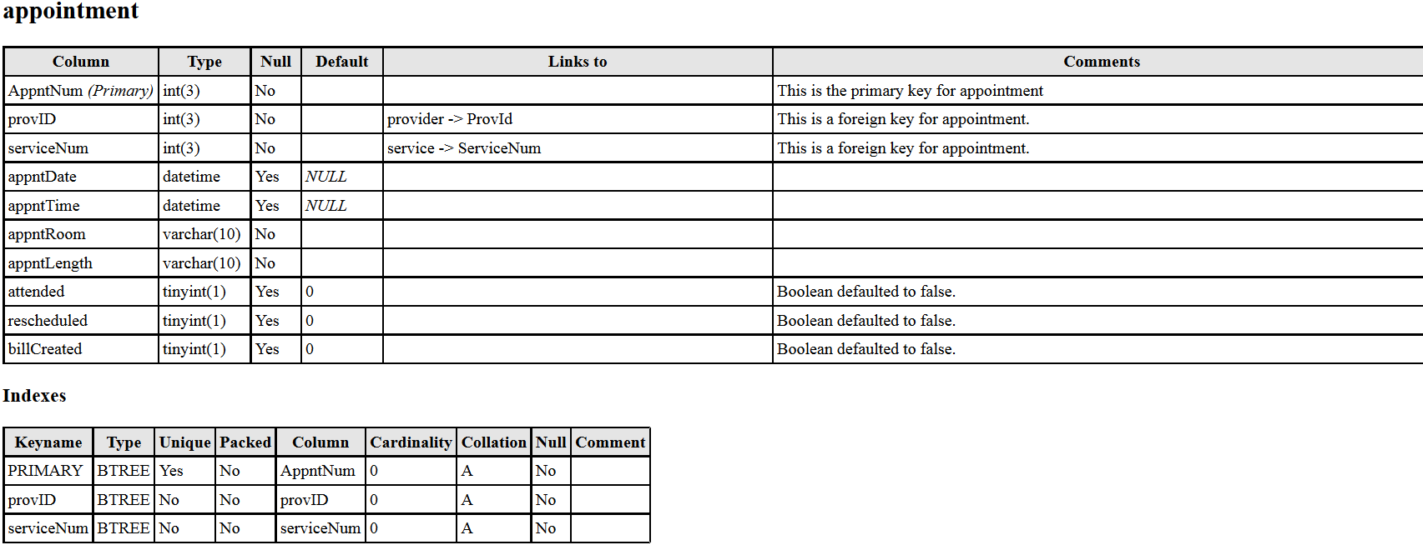

2.

AppointmentForm (AppntNum, PatID)

PK AppntNum -> Appointment

PK PatID -> Patient

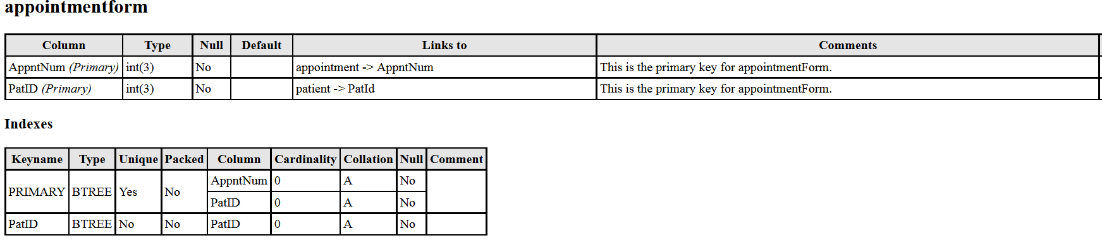

3.

Bill (BillNum, AppntNum, BillDate, BillCharge, BillTax, BillTotal)

FK AppntNum -> Appointment

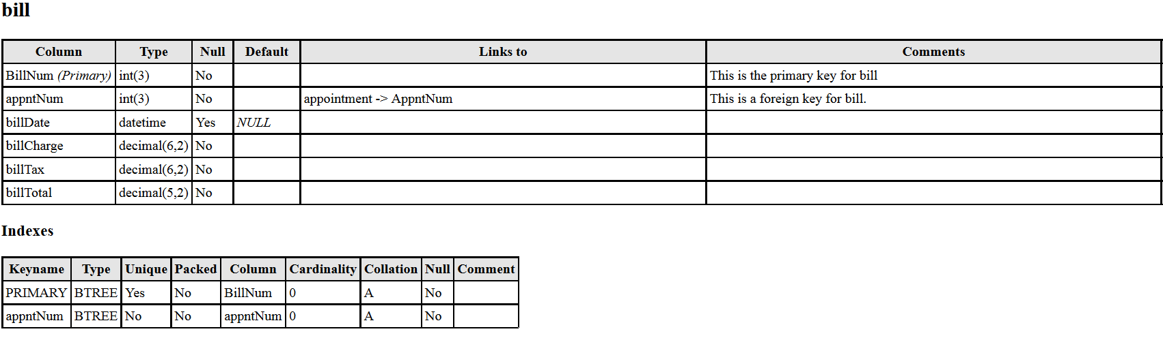

4.

Employer (EmplyrID, EmplyrName, InsurID, EmplyrStreet, EmplyrCity,

EmplyrState, EmplyrZIP, EmplyrPhone, EmplyrEmail)

SK EmplyrName

FK InsurID –> InsuranceCompany

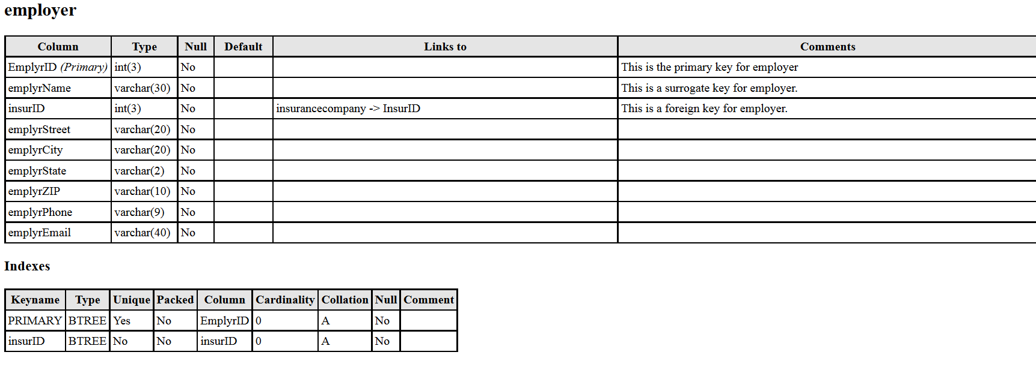

5.

Household (HouseID, HouseHeadLName, InsurID, HouseHeadFName

HouseStreet, HouseCity, HouseState, HouseZIP, HousePhone,

HouseEmail, Balance)

SK HouseHeadLName

FK EmplyrID –> Employer

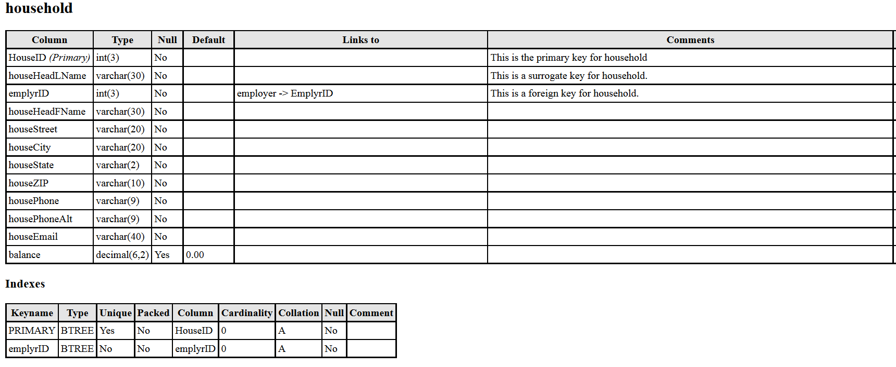

6.

InsuranceClaim (ClaimNum, CoverageType, PolicyNum, BillNum,

CoveragePercent, CoveragePay, DeductibleAmount, Remaining, ClaimDate)

SK CoverageType

FK PolicyNum -> Policy

FK BillNum -> Bill

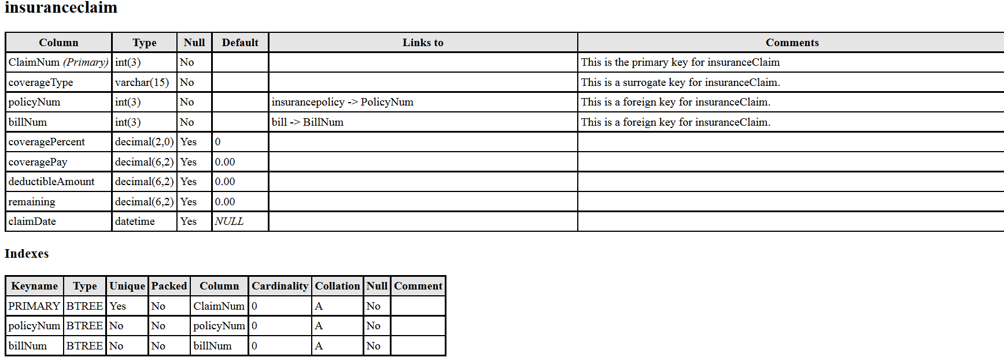

7.

InsuranceCompany (InsurID, InsurName, InsurStreet, InsurCity, InsurState,

InsurZIP, InsurPhone, InsurEmail)

SK InsurName

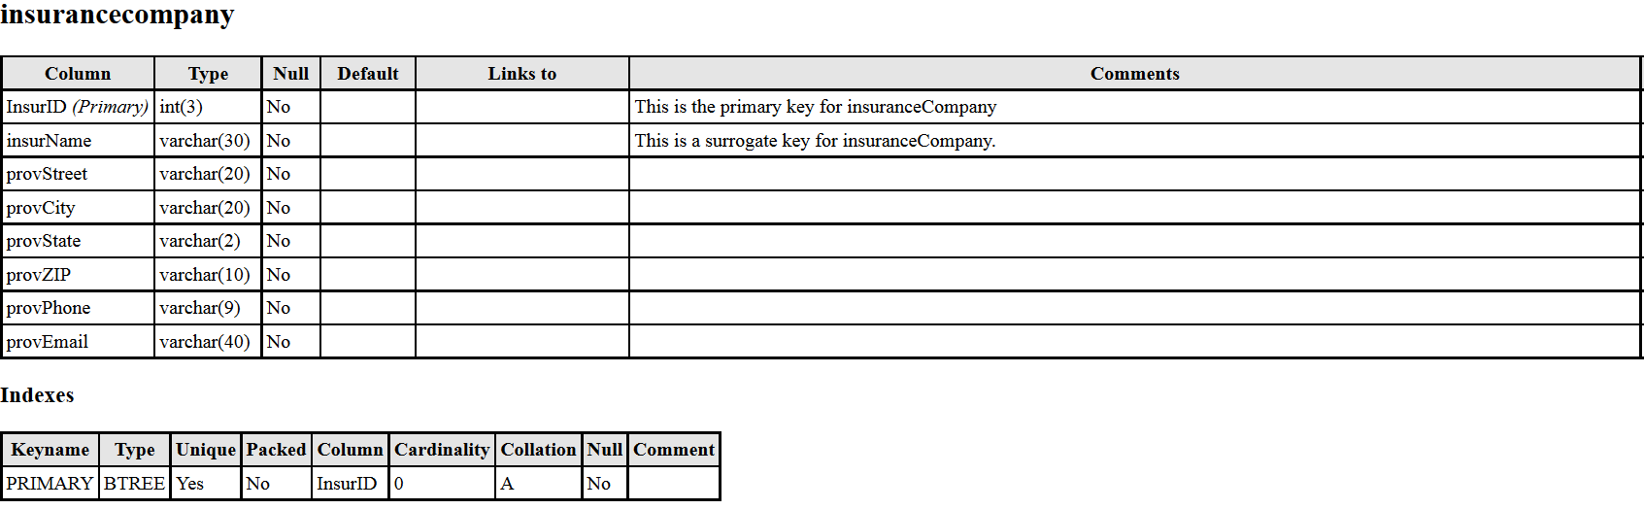

8.

InsurancePolicy (PolicyNum, PolicyName, PolicyType, InsurID, PolicyDateTo,

PolicyDateFrom)

SK PolicyName

SK PolicyType

FK InsurID -> InsuranceCompany

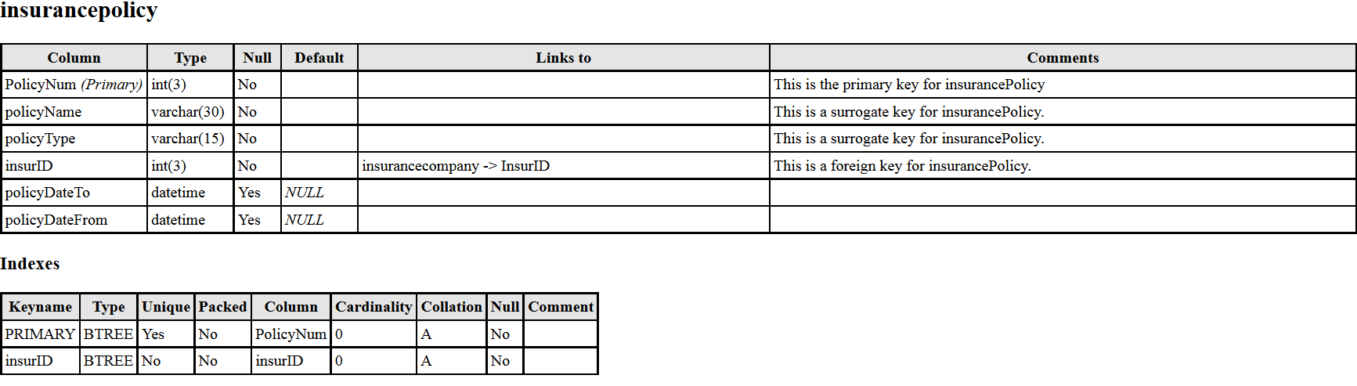

9.

MedicalSpecialty (ProvID, ServiceNum, SpecialtyName)

PK ProvID -> Provider

PK ServiceNum -> Service

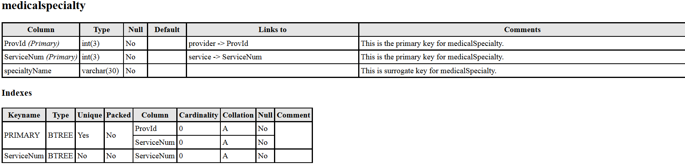

10.

Patient (PatID, PatSSN, HouseID, PolicyNum, PatLName, PatFName, PatMInitial,

PatDOB, Restricted)

AK PatSSN

FK PolicyNum -> InsurancePolicy

FK HouseID -> Household

SK PatLName

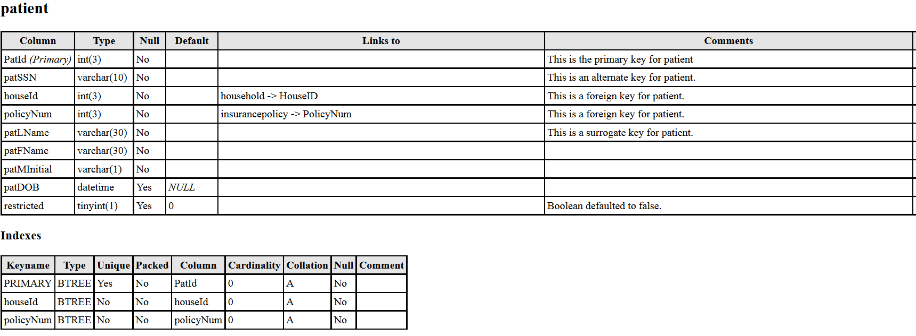

11.

Payment (PayNum, HouseID, InsurID, BillNum, PayDate, PaySource, PayAmount,

Partial, ExplanationCode)

FK HouseID -> Household

FK InsurID -> InsuranceCompany

FK BillNum -> Bill

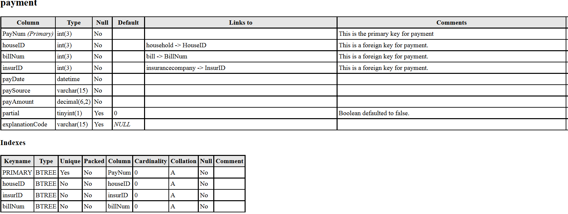

12.

Provider (ProvID, ProvSSN, ProvLName, ProvFName, ProvMInitial, ProvTitle,

ProvStreet, ProvCity, ProvState, ProvZIP, ProvPhone, ProvPhoneAlt, ProvEmail)

AK ProvSSN

SK ProvLName

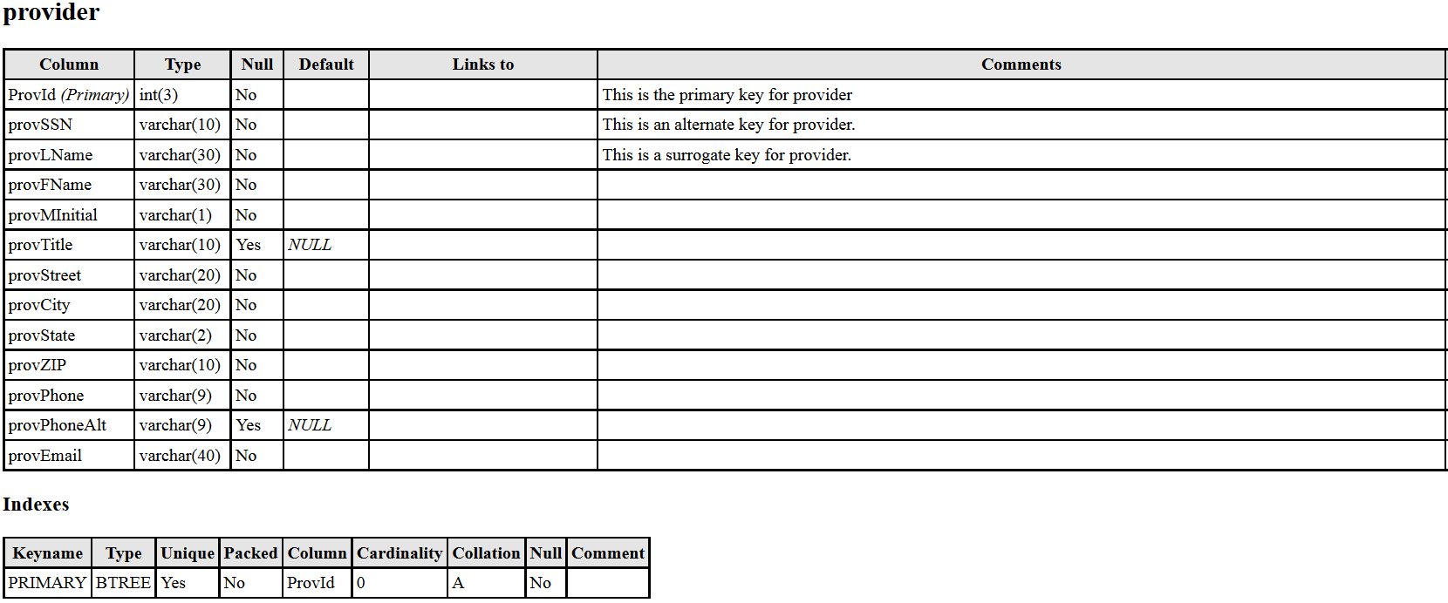

13.

Service (ServiceNum, Cpt, ServiceName, Description, Charge, Offered)

SK ServiceName

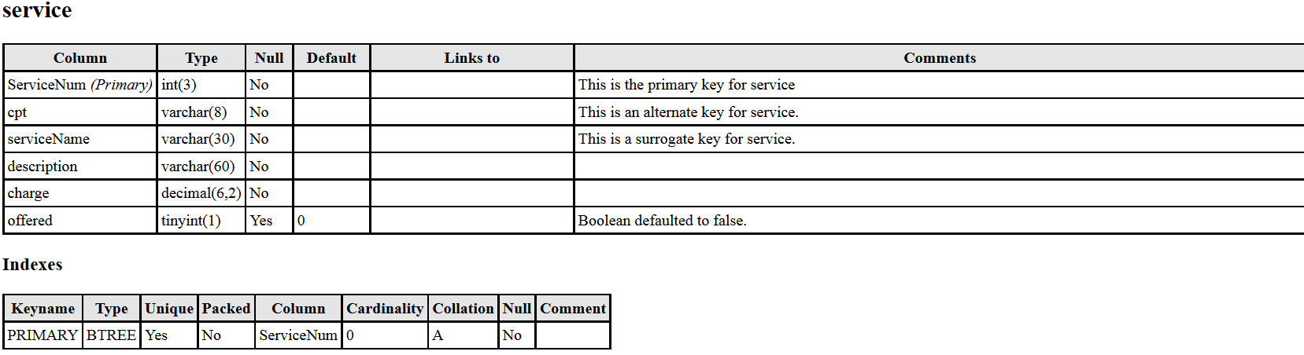

#### Part 3: Final Database User View

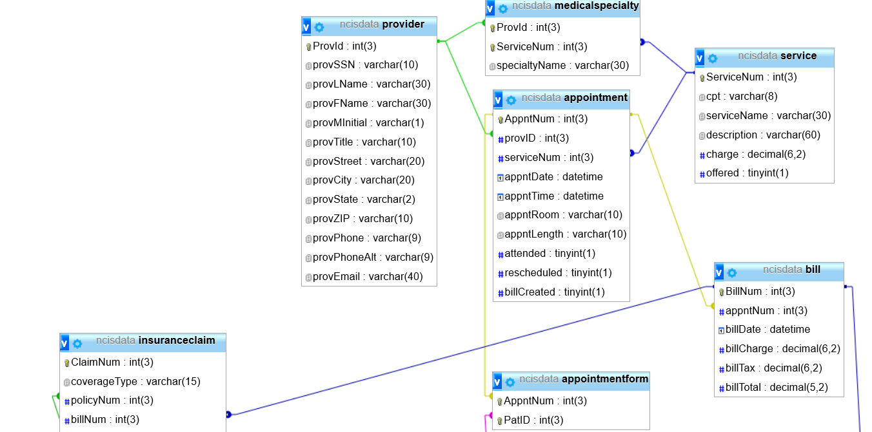

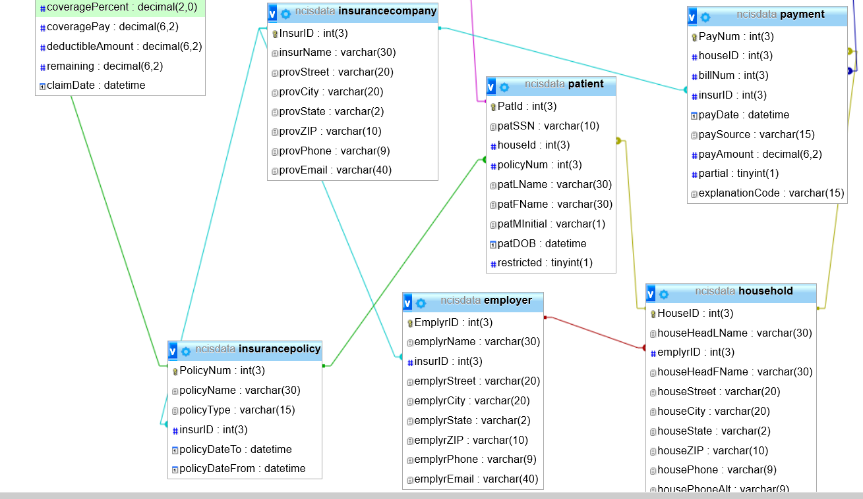

### Support Processing Design

No forms will need to be created to support the new system at this time. If it becomes apparent that there is a need for a formal document, the employee who is operating in the role of Database Manager will create the form and the documentation to address it.

Policies regarding User Access, Acceptable Use (of computers and Internet) and Security will need to be created. Patient Privacy Policy will need to be updated. All policies will reflect HIPPA compliance.

# Environmental Requirements

The new system will require a new server and four personal computers which will be set up on a local area network. A high-speed laser printer and an impact printer that can handle multipart forms will be connected as well. A high-speed modem that can exchange data with insurance companies will be provided by their internet service provider.

All new hardware will operate on the Windows 10 operating system. Future development could allow for providers to access their schedules and patient files from hand-held tablets that would work on the secure Wi-Fi signal within the facility.

The clinic will require some minor renovations to create a secure Server Room. Offices will need to be outfitted for the addition of the computers and the entire clinic will require Ethernet cabling.

There is no additional staff required for the new system.

# Implementation Requirements

Data conversion and data entry:

The system should use a PACs system to convert all the paper files over to computer. All new patient information will be entered into the system instead of creating a paper file. When an existing patient comes in for an appointment their system file will be created and their paper file will be converted to digital. This will allow for general housekeeping of the file system and the client base.

Security considerations and levels of access:

The server room will be locked and only authorized personnel will be able to access it. It will also be equipped with a built-in fire suppression system. All information on the system will be backed up daily, with a weekly back-up copy being stored off-site every Friday afternoon.

Each employee of the clinic will be given a unique username and password. We will be assisting them in generating the passwords to ensure its complexity. User accounts will be monitored by the system and stored in a space only the database administrator can access. The network will have security measures which include firewalls, network and host-based intrusion detection systems, and encrypted connections.

System changeover recommendation:

Initial implementation should begin with the patient records and scheduling modules, followed closely by the insurance reporting and financials. Full implementation should take no more than two weeks.

Each staff member will receive 10 hours of initial training and support, including a one-day workshop with all staff in attendance, as well as additional weekly training as needed for the first three months following implementation.

Once the new system is up and running, it will need routine maintenance, updating, and file backups. This can be assigned to the employee who is operating in the role of Database Manager. Additional training and support will be provided.

# Appendices

## Context Diagram

