**IE4717 Web Application Design – Project Report (Design)**

**Design project group number: F35-DG15**

**Team members:** Shannen Leong Xuan Ern

Loh Yi Hui

**Project Title:** Atlantic Cinema

**Summary of Project:** A website where the users able to buy tickets, know which of the movies have released or coming soon and able to make payment as well.

1. Application Requirements and Specifications

R1: Home page with image slider which consist of movie posters, movie posters have shown Now Showing and Coming Soon.

R2: Movies page consists of movie posters for Now Showing and Coming Soon.

R3: Buy Tickets page with movie posters for Now Showing and able to buy tickets from there.

R4: Cart page with movie poster, title/name, date, time, quantity and total price.

R5: User details page with user needs to fill up his/her particular and card details.

R6: Company‘s contact details page

1. Functional Requirements and Specifications

F1: A form allow user to fill up his/her particular and card details.

F2: A submit/reset button after the user have filled up the form and direct to the payment successful with confirmation email or payment unsuccessful page with try it again.

F3: Add to Cart Page requires a select tag for date and time.

F4: A add to cart button will require to direct to cart page.

F5: A Go to checkout button will require to direct to User Details page to enter his/her particular.

1. Design of the web application

a) Site Map

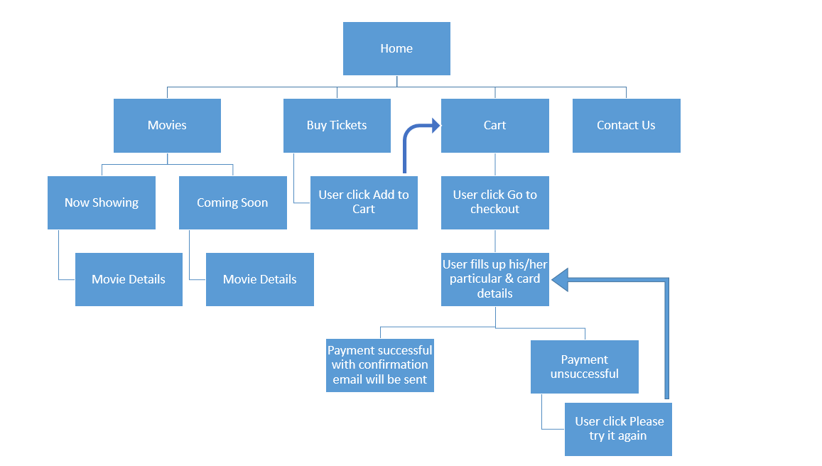

b) Story Boards

Scenario 1: User click any Movie Poster at the Home Page, it directs the user to Movie Details

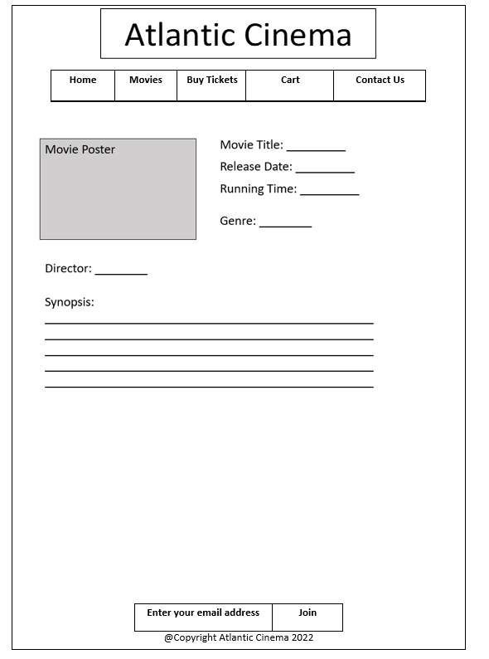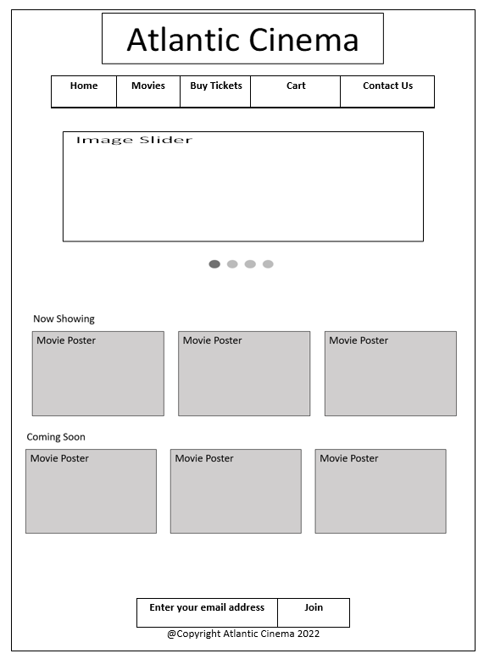

Scenario 2: User click any Movie Poster at the Movies Page, it directs the user to Movie Details

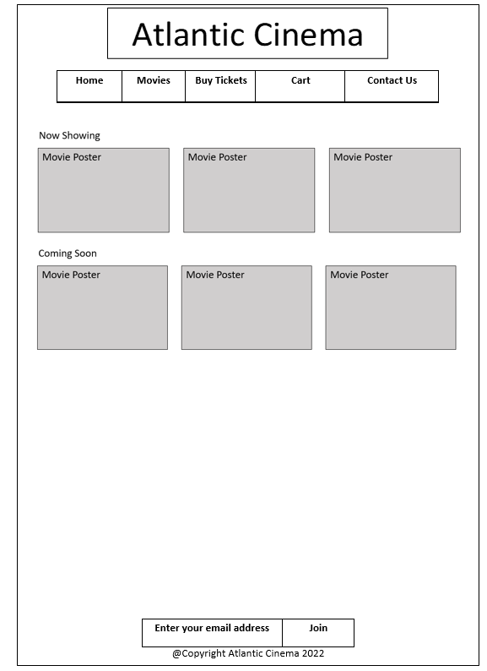

Scenario 3: User wants to buy tickets with one individual movie screening and make payment.

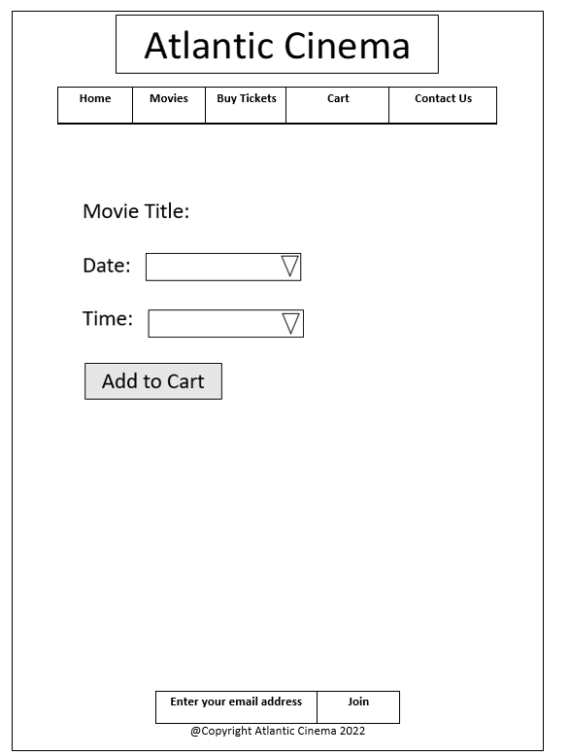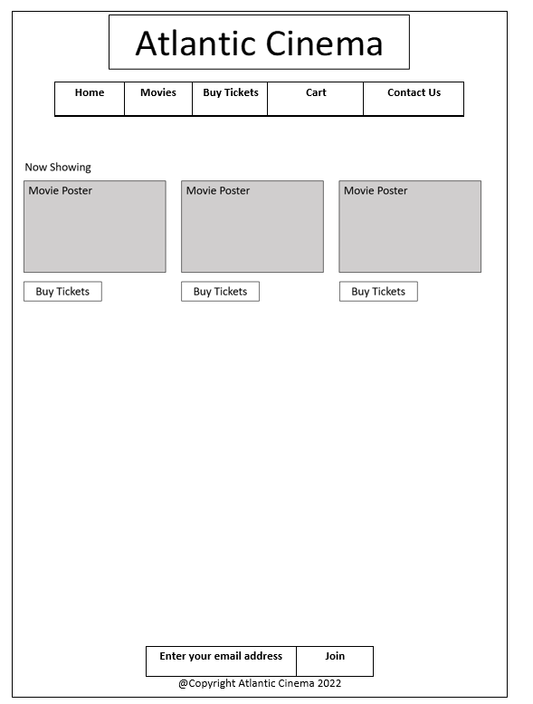

After user have selected his/her Date and Time and click add to cart, it directs user to Cart Page

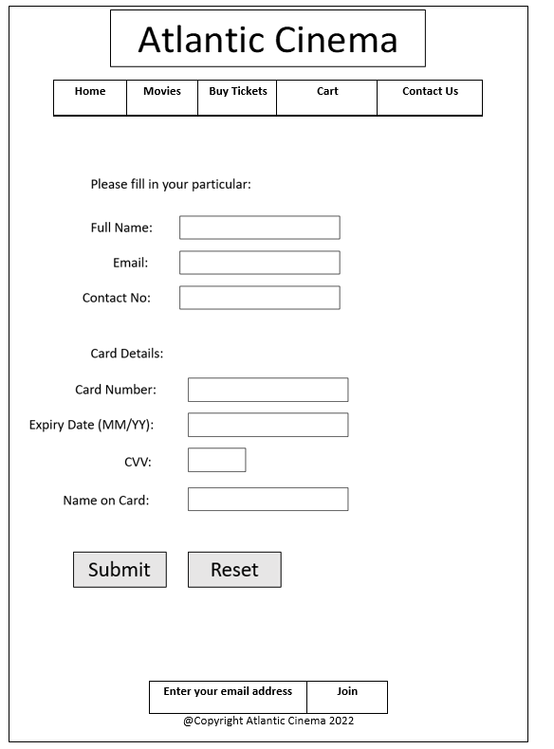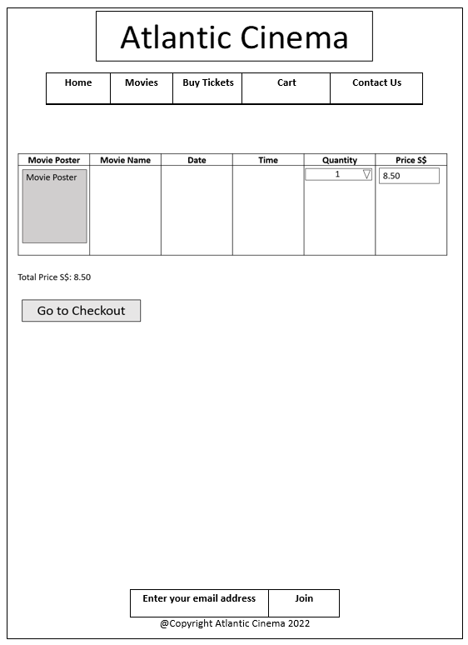

After user have clicked Go to Checkout, it directs user to User details page.

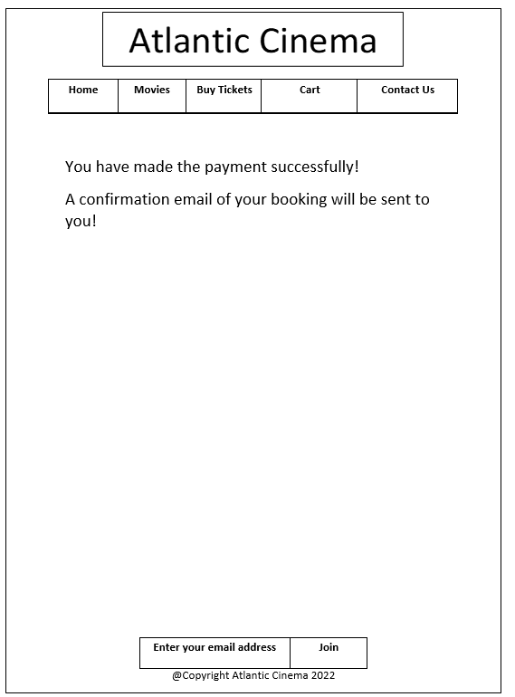

After user have clicked submit button, it directs user with Payment Successful Page.

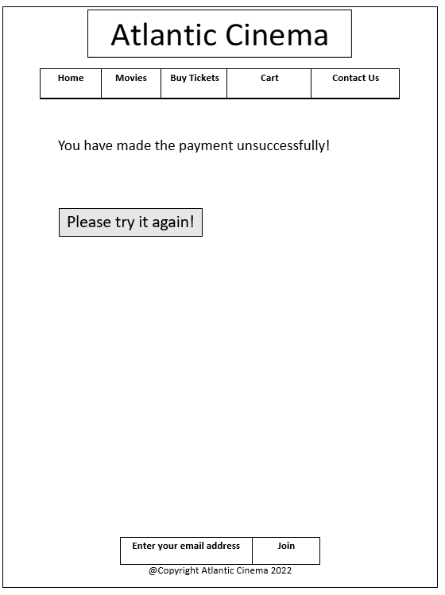

If user have clicked submit button if enter wrongly, it directs user with Payment Unsuccessful Page. User have to click Please try it again button to re-enter his/her details again.

Scenario 4: User wants to buy tickets with two movie screening and make payment.



After user have selected his/her Date and Time and click add to cart, it directs user to Cart Page



User have to click Buy Tickets that located at the navigation bar.



After user have selected his/her Date and Time and click add to cart, it directs user to Cart Page

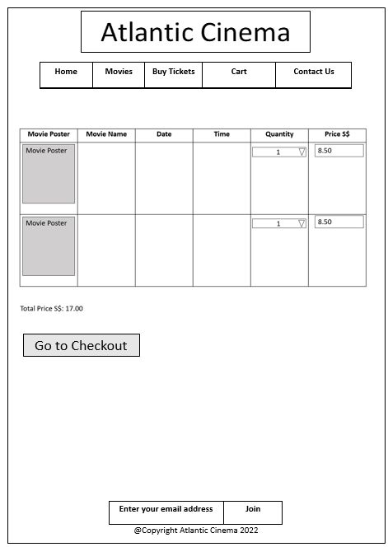

After user have clicked Go to Checkout, it directs user to User details page.



After user have clicked submit button, it directs user with Payment Successful Page.



If user have clicked submit button if enter wrongly, it directs user with Payment Unsuccessful Page. User have to click Please try it again button to re-enter his/her details again.

Scenario 5: User do have any enquires, he/she will click contact us on navigation bar.

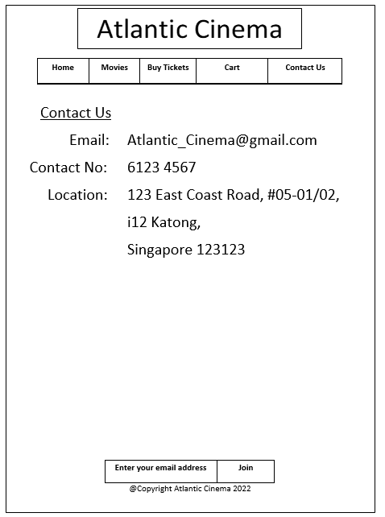

c) Wireframes

**Home page**



**Movies Page**



**Movie Details Page**



**Buy Tickets Page**



**Add to Cart Page**



**Cart Page**



**User details Page**



**Payment Successful Page**



**Payment Unsuccessful Page**



**Contact Us Page**

