Line is defined as

Point is

Let’s do this for lines and one point.

Mathematica

What is ?

Propose we have a collection of lines with

Let’s expand :

We can see that

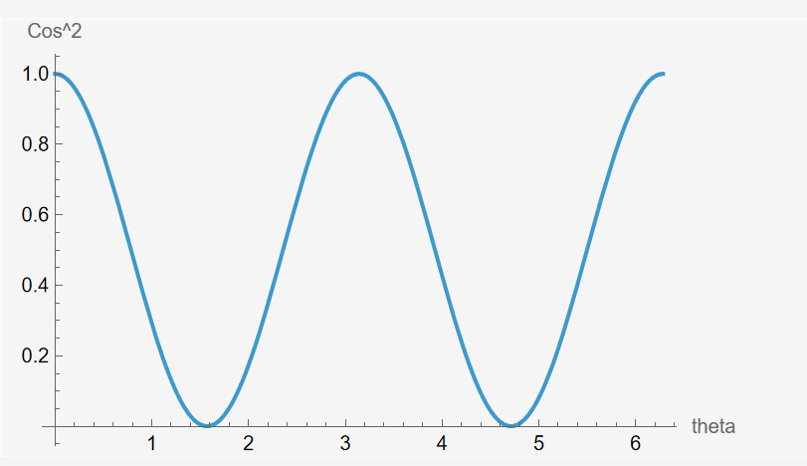

And that

And that