Shane Ferrell, Jenna Sheldon, Sergio Bustamente

EEL4598 Fall 2023

Lab 1 Report

The Lab 1 demo recordings can be found here:

Part 1 <https://youtu.be/EyCEkO0lNiU>

Part 2

Part 3

or in the Lab repository: <https://github.com/shaneferrellwv/computer-communications-labs/tree/main/lab01>

**Summary**

This lab included the exploration or ping, ICMP, and traceroute by observing them in action with the Wireshark tool.

**Part 1: ICMP and Ping**

Wireshark was used to observe packets on the network resulting from the ping command “ping -n 10 www.ust.hk”. This command sends 10 ping messages to a web server at Hong Kong University of Science and Technology. The resulting output is shown in Figure 1.

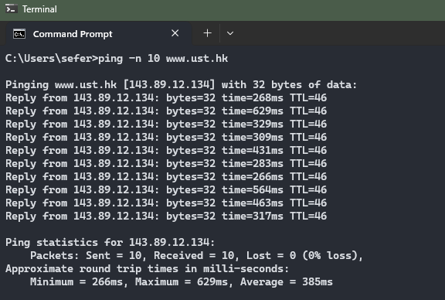

Figure : Output resulting from ping command.

The list of ICMP packets captured by Wireshark following the ping command are shown in Figure 2.

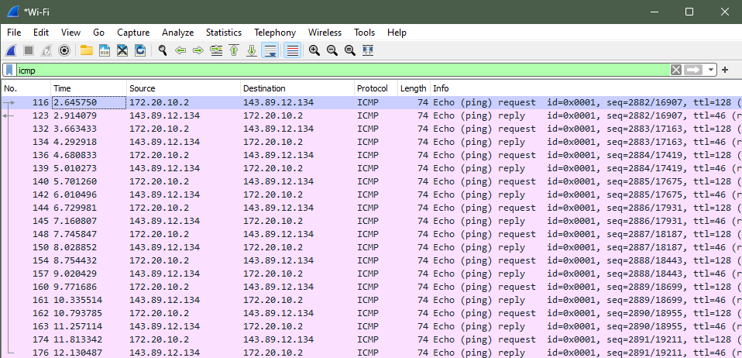

Figure : Captured ICMP packets resulting from ping command.

Details of the first packet are shown in Figure 3. The IP address of the host, listed in the Source Address field, is 172.20.10.2. The IP address of the destination host, listed in the Destination Address field, is 143.89.12.134.

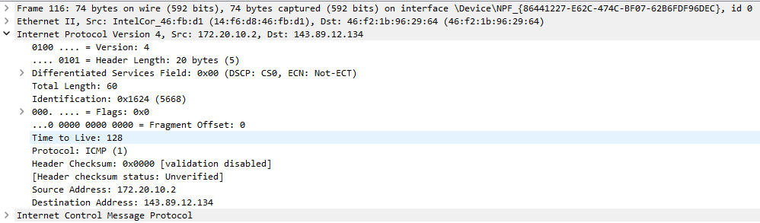

Figure : Details of first ICMP packet resulting from ping.

These ICMP packets lack source and destination port numbers because ICMP is a Network Layer protocol. ICMP is typically used for delivering error and control messages, while ports are typically associated with the transport layer.

Details of the ICMP for the first packet are shown in Figure 4. The ICMP type is 8 (Echo (ping) request) and the code number is 0. The packet also contains a checksum, two identifiers, and two sequence numbers which are represented by two bytes each.

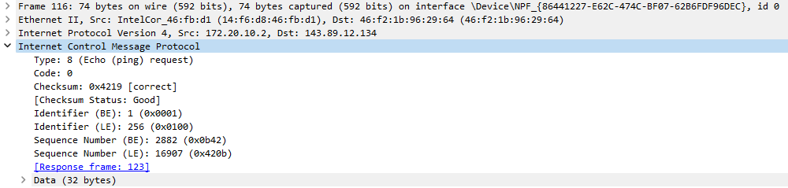

Figure : Details of the ICMP packet.

Details of the ICMP for the reply packet are shown in Figure 5. The ICMP type is 0 (Echo (ping) reply) and the code number is 0. The packet also contains a checksum, two identifiers, and two sequence numbers which are represented by two bytes each.

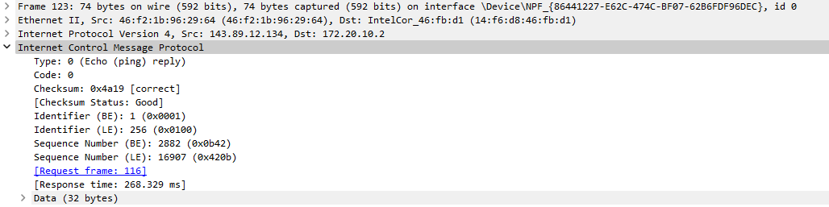

Figure : Details of the ICMP reply packet

**Part 2: ICMP and Traceroute**

Using the native Windows Command Prompt, we accessed the Tracert tool to analyze the path of a packet sent to a router located at a research institute in Paris, France. The tracert command sends three packets through a series of routers to their target destination and reports the roundtrip time between the source and each of these routers. We can use this information to identify possible sources of latency and packet loss. Figure 1 shows the result of running the tracert command with the target destination domain of www.inria.fr.

Figure 6. Output of tracert command set to destination www.inria.fr

Here we observe that the IP address of the source host is 10.138.101.230, and the IP address of the destination host is 128.93.162.83.

Figure 7. Wireshark capture incoming and outgoing ICMP packets

Expanding the ICMP dropdown menus confirms that the assigned protocol number of ICMP packets is 1, regardless of the type. If UDP packets were sent instead such as in a Unix/Linux system, the protocol number of the probe packets would be 0x11, or 17, because that is the assigned protocol number for UDP packets. Although the tracert program produces a different reply packet than the ping command used in part 1, the outgoing request packets are nearly identical. The only noticeable difference between the ICMP echo packet and the ICMP ping packets is the length of each packet. The echo packets are each 106 bytes, 32 bytes larger than the ping packets. Opening the details of the echo packets reveals that the data encapsulated by an echo packet is 64 bytes, whereas each ping packet only contains 32 bytes of data. Other than the size of the data, the fields are organized identically.

Figure 8. Echo (ping) request ICMP packets fields using tracert program

Compared to the ICMP echo packet, the ICMP error packet has an additional 28 bytes. These 28 bytes contain information about the echo packet that was sent out. The 20 bytes shown in figure 9 contain the IP header information, and the 8 bytes following the header information are the 8 bytes corresponding to the fields of the echo packet. This is the case for the error packet shown, but some of the other error packets have variations in length.

Figure 9. An additional 20 bytes corresponding to the header information of the echo request packet. The rest of the bytes contain the fields of the original echo request packet, including the data.

The last three ICMP packets are type 0, echo (ping) reply packets instead of type 11, time-to-live (TTL) exceeded packets. These echo reply packets signify that the echo request packets have made it all the way to their destination. These packets appear once the tracert program has found a data path through few enough connections to reach the destination before the TTL counter reaches 0.

Figure 10. Echo reply packet information

We refer to figure 6 to note that there is a significant latency increase between hops 19 and 20 for each of the three packets sent. The router names indicate that a router located in Washington, DC is trying to send the packet to a router in London. Transatlantic communication will inherently have a high latency due to long distances between routers. Based on the router names displayed by the tracert command, it can be inferred that the host router is located somewhere on UF’s campus, and the destination router is located at the INRIA research institute in France.

**Part 3: ICMP and Traceroute using Pingplotter**