**Assignment 4 Pets-R-Us, Part 1**

**Instructions**

**~~Part 1: Repository Setup~~**

1. ~~Create new GitHub repository and name it pets-r-us.~~
2. ~~Clone the repository to your local computer.~~

**~~Part 2: Project Setup~~**

1. ~~Initialize the pets-r-us project using the npm init command.~~

**Additional Programming Requirements**

1. ~~Set the author’s name to your name.~~
2. ~~Set the license to MIT.~~
3. ~~Remove the test script.~~
4. ~~Add a script to start the application using the keyword start. Use node to start the application.~~
5. ~~Add a script to start the application using the keyword dev. Use nodemon to start the application.~~
6. ~~Install the following dependencies: nodemon, ejs, and express. Set nodemon as a development dependency.~~
7. ~~Add a folder named views (all EJS views will go here).~~
8. ~~Add a folder named public with nested folders for images and styles (all images and CSS stylesheets will go here).~~
9. Add an index.js file with routes for the applications index.ejs and grooming.ejs views (they should be in the views folder).

**Exhibit 1. Project Folder Structure**

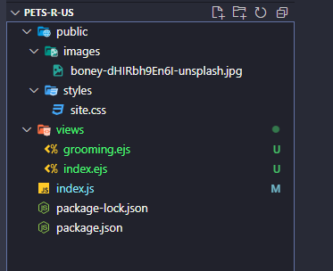

1. Design and build the index.ejs and grooming.ejs pages for the pets-r-us project. At minimum, each page must include a footer, header, text, and styling. Refer to the project’s requirement document for more information on specific requirements. Be sure to add navigation so users can navigate between the two pages (a.k.a., middleware routing).

**Special note.** The courses GitHub repository has several examples of how to create a base Node.js project, which can be located [here](https://github.com/buwebdev/web-340/tree/master/week-4). Once you have accessed the repository, you should view and test the projects in the following order:

* 1. hello-world. This project demonstrates how to create a bare Node.js project. Pay close attention to the package.json file and the “scripts” section. The command to start this project is **npm start** (from the CLI). Also, be sure to review the index.js file for an illustration on how to wire an Express server and how to set the servers PORT value.
  2. hello-views. This project demonstrates how to create a bare Node.js project and how to use routing to display an HTML page. Pay close attention to the package.json file and the “scripts” section. The command to start this project using nodemon is **npm run dev** (from the CLI). Also, be sure to review the index.js file for an illustration on how to display the index.html page. Notice how the code is using the res.render() function. res.render() tells Express what HTML to display. Also, review lines 6-9; this is how you wire EJS templates to HTML pages.
  3. hello-routes. This project demonstrates how to create a base Node.js project and how to use routing to display a variety of HTML pages. Notice how this project has HTML pages for the landing page (index.html), about page (about.html), and contact page (contact.html).
  4. fms. This project follows along with the weekly tasks in the pets-r-us project (with some modifications) and should be used as a reference guide while working on the current week’s assignment.

**Special note**. You will need to understand how these project work to complete this week’s assignment.

**Disclaimer:** no third-party CSS frameworks are allowed. You must write the code yourself.