**Assignment 5 Pets-R-Us, Part 2**

**Instructions**

1. ~~Create two partial views: header.ejs and footer.ejs. Replace the navigation and footer in the inex.ejs and grooming.ejs with the partial views. Moving forward, you will leverage the partial views in each of the pages you build.~~

**~~Special note~~**~~. Chapter 3 (3.5; Guestbook App) of the course’s textbook provides an example of how to create partial views. Additionally, the courses GitHub repository (week-5) has several examples of how to do this.~~

1. Design and build the projects boarding.ejs and training.ejs pages. Be sure to add navigation so users can navigate between the pages.

**Special note.** The courses GitHub repository has several examples of how to create a base Node.js project, which can be located [here](https://github.com/buwebdev/web-340/tree/master/week-5). Once you have accessed the repository, you should view and test the projects in the following order:

* 1. advanced-routing. This project demonstrates how to pass values between routes in an Express application. As you review this project pay close attention to how the fruit’s name is being passed through the req.params object on line 25 of the index.js file. Also, notice how the value is being passed to the route on line 45 of the index.html file. This is the basic process for passing data from an HTML page to an Express route through the req.params object.
  2. if-else-render. This project demonstrates how to use if statements in an HTML page through the EJS template engine.
  3. partial-views. This project demonstrates how to use partial views in an Express application. As you review this project notice how there is a new folder under the views folder called partials. Also, notice the naming conventions used for partial view files. Adding an underscore to the name of a partial view is considered a best practice and something that will be enforced I this course/program. Each of the HTML files (index.html, about.html, and contact.html) have calls to the partial views using the include() function. But, notice how the first argument in the function references the folder where the partial views reside. The first argument in the include() function takes the path where the HTML views are stored.
  4. fms. This project follows along with the weekly tasks in the pets-r-us project (with some modifications) and should be used as a reference guide while working on the current week’s assignment.

**Special note**. You will need to understand how these projects work to complete this week’s assignment.

1. By the end of this week your project folder structure should resemble the following:

**Exhibit 1 Project Folder Structure**

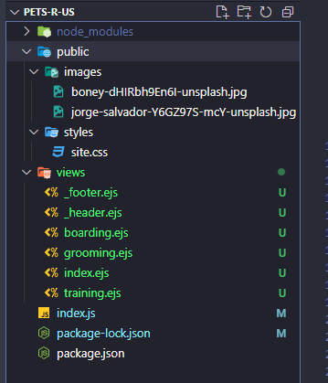

**Disclaimer:** no third-party CSS frameworks are allowed. You must write the code yourself.