**Assignment 6 Pets-R-Us, Part 3**

**Instructions**

**Part 1: MongoDB Atlas Setup**

1. ~~Follow the instructions in the MongoDB Atlas guide and create a new database for the pets-r-us project. Before you proceed to part 2, verify the following has been completed.~~ 
   1. ~~MongoDB Atlas account created.~~
   2. ~~Database created.~~
   3. ~~Custom role created.~~
   4. ~~Custom user created.~~
   5. Customers collection created.

Special note. When you create your web340DB database you will be prompted to create a new database collection. Name it “customers.” This collection will be used in part 2 of this assignment.

**Part 2: Registration**

1. ~~Add a dependency for mongoose (npm package).~~
2. ~~Add a new folder to the pets-r-us project and name it models. All mongoose models will be added to this folder.~~
3. ~~Add a new JavaScript file to the model’s folder named customer.js. And, create a new mongoose model named Customer with properties for customerId and email. Set both properties data types to strings, make them unique, and required.~~
4. Design and build the registration process.

**Additional programming requirements**

1. ~~Build the registration register page. At minimum there should be fields for customerId and email.~~
2. Add an HTTP GET route to display the registration page. This route will display register.ejs.
3. Add an HTTP POST route to handle the registration pages form submission. If the call to the create() function is successful, route users back to the landing page.

**Additional programming requirements**

1. Use Mongoose’s built-in create() function to insert a new customer object into the customers collection.

**Special note.** The courses GitHub repository has several examples of how to create a base Node.js project, which can be located [here](https://github.com/buwebdev/web-340/tree/master/week-6). Once you have accessed the repository, you should view and test the projects in the following order:

* 1. mongoose-connection. This project demonstrates how to connect to MongoDB from Node.js. As you review this project pay close attention to line 6-13.
  2. mongoose-model. This project demonstrates how to create a Mongoose model.
  3. fms. This project follows along with the weekly tasks in the pets-r-us project (with some modifications) and should be used as a reference guide while working on the current week’s assignment. Of particular note this week is the additional lines of code added to the index.js file for urlencoded and json(); lines 15-16.

**Special note**. You will need to understand how these projects work to complete this week’s assignment. That means you should download/clone the repositories, open them in VS Code to review their code bases, and run and test them in a web browser. This is the only way you will fully understand how to interact with a MongoDB database through Express.

1. By the end of this week your project folder structure should resemble the following:

**Exhibit 1 Project Folder Structure**

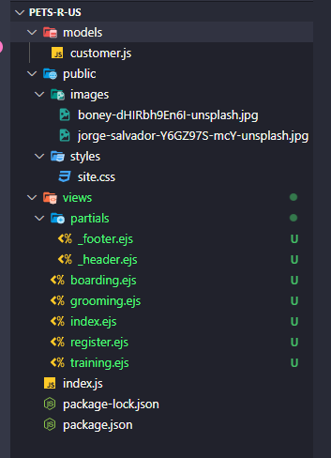

**Special note.** you are building the EJS pages and Node.js routes to interact with the pages. Also, as you can see from the above image, I moved the partial views to a folder named partials. I did this to keep the project organized.