**Assignment 7 Pets-R-Us, Part 4**

**Instructions**

1. Design and build the customer list page/process.

**Additional programming requirements**

1. ~~Build the HTTP GET route to display the customer list EJS page.~~

**Additional programming requirements**

1. ~~Use Mongoose’s built-in find() function to retrieve a list of customer documents.~~
2. ~~Use EJS’s forEach() function to iterate over the returned list of customer documents and display them in the customer-list.ejs page.~~
3. By the end of this week your project folder structure should resemble the following:

**Exhibit 1 Project Folder Structure**

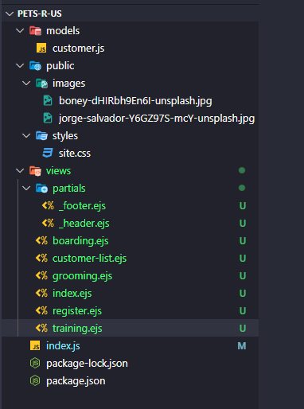

**Special note.** The courses GitHub repository has several examples of how to create a base Node.js project, which can be located [here](https://github.com/buwebdev/web-340/tree/master/week-7). Once you have accessed the repository, you should view and test the projects in the following order:

* 1. fms. This project follows along with the weekly tasks in the pets-r-us project (with some modifications) and should be used as a reference guide while working on the current week’s assignment

**Special note**. You will need to understand how these projects work to complete this week’s assignment.