Assignment 5.3 Personal Portfolio

Shane Hingtgen

2/3/2023

Bellevue University

**Colors:**

**Links hover**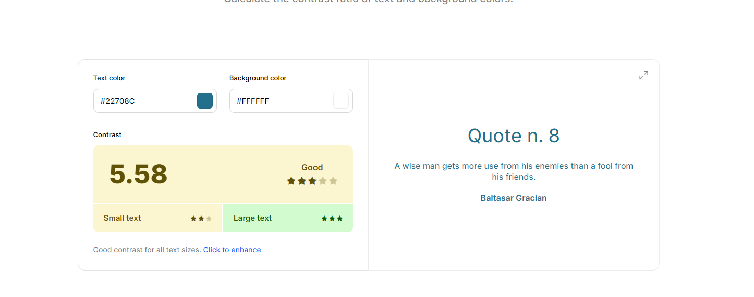

**Borders/accents**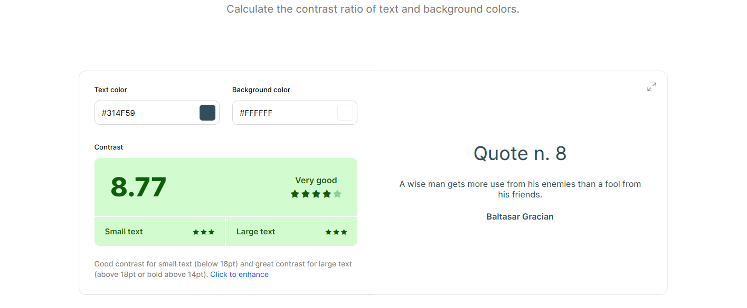

**links**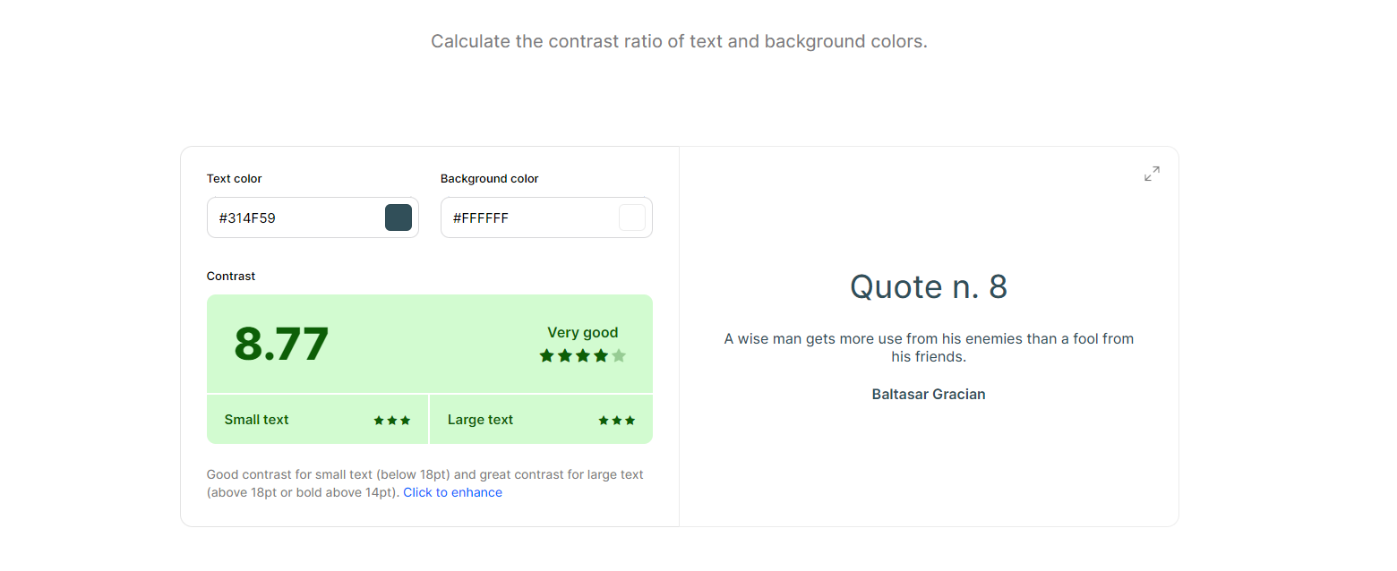

**hover nac and messages or alerts**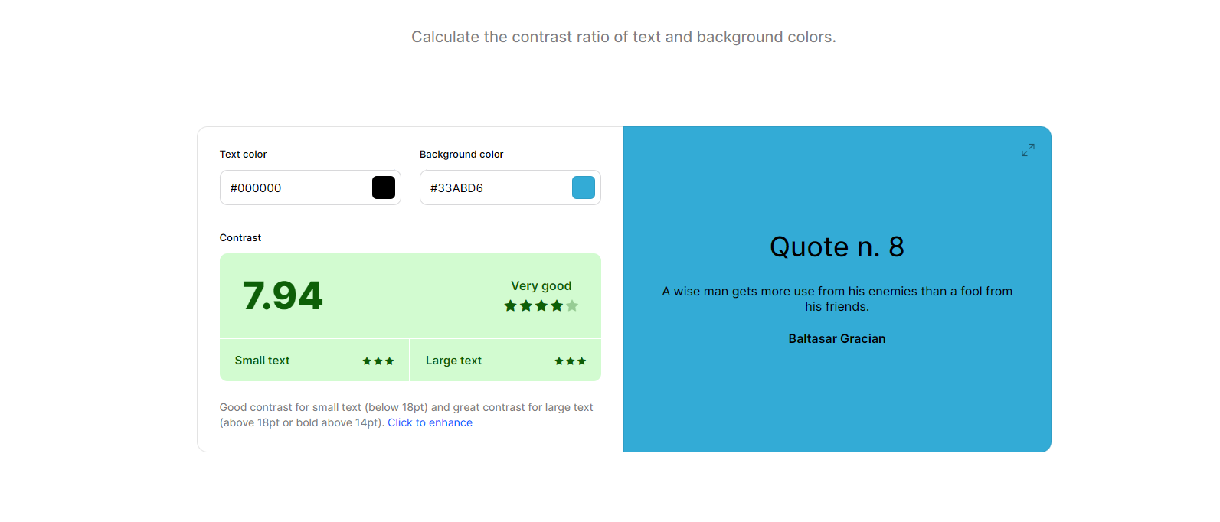

**nav**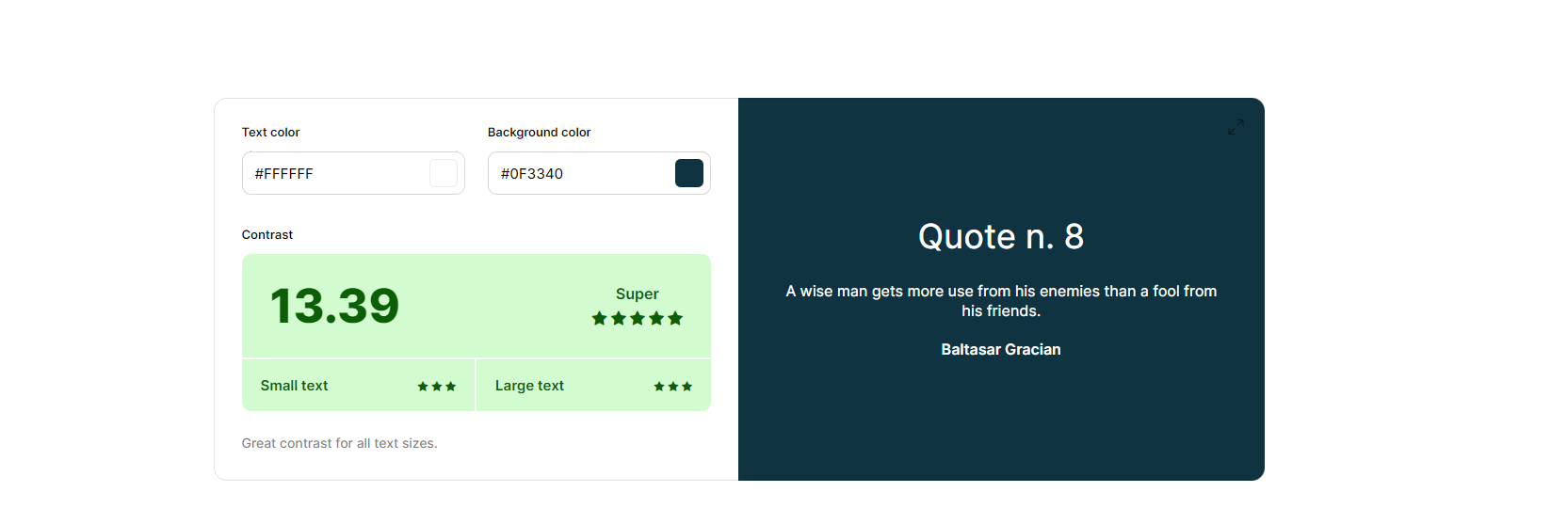

**Index**

**About**

**Resume**

**Resume hover**

**Resume btn hover**

**Projects**

**Database**

**Api**

