Assignment 4.2 – MongoDB Atlas Setup

Shane Hingtgen

4/4/23

Bellevue University

Create a new database named web335DB with a collection named users.

Create a new custom role named web335Admin. Configure this role to the "Collection Actions" option

Create a new database user named web335_user with a password of s3cret and assign it the custom role web335Admin



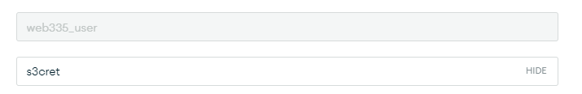

Download and install mongosh.