**Assignment 3 – Normalization**

**Overview**

Normalization is loosely defined as the process for breaking larger data sets into smaller, more “relatable” objects.

Take for example

|  |  |  |  |  |
| --- | --- | --- | --- | --- |
| firstName | lastName | address1 | address2 | address3 |

address1, address2, and address3 imply “many” addresses. And, firstName and lastName imply a “person” object. Through normalization, the latter becomes:

ORD

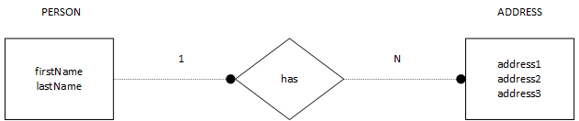

NoSQL Data Structure

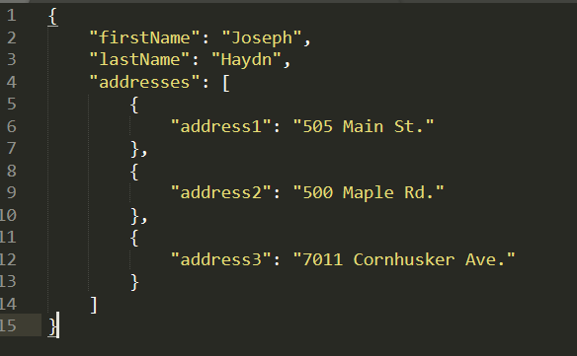

**NodeSecurity**

Business Rules

1. a USER can have one or more assigned ROLE(s)
2. a ROLE is associated with many PERMISSION(s)

**NodeBookCo**

Data Fields

|  |  |  |  |
| --- | --- | --- | --- |
| publisher_name | publisher_code | publisher_address | book_isbn |
| book_name | book_price | author_first_name | author_last_name |
| author_phone | author_email |  |  |

**Instructions**

1. ~~Create an ORD and NoSQL Data Structure to represent NodeSecurity’s business rules.~~
2. Convert NodeBookCo’s data fields into a 2NF ORD. Next, create a NoSQL Data Structure to represent NodeBookCo’s ORD.
3. Add both ORD’s (NodeSecurity and NodeBookCo) to your personal portfolio website under the “Database Diagrams” page.
4. Add the ORD’s and NoSQL Data Structures to a single Word document and include your name, date, and assignment number.