Discussion 3.1 – Normalization

Shane Hingtgen

3/23/23

Bellevue University

Normalization or Database Normalization is a process of taking the data in the database and organizing it. Normalization is the process of breaking up the tables in the database and getting rid of the unnecessary parts of the table. (*1NF, 2NF, 3NF and BCNF in Database Normalization | Studytonight*, n.d.) Such as Insert, update and deleting. (*1NF, 2NF, 3NF and BCNF in Database Normalization | Studytonight*, n.d.) According the website Study Tonight “it is a multi-step process that puts data into tabular form, removing duplicated data from the relation tables.” Also Study Tonight suggests that there are two reasons for normalizing a database, first its to get rid of the useless data, and second to make sure data dependencies are stored correctly and make sense. (*1NF, 2NF, 3NF and BCNF in Database Normalization | Studytonight*, n.d.)

Normalization is important because it cleans up the database and makes it run more efficiently. It takes up more memory and makes it harder to update and increases the amount of insertion, updation and deletions to the database. (*1NF, 2NF, 3NF and BCNF in Database Normalization | Studytonight*, n.d.) studytonight.com makes a good example of the following table. To summarize branch, hod and office_tel are all forms of redundant data. And it would be more efficient to only have rollno, name and branch in one table and have a separate table based on branch that can have branch, hod and office_tel. So now the redundant data is only listed once make updates the the table easier. (*1NF, 2NF, 3NF and BCNF in Database Normalization | Studytonight*, n.d.) 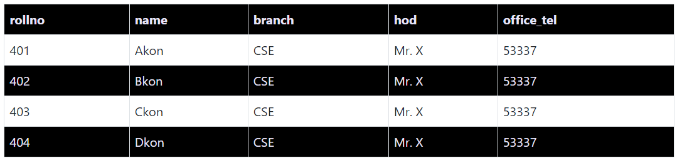

(*1NF, 2NF, 3NF and BCNF in Database Normalization | Studytonight*, n.d.)

There are five forms in which the rules of normalization are divided. First Normal Form 1Nf, Second Normal Form 2NF, Third Normal Form 3NF, Boyce and Codd Normal Forn BCNF, and finally Fourth Normal Form 4NF. The 1NF should have one value for attributes, values that will be stored in a column should have the same domain, the columns in the table will have different names and the order of the data does not matter (*1NF, 2NF, 3NF and BCNF in Database Normalization | Studytonight*, n.d.) 2NF rules will be the first normal form and will not be a partial dependency (*1NF, 2NF, 3NF and BCNF in Database Normalization | Studytonight*, n.d.). 3NF is when its in the second normal form and “doesn’t have Transitive Dependancy.” (*1NF, 2NF, 3NF and BCNF in Database Normalization | Studytonight*, n.d.). BCNF is higher than 3NF and when a certain “anomaly” isnt stated in 3NF. To comply with BCNF R is in 3NF and “functional dependancu (X -> Y) X should be a super key” (*1NF, 2NF, 3NF and BCNF in Database Normalization | Studytonight*, n.d.). Lastly 4NF will be BCNF and will not be a multi valued dependency (*1NF, 2NF, 3NF and BCNF in Database Normalization | Studytonight*, n.d.).

One to many relations in mongoDB are represented in collections. For example an employee has many addresses.

Gravelle, R. G. (19 C.E., February 13). *Relationships in MongoDB*. NaviCat. https://navicat.com/en/company/aboutus/blog/1003-relationships-in-mongodb

Where the employee and the addresses are stored separated but are embedded inside the employees document. (Wong, n.d.)

References:

Gravelle, R. G. (19 C.E., February 13). *Relationships in MongoDB*. NaviCat. https://navicat.com/en/company/aboutus/blog/1003-relationships-in-mongodb

*1NF, 2NF, 3NF and BCNF in Database Normalization | Studytonight*. (n.d.). Study Tonight. Retrieved March 23, 2023, from https://www.studytonight.com/dbms/database-normalization.php