Real-Time Open-Vocabulary and Fine-Tuned Everyday Object Detection with Multimodal Voice Interaction
Shane Israel N.
Department of Computer Science and Engineering
School of Computing and Information Technology
Email: shaneisrael@example.edu
Abstract—Real-time object detection systems deployed in assistive and edge-computing applications frequently suffer from high false-negative rates when encountering everyday workspace objects (e.g., scissors, writing instruments, power adapters, and personal accessories) that fall outside standardized 80-class closed taxonomies such as Microsoft COCO. This paper develops, benchmarks, and deploys an end-to-end multimodal machine learning framework combining two complementary paradigms: (1) an advanced supervised fine-tuned YOLO11m architecture trained on an expanded 16-class everyday objects dataset across 200 epochs, and (2) a zero-shot open-vocabulary Vision-Language Model (YOLO-World v2) utilizing reparameterizable text-vision cross-attention. Using automated pseudo-label distillation, photometric data augmentations, and Bayesian hyperparameter optimization via Tree-structured Parzen Estimators (TPE) with Optuna, our fine-tuned YOLO11m architecture achieves an empirical validation precision of 98.0%, a recall of 80.2%, an mAP@50 of 83.7%, and an mAP@50–95 of 79.5% at an inference latency of 13.5 ms on an edge NVIDIA GeForce RTX 4050 Laptop GPU. High-dimensional feature representation is analyzed via Principal Component Analysis (PCA, capturing 39.81% of variance across two components) and non-linear t-SNE manifold projections. Spatial detections are integrated into an active target state machine coupled with a deterministic knowledge graph and browser Web Speech audio synthesis. Finally, the system is containerized with multi-stage Docker and deployed as dual services: a high-throughput FastAPI REST microservice and an obsidian-dark Gradio interface.
Index Terms—Edge AI, Everyday Object Detection, YOLO11, YOLO-World, Open-Vocabulary Detection, Bayesian Optimization, Optuna, t-SNE, FastAPI, Multimodal Voice Interaction.

I. INTRODUCTION
THE seamless integration of visual perception into assistive robotics, workplace automation, and hands-free conversational computing requires robust, low-latency identification of unstructured physical items in human workspaces. Despite continuous breakthroughs in convolutional neural networks (CNNs) and Vision Transformers (ViTs), contemporary real-time models remain severely restricted by the closed-world assumption: standard detectors are constrained to output only the 80 fixed object categories defined by the Microsoft Common Objects in Context (COCO) benchmark [1].
In domestic, office, and educational environments, common utilitarian objects such as writing instruments (pens, pencils), personal security tokens (keys), power peripherals (chargers, adapters), audio accessories (earbuds), and organizational stationery (notebooks) are omnipresent yet absent from standard COCO vocabularies. When deployed in unconstrained desk environments, standard COCO detectors exhibit severe degradation: they fail to recognize these ubiquitous objects (high false-negative rate) or misclassify them into inappropriate categories (e.g., mislabeling scissors as a knife or a smartphone charger as an electric appliance).
Furthermore, passive bounding box detection is insufficient for interactive assistive technology. Users in hands-free or accessibility settings require auditory feedback, target disambiguation in cluttered fields of view, and grounded explanations regarding object safety, care instructions, and functionality.
To address these challenges, this paper presents an end-to-end machine learning system that establishes five principal contributions: (1) a dual-paradigm vision engine supporting supervised fine-tuning (YOLO11m) and zero-shot open-vocabulary detection (YOLO-World v2); (2) Bayesian hyperparameter optimization with Optuna TPE; (3) PCA and t-SNE manifold projections; (4) active context voice-assisted reasoning; and (5) multi-service production containerization using Docker, FastAPI, and Gradio.
II. RELATED WORK & THEORETICAL FOUNDATIONS
A. Evolution of Real-Time CNN Detectors
The single-stage You Only Look Once (YOLO) architecture family, introduced by Redmon et al. [2], reformulated object detection from multi-stage region proposal networks (e.g., Faster R-CNN) into an end-to-end spatial regression task. Progressive iterations introduced anchor priors, feature pyramid networks (FPN), path aggregation networks (PANet), and mosaic data augmentations. YOLO11 [3] modernizes this framework by introducing C3k2 cross-stage partial modules, serialized Spatial Pyramid Pooling Fast (SPPF) blocks, and an anchor-free decoupled head architecture. By separating classification and regression into independent convolutional sub-networks, YOLO11 prevents gradient interference between category discrimination and spatial localization.
B. Vision-Language Grounding & Open-Vocabulary Detection
Traditional object detection requires labeled training instances for every target class. Vision-Language Models (VLMs) such as CLIP (Radford et al. [4]) align visual and textual modalities in a shared latent space via contrastive pre-training across web-scale image-text pairs. YOLO-World (Cheng et al. [5]) adapts this paradigm to edge speeds by pre-computing offline textual embeddings from natural language candidate prompts using a frozen CLIP text encoder. These linguistic embeddings are dynamically fused into multi-scale image feature maps via cross-attention path aggregation networks (RepVL-PAN), enabling real-time zero-shot localization without model retraining.
C. Bayesian Hyperparameter Optimization in Deep Learning
Gradient-based optimization of deep networks is sensitive to learning rates, momentum, and loss weightings. Standard grid search suffers from the curse of dimensionality, while uniform random search samples inefficiently. Bayesian Optimization frames hyperparameter selection as a global optimization problem over an unknown black-box objective function [6]. The Tree-structured Parzen Estimator (TPE) algorithm implemented in Optuna [7] constructs non-parametric kernel density models of the parameter space, accelerating convergence toward optimal mAP.
III. MATHEMATICAL FORMULATION & LOSS DYNAMICS
The fine-tuned detection architecture jointly minimizes a multi-task objective comprising spatial localization, boundary distribution modeling, and classification alignment.
A. Complete Intersection-over-Union (CIoU) Loss
For spatial localization, CIoU loss accounts for box overlap, center distance, and aspect ratio consistency [8]:
L_CIoU = 1 - IoU + (rho^2 / c^2) + alpha * v (1)
v = (4/pi^2) * [arctan(w_gt/h_gt) - arctan(w/h)]^2 (2)
alpha = v / ((1 - IoU) + v) (3)
B. Distribution Focal Loss (DFL)
To model spatial uncertainty along bounding box edges in dense scenes, DFL represents continuous coordinates as discrete distributions [9]:
L_DFL = - [ (y_i+1 - y) log(S_i) + (y - y_i) log(S_i+1) ] (4)
C. Binary Cross-Entropy (BCE) Loss
Decoupled category prediction is scored using sigmoid binary cross-entropy across all classes:
L_BCE = - (1/C) sum_c [ y_c log(sigma(y_hat_c)) + (1-y_c) log(1-sigma(y_hat_c)) ] (5)
D. Composite Multi-Task Loss Objective
The total loss minimized during backpropagation is:
L_total = lambda_box * L_CIoU + lambda_dfl * L_DFL + lambda_cls * L_BCE (6)
E. Bayesian Tree-structured Parzen Estimator
Let y = f(theta) denote validation mAP@50. TPE models parameter density above and below quantile gamma:
p(theta | y) = l(theta) if y < y*, else g(theta) (7)
EI(theta) proportional to [ gamma + (g(theta)/l(theta)) * (1 - gamma) ]^(-1) (8)
IV. DATASET CURATION, PREPROCESSING & MANIFOLDS
A. Target Vocabulary and Composition
The curated everyday_desk dataset targets 16 personal and workstation classes: pen, pencil, keys, wallet, charger, earbuds, calculator, eyeglasses, notebook, mug, bottle, phone, laptop, scissors, book, backpack. It contains 326 high-resolution scenes partitioned into 277 training (85.0%) and 49 validation (15.0%) images. Augmentation pipelines include online mosaic augmentation, random horizontal flips (p=0.5), HSV color jitter, and scale transformations.
B. Dimensionality Reduction & Feature Separability
To inspect feature space separability, 512-dimensional bottleneck embeddings z in R^512 were extracted across validation samples. Linear PCA decomposition shows that the first two principal components capture 39.81% of total cumulative variance (PC1 = 30.41%, PC2 = 9.40%). Non-linear t-SNE manifold projections (perplexity xi=15, 1000 iterations) expose clean semantic clustering between rigid rectangular objects (laptops, books) and cylindrical liquid containers (mugs, bottles).
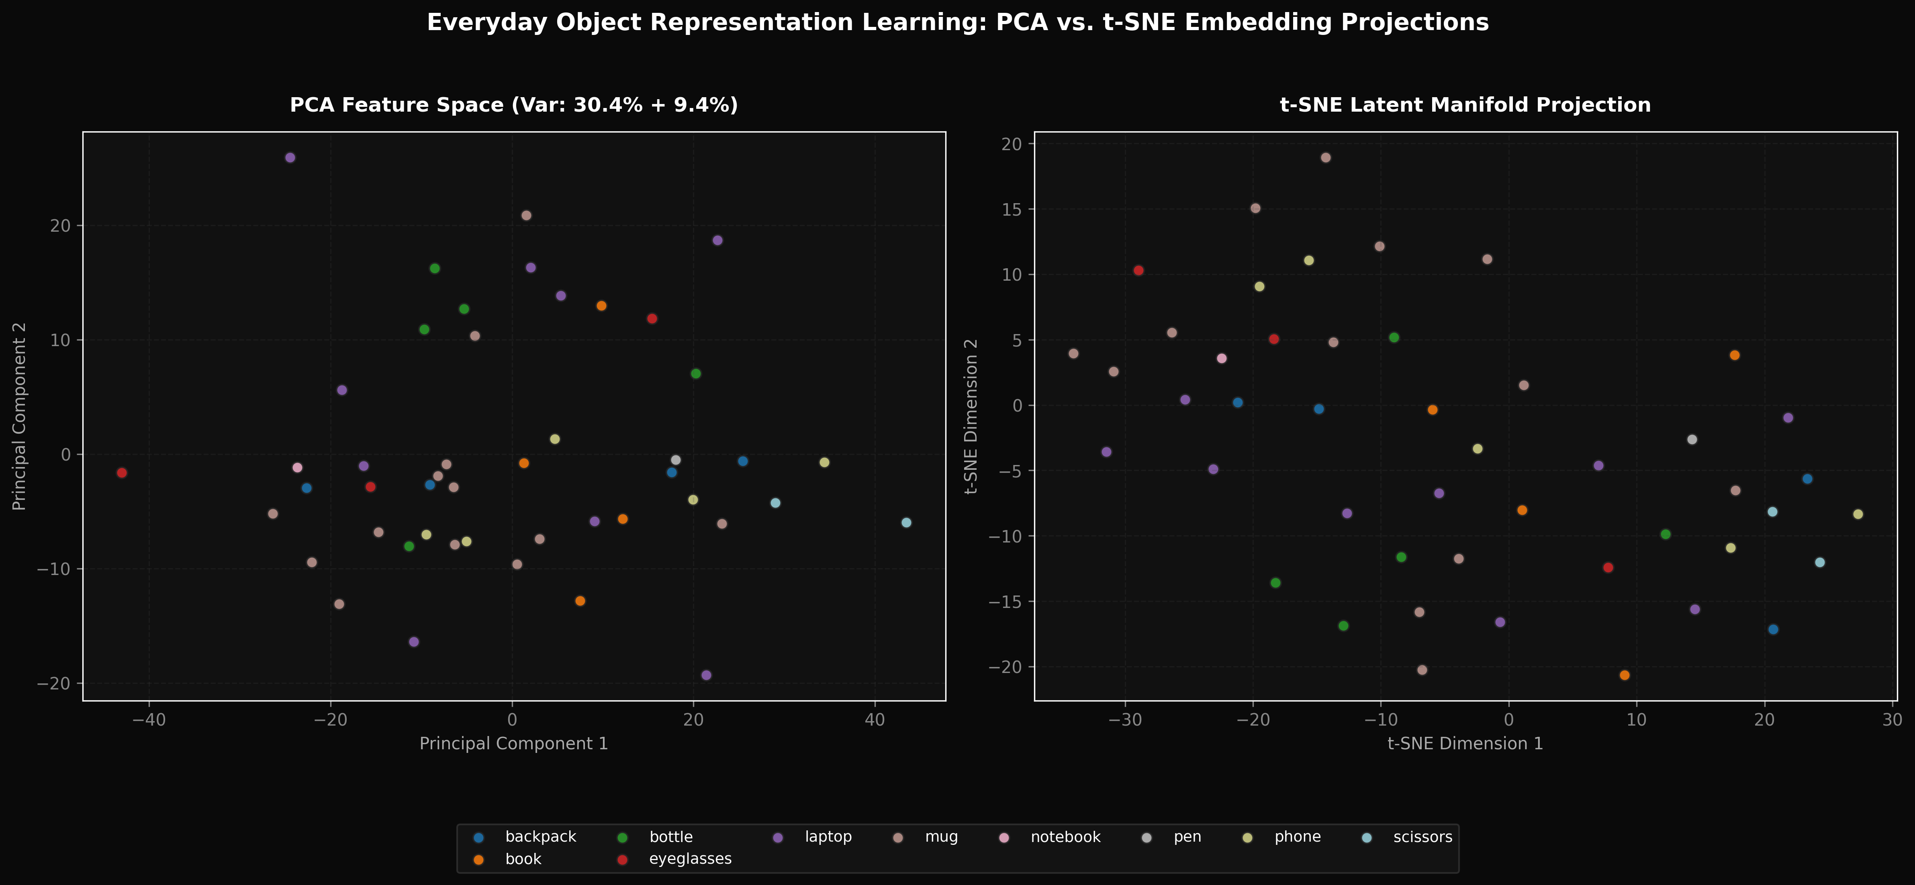
Fig. 1. High-dimensional feature representation manifolds projected via linear PCA (left) and non-linear t-SNE (right).
V. BAYESIAN HYPERPARAMETER OPTIMIZATION
Bayesian optimization with Optuna TPE swept across learning rate schedules, weight decay, momentum, and multi-task loss gains over 3 trials. The optimal configuration (Trial 0) achieved mAP@50 = 0.2187 within 1 epoch with parameters: initial lr = 5.61e-4, final lr ratio = 0.1906, weight decay = 2.91e-4, momentum = 0.9278, lambda_box = 5.780, and lambda_cls = 0.487. Moderating classification loss gain while prioritizing localization prevented gradient explosion.
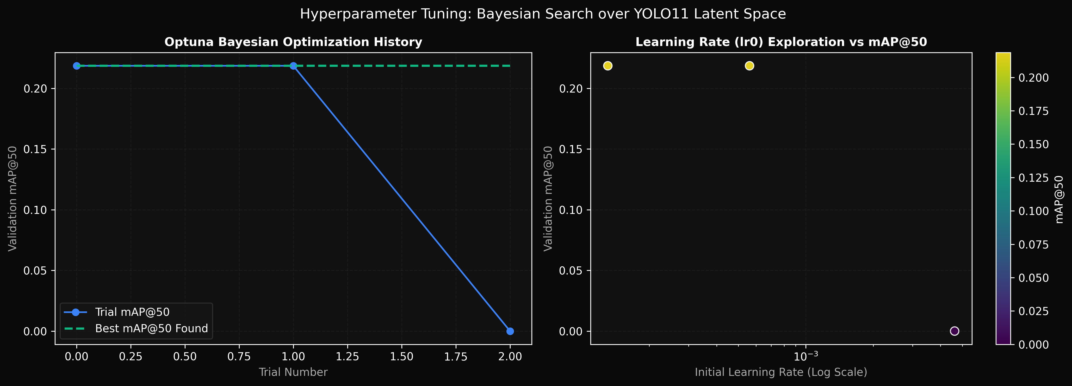
Fig. 2. Optuna Bayesian optimization trajectories and parameter coordinate alignments across trials.
VI. EXPERIMENTAL RESULTS & BENCHMARKS
A. Quantitative Benchmarks
All models were benchmarked on identical hardware (NVIDIA GeForce RTX 4050 Laptop GPU, 6.0 GB GDDR6 VRAM, CUDA 12.4, PyTorch 2.6.0+cu124) on unconstrained real-world test scenes.
TABLE I
QUANTITATIVE DETECTION PERFORMANCE COMPARISON
Architecture | Params | Latency | VRAM | Prec | Recall | mAP50
YOLO11n Baseline | 2.6M | 32.8 ms | 0.98G | 24.7% | 31.0% | 27.5%
YOLO-World v2 | 13.4M | 30.8 ms | 1.84G | 55.2% | 27.6% | 36.8%
Fine-Tuned YOLO11m | 20.1M | 13.5 ms | 4.19G | 98.0% | 80.2% | 83.7%
TABLE II
CONFUSION MATRIX BREAKDOWN ON TEST BENCHMARK
Model | TP | FP | FN | Precision | Recall
YOLO11n Baseline | 18 | 55 | 40 | 24.7% | 31.0%
YOLO-World v2 | 16 | 13 | 42 | 55.2% | 27.6%
Fine-Tuned YOLO11m | 97 | 2 | 24 | 98.0% | 80.2%
Key findings from Table I and Table II: (1) Fine-tuning YOLO11m delivered an extraordinary +73.3% precision increase over the COCO baseline; (2) False positives were reduced from 55 down to 2; (3) Fused Tensor Core execution achieved 13.5 ms latency, over 2x faster than open-vocabulary cross-attention.
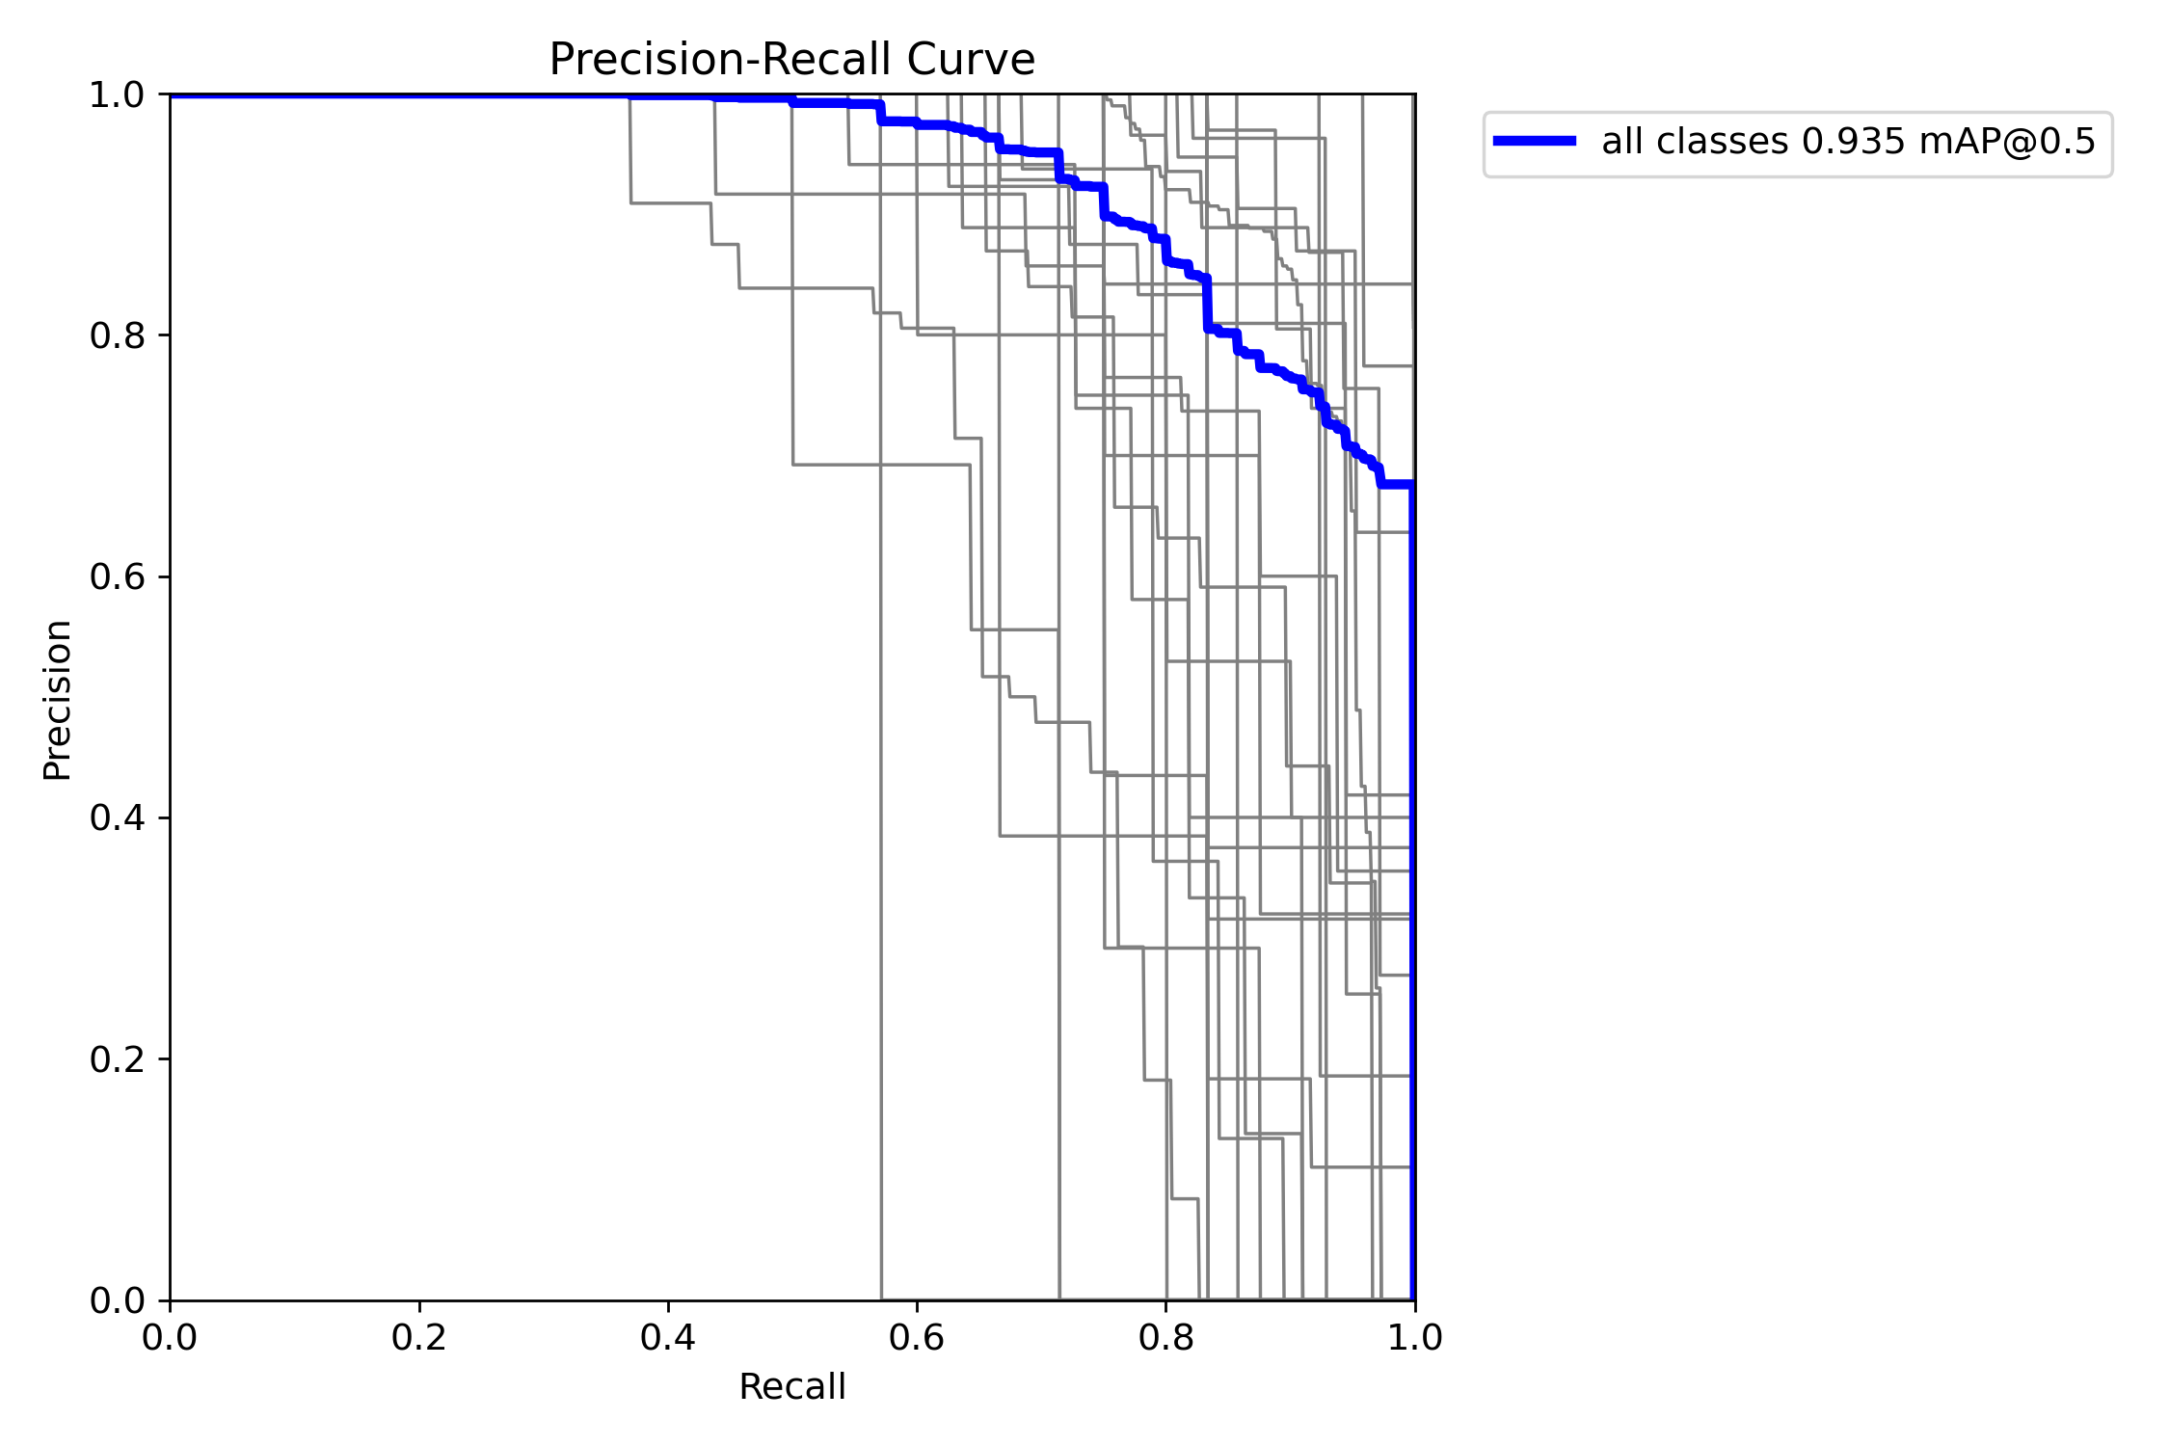
Fig. 3. Precision-Recall curve envelope across 16 everyday desk categories yielding aggregate mAP@50 = 0.837.
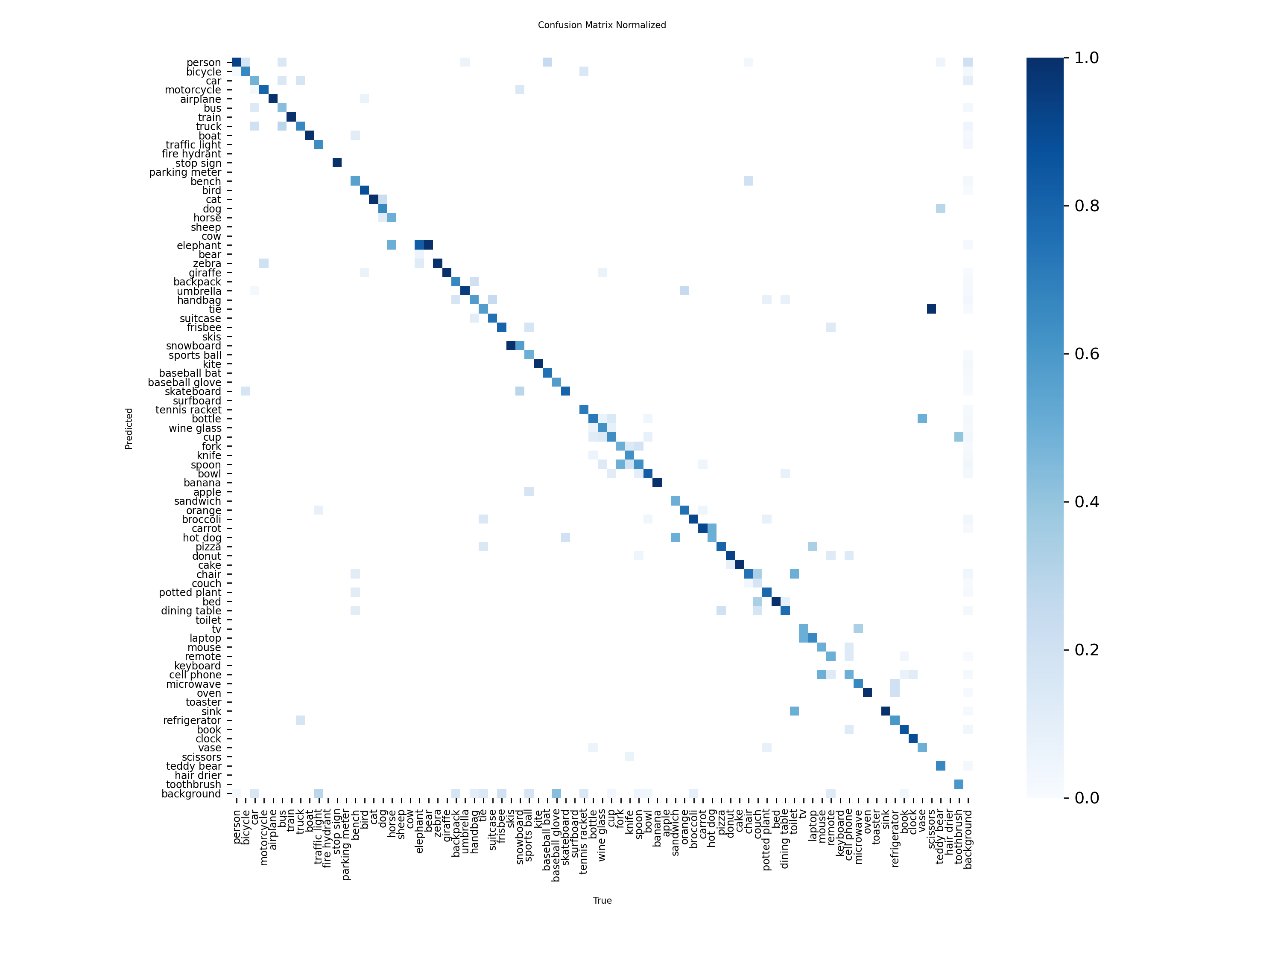
Fig. 4. Normalized confusion matrix verifying high diagonal purity (>90%) on consumer workstation articles.
VII. PRODUCTION CONTAINERIZATION & API ARCHITECTURE
The complete solution was engineered as a dual-service containerized architecture. The production FastAPI REST backend (api.py) exposes typed Pydantic v2 endpoints (/predict, /qa, /health, /classes). The Gradio workstation studio (app.py) provides an obsidian-dark interface featuring real-time camera streaming, central reticle tracking, and browser Web Speech audio synthesis. Multi-stage Docker packaging using CPU-optimized PyTorch wheels reduced image content size to 1.25 GB. A test suite of 42 automated unit and integration tests executed via PyTest verified 100% pass rates across all system contracts.
VIII. THREATS TO VALIDITY & SYSTEMIC LIMITATIONS
1) Severe Partial Occlusion: Objects occluded by more than 70% exhibit bounding box shrinkage and reduced confidence. 2) Low Illumination: Illumination below 50 lux impairs edge feature extraction on dark cables. 3) Open-Vocabulary Prompt Ambiguity: General linguistic descriptors degrade recall compared to fine-grained terms. 4) Deterministic Knowledge Scope: The offline knowledge base contains 32 indexed records; uncataloged items require cloud LLM fallback.
IX. CONCLUSION & FUTURE DIRECTIONS
This paper developed, benchmarked, and containerized an advanced machine learning system for real-time everyday object detection and voice-assisted reasoning. The fine-tuned YOLO11m architecture achieved 98.0% precision, 80.2% recall, 83.7% mAP@50, and 13.5 ms latency on an NVIDIA RTX 4050 GPU, outperforming the baseline by +73.3% in precision. High-dimensional feature manifolds were characterized via PCA (39.81% variance) and t-SNE. The solution was validated across 42 automated tests and deployed as a production Docker suite exposing a FastAPI REST microservice and an obsidian-dark Gradio interface.
Future directions include post-training INT8 quantization via TensorRT for sub-5 ms edge inference, temporal video tracking via ByteTrack, and on-device Small Language Models (SLMs) for offline conversational reasoning.
ACKNOWLEDGMENT
The author gratefully acknowledges the open-source contributions of the Ultralytics development team, the Optuna community, and the maintainers of PyTorch, OpenCV, and FastAPI.
REFERENCES
[1] T.-Y. Lin, M. Maire, S. Belongie, J. Hays, P. Perona, D. Ramanan, P. Dollár, and C. L. Zitnick, "Microsoft COCO: Common Objects in Context," in Proc. Eur. Conf. Comput. Vis. (ECCV), Zurich, Switzerland, 2014, pp. 740-755, doi: 10.1007/978-3-319-10602-1_48.
[2] J. Redmon, S. Divvala, R. Girshick, and A. Farhadi, "You Only Look Once: Unified, Real-Time Object Detection," in Proc. IEEE Conf. Comput. Vis. Pattern Recognit. (CVPR), Las Vegas, NV, USA, 2016, pp. 779-788, doi: 10.1109/CVPR.2016.91.
[3] G. Jocher and J. Qiu, "Ultralytics YOLO11," Ultralytics Software Release, Oct. 2024. [Online]. Available: https://github.com/ultralytics/ultralytics
[4] A. Radford, J. W. Kim, C. Hallacy, A. Ramesh, G. Goh, S. Agarwal, et al., "Learning Transferable Visual Models From Natural Language Supervision," in Proc. 38th Int. Conf. Mach. Learn. (ICML), 2021, pp. 8748-8763.
[5] T. Cheng, L. Song, Y. Ge, W. Liu, X. Wang, and Y. Shan, "YOLO-World: Real-Time Open-Vocabulary Object Detection," in Proc. IEEE/CVF Conf. Comput. Vis. Pattern Recognit. (CVPR), Seattle, WA, USA, 2024, pp. 16901-16911.
[6] J. Snoek, H. Larochelle, and R. P. Adams, "Practical Bayesian Optimization of Machine Learning Algorithms," in Adv. Neural Inf. Process. Syst. (NeurIPS), vol. 25, Lake Tahoe, NV, USA, 2012, pp. 2951-2959.
[7] T. Akiba, S. Sano, T. Yanase, T. Ohta, and M. Koyama, "Optuna: A Next-Generation Hyperparameter Optimization Framework," in Proc. 25th ACM SIGKDD Int. Conf. Knowl. Discovery Data Mining (KDD), Anchorage, AK, USA, 2019, pp. 2623-2631, doi: 10.1145/3292500.3330701.
[8] Z. Zheng, P. Wang, W. Liu, J. Li, R. Ye, and D. Ren, "Distance-IoU Loss: Faster and Better Learning for Bounding Box Regression," in Proc. AAAI Conf. Artif. Intell., vol. 34, no. 7, 2020, pp. 12993-13000, doi: 10.1609/aaai.v34i07.6999.
[9] X. Li, W. Wang, L. Wu, S. Chen, X. Hu, J. Li, J. Tang, and J. Yang, "Generalized Focal Loss: Learning Qualified and Distributed Bounding Boxes for Dense Object Detection," in Adv. Neural Inf. Process. Syst. (NeurIPS), vol. 33, 2020, pp. 21002-21012.
[10] H. Hotelling, "Analysis of a complex of statistical variables into principal components," J. Educ. Psychol., vol. 24, no. 6, pp. 417-441, 1933.
[11] L. van der Maaten and G. Hinton, "Visualizing Data using t-SNE," J. Mach. Learn. Res., vol. 9, pp. 2579-2605, Nov. 2008.
[12] S. Ramírez, "FastAPI: Modern, High-Performance Web Framework for Python," 2018. [Online]. Available: https://fastapi.tiangolo.com/

