**Real Estate Market Analyzer**

***Process Book***

**Shane Brown, ShaneJBrown@Gmail.com, u0852900 Sigmund Chow, sigmundccs@gmail.com, u0597938 My Huynh, my.huynh@utah.edu, u0729654**

**Project GIT repository:**

[*https://github.com/shanejb/dataviscourse-pr-RealEstateMarketAnalyzer*](https://github.com/shanejb/dataviscourse-pr-RealEstateMarketAnalyzer)

**Website:** TBD

2016

***11/11/2016***

Table of Contents

1. Background Motivation/Overview 2

2. Related Works 2

3. Question 3

4. Data 4

5. Exploratory Data Analysis 6

6. Design Evolution 7

7. Implementation 9

8. Evaluation 11

# 

# **Background Motivation and Overview**

Recently, we have been seeing many new constructions for condominiums and apartments around the city. Are millennials moving towards renting? Renting has long since been an acceptable way to pay for housing throughout the civilized world for many, many generations, but does renting make financial sense? Part of the American dream is to own your own home, but is the rising property prices pushing our young generation away from buying houses?

In a recent article in New York Times, it states “Today’s young adults have not become homeowners at the same rate that earlier generations did. That probably reflects a mix of a weak economy — and thus poor job prospects during the initial aftermath of the recession — and the lack of affordable housing supply in many of the hottest markets combined with perhaps some cultural shift toward buying homes later or even not buying at all.”[1] However, based on one of the census reports, there were more new homes sold in July than in nearly a decade. Buyers are purchasing single-family houses at annual rate of 654,000. This has motivated us to find out more about our current housing market and where we stand right now compared to the housing market crisis in 2008.

# **Related Works**

There is several websites show comparison between rent and house cost but they don’t visualize how fast house price increase in historical time as well as reveal housing market crisis in 2008. Some of website lets readers calculate renting or buying house, aim to answer which is better?. Here is an example of rent/house cost calculator: <http://www.nytimes.com/interactive/business/buy-rent-calculator.php>

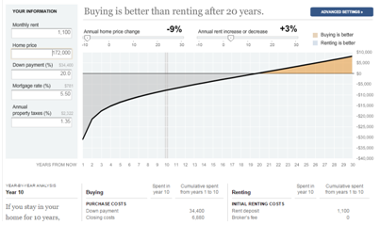

***Figure 1: screen shot of The York Times website***

In addition, many visualizations use Zillow data to compare how rent and house price between biggest cities, but not all states. <http://www.economist.com/blogs/graphicdetail/2016/08/daily-chart-20> is an example:

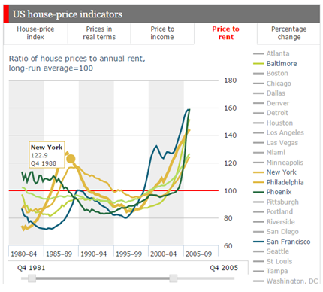

***Figure 2: screen shot of www.economist.com***

Besides, we’ve realized most of websites about house market is very heavy in text and lack of visualization.

# **Question**

This project aims to answer the following questions. Have we recovered from the 2008 housing market crash? Are housing overpriced now? When does it make sense to buy? When does it make sense to rent? What areas in the United States are the best rental markets? What areas in the United States are the best real estate markets with the highest appreciation forecast?

The goal of this project is to see how the housing market has been affected by the 2008 housing market crash and the current state of recovery. We would like to be able to display areas, which are the best rental markets in the United States. We would also like to display which areas are the most affordable home prices.

A benefit of this project is to educate others on where the best rental markets are in comparison to other states. Another benefit will be to educate the user on the differences of the rental and home prices in different states by comparing the data of the states.

# **Data**

1. **Source Links**

Our data sets are derived from below sources:

* 1996-2015 populations estimates - <https://www.census.gov/>
* 2016 population estimate - <http://worldpopulationreview.com/states/>
* ZHVI (Zillow Home Value Index) - <http://www.zillow.com/research/data/#median-home-value>
* ZRI (Zillow Rent Index) <http://www.zillow.com/research/data/#rental-data>
* Map boundaries data - <http://bl.ocks.org/mbostock/raw/2206489/7110de3d8412433d3222c9b7e3ac6593593162b2/us-states.json>

1. **Processing**

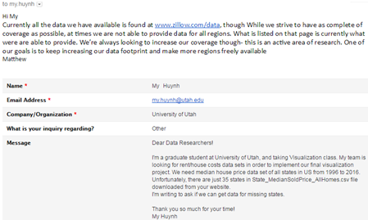We planned using sold house price dataset in 20 years from 1996 to 2016. Unfortunately, Zillow doesn’t provide enough data for all regions and there are 15 states missing data. Therefore, we consulted Zillow data research team about this issue.

They’re very helpful but we are not able to get data for all regions in US.

However, Zillow has come up with their own methodology for real estate data - Zillow Home Value Index (ZHVI). Each ZHVI is a time series tracking the monthly median home value in a particular geographical region. The ZHVI are available for seven geographical levels: neighborhood, ZIP code, city, congressional district, metropolitan area, county, state and the nation. Similar to ZHVI, Zillow Rent Index (ZRI) tracks the monthly median rent in particular regions[2]. We’ve used their ZHVI, ZRI of states, and three other metrics of population, median rental price/house cost per square foot.

In addition, missing states data is a main cause raised a dilemma faced us. In our proposal, we wanted to display how the housing market looks like since the 2008 financial crisis. We planned to have charts to show the home prices and rental rates for years from 1996 to 2016 for US States. Since that is the dates made available to us in some of the home prices data sets we found. However, since we submitted the proposal we haven't been able to find rental data prior to 2010.

There were two options came to our team. In the first option, we had to miss our project goal and only showing house price changes since 2010. On the other hand, we would show home prices from 1996 to 2016 and rental cost from 2010 to 2016 in second option. We would like to say “THANK YOU” to our TA Vinitha Yaski. She has suggested us implement our project goes the second option.

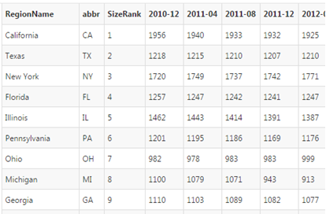Zillow offers huge data sets. In order to obtain data sets, which are suitable for what we’d like to implement in our proposal, we pick house price data in 1-year intervals from 1996 to 2016 and rent cost data in 4-month interval from Dec. 2010 to Aug. 2016.

Data sets provided by Zillow and Census actually come in CSV format. Hence, we use R for cleaning, aggregating and reformatting the data appropriated for working with in d3.

***Figure 3: screen shot of house price dataset***

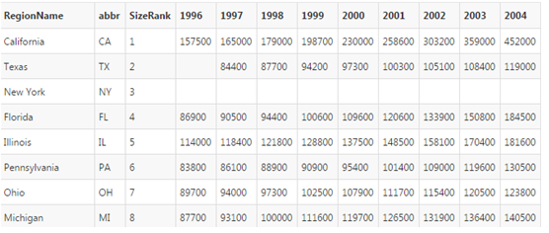

***Figure 4: screen shot of rent cost dataset***

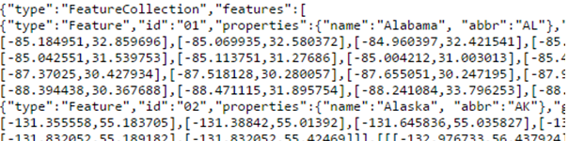Since Mike Bostock’s website provides raw U.S. map boundaries data set, in order to implement US map, we merely need to add states abbreviations to JSON file to look up quickly the data we need for those other files based on the states selected.

*Figure 5: screen shot of map boundaries dataset*

# **Exploratory Data Analysis**

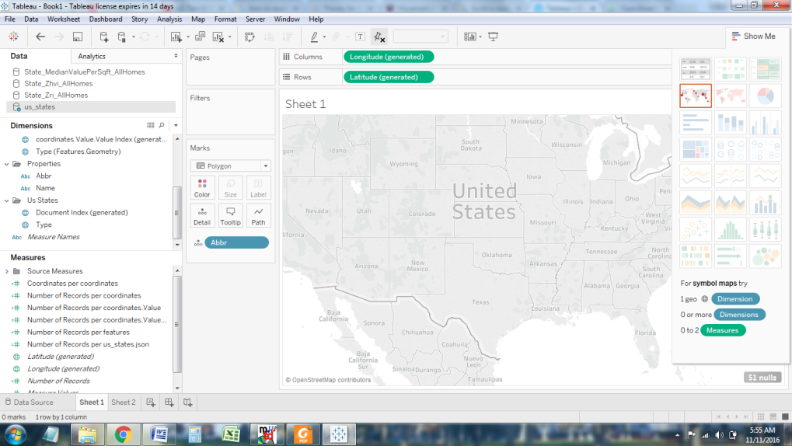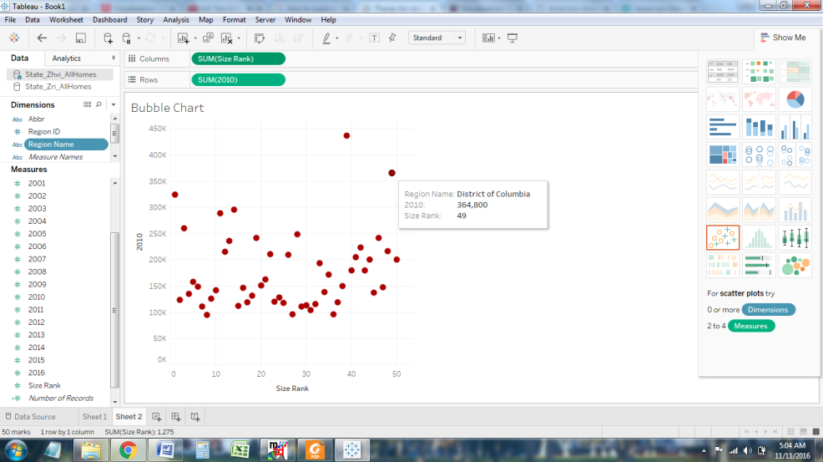We have many reasons to use Tableau in order to explore our data sets. Tableau is one of easy ways people represent data fast, beautiful and useful.

***Figure 6: Initial bubble chart and map using Tableau***

After getting initial map, we tried to color our map but Tableau showed a message that there is not any related attribute between map and rent value datasets. The important thing we gain here is that we have to add states abbreviations in datasets. We’ve learnt that exploratory data analysis is significant step that helps to detect mistakes, figure out necessary attributes, relationship between features prepared for a successful visualization.

# **Design Evolution**

1. **Final design in proposal**

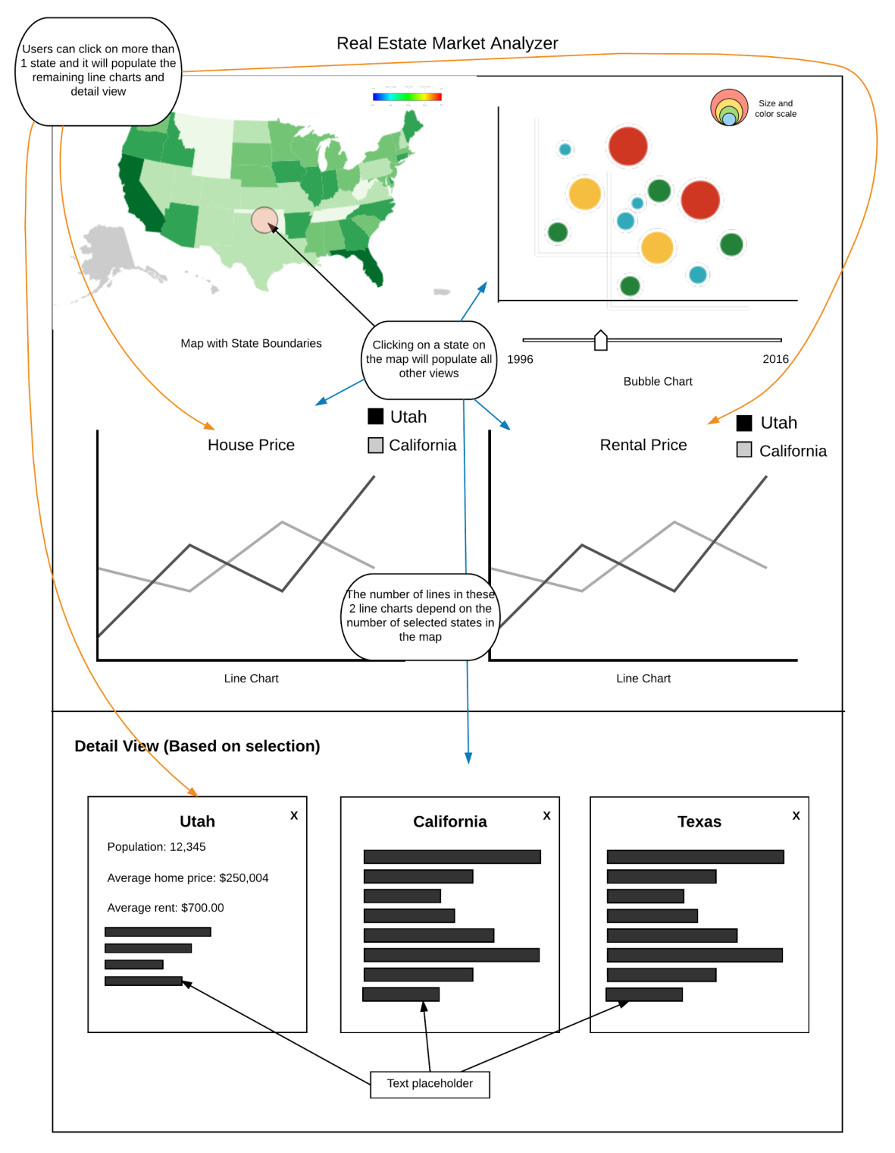

***Figure 7: our final sketch in proposal***

1. **Description**

Slider View: This will be a time slider, as in design 2, for the years 1996 to 2016, in one year increments. This will be interactive by the user to update the rest of the views.

Map View: The map section, as in design 1, will display the entire United States of America with the states outlines and names shown. The map will be interactive where the user is able to click on and select one or more states. Selected states data will be shown in the line charts view and detail view. The map will also have a color scale which will represent the rent statistics for the year selected by the slider view.

Bubble Chart View: This will be as in design 2. Chart view has a function that shows how fast housing price increases over time. As the map, bubble chart will be interactive with time slider in order to show average house price of all states have changed in 20 years. One circle represents for one state. Size and color of each circle shows US state size rank by population. The more state’s population is, the more size of circle is.

Line Charts View: This will represent historical rent and home price data for each of the selected states in either the map view or bubble chart view.

Detail View: This will represent more specific details of each of the selected states. Some details it may include, but not limited to, are population, average home price, average rent rate and so forth.

Must-Have Features:

* A map that displays all states with boundaries
* Rent throughout the years
* Median home price throughout the years
* Bubble chart shows appropriate data
* Bubble chart and map interact with time slider
* Detailed view of the selected states

Optional Features:

* Include visualizations for crime rate per capita of locations
* Include visualizations for school ratings of locations
* Include data on the cost of living of locations
* Include interest rates since 2011
* Add pan and zoom to the map

1. **Design changes**

We didn’t deviate from our proposal. We’ve decided to not change anything on the final design above but adding more optional features if we have time. Since we’ve use two different time scales for map and bubble chart, we will add one more slider into our visualization.

# **Implementation**

* 1. **Project structure**

We organize our working prototype follow HW5 layout.

**index.html**

**data/**

**State_MedianRentalPricePerSqft_AllHomes.csv**

**State_MedianValuePerSqft_AllHomes.csv**

**State_Zhvi_AllHomes.csv**

**State_Zri_AllHomes.csv**

**US_Population_AllStates.csv**

**Us_states.json**

**public/**

**css/**

**style.css**

**js/**

**bubbleChart.js** *visualizes bubble chart*

**detailCards.js** *displays detailed view*

**houseChart.js** *shows house-price line chart*

**main.js** *handles script files*

**mapView.js** *displays U.S map*

**rentChart.js** *shows rent-cost line chart*

* 1. **Implementation**
* Map

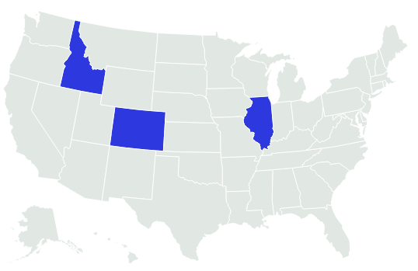

***Figure 8: initial U.S map***

In this Milestone, we’ve implemented initial U.S map allows users to select multiple states by changing the color when you click on them. The map also changes color on hover over.

Things to do:

* Add slider, set color scales, add color legend
* Implement map interacts with slider.
* Implement click event shows appropriate line charts, information views.
* Bubble chart

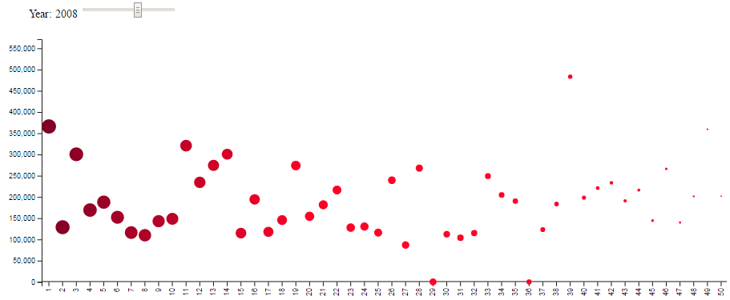

***Figure 9: initial bubble chart***

So far, we have initial bubble chart and slider with time scale from 1996 to 2016 in 1-year increment. In the chart, X-axis represents state size rank by population while Y-axis represents housing cost. We were worry that bubbles would be overlapped so that we set it interactive with slider in order to think of a better way.

Things to do:

* Add color, circle size legend.
* Radius, ‘cx’ attribute and color of circles depend on size rank value. We are thinking of how to set the radius and color base on state population.
* Add tooltip show state information
* Line charts
* Detail View

# **Evaluation**

Our datasets are ready, vis and working prototype are organized and we feel that we’re on the right way to get our project done. We also think our visualization would be much better if we add more interactions and option features. We also think add interaction between map view and bubble chart.

Moreover, teamwork is very important and vital to success the final project. Our teamwork is great and we work well together.

1. Irwin, Neil. The New York Times. “The Housing Market Is Finally Starting to Look Healthy.”

   Aug. 23, 2016. <http://www.nytimes.com/2016/08/24/upshot/the-housing-market-is-finally-starting-to-look-healthy.html>
2. Bun, Yengon. Zillow. Zillow Rent Index: Methodology. Mar., 12, 2012.http://www.zillow.com/research/zillow-rent-index-methodology-2393/