Power BI Healthcare Data Cleaning Project
Microsoft Fabric Web Portfolio Project

Prepared by: Shane Knight
Tools: Microsoft Fabric, Power BI Web, Microsoft Excel
Environment: Linux
Completion Date: July 18, 2026

Executive Summary
This portfolio project presents an interactive Healthcare Data Quality Dashboard created in Power BI through Microsoft Fabric web on a Linux operating system. The dashboard analyzes 49 patient records and summarizes key healthcare measures, including patient volume, average length of stay, hospital cost, missing data, and potential duplicate records. It includes two report pages with KPI cards, charts, slicers, and a detailed record-level table. The completed dashboard helps stakeholders evaluate healthcare activity, identify data-quality concerns, and determine which records may require additional review.

Business Problem
Healthcare data must be accurate, complete, and easy to review before it can support reliable reporting and decision-making. The dataset used for this project contained 49 patient records that required analysis for both operational performance and data quality concerns. Without a clear dashboard, it would be difficult to quickly evaluate patient volume, average length of stay, hospital costs, missing information, and potential duplicate records. This project addresses that problem by organizing the results into two report pages: Healthcare Overview, which summarizes key healthcare measures, and Data Quality Details, which highlights records that may need further review or correction.

Project Objectives
The objective of this project was to develop an interactive Power BI dashboard that summarizes healthcare activity while making data-quality concerns easier to identify. The Healthcare Overview page presents patient volume, average length of stay, total hospital cost, records with missing data, potential duplicate records, and patient distributions by department and risk level. The Data Quality Details page examines compliance status, invalid admission-date records, potential duplicate records and detailed records that may require further review.

Dataset Overview
The dataset used for this project contains 49 patient records. The dashboard analyzes patient identifiers, departments, risk levels, compliance statuses, admission and discharge dates, hospital costs, and potential duplicate indicators. These records support calculations and summaries related to patient volume, average length of stay, total hospital cost, missing data, and potential duplicate records. The dataset also provides the detailed information needed to identify records that may require additional review.

Data Cleaning and Quality Preparation
Before the dashboard was created, the healthcare dataset was reviewed and prepared for analysis. Admission and discharge dates were checked, hospital cost and length-of-stay values were assigned appropriate data types, and records with missing information were identified. Potential duplicate records and an invalid admission-date record were also flagged for further review. The prepared dataset was then imported into Microsoft Fabric and used to create the dashboard measures, charts, slicer, and detailed record table.

Dashboard Design
The dashboard was designed as a two-page Power BI report with each page serving a different purpose. The Healthcare Overview page presents five KPI cards for total patients, average length of stay, total hospital cost, records with missing data, and potential duplicate records, along with charts showing patients by department and risk level and a department slicer. The Data Quality Details page presents compliance status distribution, invalid admission-date records, potential duplicate records, and a detailed record-level table. This structure allows users to review overall healthcare activity first and then examine specific data-quality concerns in greater detail.

Healthcare Overview Page
The Healthcare Overview page provides a high-level summary of the 49 patient records included in the analysis. Five KPI cards display 49 total patients, an average length of stay of 4.18 days, a total hospital cost of $457.22K, 9 records with missing data, and 2 potential duplicate records. The page also includes charts showing patients by department and patients by risk level, along with a department slicer that allows users to focus the visuals on a selected department. Together, these elements provide a clear view of healthcare activity and the main data-quality indicators.
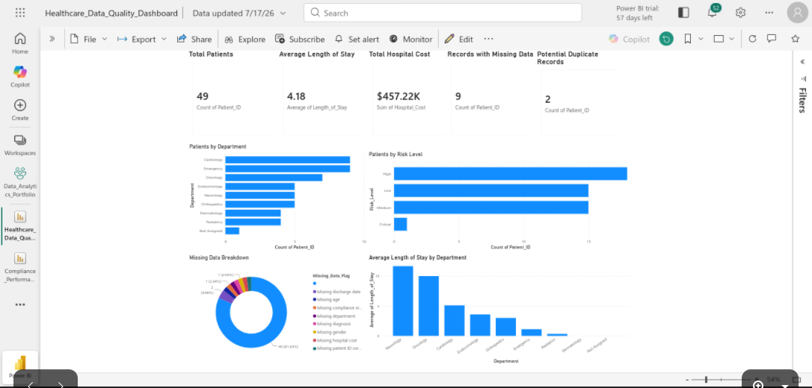

Data Quality Details Page
The Data Quality Details page provides a closer examination of records that may require review or correction. A donut chart displays the compliance status distribution, including 27 compliant records, 13 non-compliant records, 8 records pending review, and 1 record with an unknown status. Additional visuals identify 1 invalid admission-date record and 2 potential duplicate records. A detailed record-level table allows users to review patient identifiers, departments, risk levels, compliance statuses, admission and discharge dates, hospital costs, and duplicate indicators associated with the dataset.
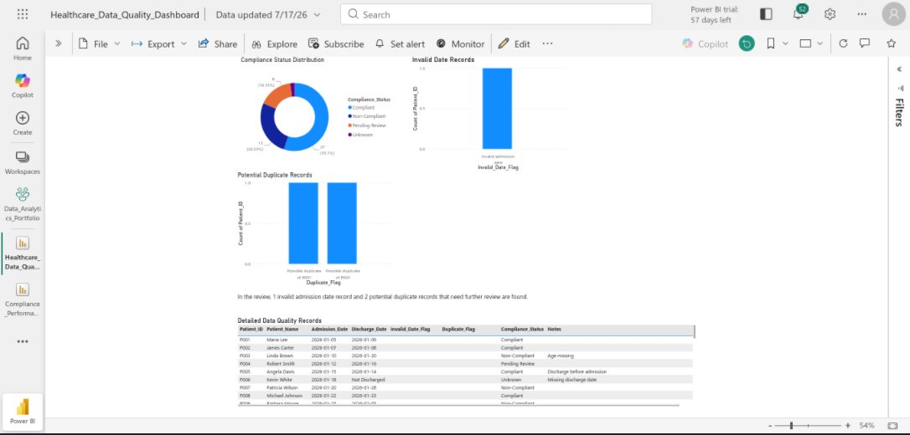

Key Findings and Business Insights
The analysis found that the dataset contains 49 patient records with an average length of stay of 4.18 days and a total hospital cost of $457.22K. Nine records contain missing information, while 2 records were identified as possible duplicates and 1 record contains an invalid admission date that requires further review. High-risk patients represent the largest risk group with 18 records, followed by 15 medium-risk records, 15 low-risk records, and 1 critical-risk record. The compliance-status results also show that 22 records were not classified as compliant, including non-compliant, pending-review, and unknown records. These findings demonstrate the importance of reviewing data-quality exceptions before using healthcare data for reporting and decision-making.

Testing and Validation
The dashboard was tested by comparing the KPI values, chart totals, and detailed records with the prepared healthcare dataset. The total patient count was confirmed as 49, and the risk-level and compliance-status categories were checked to ensure that their totals matched the dataset. The values for average length of stay, total hospital cost, records with missing data, potential duplicate records, and invalid admission-date records were also reviewed for accuracy. The department slicer was tested to confirm that it filtered the Healthcare Overview visuals correctly, and both report pages were reviewed to ensure that titles, labels, tables, and charts displayed clearly.

Tools and Technologies
This project was completed using Microsoft Excel to organize and prepare the healthcare dataset, Microsoft Fabric and Power BI web to create the interactive two-page dashboard, and Google Docs to produce the written portfolio report. The work was completed through a web browser on a Linux operating system without using Power BI Desktop. The finished dashboard was exported as a PDF, and screenshots and project files were prepared for inclusion in a GitHub portfolio repository.

Skills Demonstrated
This project demonstrates skills in healthcare data cleaning, data-quality analysis, dashboard development, and report validation. The work included reviewing missing information, potential duplicate records, and an invalid admission date; assigning appropriate data types; creating KPI cards, charts, a slicer, and a detailed record table; and organizing the results into a clear two-page Power BI report. The project also demonstrates the ability to interpret healthcare data, communicate findings, test dashboard results, and document a completed analytics project for a professional portfolio.

Challenges and Solutions
One challenge was developing the Power BI dashboard through Microsoft Fabric web on a Linux operating system without access to Power BI Desktop. This was addressed by importing the prepared healthcare data into Microsoft Fabric and completing the report entirely through the browser-based tools. Another challenge was presenting both overall healthcare measures and detailed data-quality concerns without overcrowding a single page. The solution was to divide the dashboard into a Healthcare Overview page for KPI cards, summary charts, and department filtering, and a Data Quality Details page for compliance status, invalid admission dates, potential duplicates, and detailed record review.

Future Improvements
Future improvements could include expanding the dataset with additional patient records and reporting periods to support broader analysis. The dashboard could also include more filtering options, automated data refreshes, and additional validation rules for identifying missing values, invalid dates, and potential duplicates. These enhancements would make the report more scalable and allow users to examine healthcare activity and data-quality concerns in greater detail.

GitHub Repository Contents
The GitHub repository for this project contains the complete portfolio package. It includes the Healthcare_Data_Cleaning.xlsx source workbook in the data folder; the Healthcare_Data_Quality_Dashboard.pdf and Power_BI_Healthcare_Data_Cleaning_Portfolio_Report.docx files in the reports folder; the Healthcare_Overview.png and Data_Quality_Details.png images in the screenshots folder; and a README.md file that explains the project, dashboard pages, key findings, tools, and repository structure.

