Table of Contents
About MatrexWeb 2
System Setup 3
iDevice 3
Android (2.0+) 4
Blackberry (6.0+) 4
Windows Phone 7 4
Other 4
Interface 4
Translating 5
Post-editing 7
Email 9
Search Web 9

About MatrexWeb

This is a mobile interface for the existing DCU Machine Translation (MT) System, the MaTrEx system. The interface is portable as it's developed as a web application. Thus it works on the majority of modern mobile devices.

With this interface, like other translation services; users can input a sentence or a paragraph in a language and have it translated into a desired language. Despite the high quality of the system, some translations may need further post-editing by human translators in order to achieve publishable quality. The interface also offers the functionality for the user to post-edit the MT translations, a possibility not often offered to users.

Whether or not the user post-edits, they are left with several end choices for dealing with the output. The user can simply copy the text and use it elsewhere, which is supported by most devices. Or they can choose between emailing on the output, or searching for it with a search engine chosen in the application settings.

Users also have the option of choosing the subject of their inputted text from a supported list. This is a feature which truly makes this system stand out among the others. Machine translation services are infamous for their inaccuracy, and though they may be improving, this is one way of guaranteeing a more correct output.

Simply put this is a more complete translation application. It gives the user more control over their results without becoming overly complex. It's one more step towards MT perfection.

System Setup
To use the application on a mobile device visit www.cngl.ie/MatrexWeb within your device's browser. For the best possible experience add this page to your home screen. This allows the page to act like a native application. To do this try the following -

iDevice
http://www.apple.com/iphone/features/home-screen.html (bottom right)

Android (2.0+)
http://philwilson.org/blog/2010/01/ adding-a-bookmark-to-an-android-home-screen

Blackberry (6.0+)
http://docs.blackberry.com/en/developers/deliverables/7117/ add_a_web_link_as_an_application_619196_11.jsp

Windows Phone 7
http://techblog.ginktage.com/2011/01/how-to-add- apps-and-webpage-to-the-home-screen-in-windows-phone-7

Other
Using your preferred search engine enter “bookmark to home screen <your phone type>”.

Interface
On opening the application users will be greeted by a loading screen.


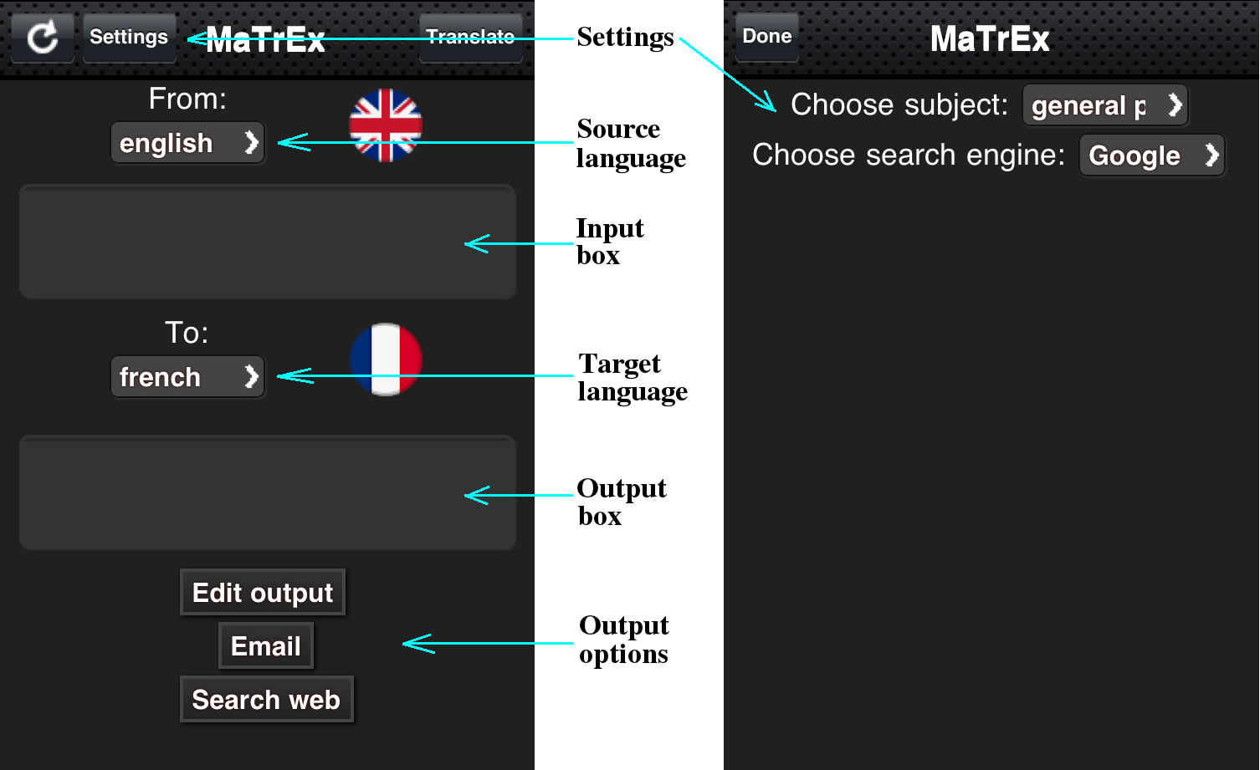
Followed by this is the interface. Which combines the main page, and the settings page.

Translating
To translate text select the input box, and input text.
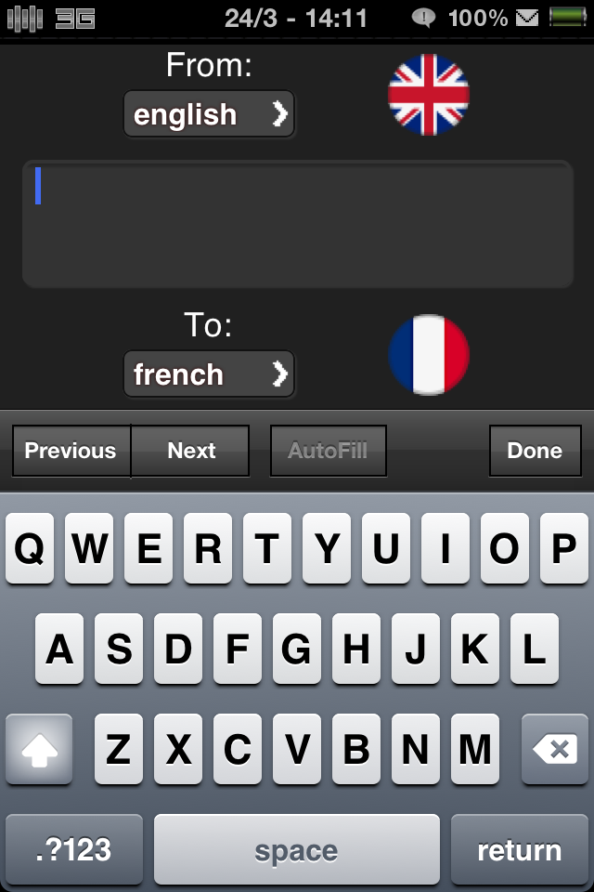

Select the source and target languages to adjust.
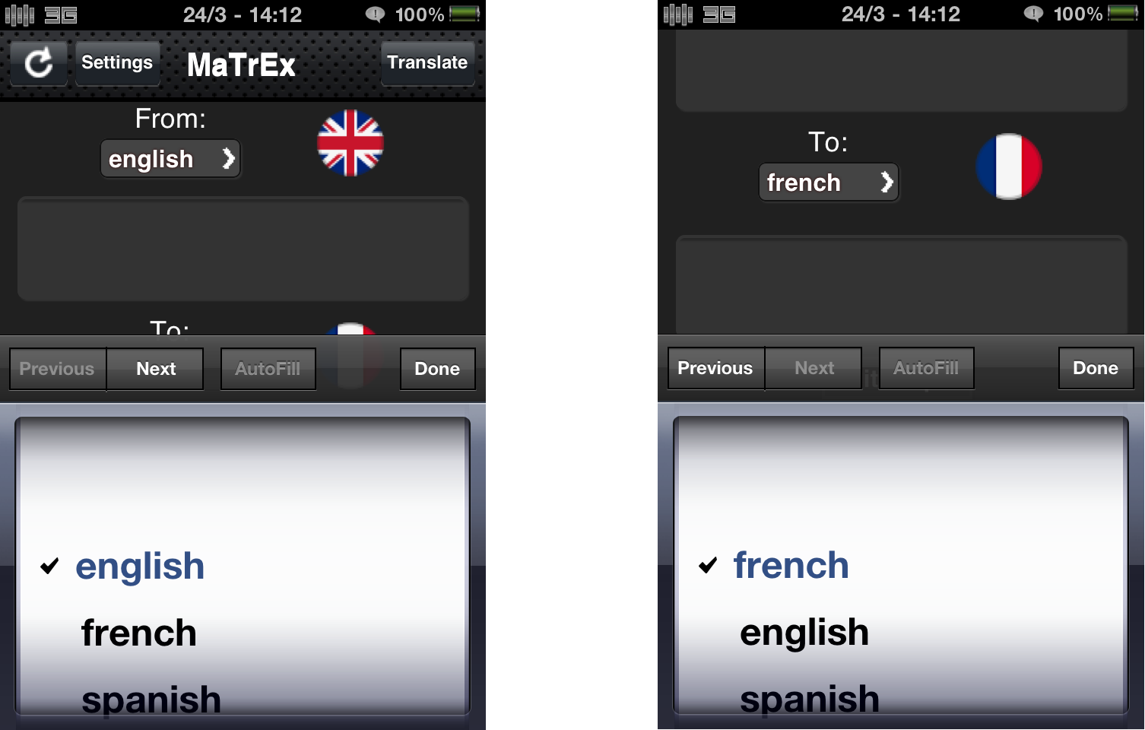
The subject option can be changed in settings. First press the “Settings” button to switch to the settings page. Select the subject to adjust.
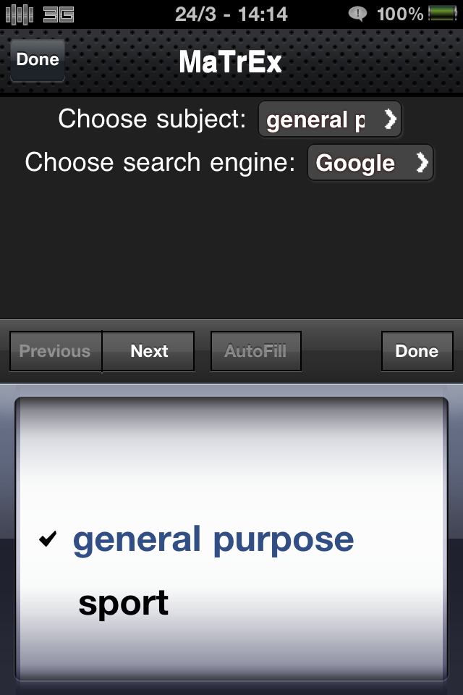

If you choose to change the subject press the “Done” button. To finally translate press the “Translate” button. Translated text appears in the output box.
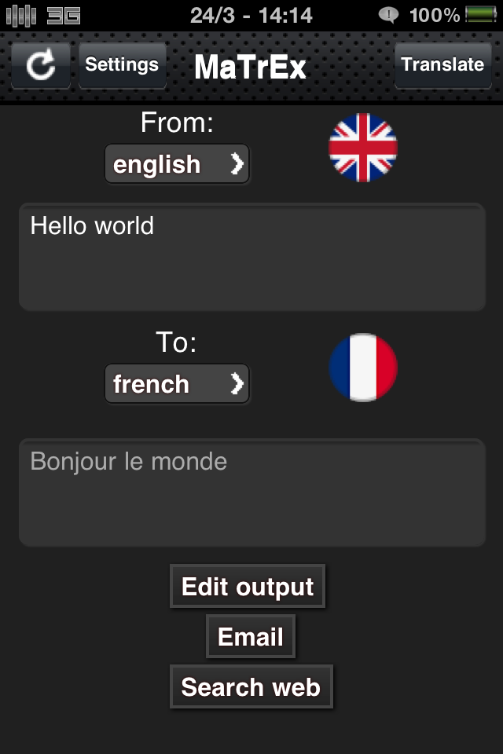

Post-editing
Once there is text in the output box post-editing is an option. To post-edit press the “Edit output” button. This activates the output box.
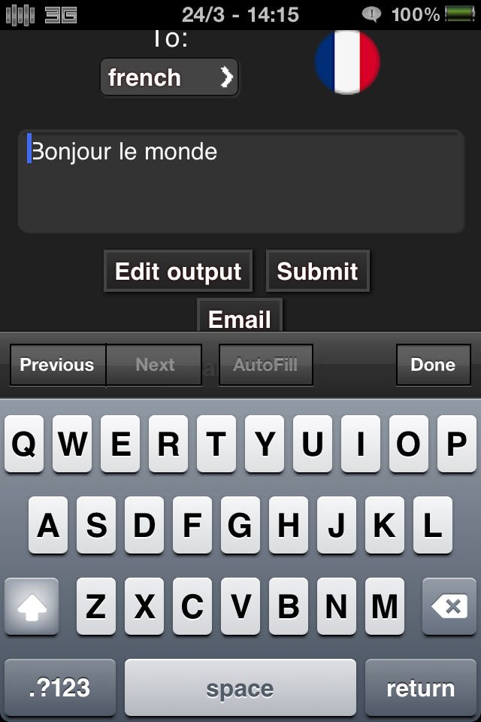

Once you have completed post-editing submit your changes. You will be notified of receipt by the server.
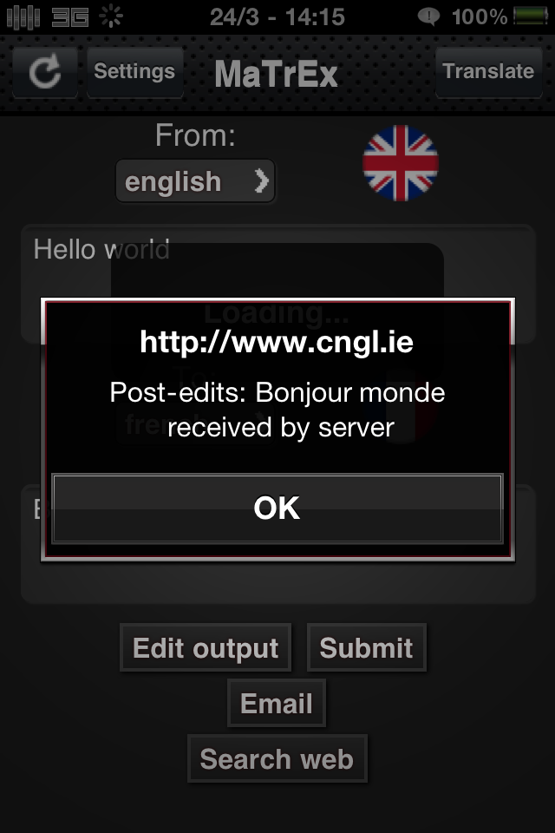

Email
There is also the choice of emailing output. To do so press the “Email” button. This will load your default mail client with the output in the body of the message.
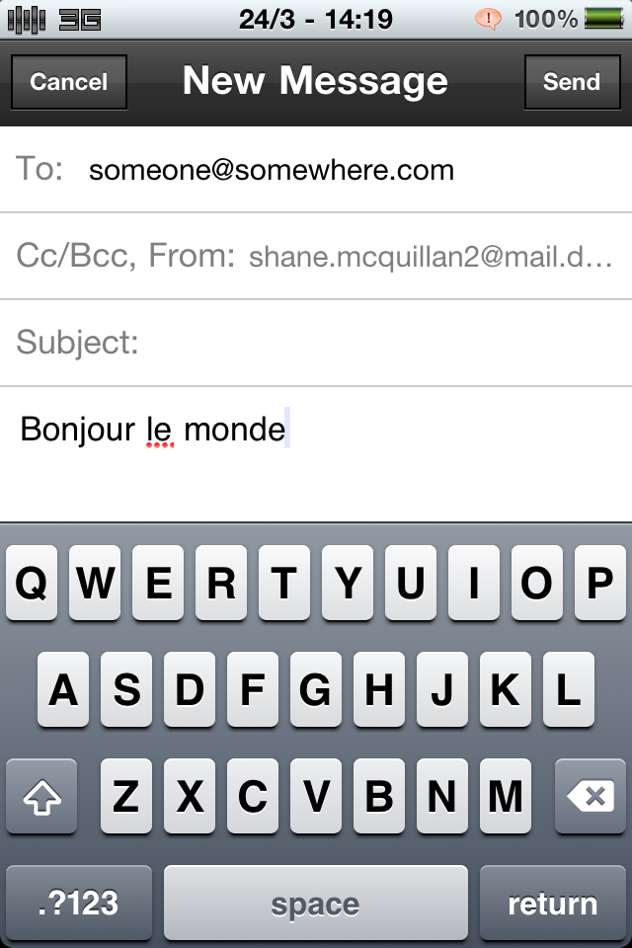

Search Web
There is also the option of searching the web for the output. To do this press the “Search Web” button. You can specify your search engine of choice from a select list in Settings.
