# Race: AQU | 2025-02-23 | Race #1 | Track: AQUEDUCT

Track: AQUEDUCT

|  |  |  |  |  |
| --- | --- | --- | --- | --- |
| Saddle Cloth # | Horse Name | Global Speed | Composite | Win Prob (%) |
| ['', 1, ''] | Super Swift | 143.1 | 5.81 | 48.46 |
| ['', 2, ''] | Just Clarity | 141.9 | 6.18 | 51.21 |
| ['', 3, ''] | Kenny Be | 73.4 | -3.90 | 0.00 |
| ['', 4, ''] | Buttah | 72.9 | 0.30 | 0.00 |
| ['', 5, ''] | Prince Valiant | 95.7 | 11.40 | 0.33 |
| ['', 6, ''] | Three B's | 73.3 | -4.09 | 0.00 |

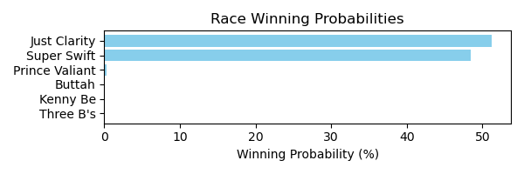

Figure: Winning Probability Distribution

NOTE: THIS RACE HAS HORSES THAT ARE MISSING CRITICAL DATA ELEMENTS

# Race: AQU | 2025-02-23 | Race #2 | Track: AQUEDUCT

Track: AQUEDUCT

|  |  |  |  |  |
| --- | --- | --- | --- | --- |
| Saddle Cloth # | Horse Name | Global Speed | Composite | Win Prob (%) |
| ['', 1, ''] | Devil's Cay | 108.1 | 2.22 | 0.00 |
| ['', 2, ''] | Quick Hammer | 96.1 | -9.35 | 0.00 |
| ['', 3, ''] | J D Factor | 142.5 | 2.63 | 3.99 |
| ['', 4, ''] | Master Freud | 60.5 | -4.66 | 0.00 |
| ['', 5, ''] | Hatch | 47.1 | -6.06 | 0.00 |
| ['', 6, ''] | Omey Island | 149.8 | 4.76 | 96.01 |

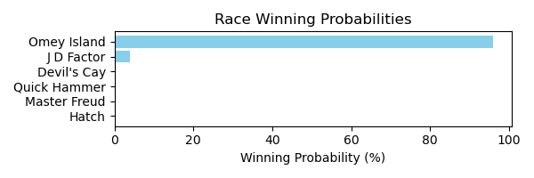

Figure: Winning Probability Distribution

NOTE: THIS RACE HAS HORSES THAT ARE MISSING CRITICAL DATA ELEMENTS

# Race: AQU | 2025-02-23 | Race #3 | Track: AQUEDUCT

Track: AQUEDUCT

|  |  |  |  |  |
| --- | --- | --- | --- | --- |
| Saddle Cloth # | Horse Name | Global Speed | Composite | Win Prob (%) |
| ['', 1, ''] | Monomoy Beach | 146.6 | 4.90 | 88.42 |
| ['', 1, 'a'] | Monomoys Partner | 139.0 | 4.21 | 11.09 |
| ['', 2, ''] | Romeo Void | 137.7 | 0.62 | 0.48 |
| ['', 3, ''] | Daytona Moonshine | 53.5 | -7.80 | 0.00 |
| ['', 4, ''] | Revivalism | 104.8 | 0.33 | 0.00 |
| ['', 5, ''] | Solar Glare | 95.3 | -4.21 | 0.00 |
| ['', 6, ''] | Fines Creek | 97.3 | -3.77 | 0.00 |
| ['', 7, ''] | Premier Cru | 110.6 | -4.55 | 0.00 |

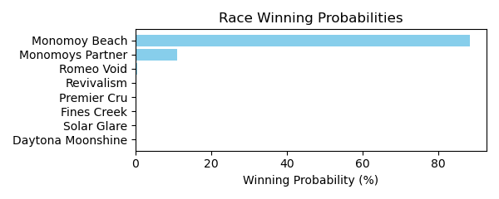

Figure: Winning Probability Distribution

NOTE: THIS RACE HAS HORSES THAT ARE MISSING CRITICAL DATA ELEMENTS

# Race: AQU | 2025-02-23 | Race #4 | Track: AQUEDUCT

Track: AQUEDUCT

|  |  |  |  |  |
| --- | --- | --- | --- | --- |
| Saddle Cloth # | Horse Name | Global Speed | Composite | Win Prob (%) |
| ['', 1, ''] | Bold Endeavor | 139.8 | 6.15 | 30.77 |
| ['', 1, 'a'] | Bold Victory | 147.0 | 4.17 | 26.65 |
| ['', 2, ''] | Celestial Moon | 123.7 | 1.83 | 0.04 |
| ['', 2, 'b'] | Just Call Ray | 117.8 | -6.15 | 0.00 |
| ['', 3, ''] | Costa Terra | 47.1 | -6.20 | 0.00 |
| ['', 4, ''] | Lost in Rome | 138.2 | 4.58 | 6.35 |
| ['', 5, ''] | Sagamore Mischief | 147.1 | 4.52 | 36.18 |
| ['', 6, ''] | Jackson Heights | 106.8 | -4.58 | 0.00 |
| ['', 7, ''] | Chelonian * | 117.8 | 1.67 | 0.01 |

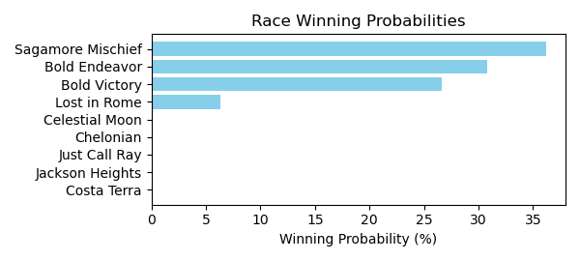

Figure: Winning Probability Distribution

NOTE: THIS RACE HAS HORSES THAT ARE MISSING CRITICAL DATA ELEMENTS

# Race: AQU | 2025-02-23 | Race #5 | Track: AQUEDUCT

Track: AQUEDUCT

|  |  |  |  |  |
| --- | --- | --- | --- | --- |
| Saddle Cloth # | Horse Name | Global Speed | Composite | Win Prob (%) |
| ['', 2, ''] | Adventurist * | 115.3 | -6.16 | 0.00 |
| ['', 3, ''] | Interceptor * | 115.6 | -6.46 | 0.00 |
| ['', 4, ''] | Quiet Moon * | 42.1 | -7.51 | 0.00 |
| ['', 5, ''] | Tracking Error | 146.4 | 6.12 | 62.40 |
| ['', 6, ''] | Kulapat * | 50.1 | -7.90 | 0.00 |
| ['', 7, ''] | Griffin's Wharf | 139.6 | 7.20 | 37.60 |

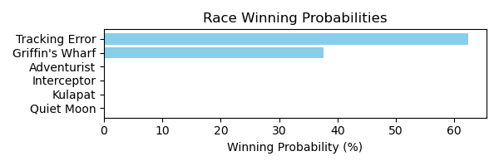

Figure: Winning Probability Distribution

NOTE: THIS RACE HAS HORSES THAT ARE MISSING CRITICAL DATA ELEMENTS

# Race: AQU | 2025-02-23 | Race #6 | Track: AQUEDUCT

Track: AQUEDUCT

|  |  |  |  |  |
| --- | --- | --- | --- | --- |
| Saddle Cloth # | Horse Name | Global Speed | Composite | Win Prob (%) |
| ['', 1, ''] | Call Her Bluff | 81.5 | -2.11 | 0.00 |
| ['', 1, 'a'] | Luna Moth | 74.4 | -6.84 | 0.00 |
| ['', 2, ''] | On Command | 40.0 | -7.77 | 0.00 |
| ['', 3, ''] | Tipple | 133.4 | 3.46 | 0.43 |
| ['', 4, ''] | Bells Beach | 149.0 | 4.66 | 25.58 |
| ['', 5, ''] | Rising Inflation | 140.5 | 6.51 | 20.30 |
| ['', 6, ''] | Malu | 144.6 | 6.68 | 53.02 |
| ['', 7, ''] | Next On Stage | 134.8 | 3.66 | 0.67 |

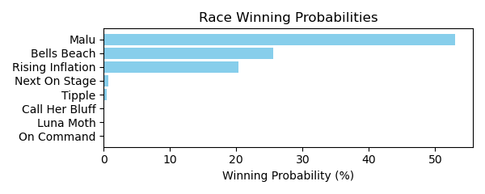

Figure: Winning Probability Distribution

NOTE: THIS RACE HAS HORSES THAT ARE MISSING CRITICAL DATA ELEMENTS

# Race: AQU | 2025-02-23 | Race #7 | Track: AQUEDUCT

Track: AQUEDUCT

|  |  |  |  |  |
| --- | --- | --- | --- | --- |
| Saddle Cloth # | Horse Name | Global Speed | Composite | Win Prob (%) |
| ['', 1, ''] | Cada Dia Mejor | 59.9 | -6.47 | 0.00 |
| ['', 2, ''] | Marvelous Richard * | 50.2 | -8.44 | 0.00 |
| ['', 3, ''] | Man From Malta | 53.3 | -8.10 | 0.00 |
| ['', 4, ''] | Monte Avi | 114.5 | 4.07 | 99.04 |
| ['', 5, ''] | Goodbye | 81.7 | -5.66 | 0.00 |
| ['', 6, ''] | Run With Honor | 117.0 | -2.35 | 0.95 |
| ['', 7, ''] | King Phoenix | 82.6 | 0.28 | 0.01 |
| ['', 8, ''] | Frontal Vision * | 76.1 | -8.66 | 0.00 |

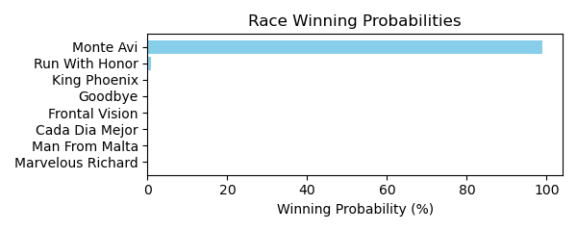

Figure: Winning Probability Distribution

NOTE: THIS RACE HAS HORSES THAT ARE MISSING CRITICAL DATA ELEMENTS

# Race: AQU | 2025-02-23 | Race #8 | Track: AQUEDUCT

Track: AQUEDUCT

|  |  |  |  |  |
| --- | --- | --- | --- | --- |
| Saddle Cloth # | Horse Name | Global Speed | Composite | Win Prob (%) |
| ['', 1, ''] | Flowing River | 77.6 | -1.66 | 0.00 |
| ['', 1, 'a'] | Can't Beat Me | 53.6 | -7.96 | 0.00 |
| ['', 2, ''] | Union Lights | 89.0 | -5.38 | 0.00 |
| ['', 3, ''] | Centavo | 49.1 | -8.26 | 0.00 |
| ['', 4, ''] | Dads Good Runner | 106.8 | -3.99 | 0.00 |
| ['', 5, ''] | Blake B. | 130.0 | 0.17 | 10.34 |
| ['', 6, ''] | Persistent Danger | 42.9 | -7.20 | 0.00 |
| ['', 7, ''] | Chalky Cat | 114.2 | 2.58 | 3.05 |
| ['', 8, ''] | Indianquest | 49.7 | -8.21 | 0.00 |
| ['', 9, ''] | Funny Joke | 124.9 | 4.10 | 86.61 |

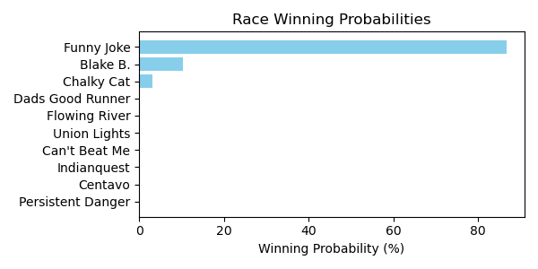

Figure: Winning Probability Distribution

NOTE: THIS RACE HAS HORSES THAT ARE MISSING CRITICAL DATA ELEMENTS

# Race: AQU | 2025-02-23 | Race #9 | Track: AQUEDUCT

Track: AQUEDUCT

|  |  |  |  |  |
| --- | --- | --- | --- | --- |
| Saddle Cloth # | Horse Name | Global Speed | Composite | Win Prob (%) |
| ['', 1, ''] | Bon Adieu | 69.2 | -6.07 | 0.00 |
| ['', 2, ''] | Catchphrase | 146.3 | 5.91 | 23.12 |
| ['', 3, ''] | Landed | 134.3 | 5.82 | 1.97 |
| ['', 4, ''] | Speightful Lily | 145.4 | 6.02 | 21.27 |
| ['', 5, ''] | Bernietakescharge | 45.3 | 3.22 | 0.00 |
| ['', 6, ''] | My Magic Wand | 147.1 | 5.96 | 28.46 |
| ['', 7, ''] | Sweet Brown Sugar | 130.7 | 5.61 | 0.82 |
| ['', 8, ''] | Cara's Time | 53.1 | -7.09 | 0.00 |
| ['', 9, ''] | Caldwell Luvs Gold | 95.4 | -5.04 | 0.00 |
| ['', 10, ''] | Snappin Buttons | 97.8 | -4.76 | 0.00 |
| ['', 11, ''] | Tough Street | 147.3 | 5.72 | 24.37 |

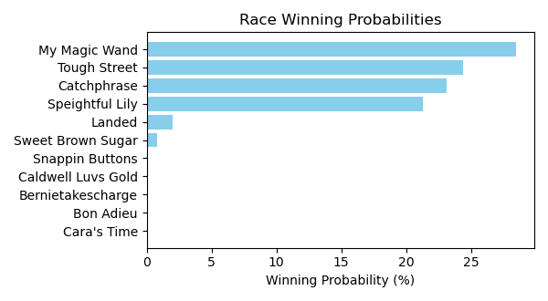

Figure: Winning Probability Distribution

NOTE: THIS RACE HAS HORSES THAT ARE MISSING CRITICAL DATA ELEMENTS

# Race: AQU | 2025-02-23 | Race #10 | Track: AQUEDUCT

Track: AQUEDUCT

|  |  |  |  |  |
| --- | --- | --- | --- | --- |
| Saddle Cloth # | Horse Name | Global Speed | Composite | Win Prob (%) |
| ['', 1, ''] | Katerina Ristova | 121.3 | 2.67 | 77.52 |
| ['', 2, ''] | Rasta Girl | 130.3 | -1.12 | 22.47 |
| ['', 4, ''] | Melancia | 50.8 | -8.06 | 0.00 |
| ['', 5, ''] | Grand Crossing * | 70.7 | 3.26 | 0.00 |
| ['', 8, ''] | Game Like Reyana | 53.3 | -8.16 | 0.00 |
| ['', 9, ''] | Improbable Friend * | 71.2 | -9.14 | 0.00 |

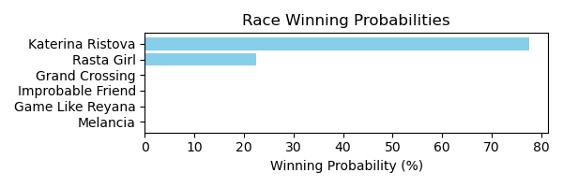

Figure: Winning Probability Distribution

NOTE: THIS RACE HAS HORSES THAT ARE MISSING CRITICAL DATA ELEMENTS

# Race: TGP | 2025-02-23 | Race #1 | Track: GULFSTREAM PARK

Track: GULFSTREAM PARK

|  |  |  |  |  |
| --- | --- | --- | --- | --- |
| Saddle Cloth # | Horse Name | Global Speed | Composite | Win Prob (%) |
| ['', 2, ''] | Mahovlich | 55.4 | -8.23 | 0.00 |
| ['', 3, ''] | Culminate * | 40.7 | -7.81 | 0.00 |
| ['', 4, ''] | Roar of the Beast | 61.6 | -6.42 | 0.00 |
| ['', 5, ''] | Sarkis | 103.9 | 3.88 | 99.97 |
| ['', 6, ''] | Start Mo Up | 50.0 | -8.11 | 0.00 |
| ['', 8, ''] | Roman Hunter * | 63.9 | 3.79 | 0.03 |

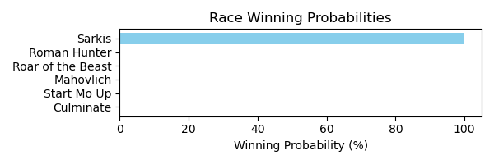

Figure: Winning Probability Distribution

NOTE: THIS RACE HAS HORSES THAT ARE MISSING CRITICAL DATA ELEMENTS

# Race: TGP | 2025-02-23 | Race #2 | Track: GULFSTREAM PARK

Track: GULFSTREAM PARK

|  |  |  |  |  |
| --- | --- | --- | --- | --- |
| Saddle Cloth # | Horse Name | Global Speed | Composite | Win Prob (%) |
| ['', 1, ''] | Drop the Hammer | 117.0 | -5.08 | 0.00 |
| ['', 2, ''] | Seger Songs | 116.7 | -2.77 | 0.00 |
| ['', 7, ''] | Princess Attitude * | 112.0 | 5.66 | 0.24 |
| ['', 9, ''] | Baby Lala * | 57.7 | -7.88 | 0.00 |
| ['', 11, ''] | Sweet Surrender | 109.6 | -4.98 | 0.00 |
| ['', 12, ''] | Tellus Mater * | 132.6 | 6.19 | 22.49 |
| ['', 13, ''] | Bunratty Manor (IRE) | 145.3 | 4.14 | 54.59 |
| ['', 14, ''] | Brown Sugar | 128.1 | 7.33 | 22.68 |

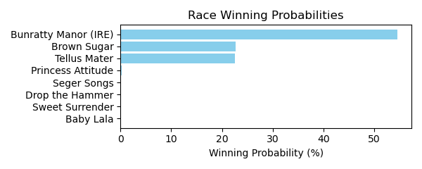

Figure: Winning Probability Distribution

NOTE: THIS RACE HAS HORSES THAT ARE MISSING CRITICAL DATA ELEMENTS

# Race: TGP | 2025-02-23 | Race #3 | Track: GULFSTREAM PARK

Track: GULFSTREAM PARK

|  |  |  |  |  |
| --- | --- | --- | --- | --- |
| Saddle Cloth # | Horse Name | Global Speed | Composite | Win Prob (%) |
| ['', 1, ''] | High Limit Room | 60.8 | -8.36 | 0.00 |
| ['', 2, ''] | Red River Rebel | 132.7 | 4.24 | 44.87 |
| ['', 3, ''] | Cadamosto (IRE) | 110.5 | -1.22 | 0.01 |
| ['', 4, ''] | Mr Narcissistic | 126.6 | 4.21 | 12.94 |
| ['', 5, ''] | Seaver | 57.4 | -7.90 | 0.00 |
| ['', 6, ''] | Zydeceaux | 61.2 | -7.74 | 0.00 |
| ['', 7, ''] | Souper Dormy | 127.1 | 3.93 | 11.56 |
| ['', 8, ''] | Doctor Jeff | 136.8 | 2.74 | 30.62 |

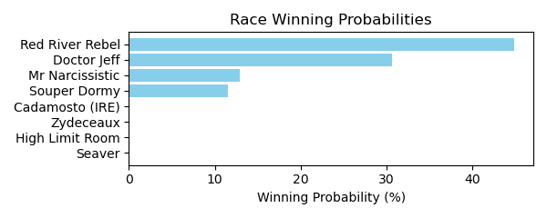

Figure: Winning Probability Distribution

NOTE: THIS RACE HAS HORSES THAT ARE MISSING CRITICAL DATA ELEMENTS

# Race: TGP | 2025-02-23 | Race #4 | Track: GULFSTREAM PARK

Track: GULFSTREAM PARK

|  |  |  |  |  |
| --- | --- | --- | --- | --- |
| Saddle Cloth # | Horse Name | Global Speed | Composite | Win Prob (%) |
| ['', 2, ''] | He's a Daredevil | 48.6 | -7.49 | 0.00 |
| ['', 3, ''] | Volatile Storm | 129.2 | -0.51 | 5.44 |
| ['', 4, ''] | Ruiz Junior | 131.4 | 2.34 | 81.77 |
| ['', 5, ''] | Yemrehanakristos | 121.3 | 2.48 | 12.28 |
| ['', 6, ''] | Winning Fortune | 98.0 | -3.49 | 0.00 |
| ['', 7, ''] | Signal Caller | 119.4 | -2.45 | 0.16 |
| ['', 8, ''] | Dimanche Gras | 115.6 | -0.53 | 0.35 |
| ['', 9, ''] | Money Tour | 51.1 | -8.13 | 0.00 |

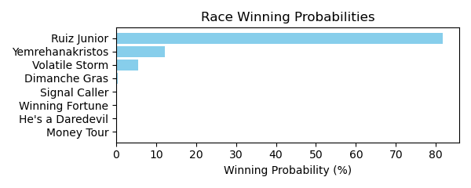

Figure: Winning Probability Distribution

NOTE: THIS RACE HAS HORSES THAT ARE MISSING CRITICAL DATA ELEMENTS

# Race: TGP | 2025-02-23 | Race #5 | Track: GULFSTREAM PARK

Track: GULFSTREAM PARK

|  |  |  |  |  |
| --- | --- | --- | --- | --- |
| Saddle Cloth # | Horse Name | Global Speed | Composite | Win Prob (%) |
| ['', 1, ''] | Neophyte | 145.2 | 4.15 | 34.43 |
| ['', 2, ''] | Warlord Cruzan | 129.3 | 4.34 | 1.64 |
| ['', 3, ''] | Dropkick Murphy | 140.8 | 2.83 | 4.94 |
| ['', 4, ''] | Louisianimal | 77.2 | 4.27 | 0.00 |
| ['', 5, ''] | Dr Oseran | 51.2 | -8.36 | 0.00 |
| ['', 6, ''] | Bella Future | 86.1 | -7.11 | 0.00 |
| ['', 7, ''] | Gepard | 95.4 | -3.42 | 0.00 |
| ['', 8, ''] | Ready for a Fight | 145.3 | 4.82 | 58.98 |
| ['', 9, ''] | Ensign Parker | 57.7 | -8.30 | 0.00 |

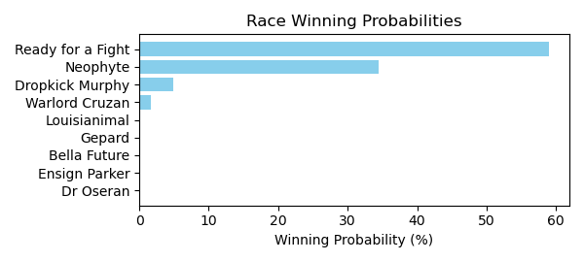

Figure: Winning Probability Distribution

NOTE: THIS RACE HAS HORSES THAT ARE MISSING CRITICAL DATA ELEMENTS

# Race: TGP | 2025-02-23 | Race #6 | Track: GULFSTREAM PARK

Track: GULFSTREAM PARK

|  |  |  |  |  |
| --- | --- | --- | --- | --- |
| Saddle Cloth # | Horse Name | Global Speed | Composite | Win Prob (%) |
| ['', 1, ''] | Valid Sense | 138.4 | 5.09 | 13.67 |
| ['', 2, ''] | Smokin Jack Flash | 99.8 | -2.14 | 0.00 |
| ['', 5, ''] | Reverend Moon | 117.2 | 2.45 | 0.02 |
| ['', 6, ''] | Not Guilty | 143.4 | 6.04 | 79.20 |
| ['', 7, ''] | Max N Fifo | 53.9 | -8.60 | 0.00 |
| ['', 8, ''] | Night of Magic | 137.7 | 4.44 | 7.11 |

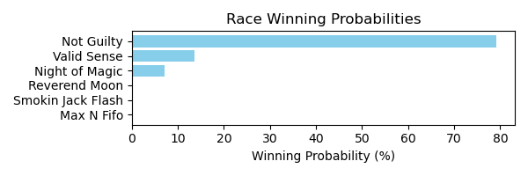

Figure: Winning Probability Distribution

NOTE: THIS RACE HAS HORSES THAT ARE MISSING CRITICAL DATA ELEMENTS

# Race: TGP | 2025-02-23 | Race #7 | Track: GULFSTREAM PARK

Track: GULFSTREAM PARK

|  |  |  |  |  |
| --- | --- | --- | --- | --- |
| Saddle Cloth # | Horse Name | Global Speed | Composite | Win Prob (%) |
| ['', 1, ''] | Bel Pensiero | 144.5 | 4.35 | 10.71 |
| ['', 2, ''] | Julee's Legacy | 142.5 | 4.40 | 7.50 |
| ['', 3, ''] | Miyako | 49.2 | -7.76 | 0.00 |
| ['', 4, ''] | Vindicate Cha Cha | 133.0 | 5.37 | 2.44 |
| ['', 5, ''] | Beauty of the Nile | 86.7 | -5.93 | 0.00 |
| ['', 7, ''] | Dial Home | 143.2 | 0.96 | 0.56 |
| ['', 8, ''] | Ultimate Ready * | 145.0 | 6.62 | 73.39 |
| ['', 9, ''] | Proud Mary | 77.9 | -5.41 | 0.00 |
| ['', 10, ''] | Royally Blue | 139.3 | 3.27 | 1.61 |
| ['', 11, ''] | Definite Diva | 145.7 | 2.74 | 3.80 |
| ['', 12, ''] | Obstreperous * | 70.5 | 6.52 | 0.00 |

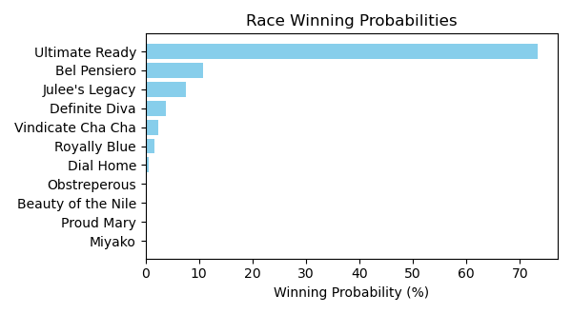

Figure: Winning Probability Distribution

NOTE: THIS RACE HAS HORSES THAT ARE MISSING CRITICAL DATA ELEMENTS

# Race: TGP | 2025-02-23 | Race #8 | Track: GULFSTREAM PARK

Track: GULFSTREAM PARK

|  |  |  |  |  |
| --- | --- | --- | --- | --- |
| Saddle Cloth # | Horse Name | Global Speed | Composite | Win Prob (%) |
| ['', 1, ''] | Christensen | 117.0 | 0.53 | 0.01 |
| ['', 2, ''] | Fast Fixer | 41.5 | -7.76 | 0.00 |
| ['', 3, ''] | Chaplin | 105.9 | -1.28 | 0.00 |
| ['', 4, ''] | One Whirlwind Ride | 74.7 | -7.48 | 0.00 |
| ['', 5, ''] | Mister Kelly | 139.9 | 2.09 | 4.59 |
| ['', 6, ''] | Rough Draft | 134.8 | 1.49 | 1.03 |
| ['', 7, ''] | Galipan | 41.2 | -7.70 | 0.00 |
| ['', 8, ''] | Souper Success | 146.0 | 4.33 | 94.36 |
| ['', 9, ''] | Banneker | 85.2 | -6.05 | 0.00 |

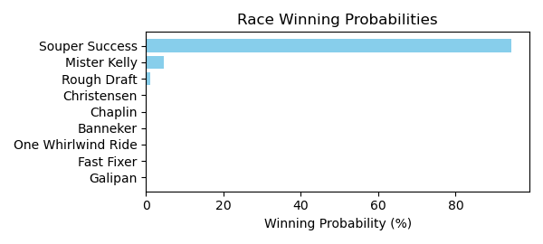

Figure: Winning Probability Distribution

NOTE: THIS RACE HAS HORSES THAT ARE MISSING CRITICAL DATA ELEMENTS

# Race: TGP | 2025-02-23 | Race #9 | Track: GULFSTREAM PARK

Track: GULFSTREAM PARK

|  |  |  |  |  |
| --- | --- | --- | --- | --- |
| Saddle Cloth # | Horse Name | Global Speed | Composite | Win Prob (%) |
| ['', 1, ''] | Latch the Hatch | 121.3 | 5.54 | 0.12 |
| ['', 2, ''] | Mati Gol | 87.7 | 2.27 | 0.00 |
| ['', 3, ''] | Cajun Venom | 144.2 | 4.47 | 5.11 |
| ['', 4, ''] | Aero Star | 130.7 | 4.76 | 0.44 |
| ['', 5, ''] | Simo * | 138.2 | 7.75 | 21.39 |
| ['', 6, ''] | Joey Muscles | 120.2 | 2.80 | 0.01 |
| ['', 7, ''] | Rookie Card | 43.2 | -3.12 | 0.00 |
| ['', 8, ''] | Cut the Dust * | 149.0 | 6.60 | 72.92 |

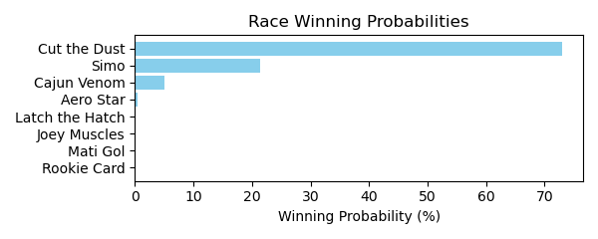

Figure: Winning Probability Distribution

NOTE: THIS RACE HAS HORSES THAT ARE MISSING CRITICAL DATA ELEMENTS

# Race: TGP | 2025-02-23 | Race #10 | Track: GULFSTREAM PARK

Track: GULFSTREAM PARK

|  |  |  |  |  |
| --- | --- | --- | --- | --- |
| Saddle Cloth # | Horse Name | Global Speed | Composite | Win Prob (%) |
| ['', 1, ''] | Ciao Chuck | 145.6 | 3.72 | 85.93 |
| ['', 2, ''] | Right to Win (IRE) | 128.3 | 5.70 | 13.25 |
| ['', 4, ''] | Wonderfinn | 106.8 | -4.90 | 0.00 |
| ['', 5, ''] | Beach Gold | 116.2 | 4.29 | 0.38 |
| ['', 6, ''] | Inherent Promise | 120.3 | 2.60 | 0.23 |
| ['', 7, ''] | Its Bourbon Thirty | 73.8 | -5.54 | 0.00 |
| ['', 8, ''] | Redemption Speight | 40.6 | -7.70 | 0.00 |
| ['', 9, ''] | Sardis | 128.9 | 0.40 | 0.21 |

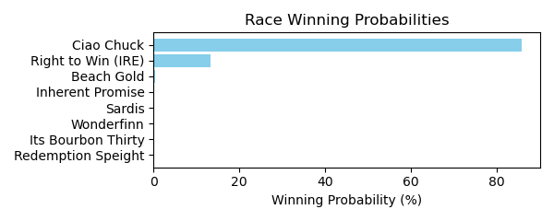

Figure: Winning Probability Distribution

NOTE: THIS RACE HAS HORSES THAT ARE MISSING CRITICAL DATA ELEMENTS

# Race: LRL | 2025-02-23 | Race #1 | Track: LAUREL PARK

Track: LAUREL PARK

|  |  |  |  |  |
| --- | --- | --- | --- | --- |
| Saddle Cloth # | Horse Name | Global Speed | Composite | Win Prob (%) |
| ['', 1, ''] | Peace Out | 83.9 | -8.76 | 0.00 |
| ['', 2, ''] | Hateful | 129.2 | 3.27 | 0.24 |
| ['', 3, ''] | Velvet Vixen | 76.5 | -6.31 | 0.00 |
| ['', 4, ''] | Police Woman | 85.0 | -7.72 | 0.00 |
| ['', 5, ''] | Maddie Ten | 126.1 | 0.61 | 0.02 |
| ['', 6, ''] | Stormy Midnight | 147.4 | 6.24 | 99.74 |
| ['', 7, ''] | Bucchanera | 40.4 | -8.53 | 0.00 |
| ['', 8, ''] | Frosty Maya | 73.8 | 8.61 | 0.00 |

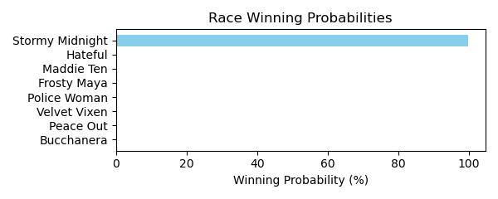

Figure: Winning Probability Distribution

NOTE: THIS RACE HAS HORSES THAT ARE MISSING CRITICAL DATA ELEMENTS

# Race: LRL | 2025-02-23 | Race #2 | Track: LAUREL PARK

Track: LAUREL PARK

|  |  |  |  |  |
| --- | --- | --- | --- | --- |
| Saddle Cloth # | Horse Name | Global Speed | Composite | Win Prob (%) |
| ['', 1, ''] | Thunder in Paris | 129.3 | 2.13 | 0.09 |
| ['', 2, ''] | dq-Fitness | 144.2 | 6.76 | 74.99 |
| ['', 3, ''] | Gotanothathingcomn * | 124.6 | -10.29 | 0.00 |
| ['', 4, ''] | Tres Aries | 144.7 | 5.13 | 22.81 |
| ['', 5, ''] | The Feisty One | 146.1 | 1.80 | 2.11 |
| ['', 6, ''] | Boujee Bubblez | 54.0 | -6.76 | 0.00 |

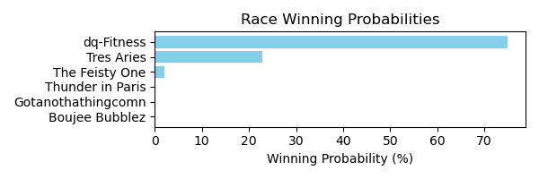

Figure: Winning Probability Distribution

NOTE: THIS RACE HAS HORSES THAT ARE MISSING CRITICAL DATA ELEMENTS

# Race: LRL | 2025-02-23 | Race #3 | Track: LAUREL PARK

Track: LAUREL PARK

|  |  |  |  |  |
| --- | --- | --- | --- | --- |
| Saddle Cloth # | Horse Name | Global Speed | Composite | Win Prob (%) |
| ['', 1, ''] | Suremeanttoobe * | 105.7 | -6.47 | 0.00 |
| ['', 3, ''] | Serendipitymonday | 95.6 | -7.31 | 0.00 |
| ['', 4, ''] | Annihilate 'Em * | 90.1 | -6.86 | 0.00 |
| ['', 5, ''] | Built by Khozan | 133.4 | 4.35 | 100.00 |
| ['', 6, ''] | Knucker Punk | 84.1 | -1.64 | 0.00 |
| ['', 7, ''] | Chase a Dream * | 42.0 | -7.96 | 0.00 |

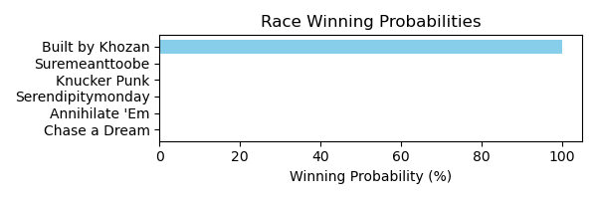

Figure: Winning Probability Distribution

NOTE: THIS RACE HAS HORSES THAT ARE MISSING CRITICAL DATA ELEMENTS

# Race: LRL | 2025-02-23 | Race #4 | Track: LAUREL PARK

Track: LAUREL PARK

|  |  |  |  |  |
| --- | --- | --- | --- | --- |
| Saddle Cloth # | Horse Name | Global Speed | Composite | Win Prob (%) |
| ['', 1, ''] | Bold Mirage * | 93.7 | -7.87 | 0.00 |
| ['', 2, ''] | Knockanara | 115.8 | -4.91 | 0.00 |
| ['', 3, ''] | Meg | 59.6 | -8.30 | 0.00 |
| ['', 5, ''] | Superlastingsecret | 142.4 | 1.90 | 99.99 |
| ['', 6, ''] | Karma's Inthehouse | 91.3 | 2.83 | 0.01 |

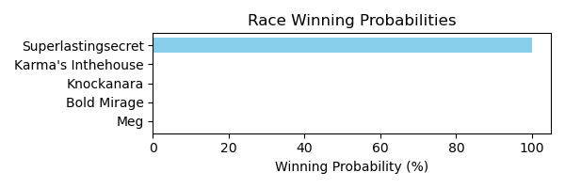

Figure: Winning Probability Distribution

NOTE: THIS RACE HAS HORSES THAT ARE MISSING CRITICAL DATA ELEMENTS

# Race: LRL | 2025-02-23 | Race #5 | Track: LAUREL PARK

Track: LAUREL PARK

|  |  |  |  |  |
| --- | --- | --- | --- | --- |
| Saddle Cloth # | Horse Name | Global Speed | Composite | Win Prob (%) |
| ['', 1, ''] | Cactus | 43.7 | -8.37 | 0.00 |
| ['', 2, ''] | Johnnyfrenchfri | 129.4 | 4.93 | 0.73 |
| ['', 3, ''] | Brazillionaire | 111.1 | -4.33 | 0.00 |
| ['', 4, ''] | Silverbullettwenty | 134.4 | 2.60 | 0.31 |
| ['', 5, ''] | Summerstateofmind | 105.5 | -0.74 | 0.00 |
| ['', 6, ''] | Gotts Got It | 76.8 | -6.22 | 0.00 |
| ['', 7, ''] | Sumo | 144.2 | 3.58 | 4.81 |
| ['', 8, ''] | Ikigai | 85.9 | -3.41 | 0.00 |
| ['', 9, ''] | My Mamba | 132.2 | 3.42 | 0.39 |
| ['', 10, ''] | Minister for Magic | 145.9 | 6.85 | 93.75 |
| ['', 11, ''] | Sunset Town | 99.1 | -2.81 | 0.00 |

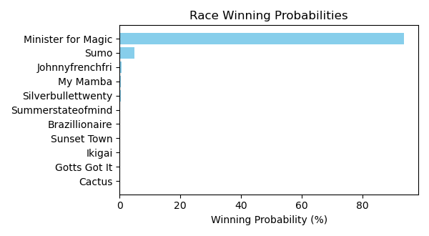

Figure: Winning Probability Distribution

NOTE: THIS RACE HAS HORSES THAT ARE MISSING CRITICAL DATA ELEMENTS

# Race: LRL | 2025-02-23 | Race #6 | Track: LAUREL PARK

Track: LAUREL PARK

|  |  |  |  |  |
| --- | --- | --- | --- | --- |
| Saddle Cloth # | Horse Name | Global Speed | Composite | Win Prob (%) |
| ['', 1, ''] | She'sarollingstone | 128.4 | 6.78 | 33.52 |
| ['', 1, 'a'] | Divine Grace | 43.7 | -6.66 | 0.00 |
| ['', 2, ''] | Brooklyn Girl | 45.1 | -8.69 | 0.00 |
| ['', 3, ''] | Sullivan Street | 119.8 | 3.19 | 0.34 |
| ['', 4, ''] | Always Forward | 130.6 | -1.48 | 0.07 |
| ['', 5, ''] | Viennese Waltz | 110.4 | -0.55 | 0.00 |
| ['', 6, ''] | Always Laughing | 135.8 | 5.62 | 58.80 |
| ['', 7, ''] | Isabella's Glory | 126.9 | 5.23 | 7.27 |
| ['', 8, ''] | Bound by Destiny | 70.6 | -9.75 | 0.00 |

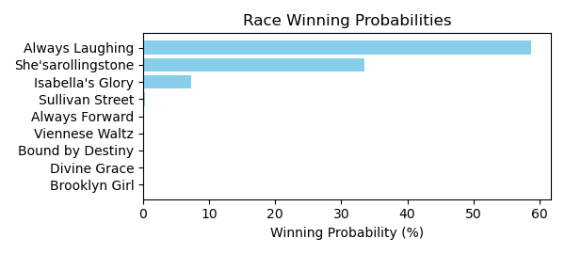

Figure: Winning Probability Distribution

NOTE: THIS RACE HAS HORSES THAT ARE MISSING CRITICAL DATA ELEMENTS

# Race: LRL | 2025-02-23 | Race #7 | Track: LAUREL PARK

Track: LAUREL PARK

|  |  |  |  |  |
| --- | --- | --- | --- | --- |
| Saddle Cloth # | Horse Name | Global Speed | Composite | Win Prob (%) |
| ['', 1, ''] | Prado Road | 127.6 | 3.45 | 1.30 |
| ['', 2, ''] | Restless | 105.0 | 3.23 | 0.01 |
| ['', 3, ''] | Elvis Himself | 65.0 | -6.07 | 0.00 |
| ['', 4, ''] | Buckin' Dreamer | 136.5 | 1.24 | 1.31 |
| ['', 5, ''] | Heard On Thestreet | 141.4 | 4.38 | 43.27 |
| ['', 6, ''] | Great Heavens | 144.0 | 3.11 | 26.12 |
| ['', 7, ''] | Carvellian Quest | 136.1 | 5.17 | 27.98 |
| ['', 8, ''] | Haileysfirstnotion | 51.6 | -8.35 | 0.00 |

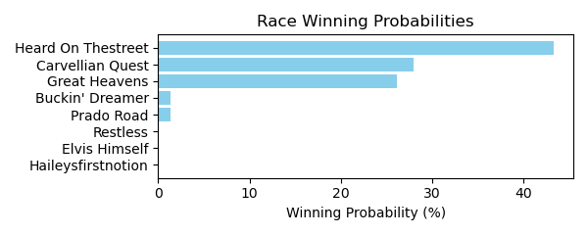

Figure: Winning Probability Distribution

NOTE: THIS RACE HAS HORSES THAT ARE MISSING CRITICAL DATA ELEMENTS

# Race: LRL | 2025-02-23 | Race #8 | Track: LAUREL PARK

Track: LAUREL PARK

|  |  |  |  |  |
| --- | --- | --- | --- | --- |
| Saddle Cloth # | Horse Name | Global Speed | Composite | Win Prob (%) |
| ['', 1, ''] | Notmyfirstrodeo | 49.9 | -6.68 | 0.00 |
| ['', 2, ''] | Flashy Dude | 65.0 | -6.06 | 0.00 |
| ['', 3, ''] | Enabler | 90.3 | -1.23 | 0.00 |
| ['', 4, ''] | Buds Island | 147.2 | 5.62 | 99.60 |
| ['', 5, ''] | Dats Mr. Tap | 43.0 | -8.43 | 0.00 |
| ['', 6, ''] | Daddy Yankee | 40.2 | -8.26 | 0.00 |
| ['', 7, ''] | Millibar | 128.5 | 3.41 | 0.40 |

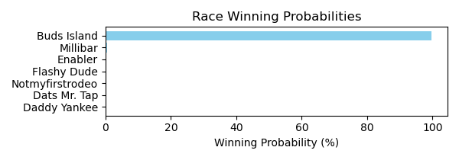

Figure: Winning Probability Distribution

NOTE: THIS RACE HAS HORSES THAT ARE MISSING CRITICAL DATA ELEMENTS

# Race: MVR | 2025-02-24 | Race #1 | Track: MAHONING VALLEY RACE COURSE

Track: MAHONING VALLEY RACE COURSE

|  |  |  |  |  |
| --- | --- | --- | --- | --- |
| Saddle Cloth # | Horse Name | Global Speed | Composite | Win Prob (%) |
| ['', 1, ''] | Divine Empire | 115.5 | -0.90 | 89.68 |
| ['', 3, ''] | Blustering Breeze | 75.8 | 0.23 | 0.08 |
| ['', 4, ''] | Galpin Sunday * | 73.8 | -8.67 | 0.00 |
| ['', 5, ''] | Great Revelation * | 114.5 | -10.17 | 0.04 |
| ['', 6, ''] | Beer Time * | 76.6 | -9.09 | 0.00 |
| ['', 7, ''] | Red in Front | 76.6 | 6.10 | 10.19 |

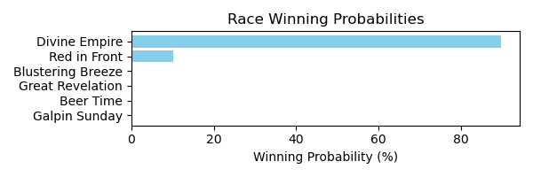

Figure: Winning Probability Distribution

NOTE: THIS RACE HAS HORSES THAT ARE MISSING CRITICAL DATA ELEMENTS

# Race: MVR | 2025-02-24 | Race #2 | Track: MAHONING VALLEY RACE COURSE

Track: MAHONING VALLEY RACE COURSE

|  |  |  |  |  |
| --- | --- | --- | --- | --- |
| Saddle Cloth # | Horse Name | Global Speed | Composite | Win Prob (%) |
| ['', 1, ''] | Dark Baron * | 116.2 | -7.17 | 0.00 |
| ['', 2, ''] | Capturethelaughter * | 115.0 | 10.53 | 38.83 |
| ['', 3, ''] | Torrefactor * | 129.1 | 7.56 | 60.75 |
| ['', 4, ''] | Verbier * | 77.9 | -1.18 | 0.00 |
| ['', 5, ''] | Gut Instinct * | 116.2 | 4.59 | 0.42 |
| ['', 6, ''] | Bayou Magic | 63.6 | -7.78 | 0.00 |
| ['', 7, ''] | Sicilian Style Two * | 77.3 | 2.33 | 0.00 |

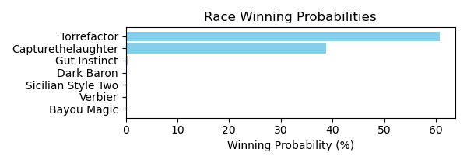

Figure: Winning Probability Distribution

NOTE: THIS RACE HAS HORSES THAT ARE MISSING CRITICAL DATA ELEMENTS

# Race: MVR | 2025-02-24 | Race #3 | Track: MAHONING VALLEY RACE COURSE

Track: MAHONING VALLEY RACE COURSE

|  |  |  |  |  |
| --- | --- | --- | --- | --- |
| Saddle Cloth # | Horse Name | Global Speed | Composite | Win Prob (%) |
| ['', 1, ''] | Bourbon Wisdom * | 122.5 | 4.89 | 88.77 |
| ['', 2, ''] | Cugine * | 77.6 | 6.22 | 0.03 |
| ['', 3, ''] | Morethanreadyeddie * | 71.0 | 6.53 | 0.01 |
| ['', 4, ''] | Napa Dude * | 77.6 | -1.78 | 0.00 |
| ['', 5, ''] | Credit River * | 77.6 | -5.88 | 0.00 |
| ['', 6, ''] | Bless the Kitten * | 77.6 | 6.01 | 0.03 |
| ['', 7, ''] | Royal Dragoon * | 117.1 | -3.67 | 0.03 |
| ['', 8, ''] | Hitsville * | 117.2 | -5.33 | 0.01 |
| ['', 9, ''] | See Spot Run * | 116.2 | 3.88 | 11.12 |

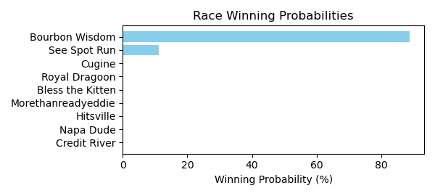

Figure: Winning Probability Distribution

# Race: MVR | 2025-02-24 | Race #4 | Track: MAHONING VALLEY RACE COURSE

Track: MAHONING VALLEY RACE COURSE

|  |  |  |  |  |
| --- | --- | --- | --- | --- |
| Saddle Cloth # | Horse Name | Global Speed | Composite | Win Prob (%) |
| ['', 1, ''] | Doctor Wu * | 96.0 | 7.80 | 35.96 |
| ['', 2, ''] | Road to Stardom * | 85.9 | -6.86 | 0.00 |
| ['', 3, ''] | Southern Sense * | 77.9 | -0.58 | 0.00 |
| ['', 4, ''] | Game Boy Benny * | 71.0 | 6.04 | 0.06 |
| ['', 5, ''] | Scratchoff * | 77.9 | 1.05 | 0.00 |
| ['', 6, ''] | Outkissed * | 87.7 | 10.52 | 59.51 |
| ['', 7, ''] | Over the Hills * | 78.0 | -11.33 | 0.00 |
| ['', 8, ''] | P Money | 96.3 | 5.11 | 4.46 |

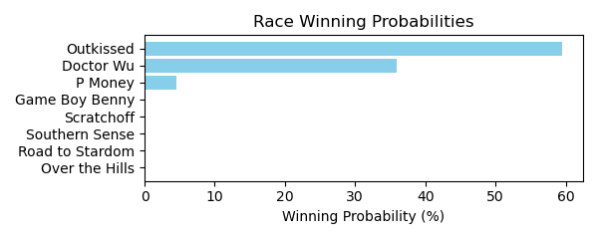

Figure: Winning Probability Distribution

NOTE: THIS RACE HAS HORSES THAT ARE MISSING CRITICAL DATA ELEMENTS

# Race: MVR | 2025-02-24 | Race #5 | Track: MAHONING VALLEY RACE COURSE

Track: MAHONING VALLEY RACE COURSE

|  |  |  |  |  |
| --- | --- | --- | --- | --- |
| Saddle Cloth # | Horse Name | Global Speed | Composite | Win Prob (%) |
| ['', 1, ''] | Ice Blast * | 116.3 | 0.24 | 0.01 |
| ['', 2, ''] | Boss Bear * | 116.3 | -7.99 | 0.00 |
| ['', 3, ''] | Exonerated Prez * | 115.7 | -10.14 | 0.00 |
| ['', 4, ''] | Had Right * | 116.3 | -0.65 | 0.00 |
| ['', 5, ''] | Mamba Forever * | 116.3 | -3.22 | 0.00 |
| ['', 6, ''] | Jarlian * | 129.3 | 8.50 | 88.57 |
| ['', 7, ''] | Kadesh * | 116.9 | -0.54 | 0.01 |
| ['', 8, ''] | Millard's Smile * | 116.3 | -1.70 | 0.00 |
| ['', 9, ''] | Small Sailor * | 77.5 | -6.50 | 0.00 |
| ['', 10, ''] | Leo and Royal * | 115.1 | 9.48 | 11.41 |

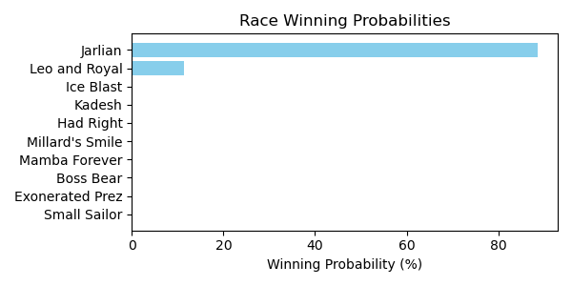

Figure: Winning Probability Distribution

# Race: MVR | 2025-02-24 | Race #6 | Track: MAHONING VALLEY RACE COURSE

Track: MAHONING VALLEY RACE COURSE

|  |  |  |  |  |
| --- | --- | --- | --- | --- |
| Saddle Cloth # | Horse Name | Global Speed | Composite | Win Prob (%) |
| ['', 1, ''] | Money Room * | 115.2 | 3.39 | 0.07 |
| ['', 2, ''] | Delta Ridge * | 115.2 | -2.28 | 0.00 |
| ['', 3, ''] | Big Popper * | 115.2 | -4.24 | 0.00 |
| ['', 4, ''] | Last Cookie * | 129.7 | 8.82 | 95.70 |
| ['', 5, ''] | Tiz Speedy | 122.0 | -2.32 | 0.00 |
| ['', 6, ''] | Mitole's Wish * | 77.5 | -6.36 | 0.00 |
| ['', 7, ''] | Law of the Jungle | 115.2 | 8.53 | 4.22 |
| ['', 8, ''] | Panthera's Fate * | 77.5 | -4.13 | 0.00 |

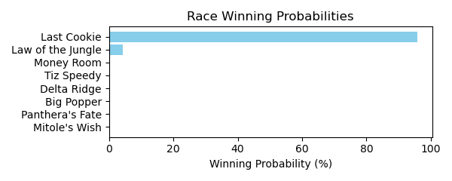

Figure: Winning Probability Distribution

NOTE: THIS RACE HAS HORSES THAT ARE MISSING CRITICAL DATA ELEMENTS

# Race: MVR | 2025-02-24 | Race #7 | Track: MAHONING VALLEY RACE COURSE

Track: MAHONING VALLEY RACE COURSE

|  |  |  |  |  |
| --- | --- | --- | --- | --- |
| Saddle Cloth # | Horse Name | Global Speed | Composite | Win Prob (%) |
| ['', 1, ''] | My Girl Kew * | 76.3 | 5.85 | 1.37 |
| ['', 2, ''] | Kiss Valentina * | 76.0 | 5.80 | 1.23 |
| ['', 3, ''] | Kiss Me Quick * | 76.3 | 6.63 | 2.56 |
| ['', 4, ''] | Beautiful Score * | 92.9 | 3.86 | 7.64 |
| ['', 5, ''] | Olympic Wings * | 76.3 | 2.54 | 0.10 |
| ['', 6, ''] | Hot Princess * | 76.0 | 0.59 | 0.02 |
| ['', 7, ''] | My Kinda Party * | 94.3 | 6.54 | 87.08 |

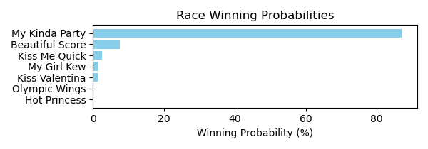

Figure: Winning Probability Distribution

# Race: MVR | 2025-02-24 | Race #8 | Track: MAHONING VALLEY RACE COURSE

Track: MAHONING VALLEY RACE COURSE

|  |  |  |  |  |
| --- | --- | --- | --- | --- |
| Saddle Cloth # | Horse Name | Global Speed | Composite | Win Prob (%) |
| ['', 1, ''] | Princessofthenorth | 77.8 | 3.58 | 0.01 |
| ['', 2, ''] | Az We Speak * | 95.1 | 10.89 | 82.55 |
| ['', 3, ''] | Kerlo's Cause | 76.0 | -6.23 | 0.00 |
| ['', 4, ''] | Princess Is Olivia | 118.4 | 2.28 | 8.78 |
| ['', 5, ''] | Go Girl * | 95.0 | 7.70 | 6.25 |
| ['', 6, ''] | Beatiful Karla * | 103.6 | 3.87 | 1.63 |
| ['', 7, ''] | Devra Warrior | 77.3 | -4.83 | 0.00 |
| ['', 8, ''] | Ashlee's Ring | 76.9 | 4.76 | 0.02 |
| ['', 9, ''] | Sacred Connection * | 115.5 | -0.03 | 0.77 |
| ['', 10, ''] | Emerson Jones * | 77.8 | -1.88 | 0.00 |

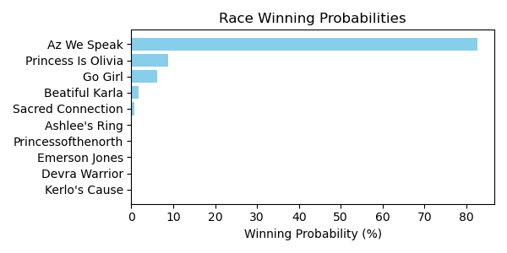

Figure: Winning Probability Distribution

NOTE: THIS RACE HAS HORSES THAT ARE MISSING CRITICAL DATA ELEMENTS

# Race: MVR | 2025-02-25 | Race #1 | Track: MAHONING VALLEY RACE COURSE

Track: MAHONING VALLEY RACE COURSE

|  |  |  |  |  |
| --- | --- | --- | --- | --- |
| Saddle Cloth # | Horse Name | Global Speed | Composite | Win Prob (%) |
| ['', 1, ''] | Master of the Nite * | 115.7 | 0.20 | 0.01 |
| ['', 2, ''] | Breakout Star | 129.1 | 8.36 | 82.47 |
| ['', 3, ''] | Ranseur * | 70.0 | -1.43 | 0.00 |
| ['', 4, ''] | Writeitontheice | 77.2 | -2.97 | 0.00 |
| ['', 5, ''] | Puff'smagicdragon | 112.2 | 10.61 | 16.98 |
| ['', 6, ''] | Royally Flushed * | 115.7 | 5.42 | 0.54 |
| ['', 7, ''] | Chaps Knight * | 115.7 | -0.34 | 0.01 |
| ['', 8, ''] | Euphoria Star | 76.9 | -7.59 | 0.00 |

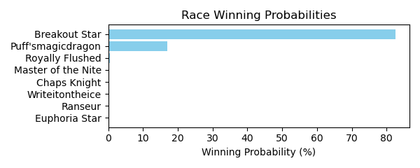

Figure: Winning Probability Distribution

NOTE: THIS RACE HAS HORSES THAT ARE MISSING CRITICAL DATA ELEMENTS

# Race: MVR | 2025-02-25 | Race #2 | Track: MAHONING VALLEY RACE COURSE

Track: MAHONING VALLEY RACE COURSE

|  |  |  |  |  |
| --- | --- | --- | --- | --- |
| Saddle Cloth # | Horse Name | Global Speed | Composite | Win Prob (%) |
| ['', 1, ''] | Kerri's Miracle * | 76.7 | 5.57 | 0.04 |
| ['', 2, ''] | Cause of Love * | 77.8 | -1.18 | 0.00 |
| ['', 3, ''] | Better Half * | 120.6 | 1.78 | 12.88 |
| ['', 4, ''] | Goodness Sakes * | 76.7 | -4.07 | 0.00 |
| ['', 5, ''] | High Fire * | 120.6 | 4.17 | 87.04 |
| ['', 6, ''] | Crossed Up * | 76.7 | 5.38 | 0.03 |
| ['', 7, ''] | The Miracle Kiut * | 77.8 | 2.10 | 0.00 |

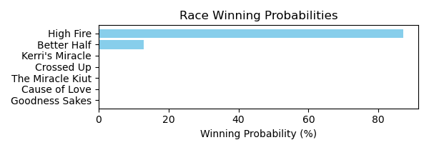

Figure: Winning Probability Distribution

# Race: MVR | 2025-02-25 | Race #3 | Track: MAHONING VALLEY RACE COURSE

Track: MAHONING VALLEY RACE COURSE

|  |  |  |  |  |
| --- | --- | --- | --- | --- |
| Saddle Cloth # | Horse Name | Global Speed | Composite | Win Prob (%) |
| ['', 1, ''] | Lucky Penny Rose * | 122.3 | 0.35 | 0.01 |
| ['', 2, ''] | Gila | 148.2 | 4.90 | 88.50 |
| ['', 3, ''] | Lady Jasper * | 133.1 | 3.94 | 1.97 |
| ['', 4, ''] | Lofty Cowtown * | 77.7 | 5.06 | 0.00 |
| ['', 5, ''] | Divine Fashion * | 77.7 | 1.60 | 0.00 |
| ['', 6, ''] | Mobil Chic * | 122.3 | -8.43 | 0.00 |
| ['', 7, ''] | Mobil Lady * | 129.4 | 6.80 | 9.51 |

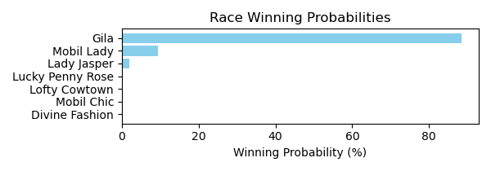

Figure: Winning Probability Distribution

NOTE: THIS RACE HAS HORSES THAT ARE MISSING CRITICAL DATA ELEMENTS

# Race: MVR | 2025-02-25 | Race #4 | Track: MAHONING VALLEY RACE COURSE

Track: MAHONING VALLEY RACE COURSE

|  |  |  |  |  |
| --- | --- | --- | --- | --- |
| Saddle Cloth # | Horse Name | Global Speed | Composite | Win Prob (%) |
| ['', 1, ''] | Play Ball * | 76.8 | -9.82 | 0.00 |
| ['', 2, ''] | Kid Russell * | 76.1 | -9.87 | 0.00 |
| ['', 3, ''] | Marvin's Express | 42.7 | -8.78 | 0.00 |
| ['', 4, ''] | El Marro * | 76.7 | -0.11 | 4.24 |
| ['', 5, ''] | dh-Spin Doctor * | 76.7 | -0.22 | 3.89 |
| ['', 6, ''] | Honor the D * | 76.1 | -7.38 | 0.01 |
| ['', 7, ''] | Bad Boy Boogie * | 69.4 | -10.87 | 0.00 |
| ['', 8, ''] | Keeping Score * | 77.1 | -10.33 | 0.00 |
| ['', 9, ''] | Beat the Dealer * | 76.7 | 3.74 | 91.86 |

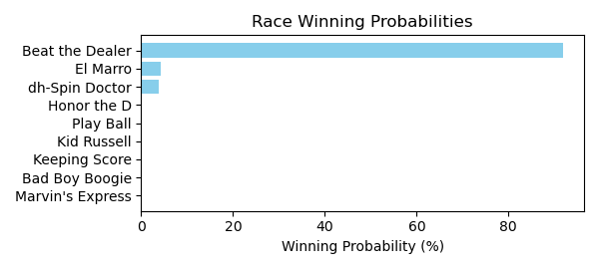

Figure: Winning Probability Distribution

NOTE: THIS RACE HAS HORSES THAT ARE MISSING CRITICAL DATA ELEMENTS

# Race: MVR | 2025-02-25 | Race #5 | Track: MAHONING VALLEY RACE COURSE

Track: MAHONING VALLEY RACE COURSE

|  |  |  |  |  |
| --- | --- | --- | --- | --- |
| Saddle Cloth # | Horse Name | Global Speed | Composite | Win Prob (%) |
| ['', 1, ''] | Lovebug | 76.6 | 6.22 | 63.52 |
| ['', 2, ''] | Rose's Wish * | 76.4 | 3.10 | 5.03 |
| ['', 3, ''] | Orgullosa Pacifica * | 76.6 | 4.26 | 13.25 |
| ['', 5, ''] | Miss Little Bit * | 63.6 | -9.84 | 0.00 |
| ['', 6, ''] | Wicked Eyes | 66.1 | -7.49 | 0.00 |
| ['', 8, ''] | Solo Surprise * | 76.6 | 4.66 | 18.21 |

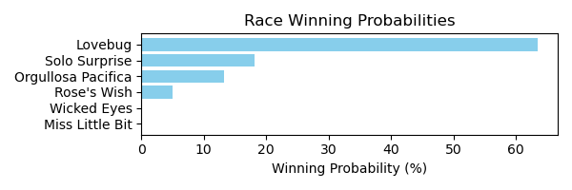

Figure: Winning Probability Distribution

NOTE: THIS RACE HAS HORSES THAT ARE MISSING CRITICAL DATA ELEMENTS

# Race: MVR | 2025-02-25 | Race #6 | Track: MAHONING VALLEY RACE COURSE

Track: MAHONING VALLEY RACE COURSE

|  |  |  |  |  |
| --- | --- | --- | --- | --- |
| Saddle Cloth # | Horse Name | Global Speed | Composite | Win Prob (%) |
| ['', 1, ''] | Bythenumbers * | 114.7 | -5.25 | 0.06 |
| ['', 2, ''] | Garden Secrets * | 128.2 | 0.67 | 97.99 |
| ['', 3, ''] | Elko * | 114.7 | -8.51 | 0.00 |
| ['', 4, ''] | Queen Lexi | 96.3 | 1.66 | 0.37 |
| ['', 5, ''] | Islandinthestream * | 77.5 | -6.82 | 0.00 |
| ['', 6, ''] | Hebrides * | 70.1 | -0.78 | 0.00 |
| ['', 7, ''] | Rumours Fly * | 114.7 | -7.32 | 0.01 |
| ['', 8, ''] | Mary Katherine * | 114.7 | -1.11 | 1.57 |
| ['', 9, ''] | Mangorita * | 114.7 | -8.79 | 0.00 |

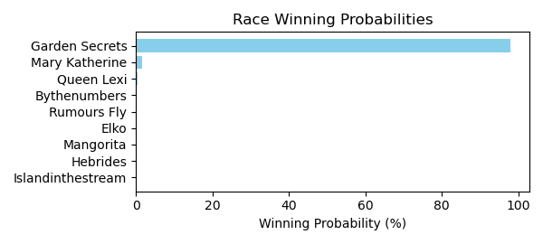

Figure: Winning Probability Distribution

NOTE: THIS RACE HAS HORSES THAT ARE MISSING CRITICAL DATA ELEMENTS

# Race: MVR | 2025-02-25 | Race #7 | Track: MAHONING VALLEY RACE COURSE

Track: MAHONING VALLEY RACE COURSE

|  |  |  |  |  |
| --- | --- | --- | --- | --- |
| Saddle Cloth # | Horse Name | Global Speed | Composite | Win Prob (%) |
| ['', 1, ''] | Battle of Bastogne * | 85.5 | -8.17 | 0.00 |
| ['', 2, ''] | Deus Ex Machina | 77.5 | -3.49 | 0.00 |
| ['', 3, ''] | Lucky Nineteen * | 77.5 | -3.89 | 0.00 |
| ['', 4, ''] | Bucket List | 77.5 | 0.95 | 0.00 |
| ['', 5, ''] | Buehler's Day Off * | 95.6 | 9.49 | 93.30 |
| ['', 6, ''] | Destino * | 77.5 | -8.93 | 0.00 |
| ['', 7, ''] | Sir * | 77.3 | 6.42 | 0.21 |
| ['', 8, ''] | Bailamos | 77.3 | 5.69 | 0.11 |
| ['', 9, ''] | Mshindi * | 95.3 | 6.16 | 6.09 |
| ['', 10, ''] | Hub | 77.5 | 6.76 | 0.28 |
| ['', 11, ''] | One Way Traffic | 85.5 | -1.79 | 0.00 |

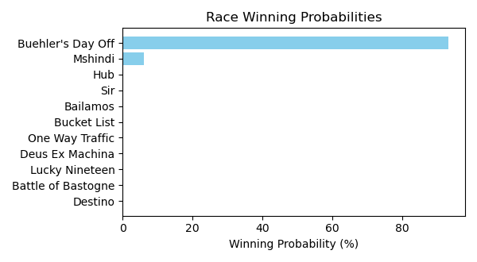

Figure: Winning Probability Distribution

NOTE: THIS RACE HAS HORSES THAT ARE MISSING CRITICAL DATA ELEMENTS

# Race: MVR | 2025-02-25 | Race #8 | Track: MAHONING VALLEY RACE COURSE

Track: MAHONING VALLEY RACE COURSE

|  |  |  |  |  |
| --- | --- | --- | --- | --- |
| Saddle Cloth # | Horse Name | Global Speed | Composite | Win Prob (%) |
| ['', 1, ''] | Domi * | 76.9 | -4.29 | 0.00 |
| ['', 2, ''] | Spuns Son | 141.7 | 5.14 | 91.81 |
| ['', 3, ''] | Convert * | 128.4 | 5.24 | 7.00 |
| ['', 4, ''] | Availability * | 114.9 | -5.53 | 0.00 |
| ['', 5, ''] | Ramsey * | 85.1 | -2.82 | 0.00 |
| ['', 6, ''] | Sage Runner * | 114.9 | -0.14 | 0.01 |
| ['', 7, ''] | Lt's Jacknthebox * | 114.9 | 6.39 | 1.18 |
| ['', 8, ''] | Bamby Boom | 70.1 | -4.84 | 0.00 |
| ['', 9, ''] | Golden Al | 84.4 | -6.32 | 0.00 |

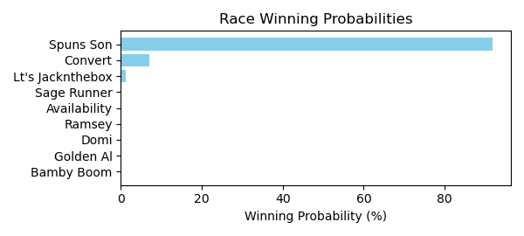

Figure: Winning Probability Distribution

NOTE: THIS RACE HAS HORSES THAT ARE MISSING CRITICAL DATA ELEMENTS

# Race: MVR | 2025-02-25 | Race #9 | Track: MAHONING VALLEY RACE COURSE

Track: MAHONING VALLEY RACE COURSE

|  |  |  |  |  |
| --- | --- | --- | --- | --- |
| Saddle Cloth # | Horse Name | Global Speed | Composite | Win Prob (%) |
| ['', 1, ''] | Dude the Legend * | 110.6 | -1.22 | 0.24 |
| ['', 2, ''] | Wild Domain * | 74.8 | 7.84 | 0.27 |
| ['', 3, ''] | Remix From Phoenix * | 74.8 | -2.19 | 0.00 |
| ['', 4, ''] | Skunk Ape * | 75.0 | -4.91 | 0.00 |
| ['', 5, ''] | Hidden Heart * | 110.6 | 6.30 | 99.34 |
| ['', 6, ''] | Indy's Hope * | 110.6 | -1.83 | 0.15 |

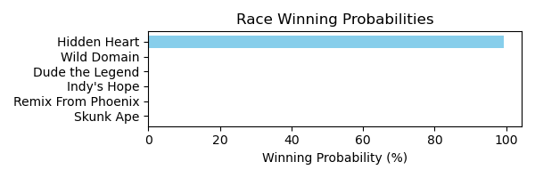

Figure: Winning Probability Distribution

# Race: MVR | 2025-02-25 | Race #10 | Track: MAHONING VALLEY RACE COURSE

Track: MAHONING VALLEY RACE COURSE

|  |  |  |  |  |
| --- | --- | --- | --- | --- |
| Saddle Cloth # | Horse Name | Global Speed | Composite | Win Prob (%) |
| ['', 3, ''] | Blue Blood Cowboy * | 74.8 | -4.96 | 0.00 |
| ['', 4, ''] | Vernon's Best * | 74.7 | 6.56 | 11.51 |
| ['', 5, ''] | P J's Boy * | 75.0 | 4.56 | 2.46 |
| ['', 6, ''] | Flaring Song * | 74.8 | 2.04 | 0.31 |
| ['', 7, ''] | Formyboys * | 110.6 | 0.11 | 85.72 |
| ['', 8, ''] | He Is Dynamic * | 74.8 | -6.71 | 0.00 |
| ['', 9, ''] | Lucky Kater * | 75.0 | -11.09 | 0.00 |

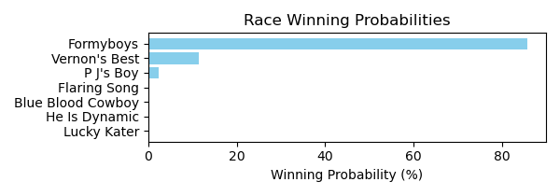

Figure: Winning Probability Distribution

# Race: MVR | 2025-02-26 | Race #1 | Track: MAHONING VALLEY RACE COURSE

Track: MAHONING VALLEY RACE COURSE

|  |  |  |  |  |
| --- | --- | --- | --- | --- |
| Saddle Cloth # | Horse Name | Global Speed | Composite | Win Prob (%) |
| ['', 1, ''] | Act Like a Lady * | 76.0 | 6.58 | 82.36 |
| ['', 2, ''] | Band of Roses | 53.0 | -8.58 | 0.00 |
| ['', 3, ''] | Quarantina * | 77.1 | -3.61 | 0.03 |
| ['', 4, ''] | Bareback Fun * | 76.0 | 4.50 | 15.61 |
| ['', 5, ''] | Big Java * | 114.4 | -7.88 | 1.69 |
| ['', 6, ''] | Secret Seduction * | 70.2 | -2.91 | 0.01 |
| ['', 7, ''] | I Got Hope * | 75.7 | -0.32 | 0.31 |

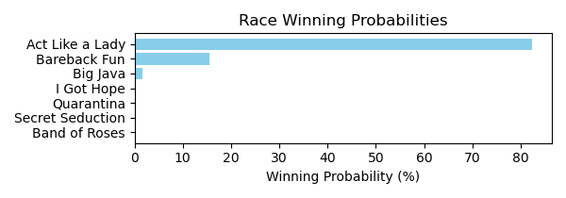

Figure: Winning Probability Distribution

NOTE: THIS RACE HAS HORSES THAT ARE MISSING CRITICAL DATA ELEMENTS

# Race: MVR | 2025-02-26 | Race #2 | Track: MAHONING VALLEY RACE COURSE

Track: MAHONING VALLEY RACE COURSE

|  |  |  |  |  |
| --- | --- | --- | --- | --- |
| Saddle Cloth # | Horse Name | Global Speed | Composite | Win Prob (%) |
| ['', 1, ''] | Divine Martha * | 77.4 | -4.09 | 0.03 |
| ['', 2, ''] | Tattered Heart * | 77.1 | -6.95 | 0.00 |
| ['', 3, ''] | Ceviche * | 77.1 | 4.34 | 26.89 |
| ['', 4, ''] | Half Birthday * | 77.1 | 3.47 | 13.38 |
| ['', 5, ''] | Big Ginger | 77.5 | 4.97 | 48.55 |
| ['', 6, ''] | Tiz Independence * | 77.1 | 3.24 | 11.14 |
| ['', 7, ''] | Cagua * | 70.2 | -6.78 | 0.00 |

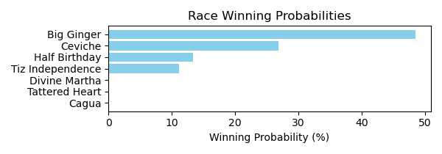

Figure: Winning Probability Distribution

NOTE: THIS RACE HAS HORSES THAT ARE MISSING CRITICAL DATA ELEMENTS

# Race: MVR | 2025-02-26 | Race #3 | Track: MAHONING VALLEY RACE COURSE

Track: MAHONING VALLEY RACE COURSE

|  |  |  |  |  |
| --- | --- | --- | --- | --- |
| Saddle Cloth # | Horse Name | Global Speed | Composite | Win Prob (%) |
| ['', 1, ''] | Loaded Once More * | 96.5 | 9.75 | 64.28 |
| ['', 2, ''] | Red Hot Lass * | 78.3 | 7.78 | 0.35 |
| ['', 3, ''] | Sharp Az Can Be * | 78.0 | 5.17 | 0.04 |
| ['', 4, ''] | Back to Ohio | 96.8 | 6.57 | 5.36 |
| ['', 5, ''] | The Sweaty Fox * | 78.3 | 3.26 | 0.01 |
| ['', 6, ''] | Larimar * | 96.4 | 8.82 | 29.96 |

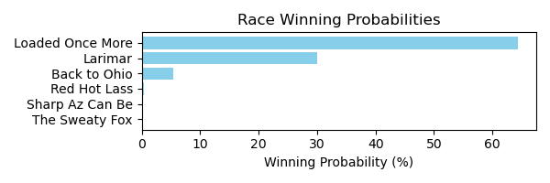

Figure: Winning Probability Distribution

NOTE: THIS RACE HAS HORSES THAT ARE MISSING CRITICAL DATA ELEMENTS

# Race: MVR | 2025-02-26 | Race #4 | Track: MAHONING VALLEY RACE COURSE

Track: MAHONING VALLEY RACE COURSE

|  |  |  |  |  |
| --- | --- | --- | --- | --- |
| Saddle Cloth # | Horse Name | Global Speed | Composite | Win Prob (%) |
| ['', 1, ''] | Derby Included * | 76.9 | -1.61 | 0.00 |
| ['', 2, ''] | Biscuits and Grits * | 77.9 | -1.39 | 0.00 |
| ['', 3, ''] | Raise the Purses * | 95.3 | 9.33 | 33.35 |
| ['', 4, ''] | Golden Money * | 129.0 | 1.21 | 42.18 |
| ['', 5, ''] | That's the Way * | 96.4 | 8.28 | 18.07 |
| ['', 6, ''] | Stunt Man * | 76.9 | 7.54 | 0.20 |
| ['', 7, ''] | Visual Mission * | 114.7 | 2.39 | 6.19 |
| ['', 8, ''] | Serendipitous * | 76.7 | -5.64 | 0.00 |

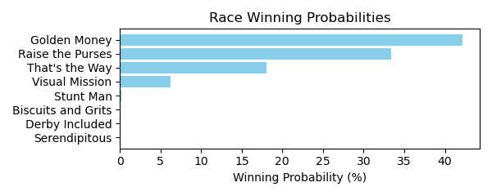

Figure: Winning Probability Distribution

# Race: MVR | 2025-02-26 | Race #5 | Track: MAHONING VALLEY RACE COURSE

Track: MAHONING VALLEY RACE COURSE

|  |  |  |  |  |
| --- | --- | --- | --- | --- |
| Saddle Cloth # | Horse Name | Global Speed | Composite | Win Prob (%) |
| ['', 1, ''] | Dr Schuster * | 76.9 | -5.78 | 0.00 |
| ['', 2, ''] | Little Vaquero * | 76.9 | -2.02 | 0.00 |
| ['', 3, ''] | Don't Stop | 87.2 | 8.01 | 96.72 |
| ['', 4, ''] | Mariachi Justice | 64.6 | 2.95 | 0.02 |
| ['', 5, ''] | Capture Mi * | 64.6 | -5.90 | 0.00 |
| ['', 6, ''] | Run for Reagan * | 64.6 | 9.03 | 2.36 |
| ['', 7, ''] | Mansion Party * | 64.6 | 7.82 | 0.90 |
| ['', 8, ''] | Cloak and Dagger * | 77.9 | -9.36 | 0.00 |
| ['', 9, ''] | El Bandido * | 76.9 | -6.78 | 0.00 |

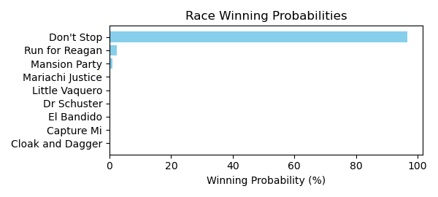

Figure: Winning Probability Distribution

NOTE: THIS RACE HAS HORSES THAT ARE MISSING CRITICAL DATA ELEMENTS

# Race: MVR | 2025-02-26 | Race #6 | Track: MAHONING VALLEY RACE COURSE

Track: MAHONING VALLEY RACE COURSE

|  |  |  |  |  |
| --- | --- | --- | --- | --- |
| Saddle Cloth # | Horse Name | Global Speed | Composite | Win Prob (%) |
| ['', 1, ''] | Carson N Spence * | 75.8 | 2.65 | 0.00 |
| ['', 2, ''] | Who Can't Wait * | 126.0 | 5.69 | 99.94 |
| ['', 3, ''] | Bobby Rob * | 75.6 | -3.84 | 0.00 |
| ['', 4, ''] | Dusty Billy * | 75.8 | 1.54 | 0.00 |
| ['', 5, ''] | Drill's Boy * | 75.5 | 2.28 | 0.00 |
| ['', 6, ''] | So Co Manhattan * | 113.1 | -0.53 | 0.05 |
| ['', 7, ''] | Strike Plate * | 75.8 | 4.31 | 0.00 |

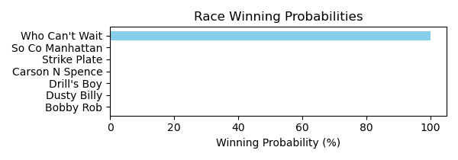

Figure: Winning Probability Distribution

# Race: MVR | 2025-02-26 | Race #7 | Track: MAHONING VALLEY RACE COURSE

Track: MAHONING VALLEY RACE COURSE

|  |  |  |  |  |
| --- | --- | --- | --- | --- |
| Saddle Cloth # | Horse Name | Global Speed | Composite | Win Prob (%) |
| ['', 1, ''] | Maliced * | 115.4 | -3.62 | 0.00 |
| ['', 2, ''] | Candymonium * | 77.5 | 4.94 | 0.00 |
| ['', 3, ''] | Starlight Love | 134.2 | 9.47 | 63.38 |
| ['', 4, ''] | Magic Palace * | 115.4 | -7.28 | 0.00 |
| ['', 5, ''] | Someday Is Today * | 129.4 | 9.95 | 36.29 |
| ['', 6, ''] | Gray Royality * | 115.4 | 7.44 | 0.29 |
| ['', 7, ''] | Liberty Belle | 115.4 | -2.16 | 0.00 |
| ['', 8, ''] | Princess Halime * | 115.4 | 4.77 | 0.03 |
| ['', 9, ''] | My Suzie Q * | 95.7 | 5.43 | 0.00 |
| ['', 10, ''] | R Three Angels * | 115.4 | -9.14 | 0.00 |

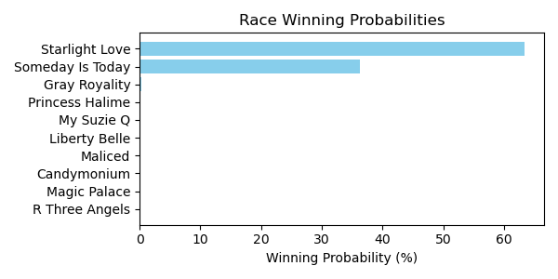

Figure: Winning Probability Distribution

NOTE: THIS RACE HAS HORSES THAT ARE MISSING CRITICAL DATA ELEMENTS

# Race: MVR | 2025-02-26 | Race #8 | Track: MAHONING VALLEY RACE COURSE

Track: MAHONING VALLEY RACE COURSE

|  |  |  |  |  |
| --- | --- | --- | --- | --- |
| Saddle Cloth # | Horse Name | Global Speed | Composite | Win Prob (%) |
| ['', 1, ''] | Moonshine Joe * | 75.6 | 2.62 | 6.48 |
| ['', 2, ''] | Earl's Stormy Wind * | 75.6 | -5.59 | 0.01 |
| ['', 3, ''] | Why Kenny Why * | 76.5 | -9.76 | 0.00 |
| ['', 4, ''] | Fort Grande * | 75.8 | 1.17 | 2.14 |
| ['', 5, ''] | Guess Again * | 75.8 | 5.82 | 88.17 |
| ['', 6, ''] | Seeking Freedom * | 75.8 | -0.86 | 0.42 |
| ['', 7, ''] | Weekend Retreat * | 75.8 | 1.50 | 2.78 |

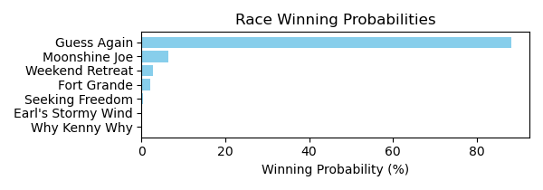

Figure: Winning Probability Distribution

# Race: MVR | 2025-02-26 | Race #9 | Track: MAHONING VALLEY RACE COURSE

Track: MAHONING VALLEY RACE COURSE

|  |  |  |  |  |
| --- | --- | --- | --- | --- |
| Saddle Cloth # | Horse Name | Global Speed | Composite | Win Prob (%) |
| ['', 1, ''] | Lesotho * | 76.3 | -7.35 | 0.00 |
| ['', 2, ''] | Rapida | 76.3 | 5.04 | 0.36 |
| ['', 3, ''] | Complexity Girl * | 76.2 | -8.31 | 0.00 |
| ['', 4, ''] | Beautiful Charade * | 76.3 | 4.43 | 0.22 |
| ['', 5, ''] | Dreaming of War * | 93.5 | 6.86 | 48.18 |
| ['', 6, ''] | Gogo Nev's * | 92.7 | 7.07 | 49.16 |
| ['', 7, ''] | Stick Around * | 76.1 | 2.63 | 0.05 |
| ['', 8, ''] | Naksu * | 74.8 | 6.23 | 0.70 |
| ['', 9, ''] | Flame for Real * | 76.3 | 6.66 | 1.33 |

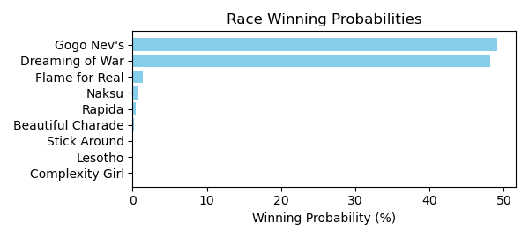

Figure: Winning Probability Distribution

NOTE: THIS RACE HAS HORSES THAT ARE MISSING CRITICAL DATA ELEMENTS

# Race: MVR | 2025-02-26 | Race #10 | Track: MAHONING VALLEY RACE COURSE

Track: MAHONING VALLEY RACE COURSE

|  |  |  |  |  |
| --- | --- | --- | --- | --- |
| Saddle Cloth # | Horse Name | Global Speed | Composite | Win Prob (%) |
| ['', 2, ''] | Cowgirltakemeaway * | 74.9 | -11.75 | 0.00 |
| ['', 3, ''] | Vicky's Gift * | 74.8 | -7.36 | 0.00 |
| ['', 4, ''] | Mo Swift * | 74.8 | 8.01 | 65.03 |
| ['', 5, ''] | Count On Me * | 74.8 | -7.03 | 0.00 |
| ['', 6, ''] | Bionic Saint * | 74.7 | -4.93 | 0.00 |
| ['', 7, ''] | Tapit Volume * | 74.8 | -8.30 | 0.00 |
| ['', 8, ''] | Rosetta * | 74.8 | 5.77 | 10.77 |
| ['', 9, ''] | Catty Remark * | 74.8 | 6.78 | 24.19 |
| ['', 10, ''] | Sharp Lady * | 74.7 | -9.94 | 0.00 |

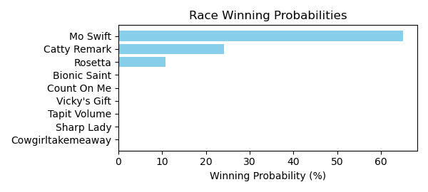

Figure: Winning Probability Distribution

# Race: TOP | 2025-02-23 | Race #1 | Track: OAKLAWN PARK

Track: OAKLAWN PARK

|  |  |  |  |  |
| --- | --- | --- | --- | --- |
| Saddle Cloth # | Horse Name | Global Speed | Composite | Win Prob (%) |
| ['', 1, ''] | Fever Night | 124.4 | 1.93 | 0.04 |
| ['', 2, ''] | Zardun * | 77.3 | 9.21 | 0.00 |
| ['', 3, ''] | Clever Again * | 147.1 | 5.77 | 78.24 |
| ['', 4, ''] | Just Classic | 44.8 | -7.57 | 0.00 |
| ['', 5, ''] | Shepherd | 98.4 | -4.80 | 0.00 |
| ['', 6, ''] | Baobab * | 131.5 | 5.81 | 3.60 |
| ['', 7, ''] | Doroteo * | 125.0 | 9.04 | 13.09 |
| ['', 8, ''] | Crisis Manager | 131.0 | 5.61 | 2.79 |
| ['', 9, ''] | Hired Gun | 136.3 | 3.84 | 1.94 |
| ['', 10, ''] | Ripped | 134.0 | 2.07 | 0.30 |

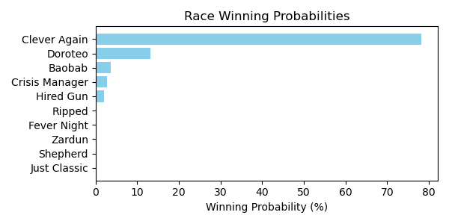

Figure: Winning Probability Distribution

NOTE: THIS RACE HAS HORSES THAT ARE MISSING CRITICAL DATA ELEMENTS

# Race: TOP | 2025-02-23 | Race #2 | Track: OAKLAWN PARK

Track: OAKLAWN PARK

|  |  |  |  |  |
| --- | --- | --- | --- | --- |
| Saddle Cloth # | Horse Name | Global Speed | Composite | Win Prob (%) |
| ['', 1, ''] | Distorted Pro | 133.2 | 4.76 | 2.28 |
| ['', 2, ''] | I'm Wide Awake | 145.5 | 5.95 | 68.58 |
| ['', 3, ''] | Rowdy Riot | 125.4 | 2.96 | 0.11 |
| ['', 4, ''] | Great Richie M | 114.1 | 0.46 | 0.00 |
| ['', 5, ''] | B Sudd | 143.1 | 4.33 | 11.73 |
| ['', 6, ''] | Manta Rey | 140.3 | 2.44 | 1.47 |
| ['', 7, ''] | Goodasiwonswas | 117.3 | 1.70 | 0.01 |
| ['', 8, ''] | Breslau | 80.6 | -6.72 | 0.00 |
| ['', 9, ''] | Run Jalen Run | 139.5 | 5.11 | 10.62 |
| ['', 10, ''] | Sitka | 131.0 | 5.61 | 2.86 |
| ['', 11, ''] | Red State | 136.4 | 4.00 | 2.34 |

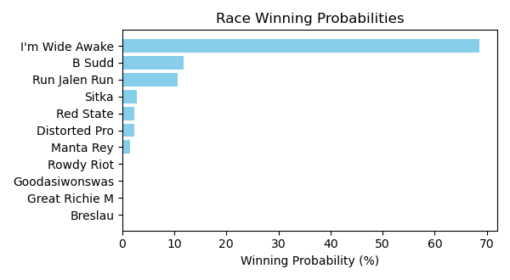

Figure: Winning Probability Distribution

NOTE: THIS RACE HAS HORSES THAT ARE MISSING CRITICAL DATA ELEMENTS

# Race: TOP | 2025-02-23 | Race #3 | Track: OAKLAWN PARK

Track: OAKLAWN PARK

|  |  |  |  |  |
| --- | --- | --- | --- | --- |
| Saddle Cloth # | Horse Name | Global Speed | Composite | Win Prob (%) |
| ['', 1, ''] | Ashburn Alley | 148.7 | 6.06 | 70.47 |
| ['', 2, ''] | Queen's Martini | 117.4 | -1.65 | 0.00 |
| ['', 3, ''] | Princess Is Olivia | 118.4 | 0.66 | 0.00 |
| ['', 4, ''] | Bennykayandsuzytoo | 144.1 | 3.60 | 3.88 |
| ['', 5, ''] | Tiffany Twist | 129.9 | 1.90 | 0.06 |
| ['', 6, ''] | Laurie's Secret | 40.8 | -7.62 | 0.00 |
| ['', 7, ''] | Insightful Miss | 143.4 | 5.38 | 14.29 |
| ['', 8, ''] | That's Our Vision * | 70.3 | -8.79 | 0.00 |
| ['', 9, ''] | Music Mistress | 74.6 | -7.00 | 0.00 |
| ['', 10, ''] | Theresasilverlinin | 66.4 | -7.73 | 0.00 |
| ['', 11, ''] | Brooklynn Drew | 51.6 | -7.64 | 0.00 |
| ['', 12, ''] | Gloriette | 148.6 | 3.78 | 11.22 |
| ['', 13, ''] | Managing Mischief | 116.1 | 0.50 | 0.00 |
| ['', 14, ''] | Popperina | 135.6 | 0.99 | 0.09 |

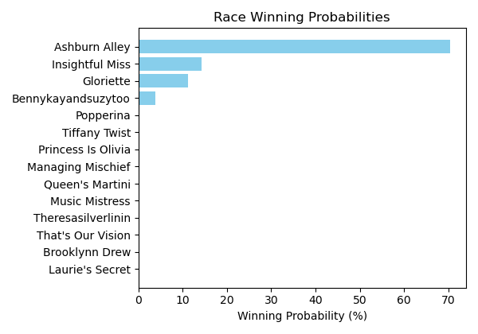

Figure: Winning Probability Distribution

NOTE: THIS RACE HAS HORSES THAT ARE MISSING CRITICAL DATA ELEMENTS

# Race: TOP | 2025-02-23 | Race #4 | Track: OAKLAWN PARK

Track: OAKLAWN PARK

|  |  |  |  |  |
| --- | --- | --- | --- | --- |
| Saddle Cloth # | Horse Name | Global Speed | Composite | Win Prob (%) |
| ['', 1, ''] | Benedetta | 142.5 | 4.38 | 17.67 |
| ['', 2, ''] | Mazoku | 146.1 | 4.73 | 48.15 |
| ['', 3, ''] | Justique | 96.4 | 5.39 | 0.00 |
| ['', 4, ''] | Sandy Bottom | 76.0 | -7.31 | 0.00 |
| ['', 5, ''] | Miss Arlington | 65.3 | -6.08 | 0.00 |
| ['', 6, ''] | Ms. Bucchero | 137.1 | 3.11 | 2.18 |
| ['', 7, ''] | American Band | 141.0 | 2.47 | 2.86 |
| ['', 8, ''] | Lady Moscato | 142.3 | 5.05 | 29.12 |
| ['', 9, ''] | Pistol | 118.7 | -0.63 | 0.00 |

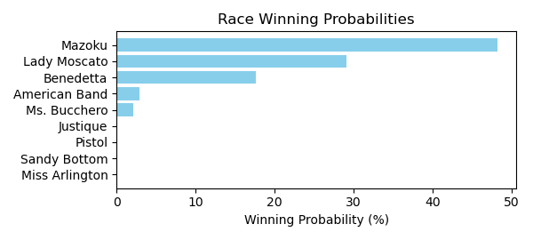

Figure: Winning Probability Distribution

NOTE: THIS RACE HAS HORSES THAT ARE MISSING CRITICAL DATA ELEMENTS

# Race: TOP | 2025-02-23 | Race #5 | Track: OAKLAWN PARK

Track: OAKLAWN PARK

|  |  |  |  |  |
| --- | --- | --- | --- | --- |
| Saddle Cloth # | Horse Name | Global Speed | Composite | Win Prob (%) |
| ['', 1, ''] | Oy Gevald * | 148.9 | 6.62 | 60.61 |
| ['', 2, ''] | Faust * | 144.7 | 6.69 | 27.76 |
| ['', 3, ''] | Sixtyseven Mustang * | 142.9 | 5.00 | 4.99 |
| ['', 4, ''] | Secret Legend | 129.6 | 2.02 | 0.03 |
| ['', 6, ''] | Chases Magic * | 77.3 | -8.83 | 0.00 |
| ['', 8, ''] | Wise Decision | 65.2 | -7.65 | 0.00 |
| ['', 9, ''] | dh-Ready to Seize * | 140.8 | 5.82 | 6.34 |
| ['', 10, ''] | Max Got Excited | 134.8 | 3.40 | 0.28 |
| ['', 11, ''] | Gun Runner Charlie | 90.6 | -8.07 | 0.00 |
| ['', 12, ''] | Oil Capital * | 68.8 | -7.08 | 0.00 |

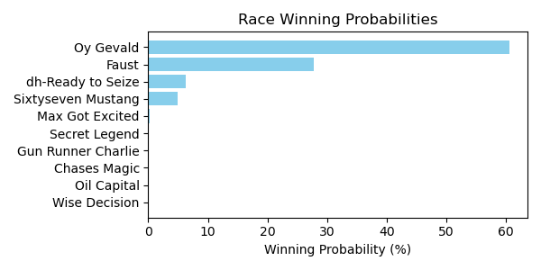

Figure: Winning Probability Distribution

NOTE: THIS RACE HAS HORSES THAT ARE MISSING CRITICAL DATA ELEMENTS

# Race: TOP | 2025-02-23 | Race #6 | Track: OAKLAWN PARK

Track: OAKLAWN PARK

|  |  |  |  |  |
| --- | --- | --- | --- | --- |
| Saddle Cloth # | Horse Name | Global Speed | Composite | Win Prob (%) |
| ['', 1, ''] | Elusive Target | 75.5 | -4.60 | 0.00 |
| ['', 2, ''] | Shot of Courage | 123.0 | 6.78 | 3.27 |
| ['', 3, ''] | One Giant Leap | 122.7 | -0.81 | 0.01 |
| ['', 4, ''] | B D Saints | 80.7 | -5.23 | 0.00 |
| ['', 5, ''] | Touch Of Glam (ARG) * | 126.4 | 0.18 | 0.03 |
| ['', 6, ''] | Nullify | 134.5 | 6.54 | 26.97 |
| ['', 7, ''] | Lambeth | 122.2 | 3.31 | 0.17 |
| ['', 8, ''] | Harleezy | 112.3 | 2.37 | 0.01 |
| ['', 9, ''] | Imperial Gun | 126.4 | -8.68 | 0.00 |
| ['', 10, ''] | Ethan Energy | 138.1 | 6.19 | 42.39 |
| ['', 11, ''] | Spoiler | 70.5 | -7.06 | 0.00 |
| ['', 12, ''] | Dynamis | 148.9 | 2.94 | 27.15 |

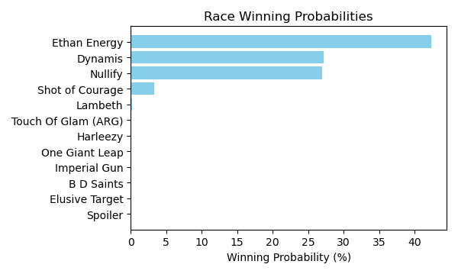

Figure: Winning Probability Distribution

NOTE: THIS RACE HAS HORSES THAT ARE MISSING CRITICAL DATA ELEMENTS

# Race: TOP | 2025-02-23 | Race #7 | Track: OAKLAWN PARK

Track: OAKLAWN PARK

|  |  |  |  |  |
| --- | --- | --- | --- | --- |
| Saddle Cloth # | Horse Name | Global Speed | Composite | Win Prob (%) |
| ['', 1, ''] | Carbone | 140.1 | 0.19 | 0.81 |
| ['', 2, ''] | Just Steel | 95.6 | -2.31 | 0.00 |
| ['', 3, ''] | Attache | 111.5 | 2.64 | 0.02 |
| ['', 4, ''] | Nasty Habit | 91.6 | -0.39 | 0.00 |
| ['', 5, ''] | Excitable Boy | 122.1 | 3.70 | 0.37 |
| ['', 6, ''] | Invulnerable | 148.4 | 2.91 | 37.60 |
| ['', 7, ''] | Eglise | 138.8 | 5.63 | 48.45 |
| ['', 8, ''] | Big City | 131.8 | 5.16 | 8.11 |
| ['', 9, ''] | Runaway Jack | 118.4 | 3.92 | 0.21 |
| ['', 10, ''] | Ninja Warrior | 134.1 | 3.81 | 4.45 |

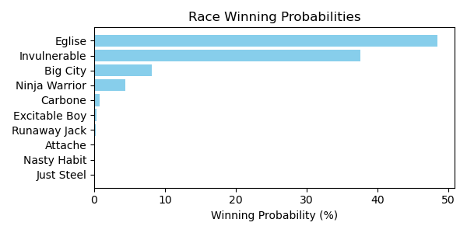

Figure: Winning Probability Distribution

NOTE: THIS RACE HAS HORSES THAT ARE MISSING CRITICAL DATA ELEMENTS

# Race: TOP | 2025-02-23 | Race #8 | Track: OAKLAWN PARK

Track: OAKLAWN PARK

|  |  |  |  |  |
| --- | --- | --- | --- | --- |
| Saddle Cloth # | Horse Name | Global Speed | Composite | Win Prob (%) |
| ['', 1, ''] | Under the Palms | 142.2 | 3.76 | 5.47 |
| ['', 2, ''] | Bru Na Boinne | 122.7 | 1.73 | 0.02 |
| ['', 3, ''] | Broughty Ferry | 136.5 | 7.18 | 26.64 |
| ['', 4, ''] | Gold Medal Anna | 82.0 | -3.90 | 0.00 |
| ['', 5, ''] | Peignoir | 131.9 | 5.54 | 2.86 |
| ['', 6, ''] | Majestic Oops | 116.5 | 1.33 | 0.00 |
| ['', 7, ''] | Bow Draw | 105.0 | -1.57 | 0.00 |
| ['', 8, ''] | Indy Label | 133.7 | 5.89 | 5.49 |
| ['', 9, ''] | Neom Beach | 59.1 | -7.41 | 0.00 |
| ['', 10, ''] | Amber Cascade | 136.4 | 7.38 | 30.90 |
| ['', 11, ''] | In Just My Heels | 140.4 | 6.28 | 28.62 |

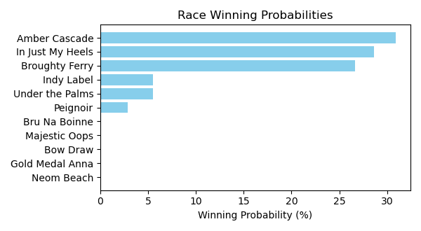

Figure: Winning Probability Distribution

NOTE: THIS RACE HAS HORSES THAT ARE MISSING CRITICAL DATA ELEMENTS

# Race: TOP | 2025-02-23 | Race #9 | Track: OAKLAWN PARK

Track: OAKLAWN PARK

|  |  |  |  |  |
| --- | --- | --- | --- | --- |
| Saddle Cloth # | Horse Name | Global Speed | Composite | Win Prob (%) |
| ['', 1, ''] | Muhimma | 147.5 | 5.77 | 11.90 |
| ['', 2, ''] | Necessity | 144.5 | 7.04 | 18.24 |
| ['', 3, ''] | Jenkin | 143.4 | 6.47 | 9.13 |
| ['', 4, ''] | Classic Appeal | 137.8 | 4.21 | 0.49 |
| ['', 5, ''] | Quickick | 143.5 | 5.42 | 4.06 |
| ['', 6, ''] | Take Charge Milady | 142.5 | 6.15 | 6.01 |
| ['', 7, ''] | Gunite Max | 134.0 | 4.50 | 0.29 |
| ['', 8, ''] | Going Steady | 143.8 | 3.56 | 0.98 |
| ['', 9, ''] | Look Forward | 142.7 | 6.62 | 9.05 |
| ['', 10, ''] | Flash Wear | 112.1 | -0.40 | 0.00 |
| ['', 11, ''] | Anonima | 136.3 | 8.57 | 11.87 |
| ['', 12, ''] | Quietside | 120.7 | 5.78 | 0.06 |
| ['', 13, ''] | Five G | 149.3 | 6.38 | 27.91 |

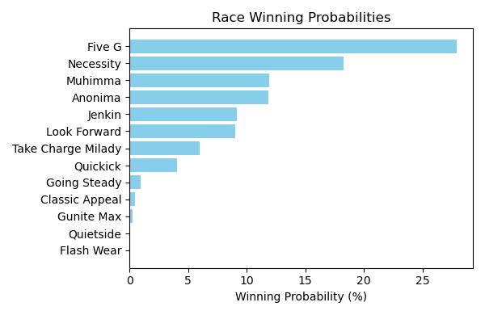

Figure: Winning Probability Distribution

NOTE: THIS RACE HAS HORSES THAT ARE MISSING CRITICAL DATA ELEMENTS

# Race: TOP | 2025-02-23 | Race #10 | Track: OAKLAWN PARK

Track: OAKLAWN PARK

|  |  |  |  |  |
| --- | --- | --- | --- | --- |
| Saddle Cloth # | Horse Name | Global Speed | Composite | Win Prob (%) |
| ['', 1, ''] | Crupi | 127.3 | 2.55 | 0.05 |
| ['', 2, ''] | Banishing | 146.1 | 5.34 | 19.90 |
| ['', 3, ''] | First Mission | 126.0 | -0.67 | 0.00 |
| ['', 4, ''] | Alexander Helios | 143.9 | 5.90 | 20.14 |
| ['', 5, ''] | Skinner | 127.9 | 5.75 | 0.73 |
| ['', 6, ''] | Full Screen | 137.4 | 1.57 | 0.17 |
| ['', 7, ''] | Dimatic | 132.9 | 2.25 | 0.12 |
| ['', 8, ''] | Baddest Good Boy | 144.9 | 6.96 | 57.15 |
| ['', 9, ''] | Henro | 125.4 | 2.11 | 0.02 |
| ['', 10, ''] | Cooke Creek | 127.9 | 6.79 | 1.66 |
| ['', 11, ''] | Tonka Warrior | 119.8 | -0.01 | 0.00 |
| ['', 12, ''] | Red Route One | 110.2 | 1.02 | 0.00 |
| ['', 13, ''] | Creative Minister | 122.2 | 3.82 | 0.05 |
| ['', 14, ''] | Seize the Night | 60.5 | -6.96 | 0.00 |

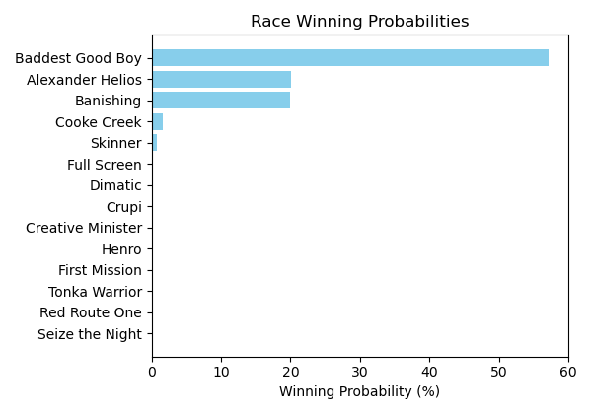

Figure: Winning Probability Distribution

NOTE: THIS RACE HAS HORSES THAT ARE MISSING CRITICAL DATA ELEMENTS

# Race: TOP | 2025-02-23 | Race #11 | Track: OAKLAWN PARK

Track: OAKLAWN PARK

|  |  |  |  |  |
| --- | --- | --- | --- | --- |
| Saddle Cloth # | Horse Name | Global Speed | Composite | Win Prob (%) |
| ['', 1, ''] | Coal Battle | 135.7 | 4.44 | 0.48 |
| ['', 2, ''] | Admiral Dennis | 135.9 | 8.96 | 18.83 |
| ['', 3, ''] | Sandman | 138.8 | 6.18 | 3.60 |
| ['', 4, ''] | Hypnus * | 135.9 | 10.31 | 55.61 |
| ['', 5, ''] | Madaket Road | 115.7 | 4.55 | 0.01 |
| ['', 6, ''] | Publisher | 98.9 | -5.50 | 0.00 |
| ['', 7, ''] | Dreaminblue | 146.8 | 4.84 | 6.14 |
| ['', 8, ''] | Innovator | 126.2 | 0.48 | 0.00 |
| ['', 9, ''] | Smoken Wicked | 97.6 | 7.91 | 0.00 |
| ['', 10, ''] | Bullard | 108.1 | 3.19 | 0.00 |
| ['', 11, ''] | Speed King | 141.7 | 6.98 | 12.19 |
| ['', 12, ''] | Brereton's Baytown | 134.4 | 4.10 | 0.29 |
| ['', 13, ''] | Tiztastic | 133.9 | 5.49 | 0.79 |
| ['', 14, ''] | Hot Gunner | 142.8 | 4.46 | 2.06 |

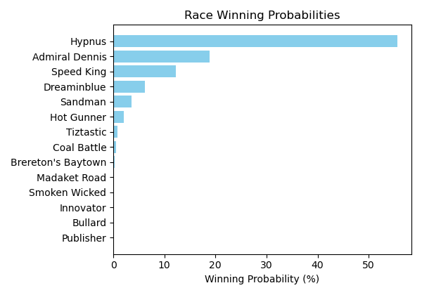

Figure: Winning Probability Distribution

NOTE: THIS RACE HAS HORSES THAT ARE MISSING CRITICAL DATA ELEMENTS

# Race: TOP | 2025-02-23 | Race #12 | Track: OAKLAWN PARK

Track: OAKLAWN PARK

|  |  |  |  |  |
| --- | --- | --- | --- | --- |
| Saddle Cloth # | Horse Name | Global Speed | Composite | Win Prob (%) |
| ['', 1, ''] | Butch * | 56.3 | -8.12 | 0.00 |
| ['', 3, ''] | Cutting Class * | 49.6 | -8.06 | 0.00 |
| ['', 4, ''] | Bote | 127.4 | -5.08 | 0.00 |
| ['', 5, ''] | Cowboycents * | 123.9 | -7.01 | 0.00 |
| ['', 6, ''] | My Russian | 54.1 | -7.78 | 0.00 |
| ['', 8, ''] | Two Dollar Eddie | 143.5 | 4.95 | 8.06 |
| ['', 9, ''] | Tizmarkus * | 142.1 | 6.75 | 25.75 |
| ['', 10, ''] | A P Ruly | 146.8 | 6.72 | 64.98 |
| ['', 11, ''] | Touchdown Arkansas * | 44.6 | -7.77 | 0.00 |
| ['', 12, ''] | Miracle Mack | 56.1 | -7.76 | 0.00 |
| ['', 13, ''] | Pearcy Road | 126.4 | 0.60 | 0.01 |
| ['', 14, ''] | God's Country | 143.7 | 2.53 | 1.21 |

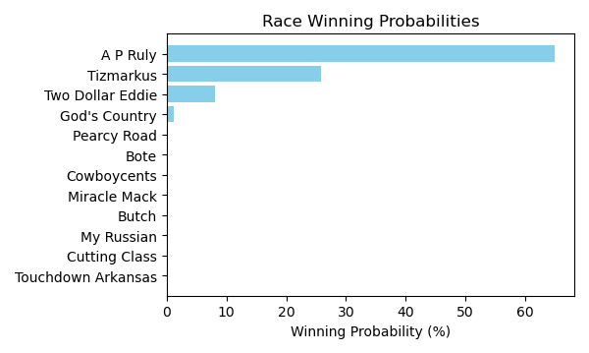

Figure: Winning Probability Distribution

NOTE: THIS RACE HAS HORSES THAT ARE MISSING CRITICAL DATA ELEMENTS

# Race: TOP | 2025-02-24 | Race #1 | Track: OAKLAWN PARK

Track: OAKLAWN PARK

|  |  |  |  |  |
| --- | --- | --- | --- | --- |
| Saddle Cloth # | Horse Name | Global Speed | Composite | Win Prob (%) |
| ['', 1, ''] | Mad Adam | 131.1 | 5.57 | 67.72 |
| ['', 2, ''] | Face Value | 78.7 | -3.97 | 0.00 |
| ['', 3, ''] | Contrabandista | 117.4 | 1.32 | 0.15 |
| ['', 4, ''] | Mr. Thunderstruck | 120.7 | 1.71 | 0.39 |
| ['', 5, ''] | Candy for Carmel | 132.8 | 4.18 | 31.61 |
| ['', 6, ''] | Tiwanaku | 52.8 | -8.18 | 0.00 |
| ['', 7, ''] | Fire Bryan | 116.1 | 1.53 | 0.13 |

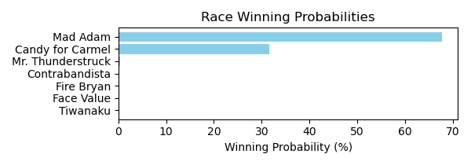

Figure: Winning Probability Distribution

NOTE: THIS RACE HAS HORSES THAT ARE MISSING CRITICAL DATA ELEMENTS

# Race: TOP | 2025-02-24 | Race #2 | Track: OAKLAWN PARK

Track: OAKLAWN PARK

|  |  |  |  |  |
| --- | --- | --- | --- | --- |
| Saddle Cloth # | Horse Name | Global Speed | Composite | Win Prob (%) |
| ['', 1, ''] | Chai Tea | 112.2 | 2.10 | 0.07 |
| ['', 2, ''] | Petula | 73.7 | -8.24 | 0.00 |
| ['', 3, ''] | Jeri Dawn | 132.2 | 4.47 | 24.48 |
| ['', 4, ''] | Navagationalbeacon | 96.9 | -2.96 | 0.00 |
| ['', 5, ''] | Magnolia Mae | 54.6 | -8.34 | 0.00 |
| ['', 6, ''] | She's Storming | 139.5 | 3.99 | 71.70 |
| ['', 7, ''] | Lady Astrid | 106.0 | 0.40 | 0.01 |
| ['', 8, ''] | Kitiara | 109.8 | -2.73 | 0.00 |
| ['', 9, ''] | War Music | 40.2 | -7.74 | 0.00 |
| ['', 10, ''] | She Be Sheehan | 120.2 | 5.13 | 3.75 |

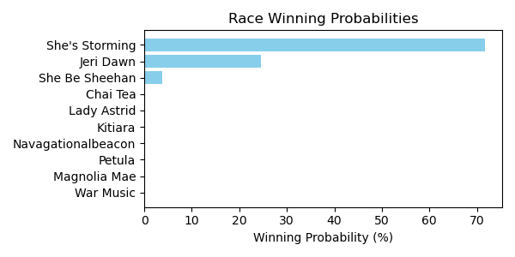

Figure: Winning Probability Distribution

NOTE: THIS RACE HAS HORSES THAT ARE MISSING CRITICAL DATA ELEMENTS

# Race: TOP | 2025-02-24 | Race #3 | Track: OAKLAWN PARK

Track: OAKLAWN PARK

|  |  |  |  |  |
| --- | --- | --- | --- | --- |
| Saddle Cloth # | Horse Name | Global Speed | Composite | Win Prob (%) |
| ['', 1, ''] | Big Paper | 61.9 | -7.09 | 0.00 |
| ['', 2, ''] | Polterer | 62.9 | -8.33 | 0.00 |
| ['', 3, ''] | Gasoline | 74.0 | -5.79 | 0.00 |
| ['', 4, ''] | Tapsasional | 112.7 | 0.50 | 13.05 |
| ['', 5, ''] | Right Tone | 117.8 | 1.57 | 86.51 |
| ['', 6, ''] | Sunrise Drive | 108.4 | -2.70 | 0.43 |
| ['', 7, ''] | Expensive Cut | 60.4 | -8.30 | 0.00 |
| ['', 8, ''] | Sittin On Go | 75.7 | -8.18 | 0.00 |
| ['', 9, ''] | W W Crazy | 80.5 | -6.71 | 0.00 |

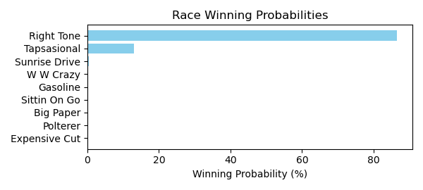

Figure: Winning Probability Distribution

NOTE: THIS RACE HAS HORSES THAT ARE MISSING CRITICAL DATA ELEMENTS

# Race: TOP | 2025-02-24 | Race #4 | Track: OAKLAWN PARK

Track: OAKLAWN PARK

|  |  |  |  |  |
| --- | --- | --- | --- | --- |
| Saddle Cloth # | Horse Name | Global Speed | Composite | Win Prob (%) |
| ['', 1, ''] | Wendelssohn | 148.8 | 5.08 | 76.92 |
| ['', 2, ''] | Booth | 86.3 | -4.04 | 0.00 |
| ['', 3, ''] | Disco Ball | 129.4 | 3.59 | 0.48 |
| ['', 4, ''] | Gold Luck | 87.1 | -4.01 | 0.00 |
| ['', 5, ''] | dh-Osbourne | 100.7 | 2.58 | 0.00 |
| ['', 6, ''] | Chiringo | 142.3 | 5.18 | 22.60 |

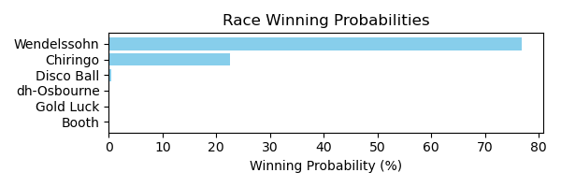

Figure: Winning Probability Distribution

NOTE: THIS RACE HAS HORSES THAT ARE MISSING CRITICAL DATA ELEMENTS

# Race: TOP | 2025-02-24 | Race #5 | Track: OAKLAWN PARK

Track: OAKLAWN PARK

|  |  |  |  |  |
| --- | --- | --- | --- | --- |
| Saddle Cloth # | Horse Name | Global Speed | Composite | Win Prob (%) |
| ['', 1, ''] | Got Thunder | 128.1 | 1.99 | 0.23 |
| ['', 2, ''] | Willtorun * | 96.5 | 8.62 | 0.09 |
| ['', 3, ''] | Sound Doctrine | 120.9 | 0.15 | 0.01 |
| ['', 4, ''] | Major Blue | 100.6 | -1.61 | 0.00 |
| ['', 5, ''] | Proprietary Trade | 107.8 | -0.04 | 0.00 |
| ['', 6, ''] | W W Scout's Honor | 132.0 | 0.04 | 0.11 |
| ['', 7, ''] | Mr Bob | 129.1 | 2.75 | 0.53 |
| ['', 8, ''] | Macron | 144.4 | 4.22 | 36.02 |
| ['', 9, ''] | Bron and Brow | 65.6 | 0.13 | 0.00 |
| ['', 10, ''] | Payne | 146.3 | 4.43 | 63.01 |

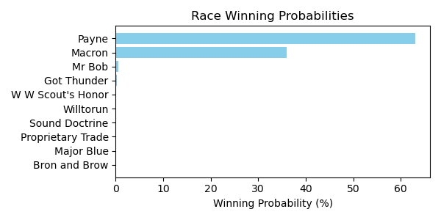

Figure: Winning Probability Distribution

NOTE: THIS RACE HAS HORSES THAT ARE MISSING CRITICAL DATA ELEMENTS

# Race: TOP | 2025-02-24 | Race #6 | Track: OAKLAWN PARK

Track: OAKLAWN PARK

|  |  |  |  |  |
| --- | --- | --- | --- | --- |
| Saddle Cloth # | Horse Name | Global Speed | Composite | Win Prob (%) |
| ['', 1, ''] | Bermuda Blitz | 137.3 | 5.98 | 8.75 |
| ['', 2, ''] | What Me Worry | 125.0 | 6.74 | 1.35 |
| ['', 3, ''] | Curvino | 145.4 | 4.58 | 14.19 |
| ['', 4, ''] | Heavenville | 133.9 | 5.71 | 3.56 |
| ['', 5, ''] | The Warden | 119.5 | 5.46 | 0.16 |
| ['', 6, ''] | Chief Liam | 138.9 | 6.56 | 18.84 |
| ['', 7, ''] | Big Boat | 146.5 | 5.94 | 52.74 |
| ['', 8, ''] | R Heisman | 129.2 | 4.13 | 0.39 |

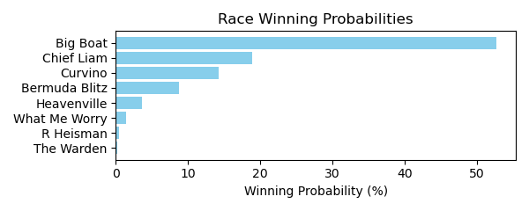

Figure: Winning Probability Distribution

NOTE: THIS RACE HAS HORSES THAT ARE MISSING CRITICAL DATA ELEMENTS

# Race: TOP | 2025-02-24 | Race #7 | Track: OAKLAWN PARK

Track: OAKLAWN PARK

|  |  |  |  |  |
| --- | --- | --- | --- | --- |
| Saddle Cloth # | Horse Name | Global Speed | Composite | Win Prob (%) |
| ['', 1, ''] | Spring Dancer | 140.3 | 6.00 | 99.70 |
| ['', 3, ''] | Mia's Mom | 45.1 | -7.94 | 0.00 |
| ['', 4, ''] | Coaster * | 124.5 | -5.71 | 0.00 |
| ['', 5, ''] | Dare to Fly | 130.0 | 0.70 | 0.18 |
| ['', 6, ''] | Avery's Mischief * | 108.2 | 5.68 | 0.12 |
| ['', 7, ''] | Now We Go * | 47.1 | -8.54 | 0.00 |

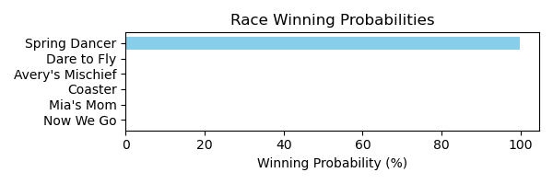

Figure: Winning Probability Distribution

NOTE: THIS RACE HAS HORSES THAT ARE MISSING CRITICAL DATA ELEMENTS

# Race: TOP | 2025-02-24 | Race #8 | Track: OAKLAWN PARK

Track: OAKLAWN PARK

|  |  |  |  |  |
| --- | --- | --- | --- | --- |
| Saddle Cloth # | Horse Name | Global Speed | Composite | Win Prob (%) |
| ['', 1, ''] | Tripolina | 109.2 | -1.30 | 0.00 |
| ['', 2, ''] | Story Hour | 65.4 | -7.44 | 0.00 |
| ['', 3, ''] | Demidanu | 130.1 | 3.33 | 2.51 |
| ['', 4, ''] | dh-Xtreme Smoke Show | 70.0 | -7.16 | 0.00 |
| ['', 5, ''] | Sharp Tune | 143.8 | 4.06 | 69.84 |
| ['', 6, ''] | Dealing Justice | 126.4 | 0.92 | 0.17 |
| ['', 7, ''] | Titled Lady | 140.1 | 2.52 | 9.56 |
| ['', 8, ''] | Stellar Lily | 64.3 | -7.15 | 0.00 |
| ['', 9, ''] | Asternia | 139.9 | 3.20 | 15.86 |
| ['', 10, ''] | Marmalade Skye | 132.3 | 2.52 | 2.05 |
| ['', 11, ''] | Always Angels | 43.2 | -7.85 | 0.00 |
| ['', 12, ''] | Pharoah's Heart | 78.8 | -7.27 | 0.00 |

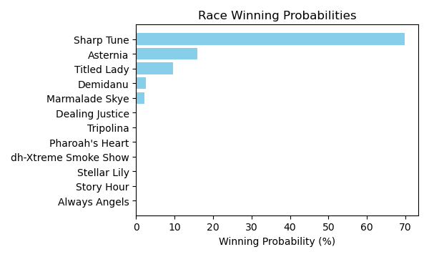

Figure: Winning Probability Distribution

NOTE: THIS RACE HAS HORSES THAT ARE MISSING CRITICAL DATA ELEMENTS

# Race: TOP | 2025-02-24 | Race #9 | Track: OAKLAWN PARK

Track: OAKLAWN PARK

|  |  |  |  |  |
| --- | --- | --- | --- | --- |
| Saddle Cloth # | Horse Name | Global Speed | Composite | Win Prob (%) |
| ['', 1, ''] | Wisconsin Gal | 93.3 | -4.66 | 0.00 |
| ['', 2, ''] | Gunite Max | 134.0 | 5.06 | 1.02 |
| ['', 3, ''] | Innocence * | 104.3 | 7.41 | 0.02 |
| ['', 4, ''] | You'll Be Back | 141.9 | 6.76 | 19.13 |
| ['', 5, ''] | Spankerboom | 70.7 | -7.21 | 0.00 |
| ['', 6, ''] | Whata Moon * | 125.6 | -9.56 | 0.00 |
| ['', 7, ''] | G W's Girl | 149.7 | 5.97 | 48.19 |
| ['', 8, ''] | Miss Martini | 147.5 | 5.98 | 31.63 |

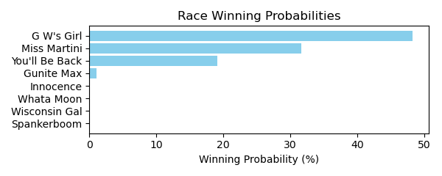

Figure: Winning Probability Distribution

NOTE: THIS RACE HAS HORSES THAT ARE MISSING CRITICAL DATA ELEMENTS

# Race: TOP | 2025-02-24 | Race #10 | Track: OAKLAWN PARK

Track: OAKLAWN PARK

|  |  |  |  |  |
| --- | --- | --- | --- | --- |
| Saddle Cloth # | Horse Name | Global Speed | Composite | Win Prob (%) |
| ['', 1, ''] | Juilliard | 42.5 | -7.65 | 0.00 |
| ['', 2, ''] | Ice Express | 86.3 | -5.70 | 0.00 |
| ['', 3, ''] | Rebelious | 66.6 | -8.56 | 0.00 |
| ['', 4, ''] | Count Dracula | 63.4 | -7.90 | 0.00 |
| ['', 5, ''] | Myra's Boy | 78.4 | -6.67 | 0.00 |
| ['', 6, ''] | Double Barrel | 93.0 | -5.95 | 0.00 |
| ['', 7, ''] | Luna Vieja | 134.3 | 6.12 | 44.75 |
| ['', 8, ''] | Searcy | 111.8 | -1.40 | 0.00 |
| ['', 9, ''] | Fireball Birdie | 128.3 | 5.10 | 6.02 |
| ['', 10, ''] | Mighty Message | 121.0 | 1.43 | 0.08 |
| ['', 11, ''] | Bolt At Midnight | 141.0 | 4.23 | 37.86 |
| ['', 12, ''] | Just Ask Watts | 130.5 | 5.33 | 11.29 |
| ['', 13, ''] | Our Dream Rye'd | 43.6 | -7.94 | 0.00 |

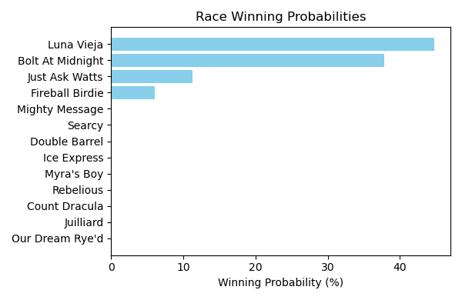

Figure: Winning Probability Distribution

NOTE: THIS RACE HAS HORSES THAT ARE MISSING CRITICAL DATA ELEMENTS

# Race: PEN | 2025-02-27 | Race #1 | Track: PENN NATIONAL

Track: PENN NATIONAL

|  |  |  |  |  |
| --- | --- | --- | --- | --- |
| Saddle Cloth # | Horse Name | Global Speed | Composite | Win Prob (%) |
| ['', 1, ''] | Pin Shot Babe * | 76.1 | 4.81 | 0.14 |
| ['', 2, ''] | Fifty Nine Fifty * | 76.1 | 8.01 | 1.83 |
| ['', 3, ''] | Sunshine Hazel | 120.8 | 1.81 | 97.99 |
| ['', 4, ''] | Episteme * | 75.8 | 3.30 | 0.04 |
| ['', 5, ''] | Strong Decision * | 76.6 | -10.67 | 0.00 |
| ['', 6, ''] | Cayuga | 40.2 | -8.81 | 0.00 |
| ['', 7, ''] | Lavender Fields * | 75.3 | -12.01 | 0.00 |
| ['', 8, ''] | Ashtead Lady * | 75.3 | -9.84 | 0.00 |

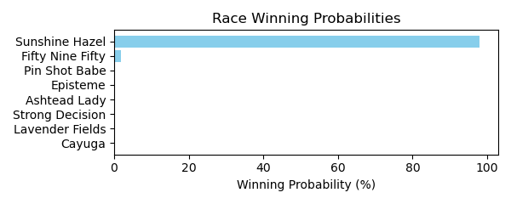

Figure: Winning Probability Distribution

NOTE: THIS RACE HAS HORSES THAT ARE MISSING CRITICAL DATA ELEMENTS

# Race: PEN | 2025-02-27 | Race #2 | Track: PENN NATIONAL

Track: PENN NATIONAL

|  |  |  |  |  |
| --- | --- | --- | --- | --- |
| Saddle Cloth # | Horse Name | Global Speed | Composite | Win Prob (%) |
| ['', 1, ''] | Scott Twentytwo | 49.2 | -8.66 | 0.00 |
| ['', 2, ''] | Charted Map | 114.1 | 1.98 | 5.53 |
| ['', 3, ''] | Bright Charger | 94.4 | 10.18 | 75.71 |
| ['', 4, ''] | Ridge Warrior * | 114.1 | -2.20 | 0.20 |
| ['', 5, ''] | English Daddy | 96.8 | 1.33 | 0.10 |
| ['', 6, ''] | Island Dream Girl * | 94.0 | 8.51 | 18.46 |
| ['', 7, ''] | Stifling Heat * | 114.1 | -9.26 | 0.00 |

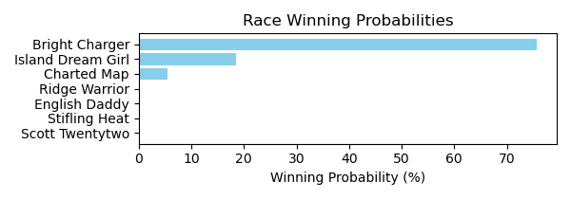

Figure: Winning Probability Distribution

NOTE: THIS RACE HAS HORSES THAT ARE MISSING CRITICAL DATA ELEMENTS

# Race: PEN | 2025-02-27 | Race #3 | Track: PENN NATIONAL

Track: PENN NATIONAL

|  |  |  |  |  |
| --- | --- | --- | --- | --- |
| Saddle Cloth # | Horse Name | Global Speed | Composite | Win Prob (%) |
| ['', 1, ''] | Tommy the Torch * | 70.1 | -0.43 | 0.01 |
| ['', 2, ''] | Red Devolution * | 76.9 | -7.62 | 0.00 |
| ['', 3, ''] | Magnificent Ride * | 77.5 | -4.94 | 0.00 |
| ['', 4, ''] | Waheel * | 70.1 | -9.25 | 0.00 |
| ['', 5, ''] | Screen Star * | 70.1 | -4.48 | 0.00 |
| ['', 6, ''] | Eclipticals Bear * | 70.1 | 2.59 | 0.06 |
| ['', 7, ''] | Cajun Occasion * | 70.1 | -7.08 | 0.00 |
| ['', 8, ''] | Dr Rags * | 70.1 | 1.97 | 0.04 |
| ['', 9, ''] | Warrior's Payoff * | 77.4 | -9.94 | 0.00 |
| ['', 10, ''] | Trivista * | 70.1 | -9.10 | 0.00 |
| ['', 11, ''] | Bee by the Sea * | 121.1 | -0.94 | 99.89 |
| ['', 12, ''] | Shanghai Superfly * | 70.1 | -5.49 | 0.00 |

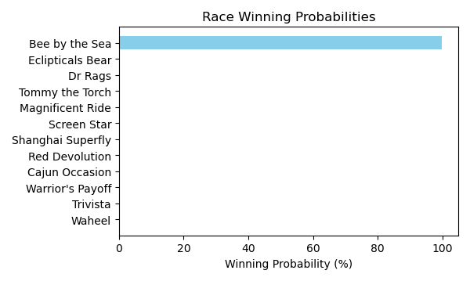

Figure: Winning Probability Distribution

# Race: PEN | 2025-02-27 | Race #4 | Track: PENN NATIONAL

Track: PENN NATIONAL

|  |  |  |  |  |
| --- | --- | --- | --- | --- |
| Saddle Cloth # | Horse Name | Global Speed | Composite | Win Prob (%) |
| ['', 1, ''] | I'manislandboy | 93.9 | -10.51 | 0.01 |
| ['', 2, ''] | Gee Power | 99.6 | 0.26 | 98.79 |
| ['', 3, ''] | Hot Truck Bob * | 60.0 | -8.88 | 0.00 |
| ['', 4, ''] | Rowdy Warrior * | 75.8 | -8.16 | 0.00 |
| ['', 5, ''] | Malibu Warrior * | 75.8 | -10.12 | 0.00 |
| ['', 6, ''] | Tankster * | 75.8 | -10.02 | 0.00 |
| ['', 7, ''] | Prince Praline | 94.2 | -3.92 | 1.20 |
| ['', 8, ''] | Gollum * | 60.0 | -9.24 | 0.00 |

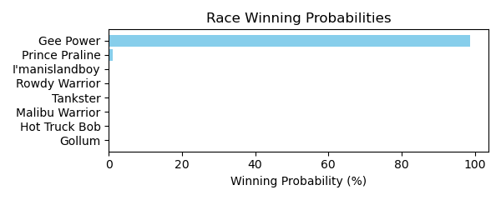

Figure: Winning Probability Distribution

NOTE: THIS RACE HAS HORSES THAT ARE MISSING CRITICAL DATA ELEMENTS

# Race: PEN | 2025-02-27 | Race #5 | Track: PENN NATIONAL

Track: PENN NATIONAL

|  |  |  |  |  |
| --- | --- | --- | --- | --- |
| Saddle Cloth # | Horse Name | Global Speed | Composite | Win Prob (%) |
| ['', 1, ''] | Peridot Pendant * | 122.5 | -1.75 | 0.23 |
| ['', 2, ''] | Plus Sized Courage * | 121.7 | -6.98 | 0.00 |
| ['', 3, ''] | Three Polks | 95.7 | 12.21 | 76.96 |
| ['', 4, ''] | Charisse | 77.0 | -1.85 | 0.00 |
| ['', 5, ''] | Annieworkstoomuch | 126.0 | 3.12 | 22.80 |
| ['', 6, ''] | Charm Alarm * | 86.5 | -10.30 | 0.00 |
| ['', 7, ''] | Normandy Life * | 86.5 | -10.04 | 0.00 |

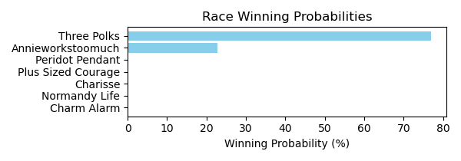

Figure: Winning Probability Distribution

NOTE: THIS RACE HAS HORSES THAT ARE MISSING CRITICAL DATA ELEMENTS

# Race: PEN | 2025-02-27 | Race #6 | Track: PENN NATIONAL

Track: PENN NATIONAL

|  |  |  |  |  |
| --- | --- | --- | --- | --- |
| Saddle Cloth # | Horse Name | Global Speed | Composite | Win Prob (%) |
| ['', 1, ''] | Yes It's Roo * | 77.9 | 7.34 | 3.75 |
| ['', 2, ''] | Mr. Marshall | 77.9 | 10.76 | 57.97 |
| ['', 3, ''] | Guns n' Rojas | 93.1 | -4.09 | 0.01 |
| ['', 4, ''] | Town's Warrior | 77.5 | 9.42 | 18.25 |
| ['', 5, ''] | One Way Farrior | 77.9 | -0.18 | 0.01 |
| ['', 6, ''] | Infamous Nono * | 95.8 | 4.95 | 20.01 |

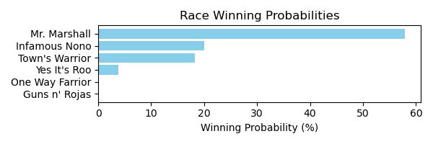

Figure: Winning Probability Distribution

NOTE: THIS RACE HAS HORSES THAT ARE MISSING CRITICAL DATA ELEMENTS

# Race: PEN | 2025-02-27 | Race #7 | Track: PENN NATIONAL

Track: PENN NATIONAL

|  |  |  |  |  |
| --- | --- | --- | --- | --- |
| Saddle Cloth # | Horse Name | Global Speed | Composite | Win Prob (%) |
| ['', 1, ''] | Undici * | 77.3 | -7.52 | 0.00 |
| ['', 2, ''] | Nail Polish | 95.5 | -1.15 | 0.05 |
| ['', 3, ''] | Quiet Maddelena | 60.3 | 2.86 | 0.00 |
| ['', 4, ''] | Bossy Kate | 104.3 | 4.37 | 23.85 |
| ['', 5, ''] | Warrior's Treasure * | 95.3 | 6.77 | 26.97 |
| ['', 6, ''] | Dancing Diana * | 125.5 | -9.13 | 0.03 |
| ['', 7, ''] | Gourmet | 116.0 | 2.34 | 49.10 |

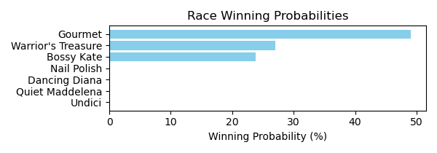

Figure: Winning Probability Distribution

NOTE: THIS RACE HAS HORSES THAT ARE MISSING CRITICAL DATA ELEMENTS

# Race: PEN | 2025-02-27 | Race #8 | Track: PENN NATIONAL

Track: PENN NATIONAL

|  |  |  |  |  |
| --- | --- | --- | --- | --- |
| Saddle Cloth # | Horse Name | Global Speed | Composite | Win Prob (%) |
| ['', 1, ''] | Josh * | 119.0 | -3.21 | 0.08 |
| ['', 2, ''] | Poker Player Kaz * | 76.3 | 8.26 | 0.14 |
| ['', 3, ''] | On Secret Service | 76.3 | -7.93 | 0.00 |
| ['', 4, ''] | Awesome Harry * | 119.5 | 5.32 | 76.81 |
| ['', 5, ''] | Magic Path | 120.6 | -10.10 | 0.00 |
| ['', 6, ''] | Lucky Double Zero * | 119.5 | 2.29 | 6.84 |
| ['', 7, ''] | Hallelujah Harris | 115.5 | 4.36 | 16.13 |

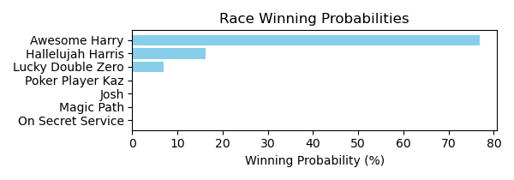

Figure: Winning Probability Distribution

NOTE: THIS RACE HAS HORSES THAT ARE MISSING CRITICAL DATA ELEMENTS

# Race: PEN | 2025-02-27 | Race #9 | Track: PENN NATIONAL

Track: PENN NATIONAL

|  |  |  |  |  |
| --- | --- | --- | --- | --- |
| Saddle Cloth # | Horse Name | Global Speed | Composite | Win Prob (%) |
| ['', 1, ''] | La Tache | 66.1 | -7.17 | 0.00 |
| ['', 2, ''] | Desi's Reward * | 114.5 | -4.76 | 0.05 |
| ['', 3, ''] | Jeanetteo * | 95.3 | 5.19 | 3.24 |
| ['', 4, ''] | Fancy Princess | 56.6 | -8.63 | 0.00 |
| ['', 5, ''] | My Jo Jo | 94.8 | -0.79 | 0.02 |
| ['', 6, ''] | Warrior Bernice * | 132.6 | 0.11 | 96.65 |
| ['', 7, ''] | Beachgrass | 63.8 | -6.57 | 0.00 |
| ['', 8, ''] | G's Fireball | 76.7 | 4.22 | 0.04 |
| ['', 9, ''] | Happybirthdaycorey | 76.6 | -8.00 | 0.00 |
| ['', 10, ''] | Flinny Tin Tin | 44.2 | -9.18 | 0.00 |

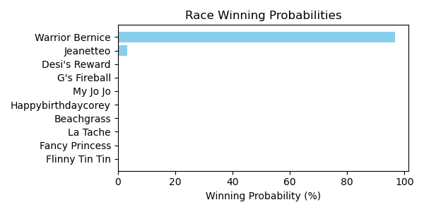

Figure: Winning Probability Distribution

NOTE: THIS RACE HAS HORSES THAT ARE MISSING CRITICAL DATA ELEMENTS

# Race: PEN | 2025-02-28 | Race #1 | Track: PENN NATIONAL

Track: PENN NATIONAL

|  |  |  |  |  |
| --- | --- | --- | --- | --- |
| Saddle Cloth # | Horse Name | Global Speed | Composite | Win Prob (%) |
| ['', 1, ''] | Ribot's Valentine * | 77.2 | 3.18 | 0.10 |
| ['', 2, ''] | Braquet | 114.9 | 2.34 | 99.59 |
| ['', 3, ''] | Rock N Reward | 94.9 | -0.37 | 0.21 |
| ['', 4, ''] | Java's Lucky Lady * | 85.6 | -1.93 | 0.01 |
| ['', 5, ''] | Blame Catalaya * | 77.2 | 2.98 | 0.09 |
| ['', 6, ''] | Lady Zeta | 85.8 | -8.10 | 0.00 |

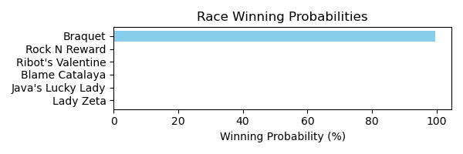

Figure: Winning Probability Distribution

NOTE: THIS RACE HAS HORSES THAT ARE MISSING CRITICAL DATA ELEMENTS

# Race: PEN | 2025-02-28 | Race #2 | Track: PENN NATIONAL

Track: PENN NATIONAL

|  |  |  |  |  |
| --- | --- | --- | --- | --- |
| Saddle Cloth # | Horse Name | Global Speed | Composite | Win Prob (%) |
| ['', 1, ''] | Cowgirl Nation * | 76.3 | -2.45 | 0.00 |
| ['', 2, ''] | Nobody's Zapper * | 117.8 | 5.83 | 100.00 |
| ['', 3, ''] | Bounty Killah * | 69.1 | -3.98 | 0.00 |
| ['', 4, ''] | Red Betty * | 69.1 | -2.78 | 0.00 |
| ['', 5, ''] | Analog * | 76.3 | -9.18 | 0.00 |
| ['', 6, ''] | Peaceoftastycake * | 76.5 | -3.89 | 0.00 |

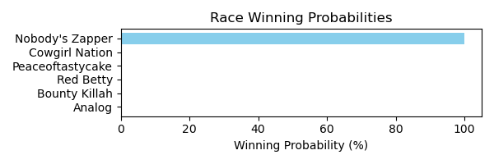

Figure: Winning Probability Distribution

# Race: PEN | 2025-02-28 | Race #3 | Track: PENN NATIONAL

Track: PENN NATIONAL

|  |  |  |  |  |
| --- | --- | --- | --- | --- |
| Saddle Cloth # | Horse Name | Global Speed | Composite | Win Prob (%) |
| ['', 1, ''] | Going At It * | 77.9 | -1.00 | 0.00 |
| ['', 2, ''] | Majestic Tiger | 40.5 | -8.50 | 0.00 |
| ['', 3, ''] | Vinnie Van Go * | 86.1 | -8.92 | 0.00 |
| ['', 4, ''] | Cajun Vibes | 95.6 | 8.62 | 99.96 |
| ['', 5, ''] | Jackie A * | 77.4 | 1.16 | 0.01 |
| ['', 6, ''] | Powerfully Built | 77.9 | 1.94 | 0.01 |
| ['', 7, ''] | Living Water * | 77.5 | 2.07 | 0.01 |
| ['', 8, ''] | Helms Deep | 77.4 | -5.79 | 0.00 |

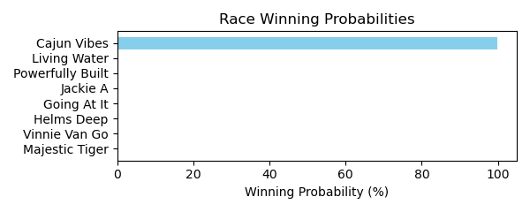

Figure: Winning Probability Distribution

NOTE: THIS RACE HAS HORSES THAT ARE MISSING CRITICAL DATA ELEMENTS

# Race: PEN | 2025-02-28 | Race #4 | Track: PENN NATIONAL

Track: PENN NATIONAL

|  |  |  |  |  |
| --- | --- | --- | --- | --- |
| Saddle Cloth # | Horse Name | Global Speed | Composite | Win Prob (%) |
| ['', 1, ''] | Twixter * | 121.4 | -10.32 | 0.00 |
| ['', 2, ''] | Musical Heart * | 122.2 | 7.66 | 96.84 |
| ['', 3, ''] | Lake Nakuru * | 115.4 | -1.76 | 0.01 |
| ['', 4, ''] | Rockin the Palace * | 120.9 | 2.18 | 0.93 |
| ['', 5, ''] | Over and Thunder * | 115.4 | 4.56 | 2.08 |
| ['', 6, ''] | Critical Thinking * | 123.8 | -5.58 | 0.00 |
| ['', 7, ''] | Bee by the Sea * | 121.1 | -0.22 | 0.14 |

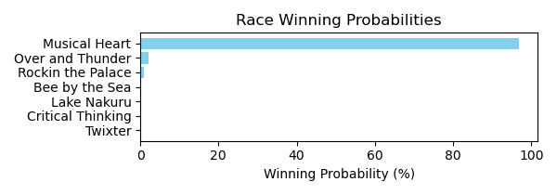

Figure: Winning Probability Distribution

# Race: PEN | 2025-02-28 | Race #5 | Track: PENN NATIONAL

Track: PENN NATIONAL

|  |  |  |  |  |
| --- | --- | --- | --- | --- |
| Saddle Cloth # | Horse Name | Global Speed | Composite | Win Prob (%) |
| ['', 1, ''] | Cathedral Beach | 58.2 | -7.27 | 0.00 |
| ['', 2, ''] | Tarsus Warrior * | 70.9 | 1.77 | 0.13 |
| ['', 3, ''] | Trophy Room * | 78.4 | -3.06 | 0.01 |
| ['', 4, ''] | Unified by Candy * | 77.9 | -8.39 | 0.00 |
| ['', 5, ''] | Keeping It Country * | 86.4 | 1.17 | 1.78 |
| ['', 6, ''] | Guardian Prince | 49.2 | -7.47 | 0.00 |
| ['', 7, ''] | Tiz Marks Spirit | 77.1 | 8.51 | 98.08 |

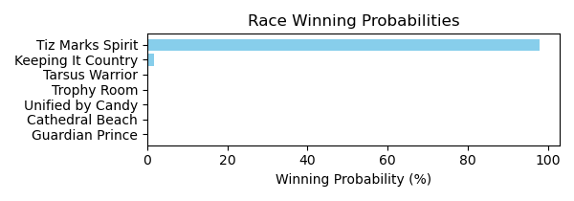

Figure: Winning Probability Distribution

NOTE: THIS RACE HAS HORSES THAT ARE MISSING CRITICAL DATA ELEMENTS

# Race: PEN | 2025-02-28 | Race #6 | Track: PENN NATIONAL

Track: PENN NATIONAL

|  |  |  |  |  |
| --- | --- | --- | --- | --- |
| Saddle Cloth # | Horse Name | Global Speed | Composite | Win Prob (%) |
| ['', 1, ''] | Taporical * | 70.0 | -5.55 | 0.00 |
| ['', 2, ''] | dh-Ramblin Chrome * | 119.5 | -8.36 | 0.00 |
| ['', 3, ''] | Brady * | 77.1 | -10.24 | 0.00 |
| ['', 4, ''] | Sweet Spite * | 128.4 | 9.79 | 96.41 |
| ['', 5, ''] | Town Kisser | 113.8 | 9.30 | 3.59 |
| ['', 6, ''] | Paynter's Prodigy * | 84.5 | 0.58 | 0.00 |
| ['', 7, ''] | Bearing Down | 70.0 | -9.60 | 0.00 |

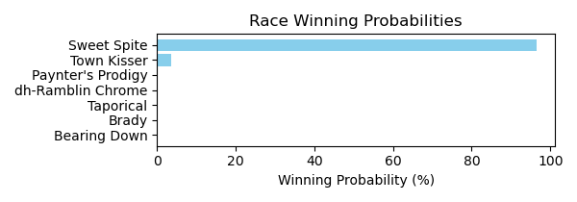

Figure: Winning Probability Distribution

NOTE: THIS RACE HAS HORSES THAT ARE MISSING CRITICAL DATA ELEMENTS

# Race: PEN | 2025-02-28 | Race #7 | Track: PENN NATIONAL

Track: PENN NATIONAL

|  |  |  |  |  |
| --- | --- | --- | --- | --- |
| Saddle Cloth # | Horse Name | Global Speed | Composite | Win Prob (%) |
| ['', 1, ''] | Addyson's Dream * | 76.3 | 8.01 | 0.00 |
| ['', 2, ''] | Added Mischief | 141.3 | -2.84 | 0.03 |
| ['', 3, ''] | Key Stat | 144.3 | 6.38 | 99.96 |
| ['', 4, ''] | Rip My Heart * | 76.3 | -7.47 | 0.00 |
| ['', 5, ''] | Mister Lincoln | 115.9 | -0.85 | 0.00 |
| ['', 6, ''] | Sandy's Refugee * | 76.3 | -1.27 | 0.00 |
| ['', 7, ''] | Malibu Knight * | 76.4 | 3.07 | 0.00 |

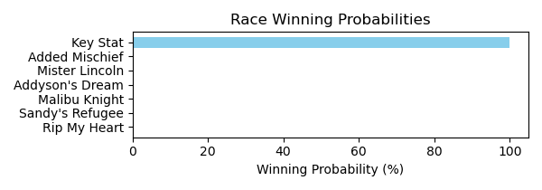

Figure: Winning Probability Distribution

NOTE: THIS RACE HAS HORSES THAT ARE MISSING CRITICAL DATA ELEMENTS

# Race: PEN | 2025-02-28 | Race #8 | Track: PENN NATIONAL

Track: PENN NATIONAL

|  |  |  |  |  |
| --- | --- | --- | --- | --- |
| Saddle Cloth # | Horse Name | Global Speed | Composite | Win Prob (%) |
| ['', 1, ''] | Collin's Grey Lady * | 76.7 | 0.61 | 0.02 |
| ['', 2, ''] | Melodious Singer * | 77.2 | -8.04 | 0.00 |
| ['', 3, ''] | Queen Wiggy * | 87.0 | 8.54 | 99.97 |
| ['', 4, ''] | Phancy Philly * | 76.7 | -0.67 | 0.01 |
| ['', 5, ''] | I'm Heading East * | 77.0 | -8.65 | 0.00 |
| ['', 6, ''] | Grand Lady Indy * | 70.1 | -2.35 | 0.00 |
| ['', 7, ''] | Bahama Pearl * | 84.8 | -9.23 | 0.00 |

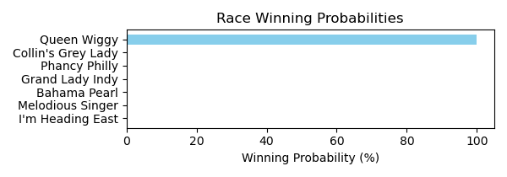

Figure: Winning Probability Distribution

# Race: PEN | 2025-02-28 | Race #9 | Track: PENN NATIONAL

Track: PENN NATIONAL

|  |  |  |  |  |
| --- | --- | --- | --- | --- |
| Saddle Cloth # | Horse Name | Global Speed | Composite | Win Prob (%) |
| ['', 1, ''] | Gormley Girl * | 132.6 | 8.13 | 99.97 |
| ['', 2, ''] | Desi's Reward * | 114.5 | -3.73 | 0.00 |
| ['', 3, ''] | My Jo Jo | 94.8 | -0.11 | 0.00 |
| ['', 4, ''] | My Boss Lady * | 76.7 | 7.37 | 0.00 |
| ['', 5, ''] | Will Or Won't | 120.3 | -2.84 | 0.00 |
| ['', 6, ''] | Secret Temptation * | 76.9 | -3.80 | 0.00 |
| ['', 7, ''] | Just Stay Home * | 132.8 | -2.12 | 0.03 |

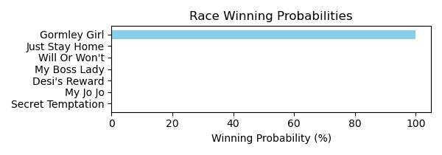

Figure: Winning Probability Distribution

NOTE: THIS RACE HAS HORSES THAT ARE MISSING CRITICAL DATA ELEMENTS

# Race: HOU | 2025-02-23 | Race #2 | Track: SAM HOUSTON RACE PARK

Track: SAM HOUSTON RACE PARK

|  |  |  |  |  |
| --- | --- | --- | --- | --- |
| Saddle Cloth # | Horse Name | Global Speed | Composite | Win Prob (%) |
| ['', 1, ''] | School Teacher | 128.6 | 2.15 | 53.29 |
| ['', 2, ''] | Fun as All Git Out * | 49.1 | -8.73 | 0.00 |
| ['', 3, ''] | Maddie's Maverick | 107.6 | 0.17 | 0.16 |
| ['', 4, ''] | Sherrys Ridge | 48.9 | -8.37 | 0.00 |
| ['', 5, ''] | Cayman Hot | 68.3 | -5.62 | 0.00 |
| ['', 6, ''] | Miss Motor Mouth * | 98.2 | -7.66 | 0.00 |
| ['', 7, ''] | Mighty Enticing * | 112.7 | -5.80 | 0.00 |
| ['', 8, ''] | Wild Steel | 120.7 | 3.97 | 46.54 |

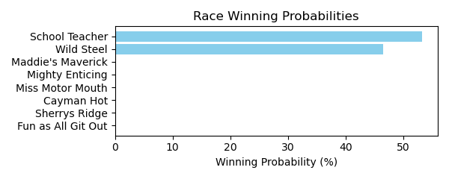

Figure: Winning Probability Distribution

NOTE: THIS RACE HAS HORSES THAT ARE MISSING CRITICAL DATA ELEMENTS

# Race: HOU | 2025-02-23 | Race #3 | Track: SAM HOUSTON RACE PARK

Track: SAM HOUSTON RACE PARK

|  |  |  |  |  |
| --- | --- | --- | --- | --- |
| Saddle Cloth # | Horse Name | Global Speed | Composite | Win Prob (%) |
| ['', 1, ''] | Honest | 132.9 | 4.37 | 19.70 |
| ['', 2, ''] | God Knows Why | 52.2 | -6.70 | 0.00 |
| ['', 3, ''] | Bling Baby | 134.9 | 5.56 | 75.92 |
| ['', 4, ''] | Gee She's Fancy | 93.8 | -5.82 | 0.00 |
| ['', 5, ''] | Avaling | 128.8 | 2.59 | 2.09 |
| ['', 6, ''] | Midshipman's Lady | 118.1 | 5.35 | 2.25 |
| ['', 7, ''] | Sassy Flyer | 114.0 | 1.48 | 0.04 |
| ['', 8, ''] | All American Lady | 78.9 | -7.85 | 0.00 |

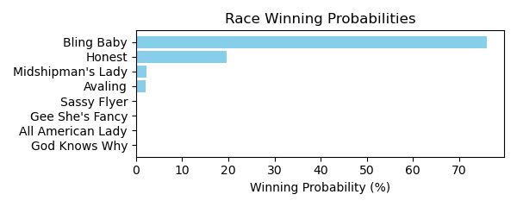

Figure: Winning Probability Distribution

NOTE: THIS RACE HAS HORSES THAT ARE MISSING CRITICAL DATA ELEMENTS

# Race: HOU | 2025-02-23 | Race #4 | Track: SAM HOUSTON RACE PARK

Track: SAM HOUSTON RACE PARK

|  |  |  |  |  |
| --- | --- | --- | --- | --- |
| Saddle Cloth # | Horse Name | Global Speed | Composite | Win Prob (%) |
| ['', 1, ''] | Highlander Honey | 109.6 | 2.19 | 0.01 |
| ['', 2, ''] | Anna Up | 126.8 | 0.42 | 0.05 |
| ['', 3, ''] | Candy Oak | 115.6 | -8.34 | 0.00 |
| ['', 4, ''] | Miss Escapade | 93.2 | -4.54 | 0.00 |
| ['', 5, ''] | Perceptive | 141.5 | 5.34 | 52.47 |
| ['', 6, ''] | Teardrop Tiara | 144.5 | 4.47 | 47.47 |
| ['', 7, ''] | Gospel Extra | 47.6 | -8.53 | 0.00 |
| ['', 8, ''] | Annamaria | 40.2 | -7.95 | 0.00 |
| ['', 9, ''] | Gospel Freely | 105.9 | -1.80 | 0.00 |
| ['', 10, ''] | Ize a Blast | 115.6 | -9.42 | 0.00 |

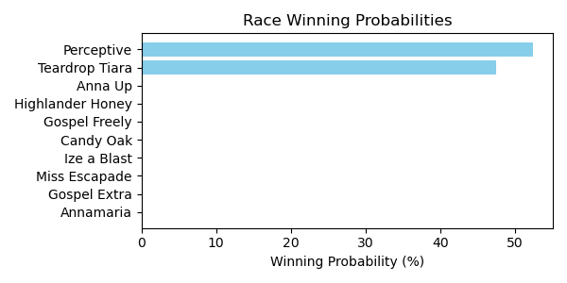

Figure: Winning Probability Distribution

NOTE: THIS RACE HAS HORSES THAT ARE MISSING CRITICAL DATA ELEMENTS

# Race: HOU | 2025-02-23 | Race #5 | Track: SAM HOUSTON RACE PARK

Track: SAM HOUSTON RACE PARK

|  |  |  |  |  |
| --- | --- | --- | --- | --- |
| Saddle Cloth # | Horse Name | Global Speed | Composite | Win Prob (%) |
| ['', 1, ''] | Gospel B. Havior | 73.3 | -5.00 | 0.00 |
| ['', 2, ''] | Kamikaze | 115.2 | -4.88 | 0.00 |
| ['', 3, ''] | Utsira | 51.1 | -8.77 | 0.00 |
| ['', 4, ''] | Contessa's Song | 112.7 | 4.10 | 0.03 |
| ['', 5, ''] | County Slugger | 147.3 | 4.66 | 44.81 |
| ['', 6, ''] | Charluche | 117.1 | 0.57 | 0.00 |
| ['', 7, ''] | Chainsaw City | 96.8 | -0.15 | 0.00 |
| ['', 8, ''] | Boltoro | 145.2 | 5.45 | 55.15 |

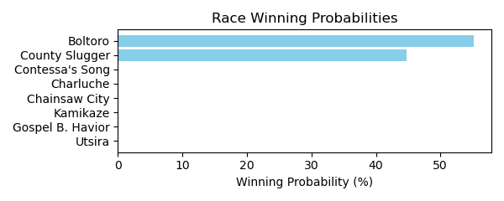

Figure: Winning Probability Distribution

NOTE: THIS RACE HAS HORSES THAT ARE MISSING CRITICAL DATA ELEMENTS

# Race: HOU | 2025-02-23 | Race #6 | Track: SAM HOUSTON RACE PARK

Track: SAM HOUSTON RACE PARK

|  |  |  |  |  |
| --- | --- | --- | --- | --- |
| Saddle Cloth # | Horse Name | Global Speed | Composite | Win Prob (%) |
| ['', 1, ''] | Pudding | 145.1 | 5.46 | 99.80 |
| ['', 2, ''] | Playing Hardball | 70.8 | 6.88 | 0.00 |
| ['', 3, ''] | Fort Hood | 83.0 | -6.13 | 0.00 |
| ['', 4, ''] | My Little Prince | 49.0 | -8.62 | 0.00 |
| ['', 5, ''] | Champagne Stooper | 71.6 | -7.20 | 0.00 |
| ['', 6, ''] | Perliano | 68.7 | -7.59 | 0.00 |
| ['', 7, ''] | Rocking Rocket | 119.8 | 3.96 | 0.19 |
| ['', 8, ''] | Cinco Steve | 95.1 | 2.72 | 0.00 |
| ['', 9, ''] | Sidetown | 115.8 | -0.01 | 0.00 |

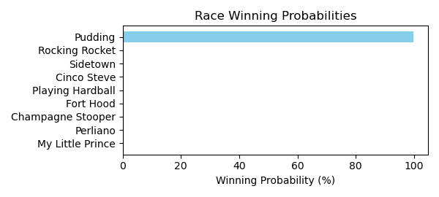

Figure: Winning Probability Distribution

NOTE: THIS RACE HAS HORSES THAT ARE MISSING CRITICAL DATA ELEMENTS

# Race: HOU | 2025-02-23 | Race #7 | Track: SAM HOUSTON RACE PARK

Track: SAM HOUSTON RACE PARK

|  |  |  |  |  |
| --- | --- | --- | --- | --- |
| Saddle Cloth # | Horse Name | Global Speed | Composite | Win Prob (%) |
| ['', 1, ''] | Piccolo Uomo | 102.3 | -1.28 | 10.92 |
| ['', 2, ''] | Blame Dennis | 47.6 | -7.93 | 0.00 |
| ['', 3, ''] | Wonderful News | 40.6 | -8.24 | 0.00 |
| ['', 4, ''] | Doc Henry Ridge | 40.9 | -8.97 | 0.00 |
| ['', 5, ''] | Midnight Talker | 105.2 | -3.83 | 2.56 |
| ['', 6, ''] | Tough Trooper | 77.5 | -6.67 | 0.00 |
| ['', 8, ''] | Fully Funded | 75.7 | 1.79 | 0.63 |
| ['', 9, ''] | Lone Tree | 69.8 | 2.40 | 0.31 |
| ['', 10, ''] | Give Him Time | 69.8 | -9.56 | 0.00 |
| ['', 11, ''] | Brewing | 85.2 | 5.56 | 85.59 |

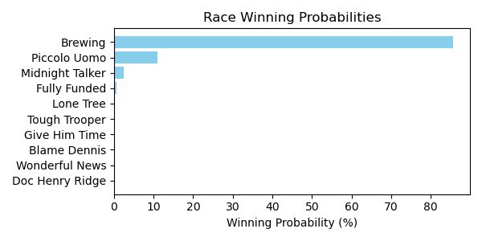

Figure: Winning Probability Distribution

NOTE: THIS RACE HAS HORSES THAT ARE MISSING CRITICAL DATA ELEMENTS

# Race: HOU | 2025-02-23 | Race #8 | Track: SAM HOUSTON RACE PARK

Track: SAM HOUSTON RACE PARK

|  |  |  |  |  |
| --- | --- | --- | --- | --- |
| Saddle Cloth # | Horse Name | Global Speed | Composite | Win Prob (%) |
| ['', 1, ''] | Big Nickel | 128.2 | 2.75 | 17.61 |
| ['', 2, ''] | Keep Up the Pace | 103.9 | -5.50 | 0.00 |
| ['', 3, ''] | Map This Out * | 123.1 | 5.96 | 82.38 |
| ['', 4, ''] | Can't Know * | 49.5 | -8.20 | 0.00 |
| ['', 5, ''] | Hank Ridge * | 44.2 | -8.35 | 0.00 |
| ['', 6, ''] | Nightlinger * | 96.8 | -6.61 | 0.00 |
| ['', 7, ''] | Floating Smokey | 40.5 | -8.55 | 0.00 |
| ['', 8, ''] | Rock Island Rocket * | 55.9 | -7.85 | 0.00 |

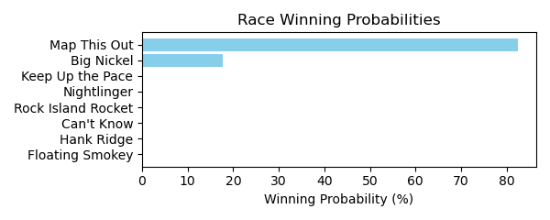

Figure: Winning Probability Distribution

NOTE: THIS RACE HAS HORSES THAT ARE MISSING CRITICAL DATA ELEMENTS

# Race: HOU | 2025-02-23 | Race #9 | Track: SAM HOUSTON RACE PARK

Track: SAM HOUSTON RACE PARK

|  |  |  |  |  |
| --- | --- | --- | --- | --- |
| Saddle Cloth # | Horse Name | Global Speed | Composite | Win Prob (%) |
| ['', 1, ''] | El Mero Mero | 103.8 | -0.71 | 0.00 |
| ['', 2, ''] | My Boy Bling | 97.3 | -4.42 | 0.00 |
| ['', 3, ''] | Bronte Diem | 46.9 | -7.65 | 0.00 |
| ['', 4, ''] | Cadillac Cowboy | 80.3 | 8.72 | 0.00 |
| ['', 5, ''] | Mister Monte Carlo | 68.4 | -6.31 | 0.00 |
| ['', 6, ''] | Optimal Trip | 142.9 | 4.57 | 12.97 |
| ['', 7, ''] | Samsplayerslounge | 144.1 | 6.63 | 84.09 |
| ['', 8, ''] | In Bond We Trust | 42.1 | -8.63 | 0.00 |
| ['', 9, ''] | Do Your Job | 123.5 | 1.98 | 0.03 |
| ['', 10, ''] | Ooey Gooey Chewy | 141.9 | 1.79 | 1.15 |
| ['', 11, ''] | Legendary Lore | 129.1 | 5.53 | 1.77 |

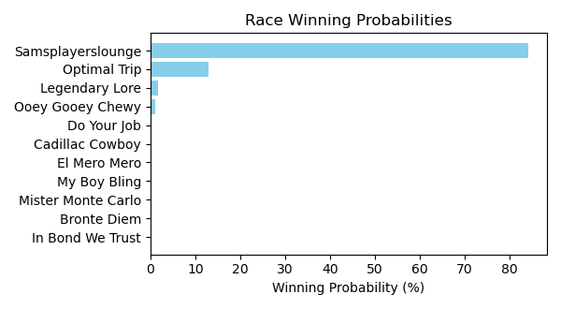

Figure: Winning Probability Distribution

NOTE: THIS RACE HAS HORSES THAT ARE MISSING CRITICAL DATA ELEMENTS

# Race: HOU | 2025-02-23 | Race #10 | Track: SAM HOUSTON RACE PARK

Track: SAM HOUSTON RACE PARK

|  |  |  |  |  |
| --- | --- | --- | --- | --- |
| Saddle Cloth # | Horse Name | Global Speed | Composite | Win Prob (%) |
| ['', 1, ''] | Levy | 74.8 | -7.37 | 0.00 |
| ['', 2, ''] | Will the Thrill | 64.6 | -7.68 | 0.00 |
| ['', 3, ''] | Nightwind | 119.9 | 1.92 | 0.07 |
| ['', 4, ''] | Federal Hill | 79.5 | -6.77 | 0.00 |
| ['', 5, ''] | Macho Grande | 138.4 | 6.28 | 91.93 |
| ['', 6, ''] | Union Data | 130.1 | 1.73 | 0.46 |
| ['', 7, ''] | Hard Gold | 142.3 | 2.17 | 7.54 |
| ['', 8, ''] | Fast Traffic | 106.1 | -1.23 | 0.00 |
| ['', 9, ''] | Big Muckity | 93.7 | -2.99 | 0.00 |
| ['', 10, ''] | Sniveling * | 115.2 | -8.02 | 0.00 |
| ['', 11, ''] | Malibu S S | 72.1 | -7.25 | 0.00 |
| ['', 12, ''] | Texas Titan | 100.2 | -7.20 | 0.00 |
| ['', 13, ''] | R D C Posse | 96.6 | -1.09 | 0.00 |

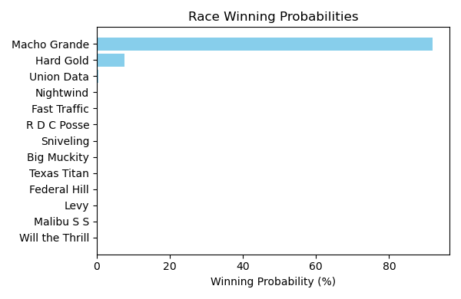

Figure: Winning Probability Distribution

NOTE: THIS RACE HAS HORSES THAT ARE MISSING CRITICAL DATA ELEMENTS

# Race: HOU | 2025-02-23 | Race #11 | Track: SAM HOUSTON RACE PARK

Track: SAM HOUSTON RACE PARK

|  |  |  |  |  |
| --- | --- | --- | --- | --- |
| Saddle Cloth # | Horse Name | Global Speed | Composite | Win Prob (%) |
| ['', 1, ''] | Violet Kitten | 124.3 | 5.69 | 1.64 |
| ['', 2, ''] | Catalyst | 141.4 | 5.22 | 34.17 |
| ['', 3, ''] | La Ronalda Y G | 47.0 | -8.09 | 0.00 |
| ['', 4, ''] | Wandering Kirby * | 43.0 | -8.31 | 0.00 |
| ['', 5, ''] | My Sweet Love | 124.3 | -7.18 | 0.00 |
| ['', 6, ''] | Summertimee | 95.7 | -0.37 | 0.00 |
| ['', 7, ''] | Razors Edge | 59.2 | -7.53 | 0.00 |
| ['', 8, ''] | Wonder Wave (IRE) | 114.7 | 1.83 | 0.01 |
| ['', 9, ''] | Sugarcoat | 143.7 | 5.42 | 64.17 |
| ['', 10, ''] | Tiz a Knockout | 106.4 | 2.05 | 0.00 |

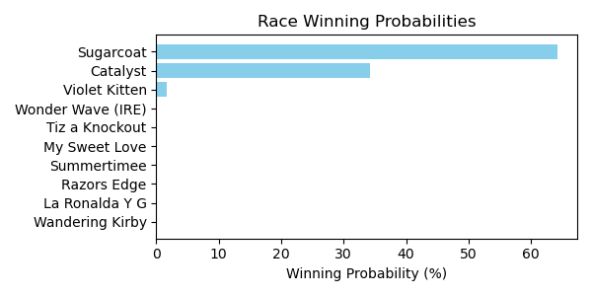

Figure: Winning Probability Distribution

NOTE: THIS RACE HAS HORSES THAT ARE MISSING CRITICAL DATA ELEMENTS

# Race: TSA | 2025-02-23 | Race #1 | Track: SANTA ANITA PARK

Track: SANTA ANITA PARK

|  |  |  |  |  |
| --- | --- | --- | --- | --- |
| Saddle Cloth # | Horse Name | Global Speed | Composite | Win Prob (%) |
| ['', 1, ''] | Broski (IRE) | 118.2 | 2.95 | 2.62 |
| ['', 2, ''] | My Hero | 41.0 | -7.47 | 0.00 |
| ['', 3, ''] | Let Seamus Go | 109.9 | -3.03 | 0.00 |
| ['', 5, ''] | Cano for the Win | 74.8 | -7.15 | 0.00 |
| ['', 6, ''] | Mysterious Husband | 135.8 | 3.05 | 97.38 |
| ['', 7, ''] | Nassau Circle | 101.0 | -5.63 | 0.00 |

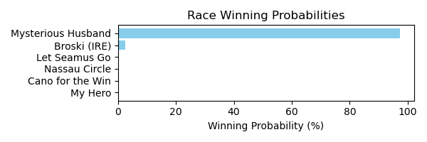

Figure: Winning Probability Distribution

NOTE: THIS RACE HAS HORSES THAT ARE MISSING CRITICAL DATA ELEMENTS

# Race: TSA | 2025-02-23 | Race #2 | Track: SANTA ANITA PARK

Track: SANTA ANITA PARK

|  |  |  |  |  |
| --- | --- | --- | --- | --- |
| Saddle Cloth # | Horse Name | Global Speed | Composite | Win Prob (%) |
| ['', 1, ''] | Shanghai Mist | 82.7 | -3.34 | 0.00 |
| ['', 2, ''] | Bold Daughter | 135.6 | 5.02 | 53.88 |
| ['', 3, ''] | Proof of Jazz | 42.0 | -8.03 | 0.00 |
| ['', 4, ''] | Dorine's Wild Cat | 82.4 | -6.24 | 0.00 |
| ['', 5, ''] | Smile Baby Smile | 54.2 | -5.84 | 0.00 |
| ['', 6, ''] | Super Ellie | 137.3 | 4.39 | 46.12 |
| ['', 7, ''] | Shezarunaway | 89.1 | -5.16 | 0.00 |

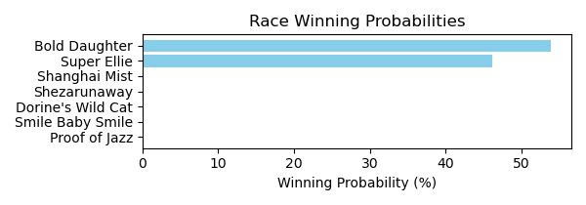

Figure: Winning Probability Distribution

NOTE: THIS RACE HAS HORSES THAT ARE MISSING CRITICAL DATA ELEMENTS

# Race: TSA | 2025-02-23 | Race #3 | Track: SANTA ANITA PARK

Track: SANTA ANITA PARK

|  |  |  |  |  |
| --- | --- | --- | --- | --- |
| Saddle Cloth # | Horse Name | Global Speed | Composite | Win Prob (%) |
| ['', 1, ''] | Nobel Gary | 66.6 | -8.09 | 0.00 |
| ['', 2, ''] | Ignatowski | 144.0 | 6.37 | 66.68 |
| ['', 3, ''] | Factory Drive | 138.8 | 4.08 | 3.74 |
| ['', 5, ''] | Eligio | 77.9 | 6.26 | 0.00 |
| ['', 6, ''] | Arromax | 143.9 | 5.38 | 29.58 |
| ['', 7, ''] | Osage Creek | 80.4 | -7.09 | 0.00 |
| ['', 8, ''] | Sinful King | 40.0 | -7.50 | 0.00 |

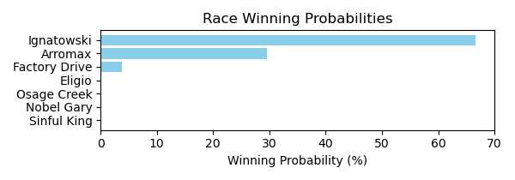

Figure: Winning Probability Distribution

NOTE: THIS RACE HAS HORSES THAT ARE MISSING CRITICAL DATA ELEMENTS

# Race: TSA | 2025-02-23 | Race #4 | Track: SANTA ANITA PARK

Track: SANTA ANITA PARK

|  |  |  |  |  |
| --- | --- | --- | --- | --- |
| Saddle Cloth # | Horse Name | Global Speed | Composite | Win Prob (%) |
| ['', 1, ''] | Naismith | 125.4 | 3.90 | 0.66 |
| ['', 2, ''] | Big Bet | 121.8 | -6.16 | 0.00 |
| ['', 3, ''] | Sir Maximus | 41.1 | -7.77 | 0.00 |
| ['', 4, ''] | Oobubbakakayo | 84.9 | -6.57 | 0.00 |
| ['', 5, ''] | Hot Legs Romolo | 44.8 | -8.14 | 0.00 |
| ['', 6, ''] | Bronko Nagurski | 96.8 | -3.59 | 0.00 |
| ['', 7, ''] | Special Flower | 79.8 | -7.39 | 0.00 |
| ['', 8, ''] | Billy Joe Shaver | 144.3 | 5.45 | 99.34 |
| ['', 9, ''] | Buckortwo | 63.5 | -7.79 | 0.00 |

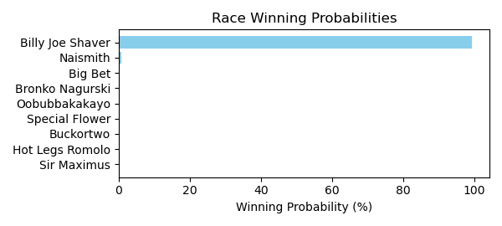

Figure: Winning Probability Distribution

NOTE: THIS RACE HAS HORSES THAT ARE MISSING CRITICAL DATA ELEMENTS

# Race: TSA | 2025-02-23 | Race #5 | Track: SANTA ANITA PARK

Track: SANTA ANITA PARK

|  |  |  |  |  |
| --- | --- | --- | --- | --- |
| Saddle Cloth # | Horse Name | Global Speed | Composite | Win Prob (%) |
| ['', 1, ''] | Canyahearmeknockin | 53.0 | -4.57 | 0.00 |
| ['', 2, ''] | Oscar's Mark * | 51.5 | -7.70 | 0.00 |
| ['', 3, ''] | Chokechery Shari | 76.5 | -2.71 | 0.00 |
| ['', 4, ''] | Southern Tornado | 128.5 | 2.81 | 100.00 |
| ['', 5, ''] | Lookin for Curly | 94.4 | -5.89 | 0.00 |
| ['', 6, ''] | Kersting Court | 55.6 | -7.52 | 0.00 |
| ['', 7, ''] | Sir Tom | 80.5 | -6.53 | 0.00 |
| ['', 8, ''] | Sir Nano | 86.1 | -5.66 | 0.00 |
| ['', 9, ''] | Thirsty Mufasa * | 40.5 | -9.01 | 0.00 |
| ['', 10, ''] | General Jackson | 42.8 | -7.29 | 0.00 |

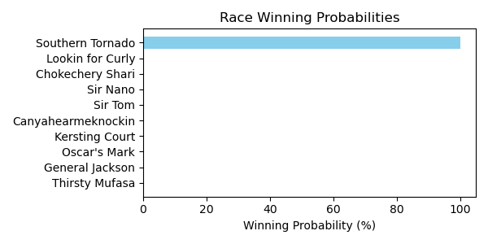

Figure: Winning Probability Distribution

NOTE: THIS RACE HAS HORSES THAT ARE MISSING CRITICAL DATA ELEMENTS

# Race: TSA | 2025-02-23 | Race #6 | Track: SANTA ANITA PARK

Track: SANTA ANITA PARK

|  |  |  |  |  |
| --- | --- | --- | --- | --- |
| Saddle Cloth # | Horse Name | Global Speed | Composite | Win Prob (%) |
| ['', 3, ''] | Nepal | 124.5 | 4.32 | 97.49 |
| ['', 4, ''] | Butterfly Beach * | 112.6 | -5.31 | 0.00 |
| ['', 7, ''] | Lava Lucy | 103.3 | 5.04 | 2.51 |
| ['', 8, ''] | Go Cami Oh | 105.8 | -4.78 | 0.00 |

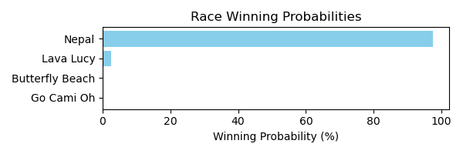

Figure: Winning Probability Distribution

NOTE: THIS RACE HAS HORSES THAT ARE MISSING CRITICAL DATA ELEMENTS

# Race: TSA | 2025-02-23 | Race #7 | Track: SANTA ANITA PARK

Track: SANTA ANITA PARK

|  |  |  |  |  |
| --- | --- | --- | --- | --- |
| Saddle Cloth # | Horse Name | Global Speed | Composite | Win Prob (%) |
| ['', 1, ''] | Rogue Son | 131.8 | 3.98 | 4.13 |
| ['', 2, ''] | Carol's Comic | 140.4 | 4.51 | 35.11 |
| ['', 3, ''] | Haywood | 40.1 | -7.61 | 0.00 |
| ['', 4, ''] | Prince Prancealot | 48.3 | -7.51 | 0.00 |
| ['', 5, ''] | Immelmann | 77.6 | -9.36 | 0.00 |
| ['', 6, ''] | Navy Man | 86.5 | -6.93 | 0.00 |
| ['', 7, ''] | Adios Nicanor * | 95.7 | 6.37 | 0.02 |
| ['', 8, ''] | Blue Cheese Olive | 45.5 | -6.57 | 0.00 |
| ['', 9, ''] | Magic Account | 140.4 | 5.19 | 60.66 |
| ['', 10, ''] | Man Child | 116.6 | 2.95 | 0.09 |
| ['', 11, ''] | Tequila Talkin | 40.4 | -7.51 | 0.00 |

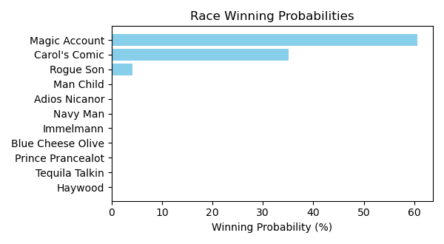

Figure: Winning Probability Distribution

NOTE: THIS RACE HAS HORSES THAT ARE MISSING CRITICAL DATA ELEMENTS

# Race: TSA | 2025-02-23 | Race #8 | Track: SANTA ANITA PARK

Track: SANTA ANITA PARK

|  |  |  |  |  |
| --- | --- | --- | --- | --- |
| Saddle Cloth # | Horse Name | Global Speed | Composite | Win Prob (%) |
| ['', 1, ''] | Count of Amazonia (IRE) | 131.2 | 2.32 | 0.50 |
| ['', 2, ''] | Hacking It Up | 63.6 | -7.29 | 0.00 |
| ['', 3, ''] | Thirty Four Coupe | 135.9 | 5.57 | 17.18 |
| ['', 4, ''] | Doncic | 71.1 | -5.86 | 0.00 |
| ['', 5, ''] | Jetovator | 137.8 | 3.40 | 4.43 |
| ['', 6, ''] | My Summer Dream | 116.7 | 2.30 | 0.03 |
| ['', 7, ''] | Moody Jim (IRE) | 122.8 | 3.07 | 0.17 |
| ['', 8, ''] | Nero Tulip (GB) | 72.5 | -7.47 | 0.00 |
| ['', 9, ''] | Don't Swear Dave | 116.6 | 2.39 | 0.03 |
| ['', 10, ''] | Devil Be Me | 147.6 | 4.53 | 77.67 |

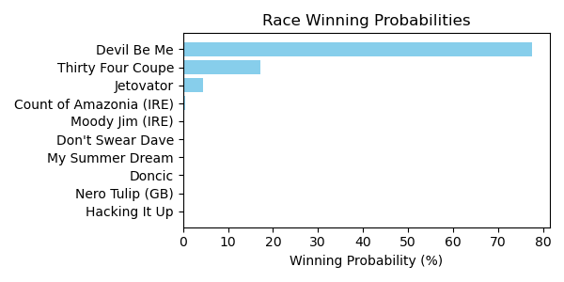

Figure: Winning Probability Distribution

NOTE: THIS RACE HAS HORSES THAT ARE MISSING CRITICAL DATA ELEMENTS

# Race: TSA | 2025-02-23 | Race #9 | Track: SANTA ANITA PARK

Track: SANTA ANITA PARK

|  |  |  |  |  |
| --- | --- | --- | --- | --- |
| Saddle Cloth # | Horse Name | Global Speed | Composite | Win Prob (%) |
| ['', 1, ''] | Tizzy Twister | 40.9 | -8.11 | 0.00 |
| ['', 2, ''] | Mayacama | 148.1 | 5.93 | 45.95 |
| ['', 3, ''] | Lady Maryann | 100.9 | -4.20 | 0.00 |
| ['', 4, ''] | Stop Digging | 118.5 | -0.42 | 0.00 |
| ['', 5, ''] | Dorie Miller | 86.4 | 8.70 | 0.00 |
| ['', 6, ''] | Sand to Sea | 63.0 | -7.96 | 0.00 |
| ['', 7, ''] | Stellar Cap | 133.5 | 1.45 | 0.07 |
| ['', 8, ''] | Eltonsingsanother | 117.2 | 2.38 | 0.01 |
| ['', 9, ''] | Wishes to Riches | 138.0 | 5.56 | 4.57 |
| ['', 10, ''] | Sharp Ride | 146.3 | 5.96 | 33.35 |
| ['', 11, ''] | Jersey Sunset | 41.0 | -7.54 | 0.00 |
| ['', 12, ''] | Chasing Kat | 142.0 | 6.14 | 16.05 |

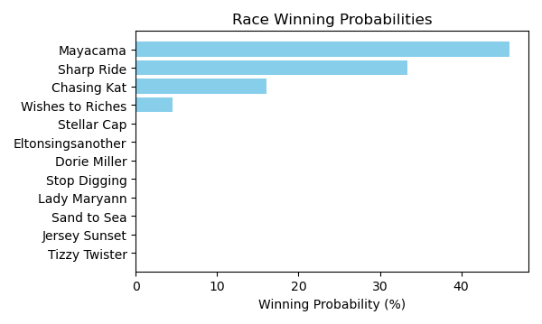

Figure: Winning Probability Distribution

NOTE: THIS RACE HAS HORSES THAT ARE MISSING CRITICAL DATA ELEMENTS

# Race: TSA | 2025-02-23 | Race #10 | Track: SANTA ANITA PARK

Track: SANTA ANITA PARK

|  |  |  |  |  |
| --- | --- | --- | --- | --- |
| Saddle Cloth # | Horse Name | Global Speed | Composite | Win Prob (%) |
| ['', 1, ''] | Brazenly | 120.3 | 3.94 | 0.31 |
| ['', 2, ''] | D D S Express | 112.9 | 1.54 | 0.01 |
| ['', 3, ''] | Keep Movin' On | 82.9 | -4.91 | 0.00 |
| ['', 4, ''] | Touchdown Brown | 140.1 | 4.36 | 22.25 |
| ['', 5, ''] | Investalot | 129.3 | 5.62 | 7.06 |
| ['', 6, ''] | Fly the Sky | 100.0 | -5.92 | 0.00 |
| ['', 7, ''] | Moogie Son | 96.5 | -6.06 | 0.00 |
| ['', 8, ''] | Silent Heat | 45.0 | -7.65 | 0.00 |
| ['', 9, ''] | Rodrigoknows | 97.7 | -5.53 | 0.00 |
| ['', 10, ''] | Speed Grazy | 139.1 | 6.05 | 70.37 |
| ['', 11, ''] | Cousin Richie | 117.2 | -1.10 | 0.00 |

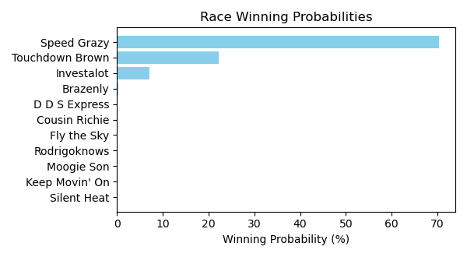

Figure: Winning Probability Distribution

NOTE: THIS RACE HAS HORSES THAT ARE MISSING CRITICAL DATA ELEMENTS

# Race: TAM | 2025-02-23 | Race #1 | Track: TAMPA BAY DOWNS

Track: TAMPA BAY DOWNS

|  |  |  |  |  |
| --- | --- | --- | --- | --- |
| Saddle Cloth # | Horse Name | Global Speed | Composite | Win Prob (%) |
| ['', 1, ''] | Starship Augusto | 51.2 | -8.47 | 0.00 |
| ['', 2, ''] | Class of Sixty Two | 46.4 | -8.24 | 0.00 |
| ['', 3, ''] | Vittoriano | 46.0 | -7.91 | 0.00 |
| ['', 4, ''] | Can't Jump | 46.4 | -8.75 | 0.00 |
| ['', 5, ''] | Westdakota | 64.9 | -6.04 | 0.00 |
| ['', 6, ''] | Lyla's Lucky Boy | 44.7 | -8.11 | 0.00 |
| ['', 7, ''] | Iconic Rock | 134.1 | 4.59 | 56.62 |
| ['', 8, ''] | Eternal Glory | 81.9 | -2.42 | 0.00 |
| ['', 9, ''] | Admiral Curl | 93.4 | -2.45 | 0.00 |
| ['', 10, ''] | Bivol | 127.8 | 5.84 | 43.34 |
| ['', 11, ''] | Right On Target | 116.0 | 0.11 | 0.04 |
| ['', 12, ''] | Air Force Royalty | 91.2 | -5.77 | 0.00 |
| ['', 13, ''] | My Right Hand | 40.2 | -8.20 | 0.00 |

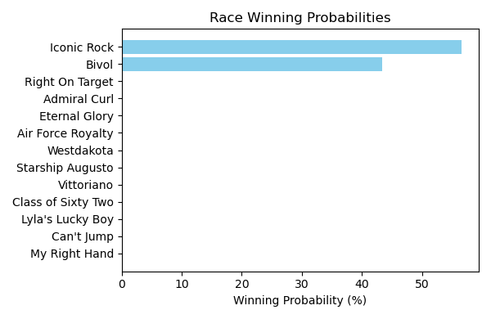

Figure: Winning Probability Distribution

NOTE: THIS RACE HAS HORSES THAT ARE MISSING CRITICAL DATA ELEMENTS

# Race: TAM | 2025-02-23 | Race #2 | Track: TAMPA BAY DOWNS

Track: TAMPA BAY DOWNS

|  |  |  |  |  |
| --- | --- | --- | --- | --- |
| Saddle Cloth # | Horse Name | Global Speed | Composite | Win Prob (%) |
| ['', 1, ''] | Cloud Storage | 132.1 | 5.05 | 6.59 |
| ['', 2, ''] | Chem Major | 88.0 | 1.78 | 0.00 |
| ['', 3, ''] | Twizzle | 140.4 | 5.56 | 52.86 |
| ['', 4, ''] | Happy Ride | 52.9 | -5.76 | 0.00 |
| ['', 5, ''] | Aferdita | 137.3 | 5.82 | 34.64 |
| ['', 6, ''] | Wheelingndealing | 118.2 | 2.32 | 0.05 |
| ['', 7, ''] | Pretty'n Awesome | 135.8 | 3.63 | 4.47 |
| ['', 8, ''] | Practicality | 127.3 | 4.31 | 1.39 |

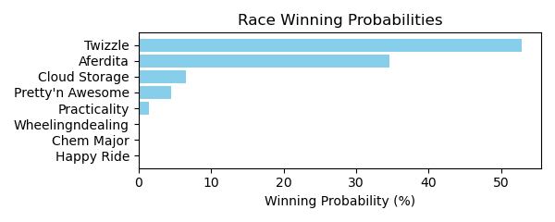

Figure: Winning Probability Distribution

NOTE: THIS RACE HAS HORSES THAT ARE MISSING CRITICAL DATA ELEMENTS

# Race: TAM | 2025-02-23 | Race #3 | Track: TAMPA BAY DOWNS

Track: TAMPA BAY DOWNS

|  |  |  |  |  |
| --- | --- | --- | --- | --- |
| Saddle Cloth # | Horse Name | Global Speed | Composite | Win Prob (%) |
| ['', 1, ''] | Mamas Lullabye | 112.6 | 1.38 | 0.01 |
| ['', 2, ''] | Son of a Slew | 120.3 | 1.31 | 0.03 |
| ['', 3, ''] | Dunkin' Run | 144.9 | 5.20 | 99.96 |
| ['', 6, ''] | Smeauxkinitup | 56.4 | -8.34 | 0.00 |
| ['', 7, ''] | Arrow Ghost | 51.3 | -8.00 | 0.00 |

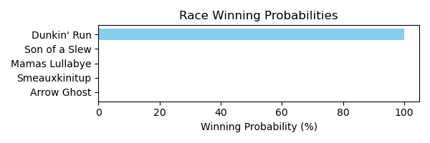

Figure: Winning Probability Distribution

NOTE: THIS RACE HAS HORSES THAT ARE MISSING CRITICAL DATA ELEMENTS

# Race: TAM | 2025-02-23 | Race #4 | Track: TAMPA BAY DOWNS

Track: TAMPA BAY DOWNS

|  |  |  |  |  |
| --- | --- | --- | --- | --- |
| Saddle Cloth # | Horse Name | Global Speed | Composite | Win Prob (%) |
| ['', 1, ''] | Endrick | 77.5 | 4.53 | 0.00 |
| ['', 2, ''] | God With Us | 120.8 | 4.72 | 0.35 |
| ['', 3, ''] | K Paz | 144.3 | 5.36 | 64.79 |
| ['', 4, ''] | Lou Man | 136.2 | 6.61 | 34.86 |
| ['', 5, ''] | He's Side Eyed | 105.3 | 2.79 | 0.00 |
| ['', 6, ''] | Spice Bag | 89.0 | -5.83 | 0.00 |
| ['', 7, ''] | El Dollar | 43.5 | -8.22 | 0.00 |

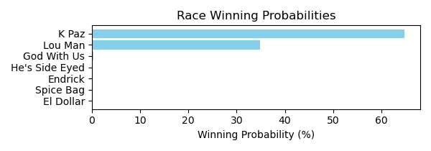

Figure: Winning Probability Distribution

NOTE: THIS RACE HAS HORSES THAT ARE MISSING CRITICAL DATA ELEMENTS

# Race: TAM | 2025-02-23 | Race #5 | Track: TAMPA BAY DOWNS

Track: TAMPA BAY DOWNS

|  |  |  |  |  |
| --- | --- | --- | --- | --- |
| Saddle Cloth # | Horse Name | Global Speed | Composite | Win Prob (%) |
| ['', 1, ''] | Ambulante | 73.7 | -3.92 | 0.00 |
| ['', 2, ''] | Russian Hammer | 122.2 | 2.05 | 0.18 |
| ['', 3, ''] | Maclin | 64.8 | -7.14 | 0.00 |
| ['', 4, ''] | Kalinba | 104.3 | -3.10 | 0.00 |
| ['', 5, ''] | Zingales King | 128.7 | 5.16 | 7.67 |
| ['', 6, ''] | Federal Exchange | 135.4 | 0.76 | 0.88 |
| ['', 7, ''] | Hakkimi (CHI) | 77.5 | -7.43 | 0.00 |
| ['', 8, ''] | Walt Whitman (IRE) | 140.8 | 5.12 | 83.26 |
| ['', 9, ''] | D Coldest | 93.0 | -2.08 | 0.00 |
| ['', 10, ''] | Sir Robert Hall | 40.0 | -7.35 | 0.00 |
| ['', 11, ''] | Mr Jack | 135.6 | 3.49 | 8.02 |
| ['', 12, ''] | Suit Me Up Charlie | 92.7 | -5.88 | 0.00 |
| ['', 13, ''] | Hay Moon | 60.7 | -7.95 | 0.00 |

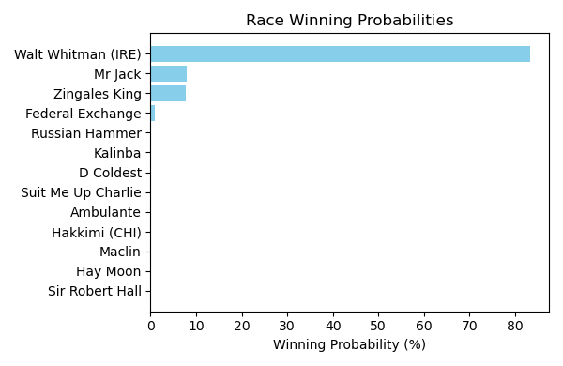

Figure: Winning Probability Distribution

NOTE: THIS RACE HAS HORSES THAT ARE MISSING CRITICAL DATA ELEMENTS

# Race: TAM | 2025-02-23 | Race #6 | Track: TAMPA BAY DOWNS

Track: TAMPA BAY DOWNS

|  |  |  |  |  |
| --- | --- | --- | --- | --- |
| Saddle Cloth # | Horse Name | Global Speed | Composite | Win Prob (%) |
| ['', 1, ''] | Bomb Cyclone | 134.2 | 5.45 | 11.48 |
| ['', 2, ''] | Max Swagger | 53.4 | -8.31 | 0.00 |
| ['', 3, ''] | Attrayant | 52.8 | -7.85 | 0.00 |
| ['', 4, ''] | Noble Star | 83.8 | -6.27 | 0.00 |
| ['', 5, ''] | Mungo | 134.9 | 6.55 | 31.80 |
| ['', 6, ''] | Ready to Reign | 79.4 | -7.30 | 0.00 |
| ['', 7, ''] | Mission Mike | 127.0 | 5.65 | 3.18 |
| ['', 8, ''] | Swen | 62.1 | -5.75 | 0.00 |
| ['', 9, ''] | Rough and Rowdy | 95.7 | -9.06 | 0.00 |
| ['', 10, ''] | Chenti | 112.1 | -4.07 | 0.00 |
| ['', 11, ''] | Micro Brewsky | 101.5 | -3.01 | 0.00 |
| ['', 12, ''] | Officer Derick | 124.8 | 1.83 | 0.10 |
| ['', 13, ''] | Adios Buccaneer | 139.5 | 5.96 | 49.73 |
| ['', 14, ''] | Immense Faith | 136.5 | 3.47 | 3.72 |

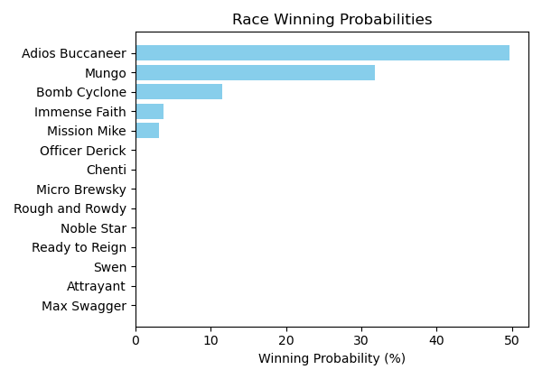

Figure: Winning Probability Distribution

NOTE: THIS RACE HAS HORSES THAT ARE MISSING CRITICAL DATA ELEMENTS

# Race: TAM | 2025-02-23 | Race #7 | Track: TAMPA BAY DOWNS

Track: TAMPA BAY DOWNS

|  |  |  |  |  |
| --- | --- | --- | --- | --- |
| Saddle Cloth # | Horse Name | Global Speed | Composite | Win Prob (%) |
| ['', 1, ''] | Big Toby | 45.0 | -8.00 | 0.00 |
| ['', 2, ''] | Tiz Lord | 102.5 | -3.59 | 0.00 |
| ['', 3, ''] | Jades Jay | 123.4 | 0.13 | 0.69 |
| ['', 4, ''] | Gucci Boy | 78.5 | -4.26 | 0.00 |
| ['', 5, ''] | Sincerito | 139.7 | 2.11 | 86.89 |
| ['', 6, ''] | Kohaku | 56.8 | -8.45 | 0.00 |
| ['', 7, ''] | Dontbesoogrouchy | 104.8 | -0.08 | 0.01 |
| ['', 8, ''] | Art Handler | 82.7 | -5.70 | 0.00 |
| ['', 9, ''] | Diamond Messa | 131.5 | -0.24 | 2.59 |
| ['', 10, ''] | Bang a Rang | 126.9 | 2.15 | 6.96 |
| ['', 11, ''] | No Problem Joe | 129.2 | 0.03 | 2.01 |
| ['', 12, ''] | Changeordersonny | 88.5 | -0.55 | 0.00 |
| ['', 13, ''] | Commander Biz | 44.0 | -8.85 | 0.00 |
| ['', 14, ''] | Awesome Entry | 120.4 | 1.15 | 0.85 |

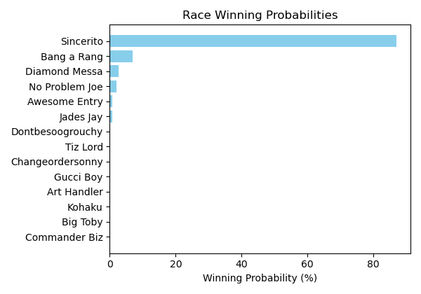

Figure: Winning Probability Distribution

NOTE: THIS RACE HAS HORSES THAT ARE MISSING CRITICAL DATA ELEMENTS

# Race: TAM | 2025-02-23 | Race #8 | Track: TAMPA BAY DOWNS

Track: TAMPA BAY DOWNS

|  |  |  |  |  |
| --- | --- | --- | --- | --- |
| Saddle Cloth # | Horse Name | Global Speed | Composite | Win Prob (%) |
| ['', 1, ''] | Initforthelove | 147.5 | 5.04 | 39.06 |
| ['', 2, ''] | The Best Distance | 68.4 | -7.56 | 0.00 |
| ['', 3, ''] | Cattin | 134.7 | 5.88 | 5.97 |
| ['', 4, ''] | Camino de Santiago | 89.3 | -6.05 | 0.00 |
| ['', 5, ''] | Dear Santa | 102.4 | 1.51 | 0.00 |
| ['', 6, ''] | Lookin to Excel | 41.1 | -7.87 | 0.00 |
| ['', 7, ''] | Lord Knows | 112.0 | 1.24 | 0.00 |
| ['', 8, ''] | Policy Option | 118.2 | 0.16 | 0.00 |
| ['', 9, ''] | Justintimeforwine | 92.7 | -5.91 | 0.00 |
| ['', 10, ''] | Action Seeker | 117.6 | 4.05 | 0.04 |
| ['', 11, ''] | In Honor of Artie | 102.9 | -0.64 | 0.00 |
| ['', 12, ''] | It's a Fact | 135.3 | 2.57 | 0.47 |
| ['', 13, ''] | Style Me Royal | 144.4 | 6.22 | 54.45 |
| ['', 14, ''] | Silent and Violent | 61.6 | -6.48 | 0.00 |

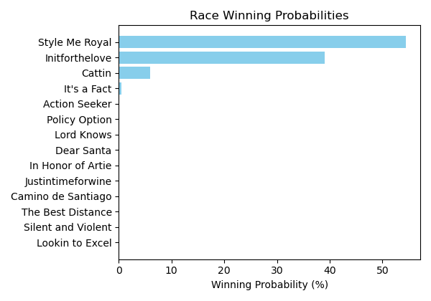

Figure: Winning Probability Distribution

NOTE: THIS RACE HAS HORSES THAT ARE MISSING CRITICAL DATA ELEMENTS

# Race: TAM | 2025-02-23 | Race #9 | Track: TAMPA BAY DOWNS

Track: TAMPA BAY DOWNS

|  |  |  |  |  |
| --- | --- | --- | --- | --- |
| Saddle Cloth # | Horse Name | Global Speed | Composite | Win Prob (%) |
| ['', 1, ''] | Flipping Fish | 137.5 | 4.13 | 85.85 |
| ['', 2, ''] | Talkscheap | 58.4 | -6.67 | 0.00 |
| ['', 3, ''] | Thrill of It | 71.5 | -6.70 | 0.00 |
| ['', 4, ''] | Catire Vizcaya | 113.8 | 0.29 | 0.03 |
| ['', 5, ''] | Electric Eel | 65.5 | -8.13 | 0.00 |
| ['', 6, ''] | Private Desire | 99.6 | -2.59 | 0.00 |
| ['', 7, ''] | Suncroft | 42.2 | -6.20 | 0.00 |
| ['', 8, ''] | Impacto | 116.4 | 0.61 | 0.07 |
| ['', 9, ''] | Timeless Bounty | 128.5 | 4.14 | 14.04 |

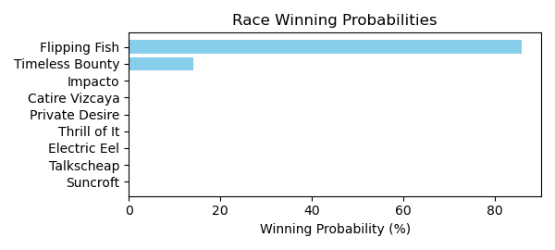

Figure: Winning Probability Distribution

NOTE: THIS RACE HAS HORSES THAT ARE MISSING CRITICAL DATA ELEMENTS

# Race: TAM | 2025-02-23 | Race #10 | Track: TAMPA BAY DOWNS

Track: TAMPA BAY DOWNS

|  |  |  |  |  |
| --- | --- | --- | --- | --- |
| Saddle Cloth # | Horse Name | Global Speed | Composite | Win Prob (%) |
| ['', 1, ''] | Real Mikey | 131.5 | 3.31 | 0.68 |
| ['', 2, ''] | Postino's Prophecy | 40.7 | -8.23 | 0.00 |
| ['', 3, ''] | My Jannet | 41.1 | -7.83 | 0.00 |
| ['', 4, ''] | World Traveler | 126.9 | 3.03 | 0.22 |
| ['', 5, ''] | Jassai | 131.8 | 2.18 | 0.29 |
| ['', 6, ''] | Girly the Butcher | 129.1 | 5.54 | 2.55 |
| ['', 7, ''] | Heartburn | 41.6 | -8.22 | 0.00 |
| ['', 8, ''] | Sadie Baby | 111.2 | 0.56 | 0.00 |
| ['', 9, ''] | Pure Magic Girl | 136.7 | 1.95 | 0.66 |
| ['', 10, ''] | Chilling Factor | 108.3 | -0.40 | 0.00 |
| ['', 11, ''] | Armonia | 121.1 | 4.90 | 0.31 |
| ['', 12, ''] | Vino Veloce | 74.6 | 3.46 | 0.00 |
| ['', 13, ''] | Ladys Chant | 144.1 | 6.34 | 95.28 |
| ['', 14, ''] | Lizqueenfluerdelis | 61.4 | -8.22 | 0.00 |

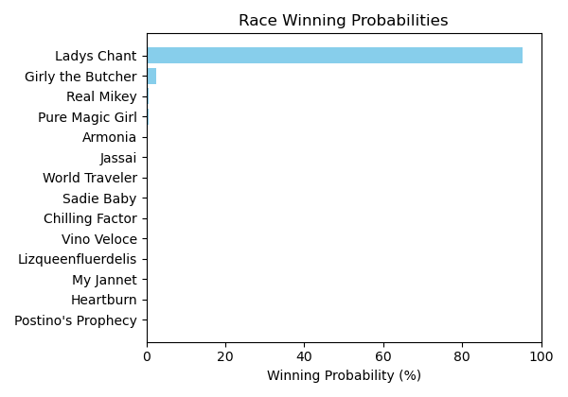

Figure: Winning Probability Distribution

NOTE: THIS RACE HAS HORSES THAT ARE MISSING CRITICAL DATA ELEMENTS

# Race: TTP | 2025-02-23 | Race #1 | Track: TURFWAY PARK

Track: TURFWAY PARK

|  |  |  |  |  |
| --- | --- | --- | --- | --- |
| Saddle Cloth # | Horse Name | Global Speed | Composite | Win Prob (%) |
| ['', 1, ''] | Miss Moon Pie | 44.7 | -8.36 | 0.00 |
| ['', 2, ''] | Isa Lei | 144.1 | 6.16 | 80.69 |
| ['', 3, ''] | Endless | 80.4 | -5.80 | 0.00 |
| ['', 4, ''] | Lucky Ana | 140.2 | 4.68 | 11.29 |
| ['', 5, ''] | Gogo Chanel | 119.7 | 5.64 | 0.40 |
| ['', 6, ''] | Cant Keep Me Down | 145.0 | -0.47 | 0.48 |
| ['', 7, ''] | Councilwoman Jilly | 136.9 | 4.92 | 7.13 |
| ['', 8, ''] | Megan's Noel | 75.6 | -7.32 | 0.00 |

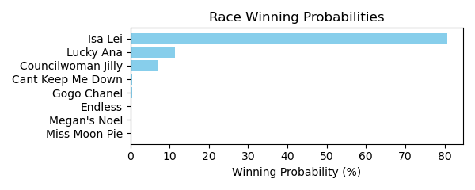

Figure: Winning Probability Distribution

NOTE: THIS RACE HAS HORSES THAT ARE MISSING CRITICAL DATA ELEMENTS

# Race: TTP | 2025-02-23 | Race #2 | Track: TURFWAY PARK

Track: TURFWAY PARK

|  |  |  |  |  |
| --- | --- | --- | --- | --- |
| Saddle Cloth # | Horse Name | Global Speed | Composite | Win Prob (%) |
| ['', 1, ''] | J W Ruckus | 107.3 | 0.64 | 0.00 |
| ['', 2, ''] | Cog | 148.8 | 4.80 | 89.86 |
| ['', 3, ''] | Violin Maker | 62.3 | -6.51 | 0.00 |
| ['', 4, ''] | Buzzer | 40.1 | -7.98 | 0.00 |
| ['', 5, ''] | Dragon Drew | 134.3 | 2.53 | 0.79 |
| ['', 6, ''] | Ready Pursuit | 104.5 | -2.45 | 0.00 |
| ['', 7, ''] | All in Sync | 116.9 | -0.15 | 0.00 |
| ['', 8, ''] | One for Richie | 140.1 | 4.17 | 9.35 |

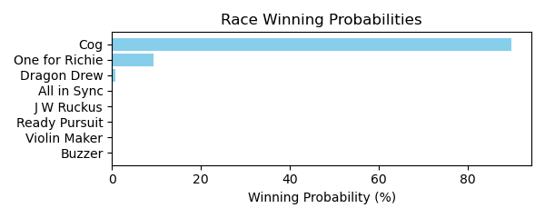

Figure: Winning Probability Distribution

NOTE: THIS RACE HAS HORSES THAT ARE MISSING CRITICAL DATA ELEMENTS

# Race: TTP | 2025-02-23 | Race #3 | Track: TURFWAY PARK

Track: TURFWAY PARK

|  |  |  |  |  |
| --- | --- | --- | --- | --- |
| Saddle Cloth # | Horse Name | Global Speed | Composite | Win Prob (%) |
| ['', 1, ''] | Tiger's Legacy | 149.2 | 3.49 | 15.10 |
| ['', 2, ''] | Script | 144.9 | 5.63 | 35.71 |
| ['', 3, ''] | Sigiloso | 131.2 | 4.17 | 0.71 |
| ['', 4, ''] | Big Hat Willie | 54.5 | -7.18 | 0.00 |
| ['', 5, ''] | Alder | 47.0 | -8.17 | 0.00 |
| ['', 6, ''] | Night Time | 146.1 | 4.69 | 21.34 |
| ['', 7, ''] | Lugan Knight | 141.1 | 1.90 | 0.83 |
| ['', 8, ''] | Simcoe | 147.0 | 4.74 | 26.29 |

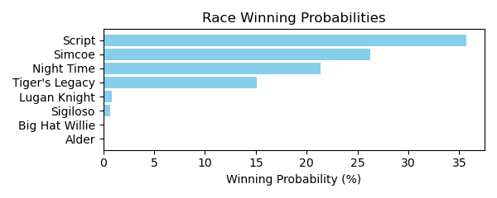

Figure: Winning Probability Distribution

NOTE: THIS RACE HAS HORSES THAT ARE MISSING CRITICAL DATA ELEMENTS

# Race: TTP | 2025-02-23 | Race #4 | Track: TURFWAY PARK

Track: TURFWAY PARK

|  |  |  |  |  |
| --- | --- | --- | --- | --- |
| Saddle Cloth # | Horse Name | Global Speed | Composite | Win Prob (%) |
| ['', 1, ''] | Dark Fury | 89.5 | -5.97 | 0.00 |
| ['', 2, ''] | Indescriptable | 50.6 | -8.12 | 0.00 |
| ['', 3, ''] | Tennesseehoneybee | 48.1 | -8.43 | 0.00 |
| ['', 4, ''] | Meet in Secret | 65.4 | -7.48 | 0.00 |
| ['', 5, ''] | Bellofthebluegrass | 43.7 | -8.29 | 0.00 |
| ['', 6, ''] | Sally's Gold | 146.5 | 6.24 | 86.56 |
| ['', 7, ''] | Yuma's Shadow | 132.6 | 7.18 | 11.45 |
| ['', 8, ''] | I'm a Cookie Lover | 136.7 | 2.68 | 0.71 |
| ['', 9, ''] | Red Hot Jeanie | 77.9 | -7.72 | 0.00 |
| ['', 10, ''] | Foolish | 108.6 | 0.88 | 0.00 |
| ['', 11, ''] | Elle's Dancer | 138.3 | 3.00 | 1.28 |
| ['', 12, ''] | Wanda Susie Doozy | 76.9 | -5.82 | 0.00 |
| ['', 13, ''] | Carolina Candy | 44.9 | -8.24 | 0.00 |

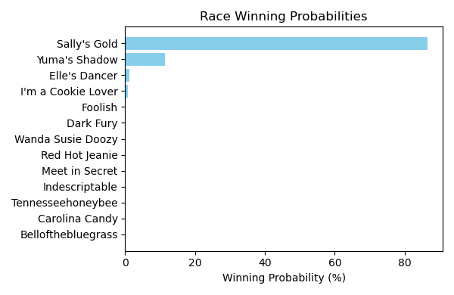

Figure: Winning Probability Distribution

NOTE: THIS RACE HAS HORSES THAT ARE MISSING CRITICAL DATA ELEMENTS

# Race: TTP | 2025-02-23 | Race #5 | Track: TURFWAY PARK

Track: TURFWAY PARK

|  |  |  |  |  |
| --- | --- | --- | --- | --- |
| Saddle Cloth # | Horse Name | Global Speed | Composite | Win Prob (%) |
| ['', 2, ''] | Don't Cross Alexis * | 148.5 | 6.23 | 91.97 |
| ['', 4, ''] | Super Maxima | 69.5 | -6.78 | 0.00 |
| ['', 5, ''] | Bonita Vida * | 128.2 | -6.44 | 0.00 |
| ['', 6, ''] | Dang It Ophelia * | 115.3 | 4.92 | 0.04 |
| ['', 7, ''] | Sister Carlie * | 96.3 | -7.03 | 0.00 |
| ['', 8, ''] | M'Lady Sansa | 89.9 | -5.07 | 0.00 |
| ['', 9, ''] | Pretty in Pearls | 128.6 | -2.50 | 0.00 |
| ['', 10, ''] | People Get Ready * | 135.3 | 6.48 | 7.97 |
| ['', 12, ''] | Her Holy Name | 135.2 | -1.21 | 0.02 |
| ['', 13, ''] | Pearl Magic * | 84.4 | -7.62 | 0.00 |
| ['', 14, ''] | Stopsprettyplaces * | 41.2 | -8.57 | 0.00 |

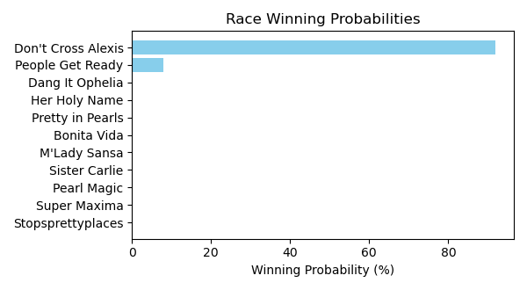

Figure: Winning Probability Distribution

NOTE: THIS RACE HAS HORSES THAT ARE MISSING CRITICAL DATA ELEMENTS

# Race: TTP | 2025-02-23 | Race #6 | Track: TURFWAY PARK

Track: TURFWAY PARK

|  |  |  |  |  |
| --- | --- | --- | --- | --- |
| Saddle Cloth # | Horse Name | Global Speed | Composite | Win Prob (%) |
| ['', 1, ''] | Match Five | 57.5 | -8.06 | 0.00 |
| ['', 2, ''] | Lalily | 81.4 | -7.40 | 0.00 |
| ['', 3, ''] | Waitinbythenile | 107.2 | -4.62 | 0.00 |
| ['', 4, ''] | Statler Inn | 126.9 | 5.69 | 99.99 |
| ['', 6, ''] | You Know Me | 101.4 | -0.46 | 0.00 |
| ['', 7, ''] | Make a Million | 70.1 | 4.35 | 0.00 |
| ['', 8, ''] | Warm Days | 50.0 | -8.00 | 0.00 |

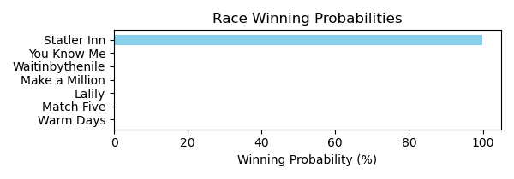

Figure: Winning Probability Distribution

NOTE: THIS RACE HAS HORSES THAT ARE MISSING CRITICAL DATA ELEMENTS

# Race: TTP | 2025-02-23 | Race #7 | Track: TURFWAY PARK

Track: TURFWAY PARK

|  |  |  |  |  |
| --- | --- | --- | --- | --- |
| Saddle Cloth # | Horse Name | Global Speed | Composite | Win Prob (%) |
| ['', 1, ''] | Epic Ride | 149.2 | 2.58 | 45.01 |
| ['', 2, ''] | B D Valeski | 144.7 | 1.53 | 7.83 |
| ['', 3, ''] | Hedwig | 87.9 | -6.55 | 0.00 |
| ['', 4, ''] | Mischievous Rogue | 144.0 | 3.39 | 30.21 |
| ['', 5, ''] | Clear the Air | 78.9 | -5.55 | 0.00 |
| ['', 6, ''] | Let My People Go | 94.1 | -5.37 | 0.00 |
| ['', 7, ''] | Transect | 42.4 | -7.22 | 0.00 |
| ['', 8, ''] | Okiro | 91.6 | -5.21 | 0.00 |
| ['', 9, ''] | Surly Furious | 138.3 | 4.09 | 16.95 |

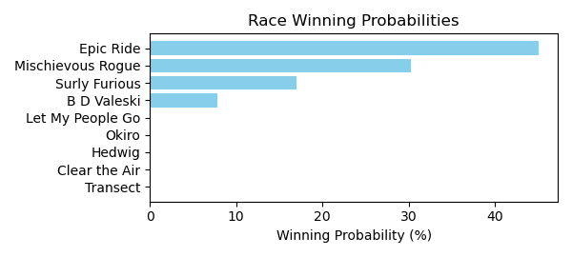

Figure: Winning Probability Distribution

NOTE: THIS RACE HAS HORSES THAT ARE MISSING CRITICAL DATA ELEMENTS

# Race: TTP | 2025-02-23 | Race #8 | Track: TURFWAY PARK

Track: TURFWAY PARK

|  |  |  |  |  |
| --- | --- | --- | --- | --- |
| Saddle Cloth # | Horse Name | Global Speed | Composite | Win Prob (%) |
| ['', 1, ''] | Berea | 83.7 | -7.55 | 0.00 |
| ['', 2, ''] | Cleomenes | 76.9 | -10.58 | 0.00 |
| ['', 3, ''] | Ligeia * | 115.5 | -1.57 | 0.00 |
| ['', 4, ''] | dh-Terpeye * | 77.1 | 1.41 | 0.00 |
| ['', 5, ''] | Sassy and Bold | 143.1 | 3.45 | 8.14 |
| ['', 6, ''] | Fireside Kitten | 60.7 | -8.18 | 0.00 |
| ['', 7, ''] | Bo Runkle * | 76.0 | 5.58 | 0.00 |
| ['', 8, ''] | Taking Charge Desi | 137.1 | 2.08 | 0.83 |
| ['', 9, ''] | Partake | 133.1 | 5.11 | 4.16 |
| ['', 10, ''] | Rock the Nile | 143.9 | 6.19 | 86.86 |

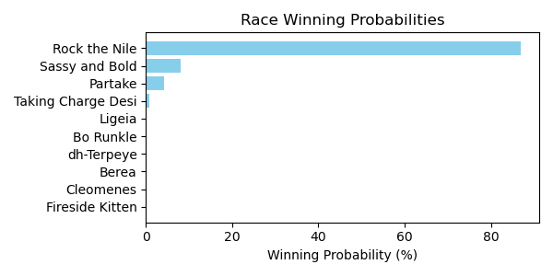

Figure: Winning Probability Distribution

NOTE: THIS RACE HAS HORSES THAT ARE MISSING CRITICAL DATA ELEMENTS

# Race: TTP | 2025-02-23 | Race #9 | Track: TURFWAY PARK

Track: TURFWAY PARK

|  |  |  |  |  |
| --- | --- | --- | --- | --- |
| Saddle Cloth # | Horse Name | Global Speed | Composite | Win Prob (%) |
| ['', 2, ''] | Kicking Clear | 98.9 | -4.36 | 0.00 |
| ['', 3, ''] | Aqueous * | 45.6 | -7.43 | 0.00 |
| ['', 4, ''] | Midnight Vengeance | 141.3 | 4.95 | 7.27 |
| ['', 5, ''] | Stargell | 117.8 | -2.66 | 0.00 |
| ['', 7, ''] | Fletcher Bay * | 65.3 | -7.72 | 0.00 |
| ['', 8, ''] | Outofpi | 62.5 | -7.81 | 0.00 |
| ['', 9, ''] | Shinigami | 42.9 | -7.84 | 0.00 |
| ['', 10, ''] | Mubarez | 69.6 | -6.72 | 0.00 |
| ['', 11, ''] | Roc and Ready Jo * | 149.8 | -8.09 | 0.00 |
| ['', 12, ''] | Sinister Smile | 148.3 | 6.38 | 92.73 |

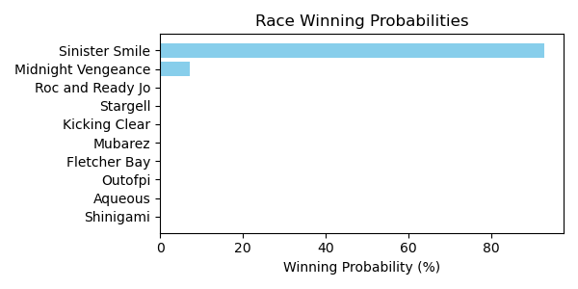

Figure: Winning Probability Distribution

NOTE: THIS RACE HAS HORSES THAT ARE MISSING CRITICAL DATA ELEMENTS

# Race: TTP | 2025-02-23 | Race #10 | Track: TURFWAY PARK

Track: TURFWAY PARK

|  |  |  |  |  |
| --- | --- | --- | --- | --- |
| Saddle Cloth # | Horse Name | Global Speed | Composite | Win Prob (%) |
| ['', 1, ''] | Egyptian King | 130.6 | 5.10 | 1.51 |
| ['', 2, ''] | Dancing Noah | 137.3 | 4.21 | 2.82 |
| ['', 3, ''] | Kykeon | 71.7 | -6.01 | 0.00 |
| ['', 4, ''] | Shiesty to Chase | 87.8 | -3.50 | 0.00 |
| ['', 5, ''] | Acting Debut | 119.1 | 1.35 | 0.01 |
| ['', 6, ''] | King Deivys | 136.9 | 3.83 | 1.94 |
| ['', 7, ''] | Righteous Star | 99.4 | -4.13 | 0.00 |
| ['', 8, ''] | Oathbreaker | 141.8 | 7.46 | 93.68 |
| ['', 9, ''] | Roundball Rock | 123.5 | 2.35 | 0.04 |
| ['', 10, ''] | Carlin Clan | 86.0 | -4.54 | 0.00 |
| ['', 11, ''] | Redhill | 121.6 | -2.22 | 0.00 |
| ['', 12, ''] | Strike Price | 80.5 | -6.50 | 0.00 |

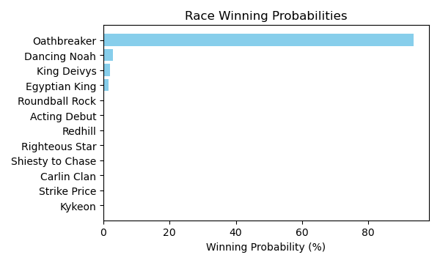

Figure: Winning Probability Distribution

NOTE: THIS RACE HAS HORSES THAT ARE MISSING CRITICAL DATA ELEMENTS

# Race: TTP | 2025-02-26 | Race #1 | Track: TURFWAY PARK

Track: TURFWAY PARK

|  |  |  |  |  |
| --- | --- | --- | --- | --- |
| Saddle Cloth # | Horse Name | Global Speed | Composite | Win Prob (%) |
| ['', 1, ''] | Myth Spun | 124.2 | 1.54 | 0.25 |
| ['', 2, ''] | Freedom Dreams | 134.5 | 6.41 | 96.49 |
| ['', 3, ''] | Liberation Day | 46.5 | -8.10 | 0.00 |
| ['', 4, ''] | Rabble | 108.1 | -2.96 | 0.00 |
| ['', 5, ''] | Baytown Storm | 120.8 | 1.33 | 0.11 |
| ['', 6, ''] | Lotta Lissa | 77.1 | -6.66 | 0.00 |
| ['', 7, ''] | Yourgloriousdaylis | 127.1 | 3.99 | 3.14 |
| ['', 8, ''] | Christina of Milan | 117.5 | 0.26 | 0.02 |
| ['', 9, ''] | Baytown Shinjuku | 68.5 | -5.91 | 0.00 |
| ['', 10, ''] | Berries and Cream | 40.9 | -8.14 | 0.00 |

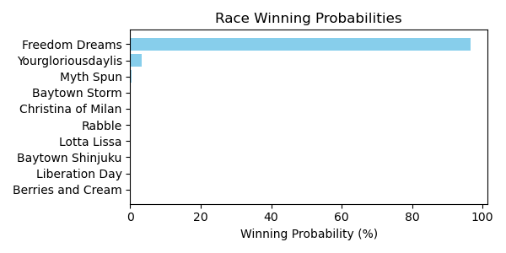

Figure: Winning Probability Distribution

NOTE: THIS RACE HAS HORSES THAT ARE MISSING CRITICAL DATA ELEMENTS

# Race: TTP | 2025-02-26 | Race #2 | Track: TURFWAY PARK

Track: TURFWAY PARK

|  |  |  |  |  |
| --- | --- | --- | --- | --- |
| Saddle Cloth # | Horse Name | Global Speed | Composite | Win Prob (%) |
| ['', 1, ''] | Spelled Well | 93.2 | -4.79 | 0.00 |
| ['', 2, ''] | Del Rayo | 143.2 | 4.76 | 30.07 |
| ['', 3, ''] | I Am the Game | 48.9 | -7.63 | 0.00 |
| ['', 4, ''] | Tony O | 85.4 | -0.50 | 0.00 |
| ['', 5, ''] | Shosha | 104.8 | -2.66 | 0.00 |
| ['', 6, ''] | One Last Bid | 143.2 | 4.99 | 35.80 |
| ['', 7, ''] | Favorite Haunt | 121.5 | -0.08 | 0.01 |
| ['', 8, ''] | Sixwillberich | 127.4 | 3.53 | 0.48 |
| ['', 9, ''] | Independent Paul | 142.6 | 5.07 | 33.65 |
| ['', 10, ''] | Cote d'Ivoire | 97.8 | -5.02 | 0.00 |

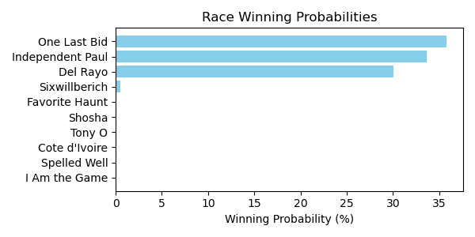

Figure: Winning Probability Distribution

NOTE: THIS RACE HAS HORSES THAT ARE MISSING CRITICAL DATA ELEMENTS

# Race: TTP | 2025-02-26 | Race #3 | Track: TURFWAY PARK

Track: TURFWAY PARK

|  |  |  |  |  |
| --- | --- | --- | --- | --- |
| Saddle Cloth # | Horse Name | Global Speed | Composite | Win Prob (%) |
| ['', 1, ''] | Janey Creed | 136.9 | 4.44 | 3.76 |
| ['', 2, ''] | Quadra Island | 138.9 | 3.35 | 2.34 |
| ['', 3, ''] | Bakwena | 98.3 | -2.16 | 0.00 |
| ['', 4, ''] | Wind Twist | 75.4 | -6.17 | 0.00 |
| ['', 5, ''] | Kissalot | 138.7 | 5.76 | 15.43 |
| ['', 6, ''] | Nyquick | 148.0 | 5.47 | 78.46 |
| ['', 7, ''] | Blue Nomore * | 77.9 | -1.06 | 0.00 |
| ['', 8, ''] | Lincoln Highway | 123.1 | -0.03 | 0.01 |
| ['', 9, ''] | Tatanka | 46.3 | -7.90 | 0.00 |

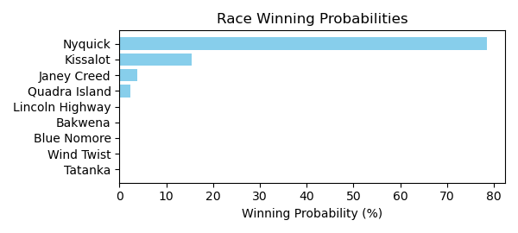

Figure: Winning Probability Distribution

NOTE: THIS RACE HAS HORSES THAT ARE MISSING CRITICAL DATA ELEMENTS

# Race: TTP | 2025-02-26 | Race #4 | Track: TURFWAY PARK

Track: TURFWAY PARK

|  |  |  |  |  |
| --- | --- | --- | --- | --- |
| Saddle Cloth # | Horse Name | Global Speed | Composite | Win Prob (%) |
| ['', 1, ''] | Up to No Good | 90.4 | -1.58 | 0.00 |
| ['', 2, ''] | Out N Out Disgrace | 40.5 | -8.29 | 0.00 |
| ['', 3, ''] | Train and Trust | 139.2 | 4.53 | 6.30 |
| ['', 4, ''] | Austin Cruise | 107.0 | 1.55 | 0.00 |
| ['', 5, ''] | Baroquen Record | 146.8 | 5.97 | 91.65 |
| ['', 6, ''] | Itsinmyblood | 119.2 | 4.06 | 0.08 |
| ['', 7, ''] | Stargazzers Dream | 135.1 | 3.26 | 1.02 |
| ['', 8, ''] | Purse Thief | 115.4 | 5.98 | 0.17 |
| ['', 9, ''] | Sweet La Crema | 98.8 | -6.58 | 0.00 |
| ['', 10, ''] | Robert's Moon | 57.1 | -8.05 | 0.00 |
| ['', 11, ''] | Dbook | 123.0 | 5.96 | 0.78 |

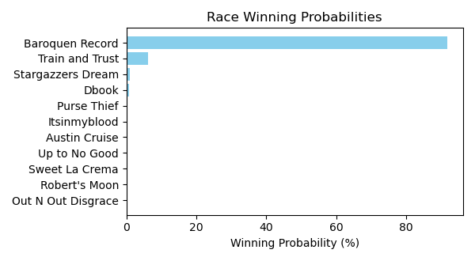

Figure: Winning Probability Distribution

NOTE: THIS RACE HAS HORSES THAT ARE MISSING CRITICAL DATA ELEMENTS

# Race: TTP | 2025-02-26 | Race #5 | Track: TURFWAY PARK

Track: TURFWAY PARK

|  |  |  |  |  |
| --- | --- | --- | --- | --- |
| Saddle Cloth # | Horse Name | Global Speed | Composite | Win Prob (%) |
| ['', 1, ''] | Nile Candy | 136.6 | 5.81 | 3.55 |
| ['', 2, ''] | Moochie Girl | 143.6 | 3.91 | 3.10 |
| ['', 3, ''] | Hearts United | 113.6 | -0.14 | 0.00 |
| ['', 4, ''] | Airforce Lightning | 143.6 | 7.46 | 53.27 |
| ['', 5, ''] | City Cocktails | 136.2 | 4.57 | 1.20 |
| ['', 6, ''] | Hear the Queen | 143.7 | 5.72 | 13.57 |
| ['', 7, ''] | Mizmalice | 49.8 | -8.22 | 0.00 |
| ['', 8, ''] | Poppy the Princess | 63.6 | -5.19 | 0.00 |
| ['', 9, ''] | Greenwich Pike | 144.9 | 4.94 | 9.22 |
| ['', 10, ''] | Sweet Bebsi | 147.9 | 4.89 | 16.09 |
| ['', 11, ''] | Bread to Run | 115.9 | 3.83 | 0.01 |
| ['', 12, ''] | Rando | 112.8 | 3.33 | 0.00 |

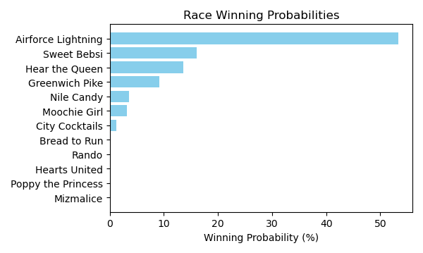

Figure: Winning Probability Distribution

NOTE: THIS RACE HAS HORSES THAT ARE MISSING CRITICAL DATA ELEMENTS

# Race: TTP | 2025-02-26 | Race #6 | Track: TURFWAY PARK

Track: TURFWAY PARK

|  |  |  |  |  |
| --- | --- | --- | --- | --- |
| Saddle Cloth # | Horse Name | Global Speed | Composite | Win Prob (%) |
| ['', 1, ''] | Tiverton (GB) | 104.4 | -2.96 | 0.00 |
| ['', 2, ''] | Rocketeightyeight | 140.7 | 4.59 | 11.74 |
| ['', 3, ''] | Unworkable | 149.4 | 3.67 | 31.77 |
| ['', 4, ''] | El Dandi | 62.1 | -7.38 | 0.00 |
| ['', 5, ''] | Rocket Hoss | 118.5 | 2.86 | 0.03 |
| ['', 6, ''] | Raging | 129.1 | 3.29 | 0.41 |
| ['', 7, ''] | Musical Maestro | 138.2 | 5.89 | 19.83 |
| ['', 8, ''] | Go Bali Go | 149.3 | 3.44 | 25.91 |
| ['', 9, ''] | Dewy's Beast | 148.6 | 2.47 | 10.31 |

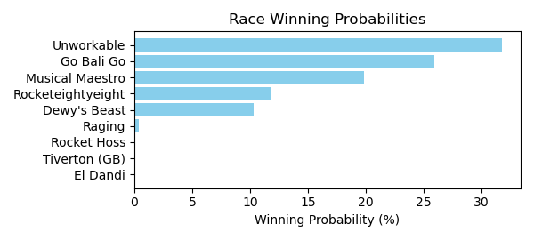

Figure: Winning Probability Distribution

NOTE: THIS RACE HAS HORSES THAT ARE MISSING CRITICAL DATA ELEMENTS

# Race: TTP | 2025-02-26 | Race #7 | Track: TURFWAY PARK

Track: TURFWAY PARK

|  |  |  |  |  |
| --- | --- | --- | --- | --- |
| Saddle Cloth # | Horse Name | Global Speed | Composite | Win Prob (%) |
| ['', 1, ''] | Shipman | 72.8 | -6.61 | 0.00 |
| ['', 2, ''] | dh-Ricky Wannabe | 99.4 | 1.28 | 0.00 |
| ['', 3, ''] | Hero Worship | 91.5 | -4.34 | 0.00 |
| ['', 4, ''] | Patriotic Jerrell | 143.7 | 3.04 | 97.92 |
| ['', 5, ''] | Classic Richie * | 77.3 | -7.83 | 0.00 |
| ['', 6, ''] | Panthor | 118.6 | -0.30 | 0.04 |
| ['', 7, ''] | Vodka N Gingerale | 70.1 | -8.24 | 0.00 |
| ['', 8, ''] | Meadow Value | 126.5 | 2.50 | 2.01 |
| ['', 9, ''] | El Gunner | 93.1 | -4.22 | 0.00 |
| ['', 10, ''] | Mr. Bali * | 112.6 | -0.01 | 0.02 |

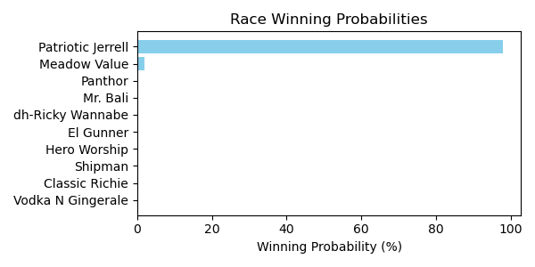

Figure: Winning Probability Distribution

NOTE: THIS RACE HAS HORSES THAT ARE MISSING CRITICAL DATA ELEMENTS

# Race: TTP | 2025-02-26 | Race #8 | Track: TURFWAY PARK

Track: TURFWAY PARK

|  |  |  |  |  |
| --- | --- | --- | --- | --- |
| Saddle Cloth # | Horse Name | Global Speed | Composite | Win Prob (%) |
| ['', 1, ''] | Royally Bitter | 131.6 | 4.54 | 15.30 |
| ['', 2, ''] | Richiesgotgame | 64.3 | -7.47 | 0.00 |
| ['', 3, ''] | Devils Gotta Go | 136.8 | 3.15 | 14.25 |
| ['', 4, ''] | Broken Justice | 136.3 | 5.28 | 70.43 |
| ['', 5, ''] | Ghost Bike | 110.6 | 0.46 | 0.01 |
| ['', 6, ''] | Sant' Antimo | 52.8 | -8.11 | 0.00 |
| ['', 7, ''] | Future Victory | 63.1 | -6.51 | 0.00 |
| ['', 8, ''] | Some R Blessed | 90.5 | -3.26 | 0.00 |
| ['', 9, ''] | Inherent Powers | 81.8 | -2.13 | 0.00 |
| ['', 10, ''] | Noahs Ark | 74.2 | -6.70 | 0.00 |
| ['', 11, ''] | Contact Tracing | 105.1 | 0.65 | 0.00 |

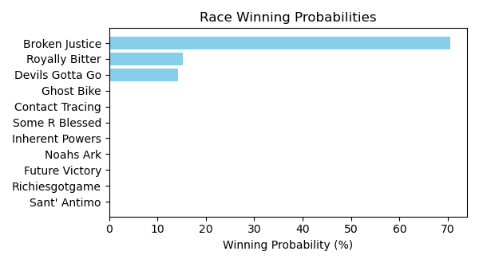

Figure: Winning Probability Distribution

NOTE: THIS RACE HAS HORSES THAT ARE MISSING CRITICAL DATA ELEMENTS

# Race: TTP | 2025-02-26 | Race #9 | Track: TURFWAY PARK

Track: TURFWAY PARK

|  |  |  |  |  |
| --- | --- | --- | --- | --- |
| Saddle Cloth # | Horse Name | Global Speed | Composite | Win Prob (%) |
| ['', 1, ''] | Urban Cowgirl | 141.4 | 6.21 | 34.56 |
| ['', 2, ''] | Chica Chula | 53.4 | -7.84 | 0.00 |
| ['', 3, ''] | Delightful Cat | 55.6 | -8.50 | 0.00 |
| ['', 4, ''] | Lemon Bomb | 54.9 | -7.87 | 0.00 |
| ['', 5, ''] | R Rose' All Day | 115.1 | 1.49 | 0.00 |
| ['', 6, ''] | Union Dolly | 43.7 | -8.02 | 0.00 |
| ['', 7, ''] | Filtered Light | 145.4 | 2.57 | 4.26 |
| ['', 8, ''] | Secret Glenda | 126.8 | 5.07 | 0.75 |
| ['', 9, ''] | Belle Brezing | 96.3 | 4.58 | 0.00 |
| ['', 10, ''] | Talkin in Cursive | 146.1 | 5.72 | 60.23 |
| ['', 11, ''] | Lubu * | 115.5 | 6.17 | 0.19 |

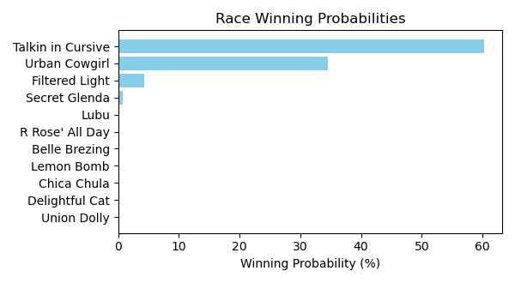

Figure: Winning Probability Distribution

NOTE: THIS RACE HAS HORSES THAT ARE MISSING CRITICAL DATA ELEMENTS

# Race: TTP | 2025-02-26 | Race #10 | Track: TURFWAY PARK

Track: TURFWAY PARK

|  |  |  |  |  |
| --- | --- | --- | --- | --- |
| Saddle Cloth # | Horse Name | Global Speed | Composite | Win Prob (%) |
| ['', 1, ''] | Elliott Moon | 135.4 | 5.49 | 26.77 |
| ['', 2, ''] | Ladle | 117.7 | 2.48 | 0.07 |
| ['', 3, ''] | Ragtime Kitty | 48.7 | -8.04 | 0.00 |
| ['', 4, ''] | Morning Holiday | 76.7 | -6.92 | 0.00 |
| ['', 5, ''] | Crystal Snow | 107.1 | -0.95 | 0.00 |
| ['', 6, ''] | Outrage | 141.4 | 5.04 | 62.61 |
| ['', 7, ''] | Miro Mogo | 88.2 | -5.48 | 0.00 |
| ['', 8, ''] | Fondre | 77.7 | -6.98 | 0.00 |
| ['', 9, ''] | Rapping Wish | 114.4 | 0.01 | 0.01 |
| ['', 10, ''] | Greatest Moment | 52.8 | -8.42 | 0.00 |
| ['', 11, ''] | Double Overtime | 112.7 | 1.88 | 0.02 |
| ['', 12, ''] | Goddess of War | 136.5 | 3.44 | 6.57 |
| ['', 13, ''] | Hold My Crown | 77.2 | -6.39 | 0.00 |
| ['', 14, ''] | D'oro Road | 138.5 | 2.32 | 3.96 |

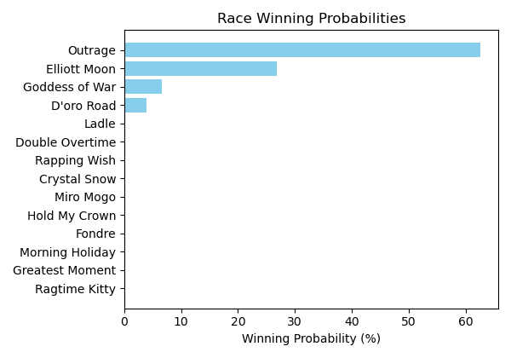

Figure: Winning Probability Distribution

NOTE: THIS RACE HAS HORSES THAT ARE MISSING CRITICAL DATA ELEMENTS