# Race: PEN | 2025-03-06 | Race #2 | Track: PENN NATIONAL

Track: PENN NATIONAL

|  |  |  |  |  |  |
| --- | --- | --- | --- | --- | --- |
| Program # | Horse Name | Morn Odds | GCSF | Model Score | Win Prob (%) |
| 1 | Brett's World | 9-5 | 89.6 | -1.88 | 5.37 |
| 2 | Souper Fortune | 4-1 | 98.5 | -2.10 | 4.48 |
| 3 | Here's Waldo | 2-1 | 81.7 | -5.47 | 2.22 |
| 4 | Copperhead Creek | 5-1 | 94.6 | -3.93 | 2.43 |
| 5 | Indirectly | 5-1 | 100.0 | -0.48 | 85.49 |

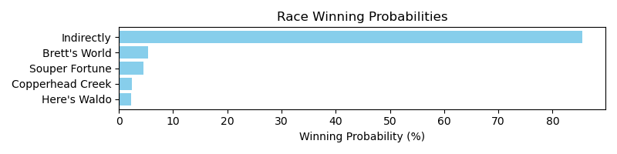

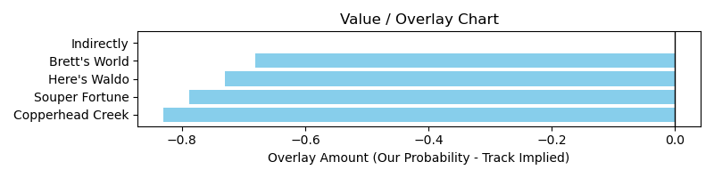

NOTE: GCSF - Global Combined Speed Figure

# Race: PEN | 2025-03-06 | Race #6 | Track: PENN NATIONAL

Track: PENN NATIONAL

|  |  |  |  |  |  |
| --- | --- | --- | --- | --- | --- |
| Program # | Horse Name | Morn Odds | GCSF | Model Score | Win Prob (%) |
| 1 | Ten Gauge | 2-1 | 81.4 | -6.06 | 1.30 |
| 2 | Uncle Caesar | 10-1 | 93.4 | -2.13 | 1.32 |
| 3 | Wine Collector | 5-2 | 106.3 | 3.46 | 91.38 |
| 4 | Termsofengagement | 8-1 | 106.6 | 1.70 | 2.70 |
| 5 | My Redemption | 12-1 | 115.3 | 1.16 | 1.98 |
| 6 | Celestial Moon | 9-5 | 99.7 | -1.74 | 1.33 |

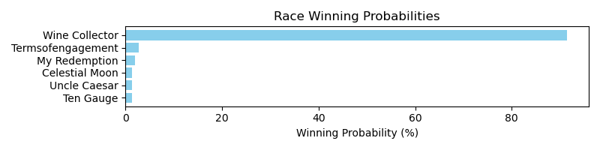

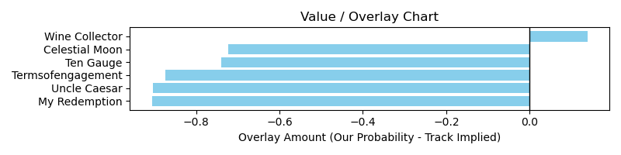

NOTE: GCSF - Global Combined Speed Figure

# Race: HOU | 2025-03-07 | Race #2 | Track: SAM HOUSTON RACE PARK

Track: SAM HOUSTON RACE PARK

|  |  |  |  |  |  |
| --- | --- | --- | --- | --- | --- |
| Program # | Horse Name | Morn Odds | GCSF | Model Score | Win Prob (%) |
| 1 | Whiskey With You | 6-1 | 105.7 | -0.45 | 0.83 |
| 2 | Singing Dixie | 15-1 | 91.2 | -5.15 | 0.69 |
| 3 | Legendary Lore | 12-1 | 93.2 | -3.92 | 0.70 |
| 4 | Get Ripped | 9-2 | 112.6 | 2.85 | 93.35 |
| 5 | Wrinkle Road | 20-1 | 101.2 | -2.81 | 0.71 |
| 6 | Emboite (IRE) | 12-1 | 96.1 | -3.28 | 0.70 |
| 7 | Summer Lover | 4-1 | 102.4 | -0.58 | 0.81 |
| 8 | Mr Insensitive | 6-1 | 97.2 | -0.73 | 0.80 |
| 9 | Miami Moonlight | 10-1 | 94.0 | -3.68 | 0.70 |
| 10 | Transactional (GB) | 3-1 | 92.2 | -2.15 | 0.72 |

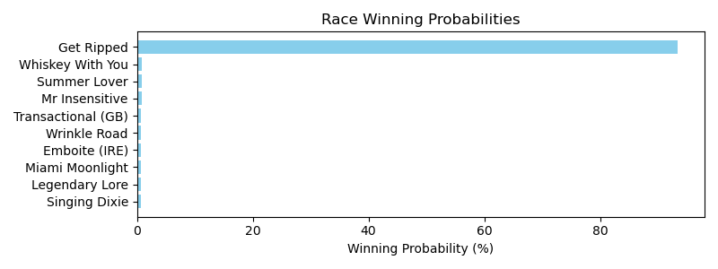

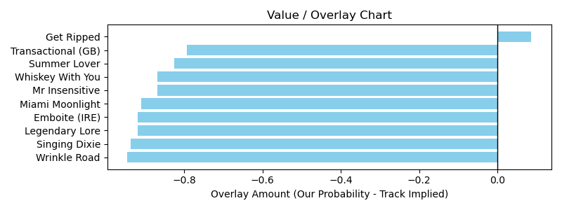

# Race: HOU | 2025-03-07 | Race #3 | Track: SAM HOUSTON RACE PARK

Track: SAM HOUSTON RACE PARK

|  |  |  |  |  |  |
| --- | --- | --- | --- | --- | --- |
| Program # | Horse Name | Morn Odds | GCSF | Model Score | Win Prob (%) |
| 1 | Just Hangin Ridge | 30-1 | 84.0 | -7.87 | 0.96 |
| 2 | Take My Money | 13-8 | 107.8 | 4.05 | 92.94 |
| 3 | Too Intimidating | 5-2 | 107.4 | 2.38 | 2.27 |
| 4 | Pretty Macho | 8-1 | 101.4 | -1.93 | 0.97 |
| 5 | Unbridled Bling | 7-2 | 98.4 | -4.24 | 0.96 |
| 6 | Appeal Guy | 30-1 | 100.0 | -5.32 | 0.96 |
| 7 | Summer Help | 4-1 | 95.1 | -4.31 | 0.96 |

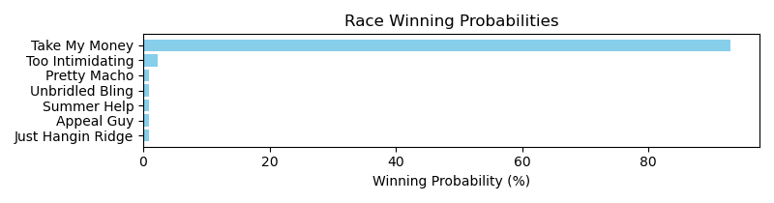

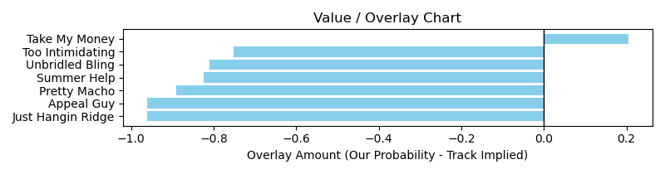

# Race: HOU | 2025-03-07 | Race #4 | Track: SAM HOUSTON RACE PARK

Track: SAM HOUSTON RACE PARK

|  |  |  |  |  |  |
| --- | --- | --- | --- | --- | --- |
| Program # | Horse Name | Morn Odds | GCSF | Model Score | Win Prob (%) |
| 1 | Sharp Lorenzo | 12-1 | 99.0 | -2.83 | 0.53 |
| 2 | Carbon Stryker | 15-1 | 85.9 | -5.67 | 0.52 |
| 3 | Hard Gold | 12-1 | 102.9 | -0.73 | 0.58 |
| 4 | Will the Thrill | 8-1 | 99.2 | -0.89 | 0.57 |
| 5 | Nightwind | 4-1 | 110.0 | 3.20 | 95.68 |
| 6 | Ghost Cowboy | 9-5 | 95.2 | -1.92 | 0.54 |
| 7 | I'm a Cowboy | 5-2 | 92.3 | -2.89 | 0.53 |
| 8 | Hello Hello Mister | 30-1 | 83.8 | -7.49 | 0.52 |
| 9 | Ima Big Bopper | 20-1 | 95.2 | -4.88 | 0.52 |

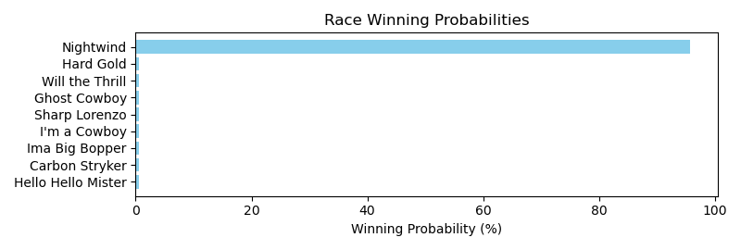

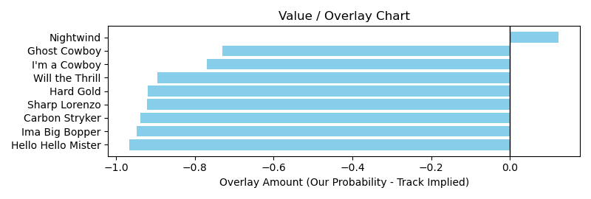

# Race: HOU | 2025-03-07 | Race #6 | Track: SAM HOUSTON RACE PARK

Track: SAM HOUSTON RACE PARK

|  |  |  |  |  |  |
| --- | --- | --- | --- | --- | --- |
| Program # | Horse Name | Morn Odds | GCSF | Model Score | Win Prob (%) |
| 1 | Union Data | 30-1 | 76.3 | -8.35 | 2.96 |
| 2 | Deanos Cape | 8-1 | 108.6 | 4.91 | 21.07 |
| 3 | Affectionto Autism | 15-1 | 107.4 | 3.54 | 4.86 |
| 4 | Kentucky Peerless | 30-1 | 90.8 | -4.55 | 2.96 |
| 5 | Cousin Larry | 9-2 | 100.8 | -1.06 | 2.98 |
| 6 | United Patriot | 12-1 | 108.6 | 1.76 | 3.22 |
| 7 | Barbacoa | 20-1 | 101.6 | -1.55 | 2.97 |
| 8 | Runway Magic | 6-1 | 98.8 | -1.68 | 2.97 |
| 9 | dq-Catholic Guilt | 4-1 | 108.0 | 5.23 | 43.47 |
| 10 | Fifteen Love Back | 20-1 | 113.1 | 2.22 | 3.38 |
| 11 | Emperador | 3-1 | 101.8 | 1.76 | 3.22 |
| 12 | Send Off | 30-1 | 98.4 | -3.53 | 2.96 |
| 13 | Call of Honor | 20-1 | 92.5 | -4.48 | 2.96 |

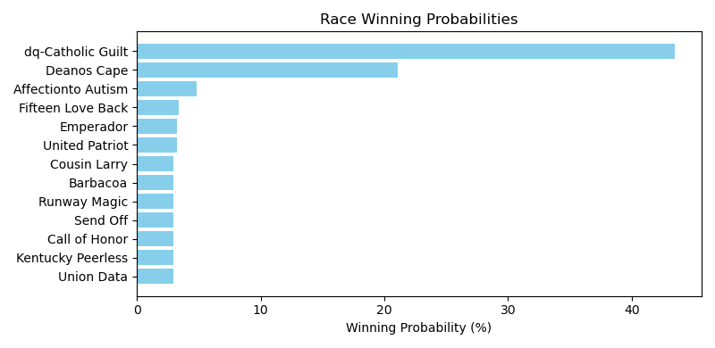

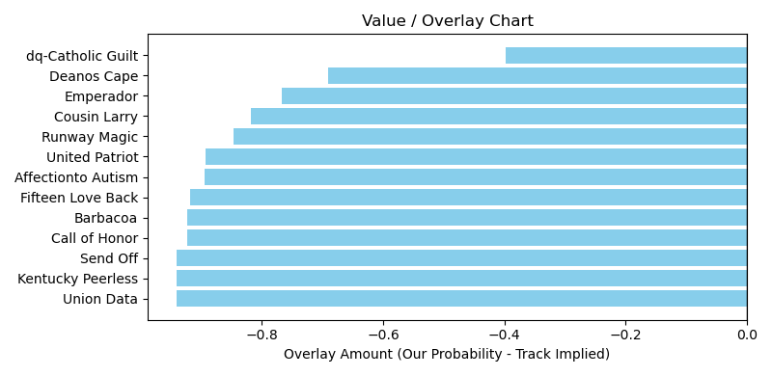

# Race: HOU | 2025-03-07 | Race #8 | Track: SAM HOUSTON RACE PARK

Track: SAM HOUSTON RACE PARK

|  |  |  |  |  |  |
| --- | --- | --- | --- | --- | --- |
| Program # | Horse Name | Morn Odds | GCSF | Model Score | Win Prob (%) |
| 1 | The Princess Says | 6-1 | 100.5 | -1.28 | 0.43 |
| 2 | Ghostly Night | 7-2 | 108.4 | 6.28 | 96.10 |
| 3 | Catching Heat | 9-2 | 100.4 | -1.57 | 0.43 |
| 4 | The Rage of Art | 15-1 | 88.9 | -5.70 | 0.43 |
| 5 | Its My Money Too | 20-1 | 92.9 | -3.48 | 0.43 |
| 6 | Lookatchu | 15-1 | 93.4 | -3.88 | 0.43 |
| 7 | Can't Zap This | 8-1 | 110.6 | 0.10 | 0.44 |
| 8 | Secret Knock | 10-1 | 106.6 | -0.04 | 0.43 |
| 9 | Bluebonnet Girl | 12-1 | 82.9 | -5.46 | 0.43 |
| 10 | Just an Opinion | 5-2 | 97.4 | 0.77 | 0.44 |

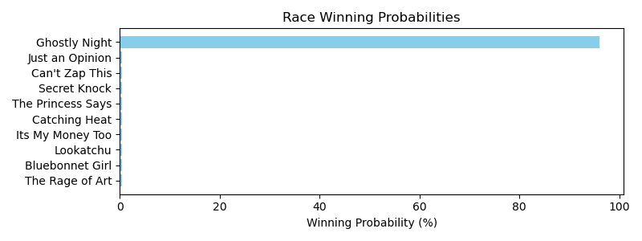

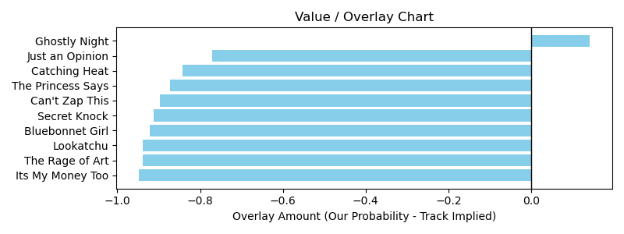

NOTE: GCSF - Global Combined Speed Figure

# Race: HOU | 2025-03-07 | Race #9 | Track: SAM HOUSTON RACE PARK

Track: SAM HOUSTON RACE PARK

|  |  |  |  |  |  |
| --- | --- | --- | --- | --- | --- |
| Program # | Horse Name | Morn Odds | GCSF | Model Score | Win Prob (%) |
| 1 | San Mateo Kat | 20-1 | 87.2 | -6.27 | 2.85 |
| 2 | She'sskysthelimit | 1-1 | 103.1 | 4.32 | 58.46 |
| 3 | Imaluckycharm | 7-2 | 98.9 | 1.51 | 3.42 |
| 4 | True Blue Sky | 4-1 | 102.9 | 2.56 | 4.80 |
| 5 | Sky Rocker | 9-2 | 111.4 | 3.07 | 6.77 |
| 6 | Talkin Cadee | 10-1 | 97.4 | -2.44 | 2.86 |
| 7 | Paintbrush | 20-1 | 94.1 | -5.42 | 2.85 |
| 8 | Gastown | 8-1 | 98.2 | -1.29 | 2.88 |
| 9 | Our Davina | 5-1 | 107.3 | 3.01 | 6.46 |
| 10 | Wild Express | 20-1 | 96.3 | -3.58 | 2.85 |
| 11 | Blameitonmidnight | 4-1 | 101.9 | -0.20 | 2.95 |
| 12 | Viewers Discretion | 6-1 | 80.2 | -6.48 | 2.85 |

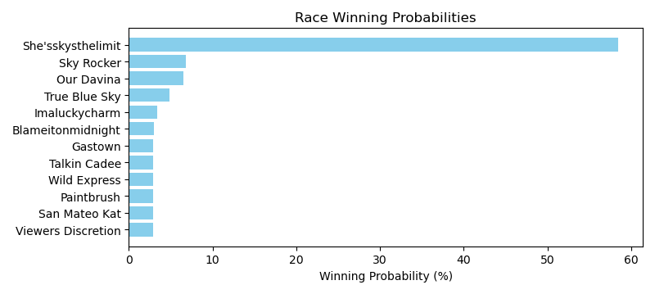

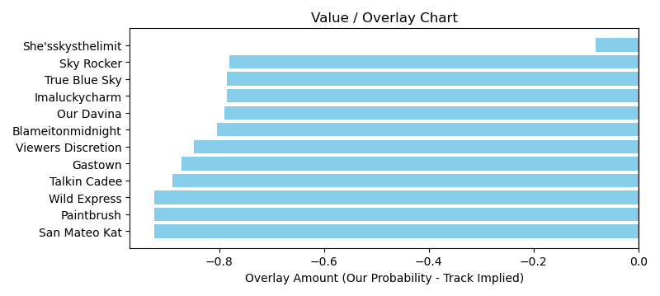

NOTE: GCSF - Global Combined Speed Figure

# Race: HOU | 2025-03-08 | Race #1 | Track: SAM HOUSTON RACE PARK

Track: SAM HOUSTON RACE PARK

|  |  |  |  |  |  |
| --- | --- | --- | --- | --- | --- |
| Program # | Horse Name | Morn Odds | GCSF | Model Score | Win Prob (%) |
| 1 | Kinky Moon | 10-1 | 100.0 | -2.65 | 1.34 |
| 2 | The Next Big Bling | 3-1 | 107.3 | 3.63 | 2.27 |
| 3 | Factor That | 4-1 | 111.3 | 5.70 | 88.28 |
| 4 | Gray Zone | 15-1 | 99.1 | -2.23 | 1.34 |
| 5 | Anajuliaforever | 6-1 | 103.6 | 0.98 | 1.39 |
| 6 | Lookatchu | 8-1 | 93.4 | -2.88 | 1.34 |
| 7 | Leone | 20-1 | 85.8 | -6.63 | 1.34 |
| 8 | Bling It to Me | 9-5 | 107.4 | 3.91 | 2.69 |

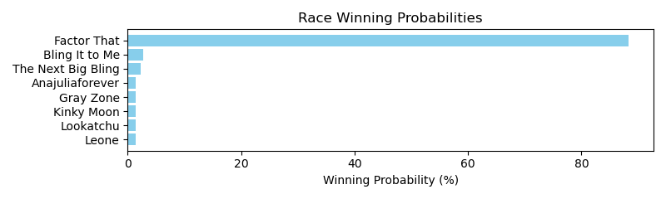

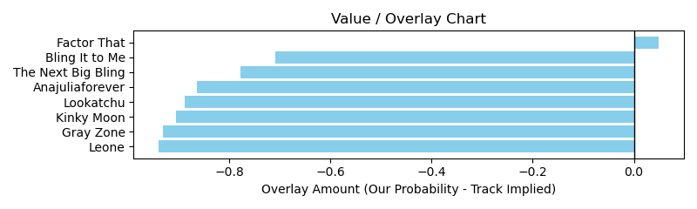

# Race: HOU | 2025-03-08 | Race #2 | Track: SAM HOUSTON RACE PARK

Track: SAM HOUSTON RACE PARK

|  |  |  |  |  |  |
| --- | --- | --- | --- | --- | --- |
| Program # | Horse Name | Morn Odds | GCSF | Model Score | Win Prob (%) |
| 1 | My Little Prince | 13-8 | 106.2 | 4.47 | 95.77 |
| 2 | Rocking Rocket | 3-1 | 104.8 | -0.11 | 0.54 |
| 3 | Threefiftyseven | 8-1 | 95.8 | -4.20 | 0.51 |
| 4 | Dose's Dream | 20-1 | 97.8 | -3.85 | 0.51 |
| 5 | Weird Year | 12-1 | 103.8 | 0.23 | 0.55 |
| 6 | Imma Blingy Lad | 30-1 | 82.6 | -6.84 | 0.51 |
| 7 | Reckless Red | 6-1 | 97.7 | -3.01 | 0.52 |
| 8 | Sam Sez | 15-1 | 101.4 | -0.71 | 0.53 |
| 9 | Play Rule | 6-1 | 101.9 | 0.07 | 0.55 |

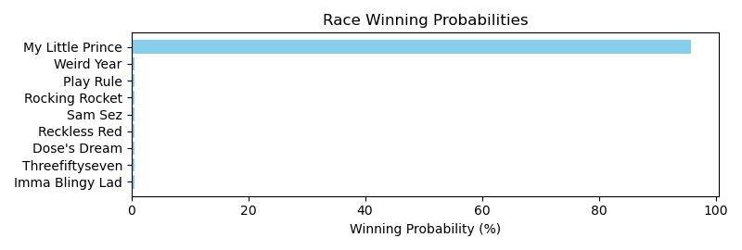

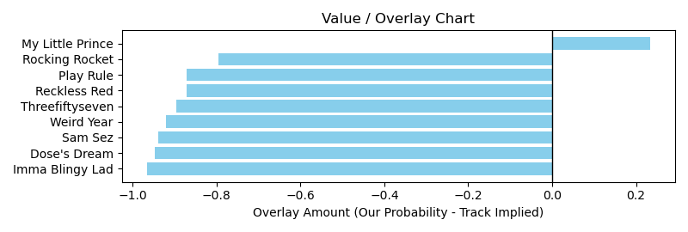

NOTE: GCSF - Global Combined Speed Figure

# Race: HOU | 2025-03-08 | Race #5 | Track: SAM HOUSTON RACE PARK

Track: SAM HOUSTON RACE PARK

|  |  |  |  |  |  |
| --- | --- | --- | --- | --- | --- |
| Program # | Horse Name | Morn Odds | GCSF | Model Score | Win Prob (%) |
| 1 | Samsplayerslounge | 20-1 | 88.8 | -6.19 | 0.50 |
| 2 | Rags Royal Prinz | 6-1 | 91.9 | -3.90 | 0.50 |
| 3 | Bandera Bling | 7-5 | 90.3 | -3.87 | 0.50 |
| 4 | My Favorite Song | 9-2 | 93.0 | -3.74 | 0.50 |
| 5 | My Boy Bling | 3-1 | 97.1 | -2.19 | 0.53 |
| 6 | God's Gold | 30-1 | 95.7 | -4.63 | 0.50 |
| 7 | Wings for Eno | 8-1 | 98.8 | -2.24 | 0.53 |
| 8 | Holiday Run | 20-1 | 110.5 | 2.14 | 96.44 |

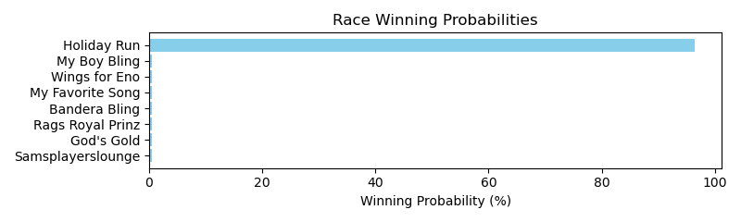

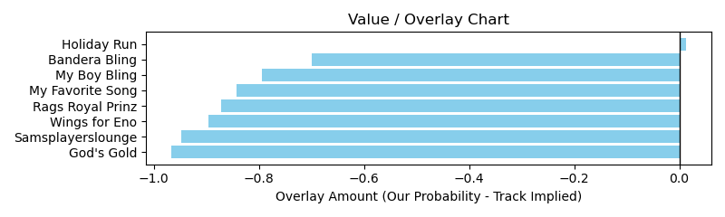

# Race: HOU | 2025-03-08 | Race #6 | Track: SAM HOUSTON RACE PARK

Track: SAM HOUSTON RACE PARK

|  |  |  |  |  |  |
| --- | --- | --- | --- | --- | --- |
| Program # | Horse Name | Morn Odds | GCSF | Model Score | Win Prob (%) |
| 1 | Golden Pursuit | 8-1 | 96.1 | -4.32 | 4.61 |
| 2 | Sir Lancelot Ridge | 20-1 | 108.5 | -0.70 | 17.77 |
| 3 | Travel Guru | 30-1 | 100.0 | -7.36 | 4.44 |
| 4 | Moro Trendsetter | 10-1 | 93.6 | -5.02 | 4.52 |
| 5 | Redfortyseven | 12-1 | 106.6 | -1.20 | 10.36 |
| 6 | Adger | 6-5 | 100.0 | -1.25 | 9.93 |
| 7 | Bennett's Leader | 12-1 | 93.4 | -5.24 | 4.50 |
| 8 | Ubsingintheblues | 15-1 | 107.0 | -0.42 | 28.04 |
| 9 | Rock Island Rocket | 8-1 | 100.0 | -4.20 | 4.63 |
| 10 | The Winning Edge | 9-2 | 100.0 | -2.15 | 6.15 |
| 11 | dh-Gus Cause | 30-1 | 111.2 | -3.09 | 5.04 |

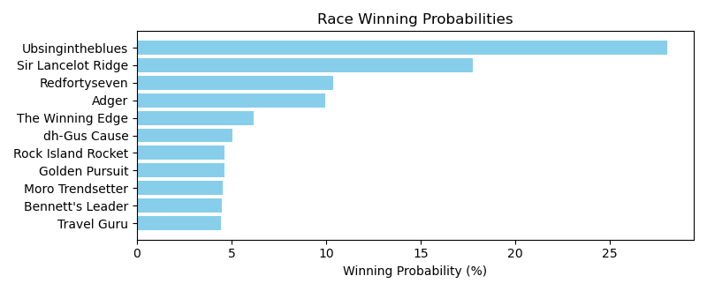

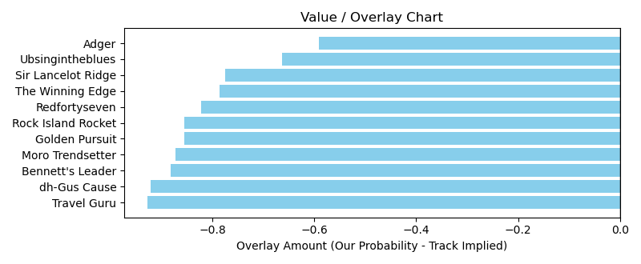

# Race: HOU | 2025-03-08 | Race #7 | Track: SAM HOUSTON RACE PARK

Track: SAM HOUSTON RACE PARK

|  |  |  |  |  |  |
| --- | --- | --- | --- | --- | --- |
| Program # | Horse Name | Morn Odds | GCSF | Model Score | Win Prob (%) |
| 1 | Brock On By | 6-1 | 97.8 | -0.94 | 0.45 |
| 2 | Cliff Diver | 12-1 | 98.0 | -0.31 | 0.46 |
| 3 | Varsity | 20-1 | 94.5 | -3.51 | 0.44 |
| 4 | Sarge's Sermon | 4-1 | 87.7 | -5.10 | 0.44 |
| 5 | Witt's Taquito | 6-1 | 98.5 | -2.00 | 0.44 |
| 6 | Thick Haze | 10-1 | 87.6 | -4.43 | 0.44 |
| 7 | Wilton | 15-1 | 93.9 | -3.77 | 0.44 |
| 8 | Glendale | 20-1 | 95.3 | -2.69 | 0.44 |
| 9 | Hold Your Applause | 5-2 | 107.9 | 4.61 | 95.99 |
| 10 | Interstellar | 9-2 | 81.5 | -6.02 | 0.44 |

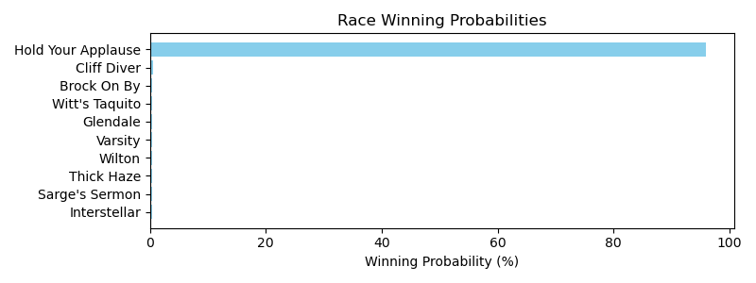

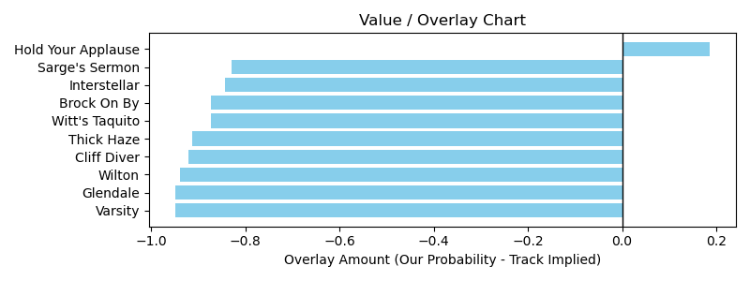

# Race: HOU | 2025-03-08 | Race #8 | Track: SAM HOUSTON RACE PARK

Track: SAM HOUSTON RACE PARK

|  |  |  |  |  |  |
| --- | --- | --- | --- | --- | --- |
| Program # | Horse Name | Morn Odds | GCSF | Model Score | Win Prob (%) |
| 1 | Structured | 13-8 | 108.5 | 3.63 | 95.01 |
| 2 | Leviathan Axe | 9-2 | 106.6 | -0.40 | 0.59 |
| 3 | Oneparticulrharbor | 20-1 | 96.8 | -3.61 | 0.54 |
| 4 | Somersetslastride | 20-1 | 110.1 | -0.64 | 0.58 |
| 5 | Island Cabana | 10-1 | 110.5 | -0.34 | 0.59 |
| 6 | All Country | 20-1 | 102.3 | -4.03 | 0.54 |
| 7 | Twelve Volt | 3-1 | 86.2 | -5.79 | 0.54 |
| 8 | All Saints | 15-1 | 100.0 | -2.74 | 0.54 |
| 9 | American Icon | 8-1 | 96.0 | -4.23 | 0.54 |
| 10 | Nephi | 20-1 | 93.4 | -5.42 | 0.54 |

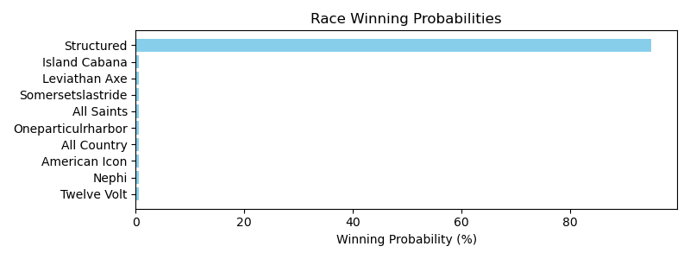

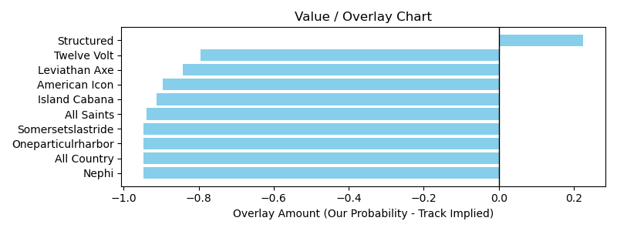

NOTE: GCSF - Global Combined Speed Figure

# Race: TTP | 2025-03-06 | Race #3 | Track: TURFWAY PARK

Track: TURFWAY PARK

|  |  |  |  |  |  |
| --- | --- | --- | --- | --- | --- |
| Program # | Horse Name | Morn Odds | GCSF | Model Score | Win Prob (%) |
| 1 | Urban Planner | 7-2 | 106.6 | 1.42 | 26.01 |
| 2 | Permit to Carry | 30-1 | 106.5 | -2.80 | 3.34 |
| 3 | Fast Joker | 10-1 | 101.4 | -2.18 | 3.43 |
| 4 | Conquering Cat | 5-1 | 89.4 | -4.91 | 3.25 |
| 5 | Spirit Rags | 8-1 | 93.7 | -3.34 | 3.30 |
| 6 | Gift Certificate | 30-1 | 90.2 | -4.07 | 3.27 |
| 7 | Pnutbutter Whiskey | 10-1 | 107.4 | 1.65 | 45.04 |
| 8 | Dr Ruben M | 5-2 | 91.5 | -2.57 | 3.37 |
| 9 | Faber | 10-1 | 95.7 | -3.35 | 3.30 |
| 10 | Big Vince | 9-2 | 100.0 | 0.11 | 5.70 |

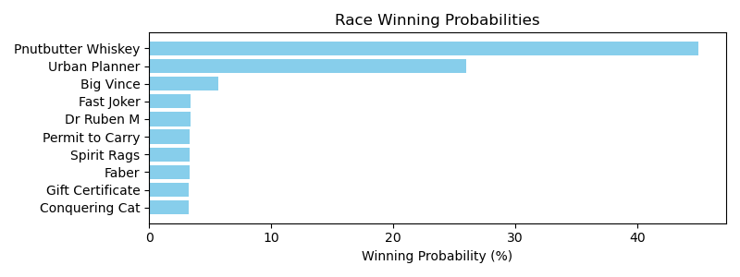

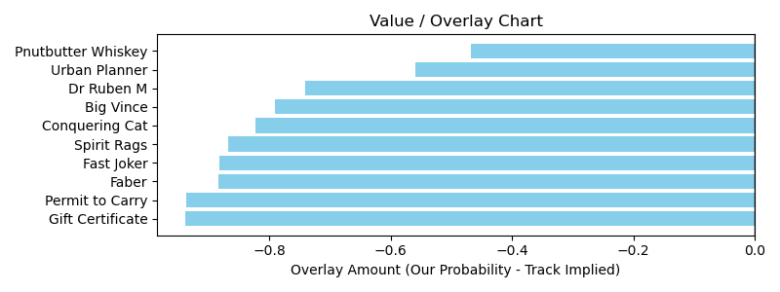

# Race: TTP | 2025-03-06 | Race #5 | Track: TURFWAY PARK

Track: TURFWAY PARK

|  |  |  |  |  |  |
| --- | --- | --- | --- | --- | --- |
| Program # | Horse Name | Morn Odds | GCSF | Model Score | Win Prob (%) |
| 1 | Crickenberger | 12-1 | 91.6 | -3.80 | 2.05 |
| 2 | Raining Sugar | 20-1 | 103.2 | -0.21 | 2.45 |
| 3 | El Kown | 20-1 | 104.5 | -0.76 | 2.27 |
| 4 | Stay Lost | 20-1 | 85.5 | -6.88 | 2.04 |
| 5 | Colonial Rose | 10-1 | 109.0 | 2.75 | 70.14 |
| 6 | Verbal Geyser (FR) | 20-1 | 90.0 | -3.99 | 2.05 |
| 7 | Bourbon Serengeti | 10-1 | 92.1 | -4.88 | 2.04 |
| 8 | Elle Est Forte | 4-1 | 91.6 | -3.93 | 2.05 |
| 9 | Befriended | 5-2 | 101.3 | 1.31 | 4.69 |
| 10 | Heart Spin | 7-2 | 99.2 | -1.15 | 2.19 |
| 11 | Malawnia | 8-1 | 99.4 | -2.19 | 2.09 |
| 12 | Faire Plaisir | 12-1 | 105.2 | 1.01 | 3.79 |
| 13 | Harvey's Princess | 15-1 | 98.0 | -1.30 | 2.17 |

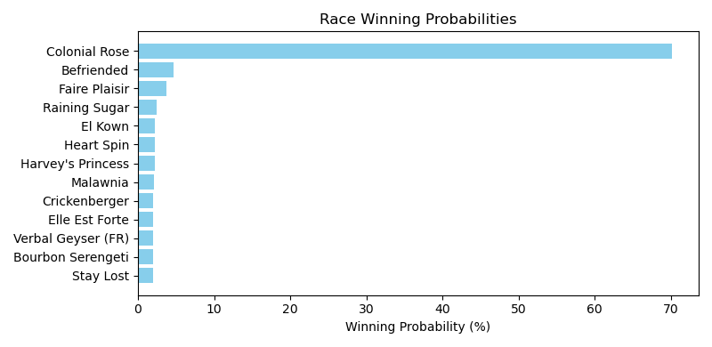

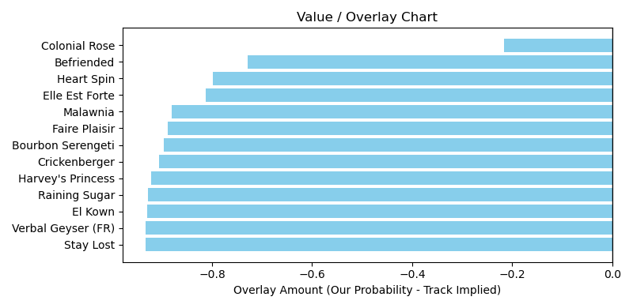

# Race: TTP | 2025-03-06 | Race #6 | Track: TURFWAY PARK

Track: TURFWAY PARK

|  |  |  |  |  |  |
| --- | --- | --- | --- | --- | --- |
| Program # | Horse Name | Morn Odds | GCSF | Model Score | Win Prob (%) |
| 1 | Thenorthremembers | 3-1 | 94.8 | -3.26 | 0.41 |
| 2 | Liltonytwophones | 12-1 | 85.7 | -6.28 | 0.41 |
| 3 | Unraptured | 6-5 | 109.1 | 6.26 | 95.85 |
| 4 | Indigo Rich | 30-1 | 111.1 | -0.54 | 0.42 |
| 5 | Puttheglassdown | 10-1 | 100.0 | -1.33 | 0.42 |
| 6 | Dragon Drew | 15-1 | 92.7 | -4.93 | 0.41 |
| 7 | Resist the Devil | 12-1 | 99.4 | -3.39 | 0.41 |
| 8 | McVicker | 12-1 | 93.4 | -3.75 | 0.41 |
| 9 | Hijack the Party | 12-1 | 93.4 | -4.91 | 0.41 |
| 10 | Get the Candy | 15-1 | 101.9 | -1.89 | 0.41 |
| 11 | Last Roo | 20-1 | 88.4 | -6.13 | 0.41 |

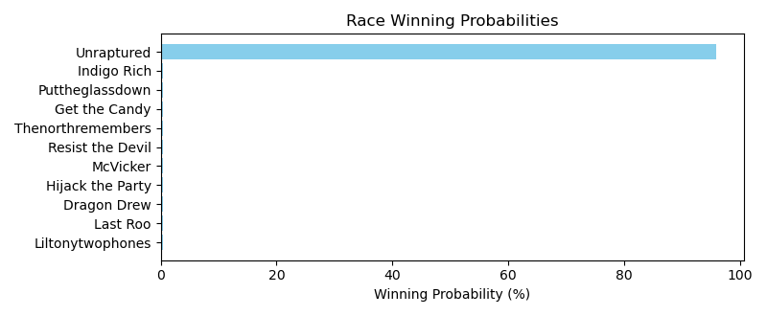

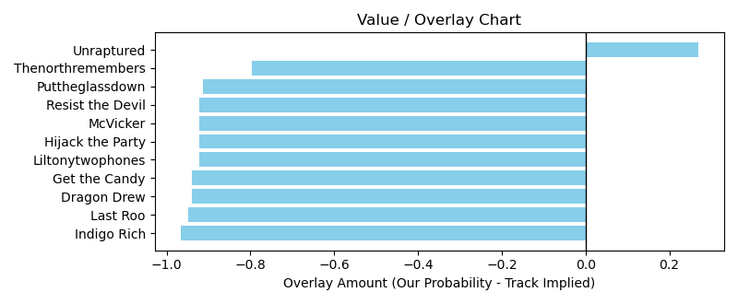

NOTE: GCSF - Global Combined Speed Figure

# Race: TTP | 2025-03-06 | Race #7 | Track: TURFWAY PARK

Track: TURFWAY PARK

|  |  |  |  |  |  |
| --- | --- | --- | --- | --- | --- |
| Program # | Horse Name | Morn Odds | GCSF | Model Score | Win Prob (%) |
| 1 | Miss Lonelle | 6-1 | 89.6 | -4.14 | 0.70 |
| 2 | Getting After It | 5-1 | 100.0 | -1.65 | 0.71 |
| 3 | Sea Lion | 12-1 | 100.0 | -1.79 | 0.71 |
| 4 | Cachinnation | 7-2 | 100.0 | 0.08 | 0.80 |
| 5 | Brooklyn Can Dance | 12-1 | 100.0 | -1.37 | 0.72 |
| 6 | Verity | 3-1 | 100.0 | 0.48 | 0.85 |
| 7 | Mezcalifornia | 15-1 | 109.8 | 3.65 | 94.04 |
| 8 | Ultima Grace | 5-1 | 100.0 | -2.39 | 0.70 |
| 9 | Indigo Stunner | 6-1 | 99.9 | -0.17 | 0.77 |

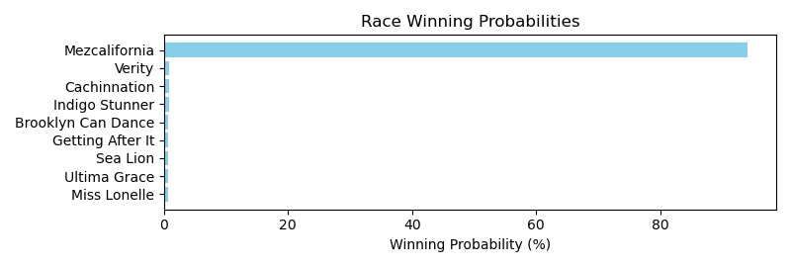

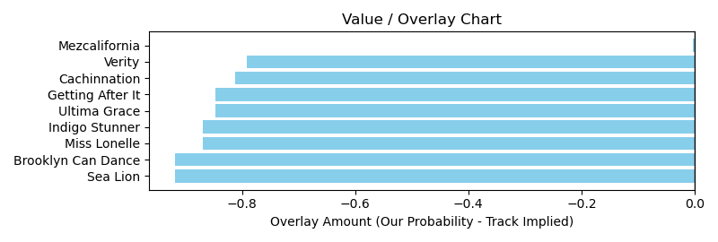

# Race: TTP | 2025-03-06 | Race #9 | Track: TURFWAY PARK

Track: TURFWAY PARK

|  |  |  |  |  |  |
| --- | --- | --- | --- | --- | --- |
| Program # | Horse Name | Morn Odds | GCSF | Model Score | Win Prob (%) |
| 1 | Endless | 12-1 | 100.1 | -1.92 | 4.74 |
| 2 | Bel Aria | 15-1 | 105.4 | 0.27 | 6.95 |
| 3 | King's Legacy | 3-1 | 103.1 | 1.22 | 13.78 |
| 4 | Second Exchange | 10-1 | 97.6 | -2.34 | 4.66 |
| 5 | Gea | 9-2 | 107.6 | 1.00 | 11.09 |
| 6 | Fireside Kitten | 20-1 | 90.1 | -5.82 | 4.52 |
| 7 | I Likem | 8-1 | 102.1 | 0.39 | 7.35 |
| 8 | Skippinjustice | 12-1 | 102.8 | -0.34 | 5.71 |
| 9 | Systematic | 4-1 | 104.5 | 1.84 | 36.11 |
| 10 | Quarterflash | 9-2 | 98.0 | -0.99 | 5.10 |

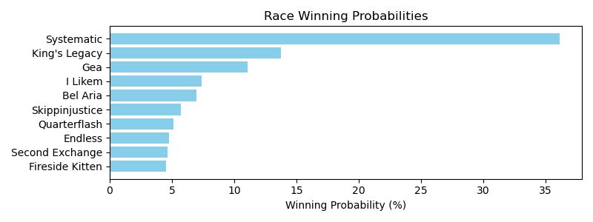

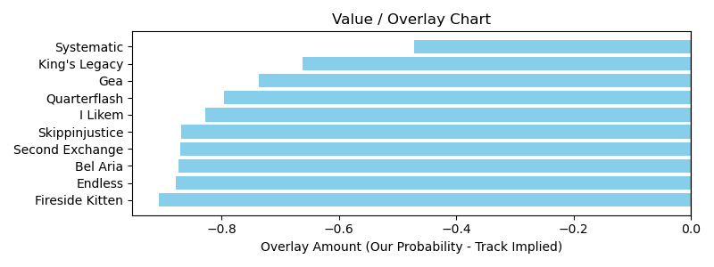

# Race: TTP | 2025-03-06 | Race #10 | Track: TURFWAY PARK

Track: TURFWAY PARK

|  |  |  |  |  |  |
| --- | --- | --- | --- | --- | --- |
| Program # | Horse Name | Morn Odds | GCSF | Model Score | Win Prob (%) |
| 1 | General Issue (FR) | 5-1 | 94.9 | -2.67 | 0.87 |
| 2 | Tiz Big Money | 20-1 | 93.2 | -4.57 | 0.86 |
| 3 | Fire Wire | 5-1 | 95.4 | -4.35 | 0.86 |
| 4 | El Peligro | 10-1 | 110.6 | 3.44 | 89.78 |
| 5 | Southern Pass Time | 20-1 | 100.0 | -5.03 | 0.86 |
| 6 | Xander | 3-1 | 100.0 | -2.22 | 0.87 |
| 7 | Fly by Night | 4-1 | 100.0 | -2.43 | 0.87 |
| 8 | Cactus Kevin | 10-1 | 91.6 | -4.38 | 0.86 |
| 9 | Strike Price | 30-1 | 83.7 | -7.67 | 0.86 |
| 10 | Dancing Noah | 12-1 | 107.1 | 0.03 | 1.00 |
| 11 | Son of a Gray | 12-1 | 110.5 | 0.94 | 1.26 |
| 12 | Glyne Beach | 12-1 | 106.6 | 0.39 | 1.07 |

