# Race: CNL | 2025-03-13 | Race #2 | Post: 13:05 | Track: COLONIAL DOWNS

Track: COLONIAL DOWNS

|  |  |  |  |  |  |
| --- | --- | --- | --- | --- | --- |
| Program # | Horse Name | Morn Odds | GCSF | Model Score | Win Prob (%) |
| 1 | Golden Philly | 1-1 | 92.3 | -14.36 | 0.00 |
| 2 | The Feisty One | 10-1 | 93.2 | -7.66 | 0.00 |
| 3 | Blessed Candy | 2-1 | 116.4 | -8.83 | 0.00 |
| 4 | Vanaka | 15-1 | 110.0 | -11.57 | 0.00 |
| 5 | My Dear Antonia | 5-2 | 98.3 | -2.68 | 99.98 |

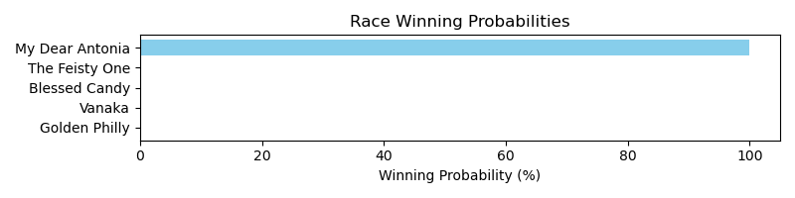

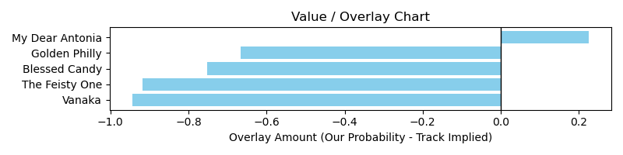

# Race: CNL | 2025-03-13 | Race #4 | Post: 14:05 | Track: COLONIAL DOWNS

Track: COLONIAL DOWNS

|  |  |  |  |  |  |
| --- | --- | --- | --- | --- | --- |
| Program # | Horse Name | Morn Odds | GCSF | Model Score | Win Prob (%) |
| 1 | Capital Conquest | 10-1 | 104.8 | -11.98 | 0.00 |
| 2 | Mowins | 8-1 | 91.5 | -10.50 | 0.00 |
| 3 | Stop the Spread | 15-1 | 99.2 | -21.13 | 0.00 |
| 4 | Shape Note | 4-1 | 93.6 | 9.77 | 0.00 |
| 5 | Quick Tempo | 7-5 | 100.3 | 4.50 | 0.00 |
| 6 | Battle of Bastogne | 20-1 | 96.7 | -2.79 | 0.00 |
| 7 | Nancy Made My Day | 2-1 | 102.2 | 14.17 | 99.97 |

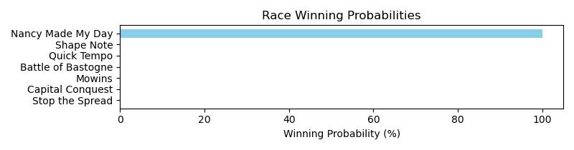

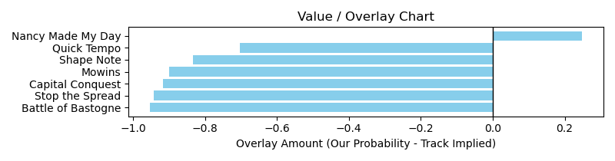

NOTE: GCSF - Global Combined Speed Figure

# Race: CNL | 2025-03-14 | Race #7 | Post: 15:28 | Track: COLONIAL DOWNS

Track: COLONIAL DOWNS

|  |  |  |  |  |  |
| --- | --- | --- | --- | --- | --- |
| Program # | Horse Name | Morn Odds | GCSF | Model Score | Win Prob (%) |
| 1 | Repo Rocks | 5-1 | 93.6 | 4.64 | 0.01 |
| 2 | Celtic Contender | 4-1 | 98.1 | 22.13 | 99.94 |
| 3 | Showstopper Copper | 30-1 | 110.5 | -22.44 | 0.01 |
| 4 | Coffeewithchris | 30-1 | 86.3 | -4.56 | 0.01 |
| 5 | Sharp Tones | 30-1 | 88.1 | -5.22 | 0.01 |
| 6 | Book'em Danno | 1-1 | 100.4 | 13.41 | 0.01 |
| 7 | Destin's Rainbow | 30-1 | 126.6 | -12.51 | 0.01 |
| 8 | Circle P | 20-1 | 100.3 | 18.95 | 0.01 |
| 9 | Power Seeker | 6-1 | 82.6 | -2.98 | 0.01 |
| 10 | Going Up | 20-1 | 115.7 | -6.15 | 0.01 |
| 11 | Paymengold | 20-1 | 99.8 | -2.99 | 0.01 |

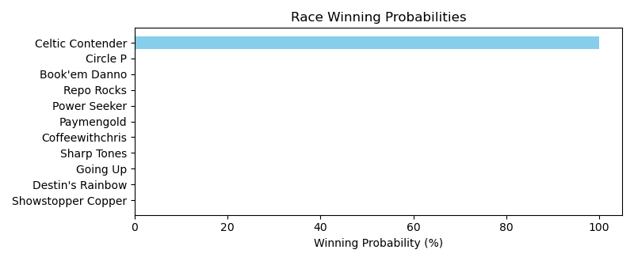

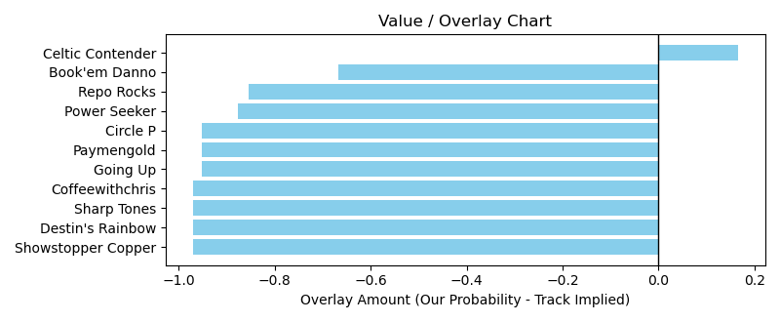

NOTE: GCSF - Global Combined Speed Figure

# Race: CNL | 2025-03-15 | Race #1 | Post: 12:00 | Track: COLONIAL DOWNS

Track: COLONIAL DOWNS

|  |  |  |  |  |  |
| --- | --- | --- | --- | --- | --- |
| Program # | Horse Name | Morn Odds | GCSF | Model Score | Win Prob (%) |
| 1 | Rosieontheriver | 3-1 | 102.0 | -1.48 | 0.00 |
| 2 | Quantum Burst | 4-5 | 98.4 | 6.98 | 99.98 |
| 3 | Krissi N | 7-2 | 92.2 | -10.95 | 0.00 |
| 4 | Luminous Secret | 8-1 | 107.5 | -6.11 | 0.00 |
| 5 | Nick's Notion | 6-1 | 97.0 | -5.96 | 0.00 |

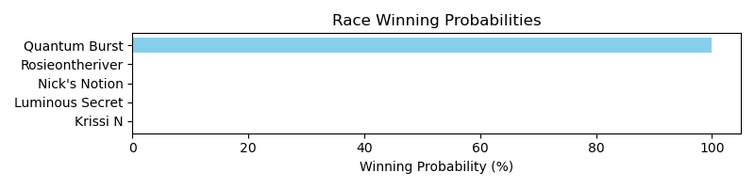

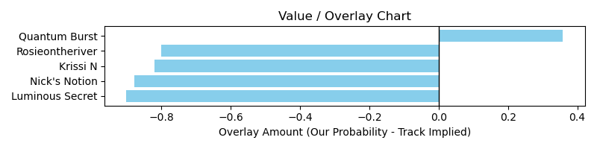

# Race: CNL | 2025-03-15 | Race #3 | Post: 13:10 | Track: COLONIAL DOWNS

Track: COLONIAL DOWNS

|  |  |  |  |  |  |
| --- | --- | --- | --- | --- | --- |
| Program # | Horse Name | Morn Odds | GCSF | Model Score | Win Prob (%) |
| 1 | Scrappy T Lee | 20-1 | 89.4 | -13.76 | 0.01 |
| 2 | Ben's Hero | 4-1 | 90.3 | -2.16 | 0.02 |
| 3 | Nola Boss | 3-1 | 92.2 | -13.17 | 0.01 |
| 4 | Medagooch | 9-2 | 85.4 | -11.47 | 0.01 |
| 5 | Mucho Tigger | 8-1 | 99.5 | -15.03 | 0.01 |
| 6 | Eastbostonbenny | 6-5 | 105.1 | 0.35 | 99.94 |
| 7 | Bishop Meade | 30-1 | 94.5 | -19.60 | 0.01 |

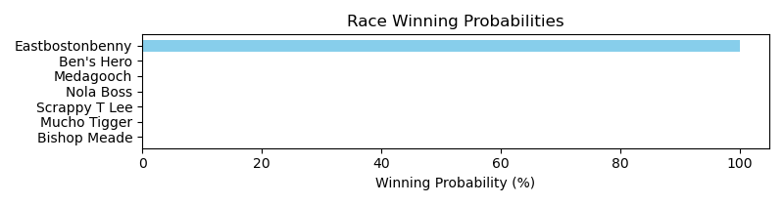

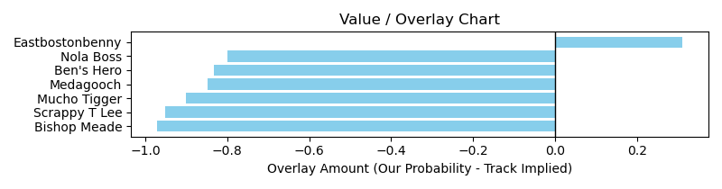

# Race: CNL | 2025-03-15 | Race #10 | Post: 17:50 | Track: COLONIAL DOWNS

Track: COLONIAL DOWNS

|  |  |  |  |  |  |
| --- | --- | --- | --- | --- | --- |
| Program # | Horse Name | Morn Odds | GCSF | Model Score | Win Prob (%) |
| 1 | Mikealicious | 6-1 | 98.8 | -1.64 | 0.00 |
| 2 | Passing Game | 9-2 | 106.6 | 8.22 | 0.00 |
| 3 | Smart Mo | 10-1 | 92.9 | -0.58 | 0.00 |
| 4 | Virginia City | 30-1 | 97.3 | -0.60 | 0.00 |
| 5 | Protege | 8-1 | 98.3 | 0.41 | 0.00 |
| 6 | Supreme Law | 6-5 | 97.1 | 13.11 | 99.96 |
| 7 | Deadpan | 10-1 | 100.3 | 7.95 | 0.00 |
| 8 | White Series | 30-1 | 99.5 | -5.44 | 0.00 |
| 9 | Mo Rewards | 6-1 | 105.5 | 2.96 | 0.00 |

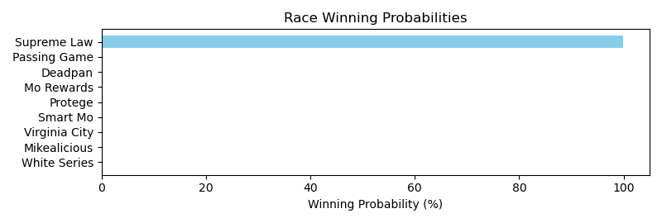

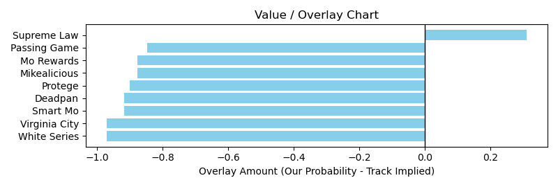

# Race: TFG | 2025-03-13 | Race #2 | Post: 13:15 | Track: FAIR GROUNDS

Track: FAIR GROUNDS

|  |  |  |  |  |  |
| --- | --- | --- | --- | --- | --- |
| Program # | Horse Name | Morn Odds | GCSF | Model Score | Win Prob (%) |
| 7 | Strummin Mary | 8-1 | 110.9 | -15.11 | 0.00 |
| 10 | Cupie Cutie | 5-1 | 108.4 | -8.10 | 100.00 |

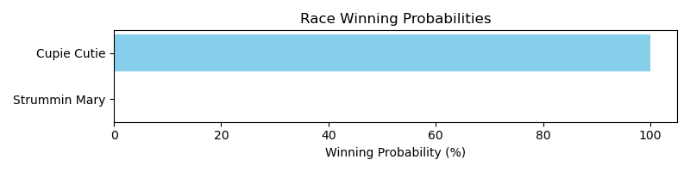

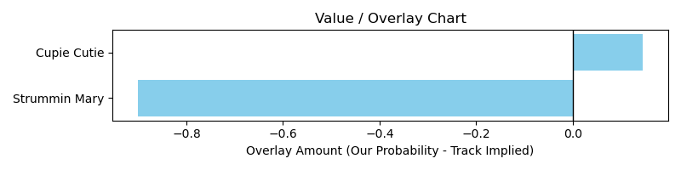

# Race: TFG | 2025-03-13 | Race #3 | Post: 13:45 | Track: FAIR GROUNDS

Track: FAIR GROUNDS

|  |  |  |  |  |  |
| --- | --- | --- | --- | --- | --- |
| Program # | Horse Name | Morn Odds | GCSF | Model Score | Win Prob (%) |
| 1 | Jerry's Eighty | 6-1 | 101.9 | -6.62 | 0.00 |
| 2 | Mr McGregor | 6-1 | 102.1 | -3.81 | 0.00 |
| 3 | Boss' Dialin In | 5-2 | 92.1 | -1.07 | 0.00 |
| 4 | Peso in My Pocket | 5-1 | 106.6 | 2.13 | 0.00 |
| 5 | Captivating Boy | 6-1 | 102.2 | -1.31 | 0.00 |
| 6 | Burninhunkoflove | 3-1 | 96.1 | 7.22 | 99.98 |
| 7 | Gilmore | 6-1 | 89.7 | -7.95 | 0.00 |

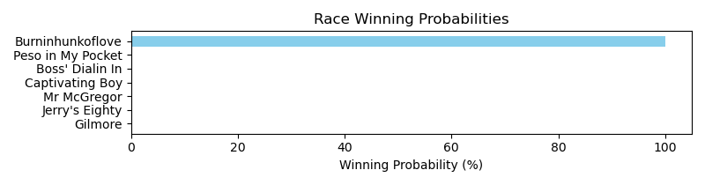

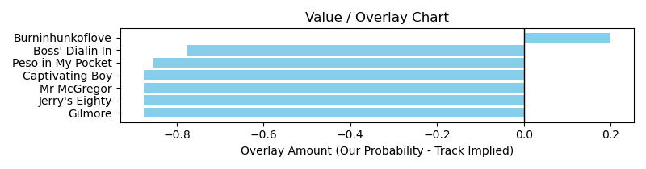

# Race: TFG | 2025-03-13 | Race #4 | Post: 14:15 | Track: FAIR GROUNDS

Track: FAIR GROUNDS

|  |  |  |  |  |  |
| --- | --- | --- | --- | --- | --- |
| Program # | Horse Name | Morn Odds | GCSF | Model Score | Win Prob (%) |
| 4 | Tensas Camp Road | 6-1 | 90.3 | 3.91 | 99.99 |
| 5 | Chaste One | 12-1 | 89.7 | -8.49 | 0.00 |
| 13 | Berndt Marshmallow | 10-1 | 107.4 | -6.52 | 0.00 |

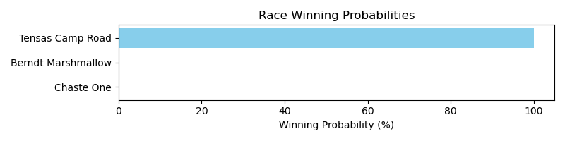

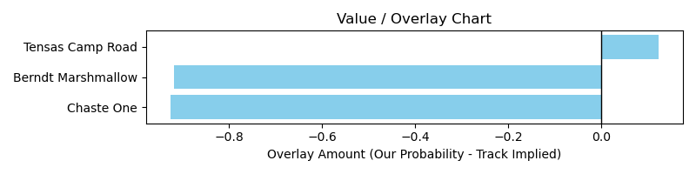

# Race: TFG | 2025-03-13 | Race #5 | Post: 14:45 | Track: FAIR GROUNDS

Track: FAIR GROUNDS

|  |  |  |  |  |  |
| --- | --- | --- | --- | --- | --- |
| Program # | Horse Name | Morn Odds | GCSF | Model Score | Win Prob (%) |
| 1 | Mr. Faversham | 8-1 | 109.7 | 3.90 | 0.04 |
| 2 | Keys Included | 7-2 | 89.5 | 6.35 | 99.87 |
| 3 | Smoothdini | 3-1 | 102.8 | 4.04 | 0.05 |
| 5 | Overanalytical | 7-2 | 93.4 | 1.73 | 0.02 |
| 8 | All West | 8-1 | 98.9 | 0.34 | 0.02 |

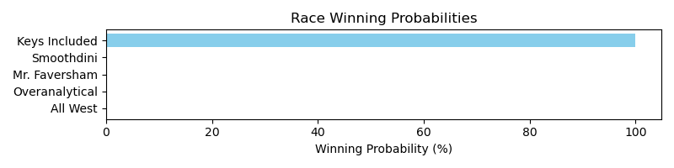

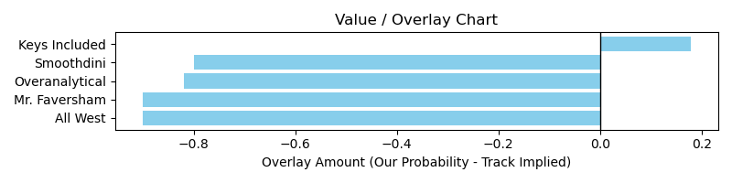

# Race: TFG | 2025-03-13 | Race #6 | Post: 15:15 | Track: FAIR GROUNDS

Track: FAIR GROUNDS

|  |  |  |  |  |  |
| --- | --- | --- | --- | --- | --- |
| Program # | Horse Name | Morn Odds | GCSF | Model Score | Win Prob (%) |
| 7 | Acceleratedvictory | 30-1 | 113.5 | -17.53 | 100.00 |

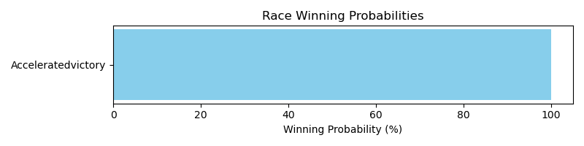

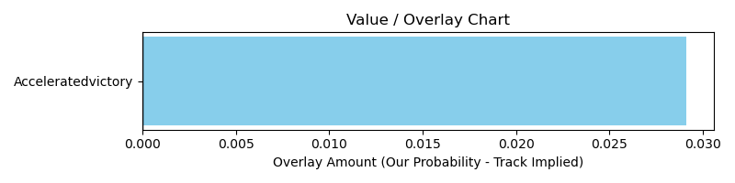

# Race: TFG | 2025-03-13 | Race #7 | Post: 15:45 | Track: FAIR GROUNDS

Track: FAIR GROUNDS

|  |  |  |  |  |  |
| --- | --- | --- | --- | --- | --- |
| Program # | Horse Name | Morn Odds | GCSF | Model Score | Win Prob (%) |
| 2 | Flight Control | 6-1 | 99.6 | 4.94 | 0.06 |
| 3 | Midnight Bella | 12-1 | 87.0 | -4.37 | 0.02 |
| 5 | Berlaine | 7-2 | 91.0 | 3.18 | 0.02 |
| 6 | Sweet Sassicaia | 9-2 | 108.1 | 0.39 | 0.02 |
| 7 | Pasta Salad Rhonda | 10-1 | 78.0 | -17.89 | 0.02 |
| 9 | Start Singing | 10-1 | 87.5 | 6.93 | 99.85 |
| 10 | Trouble With Sugar | 10-1 | 108.5 | 2.73 | 0.02 |

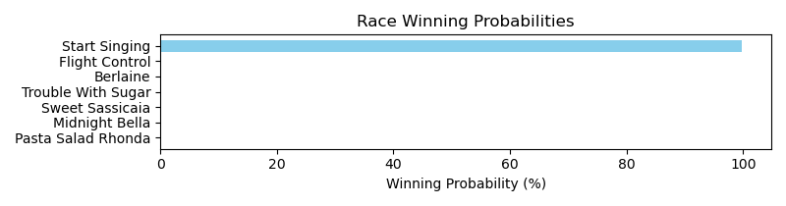

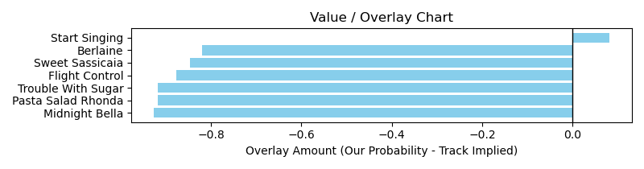

# Race: TFG | 2025-03-13 | Race #8 | Post: 16:15 | Track: FAIR GROUNDS

Track: FAIR GROUNDS

|  |  |  |  |  |  |
| --- | --- | --- | --- | --- | --- |
| Program # | Horse Name | Morn Odds | GCSF | Model Score | Win Prob (%) |
| 5 | Motel Patel | 8-1 | 89.4 | -4.61 | 100.00 |

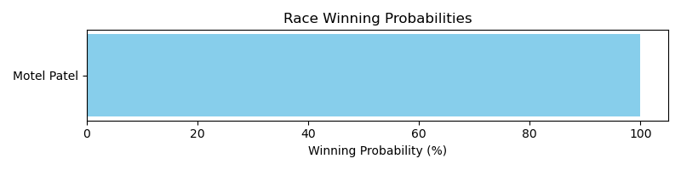

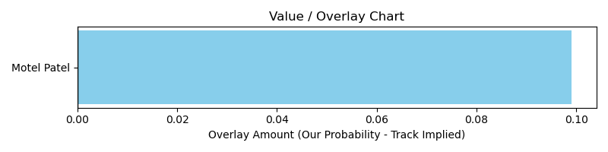

# Race: TFG | 2025-03-13 | Race #9 | Post: 16:45 | Track: FAIR GROUNDS

Track: FAIR GROUNDS

|  |  |  |  |  |  |
| --- | --- | --- | --- | --- | --- |
| Program # | Horse Name | Morn Odds | GCSF | Model Score | Win Prob (%) |
| 3 | Batter Up | 9-2 | 107.3 | 0.93 | 99.97 |
| 4 | Fast Beach | 9-2 | 106.6 | -3.14 | 0.01 |
| 5 | Crooked Bullet | 10-1 | 101.6 | -10.15 | 0.01 |
| 6 | Tequila n' Salt | 8-1 | 106.6 | -2.77 | 0.01 |
| 11 | Storm the Streets | 8-1 | 102.4 | -10.58 | 0.01 |
| 12 | Bigfoot Sighting | 10-1 | 106.3 | -7.91 | 0.01 |

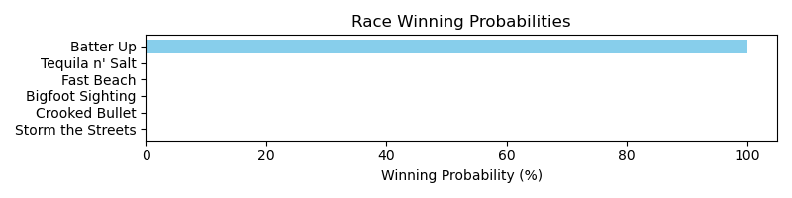

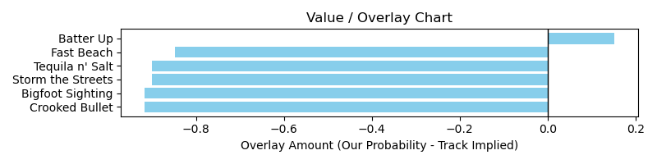

# Race: TFG | 2025-03-13 | Race #10 | Post: 17:15 | Track: FAIR GROUNDS

Track: FAIR GROUNDS

|  |  |  |  |  |  |
| --- | --- | --- | --- | --- | --- |
| Program # | Horse Name | Morn Odds | GCSF | Model Score | Win Prob (%) |
| 6 | Little Z | 5-1 | 92.2 | -5.52 | 99.99 |
| 9 | Taken It | 20-1 | 114.6 | -9.03 | 0.01 |

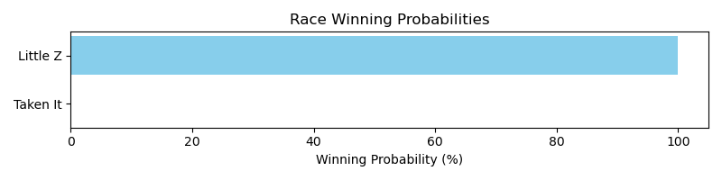

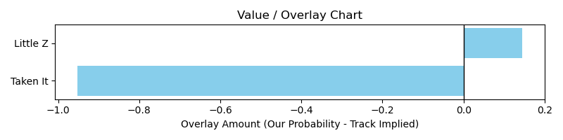

# Race: TFG | 2025-03-14 | Race #1 | Post: 12:45 | Track: FAIR GROUNDS

Track: FAIR GROUNDS

|  |  |  |  |  |  |
| --- | --- | --- | --- | --- | --- |
| Program # | Horse Name | Morn Odds | GCSF | Model Score | Win Prob (%) |
| 1 | One More Sleep | 6-1 | 96.9 | -2.10 | 0.01 |
| 2 | Its Wild Again | 8-1 | 108.6 | 3.79 | 0.01 |
| 3 | Maximum Grace | 3-1 | 104.5 | 6.81 | 99.97 |
| 5 | Lost My Bag | 5-1 | 106.3 | -0.77 | 0.01 |
| 8 | Mine Your Biz | 30-1 | 101.6 | -16.62 | 0.01 |

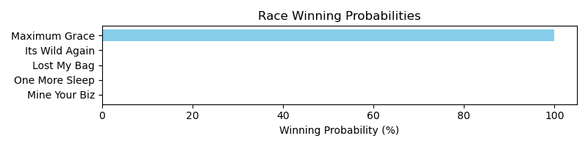

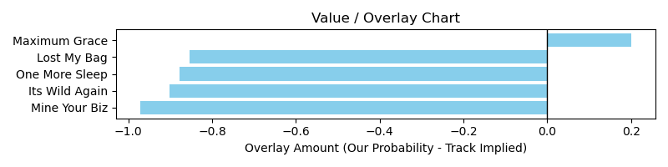

# Race: TFG | 2025-03-14 | Race #2 | Post: 13:15 | Track: FAIR GROUNDS

Track: FAIR GROUNDS

|  |  |  |  |  |  |
| --- | --- | --- | --- | --- | --- |
| Program # | Horse Name | Morn Odds | GCSF | Model Score | Win Prob (%) |
| 2 | Radiant Rebel | 5-2 | 91.9 | 2.78 | 99.99 |
| 3 | Fast Medicine | 10-1 | 112.0 | -7.35 | 0.00 |
| 8 | Run Away Samari | 20-1 | 96.4 | -4.46 | 0.00 |

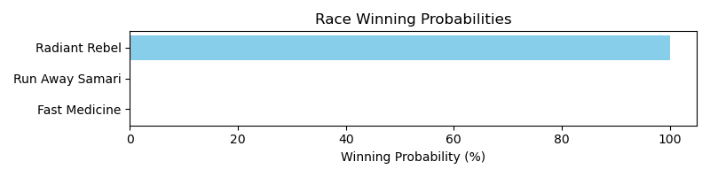

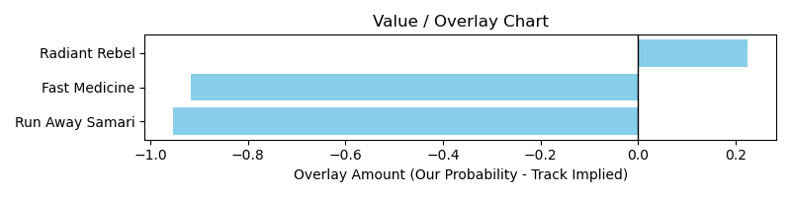

# Race: TFG | 2025-03-14 | Race #4 | Post: 14:15 | Track: FAIR GROUNDS

Track: FAIR GROUNDS

|  |  |  |  |  |  |
| --- | --- | --- | --- | --- | --- |
| Program # | Horse Name | Morn Odds | GCSF | Model Score | Win Prob (%) |
| 1 | Drewmania | 15-1 | 100.0 | -3.78 | 0.00 |
| 2 | Spanish Wells | 12-1 | 105.9 | -13.69 | 0.00 |
| 3 | Monsieur Candy | 7-2 | 106.6 | 0.51 | 0.00 |
| 5 | Bolt From Above | 10-1 | 86.1 | -12.24 | 0.00 |
| 6 | Frost Mountain | 6-1 | 92.3 | -8.32 | 0.00 |
| 7 | Princip | 8-1 | 104.0 | -5.25 | 0.00 |
| 8 | Marcus Gift | 6-1 | 93.2 | -6.15 | 0.00 |
| 9 | Cigarette Boat | 13-8 | 104.4 | 16.00 | 99.97 |

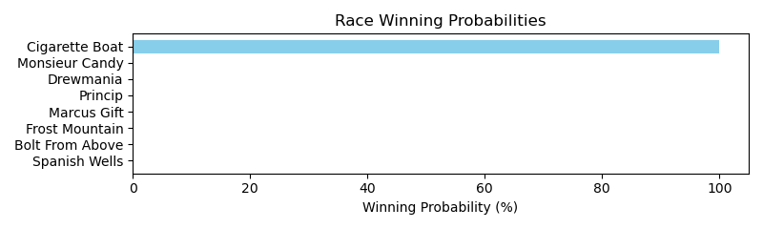

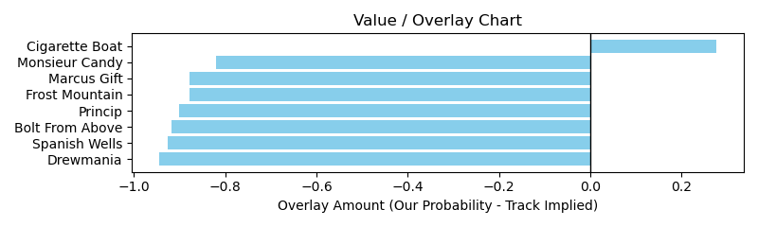

# Race: TFG | 2025-03-14 | Race #5 | Post: 14:45 | Track: FAIR GROUNDS

Track: FAIR GROUNDS

|  |  |  |  |  |  |
| --- | --- | --- | --- | --- | --- |
| Program # | Horse Name | Morn Odds | GCSF | Model Score | Win Prob (%) |
| 1 | Pico d'Oro | 5-1 | 95.7 | -20.20 | 0.00 |
| 2 | Rowdy Jess | 30-1 | 110.2 | -10.82 | 0.01 |
| 4 | Confucius | 8-1 | 103.3 | -5.42 | 99.97 |
| 6 | Treaty | 7-2 | 95.9 | -14.14 | 0.00 |
| 7 | Red Road | 4-1 | 100.8 | -9.26 | 0.01 |
| 9 | Runnin Munnin | 4-1 | 102.3 | -13.43 | 0.00 |

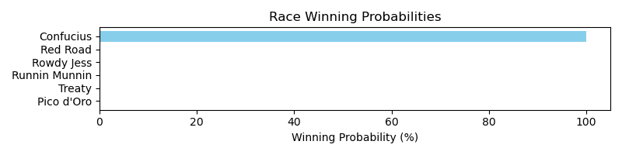

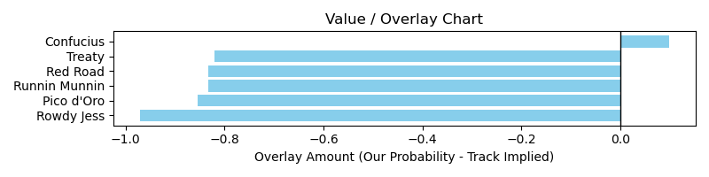

# Race: TFG | 2025-03-14 | Race #6 | Post: 15:15 | Track: FAIR GROUNDS

Track: FAIR GROUNDS

|  |  |  |  |  |  |
| --- | --- | --- | --- | --- | --- |
| Program # | Horse Name | Morn Odds | GCSF | Model Score | Win Prob (%) |
| 1 | Problem Solved | 6-1 | 93.4 | 6.79 | 0.00 |
| 3 | Reteko | 7-2 | 101.7 | 12.00 | 99.99 |
| 9 | Mr. Colossal | 10-1 | 106.6 | -3.17 | 0.00 |
| 11 | Extravagant Prince | 8-1 | 107.3 | -8.51 | 0.00 |

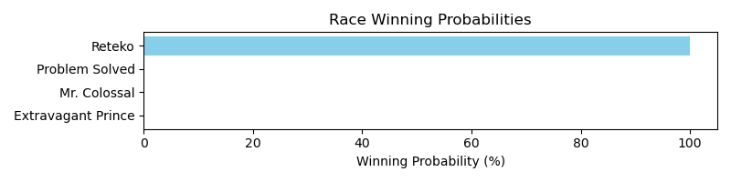

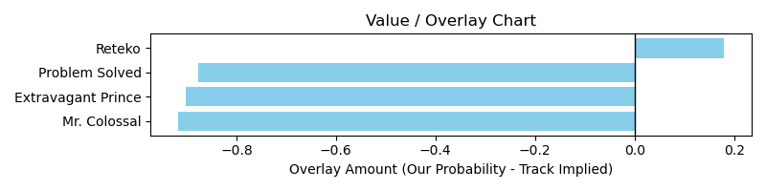

# Race: TFG | 2025-03-14 | Race #7 | Post: 15:45 | Track: FAIR GROUNDS

Track: FAIR GROUNDS

|  |  |  |  |  |  |
| --- | --- | --- | --- | --- | --- |
| Program # | Horse Name | Morn Odds | GCSF | Model Score | Win Prob (%) |
| 1 | Hercules N Love | 30-1 | 92.8 | -15.20 | 0.00 |
| 2 | Cajun Cruiser | 10-1 | 90.2 | -7.80 | 0.00 |
| 5 | Unbridled Pleasure | 7-2 | 90.2 | -3.98 | 0.00 |
| 9 | Knock'em Out Jerry | 3-1 | 99.9 | 5.08 | 99.99 |

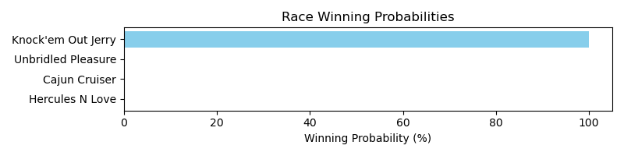

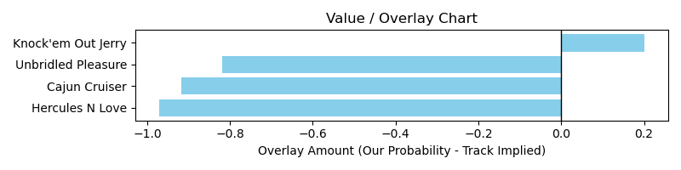

# Race: TFG | 2025-03-14 | Race #8 | Post: 16:15 | Track: FAIR GROUNDS

Track: FAIR GROUNDS

|  |  |  |  |  |  |
| --- | --- | --- | --- | --- | --- |
| Program # | Horse Name | Morn Odds | GCSF | Model Score | Win Prob (%) |
| 1 | Moon Sniper | 6-1 | 106.6 | -0.15 | 0.45 |
| 3 | Innova | 3-1 | 89.0 | -6.67 | 0.17 |
| 4 | Can't Deny It | 6-1 | 93.4 | -15.18 | 0.17 |
| 5 | Lil Muggs | 5-1 | 92.0 | 0.86 | 2.51 |
| 6 | Bridle a Butterfly | 8-1 | 93.4 | 1.72 | 96.51 |
| 7 | Corman | 8-1 | 109.8 | -2.05 | 0.19 |

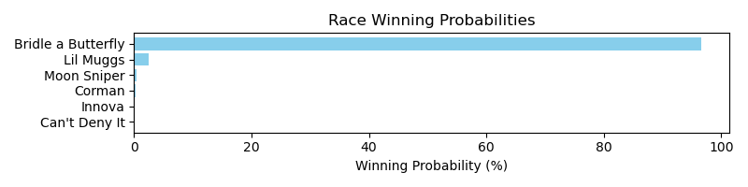

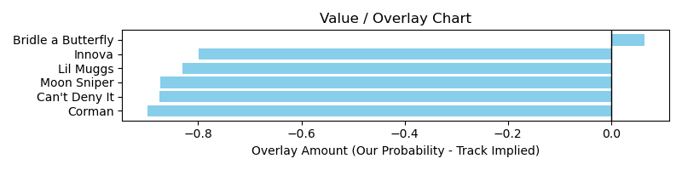

# Race: TFG | 2025-03-14 | Race #9 | Post: 16:45 | Track: FAIR GROUNDS

Track: FAIR GROUNDS

|  |  |  |  |  |  |
| --- | --- | --- | --- | --- | --- |
| Program # | Horse Name | Morn Odds | GCSF | Model Score | Win Prob (%) |
| 8 | Laryslittleracer | 10-1 | 93.4 | -7.65 | 0.00 |
| 12 | Show' Em Nola | 8-1 | 95.3 | 0.55 | 100.00 |

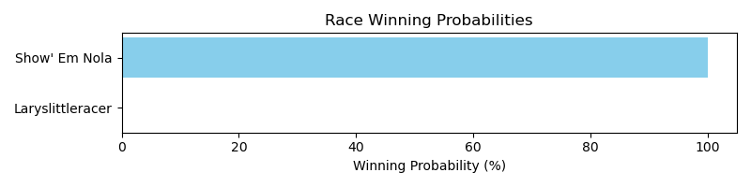

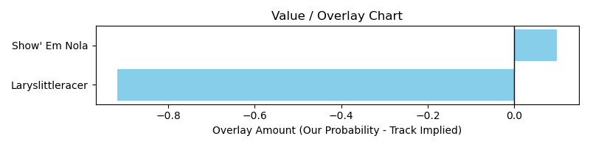

# Race: TGP | 2025-03-13 | Race #1 | Post: 12:50 | Track: GULFSTREAM PARK

Track: GULFSTREAM PARK

|  |  |  |  |  |  |
| --- | --- | --- | --- | --- | --- |
| Program # | Horse Name | Morn Odds | GCSF | Model Score | Win Prob (%) |
| 1 | High Strike | 5-1 | 114.0 | -2.48 | 0.01 |
| 2 | Paschal Moon | 5-2 | 106.2 | -15.46 | 0.01 |
| 3 | Cross Haste | 20-1 | 94.5 | -9.40 | 0.01 |
| 4 | Hey Cue | 9-5 | 98.5 | 6.11 | 0.01 |
| 5 | Lunar Rocket | 15-1 | 89.6 | -21.34 | 0.01 |
| 6 | Gone Nuts | 8-1 | 92.8 | -4.50 | 0.01 |
| 7 | Apollo Code | 3-1 | 87.8 | 9.39 | 99.96 |

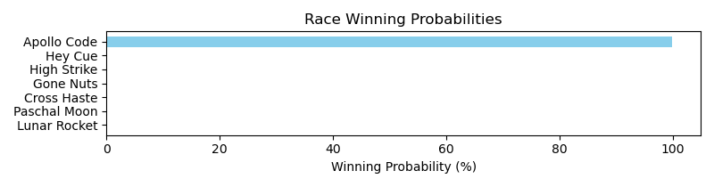

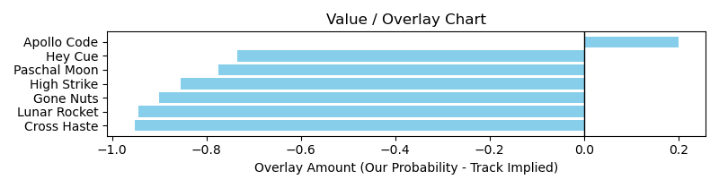

# Race: TGP | 2025-03-13 | Race #3 | Post: 13:54 | Track: GULFSTREAM PARK

Track: GULFSTREAM PARK

|  |  |  |  |  |  |
| --- | --- | --- | --- | --- | --- |
| Program # | Horse Name | Morn Odds | GCSF | Model Score | Win Prob (%) |
| 1 | Down in the Bayou | 2-1 | 101.9 | 5.77 | 0.35 |
| 2 | Princess Miss Emil | 4-1 | 99.5 | -9.74 | 0.05 |
| 3 | Vanishing Wish | 9-2 | 105.7 | -5.56 | 0.05 |
| 4 | One Smokin' Rita | 9-5 | 96.7 | 7.12 | 99.36 |
| 5 | Our Fortune Cookie | 20-1 | 91.2 | -9.94 | 0.05 |
| 6 | Divine Encounter | 20-1 | 102.4 | -11.16 | 0.05 |
| 7 | Windrush | 8-1 | 96.5 | 4.58 | 0.09 |

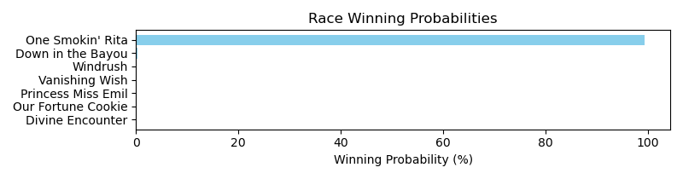

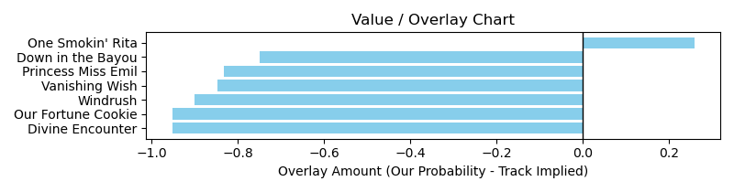

# Race: TGP | 2025-03-13 | Race #6 | Post: 15:29 | Track: GULFSTREAM PARK

Track: GULFSTREAM PARK

|  |  |  |  |  |  |
| --- | --- | --- | --- | --- | --- |
| Program # | Horse Name | Morn Odds | GCSF | Model Score | Win Prob (%) |
| 1 | Power Squeeze | 7-2 | 108.5 | 6.11 | 0.00 |
| 2 | Literate | 8-1 | 101.3 | -1.31 | 0.00 |
| 3 | Gun Song | 7-5 | 97.5 | 21.84 | 99.98 |
| 4 | Abundancia | 8-1 | 107.2 | -14.13 | 0.00 |
| 5 | Just F Y I | 13-8 | 94.8 | -13.81 | 0.00 |
| 6 | Riding Pretty | 20-1 | 103.1 | -5.46 | 0.00 |

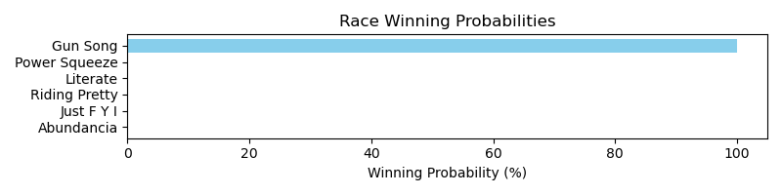

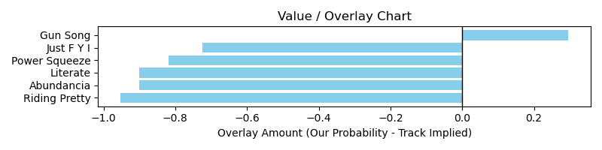

# Race: TGP | 2025-03-13 | Race #7 | Post: 16:00 | Track: GULFSTREAM PARK

Track: GULFSTREAM PARK

|  |  |  |  |  |  |
| --- | --- | --- | --- | --- | --- |
| Program # | Horse Name | Morn Odds | GCSF | Model Score | Win Prob (%) |
| 1 | Rhum Saint Esprit | 20-1 | 94.4 | -11.38 | 0.02 |
| 2 | Coercive | 12-1 | 93.2 | -16.74 | 0.02 |
| 3 | Dios Will | 15-1 | 91.6 | -15.64 | 0.02 |
| 4 | Eastbostonbenny | 8-1 | 89.0 | -3.01 | 0.02 |
| 5 | Boot's On the Moon | 12-1 | 102.5 | -9.74 | 0.02 |
| 6 | Nando | 6-1 | 94.6 | -2.86 | 0.02 |
| 7 | Fregon | 5-1 | 94.4 | -2.08 | 0.02 |
| 8 | Holding the Line (IRE) | 4-1 | 92.9 | 0.35 | 0.06 |
| 9 | Readier | 15-1 | 95.5 | -21.74 | 0.02 |
| 10 | Jefe de Obra (CHI) | 2-1 | 107.8 | 2.26 | 99.80 |

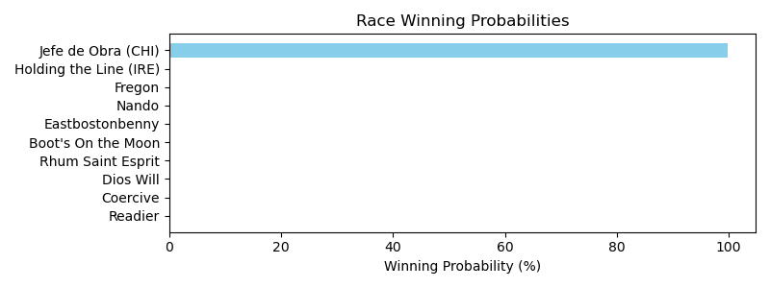

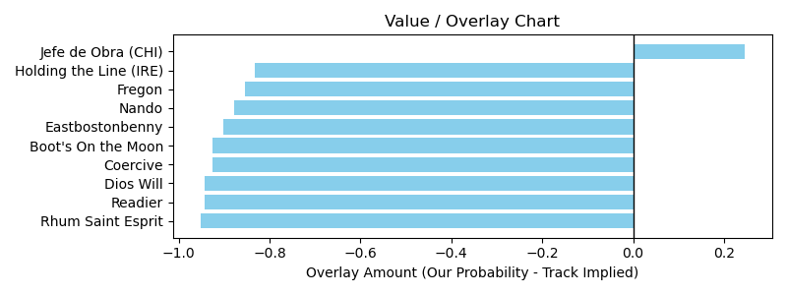

# Race: MVR | 2025-03-13 | Race #1 | Post: 12:15 | Track: MAHONING VALLEY RACE COURSE

Track: MAHONING VALLEY RACE COURSE

|  |  |  |  |  |  |
| --- | --- | --- | --- | --- | --- |
| Program # | Horse Name | Morn Odds | GCSF | Model Score | Win Prob (%) |
| 1 | Sand Wedge | 4-1 | 99.4 | -0.76 | 0.00 |
| 2 | Welloiledcat | 30-1 | 91.6 | -8.13 | 0.00 |
| 3 | Tovia | 9-2 | 111.7 | -0.65 | 0.00 |
| 4 | Minime | 3-1 | 95.1 | -9.33 | 0.00 |
| 5 | West Coast Song | 5-2 | 90.1 | 5.48 | 99.98 |
| 6 | Moonshining | 6-1 | 110.9 | -6.39 | 0.00 |
| 7 | Grace in Excess | 5-1 | 96.0 | -1.61 | 0.00 |

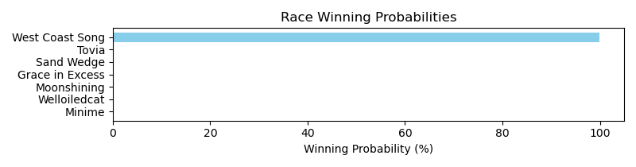

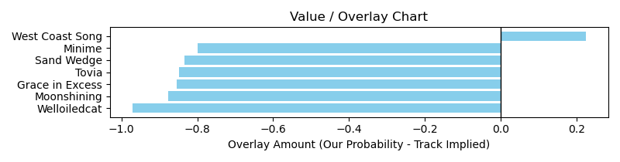

NOTE: GCSF - Global Combined Speed Figure

# Race: MVR | 2025-03-13 | Race #2 | Post: 12:43 | Track: MAHONING VALLEY RACE COURSE

Track: MAHONING VALLEY RACE COURSE

|  |  |  |  |  |  |
| --- | --- | --- | --- | --- | --- |
| Program # | Horse Name | Morn Odds | GCSF | Model Score | Win Prob (%) |
| 1 | Group Eighteen | 5-2 | 98.3 | 5.75 | 0.00 |
| 2 | Writeitontheice | 15-1 | 90.6 | -4.70 | 0.00 |
| 3 | That Khenny | 8-1 | 96.8 | -8.15 | 0.00 |
| 4 | First Citizen | 6-1 | 95.2 | 15.16 | 99.97 |
| 5 | Noble Behavior | 20-1 | 104.8 | -0.68 | 0.00 |
| 6 | Bourbon Wisdom | 9-5 | 102.3 | 8.47 | 0.00 |
| 7 | Ranseur | 20-1 | 99.0 | -5.78 | 0.00 |
| 8 | Milano | 7-2 | 105.7 | -2.25 | 0.00 |

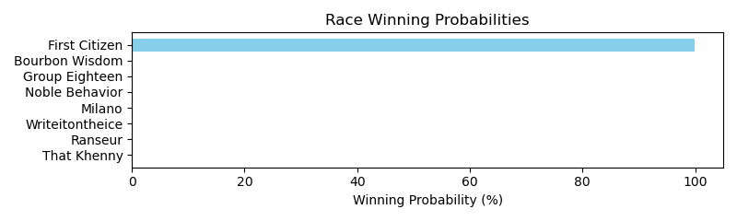

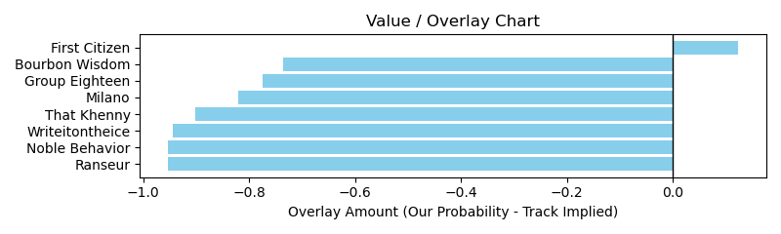

NOTE: GCSF - Global Combined Speed Figure

# Race: MVR | 2025-03-13 | Race #3 | Post: 13:11 | Track: MAHONING VALLEY RACE COURSE

Track: MAHONING VALLEY RACE COURSE

|  |  |  |  |  |  |
| --- | --- | --- | --- | --- | --- |
| Program # | Horse Name | Morn Odds | GCSF | Model Score | Win Prob (%) |
| 1 | Manfredi | 6-1 | 114.5 | -19.68 | 0.00 |
| 2 | Raven Moon | 12-1 | 99.2 | -7.13 | 0.00 |
| 3 | Moreau | 13-8 | 95.0 | 9.53 | 99.98 |
| 4 | Spencer's Boy Luna | 3-1 | 91.3 | 4.07 | 0.00 |
| 5 | John's Rock | 2-1 | 94.1 | 4.09 | 0.00 |
| 6 | Silence | 12-1 | 99.9 | -2.89 | 0.00 |

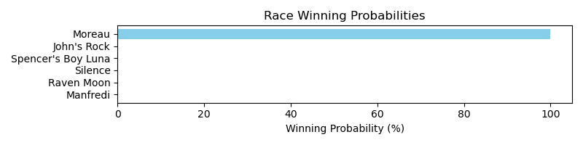

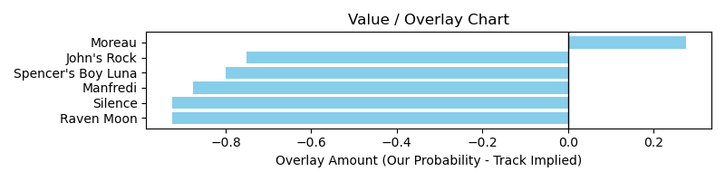

NOTE: GCSF - Global Combined Speed Figure

# Race: MVR | 2025-03-13 | Race #5 | Post: 14:07 | Track: MAHONING VALLEY RACE COURSE

Track: MAHONING VALLEY RACE COURSE

|  |  |  |  |  |  |
| --- | --- | --- | --- | --- | --- |
| Program # | Horse Name | Morn Odds | GCSF | Model Score | Win Prob (%) |
| 1 | Blue Max | 5-2 | 99.0 | -6.00 | 0.00 |
| 2 | Big Rowdy Dan | 5-1 | 98.5 | 1.60 | 0.00 |
| 3 | Guns n' Rojas | 4-1 | 97.5 | -4.78 | 0.00 |
| 4 | Doctor Wu | 9-2 | 105.2 | 3.84 | 0.00 |
| 5 | Magical Monarch | 6-1 | 97.5 | -4.09 | 0.00 |
| 6 | Logico | 7-2 | 99.4 | 12.19 | 99.98 |
| 7 | Simply Valid | 12-1 | 86.4 | -1.98 | 0.00 |

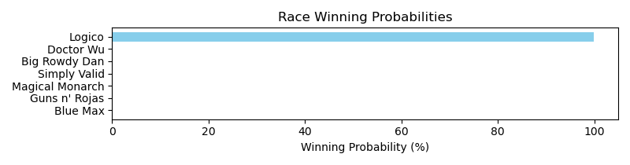

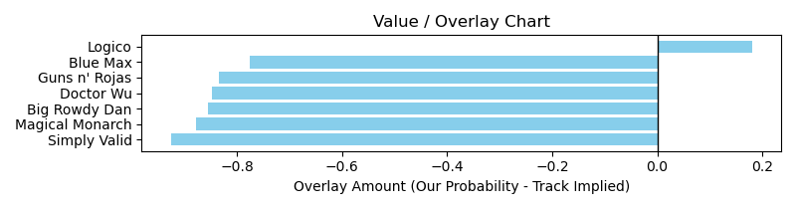

NOTE: GCSF - Global Combined Speed Figure

# Race: MVR | 2025-03-13 | Race #6 | Post: 14:35 | Track: MAHONING VALLEY RACE COURSE

Track: MAHONING VALLEY RACE COURSE

|  |  |  |  |  |  |
| --- | --- | --- | --- | --- | --- |
| Program # | Horse Name | Morn Odds | GCSF | Model Score | Win Prob (%) |
| 1 | Princessofthenorth | 10-1 | 86.5 | -11.62 | 0.01 |
| 2 | Hartful Hope | 10-1 | 94.4 | -4.81 | 0.01 |
| 3 | Blushing Betty | 4-1 | 100.7 | 1.38 | 99.92 |
| 4 | Tiz Independence | 6-1 | 99.4 | -7.52 | 0.01 |
| 5 | Tattered Heart | 20-1 | 102.7 | -12.71 | 0.01 |
| 6 | Reno Touch | 10-1 | 92.0 | -10.38 | 0.01 |
| 7 | Miss Fussy Pants | 5-2 | 105.1 | -1.27 | 0.02 |
| 8 | Kingdom Queen | 7-2 | 94.3 | -3.07 | 0.01 |
| 9 | Epicurean | 8-1 | 99.4 | -3.89 | 0.01 |

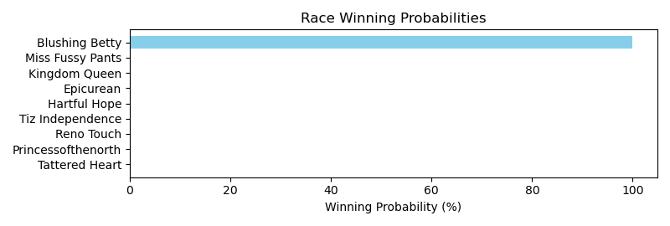

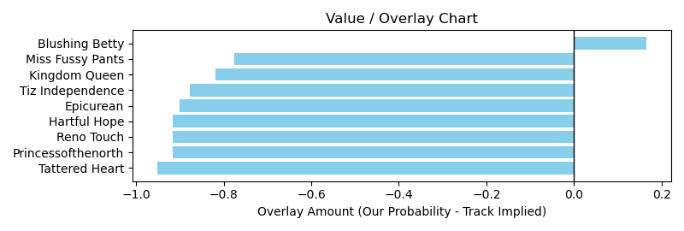

NOTE: GCSF - Global Combined Speed Figure

# Race: MVR | 2025-03-13 | Race #7 | Post: 15:03 | Track: MAHONING VALLEY RACE COURSE

Track: MAHONING VALLEY RACE COURSE

|  |  |  |  |  |  |
| --- | --- | --- | --- | --- | --- |
| Program # | Horse Name | Morn Odds | GCSF | Model Score | Win Prob (%) |
| 1 | Mshindi | 10-1 | 100.9 | -7.54 | 0.02 |
| 2 | Bucket List | 6-1 | 105.0 | -0.00 | 0.02 |
| 3 | Hub | 5-2 | 101.5 | 2.54 | 0.02 |
| 4 | Destino | 20-1 | 103.7 | 1.84 | 0.02 |
| 5 | Deus Ex Machina | 12-1 | 105.6 | -4.22 | 0.02 |
| 6 | Buehler's Day Off | 3-1 | 99.9 | 2.71 | 0.02 |
| 7 | Dixie's Two Stents | 15-1 | 113.2 | 10.43 | 99.83 |
| 8 | Bailamos | 7-2 | 92.4 | 8.39 | 0.05 |
| 9 | Don't Stop | 8-1 | 95.8 | 7.06 | 0.02 |

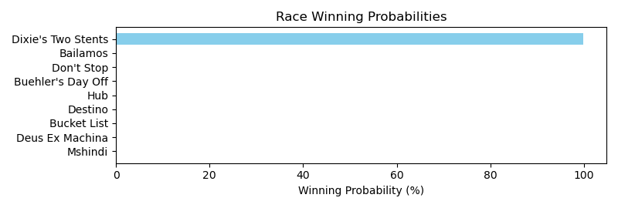

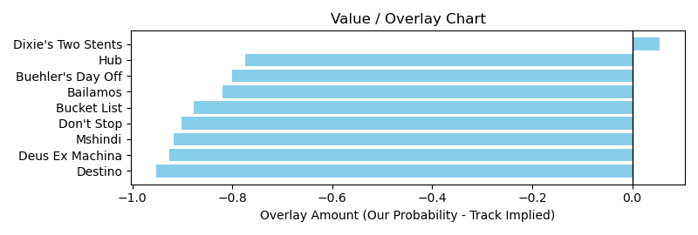

NOTE: GCSF - Global Combined Speed Figure

# Race: TOP | 2025-03-14 | Race #1 | Post: 12:35 | Track: OAKLAWN PARK

Track: OAKLAWN PARK

|  |  |  |  |  |  |
| --- | --- | --- | --- | --- | --- |
| Program # | Horse Name | Morn Odds | GCSF | Model Score | Win Prob (%) |
| 1 | Pens Street | 9-5 | 103.8 | 3.94 | 99.95 |
| 2 | Key to Success | 12-1 | 108.1 | -3.79 | 0.01 |
| 3 | Kirby Kaye | 15-1 | 115.5 | -2.73 | 0.01 |
| 4 | Best Performer | 9-2 | 83.6 | -5.07 | 0.01 |
| 5 | Sunny Isle Beach | 8-1 | 89.0 | -14.20 | 0.01 |
| 6 | Tiffany Twist | 5-1 | 112.4 | -9.05 | 0.01 |
| 7 | Rose Palace | 5-2 | 120.6 | 1.10 | 0.01 |
| 8 | Templar Red | 15-1 | 87.4 | -2.51 | 0.01 |

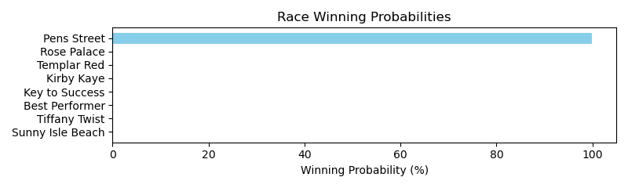

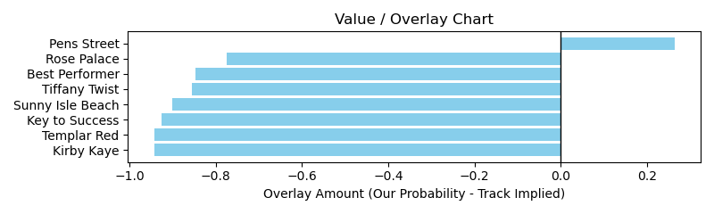

NOTE: GCSF - Global Combined Speed Figure

# Race: TOP | 2025-03-14 | Race #2 | Post: 13:10 | Track: OAKLAWN PARK

Track: OAKLAWN PARK

|  |  |  |  |  |  |
| --- | --- | --- | --- | --- | --- |
| Program # | Horse Name | Morn Odds | GCSF | Model Score | Win Prob (%) |
| 1 | Super Brady | 12-1 | 95.6 | -17.60 | 1.01 |
| 2 | Metallic Man | 10-1 | 87.3 | -17.92 | 1.01 |
| 3 | Worth Looking | 4-1 | 102.2 | -7.14 | 9.34 |
| 4 | Burning Leaves | 12-1 | 88.7 | -6.50 | 69.46 |
| 5 | Dr. Soulfire | 3-1 | 91.8 | -7.10 | 10.39 |
| 6 | Blow Torch | 12-1 | 102.1 | -8.73 | 1.59 |
| 7 | Wet and Wild | 20-1 | 100.3 | -20.48 | 1.01 |
| 8 | Gold Baron | 50-1 | 102.8 | -15.54 | 1.01 |
| 9 | Cost Basis | 6-1 | 102.5 | -16.23 | 1.01 |
| 10 | Larry's Legend | 15-1 | 99.1 | -8.73 | 1.59 |
| 11 | Warp Ride | 30-1 | 95.1 | -18.06 | 1.01 |
| 12 | Derby Date | 5-2 | 102.6 | -8.70 | 1.61 |

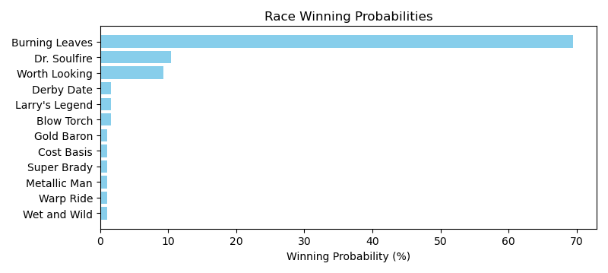

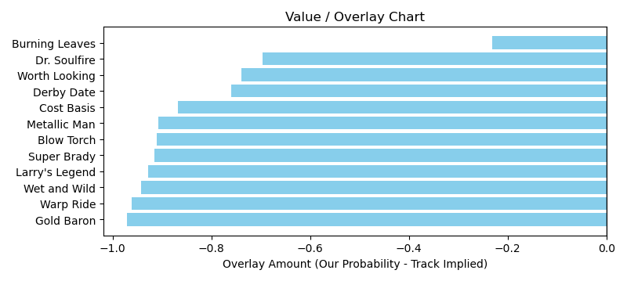

# Race: TOP | 2025-03-14 | Race #6 | Post: 15:22 | Track: OAKLAWN PARK

Track: OAKLAWN PARK

|  |  |  |  |  |  |
| --- | --- | --- | --- | --- | --- |
| Program # | Horse Name | Morn Odds | GCSF | Model Score | Win Prob (%) |
| 1 | Lend It Tewmey | 7-2 | 107.3 | 9.19 | 99.94 |
| 2 | Magical Mark | 3-1 | 89.8 | 5.97 | 0.01 |
| 3 | Without Borders | 5-2 | 109.4 | -3.63 | 0.01 |
| 4 | Here Comes Braylon | 12-1 | 96.7 | 2.91 | 0.01 |
| 5 | League of Legends | 12-1 | 97.9 | -2.37 | 0.01 |
| 6 | Crew Dragon | 10-1 | 97.9 | -0.59 | 0.01 |
| 7 | Charleston | 20-1 | 88.9 | -4.67 | 0.01 |
| 8 | Pass Line | 15-1 | 95.0 | -8.30 | 0.01 |
| 9 | Hailstorm | 9-2 | 96.7 | 4.99 | 0.01 |

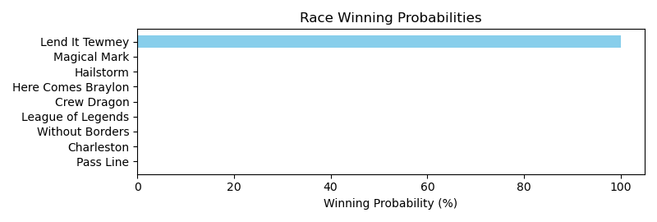

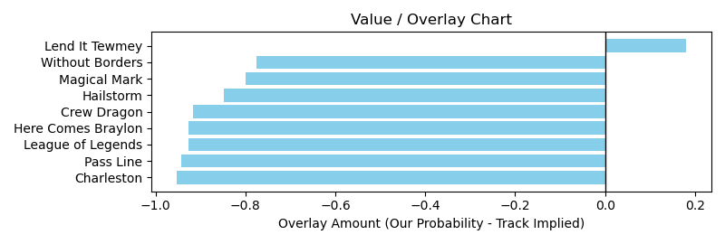

# Race: TOP | 2025-03-14 | Race #8 | Post: 16:25 | Track: OAKLAWN PARK

Track: OAKLAWN PARK

|  |  |  |  |  |  |
| --- | --- | --- | --- | --- | --- |
| Program # | Horse Name | Morn Odds | GCSF | Model Score | Win Prob (%) |
| 1 | Rewire | 3-1 | 104.6 | -0.30 | 0.02 |
| 2 | Natorade | 15-1 | 104.1 | -17.40 | 0.02 |
| 3 | Statler | 30-1 | 100.7 | -13.31 | 0.02 |
| 4 | Madmartigan | 30-1 | 100.6 | -18.66 | 0.02 |
| 5 | Air It Out | 2-1 | 104.8 | 4.49 | 99.78 |
| 6 | Celentano | 7-2 | 100.8 | 2.63 | 0.06 |
| 7 | It's a Rainy Day | 20-1 | 109.1 | -19.03 | 0.02 |
| 8 | Loud Boy | 20-1 | 92.3 | -6.42 | 0.02 |
| 9 | Improbable First | 30-1 | 93.4 | -17.25 | 0.02 |
| 10 | Gold Member | 12-1 | 107.3 | -7.39 | 0.02 |
| 11 | East From West | 15-1 | 86.4 | -12.68 | 0.02 |
| 12 | Cloud Without Rein | 6-1 | 93.7 | -2.61 | 0.02 |

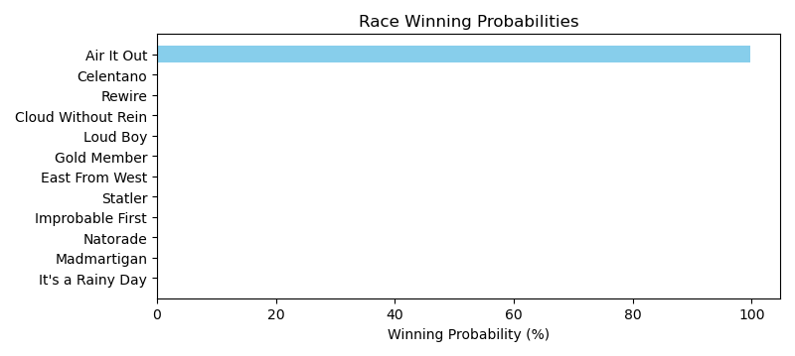

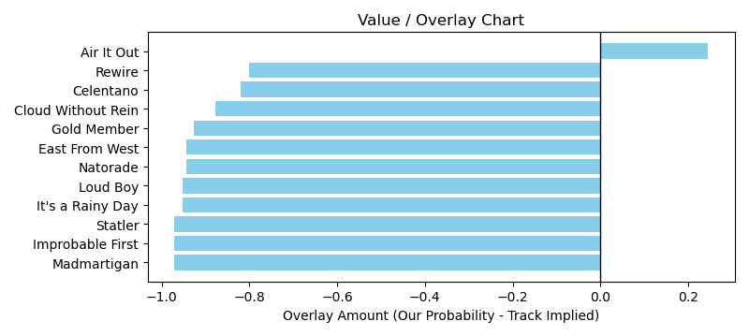

# Race: TOP | 2025-03-14 | Race #9 | Post: 16:57 | Track: OAKLAWN PARK

Track: OAKLAWN PARK

|  |  |  |  |  |  |
| --- | --- | --- | --- | --- | --- |
| Program # | Horse Name | Morn Odds | GCSF | Model Score | Win Prob (%) |
| 1 | Horace Mann | 5-1 | 111.2 | -17.53 | 0.00 |
| 2 | Zatara | 30-1 | 108.3 | 0.24 | 0.00 |
| 3 | Classic Car Wash | 20-1 | 118.1 | 7.27 | 0.00 |
| 4 | Catching Freedom | 4-1 | 90.8 | 1.38 | 0.00 |
| 5 | Bendoog | 7-5 | 90.4 | 10.26 | 0.00 |
| 6 | In a Jam | 12-1 | 98.3 | 18.77 | 99.97 |
| 7 | Tonka Warrior | 30-1 | 91.7 | -6.83 | 0.00 |
| 8 | Disarm | 2-1 | 89.7 | 14.14 | 0.00 |

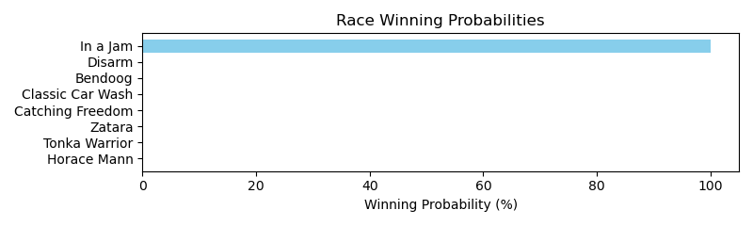

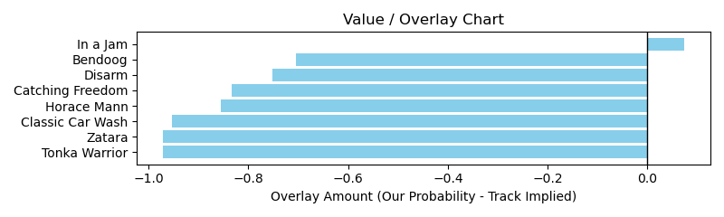

# Race: TOP | 2025-03-15 | Race #3 | Post: 13:34 | Track: OAKLAWN PARK

Track: OAKLAWN PARK

|  |  |  |  |  |  |
| --- | --- | --- | --- | --- | --- |
| Program # | Horse Name | Morn Odds | GCSF | Model Score | Win Prob (%) |
| 1 | Courageous Cappen | 20-1 | 104.2 | -5.69 | 0.00 |
| 2 | Rock Star Parking | 20-1 | 89.3 | -17.77 | 0.00 |
| 3 | Awesome Annmarie | 13-8 | 94.7 | 8.78 | 99.97 |
| 4 | Tell Me When | 5-1 | 113.2 | -2.64 | 0.00 |
| 5 | dh-Austrian Navy | 9-2 | 91.4 | 1.52 | 0.00 |
| 6 | Riobella | 12-1 | 98.3 | 2.75 | 0.00 |
| 7 | Wreaking Havoc | 6-1 | 91.1 | 2.93 | 0.00 |
| 8 | Atlantic Strike | 8-1 | 91.0 | -12.19 | 0.00 |
| 9 | Summer Shoes | 8-1 | 91.9 | -5.61 | 0.00 |

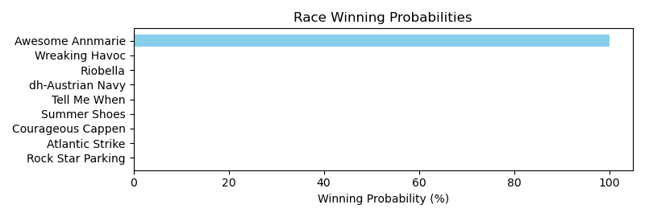

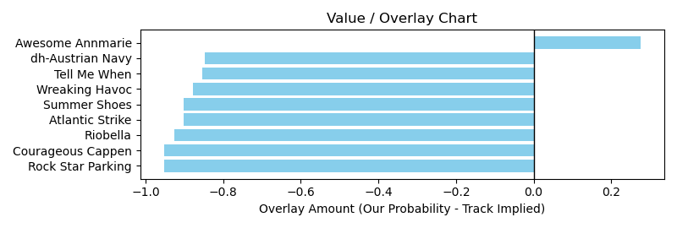

# Race: TOP | 2025-03-15 | Race #4 | Post: 14:05 | Track: OAKLAWN PARK

Track: OAKLAWN PARK

|  |  |  |  |  |  |
| --- | --- | --- | --- | --- | --- |
| Program # | Horse Name | Morn Odds | GCSF | Model Score | Win Prob (%) |
| 1 | Mo Moves | 20-1 | 96.7 | -22.66 | 0.31 |
| 2 | Dual Monarchy | 12-1 | 121.0 | -11.38 | 0.31 |
| 3 | Hey Boss | 3-1 | 86.4 | 0.87 | 2.37 |
| 4 | Mo Rum | 15-1 | 108.4 | -12.69 | 0.31 |
| 5 | dq-Feathers Road | 9-5 | 91.2 | 1.89 | 91.35 |
| 6 | Mansoura | 4-1 | 109.4 | 1.04 | 3.51 |
| 7 | Chupapi Munyayo | 15-1 | 116.4 | -5.65 | 0.31 |
| 8 | J T's Imagination | 20-1 | 93.0 | -10.65 | 0.31 |
| 9 | Patch O'Brien | 8-1 | 96.1 | -8.22 | 0.31 |
| 10 | Euclid Avenue | 12-1 | 91.4 | -6.68 | 0.31 |
| 11 | Quick Buck | 20-1 | 98.8 | -16.65 | 0.31 |
| 12 | Fight'n Ready | 50-1 | 92.3 | -20.69 | 0.31 |

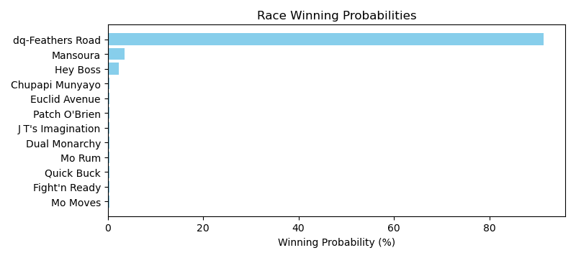

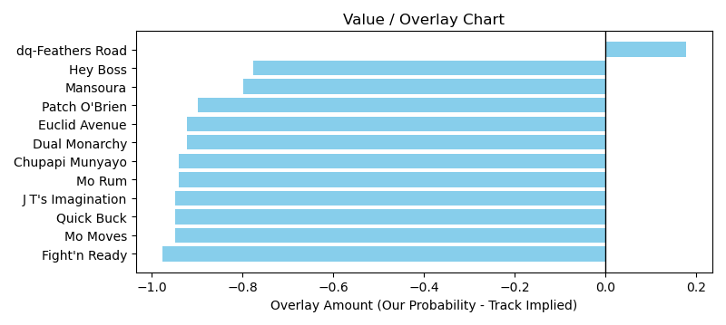

# Race: TOP | 2025-03-15 | Race #5 | Post: 14:37 | Track: OAKLAWN PARK

Track: OAKLAWN PARK

|  |  |  |  |  |  |
| --- | --- | --- | --- | --- | --- |
| Program # | Horse Name | Morn Odds | GCSF | Model Score | Win Prob (%) |
| 1 | Seas of Normandy | 7-2 | 93.6 | 7.97 | 99.95 |
| 2 | Tiwanaku | 4-1 | 98.8 | 0.56 | 0.00 |
| 3 | Allo Enry | 15-1 | 92.1 | -8.79 | 0.00 |
| 4 | Go Cats | 8-1 | 93.9 | -2.03 | 0.00 |
| 5 | Seven Flat | 9-2 | 94.8 | -1.10 | 0.00 |
| 6 | Life Is Hard | 10-1 | 107.2 | -9.95 | 0.00 |
| 7 | Lemon Drop Shot | 15-1 | 104.9 | -5.23 | 0.00 |
| 8 | Chaos Reigns | 15-1 | 97.1 | -22.05 | 0.00 |
| 9 | Deflater | 15-1 | 120.5 | -0.49 | 0.00 |
| 10 | Verb | 30-1 | 111.5 | -10.92 | 0.00 |
| 11 | Khozy My Boy | 8-1 | 85.5 | 0.62 | 0.00 |
| 12 | Logical Myth | 6-1 | 88.9 | -5.30 | 0.00 |
| 13 | Mr. Thunderstruck | 20-1 | 100.3 | -16.44 | 0.00 |
| 14 | Legendary Lore | 15-1 | 117.0 | 1.53 | 0.00 |

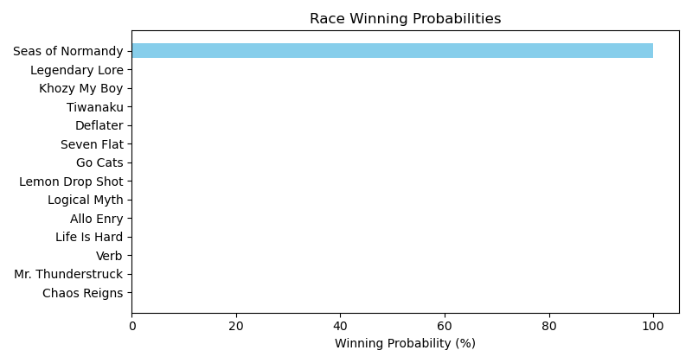

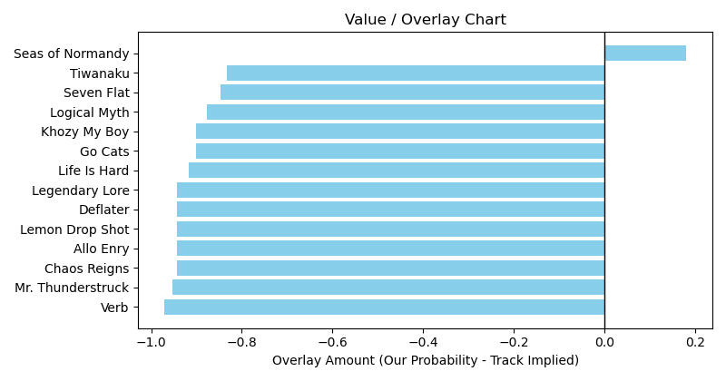

# Race: TOP | 2025-03-15 | Race #8 | Post: 16:12 | Track: OAKLAWN PARK

Track: OAKLAWN PARK

|  |  |  |  |  |  |
| --- | --- | --- | --- | --- | --- |
| Program # | Horse Name | Morn Odds | GCSF | Model Score | Win Prob (%) |
| 1 | Rabbit Hound | 4-1 | 98.7 | -0.20 | 0.00 |
| 2 | Hi Yah | 15-1 | 96.4 | -2.85 | 0.00 |
| 3 | Midnight Pranks | 5-1 | 101.6 | -4.98 | 0.00 |
| 4 | Jackman | 3-1 | 96.7 | -11.25 | 0.00 |
| 5 | Vale | 15-1 | 95.1 | -3.53 | 0.00 |
| 6 | Samurai Prince | 7-2 | 93.2 | 5.79 | 99.96 |
| 7 | Ben Diesel | 20-1 | 115.2 | -8.31 | 0.00 |
| 8 | Refuah | 6-1 | 105.9 | -2.78 | 0.00 |
| 9 | Nullarbor | 15-1 | 91.9 | -16.64 | 0.00 |
| 10 | Circle Back Jack | 15-1 | 96.7 | -11.11 | 0.00 |
| 11 | Born Flawless | 20-1 | 96.9 | -20.16 | 0.00 |

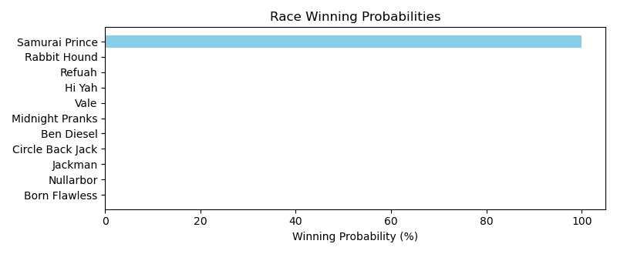

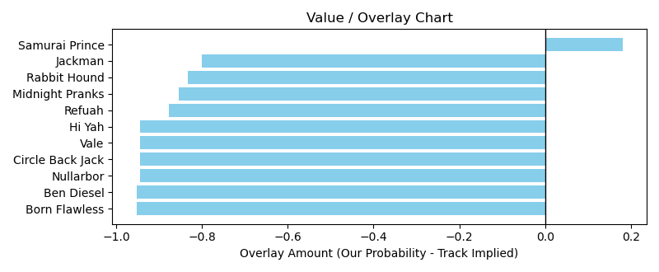

# Race: TOP | 2025-03-15 | Race #10 | Post: 17:17 | Track: OAKLAWN PARK

Track: OAKLAWN PARK

|  |  |  |  |  |  |
| --- | --- | --- | --- | --- | --- |
| Program # | Horse Name | Morn Odds | GCSF | Model Score | Win Prob (%) |
| 1 | Tejano Twist | 7-2 | 100.6 | 17.37 | 0.01 |
| 2 | Happy Is a Choice | 4-1 | 94.8 | 17.06 | 0.01 |
| 3 | Giant Mischief | 5-1 | 94.3 | 10.78 | 0.01 |
| 4 | Booth | 3-1 | 97.5 | 23.19 | 99.94 |
| 5 | Jaxon Traveler | 10-1 | 94.9 | 12.70 | 0.01 |
| 6 | Glengarry | 20-1 | 96.8 | 6.94 | 0.01 |
| 7 | Miles Ahead | 8-1 | 101.9 | 20.31 | 0.01 |
| 8 | Closethegame Sugar | 9-2 | 95.0 | -2.05 | 0.01 |
| 9 | Durante | 20-1 | 102.3 | 8.77 | 0.01 |

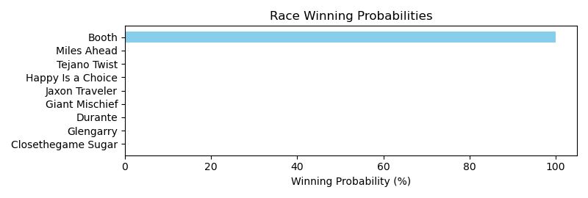

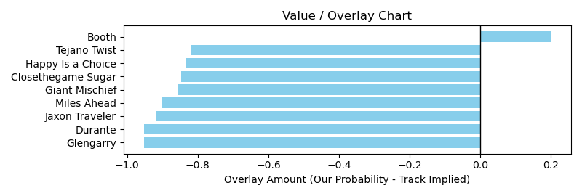

# Race: TOP | 2025-03-15 | Race #11 | Post: 17:50 | Track: OAKLAWN PARK

Track: OAKLAWN PARK

|  |  |  |  |  |  |
| --- | --- | --- | --- | --- | --- |
| Program # | Horse Name | Morn Odds | GCSF | Model Score | Win Prob (%) |
| 1 | California Tiger | 15-1 | 123.0 | -8.24 | 0.02 |
| 2 | King Russell | 9-2 | 104.2 | 11.46 | 99.69 |
| 3 | Silver Heist | 10-1 | 90.1 | 3.96 | 0.02 |
| 4 | Mena | 3-1 | 107.6 | 8.43 | 0.03 |
| 5 | Title Contender | 30-1 | 104.7 | -10.33 | 0.02 |
| 6 | Dance Some Mo | 15-1 | 94.4 | -1.18 | 0.02 |
| 7 | Bourbon Aficionado | 30-1 | 107.1 | -7.55 | 0.02 |
| 8 | Harleezy | 30-1 | 98.8 | -6.18 | 0.02 |
| 9 | Nullify | 7-2 | 96.5 | -1.06 | 0.02 |
| 10 | Pike Place | 12-1 | 92.0 | 0.37 | 0.02 |
| 11 | Spoiler | 5-1 | 96.2 | 3.99 | 0.02 |
| 12 | Ethan Energy | 6-1 | 99.3 | 9.48 | 0.06 |
| 13 | Bolt At Midnight | 12-1 | 95.4 | 5.94 | 0.02 |
| 14 | Lear | 30-1 | 105.8 | -2.89 | 0.02 |

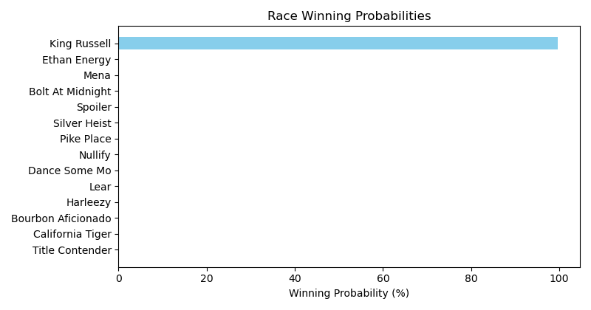

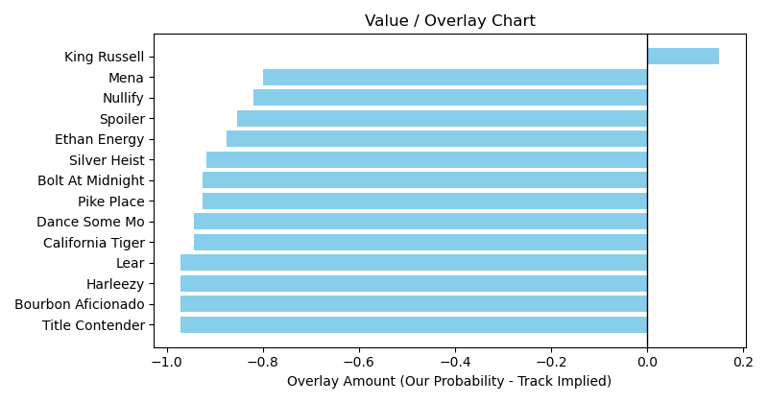

# Race: PEN | 2025-03-13 | Race #7 | Post: 20:39 | Track: PENN NATIONAL

Track: PENN NATIONAL

|  |  |  |  |  |  |
| --- | --- | --- | --- | --- | --- |
| Program # | Horse Name | Morn Odds | GCSF | Model Score | Win Prob (%) |
| 1 | Mucho Macho Eddie | 12-1 | 94.1 | -9.87 | 0.00 |
| 2 | Textpectation | 50-1 | 102.8 | 0.89 | 0.00 |
| 3 | Twixter | 6-1 | 95.9 | 5.48 | 0.00 |
| 4 | Rustys Gfivefifty | 7-2 | 100.7 | 4.69 | 0.00 |
| 5 | Lake Nakuru | 4-1 | 108.1 | 0.13 | 0.00 |
| 6 | Cajun Occasion | 12-1 | 98.8 | 7.74 | 0.00 |
| 7 | Makabim | 3-1 | 94.3 | 6.09 | 0.00 |
| 8 | Jump for the Win | 5-2 | 114.2 | 14.23 | 99.97 |

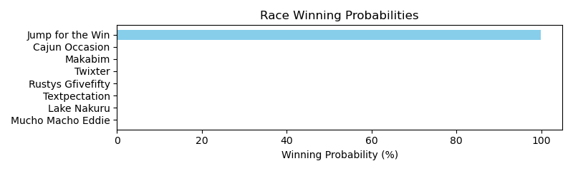

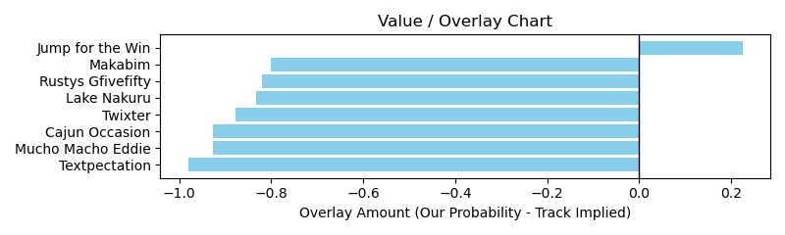

NOTE: GCSF - Global Combined Speed Figure

# Race: PEN | 2025-03-14 | Race #2 | Post: 18:14 | Track: PENN NATIONAL

Track: PENN NATIONAL

|  |  |  |  |  |  |
| --- | --- | --- | --- | --- | --- |
| Program # | Horse Name | Morn Odds | GCSF | Model Score | Win Prob (%) |
| 1 | La Tache | 5-2 | 93.4 | -6.61 | 99.06 |
| 2 | Desi's Reward | 2-1 | 119.4 | -16.10 | 0.07 |
| 3 | Beachgrass | 3-1 | 96.1 | -8.71 | 0.17 |
| 4 | Mikey's Jewel | 6-1 | 81.2 | -7.87 | 0.55 |
| 5 | G's Fireball | 7-2 | 104.2 | -12.32 | 0.07 |
| 6 | Cricket West | 50-1 | 99.8 | -13.73 | 0.07 |

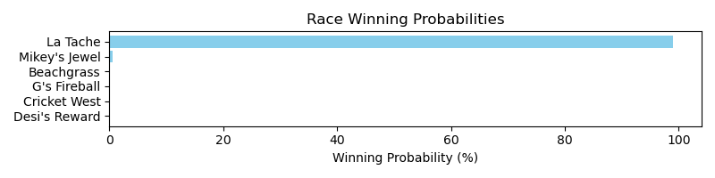

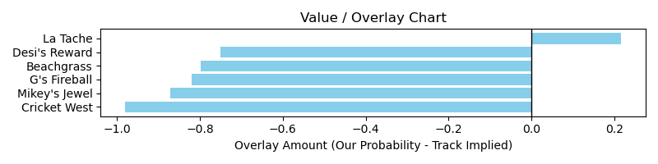

NOTE: GCSF - Global Combined Speed Figure

# Race: PEN | 2025-03-14 | Race #3 | Post: 18:43 | Track: PENN NATIONAL

Track: PENN NATIONAL

|  |  |  |  |  |  |
| --- | --- | --- | --- | --- | --- |
| Program # | Horse Name | Morn Odds | GCSF | Model Score | Win Prob (%) |
| 1 | Leonids | 4-1 | 95.7 | -9.68 | 0.07 |
| 2 | Wildhunch | 6-1 | 92.4 | -2.78 | 0.07 |
| 3 | El Divino Nino | 8-1 | 98.8 | 0.98 | 0.07 |
| 4 | Town's Warrior | 8-1 | 106.6 | -4.37 | 0.07 |
| 5 | Valyrian Sky | 6-1 | 94.5 | 12.56 | 98.48 |
| 6 | Zanduhoc | 3-1 | 93.9 | 11.62 | 1.13 |
| 7 | Uniwinner | 6-1 | 99.8 | -2.37 | 0.07 |
| 8 | Palm Island | 5-1 | 108.3 | 2.11 | 0.07 |

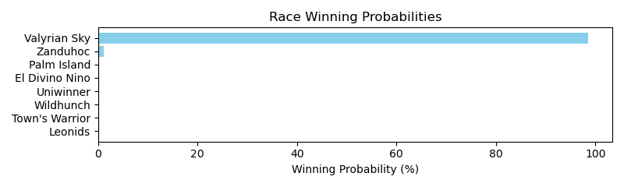

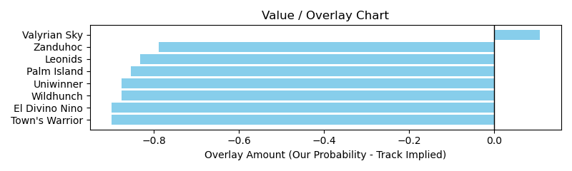

# Race: PEN | 2025-03-14 | Race #4 | Post: 19:12 | Track: PENN NATIONAL

Track: PENN NATIONAL

|  |  |  |  |  |  |
| --- | --- | --- | --- | --- | --- |
| Program # | Horse Name | Morn Odds | GCSF | Model Score | Win Prob (%) |
| 1 | Stephanie My Love | 7-2 | 94.5 | 6.68 | 0.01 |
| 2 | Carly Hustle | 10-1 | 88.4 | -13.25 | 0.01 |
| 3 | Kelly's Party Girl | 3-1 | 99.5 | -0.37 | 0.01 |
| 4 | My Boss Lady | 2-1 | 100.2 | -5.73 | 0.01 |
| 5 | Tested Positive | 20-1 | 95.2 | -5.95 | 0.01 |
| 6 | Cedar Valley | 4-1 | 111.2 | -6.79 | 0.01 |
| 7 | Stormy Spell | 8-1 | 96.8 | 10.11 | 99.97 |

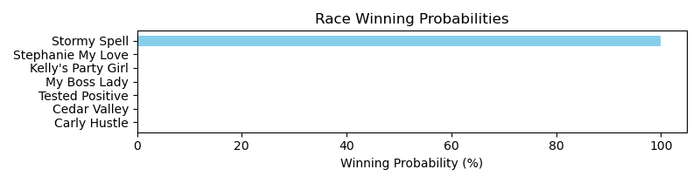

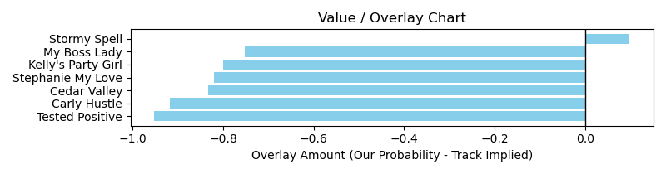

NOTE: GCSF - Global Combined Speed Figure

# Race: PEN | 2025-03-14 | Race #9 | Post: 21:37 | Track: PENN NATIONAL

Track: PENN NATIONAL

|  |  |  |  |  |  |
| --- | --- | --- | --- | --- | --- |
| Program # | Horse Name | Morn Odds | GCSF | Model Score | Win Prob (%) |
| 1 | Jackie A | 10-1 | 99.6 | -14.86 | 0.01 |
| 2 | Copperhead Creek | 5-1 | 99.4 | -9.02 | 0.01 |
| 3 | Trophy Room | 3-1 | 118.1 | -8.40 | 0.01 |
| 4 | dq-He's On Fire | 6-1 | 103.2 | -2.61 | 0.01 |
| 5 | Helms Deep | 9-2 | 99.6 | -15.04 | 0.01 |
| 6 | Entrust | 7-2 | 89.4 | 0.26 | 99.96 |
| 7 | Piccolo Diavolo | 4-1 | 96.0 | -12.71 | 0.01 |

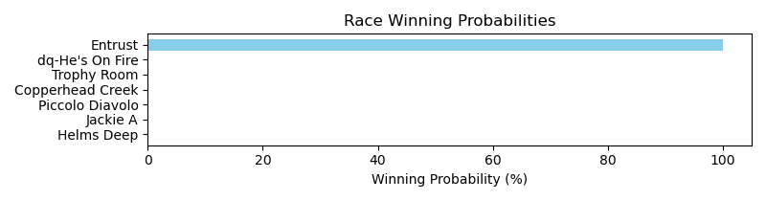

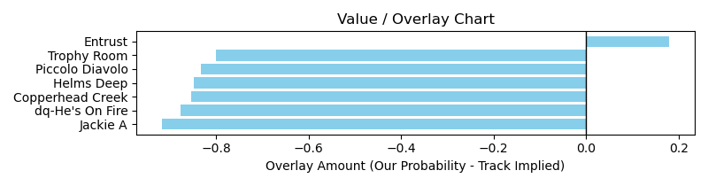

NOTE: GCSF - Global Combined Speed Figure

# Race: HOU | 2025-03-14 | Race #5 | Post: 20:30 | Track: SAM HOUSTON RACE PARK

Track: SAM HOUSTON RACE PARK

|  |  |  |  |  |  |
| --- | --- | --- | --- | --- | --- |
| Program # | Horse Name | Morn Odds | GCSF | Model Score | Win Prob (%) |
| 1 | Pudding | 9-5 | 112.8 | -2.79 | 0.13 |
| 2 | Iceatude | 5-2 | 87.3 | 1.59 | 97.12 |
| 3 | Hostile Afleet | 12-1 | 110.1 | -2.88 | 0.13 |
| 4 | Pinky Ring Bling | 6-1 | 93.8 | 0.74 | 2.10 |
| 5 | Hamazing Wisdom | 30-1 | 92.6 | -15.01 | 0.12 |
| 6 | Levy | 15-1 | 90.7 | -10.08 | 0.12 |
| 7 | In the Arch | 7-2 | 107.8 | -1.22 | 0.18 |
| 8 | Black Candy | 10-1 | 118.9 | -13.78 | 0.12 |

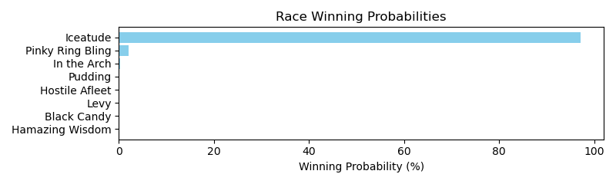

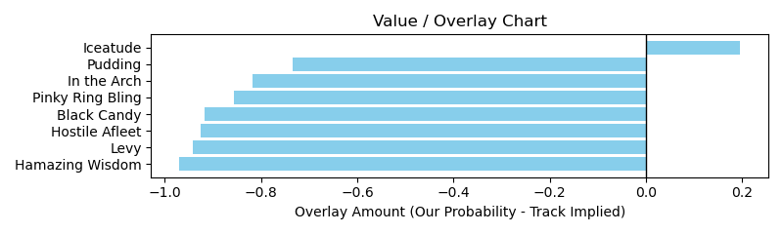

NOTE: GCSF - Global Combined Speed Figure

# Race: HOU | 2025-03-14 | Race #7 | Post: 21:30 | Track: SAM HOUSTON RACE PARK

Track: SAM HOUSTON RACE PARK

|  |  |  |  |  |  |
| --- | --- | --- | --- | --- | --- |
| Program # | Horse Name | Morn Odds | GCSF | Model Score | Win Prob (%) |
| 1 | Will Take Cash | 8-1 | 111.7 | 0.20 | 0.00 |
| 2 | Louisiana Flash | 6-1 | 101.3 | 8.41 | 0.00 |
| 3 | Competitive Shock | 10-1 | 106.6 | -12.44 | 0.00 |
| 4 | Slew Skies | 7-5 | 81.5 | 14.36 | 99.97 |
| 5 | Texas Adopter | 5-1 | 104.1 | -12.39 | 0.00 |
| 6 | Road to Eldorado | 12-1 | 85.5 | -3.03 | 0.00 |
| 7 | Kangaroo Coast | 20-1 | 102.9 | -16.54 | 0.00 |
| 8 | Flying Caesar | 4-1 | 109.7 | 3.81 | 0.00 |

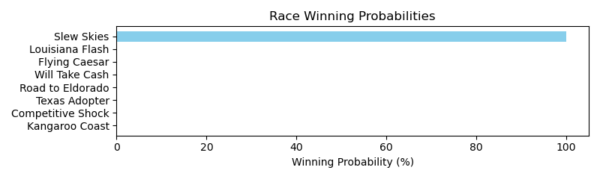

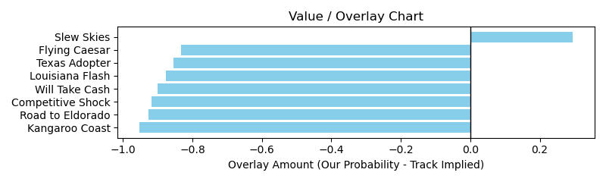

NOTE: GCSF - Global Combined Speed Figure

# Race: HOU | 2025-03-14 | Race #8 | Post: 22:00 | Track: SAM HOUSTON RACE PARK

Track: SAM HOUSTON RACE PARK

|  |  |  |  |  |  |
| --- | --- | --- | --- | --- | --- |
| Program # | Horse Name | Morn Odds | GCSF | Model Score | Win Prob (%) |
| 1 | Tay Tay's Baby | 30-1 | 112.6 | -10.55 | 0.04 |
| 2 | Supercents | 8-1 | 102.7 | 4.64 | 0.41 |
| 3 | Natural Touch | 12-1 | 93.1 | 0.34 | 0.04 |
| 4 | Georgiano | 30-1 | 96.6 | -15.49 | 0.04 |
| 5 | Math Mystery | 15-1 | 96.5 | -2.47 | 0.04 |
| 6 | Trafalgar Shore | 5-2 | 106.2 | -9.33 | 0.04 |
| 7 | Mischief Angel | 30-1 | 97.9 | -7.45 | 0.04 |
| 8 | Tura Lura | 4-1 | 93.5 | 1.30 | 0.05 |
| 9 | Longleggedlaverne | 6-1 | 93.0 | -1.17 | 0.04 |
| 10 | Coinmaker | 10-1 | 84.0 | 5.86 | 99.08 |
| 11 | Sharp Likeness | 50-1 | 116.6 | -10.57 | 0.04 |
| 12 | Mola Mia | 20-1 | 93.7 | -11.93 | 0.04 |
| 13 | Wicked Song | 10-1 | 125.3 | -13.61 | 0.04 |
| 14 | Its My Money Too | 15-1 | 111.2 | -9.92 | 0.04 |

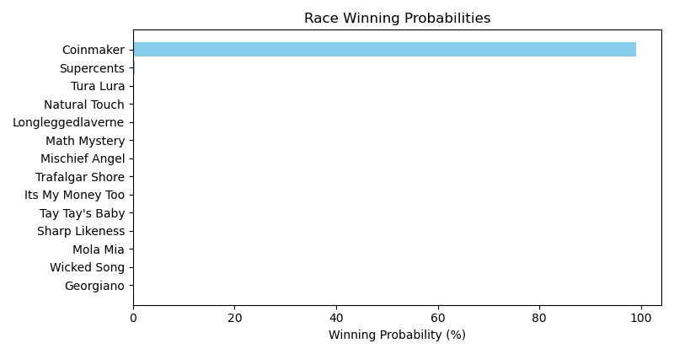

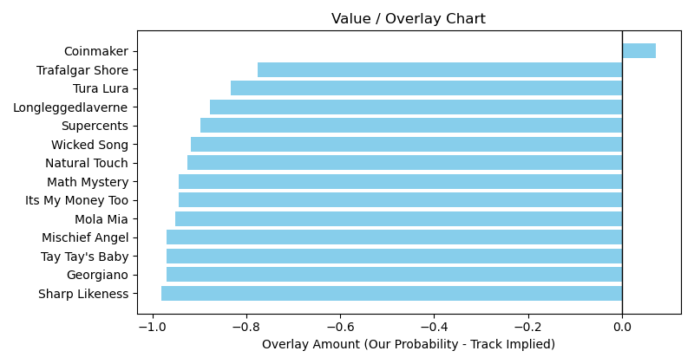

NOTE: GCSF - Global Combined Speed Figure

# Race: HOU | 2025-03-15 | Race #3 | Post: 14:00 | Track: SAM HOUSTON RACE PARK

Track: SAM HOUSTON RACE PARK

|  |  |  |  |  |  |
| --- | --- | --- | --- | --- | --- |
| Program # | Horse Name | Morn Odds | GCSF | Model Score | Win Prob (%) |
| 1 | Contrabbanda | 4-1 | 92.0 | 0.71 | 0.00 |
| 2 | Kentucky Angel | 9-2 | 98.5 | 2.78 | 0.00 |
| 3 | Claire June | 8-1 | 96.9 | -4.15 | 0.00 |
| 4 | Brad's Sweetheart | 30-1 | 94.6 | -9.24 | 0.00 |
| 5 | Cactus Blossom | 15-1 | 117.8 | -8.21 | 0.00 |
| 6 | Girls Got Game | 10-1 | 121.3 | 0.37 | 0.00 |
| 7 | Arinniti (FR) | 3-1 | 91.2 | 8.86 | 99.97 |
| 8 | Contour | 2-1 | 92.5 | 4.76 | 0.01 |

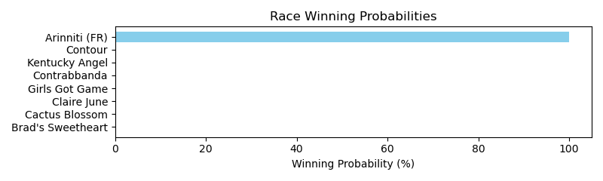

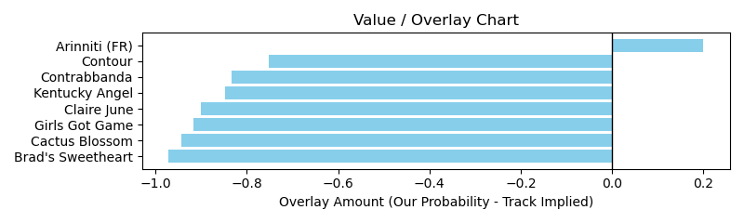

# Race: HOU | 2025-03-15 | Race #6 | Post: 15:30 | Track: SAM HOUSTON RACE PARK

Track: SAM HOUSTON RACE PARK

|  |  |  |  |  |  |
| --- | --- | --- | --- | --- | --- |
| Program # | Horse Name | Morn Odds | GCSF | Model Score | Win Prob (%) |
| 1 | Cheers to Candy | 8-1 | 113.2 | -3.22 | 0.01 |
| 2 | Charming Oakie | 6-1 | 108.8 | 3.66 | 0.01 |
| 3 | Sponge Bath | 2-1 | 95.7 | 12.96 | 99.85 |
| 4 | Polis | 15-1 | 98.2 | -6.91 | 0.01 |
| 5 | Mitole's Limit | 10-1 | 102.1 | 2.63 | 0.01 |
| 6 | Never Over Me | 20-1 | 91.5 | -8.48 | 0.01 |
| 7 | Multiple Opinions | 4-1 | 114.0 | -4.33 | 0.01 |
| 8 | Texas Creed | 3-1 | 95.8 | 11.10 | 0.06 |

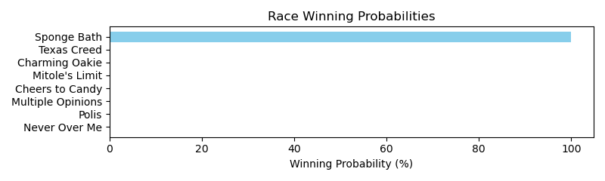

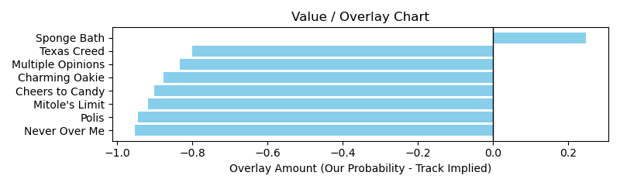

# Race: HOU | 2025-03-15 | Race #8 | Post: 16:30 | Track: SAM HOUSTON RACE PARK

Track: SAM HOUSTON RACE PARK

|  |  |  |  |  |  |
| --- | --- | --- | --- | --- | --- |
| Program # | Horse Name | Morn Odds | GCSF | Model Score | Win Prob (%) |
| 1 | Sir Sterling | 12-1 | 106.0 | -4.00 | 0.00 |
| 2 | Soul Sacrifice | 10-1 | 88.1 | -5.33 | 0.00 |
| 3 | Kentucky Dawn | 15-1 | 82.8 | -4.56 | 0.00 |
| 4 | Lea Me Be | 6-1 | 96.8 | -5.06 | 0.00 |
| 5 | Jackman's Ride | 13-8 | 119.8 | 10.46 | 99.97 |
| 6 | Established | 9-2 | 94.5 | 3.99 | 0.00 |
| 7 | Stayed in for Half | 4-1 | 113.5 | 0.30 | 0.00 |
| 8 | Third Street | 8-1 | 93.5 | 1.27 | 0.00 |

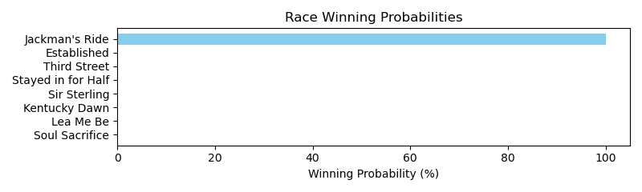

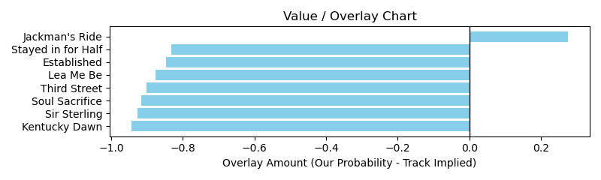

# Race: HOU | 2025-03-15 | Race #9 | Post: 17:00 | Track: SAM HOUSTON RACE PARK

Track: SAM HOUSTON RACE PARK

|  |  |  |  |  |  |
| --- | --- | --- | --- | --- | --- |
| Program # | Horse Name | Morn Odds | GCSF | Model Score | Win Prob (%) |
| 1 | Coastal Brink | 7-2 | 97.9 | -3.19 | 0.01 |
| 2 | Cinco Richie | 15-1 | 93.3 | -5.51 | 0.01 |
| 3 | You're On Mute | 20-1 | 108.4 | -15.54 | 0.01 |
| 4 | Perry County | 12-1 | 111.2 | -20.68 | 0.01 |
| 5 | Macho Grande | 10-1 | 110.2 | -12.56 | 0.01 |
| 6 | Shamayim | 15-1 | 92.8 | 3.90 | 99.94 |
| 7 | Tigers 'n Bears | 12-1 | 116.2 | -2.34 | 0.01 |
| 8 | Sarge's Sermon | 6-1 | 91.7 | -15.37 | 0.01 |
| 9 | My Calante | 8-1 | 99.3 | -11.81 | 0.01 |
| 10 | Moon Cat | 9-2 | 96.8 | 0.18 | 0.01 |
| 11 | Barefoot Samurai | 15-1 | 88.4 | -8.15 | 0.01 |
| 12 | Excaping the Blues | 5-2 | 95.7 | -2.31 | 0.01 |

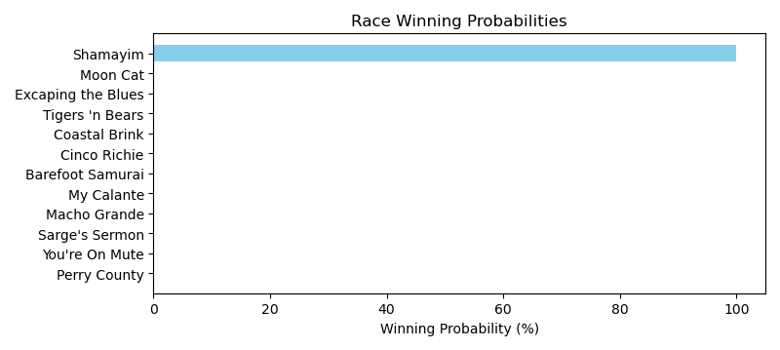

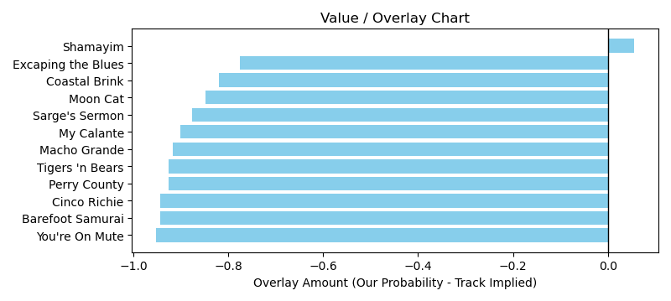

# Race: TSA | 2025-03-14 | Race #5 | Post: 15:06 | Track: SANTA ANITA PARK

Track: SANTA ANITA PARK

|  |  |  |  |  |  |
| --- | --- | --- | --- | --- | --- |
| Program # | Horse Name | Morn Odds | GCSF | Model Score | Win Prob (%) |
| 1 | Agency | 13-8 | 120.3 | -18.85 | 0.00 |
| 2 | Nero Tulip (GB) | 10-1 | 103.1 | -1.34 | 0.00 |
| 3 | Rhythem On Stage | 6-1 | 103.9 | -5.19 | 0.00 |
| 4 | Tizz a Good Thing | 15-1 | 90.3 | -2.86 | 0.00 |
| 5 | Awesome Rhythm | 8-1 | 96.4 | 11.56 | 99.97 |
| 6 | Belmont Bill | 15-1 | 92.7 | -2.92 | 0.00 |
| 7 | Hula Candy | 5-1 | 84.2 | -8.70 | 0.00 |
| 8 | Invincible | 3-1 | 93.1 | 5.31 | 0.00 |
| 9 | Baldoro | 8-1 | 110.1 | -22.19 | 0.00 |

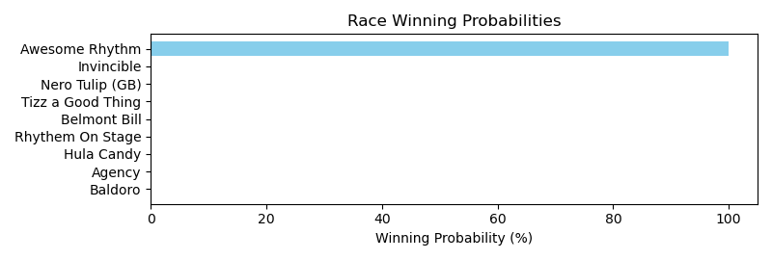

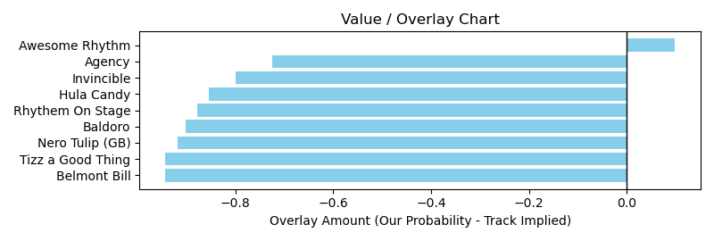

# Race: TSA | 2025-03-14 | Race #8 | Post: 16:38 | Track: SANTA ANITA PARK

Track: SANTA ANITA PARK

|  |  |  |  |  |  |
| --- | --- | --- | --- | --- | --- |
| Program # | Horse Name | Morn Odds | GCSF | Model Score | Win Prob (%) |
| 1 | Clouseau | 5-2 | 104.8 | 13.49 | 99.93 |
| 2 | Lil Richards Bello | 9-5 | 97.6 | 8.10 | 0.01 |
| 3 | Final Storm | 5-1 | 95.9 | 0.44 | 0.01 |
| 4 | Speed Grazy | 8-1 | 99.8 | -7.53 | 0.01 |
| 5 | Fowler Blue | 20-1 | 96.5 | -11.11 | 0.01 |
| 6 | Mici's Express | 9-2 | 101.2 | 4.15 | 0.01 |
| 7 | Kerry Gold | 10-1 | 98.2 | 6.96 | 0.01 |
| 8 | Pass the Baton | 20-1 | 98.3 | 10.92 | 0.02 |

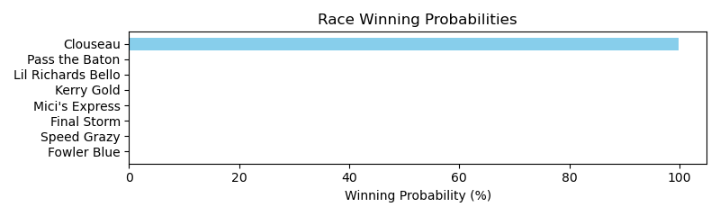

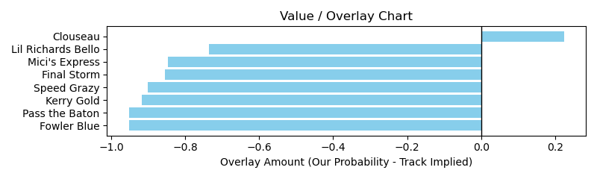

# Race: SUN | 2025-03-13 | Race #6 | Post: 14:31 | Track: SUNLAND PARK

Track: SUNLAND PARK

|  |  |  |  |  |  |
| --- | --- | --- | --- | --- | --- |
| Program # | Horse Name | Morn Odds | GCSF | Model Score | Win Prob (%) |
| 9 | Vols | 10-1 | 101.5 | -13.50 | 100.00 |

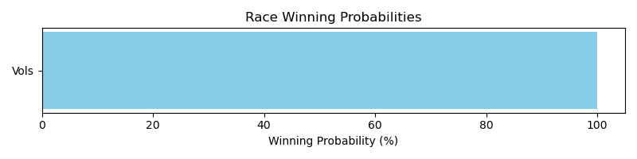

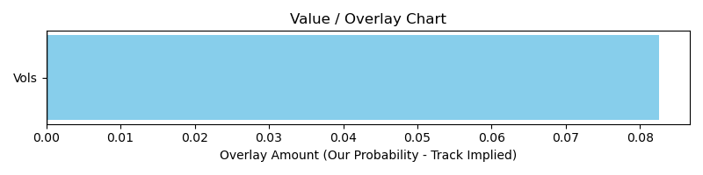

# Race: SUN | 2025-03-13 | Race #7 | Post: 14:57 | Track: SUNLAND PARK

Track: SUNLAND PARK

|  |  |  |  |  |  |
| --- | --- | --- | --- | --- | --- |
| Program # | Horse Name | Morn Odds | GCSF | Model Score | Win Prob (%) |
| 10 | Jetfire | 7-2 | 93.2 | -7.24 | 100.00 |

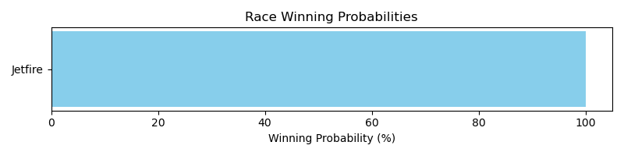

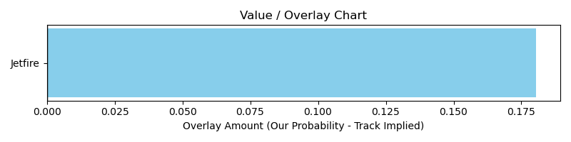

# Race: SUN | 2025-03-13 | Race #9 | Post: 15:49 | Track: SUNLAND PARK

Track: SUNLAND PARK

|  |  |  |  |  |  |
| --- | --- | --- | --- | --- | --- |
| Program # | Horse Name | Morn Odds | GCSF | Model Score | Win Prob (%) |
| 1 | Fleet of Flags | 3-1 | 103.8 | 9.38 | 97.84 |
| 5 | Real Good Magic | 8-1 | 91.0 | -12.12 | 0.09 |
| 10 | Beer Money | 10-1 | 88.1 | 8.58 | 2.07 |

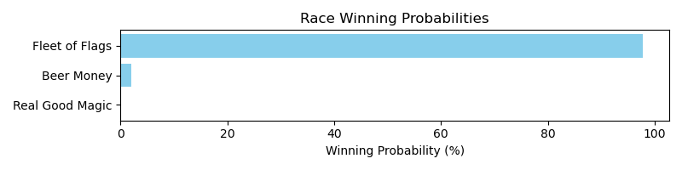

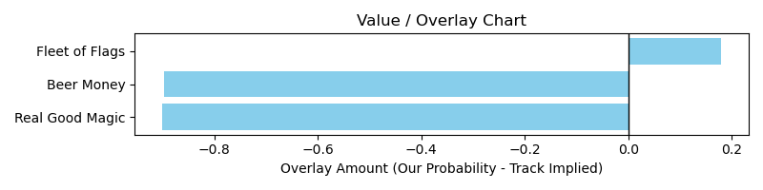

# Race: SUN | 2025-03-14 | Race #2 | Post: 12:50 | Track: SUNLAND PARK

Track: SUNLAND PARK

|  |  |  |  |  |  |
| --- | --- | --- | --- | --- | --- |
| Program # | Horse Name | Morn Odds | GCSF | Model Score | Win Prob (%) |
| 1 | Diablo Rosso | 8-1 | 103.5 | -7.66 | 0.00 |
| 2 | Threecardmonte | 6-1 | 109.8 | -4.19 | 0.01 |
| 4 | Hardball | 9-2 | 94.7 | -14.62 | 0.00 |
| 9 | Scorpion Shot | 9-5 | 109.4 | -0.31 | 99.98 |

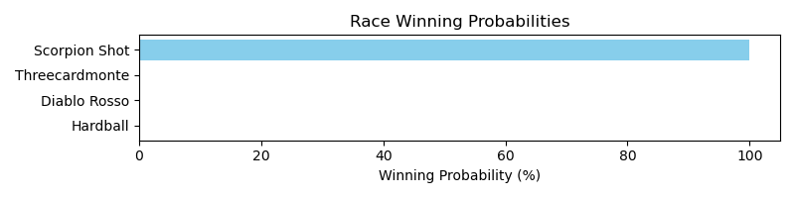

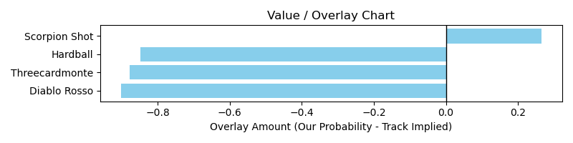

# Race: SUN | 2025-03-14 | Race #5 | Post: 14:05 | Track: SUNLAND PARK

Track: SUNLAND PARK

|  |  |  |  |  |  |
| --- | --- | --- | --- | --- | --- |
| Program # | Horse Name | Morn Odds | GCSF | Model Score | Win Prob (%) |
| 1 | Going With Her | 5-1 | 93.4 | -7.48 | 0.01 |
| 8 | Power Nap | 9-2 | 100.8 | -3.85 | 99.99 |

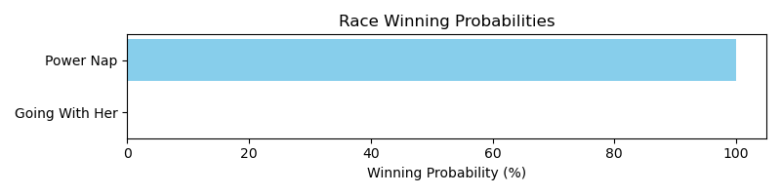

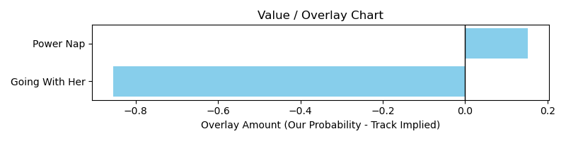

# Race: SUN | 2025-03-14 | Race #6 | Post: 14:31 | Track: SUNLAND PARK

Track: SUNLAND PARK

|  |  |  |  |  |  |
| --- | --- | --- | --- | --- | --- |
| Program # | Horse Name | Morn Odds | GCSF | Model Score | Win Prob (%) |
| 3 | Gozer | 10-1 | 91.9 | -2.94 | 100.00 |

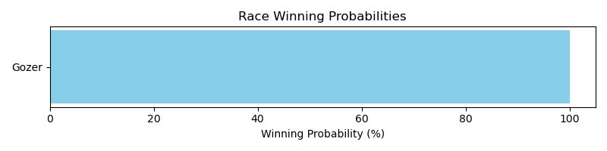

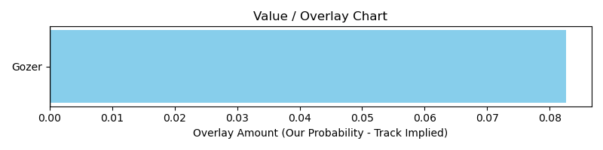

# Race: SUN | 2025-03-14 | Race #7 | Post: 14:57 | Track: SUNLAND PARK

Track: SUNLAND PARK

|  |  |  |  |  |  |
| --- | --- | --- | --- | --- | --- |
| Program # | Horse Name | Morn Odds | GCSF | Model Score | Win Prob (%) |
| 2 | Big Hopes | 6-1 | 95.8 | 7.64 | 100.00 |

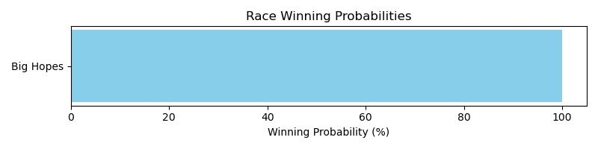

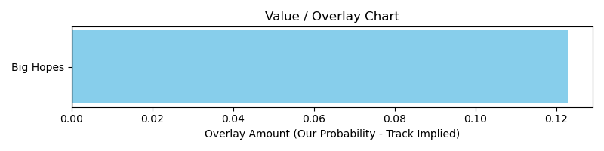

# Race: SUN | 2025-03-14 | Race #8 | Post: 15:23 | Track: SUNLAND PARK

Track: SUNLAND PARK

|  |  |  |  |  |  |
| --- | --- | --- | --- | --- | --- |
| Program # | Horse Name | Morn Odds | GCSF | Model Score | Win Prob (%) |
| 9 | Howdoyalikemenow | 5-1 | 94.7 | 1.97 | 100.00 |

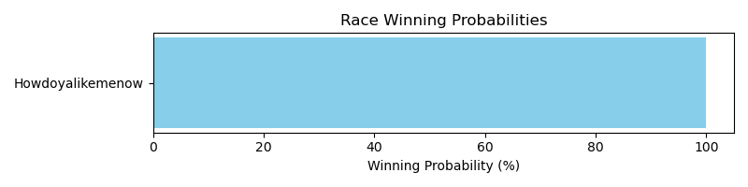

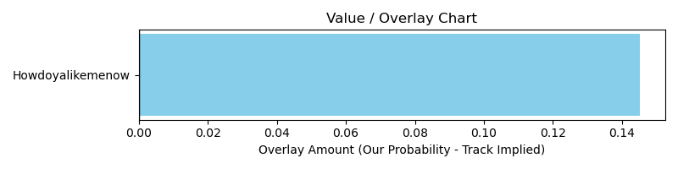

# Race: SUN | 2025-03-14 | Race #10 | Post: 16:15 | Track: SUNLAND PARK

Track: SUNLAND PARK

|  |  |  |  |  |  |
| --- | --- | --- | --- | --- | --- |
| Program # | Horse Name | Morn Odds | GCSF | Model Score | Win Prob (%) |
| 5 | Clue | 9-2 | 96.5 | -6.11 | 100.00 |

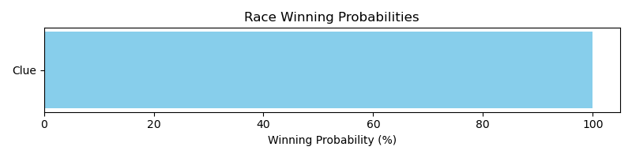

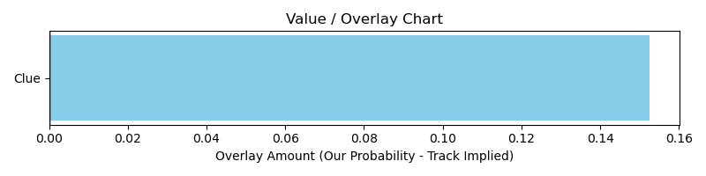

# Race: TUP | 2025-03-13 | Race #3 | Post: 14:27 | Track: TURF PARADISE

Track: TURF PARADISE

|  |  |  |  |  |  |
| --- | --- | --- | --- | --- | --- |
| Program # | Horse Name | Morn Odds | GCSF | Model Score | Win Prob (%) |
| 5 | North East Star (IRE) | 5-2 | 97.3 | 2.51 | 100.00 |

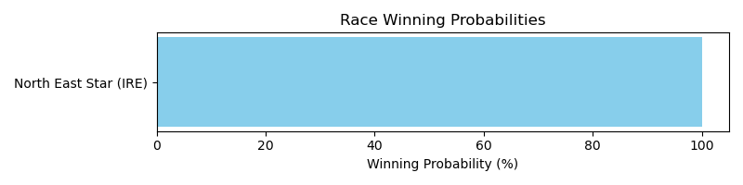

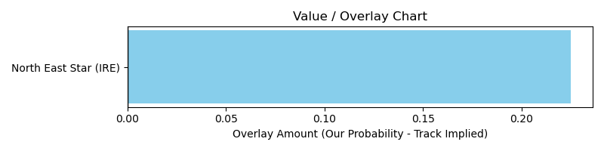

# Race: TUP | 2025-03-13 | Race #5 | Post: 15:31 | Track: TURF PARADISE

Track: TURF PARADISE

|  |  |  |  |  |  |
| --- | --- | --- | --- | --- | --- |
| Program # | Horse Name | Morn Odds | GCSF | Model Score | Win Prob (%) |
| 1 | Apollo Rising | 2-1 | 107.0 | 10.32 | 0.26 |
| 3 | Mastering | 9-2 | 101.3 | -6.00 | 0.03 |
| 4 | Stamp My Passport | 3-1 | 97.7 | -1.16 | 0.03 |
| 5 | Keen Heir | 5-1 | 100.1 | 11.66 | 99.65 |
| 7 | Nolongerahobby | 10-1 | 107.6 | -11.43 | 0.03 |

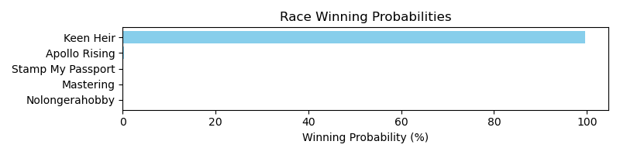

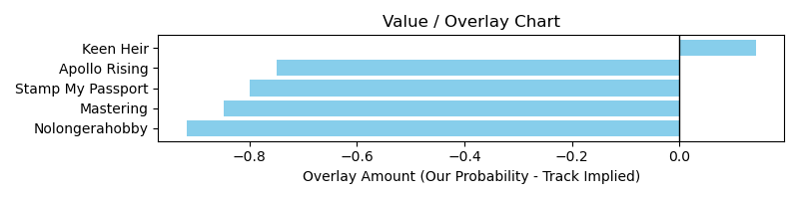

# Race: TUP | 2025-03-13 | Race #6 | Post: 16:03 | Track: TURF PARADISE

Track: TURF PARADISE

|  |  |  |  |  |  |
| --- | --- | --- | --- | --- | --- |
| Program # | Horse Name | Morn Odds | GCSF | Model Score | Win Prob (%) |
| 2 | Bad Sneakers | 5-2 | 98.7 | 8.46 | 99.99 |
| 3 | Anotherbottle | 20-1 | 106.7 | -16.10 | 0.00 |
| 5 | Rosenquist | 9-2 | 100.3 | 0.95 | 0.00 |

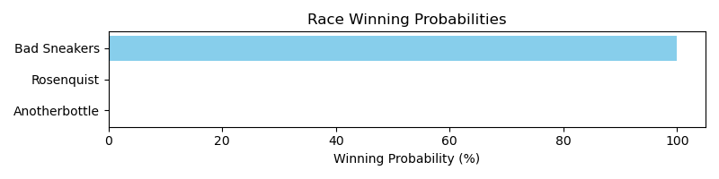

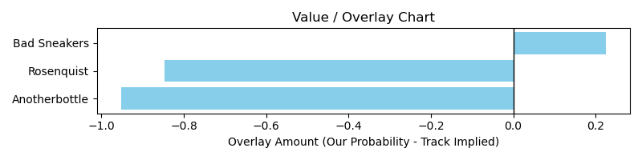

# Race: TUP | 2025-03-13 | Race #7 | Post: 16:35 | Track: TURF PARADISE

Track: TURF PARADISE

|  |  |  |  |  |  |
| --- | --- | --- | --- | --- | --- |
| Program # | Horse Name | Morn Odds | GCSF | Model Score | Win Prob (%) |
| 3 | Joy in Grace | 3-1 | 110.1 | -1.27 | 0.19 |
| 6 | Fall Moon | 8-1 | 101.5 | 0.23 | 99.76 |
| 10 | Lock It Down | 4-1 | 95.4 | -2.88 | 0.05 |

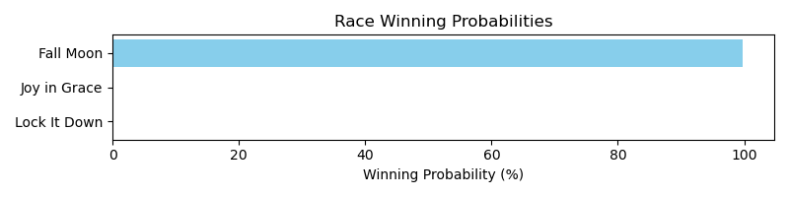

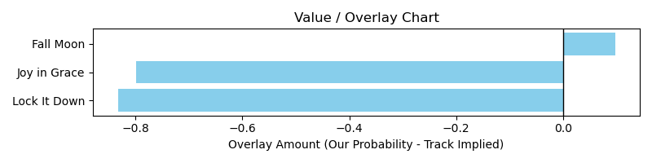

# Race: TUP | 2025-03-13 | Race #8 | Post: 17:07 | Track: TURF PARADISE

Track: TURF PARADISE

|  |  |  |  |  |  |
| --- | --- | --- | --- | --- | --- |
| Program # | Horse Name | Morn Odds | GCSF | Model Score | Win Prob (%) |
| 2 | Candy Crusher | 15-1 | 110.6 | -16.94 | 0.00 |
| 4 | Galloping Major | 4-1 | 100.4 | -9.44 | 0.00 |
| 8 | Size Lord | 5-1 | 98.6 | 3.01 | 99.99 |

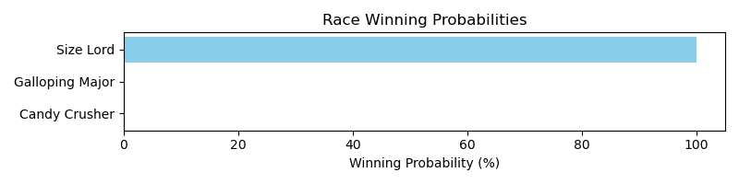

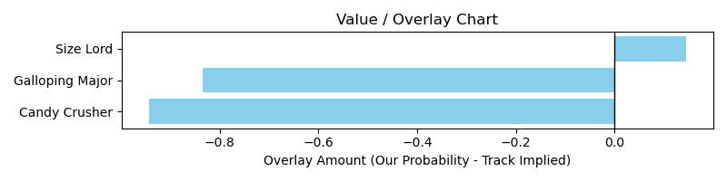

# Race: TUP | 2025-03-15 | Race #2 | Post: 13:55 | Track: TURF PARADISE

Track: TURF PARADISE

|  |  |  |  |  |  |
| --- | --- | --- | --- | --- | --- |
| Program # | Horse Name | Morn Odds | GCSF | Model Score | Win Prob (%) |
| 2 | John Dunbar | 5-1 | 98.6 | -5.91 | 0.00 |
| 3 | Dagger Ranch | 5-1 | 91.8 | 2.98 | 99.99 |
| 5 | Sensical | 10-1 | 91.7 | -11.34 | 0.00 |
| 7 | All That Glory | 3-1 | 97.4 | -4.51 | 0.00 |

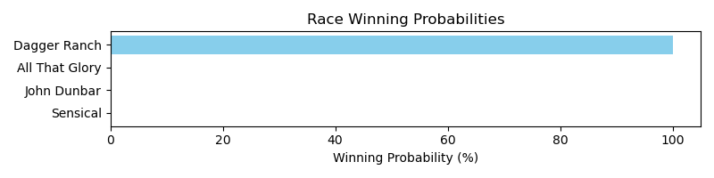

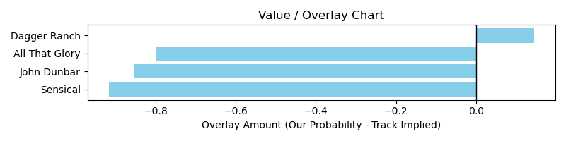

# Race: TUP | 2025-03-15 | Race #3 | Post: 14:24 | Track: TURF PARADISE

Track: TURF PARADISE

|  |  |  |  |  |  |
| --- | --- | --- | --- | --- | --- |
| Program # | Horse Name | Morn Odds | GCSF | Model Score | Win Prob (%) |
| 6 | Jaime's Commitment | 4-1 | 96.2 | 9.14 | 100.00 |
| 8 | Bodenheimer | 5-1 | 95.9 | -17.02 | 0.00 |

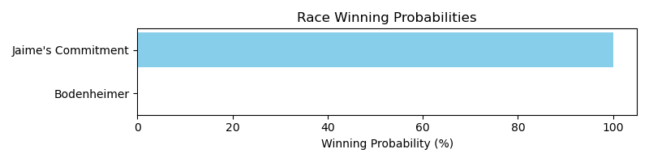

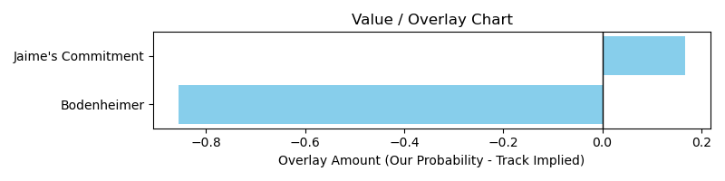

# Race: TUP | 2025-03-15 | Race #4 | Post: 14:52 | Track: TURF PARADISE

Track: TURF PARADISE

|  |  |  |  |  |  |
| --- | --- | --- | --- | --- | --- |
| Program # | Horse Name | Morn Odds | GCSF | Model Score | Win Prob (%) |
| 1 | Dads Estrella | 4-1 | 97.6 | -3.29 | 0.01 |
| 4 | Pepper Mill | 3-1 | 97.2 | 3.53 | 0.01 |
| 8 | Never Sway | 5-1 | 98.5 | 6.58 | 0.02 |
| 9 | Lets Declare Peace | 6-1 | 96.1 | 9.12 | 99.97 |

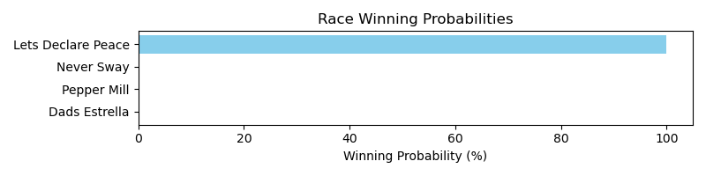

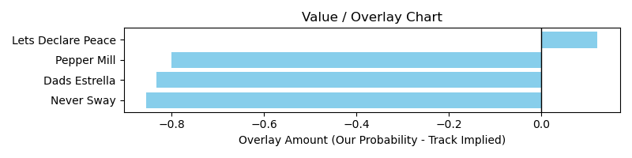

# Race: TUP | 2025-03-15 | Race #5 | Post: 15:20 | Track: TURF PARADISE

Track: TURF PARADISE

|  |  |  |  |  |  |
| --- | --- | --- | --- | --- | --- |
| Program # | Horse Name | Morn Odds | GCSF | Model Score | Win Prob (%) |
| 2 | Sarwar (FR) | 4-1 | 104.6 | 12.19 | 0.01 |
| 3 | Cornishman | 6-1 | 103.4 | 13.75 | 0.01 |
| 4 | Fearless Soldier | 12-1 | 99.0 | -6.11 | 0.01 |
| 5 | Kennebec | 7-2 | 103.8 | 14.64 | 0.01 |
| 6 | Irish Prophet | 5-1 | 98.7 | 18.72 | 99.96 |
| 7 | Saline River | 3-1 | 110.7 | 15.62 | 0.01 |

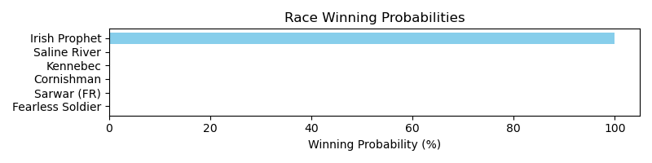

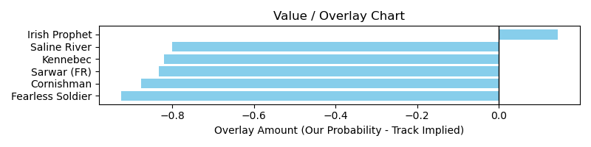

# Race: TUP | 2025-03-15 | Race #6 | Post: 15:48 | Track: TURF PARADISE

Track: TURF PARADISE

|  |  |  |  |  |  |
| --- | --- | --- | --- | --- | --- |
| Program # | Horse Name | Morn Odds | GCSF | Model Score | Win Prob (%) |
| 2 | Thirsty Vision | 20-1 | 93.4 | -1.22 | 0.00 |
| 3 | Spenard | 6-1 | 89.7 | -2.82 | 0.00 |
| 6 | My Vino | 12-1 | 93.4 | -11.37 | 0.00 |
| 9 | Just Trust Me | 4-1 | 103.0 | 6.77 | 99.99 |

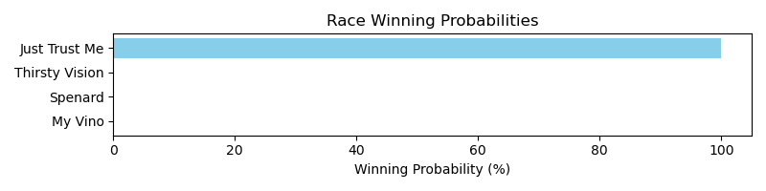

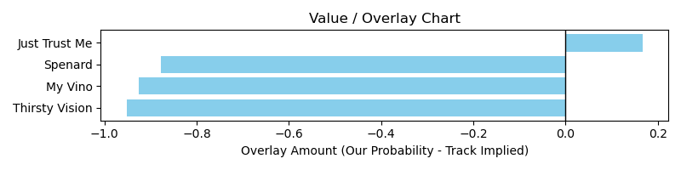

# Race: TUP | 2025-03-15 | Race #7 | Post: 16:18 | Track: TURF PARADISE

Track: TURF PARADISE

|  |  |  |  |  |  |
| --- | --- | --- | --- | --- | --- |
| Program # | Horse Name | Morn Odds | GCSF | Model Score | Win Prob (%) |
| 4 | Two Bar | 5-1 | 106.7 | -5.55 | 0.00 |
| 5 | Polythene Pam | 8-1 | 93.4 | 8.40 | 99.99 |
| 6 | Nostri Vires | 9-2 | 101.4 | -14.09 | 0.00 |

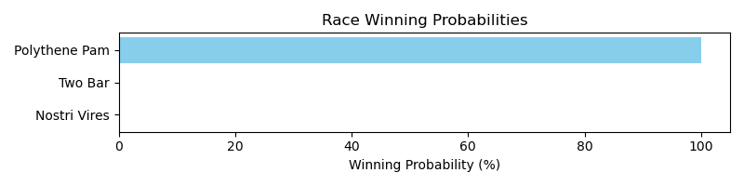

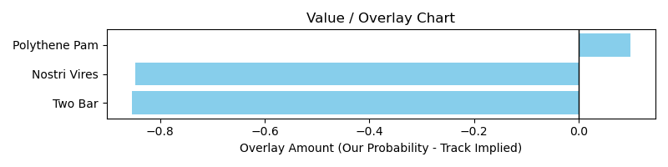

# Race: TUP | 2025-03-15 | Race #8 | Post: 16:48 | Track: TURF PARADISE

Track: TURF PARADISE

|  |  |  |  |  |  |
| --- | --- | --- | --- | --- | --- |
| Program # | Horse Name | Morn Odds | GCSF | Model Score | Win Prob (%) |
| 1 | Aventapp | 6-1 | 92.8 | -3.57 | 0.06 |
| 2 | Mucho Macho Girl | 9-2 | 113.3 | -0.19 | 0.06 |
| 3 | Big Hug | 4-1 | 90.7 | 6.05 | 98.71 |
| 4 | Valentina Day | 15-1 | 88.3 | -6.05 | 0.06 |
| 6 | Flame McGoon | 3-1 | 101.7 | 1.52 | 0.07 |
| 7 | Crystal Coast | 12-1 | 86.5 | 5.06 | 0.96 |
| 8 | Empress Ellie | 5-1 | 95.0 | -0.22 | 0.06 |

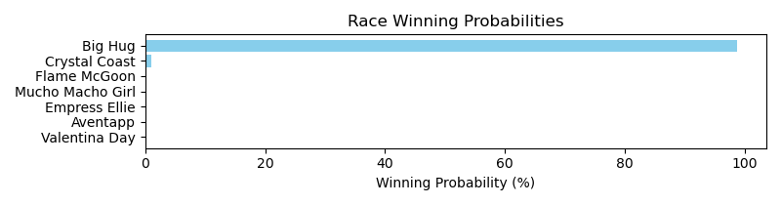

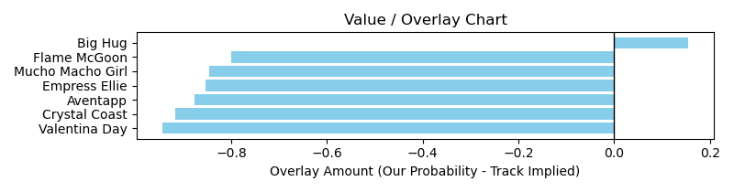

# Race: TUP | 2025-03-15 | Race #9 | Post: 17:18 | Track: TURF PARADISE

Track: TURF PARADISE

|  |  |  |  |  |  |
| --- | --- | --- | --- | --- | --- |
| Program # | Horse Name | Morn Odds | GCSF | Model Score | Win Prob (%) |
| 1 | Redline | 5-2 | 89.8 | 12.44 | 99.87 |
| 2 | Love My Jimmy | 8-1 | 96.6 | 1.25 | 0.02 |
| 3 | Ruggs | 12-1 | 104.5 | 8.80 | 0.02 |
| 4 | Plane Talk | 5-1 | 97.2 | 10.11 | 0.04 |
| 6 | Tapatio Leo | 5-1 | 98.2 | 8.22 | 0.02 |
| 7 | Perfect Dude | 15-1 | 103.7 | 5.48 | 0.02 |
| 8 | Bridleuptothebar | 10-1 | 100.4 | 8.90 | 0.02 |

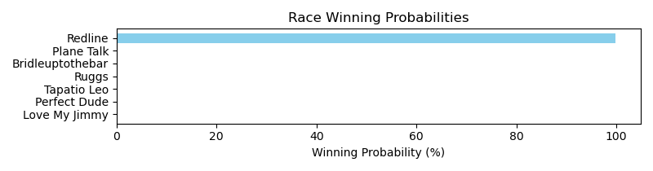

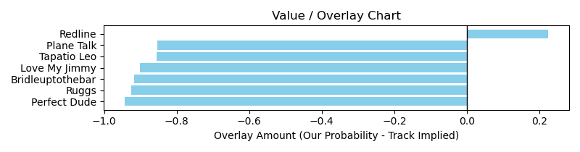

# Race: TTP | 2025-03-13 | Race #1 | Post: 17:55 | Track: TURFWAY PARK

Track: TURFWAY PARK

|  |  |  |  |  |  |
| --- | --- | --- | --- | --- | --- |
| Program # | Horse Name | Morn Odds | GCSF | Model Score | Win Prob (%) |
| 1 | Stupendous | 12-1 | 101.9 | -4.72 | 0.09 |
| 2 | Cumberland Falls | 7-2 | 94.3 | -6.87 | 0.09 |
| 3 | Mariposa de Pista | 12-1 | 94.4 | 1.13 | 0.09 |
| 4 | Ms Ks Dynasty | 20-1 | 90.2 | -19.01 | 0.09 |
| 5 | Frosty Tale | 8-1 | 112.0 | 0.90 | 0.09 |
| 6 | Temporarilyforever | 12-1 | 90.7 | 5.72 | 1.92 |
| 7 | Scarlet Red Sky | 3-1 | 93.4 | -1.28 | 0.09 |
| 8 | Camp Akeela | 8-1 | 99.9 | -2.33 | 0.09 |
| 9 | Here's Gracie | 6-1 | 93.6 | -6.59 | 0.09 |
| 10 | Fancy Prance | 30-1 | 123.8 | -10.89 | 0.09 |
| 11 | Retail Therapy | 12-1 | 91.4 | -1.47 | 0.09 |
| 12 | I Gotta Bolt | 8-1 | 105.9 | 0.90 | 0.09 |
| 13 | Sweet Daydream | 30-1 | 107.8 | -14.24 | 0.09 |
| 14 | Laughing Out Loud | 10-1 | 97.0 | 6.54 | 97.01 |

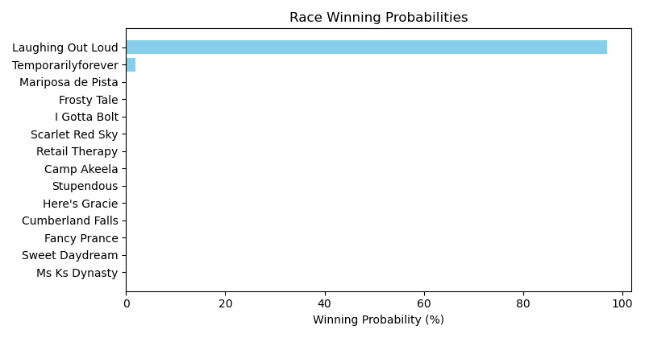

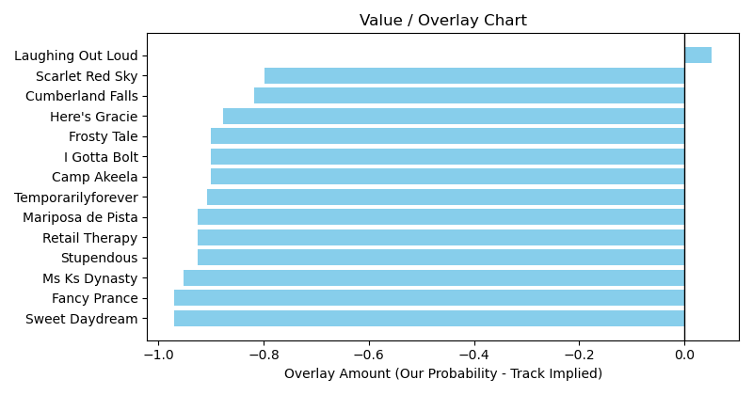

# Race: TTP | 2025-03-13 | Race #4 | Post: 19:25 | Track: TURFWAY PARK

Track: TURFWAY PARK

|  |  |  |  |  |  |
| --- | --- | --- | --- | --- | --- |
| Program # | Horse Name | Morn Odds | GCSF | Model Score | Win Prob (%) |
| 1 | Hurry On Out | 4-1 | 98.0 | 4.06 | 0.68 |
| 2 | Hemp Heaven | 12-1 | 99.5 | -7.12 | 0.05 |
| 3 | Ready to Roll | 12-1 | 106.7 | -21.79 | 0.05 |
| 4 | Noahs Ark | 15-1 | 98.1 | -2.21 | 0.05 |
| 5 | P H Factor | 7-2 | 102.0 | -15.43 | 0.05 |
| 6 | Maynard | 3-1 | 111.9 | -3.90 | 0.05 |
| 7 | Marty's Magic | 9-2 | 94.2 | 5.14 | 98.95 |
| 8 | Beealea | 15-1 | 91.9 | -7.05 | 0.05 |
| 9 | Silent Sonata | 5-1 | 102.1 | 0.33 | 0.06 |

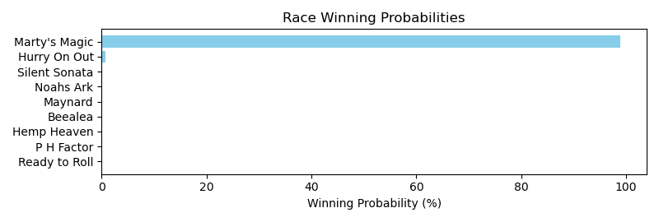

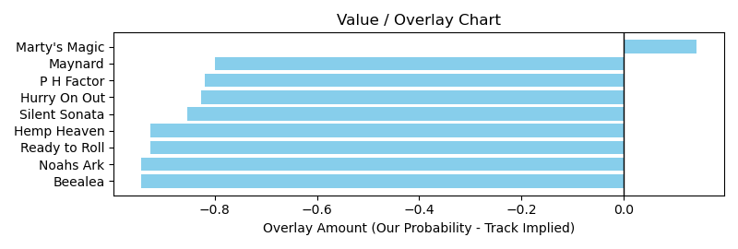

# Race: TTP | 2025-03-13 | Race #5 | Post: 19:55 | Track: TURFWAY PARK

Track: TURFWAY PARK

|  |  |  |  |  |  |
| --- | --- | --- | --- | --- | --- |
| Program # | Horse Name | Morn Odds | GCSF | Model Score | Win Prob (%) |
| 1 | Moonstrike (GB) | 5-2 | 107.7 | 9.53 | 99.93 |
| 2 | I Lucked Out | 6-1 | 95.9 | -20.05 | 0.01 |
| 3 | American Pure | 7-2 | 89.2 | 3.12 | 0.01 |
| 4 | Juanita's Express | 15-1 | 94.3 | -3.23 | 0.01 |
| 5 | English Challenge | 15-1 | 97.2 | -3.17 | 0.01 |
| 6 | Improbable Story | 15-1 | 113.3 | -8.67 | 0.01 |
| 7 | Couperin | 12-1 | 97.8 | -7.97 | 0.01 |
| 8 | Step On It | 6-1 | 97.2 | -0.65 | 0.01 |
| 9 | Hard Mission | 3-1 | 104.2 | 6.89 | 0.01 |

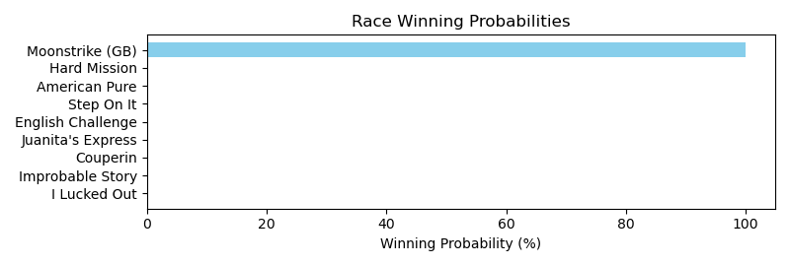

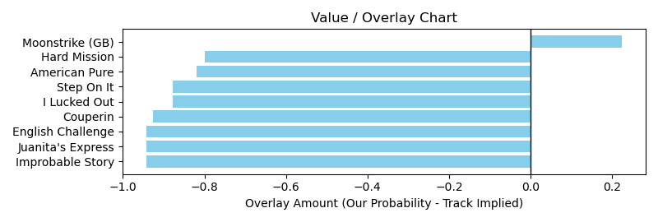

NOTE: GCSF - Global Combined Speed Figure

# Race: TTP | 2025-03-13 | Race #8 | Post: 21:25 | Track: TURFWAY PARK

Track: TURFWAY PARK

|  |  |  |  |  |  |
| --- | --- | --- | --- | --- | --- |
| Program # | Horse Name | Morn Odds | GCSF | Model Score | Win Prob (%) |
| 1 | Mine Own Star | 6-1 | 84.7 | 14.46 | 99.96 |
| 2 | Afternoon Heat | 8-1 | 100.8 | 0.94 | 0.00 |
| 3 | All Jokes Aside | 4-1 | 90.1 | 8.82 | 0.00 |
| 4 | One for My Brother | 12-1 | 106.3 | -9.26 | 0.00 |
| 5 | Crosstown Shootout | 15-1 | 101.5 | -6.83 | 0.00 |
| 6 | Protomagic | 12-1 | 95.6 | -13.64 | 0.00 |
| 7 | Posh Playday | 6-1 | 112.3 | 3.54 | 0.00 |
| 8 | Unworkable | 15-1 | 104.3 | -5.84 | 0.00 |
| 9 | Shakin Loose | 15-1 | 91.1 | -9.35 | 0.00 |
| 10 | Cut Glass | 7-2 | 101.3 | 1.83 | 0.00 |
| 11 | Mazoku | 5-1 | 105.0 | -10.30 | 0.00 |

