# Race: IND | 2025-04-15 | Race #1 | Post: 20:10 | Track: HORSESHOE INDIANAPOLIS

Track: HORSESHOE INDIANAPOLIS

|  |  |  |  |  |  |
| --- | --- | --- | --- | --- | --- |
| Program # | Horse Name | Morn Odds | GCSF | Model Score | Win Prob (%) |
| 1 | Reflex | 15-1 | 102.6 | -19.93 | 0.27 |
| 2 | Dattts Life | 7-2 | 97.0 | -12.95 | 0.51 |
| 3 | Cringe | 6-1 | 90.4 | -15.67 | 0.40 |
| 4 | Rock the Red | 10-1 | 101.5 | -15.97 | 0.39 |
| 5 | Commando Joe | 8-1 | 106.2 | -13.67 | 0.48 |
| 6 | Tiz Eddie | 13-8 | 118.2 | 45.82 | 96.36 |
| 7 | Mondavila | 6-1 | N/A | -12.37 | 0.53 |
| 8 | He B Ready | 12-1 | 96.1 | -4.71 | 1.06 |

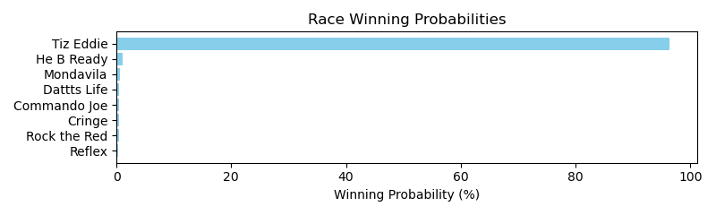

NOTE: GCSF - Global Combined Speed Figure

# Race: IND | 2025-04-15 | Race #2 | Post: 20:41 | Track: HORSESHOE INDIANAPOLIS

Track: HORSESHOE INDIANAPOLIS

|  |  |  |  |  |  |
| --- | --- | --- | --- | --- | --- |
| Program # | Horse Name | Morn Odds | GCSF | Model Score | Win Prob (%) |
| 1 | Huntertown | 6-1 | 95.3 | -10.10 | 1.09 |
| 2 | Good Sugar | 30-1 | 106.4 | -18.20 | 0.53 |
| 3 | Revs Medal | 20-1 | 96.3 | -17.42 | 0.57 |
| 4 | Cupid's Runaway | 9-5 | 95.2 | 34.99 | 60.78 |
| 5 | Unraptured | 10-1 | 97.4 | 19.38 | 15.08 |
| 6 | Campton | 7-2 | 104.5 | -3.56 | 1.95 |
| 7 | Mine Own Star | 8-1 | 103.6 | 12.78 | 8.37 |
| 8 | Swayback Jack | 3-1 | 111.1 | 16.48 | 11.64 |

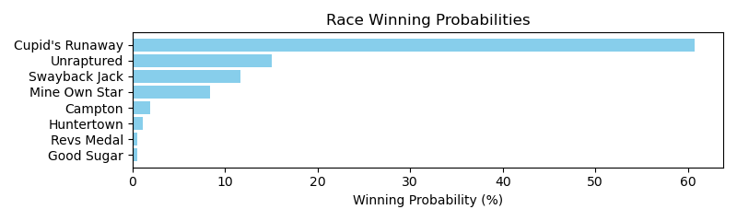

NOTE: GCSF - Global Combined Speed Figure

# Race: IND | 2025-04-15 | Race #3 | Post: 21:12 | Track: HORSESHOE INDIANAPOLIS

Track: HORSESHOE INDIANAPOLIS

|  |  |  |  |  |  |
| --- | --- | --- | --- | --- | --- |
| Program # | Horse Name | Morn Odds | GCSF | Model Score | Win Prob (%) |
| 1 | Rapid Justice | 20-1 | 106.6 | -23.80 | 0.48 |
| 2 | Polar Drift | 15-1 | 100.0 | 31.44 | 65.76 |
| 3 | Dr. Alex Is In | 7-2 | 100.0 | -8.48 | 1.86 |
| 4 | Catch a Nite Train | 15-1 | N/A | 11.58 | 11.17 |
| 5 | Star Quality | 9-2 | 91.5 | 16.88 | 17.93 |
| 6 | Slam Dunk Justice | 4-5 | 110.2 | -6.72 | 2.18 |
| 7 | Monarch of Motion | 12-1 | 110.5 | -20.83 | 0.62 |

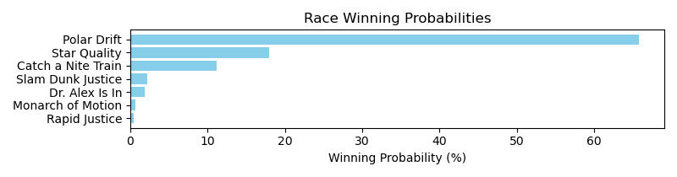

NOTE: GCSF - Global Combined Speed Figure

# Race: IND | 2025-04-15 | Race #4 | Post: 21:43 | Track: HORSESHOE INDIANAPOLIS

Track: HORSESHOE INDIANAPOLIS

|  |  |  |  |  |  |
| --- | --- | --- | --- | --- | --- |
| Program # | Horse Name | Morn Odds | GCSF | Model Score | Win Prob (%) |
| 1 | SONG OF THE VALE | 5-1 | N/A | 2.73 | 18.67 |
| 2 | Mi Sargento | 15-1 | 89.4 | -14.45 | 4.03 |
| 3 | Covert Kid | 8-1 | N/A | 6.18 | 25.40 |
| 4 | SPIRIT MATH | 9-2 | N/A | 3.45 | 19.91 |
| 5 | ALLKINDSOFTROUBLE | 5-1 | N/A | 2.02 | 17.53 |
| 6 | Instinctually | 3-1 | 90.5 | -8.42 | 6.90 |
| 7 | Taneycomo | 20-1 | 105.4 | -22.93 | 1.89 |
| 8 | Michigan Left | 7-2 | 100.6 | -10.62 | 5.67 |

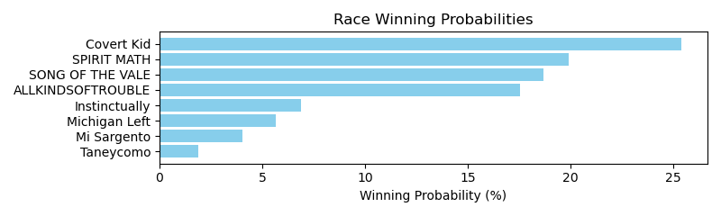

NOTE: GCSF - Global Combined Speed Figure

# Race: IND | 2025-04-15 | Race #5 | Post: 22:14 | Track: HORSESHOE INDIANAPOLIS

Track: HORSESHOE INDIANAPOLIS

|  |  |  |  |  |  |
| --- | --- | --- | --- | --- | --- |
| Program # | Horse Name | Morn Odds | GCSF | Model Score | Win Prob (%) |
| 1 | King Hazelton | 20-1 | 102.4 | -24.80 | 1.10 |
| 2 | BAJAN SUN | 8-1 | N/A | 1.40 | 11.39 |
| 3 | Vino Caldo | 3-1 | 93.8 | -9.96 | 4.13 |
| 4 | Just Pickles | 20-1 | N/A | -1.08 | 9.13 |
| 5 | Flame Rock Fire | 7-2 | 100.0 | -13.56 | 3.00 |
| 6 | Banidoso | 10-1 | N/A | 0.48 | 10.50 |
| 7 | ATOMIC SNOW | 30-1 | N/A | -1.42 | 8.86 |
| 8 | Wholeheartedly | 9-2 | N/A | 10.50 | 25.66 |
| 9 | Improbable Cause | 30-1 | N/A | 2.60 | 12.69 |
| 10 | Captain Case | 20-1 | 100.0 | -26.53 | 0.94 |
| 11 | Mr Oklahoma | 12-1 | N/A | 0.87 | 10.87 |
| 12 | Commander's Coin | 10-1 | 87.7 | -19.61 | 1.75 |

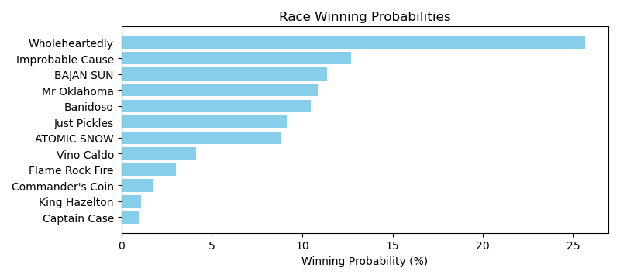

NOTE: GCSF - Global Combined Speed Figure

# Race: IND | 2025-04-15 | Race #6 | Post: 22:45 | Track: HORSESHOE INDIANAPOLIS

Track: HORSESHOE INDIANAPOLIS

|  |  |  |  |  |  |
| --- | --- | --- | --- | --- | --- |
| Program # | Horse Name | Morn Odds | GCSF | Model Score | Win Prob (%) |
| 1 | Sky Key | 30-1 | 88.7 | -22.79 | 0.29 |
| 2 | Glyne Beach | 10-1 | 102.7 | -18.15 | 0.44 |
| 3 | Odorico | 15-1 | 93.4 | 7.77 | 4.43 |
| 4 | Roundball Rock | 8-1 | 103.6 | -15.79 | 0.54 |
| 5 | Prince of Pennies | 20-1 | 103.6 | -19.06 | 0.40 |
| 6 | Smooth N Silky | 12-1 | 100.5 | -23.60 | 0.27 |
| 7 | Hadley's Max | 5-2 | 106.6 | 41.10 | 86.84 |
| 8 | Itzcoatl | 15-1 | N/A | -2.87 | 1.72 |
| 9 | El Peligro | 10-1 | 92.9 | -11.58 | 0.79 |
| 10 | Motown Star | 6-1 | N/A | 4.57 | 3.33 |
| 11 | Dude and Jumper | 10-1 | 97.5 | -19.80 | 0.38 |
| 12 | Cheesesteak | 5-1 | 79.0 | -15.13 | 0.57 |

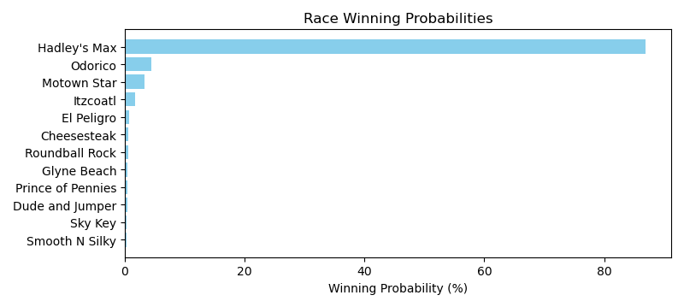

NOTE: GCSF - Global Combined Speed Figure

# Race: IND | 2025-04-15 | Race #7 | Post: 23:16 | Track: HORSESHOE INDIANAPOLIS

Track: HORSESHOE INDIANAPOLIS

|  |  |  |  |  |  |
| --- | --- | --- | --- | --- | --- |
| Program # | Horse Name | Morn Odds | GCSF | Model Score | Win Prob (%) |
| 1 | Goodlookinjustice | 9-2 | 118.0 | 26.38 | 27.18 |
| 2 | Molly's Town | 7-2 | 97.0 | 9.28 | 5.91 |
| 3 | Classic Max | 20-1 | 94.1 | -13.67 | 0.76 |
| 4 | Commander Storm | 30-1 | 97.1 | -10.51 | 1.01 |
| 5 | Scotty's On Edge | 6-1 | 107.9 | 18.83 | 13.85 |
| 6 | Run Away Rojo | 15-1 | 93.4 | 20.41 | 15.96 |
| 7 | Mr Chaos | 12-1 | 87.2 | -6.05 | 1.50 |
| 8 | Win Me Over | 8-1 | 96.6 | -7.57 | 1.31 |
| 9 | Latigo | 2-1 | 100.2 | 28.17 | 31.89 |
| 10 | Spoke | 20-1 | 89.8 | -16.18 | 0.61 |

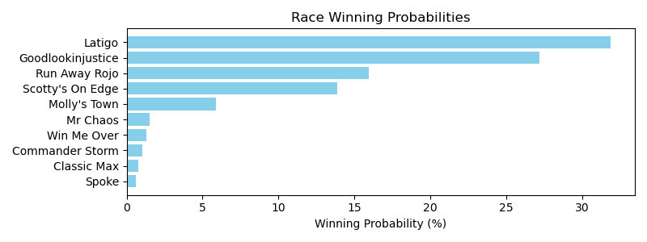

NOTE: GCSF - Global Combined Speed Figure

# Race: IND | 2025-04-15 | Race #8 | Post: 23:47 | Track: HORSESHOE INDIANAPOLIS

Track: HORSESHOE INDIANAPOLIS

|  |  |  |  |  |  |
| --- | --- | --- | --- | --- | --- |
| Program # | Horse Name | Morn Odds | GCSF | Model Score | Win Prob (%) |
| 1 | Ace Reporter | 20-1 | 103.3 | -11.01 | 2.05 |
| 2 | Revs Run | 30-1 | 96.3 | -20.76 | 0.86 |
| 3 | The Kid Pataky | 3-1 | 103.3 | 16.46 | 23.86 |
| 4 | Best Cupcake | 10-1 | 99.3 | -7.13 | 2.91 |
| 5 | Verry Amelia | 20-1 | 103.0 | -14.68 | 1.48 |
| 6 | Si Certo | 8-1 | 95.6 | 9.57 | 12.90 |
| 7 | Imagine the Moon | 6-1 | 103.2 | 16.00 | 22.89 |
| 8 | Louder Than Words | 8-1 | 95.3 | -0.58 | 5.22 |
| 9 | Crosley | 12-1 | 100.0 | -1.56 | 4.78 |
| 10 | Ekati Flatter | 5-1 | 100.5 | -2.64 | 4.34 |
| 11 | Brittanysgldnfaith | 10-1 | 92.4 | -4.44 | 3.69 |
| 12 | Don't Miss Out | 20-1 | 106.6 | 11.28 | 15.02 |

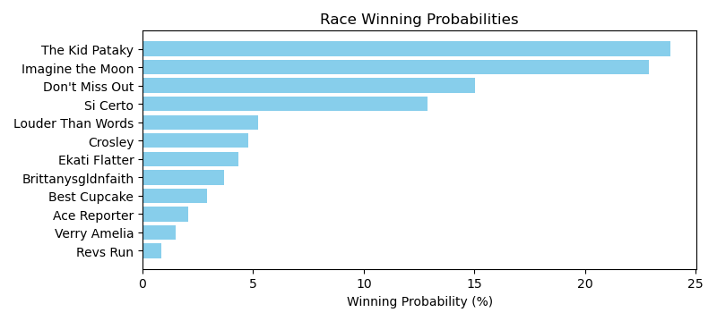

NOTE: GCSF - Global Combined Speed Figure

# Race: KEE | 2025-04-13 | Race #1 | Post: 19:00 | Track: KEENELAND

Track: KEENELAND

|  |  |  |  |  |  |
| --- | --- | --- | --- | --- | --- |
| Program # | Horse Name | Morn Odds | GCSF | Model Score | Win Prob (%) |
| 1 | TWIRLING RIDGE | 8-1 | N/A | -0.11 | 11.75 |
| 2 | OHOOPEE | 7-2 | N/A | 0.05 | 11.92 |
| 3 | BAYTOWN WONDER | 20-1 | N/A | -3.20 | 8.91 |
| 4 | MR. VAGGIO | 9-2 | N/A | -1.29 | 10.57 |
| 5 | TALMADGE | 20-1 | N/A | -3.39 | 8.76 |
| 6 | IL SORPASSO | 30-1 | N/A | -2.96 | 9.11 |
| 7 | BAYTOWN TRIOBLOIDI | 20-1 | N/A | -3.87 | 8.40 |
| 8 | DIBLASI | 4-5 | N/A | 10.61 | 30.57 |

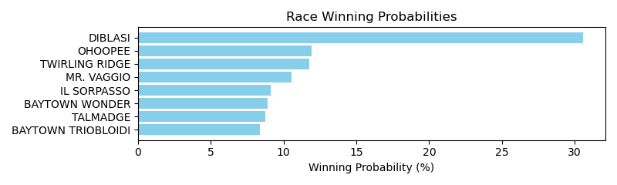

NOTE: GCSF - Global Combined Speed Figure

# Race: KEE | 2025-04-13 | Race #2 | Post: 19:32 | Track: KEENELAND

Track: KEENELAND

|  |  |  |  |  |  |
| --- | --- | --- | --- | --- | --- |
| Program # | Horse Name | Morn Odds | GCSF | Model Score | Win Prob (%) |
| 1 | Raising Kane | 8-1 | N/A | 0.96 | 15.60 |
| 2 | Lean Music Machine | 13-8 | 91.7 | 0.28 | 14.67 |
| 3 | Skyler | 20-1 | 91.6 | -16.59 | 3.26 |
| 4 | How'ya Getting On | 30-1 | 103.4 | -26.65 | 1.33 |
| 5 | Jack Rabbit | 20-1 | N/A | -3.00 | 10.95 |
| 6 | Bet On Bret | 30-1 | N/A | -3.12 | 10.83 |
| 7 | Aerate | 10-1 | 93.4 | -22.05 | 2.00 |
| 8 | Heavy Hitter | 6-1 | 100.7 | -10.90 | 5.41 |
| 9 | Captain Fancy | 12-1 | 92.3 | -16.39 | 3.31 |
| 10 | Memphis Slim | 15-1 | 93.4 | -19.23 | 2.57 |
| 11 | Stormproof | 7-2 | N/A | 8.32 | 30.08 |

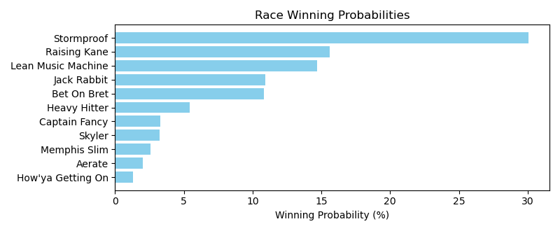

NOTE: GCSF - Global Combined Speed Figure

# Race: KEE | 2025-04-13 | Race #3 | Post: 20:04 | Track: KEENELAND

Track: KEENELAND

|  |  |  |  |  |  |
| --- | --- | --- | --- | --- | --- |
| Program # | Horse Name | Morn Odds | GCSF | Model Score | Win Prob (%) |
| 1 | Borrowed Time | 20-1 | 95.2 | -10.03 | 1.16 |
| 2 | ROCK IT | 12-1 | N/A | 4.76 | 4.33 |
| 3 | Speedini | 30-1 | N/A | 7.94 | 5.75 |
| 4 | Proudly Hailed (GB) | 8-1 | N/A | 7.33 | 5.44 |
| 5 | NOMOLIMBO | 30-1 | N/A | 3.15 | 3.75 |
| 6 | Hard Circle | 12-1 | 94.5 | -7.15 | 1.49 |
| 7 | Esmark | 15-1 | N/A | 4.12 | 4.09 |
| 8 | Global Prosperity | 20-1 | 93.4 | -10.96 | 1.06 |
| 9 | Dublin's Knight (IRE) | 9-5 | N/A | 27.94 | 34.26 |
| 10 | Salamis | 4-1 | N/A | 19.42 | 16.01 |
| 11 | World Beater | 10-1 | N/A | 13.26 | 9.24 |
| 12 | Plensa | 6-1 | N/A | 17.45 | 13.43 |

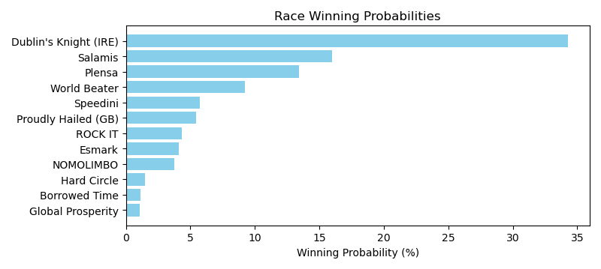

NOTE: GCSF - Global Combined Speed Figure

# Race: KEE | 2025-04-13 | Race #4 | Post: 20:36 | Track: KEENELAND

Track: KEENELAND

|  |  |  |  |  |  |
| --- | --- | --- | --- | --- | --- |
| Program # | Horse Name | Morn Odds | GCSF | Model Score | Win Prob (%) |
| 1 | Simcoe | 6-1 | 107.0 | 16.03 | 4.82 |
| 2 | Top Gunner | 4-5 | 111.5 | 41.42 | 46.51 |
| 3 | Nova Rags | 15-1 | 117.2 | -9.99 | 0.47 |
| 4 | Otto the Conqueror | 9-2 | 98.6 | -4.16 | 0.80 |
| 5 | Roll On Big Joe | 2-1 | 95.8 | 41.63 | 47.40 |

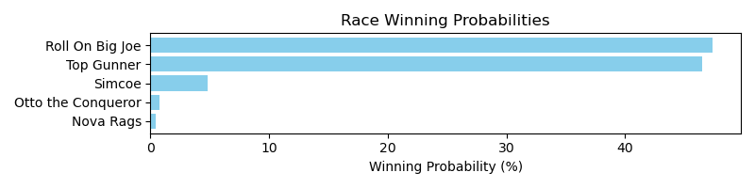

NOTE: GCSF - Global Combined Speed Figure

# Race: KEE | 2025-04-13 | Race #5 | Post: 21:08 | Track: KEENELAND

Track: KEENELAND

|  |  |  |  |  |  |
| --- | --- | --- | --- | --- | --- |
| Program # | Horse Name | Morn Odds | GCSF | Model Score | Win Prob (%) |
| 1 | KING OF GOTHAM | 20-1 | N/A | -0.59 | 11.88 |
| 2 | Venik | 5-1 | N/A | 4.86 | 19.31 |
| 3 | Holster | 6-1 | 101.0 | -10.56 | 4.88 |
| 4 | Spielman | 8-1 | 95.6 | -7.43 | 6.45 |
| 5 | PRIVATE RESERVE | 4-1 | N/A | 3.54 | 17.17 |
| 6 | Ghost Nation | 20-1 | 93.4 | -15.76 | 3.07 |
| 7 | Beechmont | 20-1 | N/A | -2.81 | 9.74 |
| 8 | El Magnifico | 7-2 | 91.5 | -3.59 | 9.09 |
| 9 | NAME IT | 8-1 | N/A | 1.18 | 13.91 |
| 10 | Secured Lender | 9-2 | 93.4 | -11.40 | 4.52 |

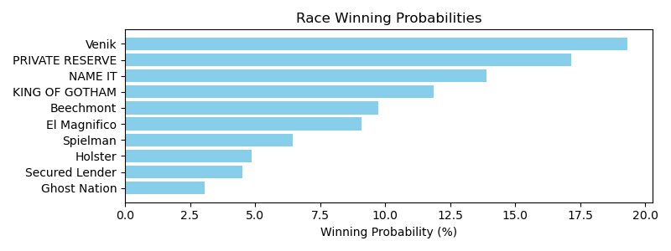

NOTE: GCSF - Global Combined Speed Figure

# Race: KEE | 2025-04-13 | Race #6 | Post: 21:40 | Track: KEENELAND

Track: KEENELAND

|  |  |  |  |  |  |
| --- | --- | --- | --- | --- | --- |
| Program # | Horse Name | Morn Odds | GCSF | Model Score | Win Prob (%) |
| 1 | Mighty Mike | 20-1 | N/A | 3.70 | 7.90 |
| 2 | Thirteen Colonies | 4-1 | N/A | 17.13 | 26.18 |
| 3 | Lebowski | 8-1 | 100.0 | -5.98 | 3.33 |
| 4 | A Bourbon for Toby | 15-1 | 93.4 | -13.97 | 1.63 |
| 5 | Zun Reyder | 30-1 | N/A | -1.88 | 4.80 |
| 6 | BIG RITZ | 15-1 | N/A | 1.89 | 6.72 |
| 7 | Dr. Niko | 20-1 | N/A | 6.98 | 10.59 |
| 8 | Anew | 9-2 | N/A | 4.42 | 8.43 |
| 9 | MOON CHANNEL | 8-1 | N/A | 3.14 | 7.51 |
| 10 | Executive | 3-1 | 100.0 | 5.97 | 9.67 |
| 11 | Money Man | 30-1 | N/A | 6.18 | 9.86 |
| 12 | Brushfire | 10-1 | 100.0 | -5.79 | 3.39 |

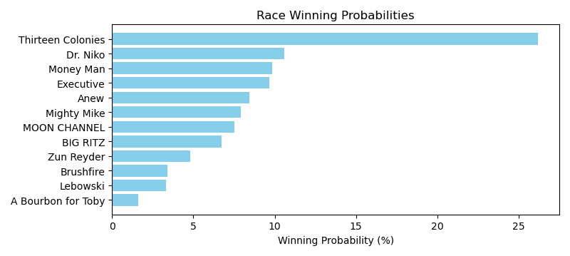

NOTE: GCSF - Global Combined Speed Figure

# Race: KEE | 2025-04-13 | Race #7 | Post: 22:12 | Track: KEENELAND

Track: KEENELAND

|  |  |  |  |  |  |
| --- | --- | --- | --- | --- | --- |
| Program # | Horse Name | Morn Odds | GCSF | Model Score | Win Prob (%) |
| 1 | Impel | 9-5 | 110.4 | 10.01 | 6.55 |
| 2 | Paynt Ya Later | 20-1 | 100.0 | 9.64 | 6.33 |
| 3 | Marmalade Skye | 20-1 | 105.6 | -12.38 | 0.89 |
| 4 | Lotsandlotsofcandy | 3-1 | 100.0 | 29.77 | 38.19 |
| 5 | Into Champagne | 6-1 | 89.7 | -14.12 | 0.76 |
| 6 | Sing a Little Song | 30-1 | 94.2 | -15.66 | 0.66 |
| 7 | Miss Enchanted | 20-1 | 96.1 | -19.49 | 0.47 |
| 8 | Caumsett | 20-1 | 97.1 | -6.11 | 1.55 |
| 9 | Pleasant Embrace | 9-2 | 99.9 | 20.87 | 17.26 |
| 10 | Easy Red | 8-1 | 110.2 | 26.02 | 27.33 |

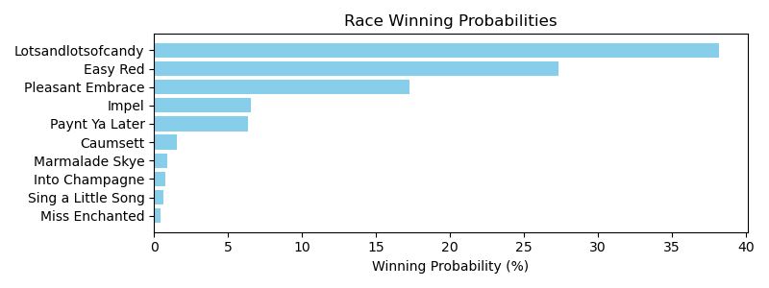

NOTE: GCSF - Global Combined Speed Figure

# Race: KEE | 2025-04-13 | Race #8 | Post: 22:44 | Track: KEENELAND

Track: KEENELAND

|  |  |  |  |  |  |
| --- | --- | --- | --- | --- | --- |
| Program # | Horse Name | Morn Odds | GCSF | Model Score | Win Prob (%) |
| 1 | B G Warrior | 20-1 | 105.2 | -13.83 | 0.58 |
| 2 | Toupie | 7-2 | 97.7 | 34.16 | 41.88 |
| 3 | Lithe Spirit | 10-1 | 94.6 | 22.28 | 14.50 |
| 4 | Future Is Now | 9-5 | 88.9 | 28.01 | 24.20 |
| 5 | Awesome Treat | 30-1 | 90.0 | -11.91 | 0.69 |
| 6 | Danse Macabre | 8-1 | 107.3 | -4.83 | 1.29 |
| 7 | Pandora's Gift (IRE) | 6-1 | N/A | 13.98 | 6.92 |
| 8 | Accomplished Girl | 20-1 | 111.8 | -11.13 | 0.74 |
| 9 | Get Twisted | 30-1 | 94.4 | 13.77 | 6.79 |
| 10 | Just a Care (IRE) | 9-2 | 95.8 | 2.27 | 2.43 |

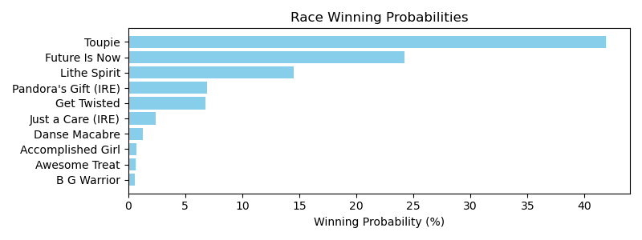

NOTE: GCSF - Global Combined Speed Figure

# Race: KEE | 2025-04-13 | Race #9 | Post: 23:16 | Track: KEENELAND

Track: KEENELAND

|  |  |  |  |  |  |
| --- | --- | --- | --- | --- | --- |
| Program # | Horse Name | Morn Odds | GCSF | Model Score | Win Prob (%) |
| 1 | Livehappy | 15-1 | 91.5 | -12.54 | 3.15 |
| 2 | Romantic Lead | 3-1 | N/A | 4.90 | 14.94 |
| 3 | Desert Aire | 20-1 | 106.6 | -16.66 | 2.18 |
| 4 | BOURBON STREET BOY | 8-1 | N/A | 0.87 | 10.43 |
| 5 | Hotline Blink | 15-1 | 93.3 | -23.05 | 1.23 |
| 6 | Soco and Lime | 20-1 | N/A | 3.37 | 13.04 |
| 7 | Maravich | 12-1 | N/A | 5.94 | 16.41 |
| 8 | Big Salt Lick | 5-1 | 106.3 | -12.04 | 3.30 |
| 9 | Hen Hen | 15-1 | N/A | -0.56 | 9.18 |
| 10 | Storm the Streets | 8-1 | 106.6 | -13.92 | 2.79 |
| 11 | BECK'S SPIRIT | 10-1 | N/A | 0.39 | 10.00 |
| 12 | PARADE OF FEARS | 4-1 | N/A | 3.63 | 13.34 |

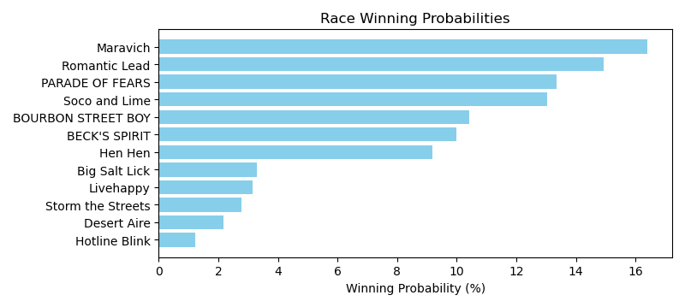

NOTE: GCSF - Global Combined Speed Figure

# Race: TOP | 2025-04-13 | Race #1 | Post: 18:20 | Track: OAKLAWN PARK

Track: OAKLAWN PARK

|  |  |  |  |  |  |
| --- | --- | --- | --- | --- | --- |
| Program # | Horse Name | Morn Odds | GCSF | Model Score | Win Prob (%) |
| 1 | COVERT QUALITY | 20-1 | N/A | -4.17 | 11.93 |
| 2 | Bye Bye Miles | 7-5 | 100.2 | -3.07 | 13.16 |
| 3 | Texian Devil | 8-1 | N/A | -0.86 | 16.03 |
| 4 | Arthur's Court | 5-1 | N/A | 1.57 | 19.92 |
| 5 | Studeny | 6-1 | 100.0 | -12.60 | 5.62 |
| 6 | QUARTERLY REPORT | 3-1 | N/A | 1.93 | 20.57 |
| 7 | NAT GAS | 12-1 | N/A | -3.41 | 12.77 |

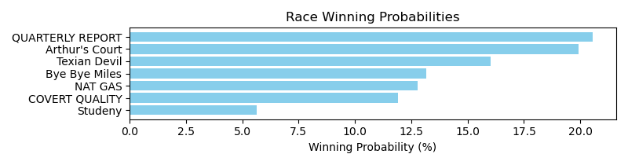

NOTE: GCSF - Global Combined Speed Figure

# Race: TOP | 2025-04-13 | Race #2 | Post: 18:52 | Track: OAKLAWN PARK

Track: OAKLAWN PARK

|  |  |  |  |  |  |
| --- | --- | --- | --- | --- | --- |
| Program # | Horse Name | Morn Odds | GCSF | Model Score | Win Prob (%) |
| 1 | Union Dame | 9-2 | 101.3 | -12.00 | 5.51 |
| 2 | I'd Be Honored | 20-1 | N/A | 4.15 | 23.29 |
| 3 | Open Flame | 5-2 | 95.6 | -4.81 | 10.47 |
| 4 | Take It to Court | 15-1 | N/A | 0.17 | 16.33 |
| 5 | Actin' Up | 20-1 | 100.0 | -25.35 | 1.67 |
| 6 | Patient Emilie | 30-1 | 110.6 | -23.94 | 1.90 |
| 7 | Acousticat | 2-1 | N/A | 8.05 | 32.99 |
| 8 | She's a Reader | 15-1 | 89.1 | -18.88 | 2.98 |
| 9 | Frosted Miracle | 7-2 | 100.0 | -18.44 | 3.10 |
| 10 | Myspittinimage | 30-1 | 106.6 | -24.90 | 1.74 |

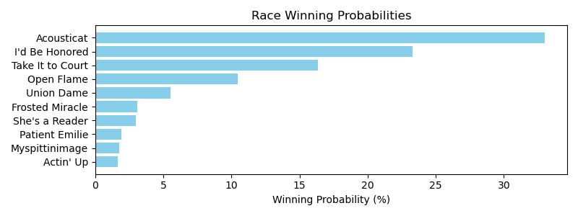

NOTE: GCSF - Global Combined Speed Figure

# Race: TOP | 2025-04-13 | Race #3 | Post: 19:26 | Track: OAKLAWN PARK

Track: OAKLAWN PARK

|  |  |  |  |  |  |
| --- | --- | --- | --- | --- | --- |
| Program # | Horse Name | Morn Odds | GCSF | Model Score | Win Prob (%) |
| 1 | Lear | 15-1 | 99.5 | -11.07 | 2.69 |
| 2 | Palm Tree | 10-1 | 95.9 | -12.27 | 2.42 |
| 3 | Special Dispatch | 5-1 | 93.1 | -7.73 | 3.62 |
| 4 | Nullify | 3-1 | 93.4 | -3.25 | 5.41 |
| 5 | Mendelssohns March | 4-1 | 109.5 | -7.50 | 3.70 |
| 6 | The Thunderer | 7-2 | 99.8 | -1.47 | 6.33 |
| 7 | Maximus Magic | 10-1 | 101.1 | -12.56 | 2.35 |
| 8 | Neon Nights | 9-2 | 103.7 | 25.99 | 73.48 |

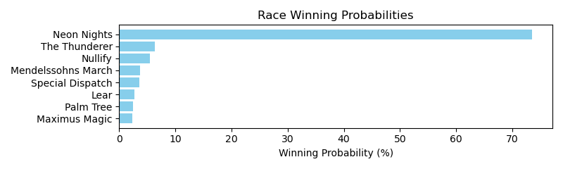

NOTE: GCSF - Global Combined Speed Figure

# Race: TOP | 2025-04-13 | Race #4 | Post: 19:58 | Track: OAKLAWN PARK

Track: OAKLAWN PARK

|  |  |  |  |  |  |
| --- | --- | --- | --- | --- | --- |
| Program # | Horse Name | Morn Odds | GCSF | Model Score | Win Prob (%) |
| 1 | Life Is Hard | 12-1 | 94.0 | -10.07 | 1.15 |
| 2 | Super Brady | 30-1 | 99.6 | -12.69 | 0.91 |
| 3 | Cost Basis | 7-2 | 88.3 | 31.99 | 49.09 |
| 4 | Palace Kitten | 20-1 | 97.2 | -17.77 | 0.58 |
| 5 | Metallic Man | 8-1 | 101.4 | -12.25 | 0.95 |
| 6 | Family Tradition | 20-1 | 92.0 | -14.10 | 0.80 |
| 7 | Miri a Coincidence | 15-1 | 125.7 | -7.63 | 1.43 |
| 8 | Ian Glass | 5-1 | 103.8 | -10.95 | 1.06 |
| 9 | Dutch Mills | 9-2 | 102.5 | -9.58 | 1.20 |
| 10 | Axton | 6-1 | 98.6 | 28.96 | 37.46 |
| 11 | Atomic Tone | 4-1 | 85.1 | 1.60 | 3.26 |
| 12 | Lions Not Sheep | 12-1 | 96.6 | -16.02 | 0.68 |
| 13 | Tie Breaker | 20-1 | 97.2 | -16.73 | 0.63 |
| 14 | Hightail Cowboy | 20-1 | 94.2 | -14.16 | 0.80 |

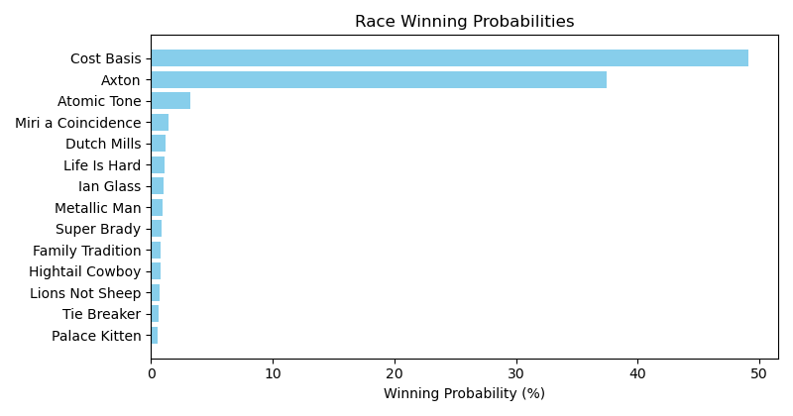

NOTE: GCSF - Global Combined Speed Figure

# Race: TOP | 2025-04-13 | Race #5 | Post: 20:30 | Track: OAKLAWN PARK

Track: OAKLAWN PARK

|  |  |  |  |  |  |
| --- | --- | --- | --- | --- | --- |
| Program # | Horse Name | Morn Odds | GCSF | Model Score | Win Prob (%) |
| 1 | Endue | 30-1 | N/A | -2.32 | 11.65 |
| 2 | Greers Ferry | 9-2 | 96.1 | -8.62 | 6.64 |
| 3 | Good News Rocket | 8-1 | 104.2 | -15.34 | 3.64 |
| 4 | Bote | 12-1 | 110.5 | -21.14 | 2.17 |
| 5 | Awol | 6-1 | 99.1 | -10.12 | 5.81 |
| 6 | Flat Out Blessed | 30-1 | N/A | -0.41 | 13.81 |
| 7 | Harvest n'Hearth | 7-2 | 100.0 | -15.10 | 3.72 |
| 8 | Tough Customer | 3-1 | N/A | 9.64 | 33.85 |
| 9 | Cavanal | 8-1 | 92.5 | -19.59 | 2.49 |
| 10 | Big Country Boy | 20-1 | 110.3 | -23.06 | 1.83 |
| 11 | Kye | 15-1 | 95.8 | -24.91 | 1.55 |
| 12 | Heckamighty | 30-1 | N/A | -1.23 | 12.83 |

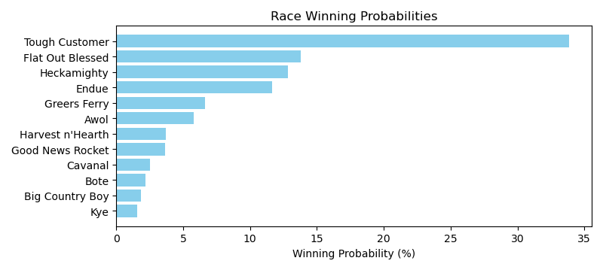

NOTE: GCSF - Global Combined Speed Figure

# Race: TOP | 2025-04-13 | Race #6 | Post: 21:02 | Track: OAKLAWN PARK

Track: OAKLAWN PARK

|  |  |  |  |  |  |
| --- | --- | --- | --- | --- | --- |
| Program # | Horse Name | Morn Odds | GCSF | Model Score | Win Prob (%) |
| 1 | Winston Wolf | 5-2 | 88.3 | 2.38 | 17.16 |
| 2 | Happy Strike | 20-1 | 108.2 | -13.97 | 3.99 |
| 3 | Hern | 20-1 | 109.4 | -15.06 | 3.62 |
| 4 | Zatara | 9-2 | 104.1 | -10.89 | 5.25 |
| 5 | Ethereal Road | 5-1 | 99.4 | -3.57 | 10.09 |
| 6 | Systemic Change | 3-1 | 111.1 | -5.70 | 8.34 |
| 7 | I Don't Get It | 7-2 | 100.1 | -5.34 | 8.61 |
| 8 | Own the Field | 10-1 | 93.3 | 12.66 | 42.95 |

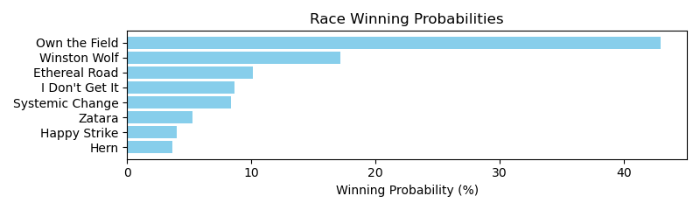

NOTE: GCSF - Global Combined Speed Figure

# Race: TOP | 2025-04-13 | Race #7 | Post: 21:34 | Track: OAKLAWN PARK

Track: OAKLAWN PARK

|  |  |  |  |  |  |
| --- | --- | --- | --- | --- | --- |
| Program # | Horse Name | Morn Odds | GCSF | Model Score | Win Prob (%) |
| 1 | D Day Reunion | 10-1 | 108.9 | -13.86 | 3.57 |
| 2 | Ducale | 3-1 | 96.5 | 3.67 | 17.08 |
| 3 | My Noble Knight | 7-2 | 99.0 | -9.37 | 5.33 |
| 4 | dq-Dick Best | 6-1 | 92.0 | 14.45 | 44.70 |
| 5 | Eternally Grateful | 4-1 | 117.2 | -4.25 | 8.42 |
| 6 | Count de Monet | 12-1 | 94.6 | -14.71 | 3.31 |
| 7 | Nip N Tuck | 20-1 | 97.9 | -15.06 | 3.21 |
| 8 | Unstable Prince | 8-1 | 99.5 | -12.73 | 3.95 |
| 9 | Dynamis | 15-1 | 96.5 | -13.41 | 3.72 |
| 10 | Seas of Normandy | 15-1 | 104.1 | -15.20 | 3.17 |
| 11 | Face Value | 12-1 | 107.9 | -13.99 | 3.53 |

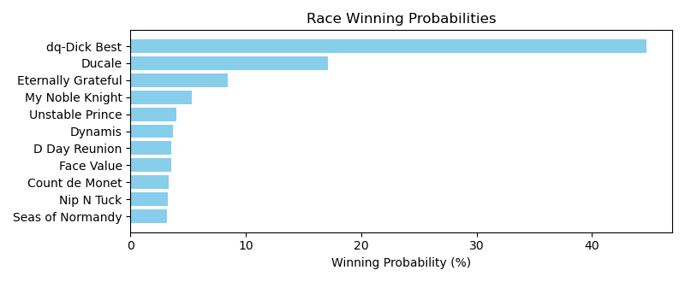

NOTE: GCSF - Global Combined Speed Figure

# Race: TOP | 2025-04-13 | Race #8 | Post: 22:06 | Track: OAKLAWN PARK

Track: OAKLAWN PARK

|  |  |  |  |  |  |
| --- | --- | --- | --- | --- | --- |
| Program # | Horse Name | Morn Odds | GCSF | Model Score | Win Prob (%) |
| 1 | Drill's Li'l Man | 30-1 | 89.2 | -18.12 | 0.65 |
| 2 | I'm Wide Awake | 7-2 | 90.6 | -5.64 | 1.98 |
| 3 | Mumayaz | 10-1 | 98.2 | -13.57 | 0.98 |
| 4 | Crushed It | 10-1 | 110.2 | -15.94 | 0.79 |
| 5 | Got Thunder | 6-1 | 99.4 | -9.59 | 1.39 |
| 6 | Willow Creek Road | 12-1 | 97.9 | -7.88 | 1.62 |
| 7 | One Ten Stadium | 15-1 | 99.7 | 10.73 | 8.55 |
| 8 | Hap Hot | 5-2 | 93.6 | 32.86 | 61.59 |
| 9 | Lochmoor | 15-1 | 97.1 | -10.88 | 1.24 |
| 10 | De Angelo | 20-1 | 93.4 | -7.21 | 1.72 |
| 11 | Midnight Taxes | 12-1 | 96.3 | -8.55 | 1.53 |
| 12 | Raymond | 9-2 | 96.6 | 19.05 | 17.95 |

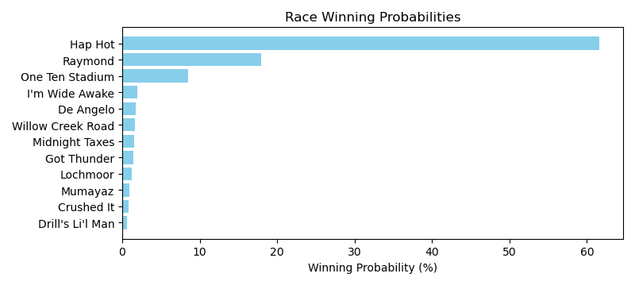

NOTE: GCSF - Global Combined Speed Figure

# Race: TOP | 2025-04-13 | Race #9 | Post: 22:38 | Track: OAKLAWN PARK

Track: OAKLAWN PARK

|  |  |  |  |  |  |
| --- | --- | --- | --- | --- | --- |
| Program # | Horse Name | Morn Odds | GCSF | Model Score | Win Prob (%) |
| 1 | Mr. Commander | 20-1 | 97.5 | 5.32 | 4.72 |
| 2 | Natorade | 5-2 | 104.0 | -12.82 | 0.94 |
| 3 | Debater | 15-1 | 87.0 | -20.06 | 0.49 |
| 4 | Classic Cinema | 6-1 | 95.4 | -16.80 | 0.66 |
| 5 | Fetchs Brahm | 30-1 | 97.4 | -22.28 | 0.40 |
| 6 | Rerun | 10-1 | 90.5 | 36.45 | 76.03 |
| 7 | Madmartigan | 30-1 | 92.0 | -23.56 | 0.36 |
| 8 | Statler | 20-1 | 95.6 | -22.47 | 0.40 |
| 9 | Aux Arcs | 8-1 | 108.4 | 14.94 | 11.15 |
| 10 | Chez Whiz | 2-1 | 99.9 | -6.91 | 1.59 |
| 11 | It's a Rainy Day | 30-1 | 90.7 | -21.44 | 0.43 |
| 12 | Moneystrike | 10-1 | 120.7 | -17.02 | 0.64 |
| 13 | To too Twentytwo | 10-1 | 106.6 | -8.32 | 1.40 |
| 14 | Gee No Hollander | 12-1 | 108.6 | -14.65 | 0.79 |

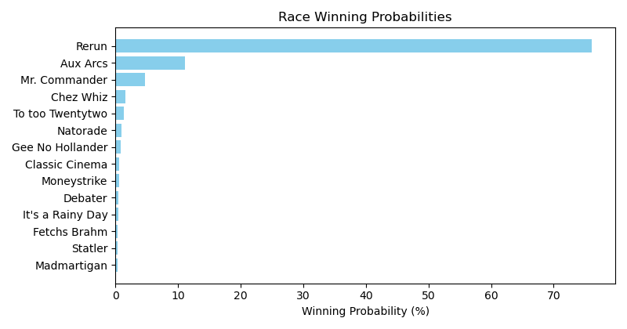

NOTE: GCSF - Global Combined Speed Figure