# Race: TCD | 2025-04-30 | Race #1 | Post: 18:45 | Track: CHURCHILL DOWNS

Track: CHURCHILL DOWNS

|  |  |  |  |  |  |
| --- | --- | --- | --- | --- | --- |
| Program # | Horse Name | Morn Odds | Rank | Model Score | Win Prob (%) |
| 1 | Marmalade Skye | 5-2 | 3.0 | 1.52 | 16.22 |
| 2 | These Apples | 3-1 | 1.0 | 1.65 | 17.74 |
| 3 | Story Hour | 4-1 | 4.0 | 1.38 | 14.79 |
| 4 | Sandra D | 10-1 | 7.0 | 0.74 | 9.52 |
| 5 | Progeny | 6-1 | 5.0 | 1.27 | 13.70 |
| 6 | Ready for Trouble | 5-1 | 2.0 | 1.54 | 16.47 |
| 7 | Always Angels | 8-1 | 6.0 | 1.03 | 11.57 |

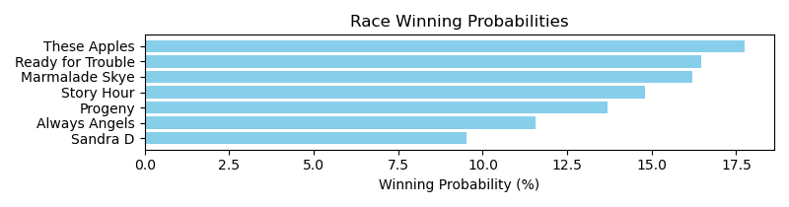

Exacta advice: key 2 → [6,1] (2 tickets)

Bandit Recommendation: Daily Double_top1_box (Expected Net: 0.00)

# Race: TCD | 2025-04-30 | Race #2 | Post: 19:15 | Track: CHURCHILL DOWNS

Track: CHURCHILL DOWNS

|  |  |  |  |  |  |
| --- | --- | --- | --- | --- | --- |
| Program # | Horse Name | Morn Odds | Rank | Model Score | Win Prob (%) |
| 1 | Celestial Harmony | 20-1 | 8.0 | -0.20 | 6.06 |
| 2 | SHE REIGNS | 9-2 | 5.0 | 0.26 | 8.35 |
| 3 | Givemethebeat | 12-1 | 9.0 | -0.25 | 5.85 |
| 4 | WAKUDA | 10-1 | 11.0 | -0.26 | 5.83 |
| 5 | BAFFLE | 9-2 | 6.0 | 0.05 | 7.23 |
| 6 | MOONLIGHT BEAUTY | 4-1 | 2.0 | 0.31 | 8.63 |
| 7 | SASSY C W | 7-2 | 4.0 | 0.28 | 8.48 |
| 8 | RED BERETTA | 15-1 | 7.0 | -0.12 | 6.42 |
| 9 | GOLDEN KEEN | 20-1 | 13.0 | -0.42 | 5.22 |
| 10 | VALIANT WAR GIRL | 12-1 | 10.0 | -0.26 | 5.83 |
| 11 | Little Sam's | 20-1 | 1.0 | 1.03 | 14.19 |
| 12 | STARDIALED | 10-1 | 3.0 | 0.29 | 8.52 |
| 13 | KABOOM | 12-1 | 12.0 | -0.39 | 5.32 |
| 14 | WOODALL PASS | 20-1 | 14.0 | -0.78 | 4.07 |

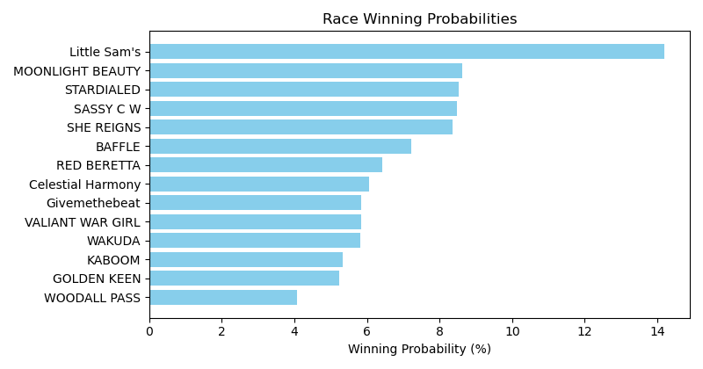

Exacta advice: key 11 → [6,12] (2 tickets)

Bandit Recommendation: Daily Double_top1_box (Expected Net: 0.56)

# Race: TCD | 2025-04-30 | Race #3 | Post: 19:45 | Track: CHURCHILL DOWNS

Track: CHURCHILL DOWNS

|  |  |  |  |  |  |
| --- | --- | --- | --- | --- | --- |
| Program # | Horse Name | Morn Odds | Rank | Model Score | Win Prob (%) |
| 1 | MO MOE MOW | 12-1 | 8.0 | -0.18 | 3.27 |
| 2 | Turnbuckle | 10-1 | 3.0 | 1.95 | 14.20 |
| 3 | Paved in Gold | 5-2 | 1.0 | 2.96 | 28.46 |
| 4 | STRAIGHTAWAY | 5-1 | 6.0 | 0.50 | 5.22 |
| 5 | Old Trace | 7-2 | 5.0 | 1.01 | 7.43 |
| 6 | Bourbon Street Boy | 15-1 | 9.0 | -0.44 | 2.75 |
| 7 | Winning Song | 6-1 | 2.0 | 2.80 | 25.56 |
| 8 | One Mor Story | 4-1 | 4.0 | 1.37 | 9.57 |
| 9 | Friendly Charlie | 15-1 | 7.0 | -0.06 | 3.55 |

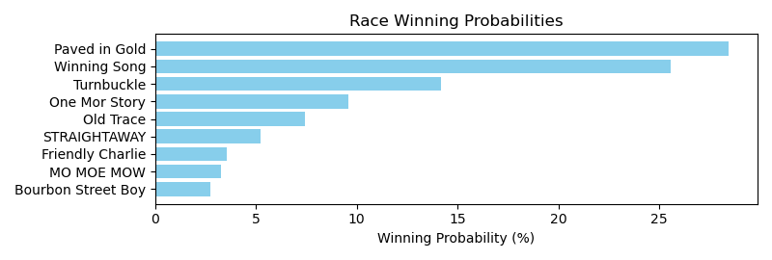

Exacta advice: key 3 → 7 (1 ticket)

Bandit Recommendation: Daily Double_top1_box (Expected Net: 0.56)

# Race: TCD | 2025-04-30 | Race #4 | Post: 20:15 | Track: CHURCHILL DOWNS

Track: CHURCHILL DOWNS

|  |  |  |  |  |  |
| --- | --- | --- | --- | --- | --- |
| Program # | Horse Name | Morn Odds | Rank | Model Score | Win Prob (%) |
| 1 | Shefflin | 8-1 | 15.0 | 0.16 | 2.84 |
| 2 | B D Valeski | 10-1 | 8.0 | 1.22 | 5.90 |
| 3 | Gilded Ruler | 9-2 | 3.0 | 1.64 | 7.89 |
| 4 | Test Factor | 6-1 | 5.0 | 1.50 | 7.17 |
| 5 | Bad Beat Brian | 12-1 | 7.0 | 1.24 | 6.00 |
| 6 | Edge to Edge | 15-1 | 10.0 | 0.96 | 4.94 |
| 7 | Alder | 20-1 | 11.0 | 0.88 | 4.68 |
| 8 | Clear the Air | 8-1 | 4.0 | 1.51 | 7.20 |
| 9 | Let It Ride | 6-1 | 2.0 | 2.25 | 12.00 |
| 10 | Eye Witness | 20-1 | 13.0 | 0.62 | 3.91 |
| 11 | Urban Legend | 7-2 | 1.0 | 2.65 | 15.78 |
| 12 | Dhabab (IRE) | 10-1 | 9.0 | 1.08 | 5.37 |
| 13 | Foxtrotanna | 30-1 | 14.0 | 0.31 | 3.14 |
| 14 | Five o' Somewhere | 30-1 | 16.0 | 0.01 | 2.56 |
| 15 | All Jokes Aside | 30-1 | 12.0 | 0.72 | 4.18 |
| 16 | Ambivalent | 4-1 | 6.0 | 1.35 | 6.44 |

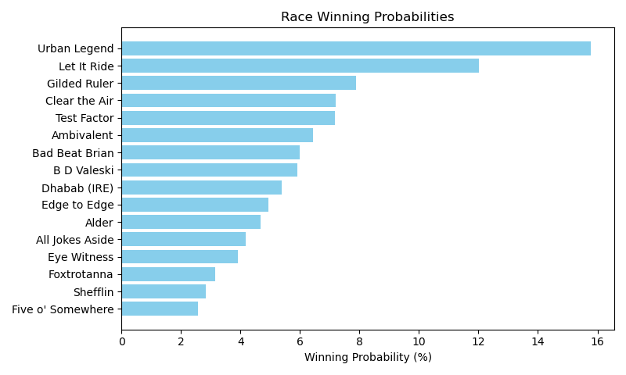

Exacta advice: key 11 → 9 (1 ticket)

Bandit Recommendation: Daily Double_top1_box (Expected Net: 0.00)

# Race: TCD | 2025-04-30 | Race #5 | Post: 20:45 | Track: CHURCHILL DOWNS

Track: CHURCHILL DOWNS

|  |  |  |  |  |  |
| --- | --- | --- | --- | --- | --- |
| Program # | Horse Name | Morn Odds | Rank | Model Score | Win Prob (%) |
| 1 | Another Monarch | 6-1 | 7.0 | 0.22 | 4.86 |
| 2 | Penrod | 5-1 | 4.0 | 0.54 | 6.06 |
| 3 | Farley Hall | 20-1 | 9.0 | -0.17 | 3.73 |
| 4 | Mighty Mo | 20-1 | 10.0 | -0.48 | 3.00 |
| 5 | Bottoms Up | 20-1 | 8.0 | -0.05 | 4.04 |
| 6 | Illini | 12-1 | 6.0 | 0.24 | 4.95 |
| 7 | Focusyn | 7-2 | 1.0 | 2.86 | 30.07 |
| 8 | Jackson's Roar | 20-1 | 5.0 | 0.30 | 5.15 |
| 9 | Perfect Prankster | 3-1 | 3.0 | 2.06 | 17.30 |
| 10 | Committee of One | 5-2 | 2.0 | 2.33 | 20.84 |

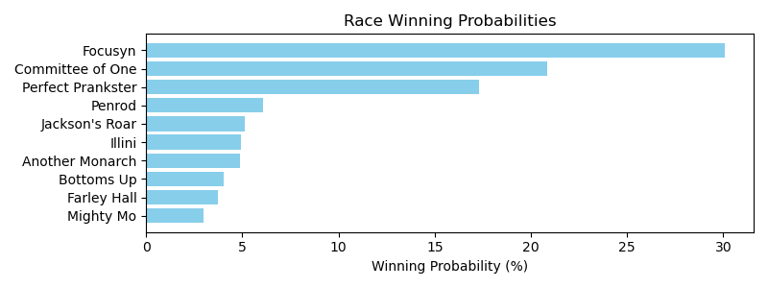

Exacta advice: key 7 → 10 (1 ticket)

Bandit Recommendation: Daily Double_top1_box (Expected Net: 0.00)

# Race: TCD | 2025-04-30 | Race #6 | Post: 21:16 | Track: CHURCHILL DOWNS

Track: CHURCHILL DOWNS

|  |  |  |  |  |  |
| --- | --- | --- | --- | --- | --- |
| Program # | Horse Name | Morn Odds | Rank | Model Score | Win Prob (%) |
| 1 | Sir Pistolero | 12-1 | 8.0 | 0.06 | 4.49 |
| 2 | Gift Certificate | 20-1 | 9.0 | -0.17 | 3.86 |
| 3 | Explosively | 4-1 | 3.0 | 1.82 | 15.11 |
| 4 | Manabi | 15-1 | 6.0 | 0.89 | 8.01 |
| 5 | Tiger's Legacy | 5-2 | 2.0 | 2.08 | 18.14 |
| 6 | Norwich | 5-1 | 4.0 | 1.61 | 13.09 |
| 7 | Shipman | 10-1 | 7.0 | 0.72 | 7.10 |
| 8 | Badgeball | 3-1 | 5.0 | 0.89 | 8.01 |
| 9 | Vertrauen | 8-1 | 1.0 | 2.37 | 22.19 |

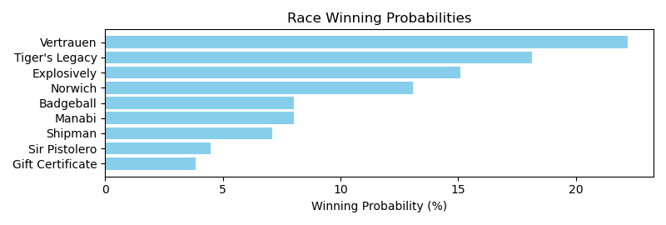

Exacta advice: key 9 → 5 (1 ticket)

Bandit Recommendation: Daily Double_top1_box (Expected Net: 0.00)

# Race: TCD | 2025-04-30 | Race #7 | Post: 21:47 | Track: CHURCHILL DOWNS

Track: CHURCHILL DOWNS

|  |  |  |  |  |  |
| --- | --- | --- | --- | --- | --- |
| Program # | Horse Name | Morn Odds | Rank | Model Score | Win Prob (%) |
| 1 | Likely Perspective (IRE) | 20-1 | 8.0 | 0.72 | 5.38 |
| 2 | Yes Indeed | 12-1 | 7.0 | 0.90 | 6.07 |
| 3 | Storm Miami (IRE) | 6-1 | 2.0 | 2.59 | 19.40 |
| 4 | Classic Q | 3-1 | 3.0 | 2.06 | 13.54 |
| 5 | New Rome | 4-1 | 5.0 | 1.36 | 8.31 |
| 6 | Dream On Stormy | 20-1 | 11.0 | -0.81 | 1.87 |
| 7 | Expatriate | 9-2 | 6.0 | 1.22 | 7.59 |
| 8 | Candy Cause | 30-1 | 9.0 | 0.21 | 3.77 |
| 9 | Hope Mission | 7-2 | 1.0 | 2.83 | 22.96 |
| 10 | Hay Stack | 15-1 | 4.0 | 1.41 | 8.66 |
| 11 | Take Shape | 20-1 | 10.0 | -0.43 | 2.44 |

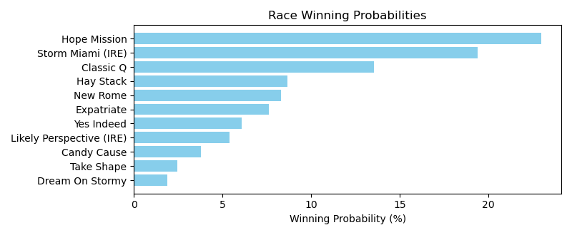

Exacta advice: key 9 → 3 (1 ticket)

Bandit Recommendation: Daily Double_top1_box (Expected Net: 0.00)

# Race: TCD | 2025-04-30 | Race #8 | Post: 22:19 | Track: CHURCHILL DOWNS

Track: CHURCHILL DOWNS

|  |  |  |  |  |  |
| --- | --- | --- | --- | --- | --- |
| Program # | Horse Name | Morn Odds | Rank | Model Score | Win Prob (%) |
| 1 | Honor Marie | 7-2 | 4.0 | 1.44 | 14.03 |
| 2 | Game Warden | 3-1 | 5.0 | 1.39 | 13.54 |
| 3 | Speed Bias | 4-1 | 2.0 | 1.70 | 16.76 |
| 4 | Warrior Johny | 10-1 | 3.0 | 1.51 | 14.68 |
| 5 | Lambeth | 2-1 | 1.0 | 1.95 | 19.93 |
| 6 | Le Gris | 20-1 | 8.0 | -0.13 | 4.75 |
| 7 | Baba Voss | 30-1 | 7.0 | 0.09 | 5.54 |
| 8 | Timeout | 8-1 | 6.0 | 1.06 | 10.77 |

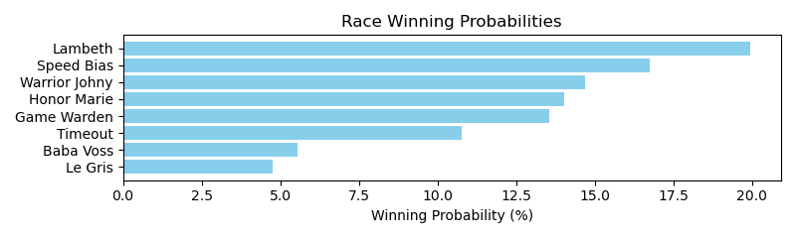

Exacta advice: key 5 → 3 (1 ticket)

Bandit Recommendation: Daily Double_top1_box (Expected Net: 0.00)

# Race: TCD | 2025-04-30 | Race #9 | Post: 22:52 | Track: CHURCHILL DOWNS

Track: CHURCHILL DOWNS

|  |  |  |  |  |  |
| --- | --- | --- | --- | --- | --- |
| Program # | Horse Name | Morn Odds | Rank | Model Score | Win Prob (%) |
| 1 | Out On Bail | 7-2 | 3.0 | 1.43 | 12.99 |
| 2 | Altobelli | 30-1 | 10.0 | -0.16 | 4.33 |
| 3 | Bridle a Butterfly | 30-1 | 11.0 | -0.32 | 3.88 |
| 4 | Normandy Coast | 8-1 | 6.0 | 0.76 | 8.16 |
| 5 | Coming in Hot | 12-1 | 4.0 | 1.07 | 10.10 |
| 6 | Makeit to Cheyenne | 4-1 | 1.0 | 1.87 | 17.55 |
| 7 | Jet Sweep Joe | 20-1 | 9.0 | -0.06 | 4.65 |
| 8 | dq-Big Vince | 15-1 | 5.0 | 0.80 | 8.40 |
| 9 | Warheart | 12-1 | 8.0 | 0.08 | 5.10 |
| 10 | Perfect Force | 15-1 | 7.0 | 0.61 | 7.39 |
| 11 | Governor Sam | 13-8 | 2.0 | 1.86 | 17.46 |

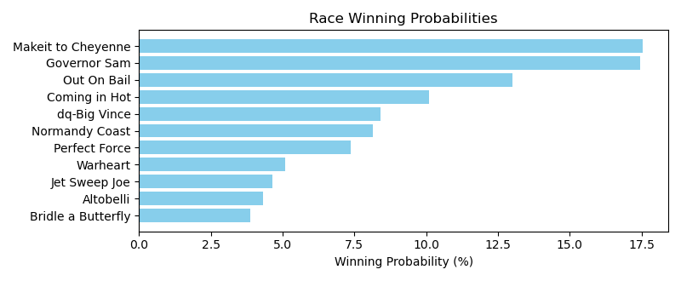

Exacta advice: box [6,11,1] (6 tickets)

Bandit Recommendation: Pick 4_top1_box (Expected Net: 0.00)

# Race: TCD | 2025-04-30 | Race #10 | Post: 23:25 | Track: CHURCHILL DOWNS

Track: CHURCHILL DOWNS

|  |  |  |  |  |  |
| --- | --- | --- | --- | --- | --- |
| Program # | Horse Name | Morn Odds | Rank | Model Score | Win Prob (%) |
| 1 | Bright Lights Joe | 9-2 | 7.0 | 1.05 | 6.77 |
| 2 | Mister Woodford | 20-1 | 8.0 | 1.02 | 6.60 |
| 3 | ZOHERE | 15-1 | 10.0 | -0.07 | 3.13 |
| 4 | Good News Rocket | 4-1 | 1.0 | 2.54 | 18.89 |
| 5 | Chado | 5-1 | 3.0 | 2.00 | 13.00 |
| 6 | Silent Breeze | 6-1 | 4.0 | 1.82 | 11.50 |
| 7 | Hasten | 3-1 | 5.0 | 1.74 | 10.89 |
| 8 | Activity | 8-1 | 2.0 | 2.08 | 13.68 |
| 9 | Beezer | 20-1 | 9.0 | 0.88 | 6.00 |
| 10 | Cajun Cruiser | 12-1 | 6.0 | 1.24 | 7.68 |
| 11 | CAUSE IMA BOSS | 20-1 | 11.0 | -0.82 | 1.86 |

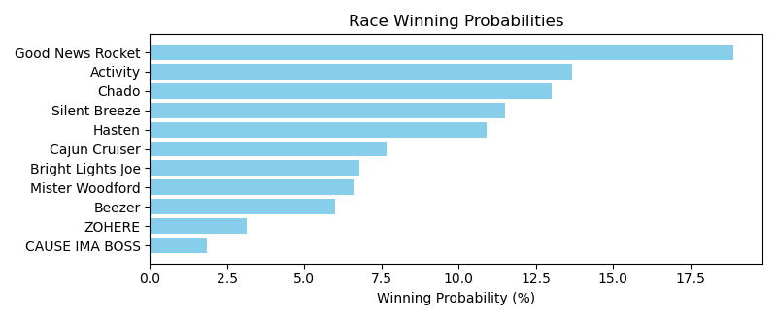

Exacta advice: key 4 → 8 (1 ticket)

Bandit Recommendation: Pick 4_top1_box (Expected Net: 0.00)

# Race: TCD | 2025-05-01 | Race #1 | Post: 18:45 | Track: CHURCHILL DOWNS

Track: CHURCHILL DOWNS

|  |  |  |  |  |  |
| --- | --- | --- | --- | --- | --- |
| Program # | Horse Name | Morn Odds | Rank | Model Score | Win Prob (%) |
| 1 | Can I Get Awitness | 5-1 | 6.0 | 0.85 | 5.10 |
| 2 | Steppin Tothe Beat | 12-1 | 9.0 | 0.02 | 2.88 |
| 3 | Tempting Lady | 6-1 | 2.0 | 3.10 | 23.94 |
| 4 | Image of Me | 6-1 | 3.0 | 2.67 | 17.78 |
| 5 | Marmo | 5-2 | 4.0 | 2.28 | 13.62 |
| 6 | Sperry Chalet | 8-1 | 8.0 | 0.25 | 3.37 |
| 7 | Warm Days | 20-1 | 5.0 | 0.91 | 5.31 |
| 8 | Big Leap | 3-1 | 1.0 | 3.11 | 24.10 |
| 9 | Sr. Mary Margaret | 15-1 | 7.0 | 0.47 | 3.91 |

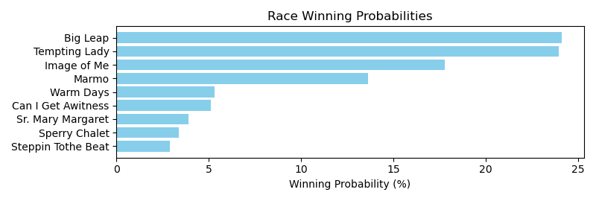

Exacta advice: box [8,3,4] (6 tickets)

Bandit Recommendation: Daily Double_top1_box (Expected Net: 0.00)

# Race: TCD | 2025-05-01 | Race #2 | Post: 19:15 | Track: CHURCHILL DOWNS

Track: CHURCHILL DOWNS

|  |  |  |  |  |  |
| --- | --- | --- | --- | --- | --- |
| Program # | Horse Name | Morn Odds | Rank | Model Score | Win Prob (%) |
| 1 | BLINGING IT BACK | 6-1 | 3.0 | 0.28 | 12.45 |
| 2 | MR AMERICAN PIE | 10-1 | 6.0 | -0.35 | 8.09 |
| 3 | CAPTAIN GABE | 12-1 | 5.0 | -0.34 | 8.14 |
| 4 | MANS GRACE | 20-1 | 10.0 | -0.74 | 6.17 |
| 5 | TURIN | 4-1 | 2.0 | 0.59 | 15.43 |
| 6 | DISTORTED SONG | 15-1 | 8.0 | -0.48 | 7.38 |
| 7 | MERCILESANIHILATOR | 3-1 | 4.0 | 0.20 | 11.76 |
| 8 | SIMONE | 10-1 | 7.0 | -0.46 | 7.50 |
| 9 | Baytown Anubis | 20-1 | 9.0 | -0.55 | 7.03 |
| 10 | MOONLIGHT BEAUTY | 5-2 | 1.0 | 0.65 | 16.06 |

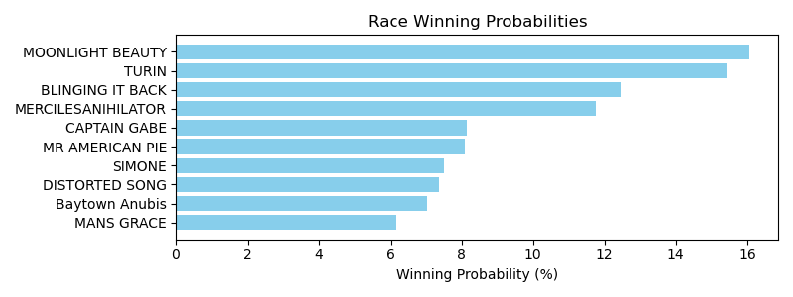

Exacta advice: box [10,5,1] (6 tickets)

Bandit Recommendation: Daily Double_top1_box (Expected Net: 0.56)

# Race: TCD | 2025-05-01 | Race #3 | Post: 19:45 | Track: CHURCHILL DOWNS

Track: CHURCHILL DOWNS

|  |  |  |  |  |  |
| --- | --- | --- | --- | --- | --- |
| Program # | Horse Name | Morn Odds | Rank | Model Score | Win Prob (%) |
| 1 | Two Eagles River | 7-5 | 1.0 | 2.14 | 25.26 |
| 2 | Underhill's Tab | 5-2 | 2.0 | 2.03 | 23.37 |
| 3 | Tagliatelle | 7-2 | 3.0 | 1.43 | 15.47 |
| 4 | Refuah | 15-1 | 5.0 | 0.70 | 9.37 |
| 5 | Regal Rey | 15-1 | 7.0 | -0.09 | 5.45 |
| 6 | Scat Free | 8-1 | 6.0 | 0.41 | 7.67 |
| 7 | Beyond Best | 10-1 | 4.0 | 1.22 | 13.41 |

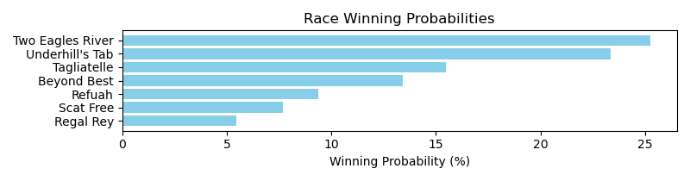

Exacta advice: key 1 → 2 (1 ticket)

Bandit Recommendation: Pick 3_top1_box (Expected Net: 0.00)

# Race: TCD | 2025-05-01 | Race #4 | Post: 20:17 | Track: CHURCHILL DOWNS

Track: CHURCHILL DOWNS

|  |  |  |  |  |  |
| --- | --- | --- | --- | --- | --- |
| Program # | Horse Name | Morn Odds | Rank | Model Score | Win Prob (%) |
| 1 | Ready to Jam | 8-1 | 6.0 | 1.23 | 6.62 |
| 2 | High Fashion Kate | 20-1 | 16.0 | 0.61 | 4.30 |
| 3 | Paynt Ya Later | 20-1 | 14.0 | 0.69 | 4.55 |
| 4 | May May Strong | 12-1 | 3.0 | 1.37 | 7.29 |
| 5 | Rue Lala | 9-2 | 2.0 | 1.79 | 9.74 |
| 6 | Top Gun Girl | 5-2 | 1.0 | 2.01 | 11.33 |
| 7 | Out too Late (GB) | 10-1 | 7.0 | 1.21 | 6.54 |
| 8 | Hideki | 15-1 | 13.0 | 0.70 | 4.58 |
| 9 | Cart Girl Sam | 8-1 | 9.0 | 1.06 | 5.89 |
| 10 | Girls Weekend | 12-1 | 8.0 | 1.11 | 6.09 |
| 11 | Numero Seis | 12-1 | 10.0 | 0.85 | 5.08 |
| 12 | Niki Nine Doors | 5-1 | 12.0 | 0.74 | 4.72 |
| 13 | Hurry Up Hannah | 15-1 | 11.0 | 0.84 | 5.04 |
| 14 | Ervadean | 10-1 | 5.0 | 1.26 | 6.76 |
| 15 | Best Cupcake | 20-1 | 15.0 | 0.68 | 4.52 |
| 16 | Bustin Bullet | 10-1 | 4.0 | 1.30 | 6.94 |

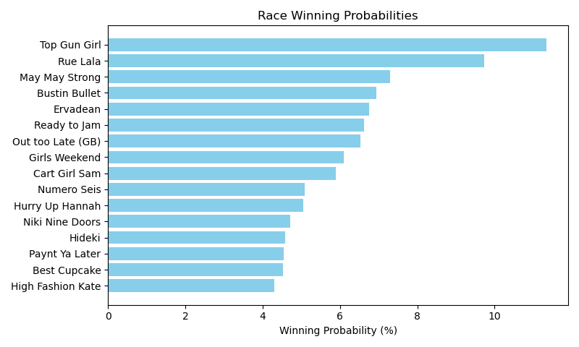

Exacta advice: key 6 → 5 (1 ticket)

Bandit Recommendation: Pick 3_top1_box (Expected Net: 0.00)

# Race: TCD | 2025-05-01 | Race #5 | Post: 20:52 | Track: CHURCHILL DOWNS

Track: CHURCHILL DOWNS

|  |  |  |  |  |  |
| --- | --- | --- | --- | --- | --- |
| Program # | Horse Name | Morn Odds | Rank | Model Score | Win Prob (%) |
| 1 | Riddle Solver | 10-1 | 5.0 | 0.99 | 9.74 |
| 2 | Bolt At Midnight | 3-1 | 2.0 | 1.90 | 18.22 |
| 3 | Tango Mike Mike | 15-1 | 8.0 | -0.29 | 4.04 |
| 4 | Lured Away | 8-1 | 7.0 | 0.20 | 5.66 |
| 5 | Gamblers Tail | 7-2 | 4.0 | 1.50 | 13.86 |
| 6 | Baytown Bruiser | 20-1 | 9.0 | -0.69 | 3.07 |
| 7 | Curlin's Gesture | 4-1 | 3.0 | 1.57 | 14.53 |
| 8 | Shortstop | 8-1 | 1.0 | 2.17 | 22.03 |
| 9 | Googol Joke | 10-1 | 6.0 | 0.85 | 8.86 |

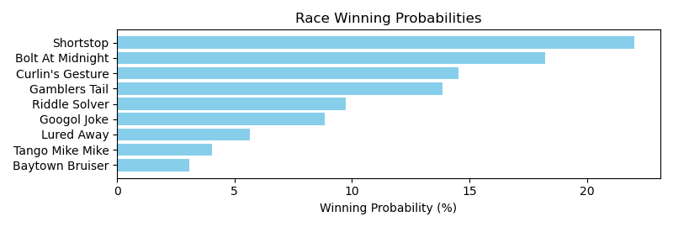

Exacta advice: key 8 → 2 (1 ticket)

Bandit Recommendation: exacta_top2_box (Expected Net: 0.00)

# Race: TCD | 2025-05-01 | Race #6 | Post: 21:27 | Track: CHURCHILL DOWNS

Track: CHURCHILL DOWNS

|  |  |  |  |  |  |
| --- | --- | --- | --- | --- | --- |
| Program # | Horse Name | Morn Odds | Rank | Model Score | Win Prob (%) |
| 1 | Daring Move | 15-1 | 7.0 | 0.58 | 5.60 |
| 2 | Maximus Prime | 15-1 | 5.0 | 0.90 | 6.93 |
| 3 | Happyhappyboy | 15-1 | 8.0 | 0.48 | 5.22 |
| 4 | Diblasi | 12-1 | 4.0 | 1.64 | 11.61 |
| 5 | Pinky Finger | 13-8 | 1.0 | 2.92 | 28.05 |
| 6 | Monster | 3-1 | 6.0 | 0.67 | 5.94 |
| 7 | Double Talker | 2-1 | 2.0 | 2.75 | 24.93 |
| 8 | Barstool | 20-1 | 3.0 | 1.66 | 11.72 |

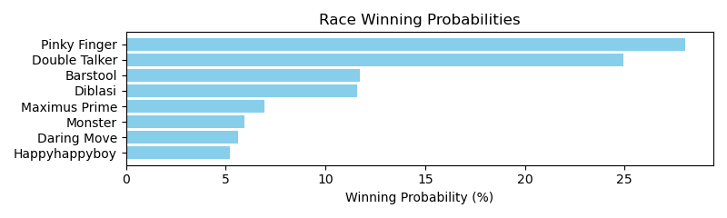

Exacta advice: key 5 → 7 (1 ticket)

Bandit Recommendation: Pick 3_top1_box (Expected Net: 0.00)

# Race: TCD | 2025-05-01 | Race #7 | Post: 22:03 | Track: CHURCHILL DOWNS

Track: CHURCHILL DOWNS

|  |  |  |  |  |  |
| --- | --- | --- | --- | --- | --- |
| Program # | Horse Name | Morn Odds | Rank | Model Score | Win Prob (%) |
| 1 | Rotterdam | 3-1 | 1.0 | 2.24 | 13.45 |
| 2 | Mega Magic | 20-1 | 16.0 | -0.62 | 1.89 |
| 3 | Transcendental | 15-1 | 14.0 | 0.16 | 3.22 |
| 4 | Multitask | 12-1 | 12.0 | 0.66 | 4.54 |
| 5 | Masayoshi | 6-1 | 3.0 | 1.72 | 9.41 |
| 6 | Domingo | 6-1 | 2.0 | 1.73 | 9.47 |
| 7 | Warhol | 15-1 | 10.0 | 0.95 | 5.54 |
| 8 | Publicity | 20-1 | 5.0 | 1.40 | 7.55 |
| 9 | Simovic | 20-1 | 6.0 | 1.25 | 6.84 |
| 10 | Thrilla | 15-1 | 15.0 | -0.05 | 2.78 |
| 11 | Presider | 5-1 | 7.0 | 1.24 | 6.77 |
| 12 | Oh Really | 9-2 | 4.0 | 1.48 | 7.99 |
| 13 | Brown Liquor Man | 10-1 | 11.0 | 0.72 | 4.73 |
| 14 | Game Point | 20-1 | 8.0 | 1.17 | 6.45 |
| 15 | Mugatu | 30-1 | 13.0 | 0.24 | 3.39 |
| 16 | Footprint | 12-1 | 9.0 | 1.06 | 5.99 |

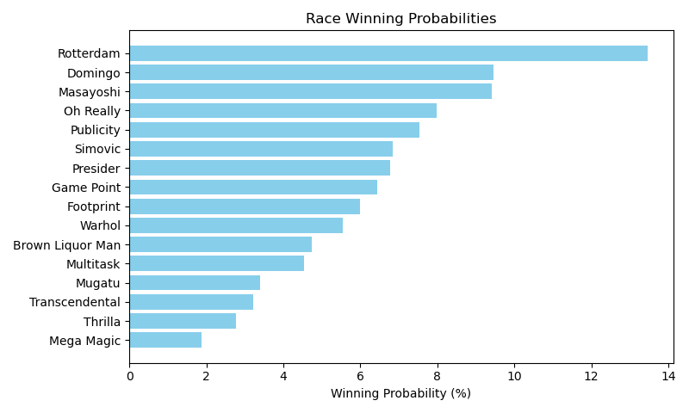

Exacta advice: key 1 → [6,5] (2 tickets)

Bandit Recommendation: Daily Double_top1_box (Expected Net: 0.00)

# Race: TCD | 2025-05-01 | Race #8 | Post: 22:38 | Track: CHURCHILL DOWNS

Track: CHURCHILL DOWNS

|  |  |  |  |  |  |
| --- | --- | --- | --- | --- | --- |
| Program # | Horse Name | Morn Odds | Rank | Model Score | Win Prob (%) |
| 1 | Polster | 10-1 | 8.0 | 0.26 | 5.51 |
| 2 | Vitement | 10-1 | 6.0 | 0.64 | 7.12 |
| 3 | Ludwig | 5-2 | 2.0 | 2.10 | 19.52 |
| 4 | Classic Legacy | 3-1 | 1.0 | 2.74 | 30.44 |
| 5 | Bebedouro | 8-1 | 7.0 | 0.52 | 6.56 |
| 6 | Spanish Wells | 12-1 | 9.0 | -0.37 | 3.57 |
| 7 | Kigali | 8-1 | 4.0 | 0.75 | 7.70 |
| 8 | Hailstorm | 4-1 | 3.0 | 1.40 | 12.10 |
| 9 | El Dandi | 12-1 | 5.0 | 0.70 | 7.47 |

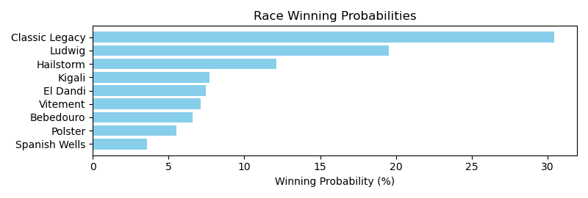

Exacta advice: key 4 → 3 (1 ticket)

Bandit Recommendation: Pick 4_top1_box (Expected Net: 0.42)

# Race: TCD | 2025-05-01 | Race #9 | Post: 23:13 | Track: CHURCHILL DOWNS

Track: CHURCHILL DOWNS

|  |  |  |  |  |  |
| --- | --- | --- | --- | --- | --- |
| Program # | Horse Name | Morn Odds | Rank | Model Score | Win Prob (%) |
| 1 | Arro Smash | 6-1 | 7.0 | 1.19 | 9.35 |
| 2 | World Record | 5-2 | 3.0 | 1.96 | 15.89 |
| 3 | Petcoff | 10-1 | 4.0 | 1.96 | 15.80 |
| 4 | Track Phantom | 6-1 | 2.0 | 1.98 | 16.10 |
| 5 | Nautical Star | 5-1 | 6.0 | 1.21 | 9.48 |
| 6 | Caramel Chip | 8-1 | 5.0 | 1.41 | 10.83 |
| 7 | Nash | 2-1 | 1.0 | 2.47 | 22.55 |

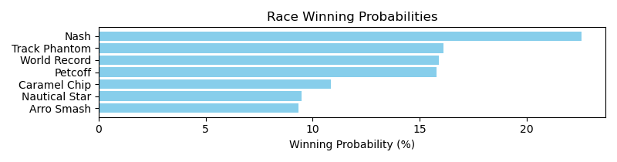

Exacta advice: key 7 → [4,2] (2 tickets)

Bandit Recommendation: Pick 4_top1_box (Expected Net: 0.00)

# Race: TCD | 2025-05-01 | Race #10 | Post: 23:47 | Track: CHURCHILL DOWNS

Track: CHURCHILL DOWNS

|  |  |  |  |  |  |
| --- | --- | --- | --- | --- | --- |
| Program # | Horse Name | Morn Odds | Rank | Model Score | Win Prob (%) |
| 1 | Piper's Factor | 20-1 | 10.0 | 0.50 | 5.05 |
| 2 | Skyro | 20-1 | 8.0 | 0.99 | 7.08 |
| 3 | Tut's Revenge | 10-1 | 7.0 | 1.17 | 8.01 |
| 4 | Money Supply | 12-1 | 4.0 | 1.49 | 9.96 |
| 5 | Portofino | 10-1 | 5.0 | 1.48 | 9.92 |
| 6 | Major Dude | 5-2 | 1.0 | 2.27 | 17.06 |
| 7 | Mercante | 4-1 | 3.0 | 1.83 | 12.56 |
| 8 | Georgie W | 20-1 | 9.0 | 0.79 | 6.15 |
| 9 | Brilliant Berti | 3-1 | 2.0 | 2.02 | 14.33 |
| 10 | Lagynos | 5-1 | 6.0 | 1.47 | 9.87 |

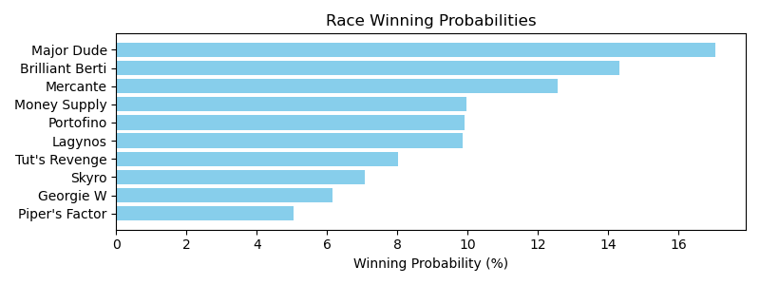

Exacta advice: key 6 → 9 (1 ticket)

Bandit Recommendation: Pick 4_top1_box (Expected Net: 0.00)

# Race: TCD | 2025-05-01 | Race #11 | Post: 00:18 | Track: CHURCHILL DOWNS

Track: CHURCHILL DOWNS

|  |  |  |  |  |  |
| --- | --- | --- | --- | --- | --- |
| Program # | Horse Name | Morn Odds | Rank | Model Score | Win Prob (%) |
| 1 | Henro | 15-1 | 9.0 | 0.64 | 5.90 |
| 2 | Miles Ahead | 10-1 | 8.0 | 1.08 | 8.00 |
| 3 | Speed Boat Beach | 5-2 | 2.0 | 2.11 | 16.27 |
| 4 | Happy Is a Choice | 4-1 | 6.0 | 1.12 | 8.23 |
| 5 | Fort Bragg | 6-1 | 7.0 | 1.11 | 8.15 |
| 6 | Red Flag | 20-1 | 10.0 | 0.37 | 4.90 |
| 7 | Bango | 8-1 | 4.0 | 1.50 | 10.69 |
| 8 | Champlin | 10-1 | 5.0 | 1.13 | 8.25 |
| 9 | Happy American | 12-1 | 3.0 | 1.66 | 11.89 |
| 10 | Valentine Candy | 9-2 | 1.0 | 2.24 | 17.71 |

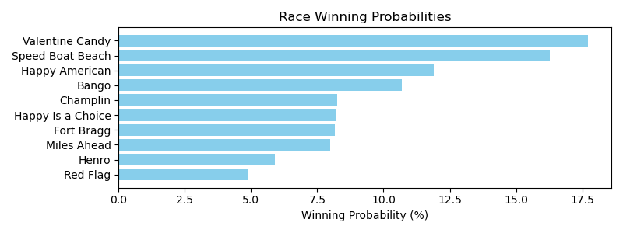

Exacta advice: key 10 → 3 (1 ticket)

Bandit Recommendation: Pick 4_top1_box (Expected Net: 0.00)

# Race: TCD | 2025-05-01 | Race #12 | Post: 00:47 | Track: CHURCHILL DOWNS

Track: CHURCHILL DOWNS

|  |  |  |  |  |  |
| --- | --- | --- | --- | --- | --- |
| Program # | Horse Name | Morn Odds | Rank | Model Score | Win Prob (%) |
| 1 | Pacific Front | 4-1 | 3.0 | 2.69 | 10.05 |
| 2 | Bee Cat | 20-1 | 8.0 | 1.94 | 6.01 |
| 3 | Achieve | 15-1 | 12.0 | 1.05 | 3.24 |
| 4 | Royal Suite | 15-1 | 14.0 | 0.80 | 2.73 |
| 5 | Moringa | 30-1 | 13.0 | 0.96 | 3.06 |
| 6 | Hello Beauty | 15-1 | 5.0 | 2.44 | 8.46 |
| 7 | Stellify | 3-1 | 7.0 | 2.03 | 6.38 |
| 8 | KENTUCKY FLAME | 15-1 | 15.0 | 0.38 | 2.05 |
| 9 | Strive for Honor | 5-1 | 11.0 | 1.59 | 4.73 |
| 10 | Fleetingly | 7-2 | 2.0 | 2.83 | 11.09 |
| 11 | My Gal | 8-1 | 6.0 | 2.13 | 6.84 |
| 12 | Turmalina | 30-1 | 16.0 | 0.36 | 2.02 |
| 13 | Vice | 6-1 | 4.0 | 2.57 | 9.28 |
| 14 | Massarat | 12-1 | 9.0 | 1.86 | 5.68 |
| 15 | Something Stronger | 12-1 | 10.0 | 1.80 | 5.43 |
| 16 | Hideaway | 5-1 | 1.0 | 3.06 | 12.97 |

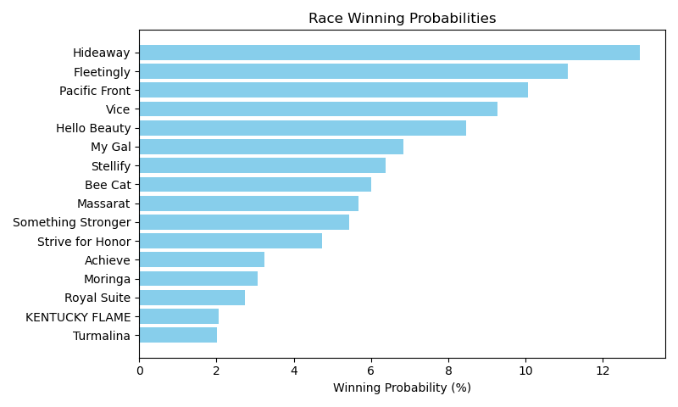

Exacta advice: key 16 → 10 (1 ticket)

Bandit Recommendation: Pick 4_top1_box (Expected Net: 0.00)

# Race: TCD | 2025-05-02 | Race #1 | Post: 17:00 | Track: CHURCHILL DOWNS

Track: CHURCHILL DOWNS

|  |  |  |  |  |  |
| --- | --- | --- | --- | --- | --- |
| Program # | Horse Name | Morn Odds | Rank | Model Score | Win Prob (%) |
| 1 | Anonima | 3-1 | 6.0 | 1.60 | 10.73 |
| 2 | Table Flirt | 12-1 | 7.0 | 0.76 | 6.02 |
| 3 | Shred the Gnar | 5-2 | 1.0 | 2.72 | 23.18 |
| 4 | Chasten | 2-1 | 2.0 | 2.07 | 14.79 |
| 5 | Sierra November | 8-1 | 4.0 | 1.77 | 12.07 |
| 6 | Talent Show | 30-1 | 3.0 | 2.01 | 14.22 |
| 7 | Flip Flops | 15-1 | 8.0 | 0.39 | 4.66 |
| 8 | Naked Eye | 20-1 | 5.0 | 1.71 | 11.56 |
| 9 | Winfinity | 12-1 | 9.0 | -0.36 | 2.78 |

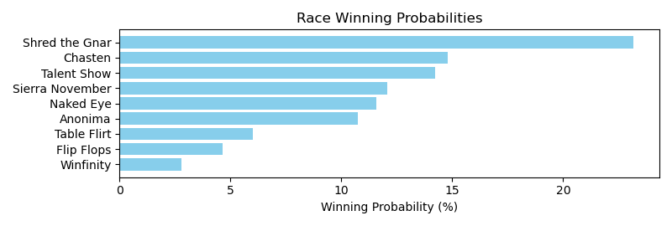

Exacta advice: key 3 → 4 (1 ticket)

Bandit Recommendation: Daily Double_top1_box (Expected Net: 0.00)

# Race: TCD | 2025-05-02 | Race #2 | Post: 17:29 | Track: CHURCHILL DOWNS

Track: CHURCHILL DOWNS

|  |  |  |  |  |  |
| --- | --- | --- | --- | --- | --- |
| Program # | Horse Name | Morn Odds | Rank | Model Score | Win Prob (%) |
| 1 | JOYOUS SONG | 12-1 | 9.0 | 0.58 | 3.94 |
| 2 | Sun Lightning | 20-1 | 11.0 | 0.00 | 2.64 |
| 3 | Saucier | 6-1 | 7.0 | 1.15 | 5.84 |
| 4 | Defiant Lass | 4-1 | 4.0 | 1.81 | 9.16 |
| 5 | ENDORSE | 8-1 | 10.0 | 0.50 | 3.71 |
| 6 | Lolo Le Plume | 12-1 | 2.0 | 2.38 | 13.63 |
| 7 | Contorted | 10-1 | 6.0 | 1.34 | 6.62 |
| 8 | Crawford | 8-1 | 3.0 | 2.18 | 11.87 |
| 9 | Salted | 3-1 | 1.0 | 3.54 | 30.25 |
| 10 | Raghba | 6-1 | 5.0 | 1.68 | 8.36 |
| 11 | Stylish Lady | 12-1 | 8.0 | 0.60 | 3.98 |

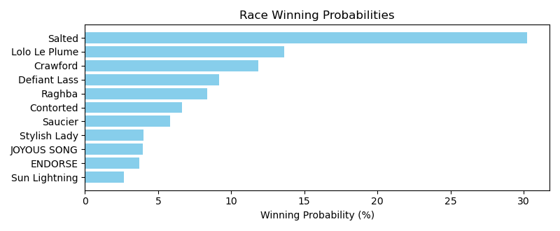

Exacta advice: key 9 → 6 (1 ticket)

Bandit Recommendation: Daily Double_top1_box (Expected Net: 0.56)

# Race: TCD | 2025-05-02 | Race #3 | Post: 17:58 | Track: CHURCHILL DOWNS

Track: CHURCHILL DOWNS

|  |  |  |  |  |  |
| --- | --- | --- | --- | --- | --- |
| Program # | Horse Name | Morn Odds | Rank | Model Score | Win Prob (%) |
| 1 | Elko County | 6-1 | 5.0 | 2.46 | 8.49 |
| 2 | Tom Collins | 8-1 | 7.0 | 2.18 | 7.01 |
| 3 | Profound | 4-1 | 12.0 | 1.21 | 3.59 |
| 4 | SPILL THE WINE | 20-1 | 15.0 | -0.05 | 1.50 |
| 5 | Demetrius | 15-1 | 10.0 | 1.99 | 6.12 |
| 6 | World Beater | 6-1 | 1.0 | 2.92 | 11.67 |
| 7 | Mighty Mike | 30-1 | 9.0 | 2.06 | 6.44 |
| 8 | No Mo Moolah | 30-1 | 11.0 | 1.60 | 4.68 |
| 9 | Marina Gamba | 15-1 | 8.0 | 2.09 | 6.59 |
| 10 | SOME PERFORMANCE | 9-2 | 13.0 | 1.10 | 3.32 |
| 11 | Vivaldi | 5-1 | 3.0 | 2.70 | 10.01 |
| 12 | Moon Channel | 6-1 | 6.0 | 2.39 | 8.06 |
| 13 | Kick It In | 30-1 | 14.0 | 1.05 | 3.21 |
| 14 | Its Bourbon Thirty | 8-1 | 2.0 | 2.78 | 10.60 |
| 15 | Ambition | 10-1 | 4.0 | 2.50 | 8.71 |

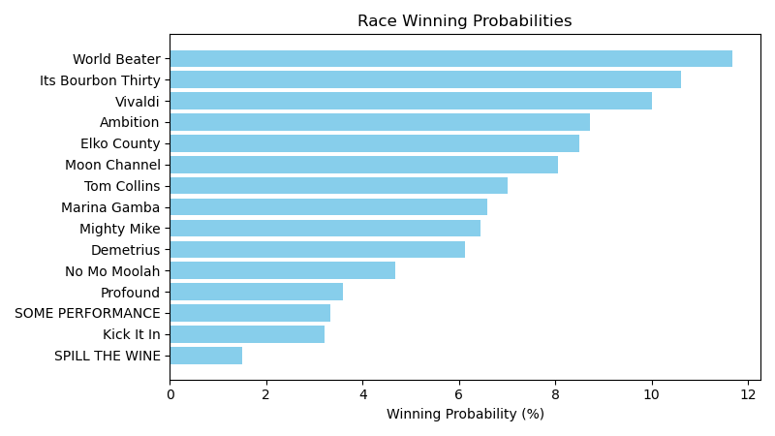

Exacta advice: key 6 → 14 (1 ticket)

Bandit Recommendation: superfecta_top4_box (Expected Net: -2.00)

# Race: TCD | 2025-05-02 | Race #4 | Post: 18:29 | Track: CHURCHILL DOWNS

Track: CHURCHILL DOWNS

|  |  |  |  |  |  |
| --- | --- | --- | --- | --- | --- |
| Program # | Horse Name | Morn Odds | Rank | Model Score | Win Prob (%) |
| 1 | Bilyana | 5-1 | 8.0 | -0.14 | 5.06 |
| 2 | Wondrous | 5-1 | 7.0 | 0.19 | 6.34 |
| 3 | Stable Currency | 7-2 | 2.0 | 1.50 | 15.65 |
| 4 | Flat Out Time | 10-1 | 6.0 | 0.29 | 6.81 |
| 5 | Moochie Girl | 10-1 | 10.0 | -0.28 | 4.59 |
| 6 | Baytown Butterfly | 30-1 | 11.0 | -0.75 | 3.33 |
| 7 | Beauty Reigns | 9-2 | 5.0 | 0.99 | 11.03 |
| 8 | Grade A | 12-1 | 3.0 | 1.11 | 12.00 |
| 9 | Mindy's Union | 8-1 | 1.0 | 1.80 | 19.23 |
| 10 | Foie Gras | 6-1 | 4.0 | 1.01 | 11.16 |
| 11 | La Marinera | 30-1 | 9.0 | -0.22 | 4.79 |

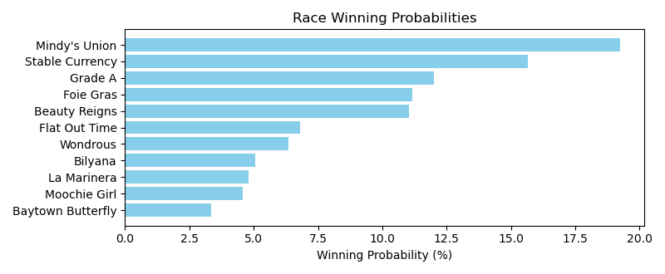

Exacta advice: key 9 → 3 (1 ticket)

Bandit Recommendation: exacta_top2_box (Expected Net: 71.64)

# Race: TCD | 2025-05-02 | Race #5 | Post: 19:03 | Track: CHURCHILL DOWNS

Track: CHURCHILL DOWNS

|  |  |  |  |  |  |
| --- | --- | --- | --- | --- | --- |
| Program # | Horse Name | Morn Odds | Rank | Model Score | Win Prob (%) |
| 1 | Gowells Delight | 10-1 | 6.0 | 0.98 | 7.19 |
| 2 | Vixen | 3-1 | 2.0 | 2.62 | 22.20 |
| 3 | Admit | 20-1 | 8.0 | 0.40 | 4.82 |
| 4 | Aterradora (IRE) | 15-1 | 7.0 | 0.92 | 6.89 |
| 5 | Nitrogen | 13-8 | 1.0 | 2.64 | 22.55 |
| 6 | Hideaway | 15-1 | 5.0 | 1.59 | 10.93 |
| 7 | Lush Lips (GB) | 7-2 | 3.0 | 1.83 | 12.87 |
| 8 | Will Then | 9-2 | 4.0 | 1.79 | 12.56 |

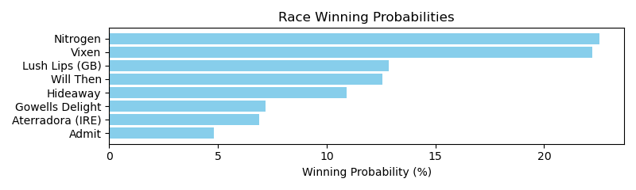

Exacta advice: box [5,2,7] (6 tickets)

Bandit Recommendation: Pick 3_top1_box (Expected Net: 0.00)

# Race: TCD | 2025-05-02 | Race #6 | Post: 19:42 | Track: CHURCHILL DOWNS

Track: CHURCHILL DOWNS

|  |  |  |  |  |  |
| --- | --- | --- | --- | --- | --- |
| Program # | Horse Name | Morn Odds | Rank | Model Score | Win Prob (%) |
| 1 | Katonah | 20-1 | 6.0 | 0.30 | 4.88 |
| 2 | Locked | 2-1 | 1.0 | 2.80 | 27.23 |
| 3 | Hall of Fame | 4-1 | 4.0 | 2.09 | 16.76 |
| 4 | Fierceness | 6-5 | 2.0 | 2.62 | 24.09 |
| 5 | Most Wanted | 7-2 | 3.0 | 2.28 | 19.09 |
| 6 | This Is Uscar | 30-1 | 5.0 | 1.01 | 7.96 |

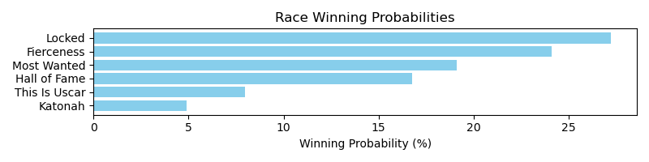

Exacta advice: key 2 → 4 (1 ticket)

Bandit Recommendation: Pick 4_top1_box (Expected Net: 0.00)

# Race: TCD | 2025-05-02 | Race #7 | Post: 20:23 | Track: CHURCHILL DOWNS

Track: CHURCHILL DOWNS

|  |  |  |  |  |  |
| --- | --- | --- | --- | --- | --- |
| Program # | Horse Name | Morn Odds | Rank | Model Score | Win Prob (%) |
| 1 | Dorth Vader | 30-1 | 7.0 | -0.27 | 4.97 |
| 2 | Thorpedo Anna | 2-5 | 1.0 | 2.22 | 27.58 |
| 3 | Literate | 30-1 | 5.0 | 0.43 | 8.07 |
| 4 | Raging Sea | 9-2 | 2.0 | 1.98 | 23.41 |
| 5 | Randomized | 6-1 | 3.0 | 1.42 | 15.94 |
| 6 | Taxed | 30-1 | 6.0 | 0.43 | 8.02 |
| 7 | Free Like a Girl | 15-1 | 4.0 | 1.01 | 12.02 |

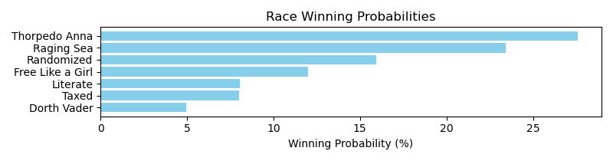

Exacta advice: key 2 → 4 (1 ticket)

Bandit Recommendation: Pick 3_top1_box (Expected Net: 0.00)

# Race: TCD | 2025-05-02 | Race #8 | Post: 21:12 | Track: CHURCHILL DOWNS

Track: CHURCHILL DOWNS

|  |  |  |  |  |  |
| --- | --- | --- | --- | --- | --- |
| Program # | Horse Name | Morn Odds | Rank | Model Score | Win Prob (%) |
| 1 | Waves of Mischief | 20-1 | 8.0 | -0.30 | 3.66 |
| 2 | Gimme a Nother (SAF) | 7-2 | 1.0 | 2.80 | 30.95 |
| 3 | Segesta | 9-2 | 4.0 | 1.32 | 11.15 |
| 4 | Pin Up Betty | 12-1 | 3.0 | 1.36 | 11.53 |
| 5 | Takemetothebeach | 30-1 | 6.0 | 0.39 | 5.91 |
| 6 | Birdie Rose | 30-1 | 7.0 | -0.07 | 4.28 |
| 7 | She Feels Pretty | 6-5 | 2.0 | 2.38 | 23.24 |
| 8 | Saffron Moon | 3-1 | 5.0 | 1.05 | 9.28 |

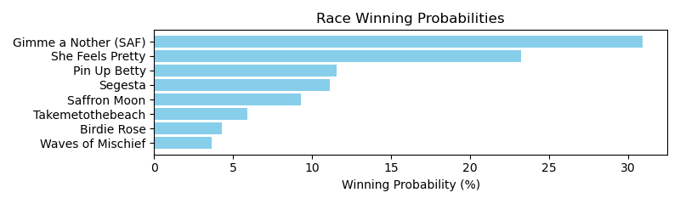

Exacta advice: key 2 → 7 (1 ticket)

Bandit Recommendation: exacta_top2_box (Expected Net: 14.20)

# Race: TCD | 2025-05-02 | Race #9 | Post: 22:07 | Track: CHURCHILL DOWNS

Track: CHURCHILL DOWNS

|  |  |  |  |  |  |
| --- | --- | --- | --- | --- | --- |
| Program # | Horse Name | Morn Odds | Rank | Model Score | Win Prob (%) |
| 1 | Unchained Elaine | 20-1 | 11.0 | -0.54 | 2.38 |
| 2 | Evanescence | 20-1 | 8.0 | 0.78 | 5.94 |
| 3 | Princess Aliyah | 15-1 | 9.0 | 0.75 | 5.79 |
| 4 | Whatintheliteral | 30-1 | 12.0 | -0.75 | 2.07 |
| 5 | Verity | 3-1 | 3.0 | 1.76 | 11.62 |
| 6 | Kimchi Cat | 15-1 | 7.0 | 0.80 | 5.99 |
| 7 | Mendela | 15-1 | 4.0 | 1.69 | 11.12 |
| 8 | Blue Fire | 12-1 | 10.0 | 0.73 | 5.70 |
| 9 | Bourbon Memory | 8-1 | 6.0 | 1.06 | 7.16 |
| 10 | Impulse Buy | 7-2 | 2.0 | 1.87 | 12.53 |
| 11 | Look Forward | 12-1 | 5.0 | 1.43 | 9.28 |
| 12 | Eclatant | 5-2 | 1.0 | 2.58 | 20.40 |

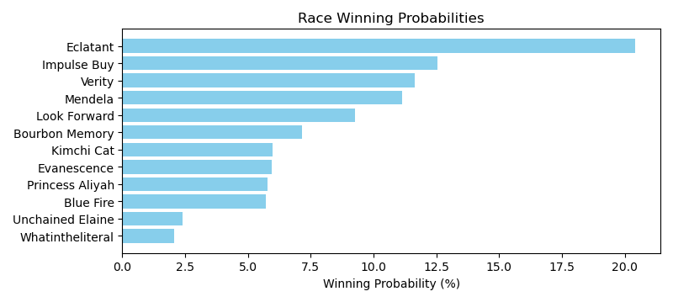

Exacta advice: key 12 → 10 (1 ticket)

Bandit Recommendation: Pick 4_top1_box (Expected Net: 1.00)

# Race: TCD | 2025-05-02 | Race #10 | Post: 22:51 | Track: CHURCHILL DOWNS

Track: CHURCHILL DOWNS

|  |  |  |  |  |  |
| --- | --- | --- | --- | --- | --- |
| Program # | Horse Name | Morn Odds | Rank | Model Score | Win Prob (%) |
| 1 | Cloudwalker | 20-1 | 8.0 | 0.49 | 6.00 |
| 2 | Awesome Treat | 15-1 | 9.0 | 0.46 | 5.89 |
| 3 | Gavea (GER) | 15-1 | 7.0 | 0.78 | 7.31 |
| 4 | Ag Bullet | 13-8 | 3.0 | 1.83 | 15.11 |
| 5 | Epona's Hope | 6-1 | 4.0 | 1.25 | 10.14 |
| 6 | Bling | 8-1 | 5.0 | 0.94 | 8.17 |
| 7 | Crown Imperial | 12-1 | 2.0 | 1.85 | 15.30 |
| 8 | Asternia | 20-1 | 6.0 | 0.78 | 7.31 |
| 9 | Queen Maxima | 2-1 | 1.0 | 2.55 | 24.77 |

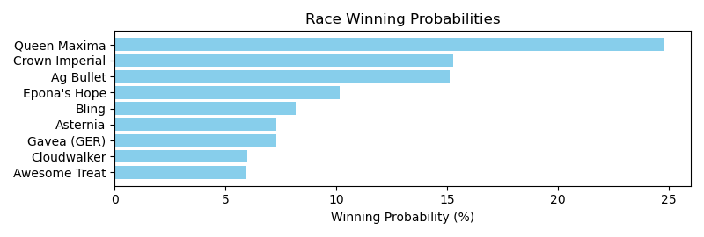

Exacta advice: key 9 → [7,4] (2 tickets)

Bandit Recommendation: exacta_top2_box (Expected Net: 0.00)

# Race: TCD | 2025-05-02 | Race #11 | Post: 23:51 | Track: CHURCHILL DOWNS

Track: CHURCHILL DOWNS

|  |  |  |  |  |  |
| --- | --- | --- | --- | --- | --- |
| Program # | Horse Name | Morn Odds | Rank | Model Score | Win Prob (%) |
| 1 | Early On | 30-1 | 9.0 | 0.78 | 5.53 |
| 2 | Simply Joking | 10-1 | 4.0 | 1.31 | 7.96 |
| 3 | Fondly | 20-1 | 10.0 | 0.77 | 5.49 |
| 4 | Drexel Hill | 30-1 | 14.0 | -0.47 | 2.34 |
| 5 | Quickick | 30-1 | 12.0 | 0.33 | 4.05 |
| 6 | Ballerina d'Oro | 10-1 | 1.0 | 2.06 | 13.36 |
| 7 | La Cara | 6-1 | 3.0 | 2.00 | 12.82 |
| 8 | Five G | 12-1 | 6.0 | 1.20 | 7.37 |
| 9 | Tenma | 12-1 | 8.0 | 0.92 | 6.09 |
| 10 | Take Charge Milady | 12-1 | 7.0 | 1.06 | 6.71 |
| 11 | Good Cheer | 6-5 | 2.0 | 2.06 | 13.31 |
| 12 | Anna's Promise | 30-1 | 13.0 | -0.37 | 2.50 |
| 13 | Bless the Broken | 30-1 | 11.0 | 0.48 | 4.50 |
| 14 | Quietside | 8-1 | 5.0 | 1.31 | 7.96 |

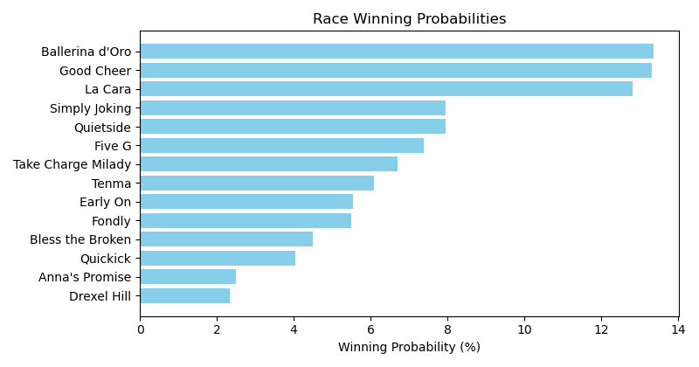

Exacta advice: box [6,11,7] (6 tickets)

Bandit Recommendation: Pick 4_top1_box (Expected Net: 0.00)

# Race: TCD | 2025-05-02 | Race #12 | Post: 00:27 | Track: CHURCHILL DOWNS

Track: CHURCHILL DOWNS

|  |  |  |  |  |  |
| --- | --- | --- | --- | --- | --- |
| Program # | Horse Name | Morn Odds | Rank | Model Score | Win Prob (%) |
| 1 | Winters Lion | 30-1 | 9.0 | 0.74 | 5.60 |
| 2 | Lat Long | 8-1 | 6.0 | 1.23 | 7.84 |
| 3 | Over and Ollie | 12-1 | 12.0 | 0.58 | 5.00 |
| 4 | Yellow Brick | 20-1 | 4.0 | 1.44 | 9.03 |
| 5 | Moonlight | 6-1 | 1.0 | 2.25 | 15.81 |
| 6 | Into Pleasure | 9-2 | 5.0 | 1.26 | 7.98 |
| 7 | Resilience | 7-2 | 2.0 | 2.14 | 14.65 |
| 8 | Deer District | 20-1 | 11.0 | 0.62 | 5.16 |
| 9 | Echo Again | 15-1 | 10.0 | 0.67 | 5.34 |
| 10 | Not This Boy | 4-1 | 3.0 | 1.72 | 11.01 |
| 11 | King Russell | 12-1 | 8.0 | 0.84 | 5.97 |
| 12 | Lure Him In | 8-1 | 7.0 | 0.98 | 6.60 |

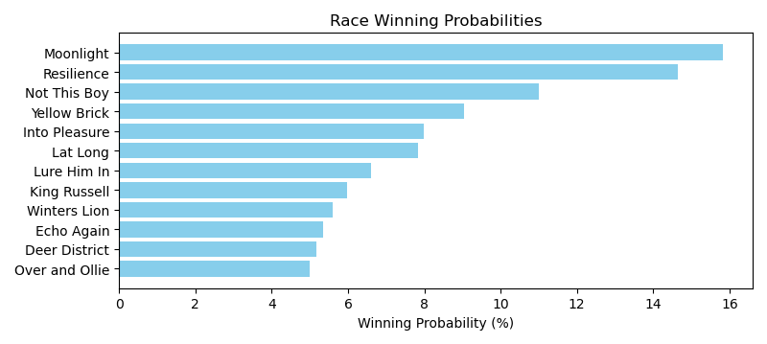

Exacta advice: key 5 → 7 (1 ticket)

Bandit Recommendation: Pick 4_top1_box (Expected Net: 0.91)

# Race: TCD | 2025-05-02 | Race #13 | Post: 01:02 | Track: CHURCHILL DOWNS

Track: CHURCHILL DOWNS

|  |  |  |  |  |  |
| --- | --- | --- | --- | --- | --- |
| Program # | Horse Name | Morn Odds | Rank | Model Score | Win Prob (%) |
| 1 | DASHIN' DIVA | 15-1 | 11.0 | 0.18 | 3.04 |
| 2 | Oraia | 6-1 | 5.0 | 1.84 | 9.52 |
| 3 | Ivory and Ebony | 5-1 | 4.0 | 2.09 | 11.31 |
| 4 | HEARTBEAT | 12-1 | 8.0 | 0.49 | 3.78 |
| 5 | Twisted Viper | 30-1 | 14.0 | -0.30 | 2.19 |
| 6 | Agia Marina | 12-1 | 13.0 | -0.13 | 2.46 |
| 7 | La Neige | 10-1 | 6.0 | 1.73 | 8.87 |
| 8 | TETIAROA | 8-1 | 10.0 | 0.32 | 3.35 |
| 9 | Speighter Woman | 10-1 | 2.0 | 2.58 | 15.94 |
| 10 | Chaching Chaching | 7-2 | 1.0 | 2.65 | 16.70 |
| 11 | Expecto Patronum | 20-1 | 12.0 | 0.17 | 3.01 |
| 12 | Cue the Duckboats | 8-1 | 3.0 | 2.14 | 11.75 |
| 13 | Fallon | 30-1 | 7.0 | 0.77 | 4.57 |
| 14 | Devastating | 12-1 | 9.0 | 0.39 | 3.51 |

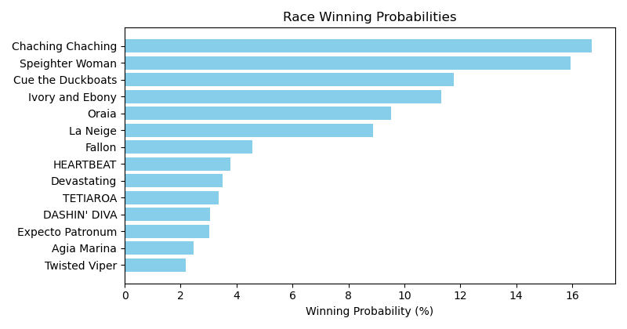

Exacta advice: box [10,9,12] (6 tickets)

Bandit Recommendation: Daily Double_top1_box (Expected Net: 0.56)

# Race: TCD | 2025-05-03 | Race #1 | Post: 17:00 | Track: CHURCHILL DOWNS

Track: CHURCHILL DOWNS

|  |  |  |  |  |  |
| --- | --- | --- | --- | --- | --- |
| Program # | Horse Name | Morn Odds | Rank | Model Score | Win Prob (%) |
| 1 | KNICKS CODE | 15-1 | 10.0 | 0.22 | 2.16 |
| 2 | Cromwell | 9-2 | 2.0 | 2.88 | 13.47 |
| 3 | Fountain Lake | 12-1 | 6.0 | 2.39 | 9.63 |
| 4 | Sturdy | 6-1 | 4.0 | 2.52 | 10.55 |
| 5 | BANDED HUMOR | 30-1 | 11.0 | 0.07 | 1.95 |
| 6 | Kicking Clear | 30-1 | 8.0 | 1.99 | 7.30 |
| 7 | Money Man | 30-1 | 9.0 | 1.85 | 6.63 |
| 8 | Sansone | 6-1 | 1.0 | 3.02 | 14.91 |
| 9 | Bourbon Society | 5-1 | 5.0 | 2.42 | 9.84 |
| 10 | Knicks Gate | 15-1 | 12.0 | -0.01 | 1.84 |
| 11 | Coffee Talk | 4-1 | 7.0 | 2.36 | 9.43 |
| 12 | Chillax | 5-1 | 3.0 | 2.74 | 12.28 |

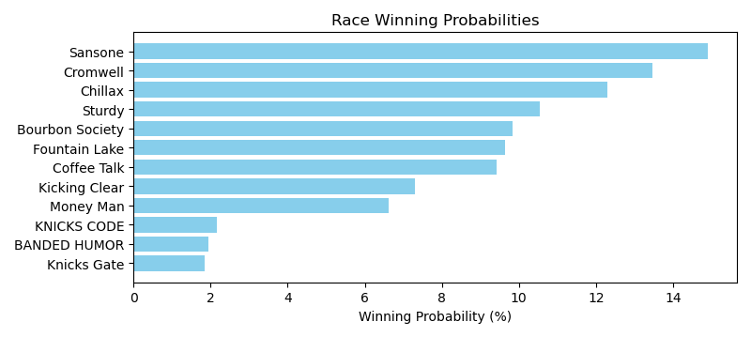

Exacta advice: key 8 → 2 (1 ticket)

Bandit Recommendation: Daily Double_top1_box (Expected Net: 0.56)

# Race: TCD | 2025-05-03 | Race #2 | Post: 17:32 | Track: CHURCHILL DOWNS

Track: CHURCHILL DOWNS

|  |  |  |  |  |  |
| --- | --- | --- | --- | --- | --- |
| Program # | Horse Name | Morn Odds | Rank | Model Score | Win Prob (%) |
| 1 | Secret Statement | 12-1 | 7.0 | 0.51 | 6.86 |
| 2 | Grace On Grace | 20-1 | 11.0 | -1.16 | 2.17 |
| 3 | Izzy's Monster | 15-1 | 10.0 | -0.27 | 4.01 |
| 4 | Home Game | 6-1 | 1.0 | 1.87 | 17.44 |
| 5 | Tapit Quick | 5-1 | 8.0 | 0.06 | 5.04 |
| 6 | Don't Bring Crazy | 6-1 | 2.0 | 1.52 | 13.70 |
| 7 | Normandy Queen | 9-2 | 5.0 | 1.33 | 12.02 |
| 8 | Lemon Muffin | 5-1 | 3.0 | 1.45 | 13.11 |
| 9 | Desert Rhapsody | 12-1 | 6.0 | 0.76 | 8.13 |
| 10 | Generous Lover | 7-2 | 4.0 | 1.43 | 12.93 |
| 11 | Barbratina | 12-1 | 9.0 | -0.07 | 4.60 |

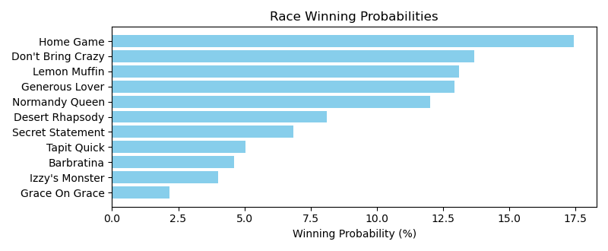

Exacta advice: key 4 → 6 (1 ticket)

Bandit Recommendation: Pick 3_top1_box (Expected Net: 0.00)

# Race: TCD | 2025-05-03 | Race #3 | Post: 18:05 | Track: CHURCHILL DOWNS

Track: CHURCHILL DOWNS

|  |  |  |  |  |  |
| --- | --- | --- | --- | --- | --- |
| Program # | Horse Name | Morn Odds | Rank | Model Score | Win Prob (%) |
| 1 | Vamos Carlitos | 20-1 | 9.0 | 0.51 | 5.24 |
| 2 | Bracket Buster | 6-1 | 1.0 | 2.48 | 20.43 |
| 3 | Valentinian | 6-1 | 6.0 | 1.22 | 8.57 |
| 4 | Racing Driver | 20-1 | 7.0 | 1.21 | 8.52 |
| 5 | Goal Oriented | 4-1 | 2.0 | 2.08 | 15.49 |
| 6 | Rapture | 7-2 | 3.0 | 1.65 | 11.51 |
| 7 | Hypnus | 6-1 | 5.0 | 1.23 | 8.60 |
| 8 | Yinzer | 12-1 | 4.0 | 1.24 | 8.67 |
| 9 | Tiz Secure | 5-1 | 8.0 | 0.74 | 6.16 |
| 10 | Strummin | 30-1 | 11.0 | -1.03 | 1.82 |
| 11 | Sorcerer's Silver | 8-1 | 10.0 | 0.44 | 5.00 |

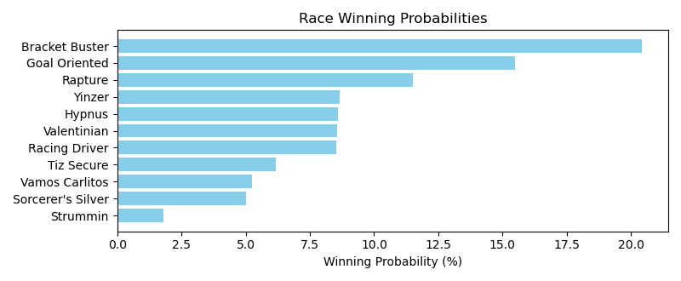

Exacta advice: key 2 → 5 (1 ticket)

Bandit Recommendation: Pick 3_top1_box (Expected Net: 0.00)

# Race: TCD | 2025-05-03 | Race #4 | Post: 18:38 | Track: CHURCHILL DOWNS

Track: CHURCHILL DOWNS

|  |  |  |  |  |  |
| --- | --- | --- | --- | --- | --- |
| Program # | Horse Name | Morn Odds | Rank | Model Score | Win Prob (%) |
| 1 | Ashcroft | 20-1 | 13.0 | 0.34 | 4.17 |
| 2 | Osbourne | 15-1 | 6.0 | 1.05 | 6.80 |
| 3 | Accretive | 6-1 | 3.0 | 1.65 | 10.31 |
| 4 | Castle Chaos | 20-1 | 9.0 | 0.76 | 5.57 |
| 5 | Keen Cat | 12-1 | 11.0 | 0.69 | 5.34 |
| 6 | Kupuna | 5-1 | 4.0 | 1.52 | 9.44 |
| 7 | Best Actor | 15-1 | 5.0 | 1.11 | 7.10 |
| 8 | Chiron | 30-1 | 14.0 | -0.46 | 2.40 |
| 9 | Liberal Arts | 3-1 | 1.0 | 2.09 | 14.00 |
| 10 | Implementation | 6-1 | 2.0 | 1.98 | 12.90 |
| 11 | Inveigled | 10-1 | 7.0 | 0.89 | 6.10 |
| 12 | Patriot Spirit | 8-1 | 12.0 | 0.49 | 4.64 |
| 13 | New King | 12-1 | 10.0 | 0.69 | 5.34 |
| 14 | Quality Chic | 20-1 | 8.0 | 0.83 | 5.87 |

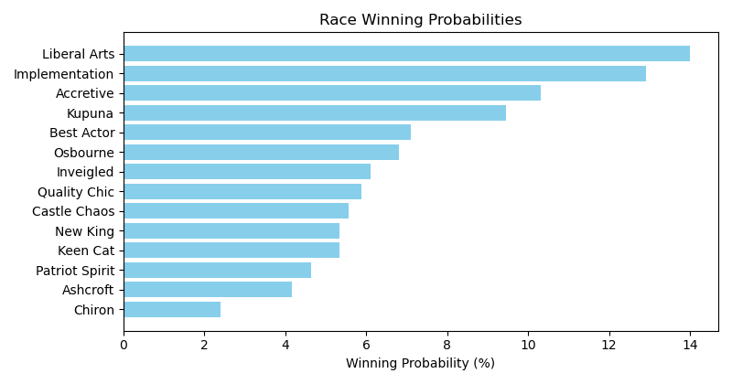

Exacta advice: key 9 → 10 (1 ticket)

Bandit Recommendation: Pick 4_top1_box (Expected Net: 0.00)

# Race: TCD | 2025-05-03 | Race #5 | Post: 19:12 | Track: CHURCHILL DOWNS

Track: CHURCHILL DOWNS

|  |  |  |  |  |  |
| --- | --- | --- | --- | --- | --- |
| Program # | Horse Name | Morn Odds | Rank | Model Score | Win Prob (%) |
| 1 | Venencia (FR) | 15-1 | 6.0 | 1.54 | 9.35 |
| 2 | Movin' On Up | 5-1 | 7.0 | 1.48 | 8.97 |
| 3 | Pin Up Betty | 12-1 | 8.0 | 1.35 | 8.21 |
| 4 | Serene Seraph (IRE) | 20-1 | 9.0 | 0.88 | 5.93 |
| 5 | Five Towns (GB) | 10-1 | 5.0 | 1.68 | 10.30 |
| 6 | Sacred Wish | 3-1 | 4.0 | 1.70 | 10.43 |
| 7 | Tax Implications (GB) | 5-1 | 2.0 | 1.90 | 12.00 |
| 8 | Poolside With Slim (IRE) | 8-1 | 3.0 | 1.82 | 11.39 |
| 9 | Simply in Front | 15-1 | 10.0 | 0.55 | 4.75 |
| 10 | Special Wan (IRE) | 5-2 | 1.0 | 2.54 | 18.66 |

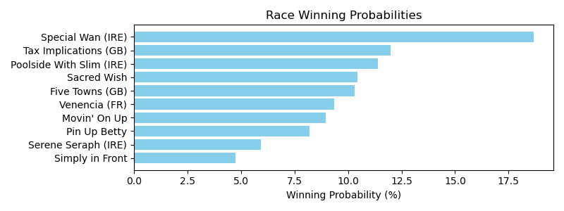

Exacta advice: key 10 → 7 (1 ticket)

Bandit Recommendation: Daily Double_top1_box (Expected Net: 0.00)

# Race: TCD | 2025-05-03 | Race #6 | Post: 19:53 | Track: CHURCHILL DOWNS

Track: CHURCHILL DOWNS

|  |  |  |  |  |  |
| --- | --- | --- | --- | --- | --- |
| Program # | Horse Name | Morn Odds | Rank | Model Score | Win Prob (%) |
| 1 | Madaket Road | 2-1 | 3.0 | 1.92 | 15.64 |
| 2 | Built | 7-2 | 1.0 | 2.35 | 21.09 |
| 3 | California Burrito | 12-1 | 7.0 | 0.57 | 6.17 |
| 4 | Smoken Wicked | 12-1 | 5.0 | 1.02 | 8.42 |
| 5 | Gate to Wire | 6-1 | 4.0 | 1.65 | 12.98 |
| 6 | Gaming | 3-1 | 2.0 | 2.23 | 19.40 |
| 7 | Macho Music | 12-1 | 9.0 | -0.08 | 3.95 |
| 8 | Innovator | 20-1 | 6.0 | 0.75 | 6.99 |
| 9 | Perfect Force | 12-1 | 8.0 | 0.36 | 5.36 |

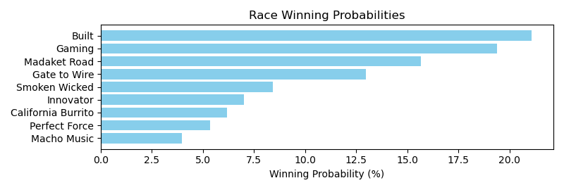

Exacta advice: key 2 → 6 (1 ticket)

Bandit Recommendation: Pick 4_top1_box (Expected Net: 0.00)

# Race: TCD | 2025-05-03 | Race #7 | Post: 20:38 | Track: CHURCHILL DOWNS

Track: CHURCHILL DOWNS

|  |  |  |  |  |  |
| --- | --- | --- | --- | --- | --- |
| Program # | Horse Name | Morn Odds | Rank | Model Score | Win Prob (%) |
| 1 | Coppola | 10-1 | 10.0 | 0.88 | 5.23 |
| 2 | Ambivalent | 12-1 | 12.0 | 0.59 | 4.27 |
| 3 | Nobals | 6-1 | 2.0 | 1.88 | 10.37 |
| 4 | One Timer | 10-1 | 3.0 | 1.72 | 9.30 |
| 5 | Arrest Me Red | 6-1 | 6.0 | 1.62 | 8.72 |
| 6 | Run Carson | 6-1 | 4.0 | 1.71 | 9.23 |
| 7 | Think Big | 4-1 | 5.0 | 1.68 | 9.07 |
| 8 | Rogue Lightning (IRE) | 7-2 | 1.0 | 2.81 | 19.80 |
| 9 | Boss Sully | 15-1 | 11.0 | 0.71 | 4.65 |
| 10 | Unconquerable Keen (IRE) | 30-1 | 7.0 | 1.40 | 7.46 |
| 11 | Eamonn | 12-1 | 8.0 | 1.09 | 6.04 |
| 12 | Mischievous Rogue | 20-1 | 9.0 | 1.04 | 5.85 |

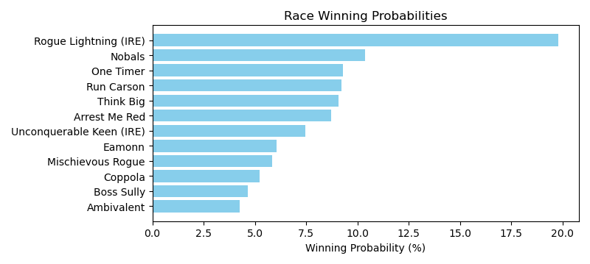

Exacta advice: key 8 → 3 (1 ticket)

Bandit Recommendation: no_bet (Expected Net: 0.99)

# Race: TCD | 2025-05-03 | Race #8 | Post: 21:23 | Track: CHURCHILL DOWNS

Track: CHURCHILL DOWNS

|  |  |  |  |  |  |
| --- | --- | --- | --- | --- | --- |
| Program # | Horse Name | Morn Odds | Rank | Model Score | Win Prob (%) |
| 1 | Just Steel | 30-1 | 11.0 | 0.27 | 4.41 |
| 2 | Banishing | 5-1 | 7.0 | 1.21 | 8.47 |
| 3 | Book'em Danno | 8-1 | 5.0 | 1.42 | 9.77 |
| 4 | Giant Mischief | 8-1 | 6.0 | 1.26 | 8.71 |
| 5 | Tejano Twist | 15-1 | 8.0 | 1.03 | 7.45 |
| 6 | Extra Anejo | 12-1 | 3.0 | 1.68 | 11.68 |
| 7 | Mindframe | 3-1 | 2.0 | 1.74 | 12.16 |
| 8 | Hoist the Gold | 20-1 | 9.0 | 0.67 | 5.82 |
| 9 | Here Mi Song | 30-1 | 10.0 | 0.57 | 5.44 |
| 10 | Nysos | 4-1 | 4.0 | 1.59 | 10.95 |
| 11 | Mullikin | 7-2 | 1.0 | 2.06 | 15.12 |

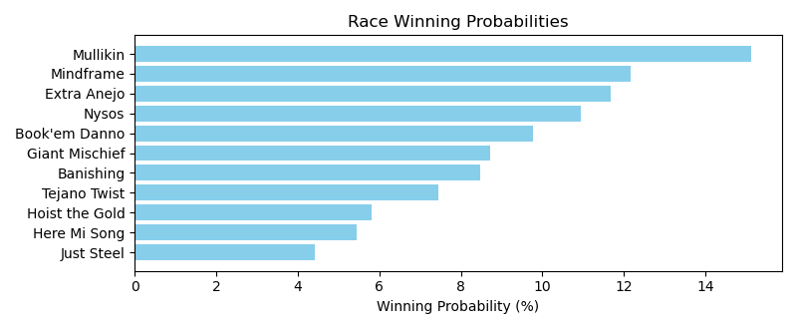

Exacta advice: key 11 → 7 (1 ticket)

Bandit Recommendation: no_bet (Expected Net: 0.00)

# Race: TCD | 2025-05-03 | Race #9 | Post: 22:06 | Track: CHURCHILL DOWNS

Track: CHURCHILL DOWNS

|  |  |  |  |  |  |
| --- | --- | --- | --- | --- | --- |
| Program # | Horse Name | Morn Odds | Rank | Model Score | Win Prob (%) |
| 1 | Warlander | 20-1 | 18.0 | -0.01 | 1.76 |
| 2 | Scipio | 12-1 | 7.0 | 1.36 | 4.54 |
| 3 | New Century (GB) | 3-1 | 4.0 | 1.98 | 6.94 |
| 4 | Mi Bago | 10-1 | 8.0 | 1.22 | 4.11 |
| 5 | Test Score | 10-1 | 2.0 | 2.65 | 11.06 |
| 6 | Maximum Promise | 20-1 | 12.0 | 0.69 | 2.86 |
| 7 | Zulu Kingdom (IRE) | 4-1 | 1.0 | 3.81 | 24.59 |
| 8 | Charlie's to Blame | 8-1 | 11.0 | 0.78 | 3.04 |
| 9 | Giocoso | 30-1 | 17.0 | 0.01 | 1.79 |
| 10 | Iron Man Cal | 9-2 | 6.0 | 1.61 | 5.37 |
| 11 | Classic of Course | 20-1 | 9.0 | 1.09 | 3.78 |
| 12 | Golden Afternoon | 20-1 | 15.0 | 0.54 | 2.57 |
| 13 | Maui Strong | 30-1 | 10.0 | 0.88 | 3.25 |
| 14 | Megalodon | 20-1 | 14.0 | 0.57 | 2.63 |
| 15 | Hammerhead | 30-1 | 13.0 | 0.69 | 2.85 |
| 16 | Spirit Rags | 20-1 | 16.0 | 0.23 | 2.08 |
| 17 | A. P. Kid | 15-1 | 3.0 | 2.51 | 9.98 |
| 18 | Discreet Dancer | 20-1 | 5.0 | 1.95 | 6.80 |

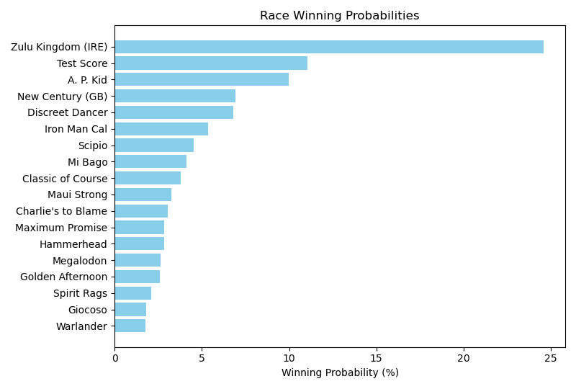

Exacta advice: key 7 → 5 (1 ticket)

Bandit Recommendation: Daily Double_top1_box (Expected Net: 0.00)

# Race: TCD | 2025-05-03 | Race #10 | Post: 22:50 | Track: CHURCHILL DOWNS

Track: CHURCHILL DOWNS

|  |  |  |  |  |  |
| --- | --- | --- | --- | --- | --- |
| Program # | Horse Name | Morn Odds | Rank | Model Score | Win Prob (%) |
| 1 | Scylla | 4-1 | 2.0 | 2.25 | 13.00 |
| 2 | Kopion | 8-1 | 5.0 | 1.33 | 6.89 |
| 3 | Benedetta | 30-1 | 13.0 | 0.18 | 3.12 |
| 4 | Awesome Treat | 30-1 | 15.0 | 0.10 | 2.96 |
| 5 | Haulin Ice | 15-1 | 7.0 | 1.19 | 6.25 |
| 6 | Mystic Lake | 8-1 | 4.0 | 1.43 | 7.41 |
| 7 | Vahva | 6-1 | 3.0 | 1.54 | 7.94 |
| 8 | Ways and Means | 3-1 | 1.0 | 2.62 | 16.75 |
| 9 | Emery | 6-1 | 8.0 | 1.16 | 6.12 |
| 10 | Dorth Vader | 30-1 | 16.0 | -0.52 | 1.93 |
| 11 | Positano Sunset | 12-1 | 12.0 | 0.37 | 3.56 |
| 12 | Hope Road | 15-1 | 9.0 | 0.91 | 5.16 |
| 13 | My Mane Squeeze | 12-1 | 10.0 | 0.87 | 5.02 |
| 14 | Taxed | 30-1 | 14.0 | 0.14 | 3.04 |
| 15 | Grand Job | 10-1 | 6.0 | 1.28 | 6.67 |
| 16 | Miss Susan B | 30-1 | 11.0 | 0.61 | 4.19 |

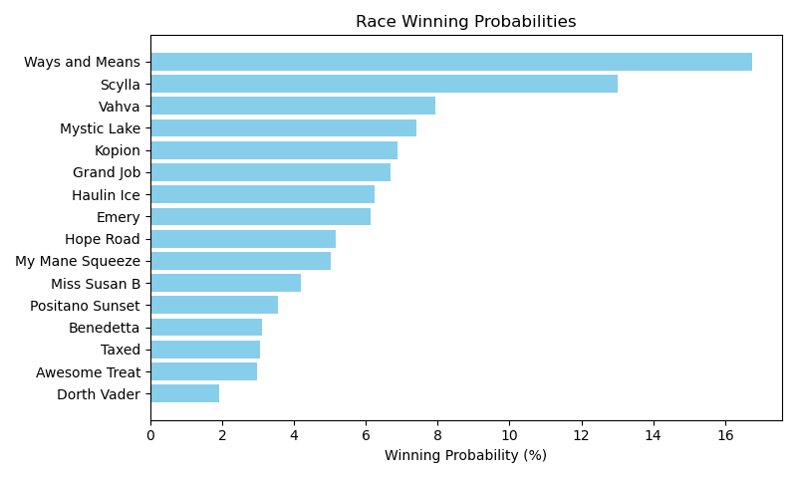

Exacta advice: key 8 → 1 (1 ticket)

Bandit Recommendation: no_bet (Expected Net: 0.18)

# Race: TCD | 2025-05-03 | Race #11 | Post: 23:39 | Track: CHURCHILL DOWNS

Track: CHURCHILL DOWNS

|  |  |  |  |  |  |
| --- | --- | --- | --- | --- | --- |
| Program # | Horse Name | Morn Odds | Rank | Model Score | Win Prob (%) |
| 1 | Integration | 4-1 | 1.0 | 1.92 | 12.03 |
| 2 | Gold Phoenix (IRE) | 10-1 | 9.0 | 1.22 | 7.41 |
| 3 | Highway Robber | 6-1 | 11.0 | 0.96 | 6.19 |
| 4 | Redistricting (GB) | 10-1 | 5.0 | 1.34 | 8.05 |
| 5 | Idratherbeblessed | 15-1 | 12.0 | 0.32 | 3.98 |
| 6 | Taking Candy | 8-1 | 2.0 | 1.85 | 11.45 |
| 7 | Running Bee | 5-1 | 6.0 | 1.34 | 8.05 |
| 8 | Cameo Performance | 20-1 | 4.0 | 1.61 | 9.72 |
| 9 | Mercante | 10-1 | 7.0 | 1.26 | 7.62 |
| 10 | Spirit of St Louis | 9-2 | 3.0 | 1.81 | 11.18 |
| 11 | Brilliant Berti | 12-1 | 10.0 | 1.10 | 6.85 |
| 12 | Gigante | 15-1 | 8.0 | 1.23 | 7.48 |

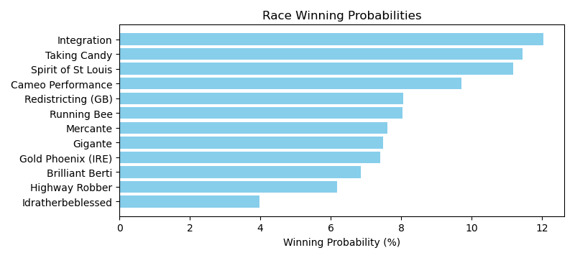

Exacta advice: box [1,6,10] (6 tickets)

Bandit Recommendation: Daily Double_top1_box (Expected Net: 48.20)

# Race: TCD | 2025-05-03 | Race #12 | Post: 00:57 | Track: CHURCHILL DOWNS

Track: CHURCHILL DOWNS

|  |  |  |  |  |  |
| --- | --- | --- | --- | --- | --- |
| Program # | Horse Name | Morn Odds | Rank | Model Score | Win Prob (%) |
| 1 | Citizen Bull | 20-1 | 21.0 | -0.32 | 2.02 |
| 2 | Neoequos | 30-1 | 14.0 | 0.38 | 3.27 |
| 3 | Final Gambit | 30-1 | 12.0 | 0.65 | 3.93 |
| 4 | Rodriguez | 12-1 | 11.0 | 0.68 | 4.00 |
| 5 | American Promise | 30-1 | 19.0 | -0.16 | 2.25 |
| 6 | ADMIRE DAYTONA (JPN) | 30-1 | 10.0 | 0.88 | 4.61 |
| 7 | LUXOR CAFE | 15-1 | 6.0 | 1.30 | 6.16 |
| 8 | Journalism | 3-1 | 1.0 | 1.86 | 9.03 |
| 9 | Burnham Square | 12-1 | 16.0 | 0.30 | 3.09 |
| 10 | Grande | 20-1 | 17.0 | 0.15 | 2.78 |
| 11 | Flying Mohawk | 30-1 | 9.0 | 1.14 | 5.49 |
| 12 | East Avenue | 20-1 | 8.0 | 1.24 | 5.90 |
| 13 | Publisher | 30-1 | 4.0 | 1.55 | 7.32 |
| 14 | Tiztastic | 20-1 | 5.0 | 1.53 | 7.23 |
| 15 | Render Judgment | 30-1 | 20.0 | -0.28 | 2.07 |
| 16 | Coal Battle | 30-1 | 18.0 | -0.07 | 2.39 |
| 17 | Sandman | 6-1 | 2.0 | 1.77 | 8.50 |
| 18 | Sovereignty | 5-1 | 3.0 | 1.58 | 7.49 |
| 19 | Chunk of Gold | 30-1 | 13.0 | 0.39 | 3.28 |
| 20 | dh-Owen Almighty | 30-1 | 15.0 | 0.30 | 3.09 |
| 21 | Baeza | 12-1 | 7.0 | 1.29 | 6.13 |

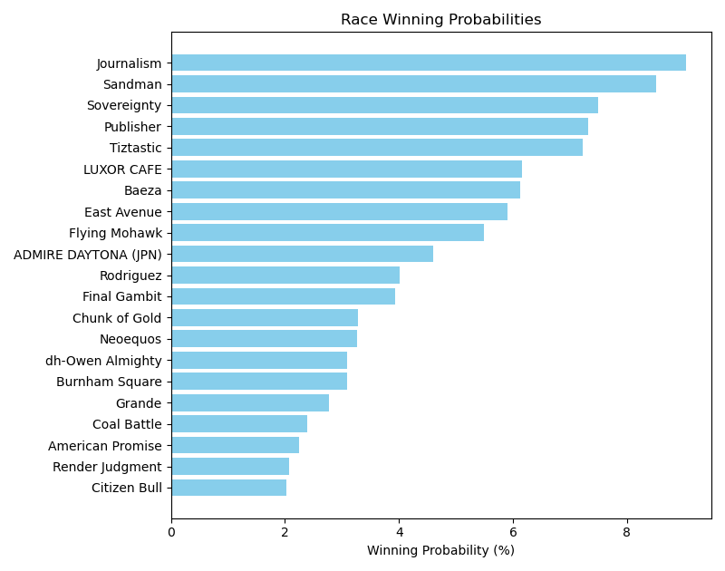

Exacta advice: box [8,17,18] (6 tickets)

Bandit Recommendation: Daily Double_top1_box (Expected Net: 0.00)

# Race: TCD | 2025-05-03 | Race #13 | Post: 02:00 | Track: CHURCHILL DOWNS

Track: CHURCHILL DOWNS

|  |  |  |  |  |  |
| --- | --- | --- | --- | --- | --- |
| Program # | Horse Name | Morn Odds | Rank | Model Score | Win Prob (%) |
| 1 | Jack's Promise | 10-1 | 6.0 | 1.14 | 5.73 |
| 2 | Dapper Moon | 15-1 | 7.0 | 0.73 | 4.34 |
| 3 | Furio | 10-1 | 4.0 | 1.49 | 7.32 |
| 4 | Shan | 30-1 | 13.0 | -0.45 | 1.92 |
| 5 | Tiny Lake | 30-1 | 16.0 | -0.99 | 1.33 |
| 6 | Classic Time | 15-1 | 15.0 | -0.50 | 1.86 |
| 7 | Multiverse | 12-1 | 8.0 | 0.59 | 3.92 |
| 8 | Touchy | 6-1 | 1.0 | 3.28 | 25.10 |
| 9 | Romanesque | 5-1 | 9.0 | 0.52 | 3.74 |
| 10 | Optical | 20-1 | 11.0 | 0.18 | 2.96 |
| 11 | Patch Adams | 5-2 | 3.0 | 2.41 | 13.77 |
| 12 | Joejoe Go | 20-1 | 14.0 | -0.49 | 1.87 |
| 13 | Fully Volatile | 30-1 | 12.0 | -0.25 | 2.21 |
| 14 | Big Truzz | 9-2 | 2.0 | 2.52 | 14.88 |
| 15 | Haunted Flame | 30-1 | 10.0 | 0.34 | 3.30 |
| 16 | TERRAPIN STATION | 15-1 | 5.0 | 1.14 | 5.74 |

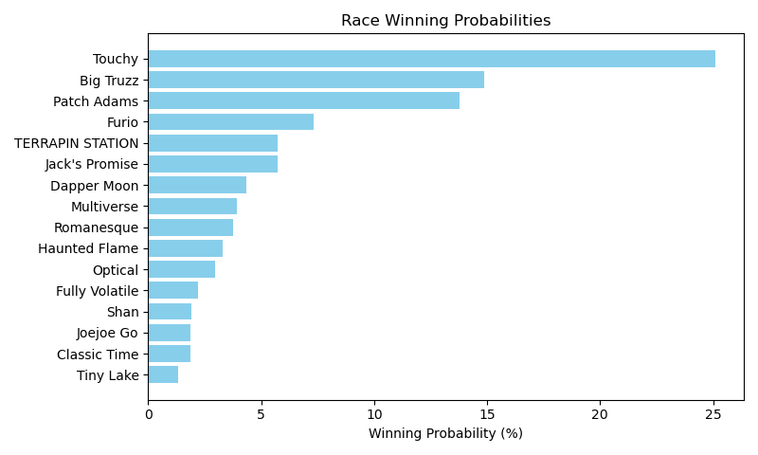

Exacta advice: key 8 → 14 (1 ticket)

Bandit Recommendation: no_bet (Expected Net: 0.00)

# Race: TCD | 2025-05-03 | Race #14 | Post: 02:33 | Track: CHURCHILL DOWNS

Track: CHURCHILL DOWNS

|  |  |  |  |  |  |
| --- | --- | --- | --- | --- | --- |
| Program # | Horse Name | Morn Odds | Rank | Model Score | Win Prob (%) |
| 1 | Into Thin Air | 20-1 | 12.0 | 0.18 | 2.57 |
| 2 | Pediatrician | 20-1 | 11.0 | 1.17 | 5.08 |
| 3 | Bon Temps | 20-1 | 6.0 | 1.40 | 5.93 |
| 4 | Blistering | 30-1 | 14.0 | -0.71 | 1.39 |
| 5 | Advanced Spirit | 5-1 | 2.0 | 2.50 | 12.66 |
| 6 | Arthur Jr | 30-1 | 10.0 | 1.18 | 5.11 |
| 7 | Send Coins | 20-1 | 13.0 | 0.02 | 2.29 |
| 8 | Harbe | 12-1 | 9.0 | 1.20 | 5.18 |
| 9 | Delta Tau Chi | 10-1 | 8.0 | 1.26 | 5.41 |
| 10 | Excite | 12-1 | 3.0 | 2.31 | 11.12 |
| 11 | Shallus | 20-1 | 7.0 | 1.39 | 5.89 |
| 12 | Pursuitneversleeps | 3-1 | 5.0 | 2.19 | 10.21 |
| 13 | Lambo | 5-1 | 4.0 | 2.24 | 10.59 |
| 14 | Mainstream | 7-2 | 1.0 | 2.89 | 16.59 |

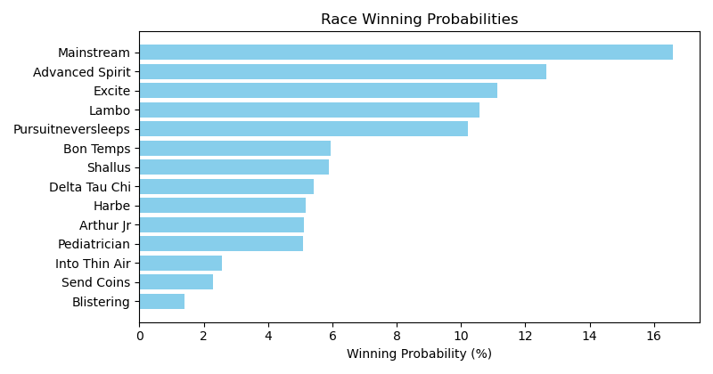

Exacta advice: key 14 → 5 (1 ticket)

Bandit Recommendation: Pick 4_top1_box (Expected Net: 0.00)

# Race: TGP | 2025-05-01 | Race #1 | Post: 18:50 | Track: GULFSTREAM PARK

Track: GULFSTREAM PARK

|  |  |  |  |  |  |
| --- | --- | --- | --- | --- | --- |
| Program # | Horse Name | Morn Odds | Rank | Model Score | Win Prob (%) |
| 1 | Instapurchase | 30-1 | 6.0 | -0.78 | 6.20 |
| 2 | Deborahaprophetess | 20-1 | 7.0 | -0.88 | 5.76 |
| 3 | Ruth the Moabitess | 30-1 | 8.0 | -1.01 | 5.30 |
| 4 | Drama | 4-5 | 1.0 | 1.73 | 34.79 |
| 5 | RIPPLE | 3-1 | 4.0 | 0.19 | 12.07 |
| 6 | DARE GREATLY | 7-2 | 2.0 | 0.46 | 14.59 |
| 7 | Willow Case | 10-1 | 3.0 | 0.39 | 13.86 |
| 8 | A Rose for Skyler | 20-1 | 5.0 | -0.52 | 7.43 |

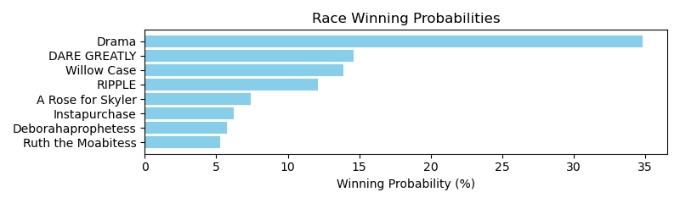

Exacta advice: key 4 → 6 (1 ticket)

Bandit Recommendation: Daily Double_top1_box (Expected Net: 0.56)

# Race: TGP | 2025-05-01 | Race #2 | Post: 19:22 | Track: GULFSTREAM PARK

Track: GULFSTREAM PARK

|  |  |  |  |  |  |
| --- | --- | --- | --- | --- | --- |
| Program # | Horse Name | Morn Odds | Rank | Model Score | Win Prob (%) |
| 1 | Mitoleta | 12-1 | 6.0 | 1.24 | 8.38 |
| 2 | Perchance to Dream | 15-1 | 11.0 | -0.15 | 3.22 |
| 3 | Trumpetta | 9-2 | 1.0 | 2.49 | 19.77 |
| 4 | It's Just a Game | 3-1 | 2.0 | 2.13 | 15.43 |
| 5 | Itsachardonneigh | 10-1 | 10.0 | 0.14 | 3.94 |
| 6 | Tapit's Shady Lady | 8-1 | 8.0 | 0.78 | 6.12 |
| 7 | Mi Mitole Girl | 20-1 | 5.0 | 1.33 | 8.91 |
| 8 | Done Dirt Cheap | 20-1 | 7.0 | 0.86 | 6.43 |
| 9 | Toku | 2-1 | 3.0 | 1.84 | 12.63 |
| 10 | Mama Maritza N | 30-1 | 9.0 | 0.53 | 5.15 |
| 11 | Gray Lark | 15-1 | 4.0 | 1.50 | 10.01 |

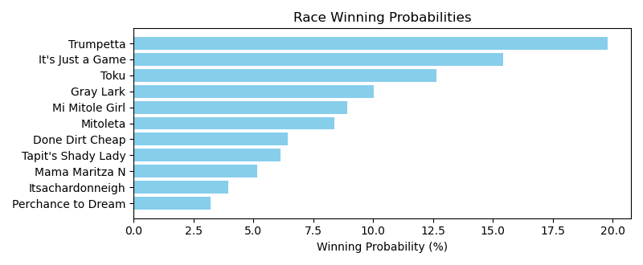

Exacta advice: key 3 → 4 (1 ticket)

Bandit Recommendation: Pick 3_top1_box (Expected Net: 0.00)

# Race: TGP | 2025-05-01 | Race #3 | Post: 19:54 | Track: GULFSTREAM PARK

Track: GULFSTREAM PARK

|  |  |  |  |  |  |
| --- | --- | --- | --- | --- | --- |
| Program # | Horse Name | Morn Odds | Rank | Model Score | Win Prob (%) |
| 1 | Blue Spearman | 3-1 | 4.0 | 1.29 | 13.52 |
| 2 | Papa Katz | 30-1 | 6.0 | 0.03 | 5.67 |
| 3 | Otto | 9-5 | 5.0 | 1.17 | 12.43 |
| 4 | Lace Up | 7-2 | 3.0 | 1.39 | 14.49 |
| 5 | Ekati King | 5-1 | 2.0 | 1.55 | 16.17 |
| 6 | Federal Exchange | 20-1 | 7.0 | -0.36 | 4.33 |
| 7 | Fattoush | 4-1 | 1.0 | 2.60 | 33.38 |

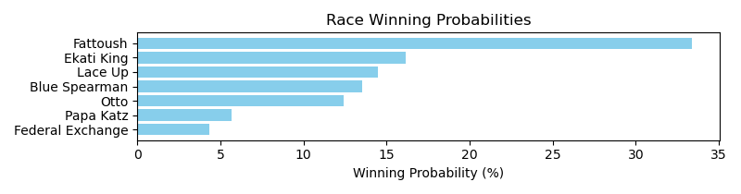

Exacta advice: key 7 → 5 (1 ticket)

Bandit Recommendation: Daily Double_top1_box (Expected Net: 0.89)

# Race: TGP | 2025-05-01 | Race #4 | Post: 20:26 | Track: GULFSTREAM PARK

Track: GULFSTREAM PARK

|  |  |  |  |  |  |
| --- | --- | --- | --- | --- | --- |
| Program # | Horse Name | Morn Odds | Rank | Model Score | Win Prob (%) |
| 1 | Georgeisimportant | 15-1 | 6.0 | 0.76 | 5.85 |
| 2 | Paez | 9-5 | 1.0 | 2.95 | 26.39 |
| 3 | Lao Way | 20-1 | 7.0 | 0.50 | 4.88 |
| 4 | Max N Fifo | 3-1 | 3.0 | 2.28 | 16.71 |
| 5 | Show Boat | 4-1 | 4.0 | 2.22 | 15.97 |
| 6 | Prince David | 5-2 | 2.0 | 2.53 | 19.79 |
| 7 | Herecomesdapeach | 10-1 | 5.0 | 1.60 | 10.41 |

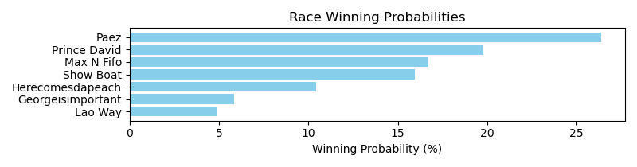

Exacta advice: key 2 → 6 (1 ticket)

Bandit Recommendation: Daily Double_top1_box (Expected Net: -2.00)

# Race: TGP | 2025-05-01 | Race #5 | Post: 20:58 | Track: GULFSTREAM PARK

Track: GULFSTREAM PARK

|  |  |  |  |  |  |
| --- | --- | --- | --- | --- | --- |
| Program # | Horse Name | Morn Odds | Rank | Model Score | Win Prob (%) |
| 1 | Fregon | 7-2 | 5.0 | 0.99 | 10.85 |
| 2 | Bandoola | 4-1 | 2.0 | 1.70 | 17.64 |
| 3 | For the Chief | 5-2 | 1.0 | 2.19 | 24.78 |
| 4 | Nostalgia's Smile | 20-1 | 7.0 | -0.54 | 3.76 |
| 5 | To Monarch | 5-1 | 3.0 | 1.53 | 15.74 |
| 6 | Dixie Preach | 6-1 | 4.0 | 1.24 | 12.82 |
| 7 | Wannabeeloved | 9-2 | 6.0 | 0.99 | 10.82 |
| 8 | Giuro | 30-1 | 8.0 | -0.62 | 3.58 |

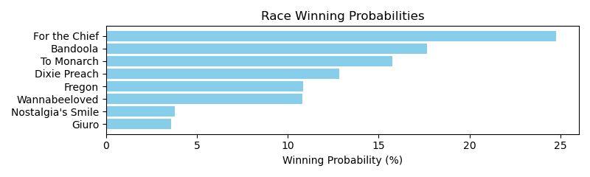

Exacta advice: key 3 → 2 (1 ticket)

Bandit Recommendation: Daily Double_top1_box (Expected Net: 0.00)

# Race: TGP | 2025-05-01 | Race #6 | Post: 21:32 | Track: GULFSTREAM PARK

Track: GULFSTREAM PARK

|  |  |  |  |  |  |
| --- | --- | --- | --- | --- | --- |
| Program # | Horse Name | Morn Odds | Rank | Model Score | Win Prob (%) |
| 1 | Mackor | 7-2 | 2.0 | 2.59 | 21.55 |
| 2 | National Secret | 5-2 | 3.0 | 2.44 | 19.38 |
| 3 | LUCKY OLD SON | 9-2 | 5.0 | 0.56 | 5.32 |
| 4 | Fire Lee | 12-1 | 6.0 | 0.31 | 4.49 |
| 5 | Replevin | 2-1 | 1.0 | 3.34 | 36.23 |
| 6 | El Guty | 10-1 | 4.0 | 1.30 | 8.86 |
| 7 | FROSTED PUNK | 10-1 | 7.0 | 0.21 | 4.18 |

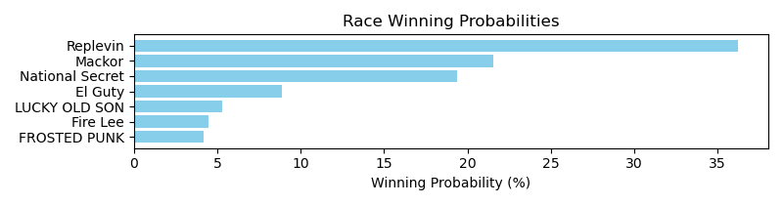

Exacta advice: key 5 → 1 (1 ticket)

Bandit Recommendation: Pick 4_top1_box (Expected Net: 0.00)

# Race: TGP | 2025-05-01 | Race #7 | Post: 22:06 | Track: GULFSTREAM PARK

Track: GULFSTREAM PARK

|  |  |  |  |  |  |
| --- | --- | --- | --- | --- | --- |
| Program # | Horse Name | Morn Odds | Rank | Model Score | Win Prob (%) |
| 1 | Gatsby | 8-1 | 6.0 | 1.38 | 6.18 |
| 2 | Great Lilo | 12-1 | 8.0 | 0.55 | 3.48 |
| 3 | Back Em Up | 10-1 | 4.0 | 2.11 | 10.24 |
| 4 | Tshiebwe | 20-1 | 7.0 | 0.58 | 3.55 |
| 5 | Centrodelantero | 4-1 | 2.0 | 3.47 | 26.09 |
| 6 | Con Compania (CHI) | 5-2 | 1.0 | 3.78 | 32.17 |
| 7 | Hurricane Nelson | 2-1 | 3.0 | 2.28 | 11.50 |
| 8 | QUEREME PASS (ARG) | 6-1 | 5.0 | 1.52 | 6.79 |

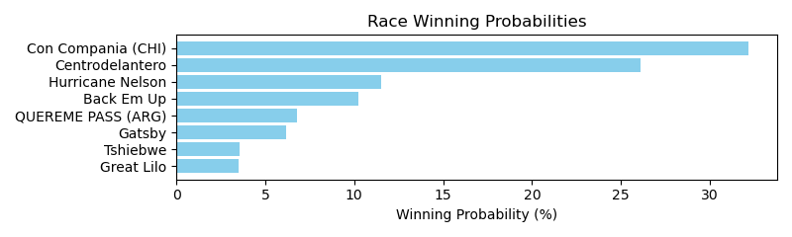

Exacta advice: key 6 → 5 (1 ticket)

Bandit Recommendation: Pick 4_top1_box (Expected Net: 0.00)

# Race: TGP | 2025-05-01 | Race #8 | Post: 22:41 | Track: GULFSTREAM PARK

Track: GULFSTREAM PARK

|  |  |  |  |  |  |
| --- | --- | --- | --- | --- | --- |
| Program # | Horse Name | Morn Odds | Rank | Model Score | Win Prob (%) |
| 1 | Xy Speed | 5-2 | 1.0 | 2.46 | 18.64 |
| 2 | Bring Theband Home | 8-1 | 6.0 | 1.37 | 8.83 |
| 3 | Biz Biz Buzz | 10-1 | 8.0 | 1.15 | 7.56 |
| 4 | Souper Quest | 9-2 | 3.0 | 2.11 | 14.71 |
| 5 | Johnny Podres | 7-2 | 4.0 | 1.87 | 12.44 |
| 6 | Reef Runner | 3-1 | 2.0 | 2.44 | 18.40 |
| 7 | Extendo | 15-1 | 5.0 | 1.67 | 10.86 |
| 8 | Axthelm | 10-1 | 7.0 | 1.33 | 8.57 |

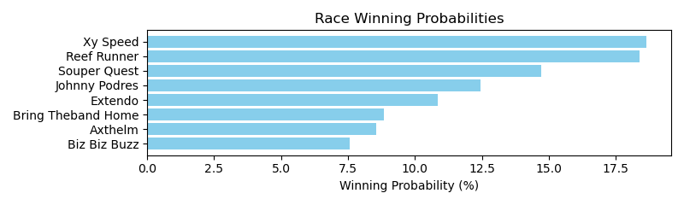

Exacta advice: box [1,6,4] (6 tickets)

Bandit Recommendation: Pick 4_top1_box (Expected Net: 0.00)

# Race: TGP | 2025-05-01 | Race #9 | Post: 23:16 | Track: GULFSTREAM PARK

Track: GULFSTREAM PARK

|  |  |  |  |  |  |
| --- | --- | --- | --- | --- | --- |
| Program # | Horse Name | Morn Odds | Rank | Model Score | Win Prob (%) |
| 1 | Veronika Z | 7-2 | 1.0 | 3.77 | 35.34 |
| 2 | Brisa Veloz | 4-1 | 2.0 | 3.14 | 22.90 |
| 3 | EMISSARY | 15-1 | 7.0 | 0.71 | 4.30 |
| 4 | Luna Louska | 8-1 | 4.0 | 1.75 | 8.82 |
| 5 | Lisca Bianca | 6-1 | 5.0 | 1.51 | 7.48 |
| 6 | STARSHIP BELLA | 20-1 | 8.0 | 0.23 | 3.08 |
| 7 | Striver | 2-1 | 3.0 | 2.34 | 13.25 |
| 8 | REGALTON (GB) | 5-1 | 6.0 | 0.88 | 4.82 |

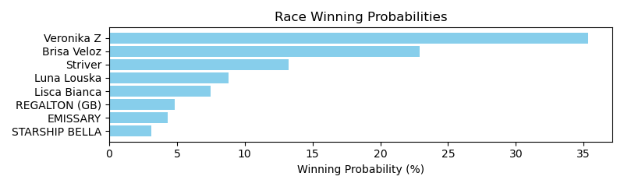

Exacta advice: key 1 → 2 (1 ticket)

Bandit Recommendation: exacta_top2_box (Expected Net: 0.12)

# Race: IND | 2025-04-30 | Race #1 | Post: 20:10 | Track: HORSESHOE INDIANAPOLIS

Track: HORSESHOE INDIANAPOLIS

|  |  |  |  |  |  |
| --- | --- | --- | --- | --- | --- |
| Program # | Horse Name | Morn Odds | Rank | Model Score | Win Prob (%) |
| 1 | Kykeon | 5-2 | 4.0 | 1.04 | 14.46 |
| 2 | Fierce Assault | 6-1 | 5.0 | 0.80 | 12.27 |
| 3 | Wissam Sharaf | 15-1 | 6.0 | 0.45 | 9.60 |
| 4 | My Brother Keith | 8-1 | 3.0 | 1.29 | 17.17 |
| 5 | Sixwillberich | 9-2 | 2.0 | 1.50 | 19.83 |
| 6 | Tiverton | 12-1 | 7.0 | -0.62 | 4.59 |
| 7 | Daddy Justify | 9-5 | 1.0 | 1.66 | 22.07 |

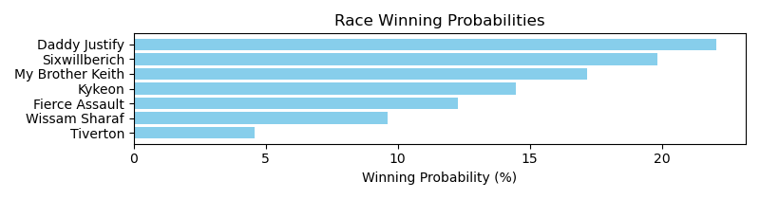

Exacta advice: key 7 → 5 (1 ticket)

Bandit Recommendation: exacta_top2_box (Expected Net: 37.20)

# Race: IND | 2025-04-30 | Race #2 | Post: 20:41 | Track: HORSESHOE INDIANAPOLIS

Track: HORSESHOE INDIANAPOLIS

|  |  |  |  |  |  |
| --- | --- | --- | --- | --- | --- |
| Program # | Horse Name | Morn Odds | Rank | Model Score | Win Prob (%) |
| 1 | Unbridled Devine | 7-2 | 1.0 | 1.49 | 20.32 |
| 2 | Beach Kitten | 2-1 | 3.0 | 1.30 | 17.88 |
| 3 | The Princess Says | 5-1 | 4.0 | 1.08 | 15.33 |
| 4 | Lucky Phoenix | 6-1 | 5.0 | 0.49 | 10.19 |
| 5 | Flat Discount | 12-1 | 6.0 | 0.25 | 8.64 |
| 6 | Pioneer Parade | 4-1 | 2.0 | 1.48 | 20.24 |
| 7 | Banned From Midway | 10-1 | 7.0 | 0.02 | 7.41 |

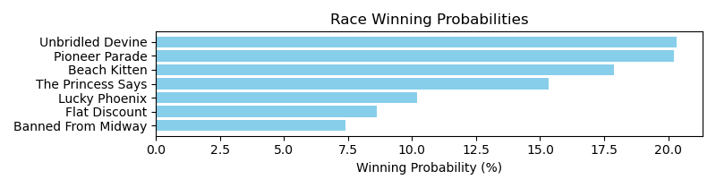

Exacta advice: box [1,6,2] (6 tickets)

Bandit Recommendation: Pick 3_top1_box (Expected Net: 0.00)

# Race: IND | 2025-04-30 | Race #3 | Post: 21:12 | Track: HORSESHOE INDIANAPOLIS

Track: HORSESHOE INDIANAPOLIS

|  |  |  |  |  |  |
| --- | --- | --- | --- | --- | --- |
| Program # | Horse Name | Morn Odds | Rank | Model Score | Win Prob (%) |
| 1 | Trew Violence | 6-1 | 6.0 | -0.03 | 10.20 |
| 2 | El Sargento | 8-1 | 4.0 | 0.14 | 11.48 |
| 3 | Special Caliber | 5-1 | 3.0 | 0.44 | 14.07 |
| 4 | Up to No Good | 7-2 | 2.0 | 0.60 | 15.75 |
| 5 | Canisius | 8-1 | 5.0 | 0.13 | 11.35 |
| 6 | Pagode | 2-1 | 1.0 | 1.52 | 29.72 |
| 7 | Via Del Corso | 9-2 | 7.0 | -0.49 | 7.44 |

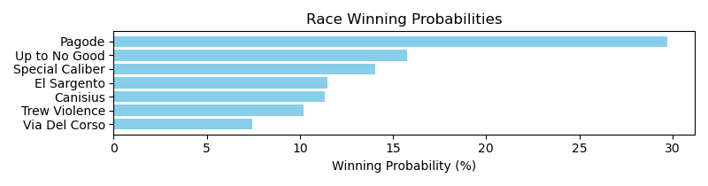

Exacta advice: key 6 → 4 (1 ticket)

Bandit Recommendation: trifecta_top3_box (Expected Net: 272.50)

# Race: IND | 2025-04-30 | Race #4 | Post: 21:43 | Track: HORSESHOE INDIANAPOLIS

Track: HORSESHOE INDIANAPOLIS

|  |  |  |  |  |  |
| --- | --- | --- | --- | --- | --- |
| Program # | Horse Name | Morn Odds | Rank | Model Score | Win Prob (%) |
| 1 | Shipshape | 20-1 | 5.0 | 0.21 | 9.18 |
| 2 | Me and Chili | 15-1 | 7.0 | -0.16 | 7.11 |
| 3 | Zappinit | 7-5 | 1.0 | 1.47 | 21.88 |
| 4 | Mr Negativity | 6-1 | 4.0 | 0.68 | 12.72 |
| 5 | Good Sugar | 5-1 | 3.0 | 1.13 | 17.34 |
| 6 | Turbonator | 10-1 | 8.0 | -0.26 | 6.64 |
| 7 | Binge | 7-2 | 2.0 | 1.15 | 17.51 |
| 8 | For Mama | 12-1 | 6.0 | -0.06 | 7.62 |

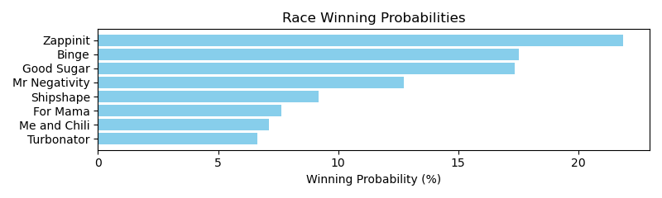

Exacta advice: key 3 → [7,5] (2 tickets)

Bandit Recommendation: Daily Double_top1_box (Expected Net: 8.80)

# Race: IND | 2025-04-30 | Race #5 | Post: 22:14 | Track: HORSESHOE INDIANAPOLIS

Track: HORSESHOE INDIANAPOLIS

|  |  |  |  |  |  |
| --- | --- | --- | --- | --- | --- |
| Program # | Horse Name | Morn Odds | Rank | Model Score | Win Prob (%) |
| 1 | Monarch of Motion | 15-1 | 8.0 | -0.40 | 5.27 |
| 2 | Barca Billy | 12-1 | 6.0 | -0.22 | 5.96 |
| 3 | Slink | 10-1 | 5.0 | 0.19 | 7.92 |
| 4 | Justiceonemoretime | 5-1 | 2.0 | 1.05 | 14.35 |
| 5 | Star Review | 9-2 | 4.0 | 0.67 | 10.99 |
| 6 | Specialty Act | 6-1 | 7.0 | -0.22 | 5.95 |
| 7 | Neon Leon | 13-8 | 3.0 | 1.01 | 13.92 |
| 8 | Covert Kid | 6-1 | 1.0 | 2.37 | 35.64 |

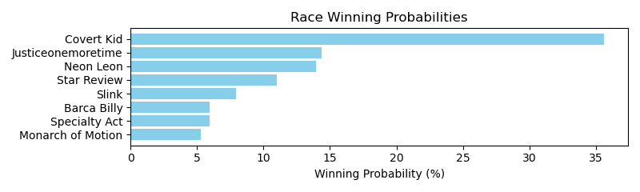

Exacta advice: key 8 → [4,7] (2 tickets)

Bandit Recommendation: exacta_top2_box (Expected Net: -2.00)

# Race: IND | 2025-04-30 | Race #6 | Post: 22:45 | Track: HORSESHOE INDIANAPOLIS

Track: HORSESHOE INDIANAPOLIS

|  |  |  |  |  |  |
| --- | --- | --- | --- | --- | --- |
| Program # | Horse Name | Morn Odds | Rank | Model Score | Win Prob (%) |
| 1 | Littleransomsfire | 3-1 | 1.0 | 2.48 | 23.95 |
| 2 | B On the Loose | 9-2 | 4.0 | 1.69 | 13.93 |
| 3 | TIGER JUMPER | 5-1 | 5.0 | 1.28 | 10.49 |
| 4 | Mc Baby | 20-1 | 8.0 | -1.00 | 2.18 |
| 5 | SEASHELLSALLYSELLS | 15-1 | 6.0 | 0.87 | 7.91 |
| 6 | Micki Valentine | 2-1 | 2.0 | 2.23 | 20.24 |
| 7 | RIBS AND SAUSAGE | 12-1 | 7.0 | 0.54 | 6.32 |
| 8 | Lady Artist | 8-1 | 3.0 | 1.80 | 14.99 |

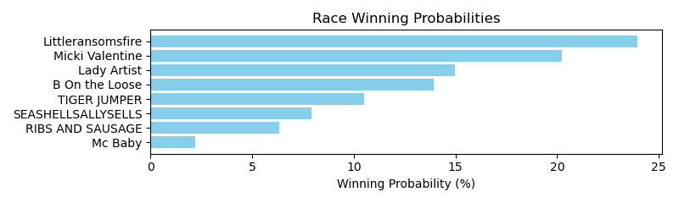

Exacta advice: key 1 → 6 (1 ticket)

Bandit Recommendation: Pick 4_top1_box (Expected Net: 0.00)

# Race: IND | 2025-04-30 | Race #7 | Post: 23:16 | Track: HORSESHOE INDIANAPOLIS

Track: HORSESHOE INDIANAPOLIS

|  |  |  |  |  |  |
| --- | --- | --- | --- | --- | --- |
| Program # | Horse Name | Morn Odds | Rank | Model Score | Win Prob (%) |
| 1 | July Four | 20-1 | 5.0 | 0.85 | 7.66 |
| 2 | Quibble | 30-1 | 6.0 | 0.75 | 7.16 |
| 3 | Gold Delight | 7-2 | 1.0 | 2.09 | 17.94 |
| 4 | FAT CHANCE | 4-1 | 7.0 | 0.58 | 6.37 |
| 5 | Copper Chrome | 15-1 | 4.0 | 1.29 | 10.38 |
| 6 | No Self Control | 15-1 | 2.0 | 1.84 | 15.19 |
| 7 | OSO FANCY | 5-1 | 8.0 | 0.42 | 5.70 |
| 8 | Hazel My Candy | 8-1 | 3.0 | 1.79 | 14.68 |
| 9 | LO MACHAR | 12-1 | 11.0 | -0.33 | 3.39 |
| 10 | Yotowin | 30-1 | 12.0 | -0.81 | 2.44 |
| 11 | SWIFT BEE | 12-1 | 10.0 | -0.07 | 4.06 |
| 12 | AD LITTERAM | 6-1 | 9.0 | 0.24 | 5.04 |

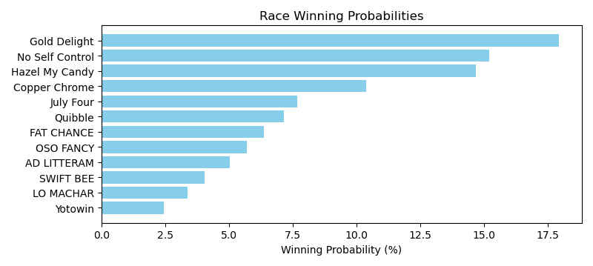

Exacta advice: key 3 → [6,8] (2 tickets)

Bandit Recommendation: Daily Double_top1_box (Expected Net: 0.00)

# Race: IND | 2025-04-30 | Race #8 | Post: 23:47 | Track: HORSESHOE INDIANAPOLIS

Track: HORSESHOE INDIANAPOLIS

|  |  |  |  |  |  |
| --- | --- | --- | --- | --- | --- |
| Program # | Horse Name | Morn Odds | Rank | Model Score | Win Prob (%) |
| 1 | Sarah's Smiles | 30-1 | 10.0 | -1.38 | 2.64 |
| 2 | She's a Whirlwind | 30-1 | 11.0 | -2.02 | 1.70 |
| 3 | Redhotjustice | 15-1 | 9.0 | -0.51 | 4.80 |
| 4 | D' Kitten | 5-2 | 3.0 | 0.75 | 11.45 |
| 5 | Enchanted Melody | 6-1 | 6.0 | 0.21 | 7.92 |
| 6 | Mygaljustice | 4-1 | 7.0 | 0.11 | 7.37 |
| 7 | Luna Diva | 8-1 | 1.0 | 1.60 | 20.57 |
| 8 | Lotta Latte | 20-1 | 4.0 | 0.70 | 11.10 |
| 9 | Hard Truth Wins | 5-1 | 5.0 | 0.33 | 8.59 |
| 10 | No Trust | 15-1 | 2.0 | 1.33 | 17.12 |
| 11 | When's Forever | 10-1 | 8.0 | -0.02 | 6.74 |

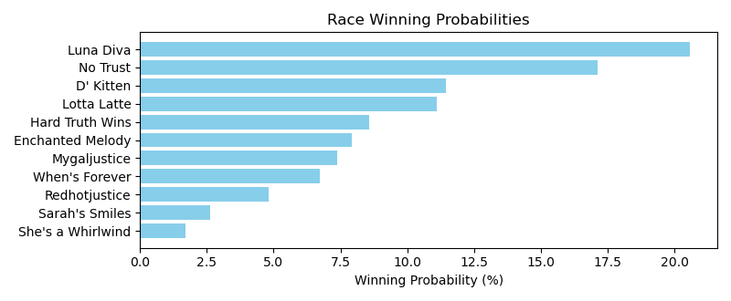

Exacta advice: key 7 → 10 (1 ticket)

Bandit Recommendation: Pick 4_top1_box (Expected Net: 0.09)

# Race: TLS | 2025-05-02 | Race #1 | Post: 00:35 | Track: LONE STAR PARK

Track: LONE STAR PARK

|  |  |  |  |  |  |
| --- | --- | --- | --- | --- | --- |
| Program # | Horse Name | Morn Odds | Rank | Model Score | Win Prob (%) |
| 1 | Scooter's Honor | 7-2 | 4.0 | 1.21 | 14.83 |
| 2 | Cayman Hot | 8-1 | 6.0 | -0.36 | 5.03 |
| 3 | Stirring Up Dust | 3-1 | 3.0 | 1.27 | 15.48 |
| 4 | Sassy Flyer | 6-1 | 5.0 | 0.13 | 7.09 |
| 5 | Franny | 2-1 | 1.0 | 2.38 | 33.38 |
| 6 | Light a Shuck | 4-1 | 2.0 | 1.92 | 24.18 |

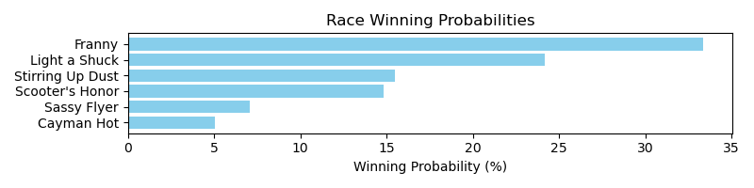

Exacta advice: key 5 → 6 (1 ticket)

Bandit Recommendation: Daily Double_top1_box (Expected Net: 0.00)

# Race: TLS | 2025-05-02 | Race #2 | Post: 01:02 | Track: LONE STAR PARK

Track: LONE STAR PARK

|  |  |  |  |  |  |
| --- | --- | --- | --- | --- | --- |
| Program # | Horse Name | Morn Odds | Rank | Model Score | Win Prob (%) |
| 1 | Viewers Discretion | 12-1 | 7.0 | 0.87 | 8.58 |
| 2 | Sky Rocker | 6-1 | 6.0 | 1.16 | 10.45 |
| 3 | Blood Orange | 3-1 | 4.0 | 1.49 | 13.18 |
| 4 | Flame McGoon | 8-1 | 3.0 | 1.51 | 13.37 |
| 5 | Imaluckycharm | 5-2 | 1.0 | 2.07 | 19.58 |
| 6 | Doudoudouwanadance | 7-2 | 5.0 | 1.16 | 10.51 |
| 7 | Geometrique | 9-2 | 8.0 | 0.77 | 8.01 |
| 8 | Appropriated Funds | 7-2 | 2.0 | 1.80 | 16.31 |

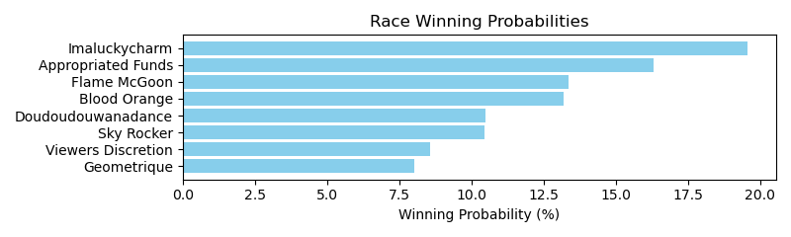

Exacta advice: key 5 → 8 (1 ticket)

Bandit Recommendation: trifecta_top3_box (Expected Net: 0.00)

# Race: TLS | 2025-05-02 | Race #3 | Post: 01:29 | Track: LONE STAR PARK

Track: LONE STAR PARK

|  |  |  |  |  |  |
| --- | --- | --- | --- | --- | --- |
| Program # | Horse Name | Morn Odds | Rank | Model Score | Win Prob (%) |
| 1 | Makin a Beeline | 3-1 | 2.0 | 2.12 | 20.86 |
| 2 | Miss Motor Mouth | 12-1 | 7.0 | 0.22 | 5.65 |
| 3 | Checker's Song | 8-1 | 3.0 | 1.49 | 13.53 |
| 4 | No Moro Here | 10-1 | 4.0 | 1.44 | 13.09 |
| 5 | Uptown Jive | 6-5 | 1.0 | 2.38 | 24.88 |
| 6 | Julia Ann | 15-1 | 5.0 | 1.07 | 10.14 |
| 7 | Chell Jae | 6-1 | 6.0 | 0.38 | 6.27 |
| 8 | Lucky Glitter | 20-1 | 9.0 | -0.99 | 2.44 |
| 9 | True Chief | 15-1 | 8.0 | -0.63 | 3.15 |

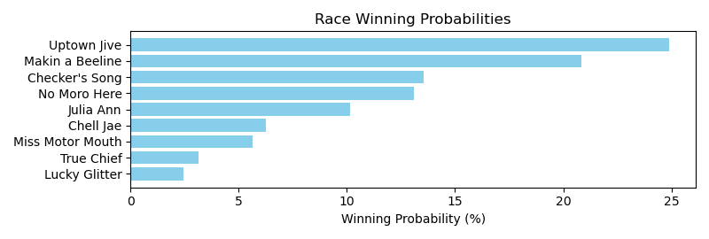

Exacta advice: key 5 → 1 (1 ticket)

Bandit Recommendation: Pick 3_top1_box (Expected Net: 0.00)

# Race: TLS | 2025-05-02 | Race #4 | Post: 01:56 | Track: LONE STAR PARK

Track: LONE STAR PARK

|  |  |  |  |  |  |
| --- | --- | --- | --- | --- | --- |
| Program # | Horse Name | Morn Odds | Rank | Model Score | Win Prob (%) |
| 1 | Heats Hero | 9-2 | 5.0 | 1.37 | 8.47 |
| 2 | Flying Tex | 10-1 | 8.0 | 1.07 | 6.91 |
| 3 | Drama King | 8-1 | 4.0 | 1.50 | 9.26 |
| 4 | Xander S | 15-1 | 3.0 | 1.53 | 9.48 |
| 5 | Fair Weather Flyer | 20-1 | 6.0 | 1.10 | 7.02 |
| 6 | Binary Code | 6-1 | 7.0 | 1.10 | 7.01 |
| 7 | Ihavetoomuchair | 3-1 | 2.0 | 2.48 | 18.22 |
| 8 | Curly's One Thing | 13-8 | 1.0 | 3.37 | 33.62 |

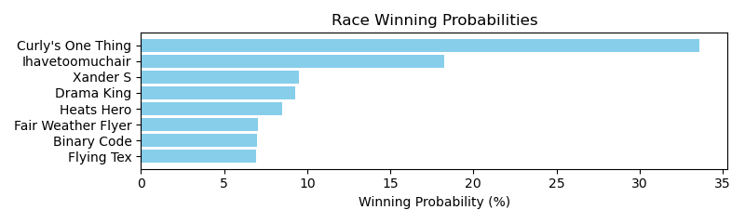

Exacta advice: key 8 → 7 (1 ticket)

Bandit Recommendation: Pick 3_top1_box (Expected Net: 0.00)

# Race: TLS | 2025-05-02 | Race #5 | Post: 02:23 | Track: LONE STAR PARK

Track: LONE STAR PARK

|  |  |  |  |  |  |
| --- | --- | --- | --- | --- | --- |
| Program # | Horse Name | Morn Odds | Rank | Model Score | Win Prob (%) |
| 1 | Speak Softly | 6-1 | 6.0 | 0.28 | 8.23 |
| 2 | Take My Picture | 7-5 | 1.0 | 1.87 | 24.74 |
| 3 | Ruby Cantu | 8-1 | 5.0 | 0.63 | 10.54 |
| 4 | Kause I'm Devine | 15-1 | 8.0 | -0.12 | 6.28 |
| 5 | Blue Heavenly | 12-1 | 2.0 | 1.38 | 17.59 |
| 6 | Wilburnsclassylady | 7-2 | 4.0 | 0.83 | 12.10 |
| 7 | Athena d'Oro | 15-1 | 7.0 | -0.06 | 6.53 |
| 8 | Cafezinho | 9-2 | 3.0 | 1.05 | 13.99 |

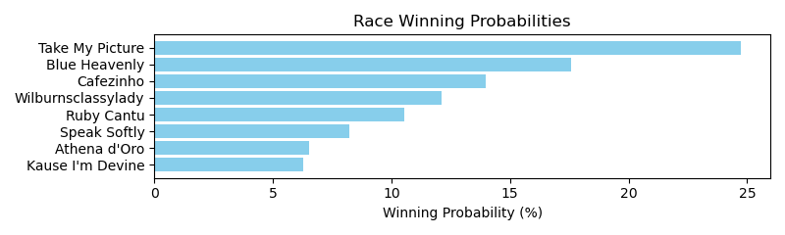

Exacta advice: key 2 → 5 (1 ticket)

Bandit Recommendation: Pick 3_top1_box (Expected Net: 0.00)

# Race: TLS | 2025-05-02 | Race #6 | Post: 02:50 | Track: LONE STAR PARK

Track: LONE STAR PARK

|  |  |  |  |  |  |
| --- | --- | --- | --- | --- | --- |
| Program # | Horse Name | Morn Odds | Rank | Model Score | Win Prob (%) |
| 1 | Crazy Ridge | 8-1 | 3.0 | 0.68 | 14.06 |
| 2 | Valdina Dreams | 15-1 | 7.0 | -0.28 | 7.24 |
| 3 | Take My Money | 5-2 | 1.0 | 1.18 | 19.87 |
| 4 | Uptowneagleslanded | 15-1 | 6.0 | 0.14 | 9.65 |
| 5 | Wings for Eno | 10-1 | 5.0 | 0.23 | 10.28 |
| 6 | Rags Royal Prinz | 3-1 | 2.0 | 1.04 | 17.97 |
| 7 | Rich Mountain | 4-1 | 8.0 | -0.34 | 6.96 |
| 8 | True and Ready | 6-1 | 4.0 | 0.67 | 13.96 |

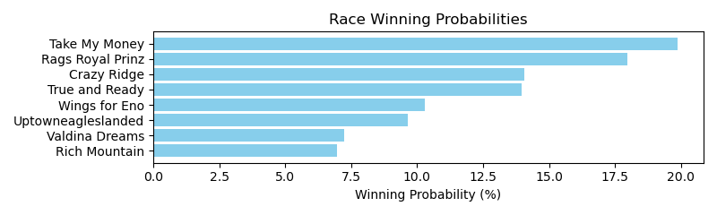

Exacta advice: key 3 → 6 (1 ticket)

Bandit Recommendation: exacta_top2_box (Expected Net: 0.00)

# Race: TLS | 2025-05-02 | Race #7 | Post: 03:17 | Track: LONE STAR PARK

Track: LONE STAR PARK

|  |  |  |  |  |  |
| --- | --- | --- | --- | --- | --- |
| Program # | Horse Name | Morn Odds | Rank | Model Score | Win Prob (%) |
| 1 | Ooh La Da Stoops | 15-1 | 8.0 | -0.71 | 4.76 |
| 2 | Honest | 3-1 | 2.0 | 1.02 | 15.62 |
| 3 | Successfulpath | 12-1 | 4.0 | 0.81 | 13.51 |
| 4 | Naval Woman | 7-2 | 1.0 | 1.34 | 19.50 |
| 5 | Cajun Doll | 15-1 | 7.0 | -0.37 | 6.01 |
| 6 | Mor Peanuts | 5-1 | 5.0 | 0.74 | 12.86 |
| 7 | Dulce Amanecer Yg | 20-1 | 9.0 | -0.73 | 4.70 |
| 8 | City Ghost | 10-1 | 6.0 | -0.05 | 7.45 |
| 9 | Stilettos | 2-1 | 3.0 | 1.02 | 15.58 |

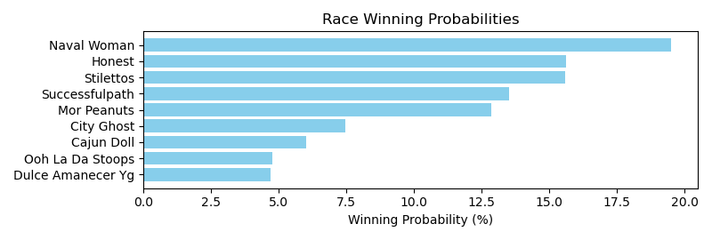

Exacta advice: key 4 → [2,9] (2 tickets)

Bandit Recommendation: Pick 4_top1_box (Expected Net: 0.00)

# Race: TLS | 2025-05-02 | Race #8 | Post: 03:44 | Track: LONE STAR PARK

Track: LONE STAR PARK

|  |  |  |  |  |  |
| --- | --- | --- | --- | --- | --- |
| Program # | Horse Name | Morn Odds | Rank | Model Score | Win Prob (%) |
| 1 | Diamond Empress | 20-1 | 12.0 | -0.28 | 3.32 |
| 2 | Miss Mozetti | 15-1 | 2.0 | 1.92 | 15.11 |
| 3 | Dr. Ray D. | 5-2 | 1.0 | 2.18 | 18.03 |
| 4 | Penny Powers | 20-1 | 5.0 | 1.04 | 8.25 |
| 5 | dh-Regal Rumor | 15-1 | 10.0 | -0.24 | 3.41 |
| 6 | Wec Keah | 4-1 | 3.0 | 1.86 | 14.50 |
| 7 | Honor and Fire | 20-1 | 13.0 | -0.73 | 2.44 |
| 8 | Bluebonnet Girl | 20-1 | 6.0 | 0.92 | 7.59 |
| 9 | Custom Sunshine | 20-1 | 11.0 | -0.25 | 3.40 |
| 10 | Dulcia | 12-1 | 9.0 | -0.18 | 3.55 |
| 11 | Wauneka | 3-1 | 4.0 | 1.40 | 10.54 |
| 12 | Rubia | 5-1 | 7.0 | 0.41 | 5.35 |
| 13 | On Wing | 12-1 | 8.0 | 0.17 | 4.53 |

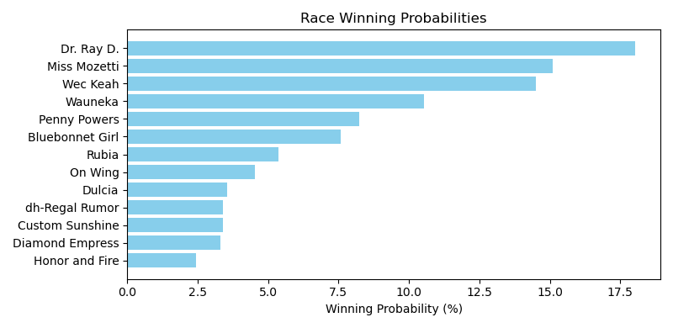

Exacta advice: key 3 → 2 (1 ticket)

Bandit Recommendation: trifecta_top3_box (Expected Net: -2.00)

# Race: TLS | 2025-05-03 | Race #1 | Post: 19:35 | Track: LONE STAR PARK

Track: LONE STAR PARK

|  |  |  |  |  |  |
| --- | --- | --- | --- | --- | --- |
| Program # | Horse Name | Morn Odds | Rank | Model Score | Win Prob (%) |
| 1 | Holiday Cruise | 30-1 | 5.0 | 0.51 | 6.67 |
| 2 | Taps Mistress | 1-1 | 1.0 | 2.96 | 36.14 |
| 3 | Find the Light | 20-1 | 4.0 | 0.67 | 7.43 |
| 4 | Holiday Lines | 12-1 | 8.0 | 0.03 | 4.78 |
| 5 | Chip Alternative | 30-1 | 7.0 | 0.17 | 5.27 |
| 6 | Shy Ann | 7-5 | 2.0 | 2.00 | 18.61 |
| 7 | Sherrys Ridge | 30-1 | 6.0 | 0.34 | 5.93 |
| 8 | Shake Those Dice | 8-1 | 3.0 | 1.40 | 12.29 |
| 9 | Delta Delicious | 30-1 | 9.0 | -0.71 | 2.88 |

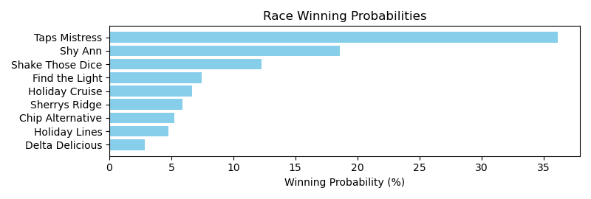

Exacta advice: key 2 → 6 (1 ticket)

Bandit Recommendation: Daily Double_top1_box (Expected Net: 0.00)

# Race: TLS | 2025-05-03 | Race #2 | Post: 20:03 | Track: LONE STAR PARK

Track: LONE STAR PARK

|  |  |  |  |  |  |
| --- | --- | --- | --- | --- | --- |
| Program # | Horse Name | Morn Odds | Rank | Model Score | Win Prob (%) |
| 1 | Promises to Dance | 3-1 | 2.0 | 1.29 | 23.06 |
| 2 | Shezawildstorm | 5-1 | 6.0 | -0.48 | 6.82 |
| 3 | Cajun Ninja | 4-1 | 4.0 | 0.89 | 17.57 |
| 4 | Blushing Belle | 2-1 | 1.0 | 1.29 | 23.18 |
| 5 | Angel Kiss | 8-1 | 5.0 | 0.28 | 11.55 |
| 6 | Brand Loyalty | 6-1 | 3.0 | 0.91 | 17.83 |

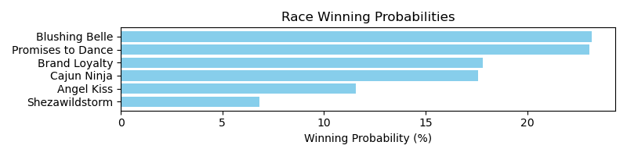

Exacta advice: box [4,1,6] (6 tickets)

Bandit Recommendation: Pick 3_top1_box (Expected Net: 0.00)

# Race: TLS | 2025-05-03 | Race #3 | Post: 20:31 | Track: LONE STAR PARK

Track: LONE STAR PARK

|  |  |  |  |  |  |
| --- | --- | --- | --- | --- | --- |
| Program # | Horse Name | Morn Odds | Rank | Model Score | Win Prob (%) |
| 1 | Grind Jim | 7-2 | 3.0 | 1.57 | 18.05 |
| 2 | Hank Ridge | 30-1 | 5.0 | -0.04 | 5.91 |
| 3 | Otherbrotherdaryl | 8-1 | 4.0 | 1.18 | 13.74 |
| 4 | FOLLOWMEIFYOUCAN | 20-1 | 7.0 | -0.69 | 3.80 |
| 5 | Famous Tutt | 2-1 | 2.0 | 1.86 | 21.96 |
| 6 | Obvious Conclusion | 13-8 | 1.0 | 2.35 | 30.76 |
| 7 | UNCLE ARTHUR | 10-1 | 6.0 | -0.08 | 5.79 |

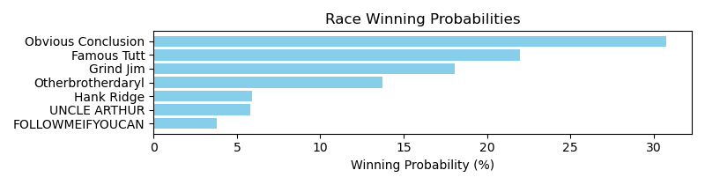

Exacta advice: key 6 → 5 (1 ticket)

Bandit Recommendation: Pick 3_top1_box (Expected Net: 0.00)

# Race: TLS | 2025-05-03 | Race #4 | Post: 20:59 | Track: LONE STAR PARK

Track: LONE STAR PARK

|  |  |  |  |  |  |
| --- | --- | --- | --- | --- | --- |
| Program # | Horse Name | Morn Odds | Rank | Model Score | Win Prob (%) |
| 1 | Golden Pursuit | 10-1 | 5.0 | 1.12 | 7.70 |
| 2 | Weekend Kash | 12-1 | 11.0 | -0.14 | 3.23 |
| 3 | Echo Marine | 5-2 | 3.0 | 1.96 | 13.71 |
| 4 | Spiders Revenge | 30-1 | 8.0 | 0.51 | 5.04 |
| 5 | Bayou Boy | 12-1 | 4.0 | 1.21 | 8.16 |
| 6 | Doc Henry Ridge | 20-1 | 7.0 | 0.62 | 5.44 |
| 7 | C J's Mischief | 30-1 | 9.0 | 0.42 | 4.76 |
| 8 | CROWN BLING | 30-1 | 12.0 | -0.92 | 1.89 |
| 9 | He's Charming | 7-2 | 2.0 | 2.38 | 18.34 |
| 10 | Moro Trendsetter | 20-1 | 6.0 | 1.07 | 7.44 |
| 11 | Tiger Man McKool | 2-1 | 1.0 | 2.58 | 20.98 |
| 12 | Keep a Copy | 30-1 | 10.0 | -0.10 | 3.32 |

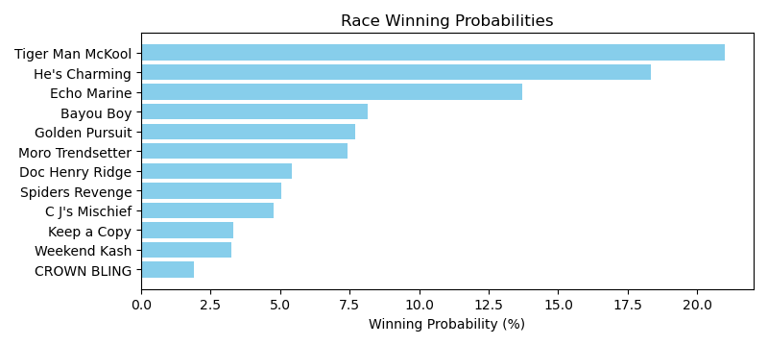

Exacta advice: key 11 → 9 (1 ticket)

Bandit Recommendation: Pick 4_top1_box (Expected Net: 0.00)

# Race: TLS | 2025-05-03 | Race #5 | Post: 21:27 | Track: LONE STAR PARK

Track: LONE STAR PARK

|  |  |  |  |  |  |
| --- | --- | --- | --- | --- | --- |
| Program # | Horse Name | Morn Odds | Rank | Model Score | Win Prob (%) |
| 1 | Moven Van | 12-1 | 5.0 | 0.50 | 13.85 |
| 2 | Sweet Tapin Moro | 15-1 | 8.0 | -0.88 | 5.36 |
| 3 | Autism Inclusion | 15-1 | 7.0 | -0.48 | 7.05 |
| 4 | Optimal Trip | 7-2 | 1.0 | 0.78 | 16.77 |
| 5 | Arthur | 5-1 | 4.0 | 0.57 | 14.57 |
| 6 | Summer Lover | 9-2 | 2.0 | 0.69 | 15.73 |
| 7 | My Wife Is Right | 13-8 | 3.0 | 0.67 | 15.58 |
| 8 | Ripster | 6-1 | 6.0 | 0.18 | 11.09 |

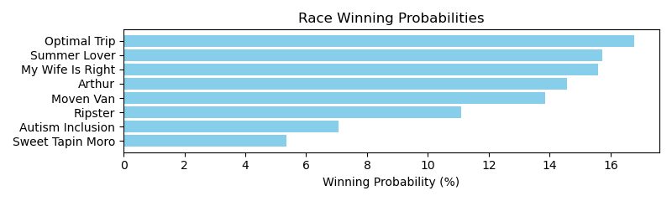

Exacta advice: box [4,6,7] (6 tickets)

Bandit Recommendation: Pick 3_top1_box (Expected Net: 0.00)

# Race: TLS | 2025-05-03 | Race #6 | Post: 21:55 | Track: LONE STAR PARK

Track: LONE STAR PARK

|  |  |  |  |  |  |
| --- | --- | --- | --- | --- | --- |
| Program # | Horse Name | Morn Odds | Rank | Model Score | Win Prob (%) |
| 1 | Champagne Stooper | 7-2 | 2.0 | 1.49 | 15.12 |
| 2 | Talk About Autism | 15-1 | 6.0 | 0.42 | 7.24 |
| 3 | Cinco Majestic | 12-1 | 5.0 | 1.15 | 11.98 |
| 4 | Varsity | 15-1 | 7.0 | 0.28 | 6.55 |
| 5 | Send Off | 20-1 | 8.0 | 0.00 | 5.43 |
| 6 | Wilton | 15-1 | 9.0 | -0.18 | 4.78 |
| 7 | Union Data | 8-1 | 4.0 | 1.38 | 14.04 |
| 8 | Sunday Bling | 2-1 | 3.0 | 1.44 | 14.58 |
| 9 | Emperador | 5-2 | 1.0 | 1.92 | 20.29 |

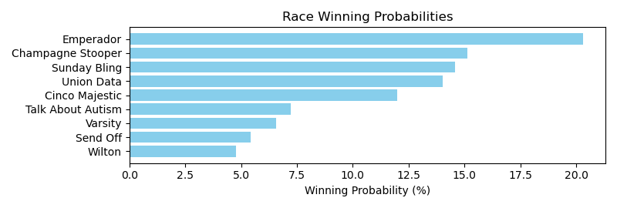

Exacta advice: key 9 → 1 (1 ticket)

Bandit Recommendation: trifecta_top3_box (Expected Net: 0.00)

# Race: TLS | 2025-05-03 | Race #7 | Post: 22:23 | Track: LONE STAR PARK

Track: LONE STAR PARK

|  |  |  |  |  |  |
| --- | --- | --- | --- | --- | --- |
| Program # | Horse Name | Morn Odds | Rank | Model Score | Win Prob (%) |
| 1 | Pinehurst (IRE) | 20-1 | 7.0 | 0.34 | 4.40 |
| 2 | Khantaro d'Oro | 15-1 | 9.0 | 0.14 | 3.82 |
| 3 | Ghurair's Warrior | 20-1 | 11.0 | -0.05 | 3.36 |
| 4 | Old Boys Club | 15-1 | 12.0 | -0.23 | 2.97 |
| 5 | Polis | 30-1 | 13.0 | -0.69 | 2.15 |
| 6 | Silver Stef Hit | 10-1 | 10.0 | -0.02 | 3.42 |
| 7 | Gold Prize | 12-1 | 4.0 | 1.28 | 8.40 |
| 8 | Gwyneth's Malibu | 15-1 | 5.0 | 1.13 | 7.58 |
| 9 | One Time Mark | 7-5 | 1.0 | 3.00 | 27.50 |
| 10 | Moneyline | 3-1 | 6.0 | 0.70 | 5.63 |
| 11 | Island Cabana | 12-1 | 8.0 | 0.21 | 4.00 |
| 12 | Roustabout | 15-1 | 2.0 | 2.38 | 17.91 |
| 13 | You're On Mute | 5-1 | 3.0 | 1.36 | 8.87 |

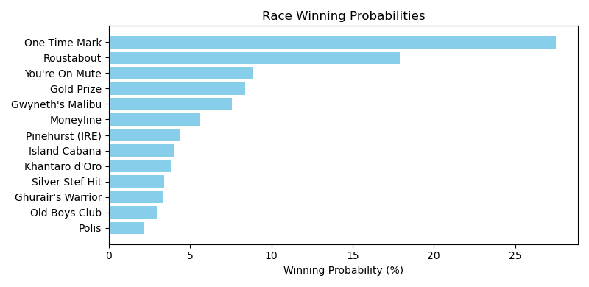

Exacta advice: key 9 → 12 (1 ticket)

Bandit Recommendation: Pick 3_top1_box (Expected Net: 0.00)

# Race: TLS | 2025-05-03 | Race #8 | Post: 22:51 | Track: LONE STAR PARK

Track: LONE STAR PARK

|  |  |  |  |  |  |
| --- | --- | --- | --- | --- | --- |
| Program # | Horse Name | Morn Odds | Rank | Model Score | Win Prob (%) |
| 1 | Expect Glory | 20-1 | 7.0 | -0.59 | 3.75 |
| 2 | Summer Help | 20-1 | 5.0 | -0.02 | 5.57 |
| 3 | He Is Heaven Sent | 6-1 | 4.0 | 0.79 | 9.71 |
| 4 | Adger | 10-1 | 3.0 | 1.65 | 17.54 |
| 5 | Berry Mischievous | 3-1 | 1.0 | 2.67 | 35.50 |
| 6 | Bradix | 15-1 | 8.0 | -0.90 | 3.04 |
| 7 | Yo Soy Roy | 12-1 | 6.0 | -0.24 | 4.77 |
| 8 | Proven Advocate | 6-5 | 2.0 | 1.85 | 20.13 |

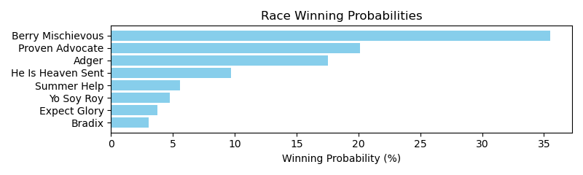

Exacta advice: key 5 → 8 (1 ticket)

Bandit Recommendation: superfecta_top4_box (Expected Net: -2.00)

# Race: TLS | 2025-05-03 | Race #9 | Post: 23:19 | Track: LONE STAR PARK

Track: LONE STAR PARK

|  |  |  |  |  |  |
| --- | --- | --- | --- | --- | --- |
| Program # | Horse Name | Morn Odds | Rank | Model Score | Win Prob (%) |
| 1 | Reckless Red | 10-1 | 4.0 | 0.51 | 9.08 |
| 2 | Race Around | 12-1 | 8.0 | -0.49 | 4.57 |
| 3 | Coalcowboy | 5-2 | 7.0 | 0.02 | 6.49 |
| 4 | Texas Creed | 3-1 | 1.0 | 2.36 | 32.45 |
| 5 | Daryls Trump Card | 10-1 | 6.0 | 0.32 | 7.97 |
| 6 | Bubba's Reckless | 12-1 | 3.0 | 0.61 | 9.72 |
| 7 | Capote's Glitter | 30-1 | 10.0 | -1.80 | 1.84 |
| 8 | Ghost Cowboy | 7-2 | 2.0 | 1.32 | 15.82 |
| 9 | Sparra | 8-1 | 5.0 | 0.42 | 8.53 |
| 10 | Mr. Texas Charm | 20-1 | 9.0 | -0.86 | 3.53 |

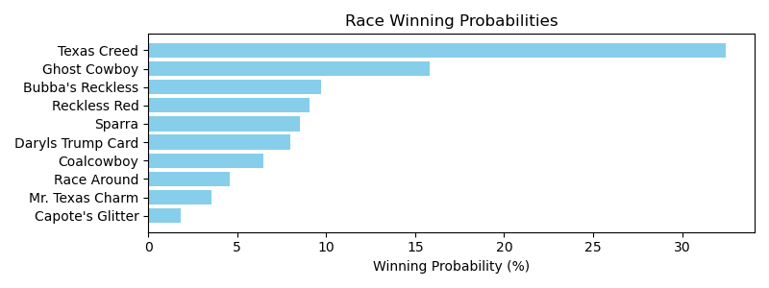

Exacta advice: key 4 → 8 (1 ticket)

Bandit Recommendation: Pick 3_top1_box (Expected Net: 0.00)

# Race: TLS | 2025-05-03 | Race #10 | Post: 00:20 | Track: LONE STAR PARK

Track: LONE STAR PARK

|  |  |  |  |  |  |
| --- | --- | --- | --- | --- | --- |
| Program # | Horse Name | Morn Odds | Rank | Model Score | Win Prob (%) |
| 1 | Tiz a Knockout | 8-1 | 2.0 | 2.22 | 11.32 |
| 2 | Allegrodimolto | 6-1 | 5.0 | 1.92 | 9.22 |
| 3 | Affair | 7-2 | 1.0 | 2.27 | 11.74 |
| 4 | Forever Safe | 3-1 | 4.0 | 2.02 | 9.84 |
| 5 | La Ronalda Y G | 30-1 | 11.0 | 1.09 | 5.20 |
| 6 | Ladypacksapistol | 15-1 | 12.0 | 0.16 | 2.74 |
| 7 | Passando | 20-1 | 9.0 | 1.52 | 6.98 |
| 8 | Very Unlikely | 12-1 | 7.0 | 1.67 | 7.77 |
| 9 | She's a Reader | 8-1 | 6.0 | 1.81 | 8.54 |
| 10 | Beachya | 20-1 | 10.0 | 1.28 | 5.91 |
| 11 | Maybe So | 10-1 | 8.0 | 1.57 | 7.26 |
| 12 | Royal Subject | 6-1 | 3.0 | 2.16 | 10.85 |
| 13 | Gormley's Kitten | 15-1 | 13.0 | 0.10 | 2.63 |

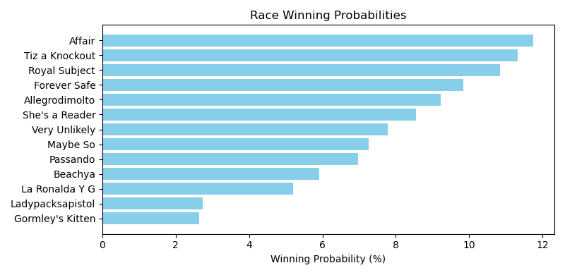

Exacta advice: box [3,1,12] (6 tickets)

Bandit Recommendation: no_bet (Expected Net: 0.00)

# Race: TLS | 2025-05-04 | Race #1 | Post: 19:35 | Track: LONE STAR PARK

Track: LONE STAR PARK

|  |  |  |  |  |  |
| --- | --- | --- | --- | --- | --- |
| Program # | Horse Name | Morn Odds | Rank | Model Score | Win Prob (%) |
| 1 | COURTINBYMOONLIGHT | 9-2 | 5.0 | 0.27 | 6.45 |
| 2 | Moon Crater | 3-1 | 2.0 | 2.23 | 24.84 |
| 3 | Cowgirl Dream | 5-2 | 1.0 | 2.64 | 32.95 |
| 4 | R S American Tide | 5-1 | 4.0 | 1.12 | 11.57 |
| 5 | Clever Clementine | 10-1 | 6.0 | 0.15 | 5.94 |
| 6 | A Thousand Sails | 7-2 | 3.0 | 1.78 | 18.25 |

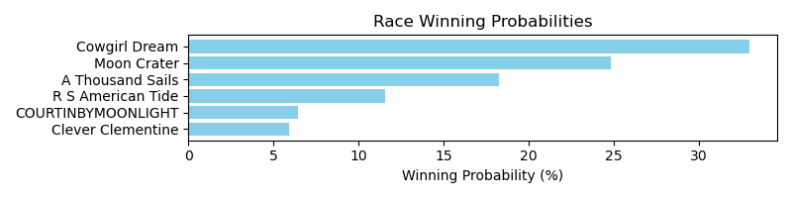

Exacta advice: key 3 → 2 (1 ticket)

Bandit Recommendation: Daily Double_top1_box (Expected Net: 0.58)

# Race: TLS | 2025-05-04 | Race #2 | Post: 20:15 | Track: LONE STAR PARK

Track: LONE STAR PARK

|  |  |  |  |  |  |
| --- | --- | --- | --- | --- | --- |
| Program # | Horse Name | Morn Odds | Rank | Model Score | Win Prob (%) |
| 1 | Optimal Courage | 15-1 | 7.0 | 1.23 | 8.95 |
| 2 | Available Star | 8-1 | 6.0 | 1.40 | 10.09 |
| 3 | Jackman's Ride | 4-1 | 2.0 | 1.91 | 14.36 |
| 4 | Dark Afternoon | 5-1 | 3.0 | 1.66 | 12.09 |
| 5 | Bye | 12-1 | 9.0 | 0.33 | 4.84 |
| 6 | Agent Peter Graves | 3-1 | 4.0 | 1.63 | 11.84 |
| 7 | Twentyone N Change | 5-2 | 5.0 | 1.55 | 11.21 |
| 8 | Brucelea | 6-1 | 8.0 | 0.55 | 5.63 |
| 9 | Tape to Tape | 13-8 | 1.0 | 2.46 | 20.99 |

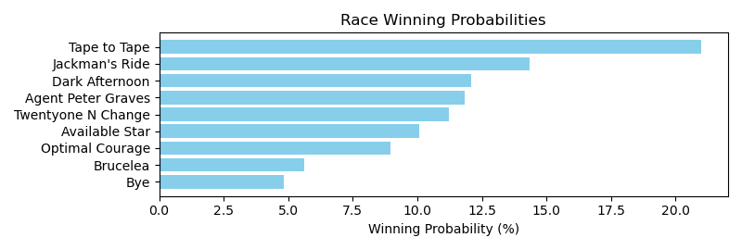

Exacta advice: key 9 → 3 (1 ticket)

Bandit Recommendation: Daily Double_top1_box (Expected Net: 13.00)

# Race: TLS | 2025-05-04 | Race #3 | Post: 20:43 | Track: LONE STAR PARK

Track: LONE STAR PARK

|  |  |  |  |  |  |
| --- | --- | --- | --- | --- | --- |
| Program # | Horse Name | Morn Odds | Rank | Model Score | Win Prob (%) |
| 1 | Supercents | 13-8 | 2.0 | 0.90 | 20.63 |
| 2 | Coinmaker | 4-1 | 5.0 | 0.40 | 14.60 |
| 3 | Mola Mia | 15-1 | 6.0 | -0.50 | 7.83 |
| 4 | Gee Gee | 2-1 | 3.0 | 0.58 | 16.55 |
| 5 | Sharp Likeness | 8-1 | 4.0 | 0.45 | 15.09 |
| 6 | Tura Lura | 6-1 | 1.0 | 1.20 | 25.30 |

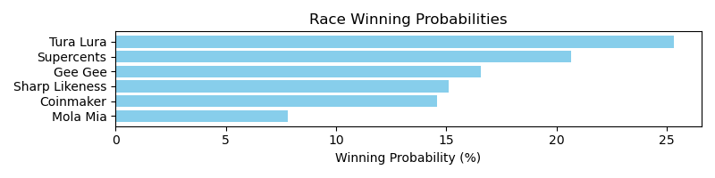

Exacta advice: key 6 → 1 (1 ticket)

Bandit Recommendation: Pick 4_top1_box (Expected Net: 0.00)

# Race: TLS | 2025-05-04 | Race #4 | Post: 21:23 | Track: LONE STAR PARK

Track: LONE STAR PARK

|  |  |  |  |  |  |
| --- | --- | --- | --- | --- | --- |
| Program # | Horse Name | Morn Odds | Rank | Model Score | Win Prob (%) |
| 1 | Mintastic | 20-1 | 1.0 | 2.00 | 29.08 |
| 2 | Jolly Samurai | 13-8 | 3.0 | 1.24 | 17.19 |
| 3 | Wow That's Hot | 8-1 | 4.0 | 0.46 | 10.05 |
| 4 | Brooklyn Alley Cat | 20-1 | 6.0 | 0.16 | 8.19 |
| 5 | Itsmybirthday | 3-1 | 5.0 | 0.28 | 8.90 |
| 6 | Countthebrave | 15-1 | 7.0 | -0.40 | 5.58 |
| 7 | Take Charge Tom | 9-5 | 2.0 | 1.53 | 21.02 |

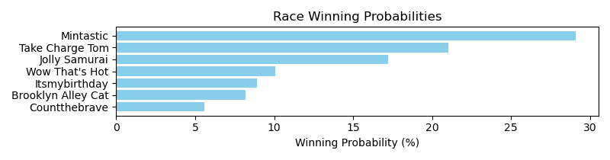

Exacta advice: key 1 → 7 (1 ticket)

Bandit Recommendation: Pick 3_top1_box (Expected Net: 73.40)

# Race: TLS | 2025-05-04 | Race #5 | Post: 21:51 | Track: LONE STAR PARK

Track: LONE STAR PARK

|  |  |  |  |  |  |
| --- | --- | --- | --- | --- | --- |
| Program # | Horse Name | Morn Odds | Rank | Model Score | Win Prob (%) |
| 1 | Carlea's Dream | 4-1 | 2.0 | 2.16 | 11.42 |
| 2 | Ocelot | 5-2 | 4.0 | 2.15 | 11.38 |
| 3 | Creative Minister | 6-1 | 7.0 | 1.77 | 8.73 |
| 4 | Illustrator | 8-1 | 8.0 | 1.71 | 8.37 |
| 5 | Regal Terka | 8-1 | 9.0 | 0.87 | 4.70 |
| 6 | Pico d'Oro | 15-1 | 6.0 | 2.00 | 10.26 |
| 7 | Mor Victory | 20-1 | 11.0 | 0.59 | 3.87 |
| 8 | Hold Your Applause | 12-1 | 10.0 | 0.71 | 4.22 |
| 9 | Sunlit Song | 7-2 | 3.0 | 2.15 | 11.39 |
| 10 | Prowling Tiger | 20-1 | 12.0 | 0.43 | 3.46 |
| 11 | Edified | 5-2 | 1.0 | 2.20 | 11.75 |
| 12 | Without a Trace | 7-2 | 5.0 | 2.03 | 10.44 |

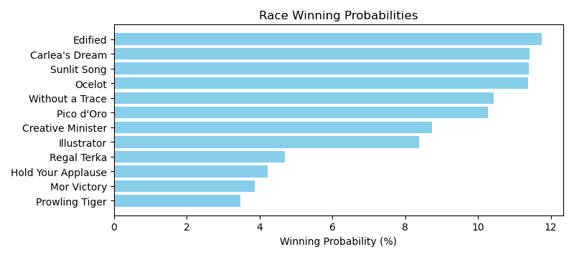

Exacta advice: box [11,1,9] (6 tickets)

Bandit Recommendation: Daily Double_top1_box (Expected Net: 0.00)

# Race: TLS | 2025-05-04 | Race #6 | Post: 22:31 | Track: LONE STAR PARK

Track: LONE STAR PARK

|  |  |  |  |  |  |
| --- | --- | --- | --- | --- | --- |
| Program # | Horse Name | Morn Odds | Rank | Model Score | Win Prob (%) |
| 1 | Ibendliedto | 20-1 | 7.0 | 0.05 | 4.76 |
| 2 | Mucho Vapor | 9-2 | 1.0 | 2.47 | 25.07 |
| 3 | Cause Mimi Said | 13-8 | 3.0 | 2.00 | 18.18 |
| 4 | Bello | 10-1 | 5.0 | 1.07 | 9.57 |
| 5 | Blame Dennis | 8-1 | 4.0 | 1.29 | 11.14 |
| 6 | Austin's Map | 2-1 | 2.0 | 2.29 | 22.29 |
| 7 | Too Much Long Legs | 8-1 | 6.0 | 0.98 | 8.99 |

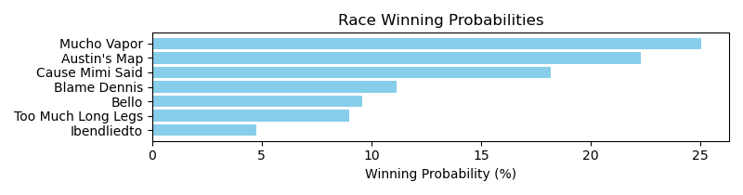

Exacta advice: key 2 → 6 (1 ticket)

Bandit Recommendation: Daily Double_top1_box (Expected Net: 0.56)

# Race: TLS | 2025-05-04 | Race #7 | Post: 22:59 | Track: LONE STAR PARK

Track: LONE STAR PARK

|  |  |  |  |  |  |
| --- | --- | --- | --- | --- | --- |
| Program # | Horse Name | Morn Odds | Rank | Model Score | Win Prob (%) |
| 1 | Secrecy Is Evil | 15-1 | 9.0 | -0.81 | 2.07 |
| 2 | Three Echoes | 3-1 | 3.0 | 1.68 | 11.45 |
| 3 | Knock Knock Joke | 9-5 | 1.0 | 3.58 | 42.40 |
| 4 | Dancin for Gold | 5-1 | 4.0 | 1.58 | 10.69 |
| 5 | Go Go Boss | 6-1 | 2.0 | 2.40 | 18.86 |
| 6 | Heavenville | 9-2 | 5.0 | 0.63 | 5.58 |
| 7 | Smartier | 15-1 | 8.0 | -0.37 | 2.80 |
| 8 | Good Product | 20-1 | 6.0 | -0.13 | 3.28 |
| 9 | Gold Front | 20-1 | 7.0 | -0.33 | 2.87 |

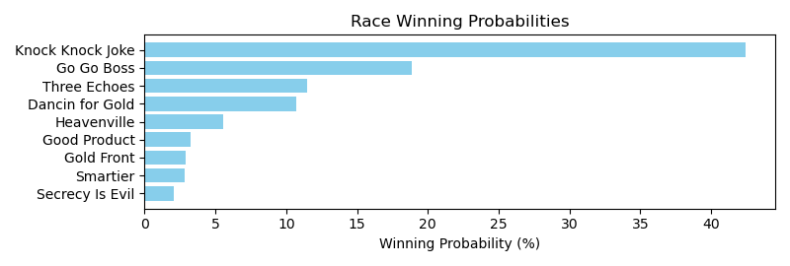

Exacta advice: key 3 → 5 (1 ticket)

Bandit Recommendation: Daily Double_top1_box (Expected Net: 38.80)

# Race: TLS | 2025-05-04 | Race #8 | Post: 23:39 | Track: LONE STAR PARK

Track: LONE STAR PARK

|  |  |  |  |  |  |
| --- | --- | --- | --- | --- | --- |
| Program # | Horse Name | Morn Odds | Rank | Model Score | Win Prob (%) |
| 1 | Flash Master | 20-1 | 11.0 | -0.01 | 4.34 |
| 2 | Channel Launch | 15-1 | 10.0 | 0.20 | 4.98 |
| 3 | Overcast | 20-1 | 9.0 | 0.25 | 5.16 |
| 4 | Airo Dinero | 5-1 | 8.0 | 0.46 | 5.97 |
| 5 | Peak Earnings (GB) | 3-1 | 6.0 | 0.58 | 6.47 |
| 6 | Hakuhia | 20-1 | 3.0 | 1.31 | 10.74 |
| 7 | Just a Sip | 7-2 | 7.0 | 0.50 | 6.15 |
| 8 | County Slugger | 8-1 | 13.0 | -0.39 | 3.32 |
| 9 | Secured | 12-1 | 4.0 | 1.18 | 9.81 |
| 10 | Utsira | 4-1 | 5.0 | 1.15 | 9.59 |
| 11 | Ok by Me | 30-1 | 14.0 | -1.28 | 1.80 |
| 12 | She's a Gold Lady | 8-1 | 12.0 | -0.12 | 4.00 |
| 13 | Real Mischievous | 15-1 | 2.0 | 1.37 | 11.19 |
| 14 | Summertimee | 3-1 | 1.0 | 1.93 | 16.48 |

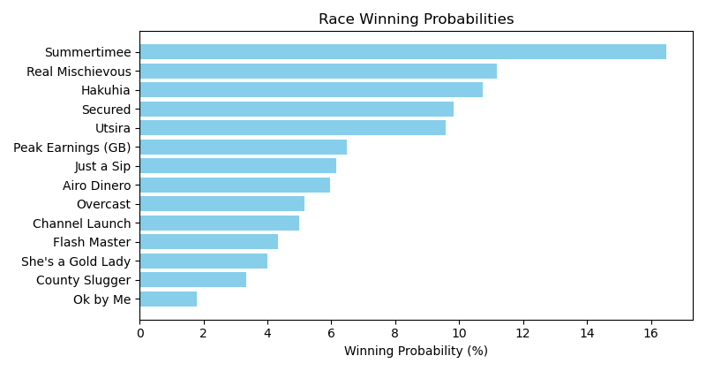

Exacta advice: key 14 → 13 (1 ticket)

Bandit Recommendation: Pick 4_top1_box (Expected Net: 0.00)

# Race: TOP | 2025-05-01 | Race #1 | Post: 18:30 | Track: OAKLAWN PARK

Track: OAKLAWN PARK

|  |  |  |  |  |  |
| --- | --- | --- | --- | --- | --- |
| Program # | Horse Name | Morn Odds | Rank | Model Score | Win Prob (%) |
| 1 | Real Blues | 5-2 | 1.0 | 3.10 | 22.62 |
| 2 | E Money | 20-1 | 7.0 | 0.93 | 5.09 |
| 3 | Work Boots | 30-1 | 9.0 | 0.48 | 3.73 |
| 4 | Megastar | 15-1 | 5.0 | 1.56 | 7.85 |
| 5 | Believe in Dreams | 15-1 | 6.0 | 1.38 | 6.93 |
| 6 | Arjun for Karz | 30-1 | 10.0 | 0.28 | 3.24 |
| 7 | Joewilly | 3-1 | 2.0 | 2.96 | 20.58 |
| 8 | Double Burn | 12-1 | 8.0 | 0.60 | 4.05 |
| 9 | Asleep At Eight | 6-1 | 4.0 | 1.94 | 10.17 |
| 10 | Fairfield Bay | 2-1 | 3.0 | 2.57 | 15.74 |

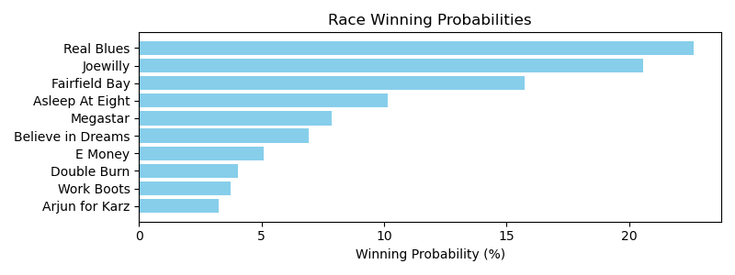

Exacta advice: key 1 → 7 (1 ticket)

Bandit Recommendation: Daily Double_top1_box (Expected Net: 0.00)

# Race: TOP | 2025-05-01 | Race #2 | Post: 19:01 | Track: OAKLAWN PARK

Track: OAKLAWN PARK

|  |  |  |  |  |  |
| --- | --- | --- | --- | --- | --- |
| Program # | Horse Name | Morn Odds | Rank | Model Score | Win Prob (%) |
| 1 | Plinko Chip | 9-2 | 4.0 | -0.06 | 6.12 |
| 2 | Street Painter | 15-1 | 9.0 | -0.58 | 4.30 |
| 3 | Principal Anita | 5-1 | 5.0 | -0.07 | 6.09 |
| 4 | Morally Complex | 15-1 | 10.0 | -1.04 | 3.13 |
| 5 | Sunnyandseventy | 20-1 | 11.0 | -1.32 | 2.58 |
| 6 | Cosmic Chic | 8-1 | 8.0 | -0.52 | 4.46 |
| 7 | Blue Ember | 20-1 | 7.0 | -0.52 | 4.48 |
| 8 | Moenchanted | 8-1 | 3.0 | 1.31 | 15.78 |
| 9 | Appealing Addie | 2-1 | 1.0 | 2.18 | 28.64 |
| 10 | Cashmere Baby | 15-1 | 6.0 | -0.30 | 5.19 |
| 11 | L. A. Diamond | 6-1 | 2.0 | 1.60 | 19.22 |

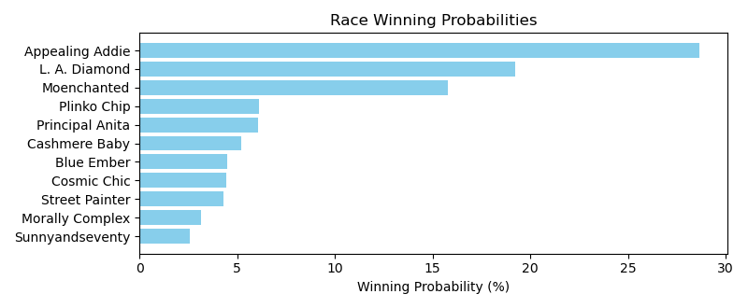

Exacta advice: key 9 → 11 (1 ticket)

Bandit Recommendation: Pick 3_top1_box (Expected Net: 0.00)

# Race: TOP | 2025-05-01 | Race #3 | Post: 19:32 | Track: OAKLAWN PARK

Track: OAKLAWN PARK

|  |  |  |  |  |  |
| --- | --- | --- | --- | --- | --- |
| Program # | Horse Name | Morn Odds | Rank | Model Score | Win Prob (%) |
| 1 | Super Enticing | 4-1 | 1.0 | 1.61 | 14.85 |
| 1A | Divine Gal | 4-1 | 2.0 | 1.58 | 14.57 |
| 2 | Lady Mercedes | 15-1 | 9.0 | 0.20 | 5.63 |
| 3 | Grace Given | 8-1 | 6.0 | 0.87 | 8.92 |
| 4 | Sensible Choice | 5-2 | 5.0 | 1.17 | 11.02 |
| 5 | Boltoro | 20-1 | 8.0 | 0.44 | 6.64 |
| 6 | Templar Red | 15-1 | 4.0 | 1.26 | 11.67 |
| 7 | Makemebelieve | 5-1 | 7.0 | 0.79 | 8.49 |
| 8 | Fearless Kristie | 20-1 | 10.0 | -0.03 | 4.81 |
| 9 | Midway Vow | 8-1 | 3.0 | 1.46 | 13.39 |

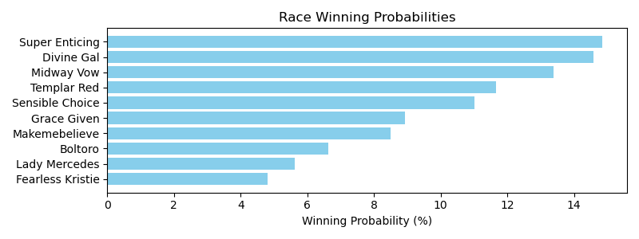

Exacta advice: box [1,1A,9] (6 tickets)

Bandit Recommendation: Daily Double_top1_box (Expected Net: 0.00)

# Race: TOP | 2025-05-01 | Race #4 | Post: 20:04 | Track: OAKLAWN PARK

Track: OAKLAWN PARK

|  |  |  |  |  |  |
| --- | --- | --- | --- | --- | --- |
| Program # | Horse Name | Morn Odds | Rank | Model Score | Win Prob (%) |
| 1 | Rogue Justice | 3-1 | 4.0 | 1.64 | 10.47 |
| 2 | Miracle Minded | 30-1 | 10.0 | -0.08 | 3.19 |
| 3 | Acousticat | 12-1 | 3.0 | 1.72 | 11.05 |
| 4 | Fab Girl | 20-1 | 7.0 | 1.24 | 7.94 |
| 5 | Ride the Broom | 5-1 | 5.0 | 1.52 | 9.65 |
| 6 | Melly's Birkin | 20-1 | 8.0 | 0.58 | 5.04 |
| 7 | Super Costly | 12-1 | 6.0 | 1.28 | 8.14 |
| 8 | Funding Source | 4-1 | 2.0 | 2.02 | 13.54 |
| 9 | Heir Tua Throne | 10-1 | 9.0 | 0.56 | 4.96 |
| 10 | Ez Tree Ates | 2-1 | 1.0 | 2.96 | 26.02 |

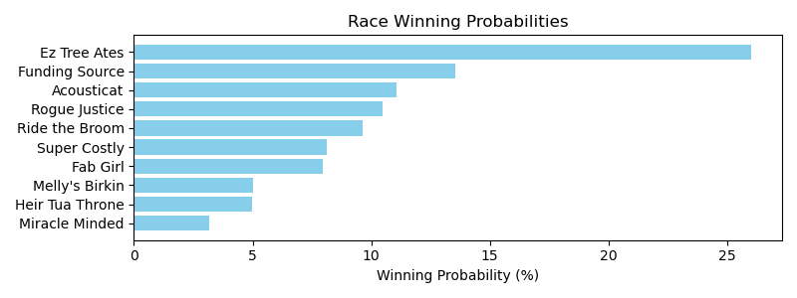

Exacta advice: key 10 → 8 (1 ticket)

Bandit Recommendation: Pick 4_top1_box (Expected Net: 0.00)

# Race: TOP | 2025-05-01 | Race #5 | Post: 20:39 | Track: OAKLAWN PARK

Track: OAKLAWN PARK

|  |  |  |  |  |  |
| --- | --- | --- | --- | --- | --- |
| Program # | Horse Name | Morn Odds | Rank | Model Score | Win Prob (%) |
| 1 | De Angelo | 15-1 | 8.0 | 0.89 | 6.71 |
| 2 | Magical Mark | 15-1 | 4.0 | 1.33 | 9.14 |
| 3 | Cat On Time | 2-1 | 2.0 | 1.75 | 12.18 |
| 4 | Sinner's Sin | 12-1 | 12.0 | 0.22 | 4.25 |
| 5 | Mish | 5-2 | 1.0 | 2.02 | 14.66 |
| 6 | Al's Romeo | 12-1 | 5.0 | 1.06 | 7.58 |
| 7 | Mischievous M | 8-1 | 9.0 | 0.73 | 6.03 |
| 8 | Toddchero | 15-1 | 6.0 | 1.04 | 7.47 |
| 9 | Market Street | 30-1 | 13.0 | 0.17 | 4.10 |
| 10 | Jackman | 15-1 | 3.0 | 1.38 | 9.43 |
| 11 | Favorite Outlaw | 15-1 | 11.0 | 0.59 | 5.48 |
| 12 | Breslau | 6-1 | 7.0 | 1.04 | 7.47 |
| 13 | Midnight Pranks | 20-1 | 10.0 | 0.60 | 5.50 |

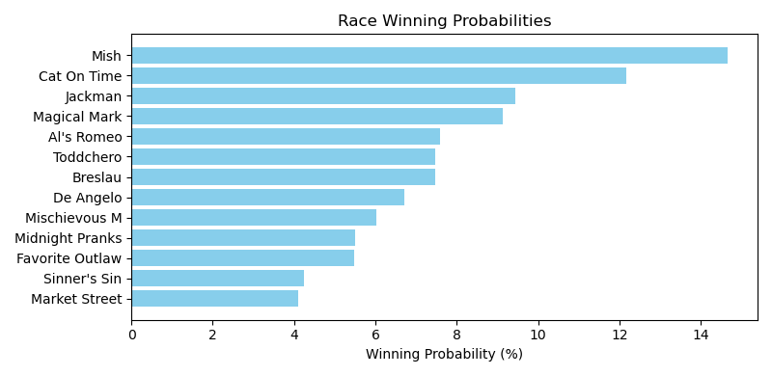

Exacta advice: key 5 → 3 (1 ticket)

Bandit Recommendation: Pick 3_top1_box (Expected Net: 0.00)

# Race: TOP | 2025-05-01 | Race #6 | Post: 21:11 | Track: OAKLAWN PARK

Track: OAKLAWN PARK

|  |  |  |  |  |  |
| --- | --- | --- | --- | --- | --- |
| Program # | Horse Name | Morn Odds | Rank | Model Score | Win Prob (%) |
| 1 | Stellar Vino | 10-1 | 10.0 | 0.27 | 3.54 |
| 2 | Caper's Hooley | 3-1 | 2.0 | 2.18 | 13.16 |
| 3 | Speechless | 10-1 | 4.0 | 1.86 | 10.54 |
| 4 | Gold Sweep | 5-2 | 3.0 | 1.94 | 11.15 |
| 5 | Copper Storm | 5-1 | 8.0 | 1.24 | 6.88 |
| 6 | Airborne Elite | 6-1 | 6.0 | 1.35 | 7.44 |
| 7 | Catalina Crush | 15-1 | 5.0 | 1.80 | 10.15 |
| 8 | G. Erik | 30-1 | 7.0 | 1.24 | 6.91 |
| 9 | Big Producer | 20-1 | 12.0 | -0.21 | 2.53 |
| 10 | Devilish Desire | 15-1 | 9.0 | 0.68 | 4.70 |
| 11 | Nacho Bar | 30-1 | 13.0 | -1.40 | 1.12 |
| 12 | Maverama | 20-1 | 11.0 | -0.06 | 2.81 |
| 13 | Handsome Herb | 6-1 | 1.0 | 2.72 | 19.08 |

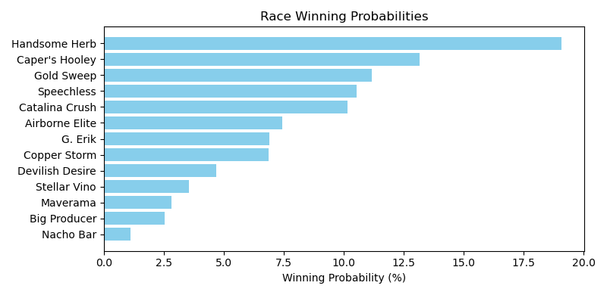

Exacta advice: key 13 → 2 (1 ticket)

Bandit Recommendation: Pick 3_top1_box (Expected Net: 0.00)

# Race: TOP | 2025-05-01 | Race #7 | Post: 21:44 | Track: OAKLAWN PARK

Track: OAKLAWN PARK

|  |  |  |  |  |  |
| --- | --- | --- | --- | --- | --- |
| Program # | Horse Name | Morn Odds | Rank | Model Score | Win Prob (%) |
| 1 | I'm Wide Awake | 6-1 | 6.0 | 1.05 | 8.39 |
| 2 | Bourbon Heist | 12-1 | 5.0 | 1.14 | 8.93 |
| 3 | Morello | 30-1 | 11.0 | 0.36 | 5.23 |
| 4 | Hap Hot | 7-2 | 2.0 | 1.28 | 9.79 |
| 5 | Touchdown Arkansas | 8-1 | 7.0 | 0.96 | 7.89 |
| 6 | Ceepeegee | 20-1 | 10.0 | 0.67 | 6.43 |
| 7 | Whatchatalkinabout | 7-5 | 1.0 | 2.01 | 16.30 |
| 8 | Go West Go | 20-1 | 12.0 | 0.20 | 4.68 |
| 9 | Eli's Promise | 20-1 | 8.0 | 0.83 | 7.23 |
| 10 | Sitka | 10-1 | 3.0 | 1.27 | 9.75 |
| 11 | Miracle Worker | 8-1 | 4.0 | 1.14 | 8.95 |
| 12 | Trust Daddy | 15-1 | 9.0 | 0.67 | 6.43 |

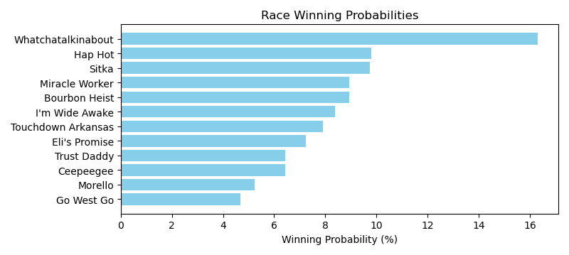

Exacta advice: key 7 → [4,10] (2 tickets)

Bandit Recommendation: Pick 4_top1_box (Expected Net: 0.00)

# Race: TOP | 2025-05-01 | Race #8 | Post: 22:20 | Track: OAKLAWN PARK

Track: OAKLAWN PARK

|  |  |  |  |  |  |
| --- | --- | --- | --- | --- | --- |
| Program # | Horse Name | Morn Odds | Rank | Model Score | Win Prob (%) |
| 1 | Absinthe | 9-2 | 8.0 | 0.69 | 6.62 |
| 2 | Gloriette | 15-1 | 10.0 | 0.46 | 5.64 |
| 3 | Pharoah's Heart | 15-1 | 5.0 | 1.23 | 9.58 |
| 4 | Itzel | 6-1 | 4.0 | 1.34 | 10.37 |
| 5 | Pistol | 12-1 | 9.0 | 0.62 | 6.28 |
| 6 | Titled Lady | 4-1 | 2.0 | 1.76 | 13.82 |
| 7 | Gray Lightning | 3-1 | 1.0 | 1.84 | 14.63 |
| 8 | Dashingly | 20-1 | 11.0 | 0.28 | 4.98 |
| 9 | Mischievous Gal | 8-1 | 6.0 | 0.97 | 8.02 |
| 10 | Effortlesslyelgant | 10-1 | 7.0 | 0.76 | 6.93 |
| 11 | Popperina | 10-1 | 3.0 | 1.69 | 13.13 |

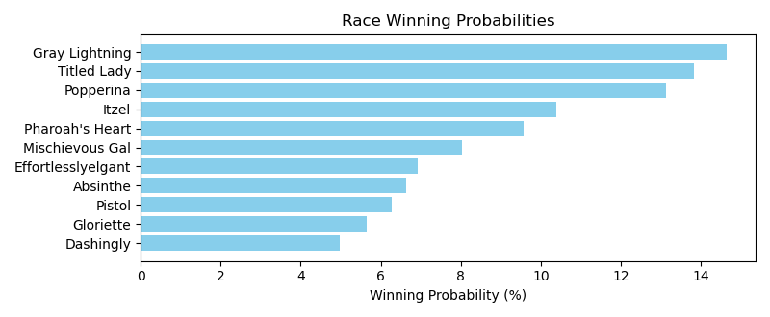

Exacta advice: box [7,6,11] (6 tickets)

Bandit Recommendation: Pick 3_top1_box (Expected Net: 0.00)

# Race: TOP | 2025-05-01 | Race #9 | Post: 22:54 | Track: OAKLAWN PARK

Track: OAKLAWN PARK

|  |  |  |  |  |  |
| --- | --- | --- | --- | --- | --- |
| Program # | Horse Name | Morn Odds | Rank | Model Score | Win Prob (%) |
| 1 | Stealthespotlight | 12-1 | 9.0 | -0.04 | 4.33 |
| 2 | Texas Hottie | 20-1 | 14.0 | -1.18 | 1.98 |
| 3 | Texas Sequoia | 15-1 | 10.0 | -0.28 | 3.68 |
| 4 | Sassy Lass | 3-1 | 5.0 | 0.80 | 7.74 |
| 5 | New Woman | 30-1 | 13.0 | -0.75 | 2.66 |
| 6 | Sparkly | 12-1 | 11.0 | -0.62 | 2.92 |
| 7 | Devious Diva | 12-1 | 7.0 | 0.12 | 4.86 |
| 8 | Adamantly | 30-1 | 12.0 | -0.64 | 2.86 |
| 9 | So Thrilling | 8-1 | 1.0 | 2.41 | 23.45 |
| 10 | Commander Dixie | 6-1 | 2.0 | 1.69 | 14.28 |
| 11 | Evocation | 5-2 | 6.0 | 0.78 | 7.65 |
| 12 | Fly Like the Wind | 10-1 | 8.0 | 0.11 | 4.81 |
| 13 | Chica Arma | 7-2 | 3.0 | 1.15 | 9.84 |
| 14 | Wampus Kitten | 3-1 | 4.0 | 1.01 | 8.93 |

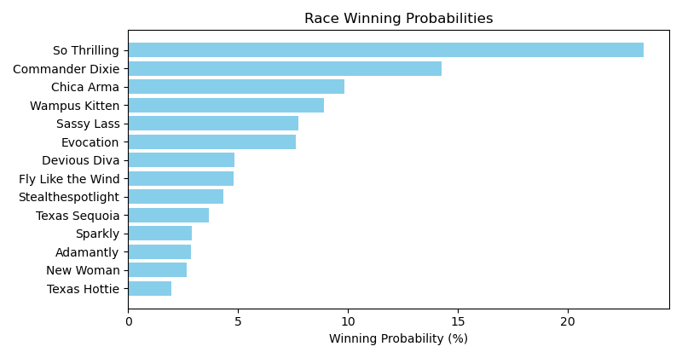

Exacta advice: key 9 → 10 (1 ticket)

Bandit Recommendation: Pick 3_top1_box (Expected Net: 123.80)

# Race: TOP | 2025-05-02 | Race #1 | Post: 18:00 | Track: OAKLAWN PARK

Track: OAKLAWN PARK

|  |  |  |  |  |  |
| --- | --- | --- | --- | --- | --- |
| Program # | Horse Name | Morn Odds | Rank | Model Score | Win Prob (%) |
| 1 | Money Game | 6-5 | 1.0 | 2.76 | 30.02 |
| 2 | Landing Craft | 2-1 | 3.0 | 1.96 | 17.29 |
| 3 | Rock Solo | 5-1 | 5.0 | 1.21 | 10.27 |
| 4 | Curvino | 9-2 | 4.0 | 1.81 | 15.53 |
| 5 | Iron Sharpens Iron | 15-1 | 2.0 | 2.01 | 17.91 |
| 6 | Able Seaman | 20-1 | 6.0 | 1.01 | 8.98 |

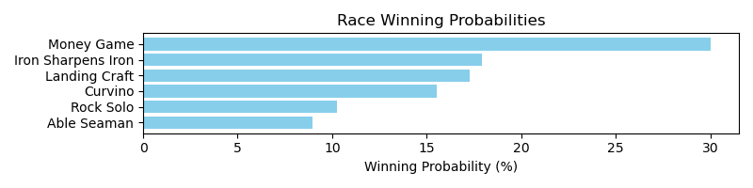

Exacta advice: key 1 → 5 (1 ticket)

Bandit Recommendation: Daily Double_top1_box (Expected Net: 0.00)

# Race: TOP | 2025-05-02 | Race #2 | Post: 18:31 | Track: OAKLAWN PARK

Track: OAKLAWN PARK

|  |  |  |  |  |  |
| --- | --- | --- | --- | --- | --- |
| Program # | Horse Name | Morn Odds | Rank | Model Score | Win Prob (%) |
| 1 | Lady of Silence | 9-5 | 3.0 | 2.44 | 18.25 |
| 2 | Kentucky Starlet | 20-1 | 6.0 | 1.46 | 9.26 |
| 3 | La Fantastica | 9-2 | 2.0 | 2.47 | 18.56 |
| 4 | Nana Grace | 6-1 | 5.0 | 2.07 | 14.08 |
| 5 | Suitefourfourthree | 2-1 | 4.0 | 2.13 | 14.69 |
| 6 | Don't Look Back | 5-1 | 1.0 | 2.52 | 19.18 |
| 7 | Miss World Peace | 20-1 | 7.0 | 0.82 | 5.98 |

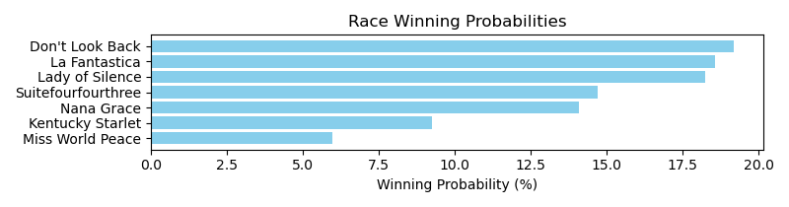

Exacta advice: box [6,3,1] (6 tickets)

Bandit Recommendation: Pick 3_top1_box (Expected Net: 0.80)

# Race: TOP | 2025-05-02 | Race #3 | Post: 19:03 | Track: OAKLAWN PARK

Track: OAKLAWN PARK

|  |  |  |  |  |  |
| --- | --- | --- | --- | --- | --- |
| Program # | Horse Name | Morn Odds | Rank | Model Score | Win Prob (%) |
| 1 | Trafalgar Shore | 3-1 | 4.0 | 1.29 | 14.69 |
| 1A | Backed by Gold | 3-1 | 3.0 | 1.34 | 15.14 |
| 2 | My Maybelenne | 15-1 | 10.0 | -0.89 | 3.26 |
| 3 | Lady Astrid | 10-1 | 7.0 | -0.19 | 5.28 |
| 4 | Bertie's Cause | 2-1 | 2.0 | 1.36 | 15.36 |
| 5 | She's Storming | 20-1 | 9.0 | -0.37 | 4.68 |
| 6 | Shout It Out | 20-1 | 6.0 | -0.07 | 5.74 |
| 7 | Cankton's Cowgirl | 20-1 | 8.0 | -0.25 | 5.08 |
| 8 | Pattern Bet | 12-1 | 5.0 | 0.53 | 8.68 |
| 9 | Edistrudis | 9-5 | 1.0 | 1.89 | 22.09 |

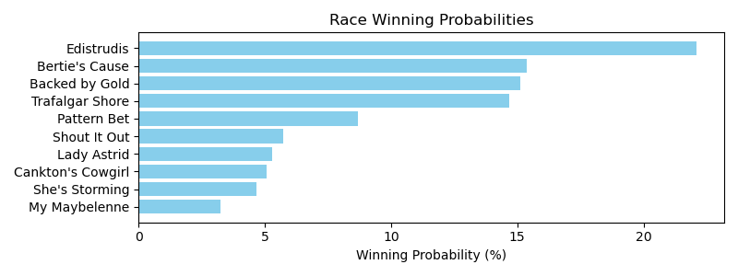

Exacta advice: key 9 → [4,1A] (2 tickets)

Bandit Recommendation: Pick 4_top1_box (Expected Net: 0.00)

# Race: TOP | 2025-05-02 | Race #4 | Post: 19:35 | Track: OAKLAWN PARK

Track: OAKLAWN PARK

|  |  |  |  |  |  |
| --- | --- | --- | --- | --- | --- |
| Program # | Horse Name | Morn Odds | Rank | Model Score | Win Prob (%) |
| 1 | Icy River | 7-2 | 4.0 | 1.49 | 14.29 |
| 2 | Collected Glory | 8-1 | 5.0 | 1.20 | 11.74 |
| 3 | Adiva | 10-1 | 7.0 | 0.04 | 5.25 |
| 4 | Open Soul Autism | 4-1 | 1.0 | 2.35 | 25.78 |
| 5 | Tell Me When | 3-1 | 2.0 | 1.80 | 17.66 |
| 6 | Rock Star Parking | 5-2 | 3.0 | 1.63 | 15.76 |
| 7 | Singing Emma | 10-1 | 6.0 | 0.90 | 9.51 |

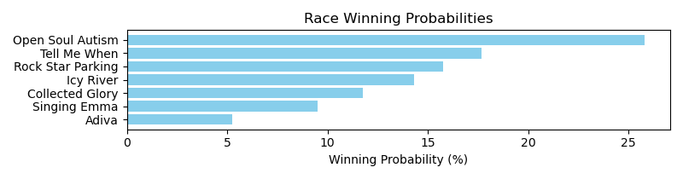

Exacta advice: key 4 → 5 (1 ticket)

Bandit Recommendation: Daily Double_top1_box (Expected Net: 27.80)

# Race: TOP | 2025-05-02 | Race #5 | Post: 20:07 | Track: OAKLAWN PARK

Track: OAKLAWN PARK

|  |  |  |  |  |  |
| --- | --- | --- | --- | --- | --- |
| Program # | Horse Name | Morn Odds | Rank | Model Score | Win Prob (%) |
| 1 | Ryno Wrecker | 30-1 | 11.0 | -1.17 | 2.12 |
| 2 | Wind of Change (BRZ) | 8-1 | 6.0 | 0.53 | 6.82 |
| 3 | Worth Looking | 20-1 | 4.0 | 0.75 | 7.97 |
| 4 | Run the Table | 20-1 | 10.0 | -0.73 | 2.87 |
| 5 | Dr. Soulfire | 5-2 | 1.0 | 2.43 | 25.32 |
| 6 | Husker Butch | 12-1 | 8.0 | 0.33 | 5.95 |
| 7 | Western Command | 12-1 | 5.0 | 0.68 | 7.59 |
| 8 | Pass Line | 7-2 | 2.0 | 1.83 | 16.74 |
| 9 | King Peanut | 12-1 | 7.0 | 0.43 | 6.36 |
| 10 | Baseball Politics | 2-1 | 3.0 | 1.41 | 12.49 |
| 11 | Hello Hot Rod | 20-1 | 9.0 | 0.29 | 5.77 |

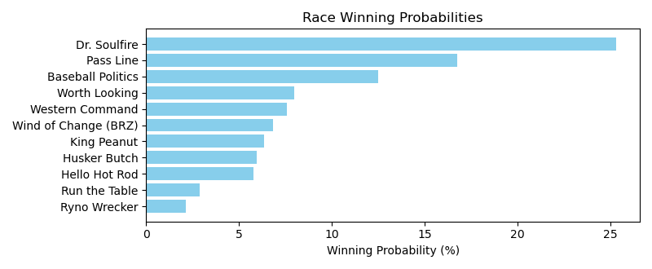

Exacta advice: key 5 → 8 (1 ticket)

Bandit Recommendation: no_bet (Expected Net: 0.48)

# Race: TOP | 2025-05-02 | Race #6 | Post: 20:42 | Track: OAKLAWN PARK

Track: OAKLAWN PARK

|  |  |  |  |  |  |
| --- | --- | --- | --- | --- | --- |
| Program # | Horse Name | Morn Odds | Rank | Model Score | Win Prob (%) |
| 1 | Pahoehoe d'Oro | 9-5 | 2.0 | 2.18 | 16.01 |
| 2 | Spring Dancer | 2-1 | 1.0 | 3.10 | 30.06 |
| 3 | Electrifying Lady | 4-1 | 3.0 | 2.01 | 14.22 |
| 4 | LIGHTNING LIZ | 20-1 | 8.0 | -0.06 | 3.41 |
| 5 | Cocktail Humor | 8-1 | 4.0 | 1.93 | 13.47 |
| 6 | Flat Stormin | 20-1 | 5.0 | 1.61 | 10.80 |
| 7 | SMOOTH MARRIAGE | 20-1 | 9.0 | -0.24 | 3.02 |
| 8 | Summer Travels | 12-1 | 7.0 | -0.01 | 3.52 |
| 9 | Braken Good | 12-1 | 6.0 | 0.63 | 5.48 |

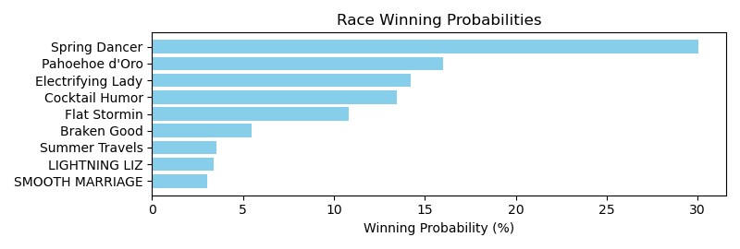

Exacta advice: key 2 → 1 (1 ticket)

Bandit Recommendation: Pick 4_top1_box (Expected Net: 0.00)

# Race: TOP | 2025-05-02 | Race #7 | Post: 21:16 | Track: OAKLAWN PARK

Track: OAKLAWN PARK

|  |  |  |  |  |  |
| --- | --- | --- | --- | --- | --- |
| Program # | Horse Name | Morn Odds | Rank | Model Score | Win Prob (%) |
| 1 | Axton | 9-2 | 1.0 | 1.72 | 17.04 |
| 2 | Dance Man | 12-1 | 7.0 | 0.41 | 6.93 |
| 3 | Hightail Cowboy | 30-1 | 9.0 | 0.14 | 5.73 |
| 4 | Go West | 6-1 | 3.0 | 1.07 | 10.90 |
| 5 | Quick Buck | 30-1 | 12.0 | -0.58 | 3.49 |
| 6 | I'm an Oak | 20-1 | 11.0 | -0.33 | 4.16 |
| 7 | Unpredictable Bay | 8-1 | 5.0 | 0.89 | 9.63 |
| 8 | Lend It Tewmey | 5-2 | 2.0 | 1.33 | 12.98 |
| 9 | Born Flawless | 20-1 | 8.0 | 0.35 | 6.63 |
| 10 | Dalton's Rutrow | 20-1 | 10.0 | -0.23 | 4.45 |
| 11 | Tim Tal | 15-1 | 6.0 | 0.47 | 7.21 |
| 12 | Elusive d'Oro | 3-1 | 4.0 | 1.07 | 10.86 |

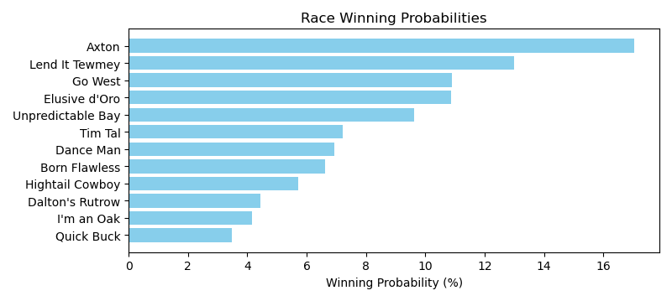

Exacta advice: key 1 → 8 (1 ticket)

Bandit Recommendation: no_bet (Expected Net: 0.00)

# Race: TOP | 2025-05-02 | Race #8 | Post: 21:50 | Track: OAKLAWN PARK

Track: OAKLAWN PARK

|  |  |  |  |  |  |
| --- | --- | --- | --- | --- | --- |
| Program # | Horse Name | Morn Odds | Rank | Model Score | Win Prob (%) |
| 1 | Midnight Pranks | 20-1 | 6.0 | 0.64 | 8.63 |
| 2 | Raymond | 8-1 | 5.0 | 1.03 | 11.26 |
| 3 | Happy American | 10-1 | 3.0 | 1.64 | 17.16 |
| 4 | Ryvit | 5-1 | 2.0 | 2.01 | 22.20 |
| 5 | Durante | 12-1 | 4.0 | 1.06 | 11.48 |
| 6 | Skelly | 2-5 | 1.0 | 2.42 | 29.28 |

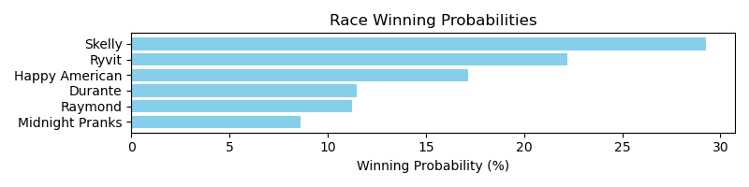

Exacta advice: key 6 → 4 (1 ticket)

Bandit Recommendation: Daily Double_top1_box (Expected Net: 0.00)

# Race: TOP | 2025-05-02 | Race #9 | Post: 22:24 | Track: OAKLAWN PARK

Track: OAKLAWN PARK

|  |  |  |  |  |  |
| --- | --- | --- | --- | --- | --- |
| Program # | Horse Name | Morn Odds | Rank | Model Score | Win Prob (%) |
| 1 | Rocket Night | 6-1 | 3.0 | 2.38 | 12.33 |
| 2 | The Hit King Rose | 30-1 | 13.0 | 0.31 | 2.95 |
| 3 | Audax Minor | 20-1 | 7.0 | 1.45 | 6.50 |
| 4 | Quarterly Report | 5-2 | 10.0 | 0.84 | 4.27 |
| 5 | Vino Vidi Vici | 10-1 | 4.0 | 1.79 | 8.23 |
| 6 | Endue | 30-1 | 14.0 | 0.19 | 2.73 |
| 7 | Grey Street | 20-1 | 5.0 | 1.52 | 6.81 |
| 8 | Irish Whiskey | 20-1 | 8.0 | 1.32 | 5.96 |
| 9 | Crabtree | 7-2 | 2.0 | 2.52 | 13.57 |
| 10 | Mandatory Mission | 30-1 | 6.0 | 1.48 | 6.61 |
| 11 | Vaden | 3-1 | 1.0 | 2.86 | 17.20 |
| 12 | Kye | 15-1 | 9.0 | 1.27 | 5.72 |
| 13 | Tarps Storm | 30-1 | 11.0 | 0.74 | 4.00 |
| 14 | Southfork | 30-1 | 12.0 | 0.38 | 3.12 |

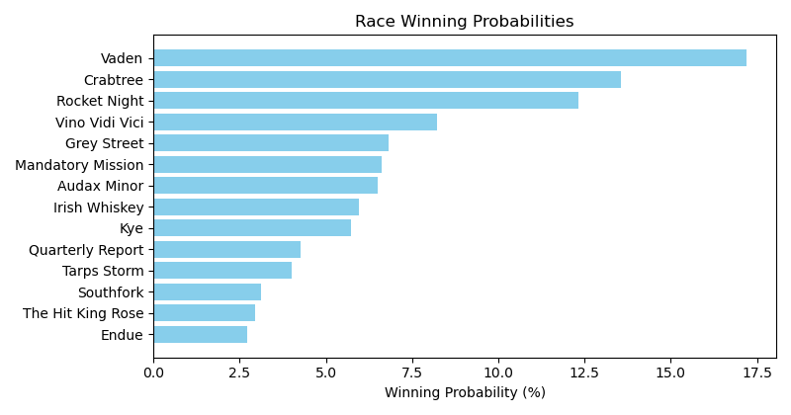

Exacta advice: key 11 → 9 (1 ticket)

Bandit Recommendation: Pick 4_top1_box (Expected Net: 0.00)

# Race: TOP | 2025-05-02 | Race #10 | Post: 22:59 | Track: OAKLAWN PARK

Track: OAKLAWN PARK

|  |  |  |  |  |  |
| --- | --- | --- | --- | --- | --- |
| Program # | Horse Name | Morn Odds | Rank | Model Score | Win Prob (%) |
| 1 | Little Blaze | 5-2 | 2.0 | 1.77 | 17.40 |
| 2 | Bourbon Breeze | 10-1 | 9.0 | 0.20 | 5.88 |
| 3 | Dealing Justice | 8-1 | 5.0 | 0.61 | 7.78 |
| 4 | First Hill | 30-1 | 7.0 | 0.36 | 6.59 |
| 5 | Bennykayandsuzytoo | 6-1 | 3.0 | 1.20 | 11.71 |
| 6 | Insightful Miss | 20-1 | 11.0 | -0.52 | 3.57 |
| 7 | Amy Z | 10-1 | 6.0 | 0.58 | 7.65 |
| 8 | Doubledaddy Issues | 30-1 | 8.0 | 0.33 | 6.45 |
| 9 | Itzel | 13-8 | 1.0 | 1.99 | 20.13 |
| 10 | Music Mistress | 20-1 | 4.0 | 0.75 | 8.61 |
| 11 | Spicy Delight | 20-1 | 10.0 | -0.28 | 4.22 |

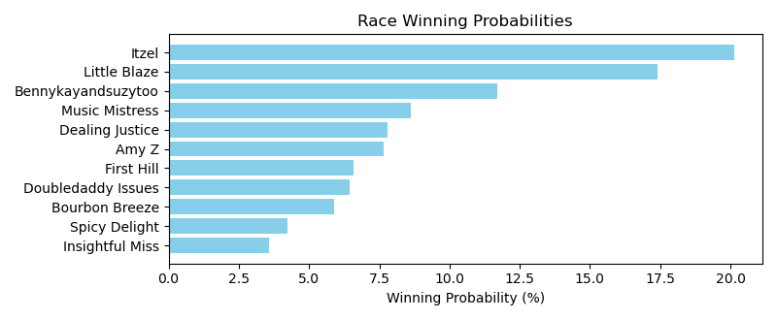

Exacta advice: key 9 → 1 (1 ticket)

Bandit Recommendation: no_bet (Expected Net: 0.00)

# Race: TOP | 2025-05-02 | Race #11 | Post: 23:40 | Track: OAKLAWN PARK

Track: OAKLAWN PARK

|  |  |  |  |  |  |
| --- | --- | --- | --- | --- | --- |
| Program # | Horse Name | Morn Odds | Rank | Model Score | Win Prob (%) |
| 1 | Putting Eagle | 15-1 | 1.0 | 2.42 | 21.38 |
| 2 | Kale's Angel | 13-8 | 2.0 | 2.20 | 18.37 |
| 3 | Wildncrazynight | 15-1 | 4.0 | 1.50 | 11.37 |
| 4 | Cool Cowboy | 9-2 | 7.0 | 0.31 | 4.99 |
| 5 | Raise the Bar | 20-1 | 9.0 | -0.89 | 2.19 |
| 6 | Amor Patriae | 8-1 | 8.0 | 0.31 | 4.98 |
| 7 | Baby Boat | 10-1 | 6.0 | 1.29 | 9.84 |
| 8 | Bye Bye Miles | 12-1 | 3.0 | 1.97 | 15.66 |
| 9 | Max Got Excited | 3-1 | 5.0 | 1.48 | 11.22 |

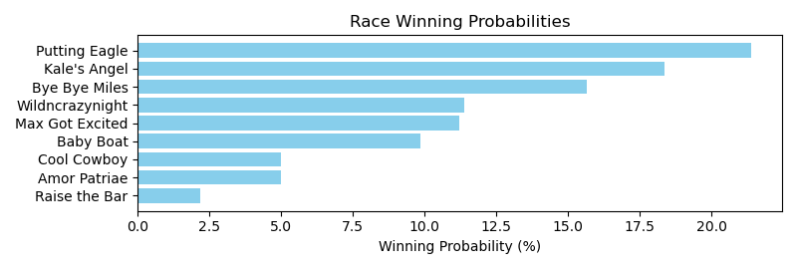

Exacta advice: key 1 → 2 (1 ticket)

Bandit Recommendation: Pick 4_top1_box (Expected Net: 0.00)

# Race: TOP | 2025-05-02 | Race #12 | Post: 00:15 | Track: OAKLAWN PARK

Track: OAKLAWN PARK

|  |  |  |  |  |  |
| --- | --- | --- | --- | --- | --- |
| Program # | Horse Name | Morn Odds | Rank | Model Score | Win Prob (%) |
| 1 | CALL ME BREEZE | 30-1 | 12.0 | -0.27 | 3.24 |
| 2 | Devlish Gal | 6-1 | 2.0 | 1.88 | 14.16 |
| 3 | Melania T | 12-1 | 6.0 | 1.18 | 8.75 |
| 4 | EXQUISITE CANDY | 30-1 | 13.0 | -0.42 | 2.91 |
| 5 | Zettie | 15-1 | 3.0 | 1.37 | 10.03 |
| 6 | Kiamichi | 8-1 | 8.0 | 0.37 | 5.03 |
| 7 | Kava | 12-1 | 4.0 | 1.27 | 9.35 |
| 8 | Mo Hopeful | 30-1 | 5.0 | 1.23 | 9.07 |
| 9 | Intriguing Suspect | 30-1 | 10.0 | -0.10 | 3.64 |
| 10 | MONETA | 10-1 | 7.0 | 0.52 | 5.55 |
| 11 | Ministry's Destiny | 4-5 | 1.0 | 2.25 | 18.29 |
| 12 | KIM'S PULL | 20-1 | 11.0 | -0.24 | 3.30 |
| 13 | Hamazing Treasure | 30-1 | 14.0 | -0.85 | 2.17 |
| 14 | This Damsel Mayfly | 30-1 | 9.0 | 0.22 | 4.52 |

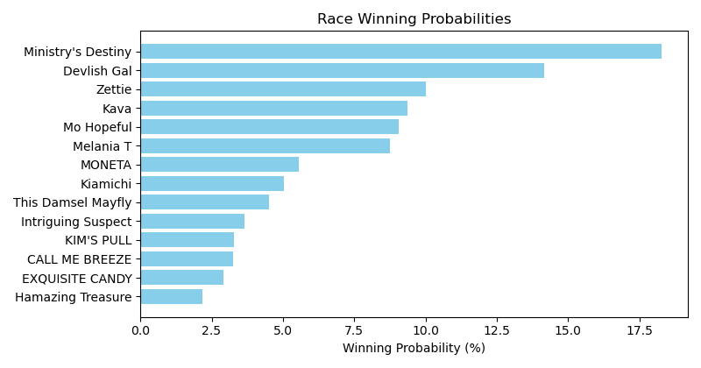

Exacta advice: key 11 → 2 (1 ticket)

Bandit Recommendation: Daily Double_top1_box (Expected Net: 0.56)

# Race: PEN | 2025-05-01 | Race #1 | Post: 23:45 | Track: PENN NATIONAL

Track: PENN NATIONAL

|  |  |  |  |  |  |
| --- | --- | --- | --- | --- | --- |
| Program # | Horse Name | Morn Odds | Rank | Model Score | Win Prob (%) |
| 1 | Dynamite Karma | 8-1 | 7.0 | 0.38 | 7.79 |
| 2 | First Glimpse | 7-2 | 1.0 | 1.70 | 19.46 |
| 3 | Debate | 12-1 | 5.0 | 0.92 | 11.36 |
| 4 | Memory Bouquet | 9-2 | 4.0 | 1.37 | 15.46 |
| 5 | Styner | 3-1 | 3.0 | 1.46 | 16.50 |
| 6 | Curlington | 5-2 | 2.0 | 1.64 | 18.60 |
| 7 | Tallahatchiebridge | 6-1 | 6.0 | 0.85 | 10.83 |

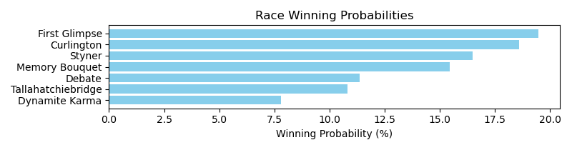

Exacta advice: box [2,6,5] (6 tickets)

Bandit Recommendation: Daily Double_top1_box (Expected Net: 0.00)

# Race: PEN | 2025-05-01 | Race #2 | Post: 00:14 | Track: PENN NATIONAL

Track: PENN NATIONAL

|  |  |  |  |  |  |
| --- | --- | --- | --- | --- | --- |
| Program # | Horse Name | Morn Odds | Rank | Model Score | Win Prob (%) |
| 1 | Pretty Lily | 6-1 | 7.0 | -1.18 | 4.69 |
| 2 | Ladro Di Fichi | 5-1 | 3.0 | 0.89 | 19.46 |
| 3 | Early Frost | 50-1 | 6.0 | -0.95 | 5.50 |
| 4 | Bella Prima | 7-2 | 4.0 | 0.53 | 15.27 |
| 5 | Stormy Spell | 5-1 | 5.0 | -0.23 | 9.05 |
| 6 | Kaz Music | 4-1 | 1.0 | 1.14 | 23.18 |
| 7 | Tilted Tiara | 2-1 | 2.0 | 1.12 | 22.85 |

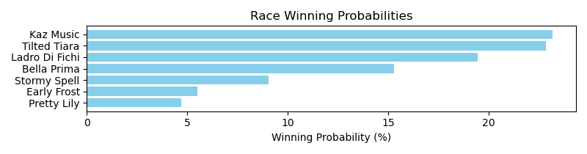

Exacta advice: box [6,7,2] (6 tickets)

Bandit Recommendation: trifecta_top3_box (Expected Net: -2.00)

# Race: PEN | 2025-05-01 | Race #3 | Post: 00:43 | Track: PENN NATIONAL

Track: PENN NATIONAL

|  |  |  |  |  |  |
| --- | --- | --- | --- | --- | --- |
| Program # | Horse Name | Morn Odds | Rank | Model Score | Win Prob (%) |
| 1 | Head of the Class | 6-1 | 4.0 | 1.91 | 11.17 |
| 2 | Built by Khozan | 5-1 | 3.0 | 2.46 | 16.38 |
| 3 | Siete Siete Siete | 30-1 | 8.0 | 0.43 | 4.05 |
| 4 | MUNTAGE | 8-1 | 10.0 | 0.26 | 3.60 |
| 5 | Minister | 8-1 | 5.0 | 1.70 | 9.68 |
| 6 | SAFFIE JUNIOR | 15-1 | 11.0 | 0.06 | 3.13 |
| 7 | Jace Is No Joke | 10-1 | 6.0 | 1.23 | 7.03 |
| 8 | Manseeyasway | 30-1 | 7.0 | 1.19 | 6.84 |
| 9 | Pump It Up | 4-1 | 2.0 | 2.50 | 16.77 |
| 10 | THICK AND JUICY | 10-1 | 9.0 | 0.30 | 3.69 |
| 11 | Pilote Comete | 3-1 | 1.0 | 2.57 | 17.66 |

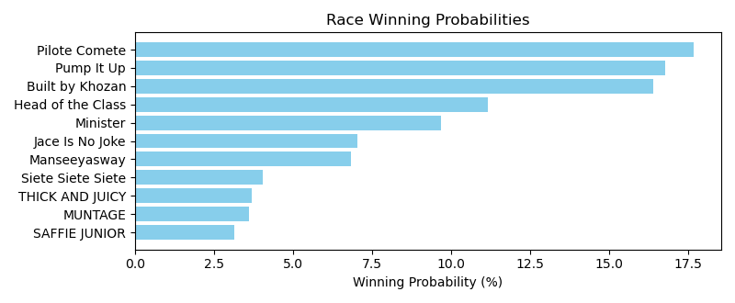

Exacta advice: box [11,9,2] (6 tickets)

Bandit Recommendation: Daily Double_top1_box (Expected Net: 0.56)

# Race: PEN | 2025-05-01 | Race #4 | Post: 01:12 | Track: PENN NATIONAL

Track: PENN NATIONAL

|  |  |  |  |  |  |
| --- | --- | --- | --- | --- | --- |
| Program # | Horse Name | Morn Odds | Rank | Model Score | Win Prob (%) |
| 1 | Desi's Reward | 2-1 | 1.0 | 1.14 | 29.85 |
| 2 | A Bit Bad N Boujee | 10-1 | 6.0 | -0.76 | 8.07 |
| 3 | My Jo Jo | 6-1 | 4.0 | -0.04 | 13.21 |
| 4 | Louella Street | 5-2 | 2.0 | 0.61 | 20.73 |
| 5 | Mikey's Jewel | 5-2 | 3.0 | 0.18 | 15.45 |
| 6 | Scott Alaia | 8-1 | 5.0 | -0.10 | 12.69 |

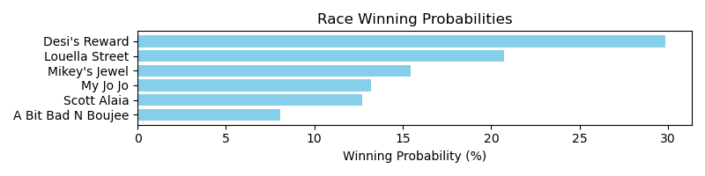

Exacta advice: key 1 → 4 (1 ticket)

Bandit Recommendation: Pick 4_top1_box (Expected Net: 0.00)

# Race: PEN | 2025-05-01 | Race #5 | Post: 01:41 | Track: PENN NATIONAL

Track: PENN NATIONAL

|  |  |  |  |  |  |
| --- | --- | --- | --- | --- | --- |
| Program # | Horse Name | Morn Odds | Rank | Model Score | Win Prob (%) |
| 1 | Cardinal War Cry | 4-1 | 4.0 | 0.03 | 9.18 |
| 2 | Cruzin Anna | 15-1 | 10.0 | -1.64 | 2.92 |
| 3 | Dakota Springs | 6-1 | 7.0 | -0.29 | 7.37 |
| 4 | Warrior's Defense | 9-2 | 2.0 | 0.75 | 15.12 |
| 5 | Dancing Chime | 12-1 | 8.0 | -0.86 | 5.01 |
| 6 | Fleeting Ember | 5-1 | 3.0 | 0.08 | 9.57 |
| 7 | Quivira Crane | 15-1 | 5.0 | 0.02 | 9.18 |
| 8 | Cloud in the Wind | 7-2 | 1.0 | 1.75 | 30.15 |
| 9 | Dancing Diana | 8-1 | 6.0 | -0.16 | 8.09 |
| 10 | Kashmir Witch | 12-1 | 9.0 | -1.41 | 3.41 |

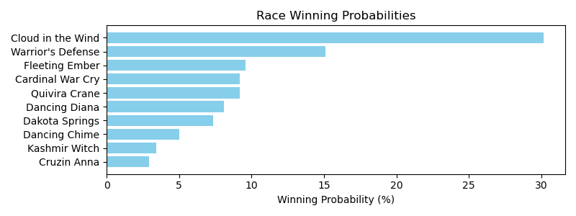

Exacta advice: key 8 → 4 (1 ticket)

Bandit Recommendation: Pick 3_top1_box (Expected Net: 0.00)

# Race: PEN | 2025-05-01 | Race #6 | Post: 02:10 | Track: PENN NATIONAL

Track: PENN NATIONAL

|  |  |  |  |  |  |
| --- | --- | --- | --- | --- | --- |
| Program # | Horse Name | Morn Odds | Rank | Model Score | Win Prob (%) |
| 1 | Episteme | 10-1 | 6.0 | 0.04 | 8.65 |
| 2 | Red Betty | 2-1 | 3.0 | 1.09 | 17.81 |
| 3 | Daisy's Angel | 7-2 | 1.0 | 1.25 | 19.88 |
| 4 | Cashpoint | 5-1 | 4.0 | 1.03 | 17.09 |
| 5 | R Serenity | 20-1 | 7.0 | -0.34 | 6.65 |
| 6 | One Eyed Jackie | 5-2 | 2.0 | 1.18 | 18.93 |
| 7 | Analog | 8-1 | 5.0 | 0.39 | 10.99 |

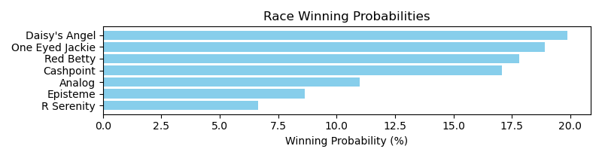

Exacta advice: box [3,6,2] (6 tickets)

Bandit Recommendation: Pick 3_top1_box (Expected Net: 0.00)

# Race: PEN | 2025-05-01 | Race #7 | Post: 02:39 | Track: PENN NATIONAL

Track: PENN NATIONAL

|  |  |  |  |  |  |
| --- | --- | --- | --- | --- | --- |
| Program # | Horse Name | Morn Odds | Rank | Model Score | Win Prob (%) |
| 1 | Phancy Philly | 5-1 | 3.0 | 0.13 | 11.44 |
| 2 | Bahama Pearl | 7-2 | 5.0 | -0.03 | 10.25 |
| 3 | Road to Dreams | 10-1 | 9.0 | -0.87 | 5.75 |
| 4 | Prussian Blue | 6-1 | 4.0 | 0.07 | 10.97 |
| 5 | Bowtothequeen | 6-1 | 1.0 | 0.24 | 12.42 |
| 6 | Amirati | 30-1 | 10.0 | -1.04 | 5.14 |
| 7 | Shinelikeadiamond | 4-1 | 2.0 | 0.21 | 12.09 |
| 8 | Kelly's Party Girl | 12-1 | 6.0 | -0.09 | 9.89 |
| 9 | La Lima | 20-1 | 11.0 | -1.07 | 5.02 |
| 10 | Bonita Lassie | 10-1 | 7.0 | -0.09 | 9.83 |
| 11 | Luckbealadytonight | 12-1 | 8.0 | -0.55 | 7.19 |

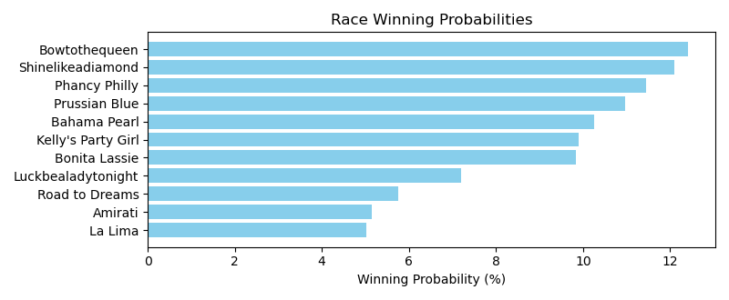

Exacta advice: box [5,7,1] (6 tickets)

Bandit Recommendation: Daily Double_top1_box (Expected Net: 0.00)

# Race: PEN | 2025-05-02 | Race #1 | Post: 23:45 | Track: PENN NATIONAL

Track: PENN NATIONAL

|  |  |  |  |  |  |
| --- | --- | --- | --- | --- | --- |
| Program # | Horse Name | Morn Odds | Rank | Model Score | Win Prob (%) |
| 1 | Combat Hoofs | 2-1 | 3.0 | 0.79 | 19.06 |
| 2 | Charm Alarm | 5-1 | 2.0 | 0.90 | 20.63 |
| 3 | Xerces | 7-2 | 4.0 | 0.16 | 12.35 |
| 4 | Emily's On Fire | 13-8 | 1.0 | 1.51 | 31.41 |
| 5 | Amplio Esquema | 15-1 | 6.0 | -0.44 | 8.18 |
| 6 | Olivia Dee | 12-1 | 5.0 | -0.40 | 8.38 |

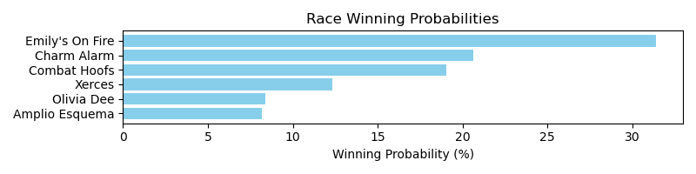

Exacta advice: key 4 → 2 (1 ticket)

Bandit Recommendation: Daily Double_top1_box (Expected Net: 0.00)

# Race: PEN | 2025-05-02 | Race #2 | Post: 00:14 | Track: PENN NATIONAL

Track: PENN NATIONAL

|  |  |  |  |  |  |
| --- | --- | --- | --- | --- | --- |
| Program # | Horse Name | Morn Odds | Rank | Model Score | Win Prob (%) |
| 1 | HOARDING | 3-1 | 3.0 | 1.13 | 15.02 |
| 2 | My Detroit City | 2-1 | 1.0 | 1.88 | 25.17 |
| 3 | Viral Video | 6-1 | 5.0 | 0.92 | 12.99 |
| 4 | Chucky Our Law | 7-2 | 2.0 | 1.84 | 24.48 |
| 5 | MO SAYS | 3-1 | 4.0 | 0.98 | 13.61 |
| 6 | It's Saul Goodman | 15-1 | 6.0 | 0.34 | 8.72 |

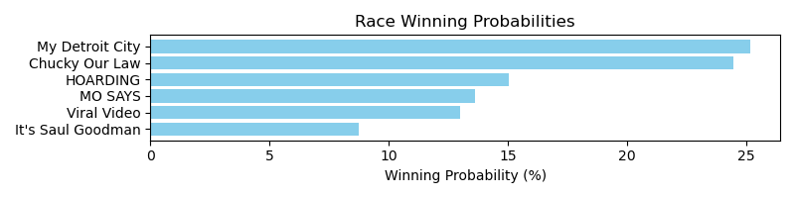

Exacta advice: box [2,4,1] (6 tickets)

Bandit Recommendation: Daily Double_top1_box (Expected Net: 0.56)

# Race: PEN | 2025-05-02 | Race #3 | Post: 00:43 | Track: PENN NATIONAL

Track: PENN NATIONAL

|  |  |  |  |  |  |
| --- | --- | --- | --- | --- | --- |
| Program # | Horse Name | Morn Odds | Rank | Model Score | Win Prob (%) |
| 1 | Abby's Spirit | 5-1 | 6.0 | -0.34 | 10.43 |
| 2 | Grumpy Brooksie | 15-1 | 8.0 | -1.15 | 5.96 |
| 3 | Long Tom | 30-1 | 4.0 | 0.05 | 13.67 |
| 4 | Leonids | 5-2 | 1.0 | 0.59 | 19.87 |
| 5 | Strasse | 3-1 | 3.0 | 0.09 | 14.09 |
| 6 | Keep Dem Talking | 8-1 | 7.0 | -0.45 | 9.68 |
| 7 | Purecrazigroove | 6-1 | 5.0 | -0.13 | 12.11 |
| 8 | Freedom's Start | 4-1 | 2.0 | 0.11 | 14.20 |

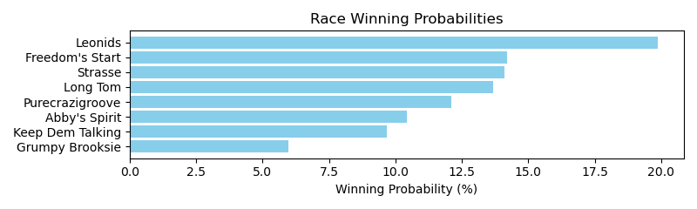

Exacta advice: key 4 → [8,5] (2 tickets)

Bandit Recommendation: Pick 4_top1_box (Expected Net: 0.00)

# Race: PEN | 2025-05-02 | Race #4 | Post: 01:12 | Track: PENN NATIONAL

Track: PENN NATIONAL

|  |  |  |  |  |  |
| --- | --- | --- | --- | --- | --- |
| Program # | Horse Name | Morn Odds | Rank | Model Score | Win Prob (%) |
| 1 | Normandy Life | 12-1 | 7.0 | -0.58 | 5.40 |
| 2 | Three Polks | 2-1 | 2.0 | 1.50 | 22.68 |
| 3 | Pink Rose | 7-2 | 1.0 | 1.60 | 24.35 |
| 4 | Undici | 12-1 | 6.0 | -0.39 | 6.17 |
| 5 | Queen Wiggy | 12-1 | 5.0 | 0.07 | 8.45 |
| 6 | Diane's Merlot | 4-1 | 4.0 | 0.47 | 11.15 |
| 7 | Marion Grace | 5-2 | 3.0 | 1.44 | 21.81 |

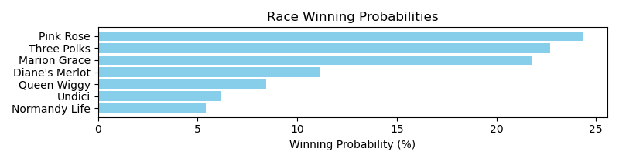

Exacta advice: key 3 → 2 (1 ticket)

Bandit Recommendation: Pick 4_top1_box (Expected Net: 0.00)

# Race: PEN | 2025-05-02 | Race #5 | Post: 01:41 | Track: PENN NATIONAL

Track: PENN NATIONAL

|  |  |  |  |  |  |
| --- | --- | --- | --- | --- | --- |
| Program # | Horse Name | Morn Odds | Rank | Model Score | Win Prob (%) |
| 1 | King of Hollywood | 2-1 | 1.0 | 1.77 | 25.27 |
| 2 | Martini Martin | 7-2 | 2.0 | 1.61 | 22.72 |
| 3 | Last Romance | 10-1 | 6.0 | 0.17 | 8.40 |
| 4 | Tubtimsiam | 8-1 | 5.0 | 0.54 | 10.88 |
| 5 | Entrust | 4-1 | 4.0 | 0.90 | 13.89 |
| 6 | Brett's World | 5-2 | 3.0 | 1.34 | 18.84 |

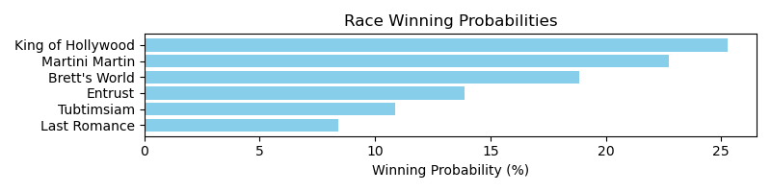

Exacta advice: key 1 → 2 (1 ticket)

Bandit Recommendation: exacta_top2_box (Expected Net: 0.00)

# Race: PEN | 2025-05-02 | Race #6 | Post: 02:10 | Track: PENN NATIONAL

Track: PENN NATIONAL

|  |  |  |  |  |  |
| --- | --- | --- | --- | --- | --- |
| Program # | Horse Name | Morn Odds | Rank | Model Score | Win Prob (%) |
| 1 | Skellig Island | 4-1 | 1.0 | 0.84 | 24.98 |
| 2 | Malibu Warrior | 3-1 | 2.0 | 0.55 | 20.46 |
| 3 | Town Kisser | 5-2 | 3.0 | 0.49 | 19.56 |
| 4 | Runawaytothemoon | 8-1 | 5.0 | -0.96 | 7.20 |
| 5 | Red Abarrio | 3-1 | 4.0 | 0.07 | 14.71 |
| 6 | Nightscape | 8-1 | 6.0 | -1.03 | 6.86 |
| 7 | Ramblin Chrome | 20-1 | 7.0 | -1.17 | 6.23 |

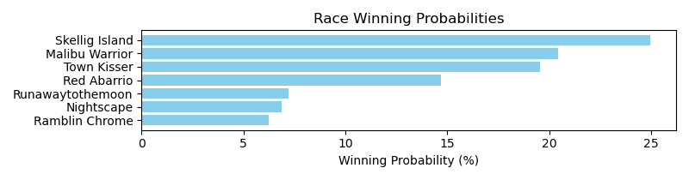

Exacta advice: key 1 → 2 (1 ticket)

Bandit Recommendation: Daily Double_top1_box (Expected Net: 9.60)

# Race: PEN | 2025-05-02 | Race #7 | Post: 02:39 | Track: PENN NATIONAL

Track: PENN NATIONAL

|  |  |  |  |  |  |
| --- | --- | --- | --- | --- | --- |
| Program # | Horse Name | Morn Odds | Rank | Model Score | Win Prob (%) |
| 1 | Spinning Musician | 5-2 | 3.0 | 0.63 | 16.74 |
| 2 | Pylon | 8-1 | 4.0 | 0.28 | 13.15 |
| 3 | Mighty Minion | 10-1 | 5.0 | -0.36 | 8.44 |
| 4 | Hibachi | 15-1 | 6.0 | -0.78 | 6.32 |
| 5 | dh-We Be There | 2-1 | 1.0 | 1.44 | 29.11 |
| 6 | Birthday Bond Rob | 10-1 | 7.0 | -0.88 | 5.88 |
| 7 | Gimmebackmybullets | 5-2 | 2.0 | 0.92 | 20.37 |

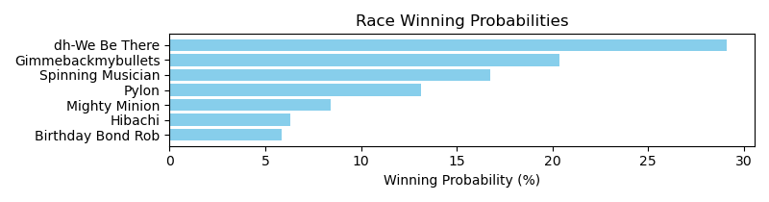

Exacta advice: key 5 → 7 (1 ticket)

Bandit Recommendation: trifecta_top3_box (Expected Net: 59.50)

# Race: PEN | 2025-05-03 | Race #1 | Post: 20:00 | Track: PENN NATIONAL

Track: PENN NATIONAL

|  |  |  |  |  |  |
| --- | --- | --- | --- | --- | --- |
| Program # | Horse Name | Morn Odds | Rank | Model Score | Win Prob (%) |
| 1 | Peaceoftastycake | 6-1 | 6.0 | 0.18 | 7.76 |
| 2 | R Penelope | 5-1 | 5.0 | 0.54 | 9.91 |
| 3 | Simply Tenacious | 12-1 | 7.0 | -0.31 | 5.51 |
| 4 | Warriors Jewel | 5-2 | 1.0 | 2.57 | 40.09 |
| 5 | Nittany Lioness | 4-1 | 3.0 | 0.87 | 12.43 |
| 6 | Diamond Essence | 7-2 | 2.0 | 0.95 | 13.21 |
| 7 | Avril | 5-1 | 4.0 | 0.70 | 11.09 |

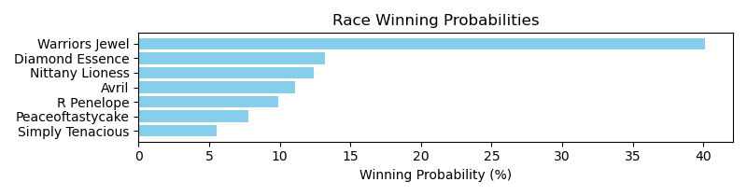

Exacta advice: key 4 → 6 (1 ticket)

Bandit Recommendation: Daily Double_top1_box (Expected Net: 0.00)

# Race: PEN | 2025-05-03 | Race #2 | Post: 20:28 | Track: PENN NATIONAL

Track: PENN NATIONAL

|  |  |  |  |  |  |
| --- | --- | --- | --- | --- | --- |
| Program # | Horse Name | Morn Odds | Rank | Model Score | Win Prob (%) |
| 1 | Pentatonic | 6-1 | 4.0 | 0.45 | 16.47 |
| 2 | Helms Deep | 13-8 | 2.0 | 1.00 | 24.03 |
| 3 | Saint Templar | 9-5 | 1.0 | 1.12 | 26.03 |
| 4 | Warrior On Tap | 5-2 | 3.0 | 0.62 | 18.46 |
| 5 | Mastermind | 12-1 | 5.0 | 0.32 | 15.02 |

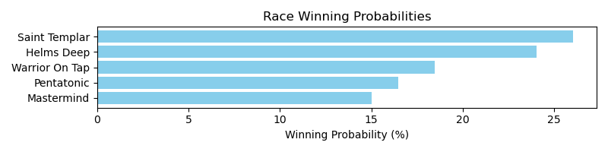

Exacta advice: key 3 → 2 (1 ticket)

Bandit Recommendation: Pick 3_top1_box (Expected Net: 0.00)

# Race: PEN | 2025-05-03 | Race #3 | Post: 20:56 | Track: PENN NATIONAL

Track: PENN NATIONAL

|  |  |  |  |  |  |
| --- | --- | --- | --- | --- | --- |
| Program # | Horse Name | Morn Odds | Rank | Model Score | Win Prob (%) |
| 1 | Pit Stop Man | 2-1 | 2.0 | 2.08 | 23.49 |
| 2 | Yes It's Roo | 15-1 | 8.0 | 0.01 | 5.64 |
| 3 | Mat Matters | 12-1 | 6.0 | 0.19 | 6.38 |
| 4 | One Way Farrior | 8-1 | 4.0 | 0.61 | 8.55 |
| 5 | Mask Patrol | 8-1 | 7.0 | 0.02 | 5.67 |
| 6 | Byk | 5-2 | 1.0 | 2.47 | 30.72 |
| 7 | Mobeer | 7-2 | 3.0 | 1.16 | 12.47 |
| 8 | Majestic Tiger | 12-1 | 5.0 | 0.34 | 7.08 |

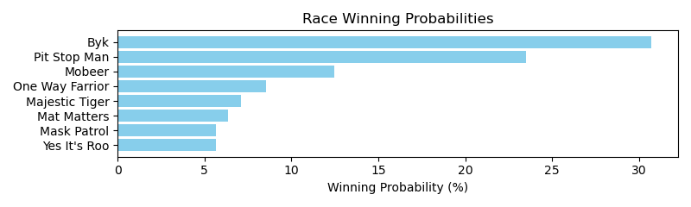

Exacta advice: key 6 → 1 (1 ticket)

Bandit Recommendation: Daily Double_top1_box (Expected Net: 0.00)

# Race: PEN | 2025-05-03 | Race #4 | Post: 21:24 | Track: PENN NATIONAL

Track: PENN NATIONAL

|  |  |  |  |  |  |
| --- | --- | --- | --- | --- | --- |
| Program # | Horse Name | Morn Odds | Rank | Model Score | Win Prob (%) |
| 1 | Picture This | 3-1 | 1.0 | 1.83 | 30.64 |
| 2 | Quilling | 7-2 | 4.0 | 0.62 | 13.28 |
| 3 | Capt. Candy | 6-1 | 5.0 | 0.59 | 13.09 |
| 4 | Tactical Humor | 4-1 | 3.0 | 0.66 | 13.73 |
| 5 | Mr Sandman | 2-1 | 2.0 | 1.28 | 21.03 |
| 6 | Force of Justice | 8-1 | 6.0 | -0.08 | 8.23 |

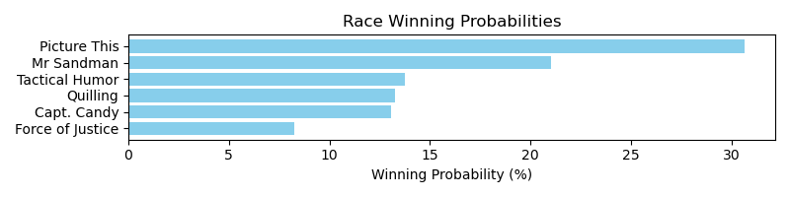

Exacta advice: key 1 → 5 (1 ticket)

Bandit Recommendation: exacta_top2_box (Expected Net: 0.75)

# Race: PEN | 2025-05-03 | Race #5 | Post: 21:52 | Track: PENN NATIONAL

Track: PENN NATIONAL

|  |  |  |  |  |  |
| --- | --- | --- | --- | --- | --- |
| Program # | Horse Name | Morn Odds | Rank | Model Score | Win Prob (%) |
| 1 | Donnelly's Hollow | 5-1 | 5.0 | 0.70 | 10.27 |
| 2 | Kevin Mac | 3-1 | 2.0 | 1.62 | 19.30 |
| 3 | Spezia's Son | 30-1 | 7.0 | -0.00 | 6.32 |
| 4 | Pops Harper | 5-2 | 1.0 | 2.23 | 29.44 |
| 5 | Michaelshatrick | 50-1 | 6.0 | 0.04 | 6.49 |
| 6 | Sapphire Prince | 9-5 | 3.0 | 1.43 | 16.99 |
| 7 | Sams After Party | 6-1 | 4.0 | 0.83 | 11.20 |

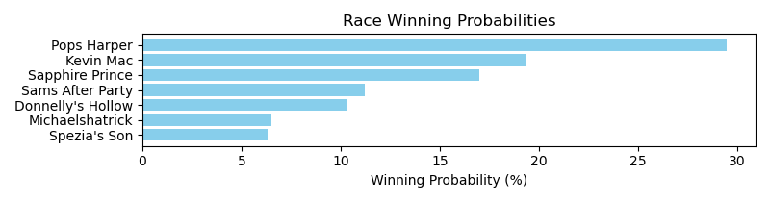

Exacta advice: key 4 → 2 (1 ticket)

Bandit Recommendation: Pick 4_top1_box (Expected Net: 173.00)

# Race: PEN | 2025-05-03 | Race #6 | Post: 22:20 | Track: PENN NATIONAL

Track: PENN NATIONAL

|  |  |  |  |  |  |
| --- | --- | --- | --- | --- | --- |
| Program # | Horse Name | Morn Odds | Rank | Model Score | Win Prob (%) |
| 1 | Mischief Warrior | 30-1 | 8.0 | -0.58 | 5.70 |
| 2 | Magnificent Ride | 10-1 | 4.0 | 0.65 | 13.30 |
| 3 | Termsofengagement | 5-2 | 2.0 | 0.98 | 16.62 |
| 4 | Trophy Room | 3-1 | 1.0 | 1.00 | 16.85 |
| 5 | My Blue Eyes | 8-1 | 7.0 | -0.07 | 8.10 |
| 6 | Kbcya Later | 4-1 | 3.0 | 0.97 | 16.58 |
| 7 | Eddiemush | 6-1 | 6.0 | 0.29 | 10.35 |
| 8 | Swing Oil | 6-1 | 5.0 | 0.56 | 12.50 |

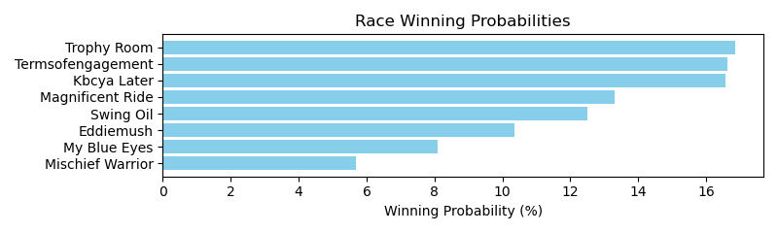

Exacta advice: box [4,3,6] (6 tickets)

Bandit Recommendation: Daily Double_top1_box (Expected Net: 0.00)

# Race: PEN | 2025-05-03 | Race #7 | Post: 22:48 | Track: PENN NATIONAL

Track: PENN NATIONAL

|  |  |  |  |  |  |
| --- | --- | --- | --- | --- | --- |
| Program # | Horse Name | Morn Odds | Rank | Model Score | Win Prob (%) |
| 1 | Sunshine Johnny | 4-1 | 2.0 | 1.97 | 25.47 |
| 2 | Harbour Bridge | 2-1 | 1.0 | 2.13 | 28.44 |
| 3 | Rolly | 4-1 | 4.0 | 0.27 | 7.92 |
| 4 | Midnight Ambition | 6-1 | 3.0 | 1.77 | 22.18 |
| 5 | Sylvia I Am | 8-1 | 6.0 | -0.56 | 4.45 |
| 6 | Wizardofez | 7-2 | 5.0 | 0.19 | 7.45 |
| 7 | Private Cabana | 20-1 | 7.0 | -0.69 | 4.08 |

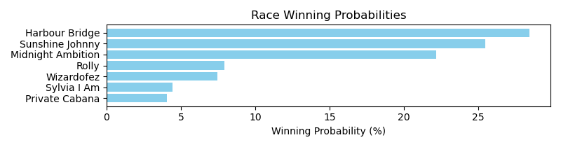

Exacta advice: key 2 → 1 (1 ticket)

Bandit Recommendation: Pick 3_top1_box (Expected Net: 0.00)

# Race: TAM | 2025-04-30 | Race #1 | Post: 18:28 | Track: TAMPA BAY DOWNS

Track: TAMPA BAY DOWNS

|  |  |  |  |  |  |
| --- | --- | --- | --- | --- | --- |
| Program # | Horse Name | Morn Odds | Rank | Model Score | Win Prob (%) |
| 1 | Banded Rocket | 6-1 | 5.0 | 1.12 | 12.35 |
| 2 | Big Louie | 10-1 | 7.0 | 0.33 | 7.17 |
| 3 | Capture the Time | 2-1 | 2.0 | 1.81 | 19.82 |
| 4 | El Principito | 3-1 | 3.0 | 1.49 | 15.92 |
| 5 | Hector | 8-1 | 6.0 | 0.96 | 11.09 |
| 6 | Aggrandize | 15-1 | 4.0 | 1.15 | 12.64 |
| 7 | Zydeceaux | 5-2 | 1.0 | 1.89 | 21.02 |

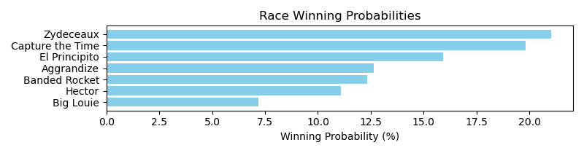

Exacta advice: box [7,3,4] (6 tickets)

Bandit Recommendation: Daily Double_top1_box (Expected Net: 0.00)

# Race: TAM | 2025-04-30 | Race #2 | Post: 18:58 | Track: TAMPA BAY DOWNS

Track: TAMPA BAY DOWNS

|  |  |  |  |  |  |
| --- | --- | --- | --- | --- | --- |
| Program # | Horse Name | Morn Odds | Rank | Model Score | Win Prob (%) |
| 1 | ALWAYS WIN | 10-1 | 7.0 | -0.00 | 3.90 |
| 2 | Emirates Honor | 3-1 | 1.0 | 2.98 | 30.32 |
| 3 | G Speedy | 4-1 | 5.0 | 1.34 | 9.81 |
| 4 | Noble Soul | 15-1 | 8.0 | -0.13 | 3.57 |
| 5 | Super Casper | 20-1 | 9.0 | -0.25 | 3.29 |
| 6 | Cinco Halo | 30-1 | 10.0 | -0.52 | 2.73 |
| 7 | Wow Bubble | 9-2 | 4.0 | 1.48 | 10.82 |
| 8 | Highs N Lows | 6-1 | 3.0 | 1.75 | 13.04 |
| 9 | So Grand | 12-1 | 6.0 | 0.81 | 6.83 |
| 10 | Fit to Fire | 7-2 | 2.0 | 2.02 | 15.69 |

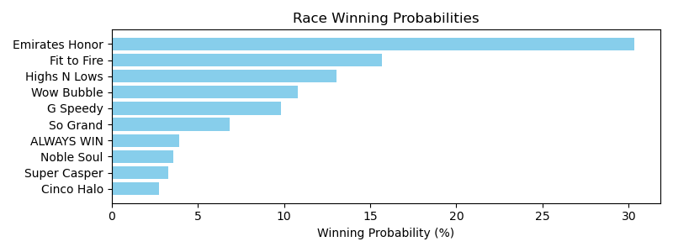

Exacta advice: key 2 → 10 (1 ticket)

Bandit Recommendation: no_bet (Expected Net: 0.00)

# Race: TAM | 2025-04-30 | Race #3 | Post: 19:28 | Track: TAMPA BAY DOWNS

Track: TAMPA BAY DOWNS

|  |  |  |  |  |  |
| --- | --- | --- | --- | --- | --- |
| Program # | Horse Name | Morn Odds | Rank | Model Score | Win Prob (%) |
| 1 | Venezuelan Flower | 7-2 | 4.0 | 0.23 | 14.26 |
| 2 | Ms Kendrick B. | 4-1 | 1.0 | 1.01 | 24.44 |
| 3 | Wildcat Minny | 5-1 | 3.0 | 0.36 | 15.60 |
| 4 | Charlie's Beauty | 5-2 | 7.0 | -1.19 | 5.39 |
| 5 | Lady Collected | 15-1 | 6.0 | -0.46 | 8.89 |
| 6 | Ran the Red | 4-1 | 2.0 | 0.88 | 22.40 |
| 7 | Cantafio | 8-1 | 5.0 | -0.44 | 9.04 |

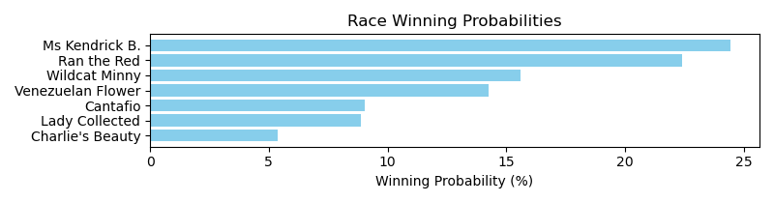

Exacta advice: key 2 → 6 (1 ticket)

Bandit Recommendation: Pick 3_top1_box (Expected Net: 0.00)

# Race: TAM | 2025-04-30 | Race #4 | Post: 19:58 | Track: TAMPA BAY DOWNS

Track: TAMPA BAY DOWNS

|  |  |  |  |  |  |
| --- | --- | --- | --- | --- | --- |
| Program # | Horse Name | Morn Odds | Rank | Model Score | Win Prob (%) |
| 1 | Kalinba | 30-1 | 13.0 | -0.32 | 3.37 |
| 2 | Estilo Magico | 5-1 | 3.0 | 1.35 | 10.64 |
| 3 | Braggadocious | 4-1 | 2.0 | 1.61 | 12.72 |
| 4 | Coaches Meeting | 7-2 | 5.0 | 1.14 | 9.19 |
| 5 | Haberdashery | 15-1 | 10.0 | 0.36 | 5.36 |
| 6 | Bounteous | 10-1 | 11.0 | 0.35 | 5.35 |
| 7 | Midnight Onyx | 3-1 | 6.0 | 0.99 | 8.29 |
| 8 | Diamond Messa | 6-1 | 8.0 | 0.50 | 5.90 |
| 9 | Poseidons Myth | 20-1 | 12.0 | -0.27 | 3.48 |
| 10 | Likebelivingnmagic | 10-1 | 4.0 | 1.18 | 9.46 |
| 11 | Leopardi | 6-1 | 9.0 | 0.39 | 5.49 |
| 12 | Gun Right | 8-1 | 7.0 | 0.59 | 6.28 |
| 13 | Gucci Boy | 9-2 | 1.0 | 1.80 | 14.47 |

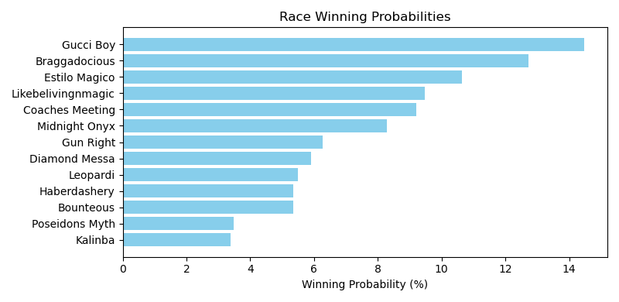

Exacta advice: key 13 → 3 (1 ticket)

Bandit Recommendation: Daily Double_top1_box (Expected Net: 0.00)

# Race: TAM | 2025-04-30 | Race #5 | Post: 20:28 | Track: TAMPA BAY DOWNS

Track: TAMPA BAY DOWNS

|  |  |  |  |  |  |
| --- | --- | --- | --- | --- | --- |
| Program # | Horse Name | Morn Odds | Rank | Model Score | Win Prob (%) |
| 1 | Growth Capital | 5-2 | 1.0 | 2.15 | 22.38 |
| 2 | Rocket Dragon | 6-1 | 3.0 | 1.52 | 14.43 |
| 3 | Magic Heart | 9-2 | 6.0 | 0.50 | 7.14 |
| 4 | Praline's Cat | 15-1 | 8.0 | 0.31 | 6.27 |
| 5 | Benvolio | 9-2 | 5.0 | 1.04 | 10.40 |
| 6 | Toro Forward | 3-1 | 4.0 | 1.44 | 13.65 |
| 7 | Son of a Slew | 20-1 | 2.0 | 1.53 | 14.58 |
| 8 | Fast N Steady | 30-1 | 9.0 | -0.25 | 4.26 |
| 9 | dh-Dial Him Up | 10-1 | 7.0 | 0.44 | 6.89 |

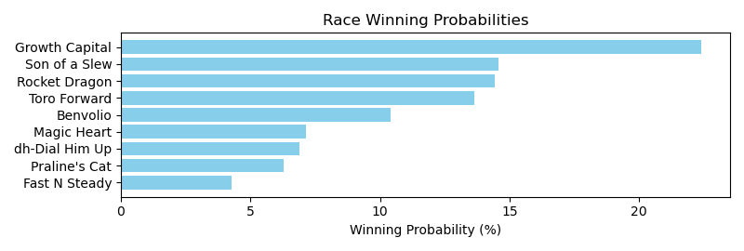

Exacta advice: key 1 → [7,2] (2 tickets)

Bandit Recommendation: Daily Double_top1_box (Expected Net: 0.00)

# Race: TAM | 2025-04-30 | Race #6 | Post: 20:58 | Track: TAMPA BAY DOWNS

Track: TAMPA BAY DOWNS

|  |  |  |  |  |  |
| --- | --- | --- | --- | --- | --- |
| Program # | Horse Name | Morn Odds | Rank | Model Score | Win Prob (%) |
| 1 | Practicality | 4-1 | 4.0 | 1.30 | 14.14 |
| 2 | Thelastbulletsmine | 8-1 | 5.0 | 1.27 | 13.83 |
| 3 | Zip Code Envy | 15-1 | 7.0 | 0.41 | 7.68 |
| 4 | D' tiger Lily | 10-1 | 8.0 | 0.08 | 6.11 |
| 5 | Moanas Power | 4-1 | 3.0 | 1.40 | 15.10 |
| 6 | Moretastic | 3-1 | 1.0 | 1.45 | 15.64 |
| 7 | Spanish Delight | 8-1 | 6.0 | 1.07 | 12.11 |
| 8 | Wheelingndealing | 7-2 | 2.0 | 1.42 | 15.37 |

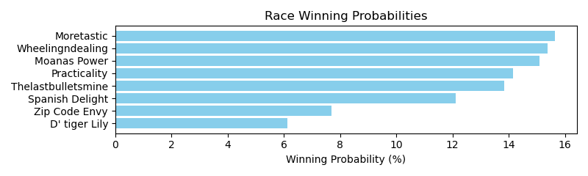

Exacta advice: box [6,8,5] (6 tickets)

Bandit Recommendation: Daily Double_top1_box (Expected Net: -2.00)

# Race: TAM | 2025-04-30 | Race #7 | Post: 21:28 | Track: TAMPA BAY DOWNS

Track: TAMPA BAY DOWNS

|  |  |  |  |  |  |
| --- | --- | --- | --- | --- | --- |
| Program # | Horse Name | Morn Odds | Rank | Model Score | Win Prob (%) |
| 1 | Harpoon Harry | 7-2 | 5.0 | 1.35 | 8.73 |
| 2 | Cinco de Mo | 15-1 | 9.0 | 0.81 | 6.04 |
| 3 | Policy Option | 3-1 | 2.0 | 1.84 | 12.24 |
| 4 | Yes This Time | 5-1 | 3.0 | 1.81 | 12.05 |
| 5 | Feuilleton | 15-1 | 10.0 | 0.55 | 5.05 |
| 6 | Smart Striker | 8-1 | 6.0 | 1.32 | 8.59 |
| 7 | Burnin Turf | 5-2 | 1.0 | 2.01 | 13.79 |
| 8 | Arak | 15-1 | 13.0 | -0.59 | 2.31 |
| 9 | Starship Mocha | 30-1 | 12.0 | -0.27 | 2.87 |
| 10 | Well Connected | 20-1 | 8.0 | 0.88 | 6.31 |
| 11 | Damir | 30-1 | 14.0 | -0.89 | 1.87 |
| 12 | Post Facto | 10-1 | 7.0 | 0.95 | 6.65 |
| 13 | K P All Systems Go | 15-1 | 11.0 | 0.07 | 3.62 |
| 14 | Elevated Game | 4-1 | 4.0 | 1.52 | 9.86 |

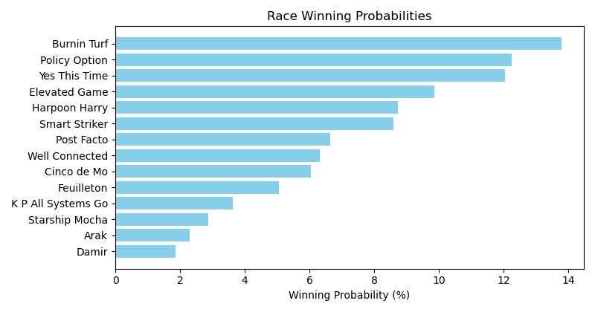

Exacta advice: key 7 → [3,4] (2 tickets)

Bandit Recommendation: no_bet (Expected Net: 0.00)

# Race: TAM | 2025-04-30 | Race #8 | Post: 21:58 | Track: TAMPA BAY DOWNS

Track: TAMPA BAY DOWNS

|  |  |  |  |  |  |
| --- | --- | --- | --- | --- | --- |
| Program # | Horse Name | Morn Odds | Rank | Model Score | Win Prob (%) |
| 1 | OUR KHOZIE ROSIE | 9-2 | 11.0 | 0.17 | 4.04 |
| 2 | Cawama | 30-1 | 10.0 | 0.23 | 4.20 |
| 3 | Curling Rose | 4-1 | 2.0 | 1.85 | 12.82 |
| 4 | Mamas Lullabye | 12-1 | 4.0 | 1.46 | 9.79 |
| 5 | Soundtrack | 5-2 | 1.0 | 2.52 | 20.30 |
| 6 | dh-Always Drama | 15-1 | 7.0 | 0.66 | 5.64 |
| 7 | Bonita Diamond | 15-1 | 5.0 | 1.34 | 9.04 |
| 8 | Electrica | 30-1 | 12.0 | -0.27 | 2.97 |
| 9 | Adjust My Halo | 3-1 | 3.0 | 1.80 | 12.42 |
| 10 | Final Note | 20-1 | 9.0 | 0.55 | 5.24 |
| 11 | Cameo | 20-1 | 6.0 | 1.20 | 8.19 |
| 12 | Gracious Beauty | 20-1 | 8.0 | 0.57 | 5.33 |

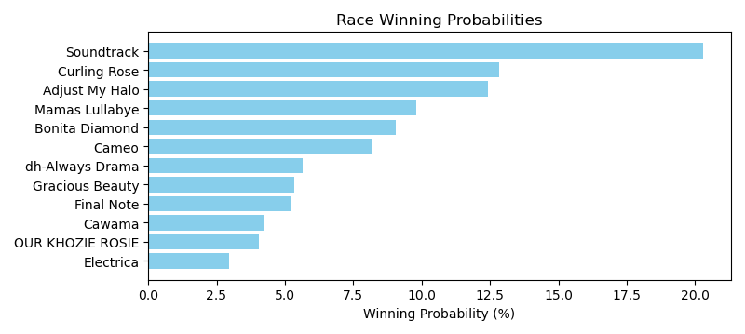

Exacta advice: key 5 → [3,9] (2 tickets)

Bandit Recommendation: Daily Double_top1_box (Expected Net: 0.56)

# Race: TAM | 2025-04-30 | Race #9 | Post: 22:28 | Track: TAMPA BAY DOWNS

Track: TAMPA BAY DOWNS

|  |  |  |  |  |  |
| --- | --- | --- | --- | --- | --- |
| Program # | Horse Name | Morn Odds | Rank | Model Score | Win Prob (%) |
| 1 | Money Trail | 5-1 | 5.0 | 1.97 | 10.07 |
| 2 | Crafty Collector | 5-2 | 1.0 | 3.16 | 22.91 |
| 3 | Nouveau | 3-1 | 4.0 | 2.13 | 11.27 |
| 4 | TOO MUCH FUN | 15-1 | 9.0 | 0.38 | 3.36 |
| 5 | Dorotea Dream | 6-1 | 3.0 | 2.25 | 12.19 |
| 6 | Power Party | 15-1 | 6.0 | 1.81 | 8.99 |
| 7 | Authenticate Now | 4-1 | 2.0 | 2.97 | 20.00 |
| 8 | La Canonica | 15-1 | 10.0 | -0.10 | 2.42 |
| 9 | Giftbox Surprise | 30-1 | 7.0 | 1.05 | 5.36 |
| 10 | FRATERNIZE | 20-1 | 8.0 | 0.40 | 3.42 |

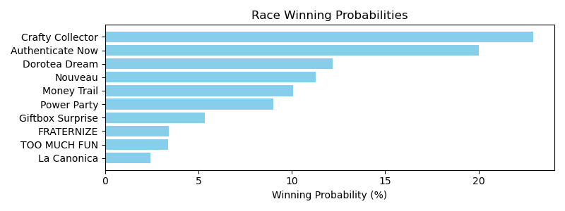

Exacta advice: key 2 → 7 (1 ticket)

Bandit Recommendation: exacta_top2_box (Expected Net: 0.00)

# Multi-Race Bet Recommendations

Daily Double advised: TCD_2025-04-30_1 + TCD_2025-04-30_2

Daily Double advised: TCD_2025-04-30_2 + TCD_2025-04-30_3

Daily Double advised: TCD_2025-04-30_3 + TCD_2025-04-30_4

Daily Double advised: TCD_2025-04-30_4 + TCD_2025-04-30_5

Daily Double advised: TCD_2025-04-30_5 + TCD_2025-04-30_6

Daily Double advised: TCD_2025-04-30_6 + TCD_2025-04-30_7

Daily Double advised: TCD_2025-04-30_7 + TCD_2025-04-30_8

Daily Double advised: TCD_2025-05-01_3 + TCD_2025-05-01_4

Daily Double advised: TCD_2025-05-01_4 + TCD_2025-05-01_5

Daily Double advised: TCD_2025-05-01_5 + TCD_2025-05-01_6

Daily Double advised: TCD_2025-05-01_6 + TCD_2025-05-01_7

Daily Double advised: TCD_2025-05-01_7 + TCD_2025-05-01_8

Daily Double advised: TCD_2025-05-01_8 + TCD_2025-05-01_9

Daily Double advised: TCD_2025-05-01_9 + TCD_2025-05-01_10

Daily Double advised: TCD_2025-05-01_10 + TCD_2025-05-01_11

Daily Double advised: TCD_2025-05-01_11 + TCD_2025-05-01_12

Daily Double advised: TCD_2025-05-01_12 + TCD_2025-05-02_1

Daily Double advised: TCD_2025-05-02_1 + TCD_2025-05-02_2

Daily Double advised: TCD_2025-05-02_2 + TCD_2025-05-02_3

Daily Double advised: TCD_2025-05-02_3 + TCD_2025-05-02_4

Daily Double advised: TCD_2025-05-02_6 + TCD_2025-05-02_7

Daily Double advised: TCD_2025-05-02_7 + TCD_2025-05-02_8

Daily Double advised: TCD_2025-05-02_8 + TCD_2025-05-02_9

Daily Double advised: TCD_2025-05-02_9 + TCD_2025-05-02_10

Daily Double advised: TCD_2025-05-03_1 + TCD_2025-05-03_2

Daily Double advised: TCD_2025-05-03_2 + TCD_2025-05-03_3

Daily Double advised: TCD_2025-05-03_3 + TCD_2025-05-03_4

Daily Double advised: TCD_2025-05-03_4 + TCD_2025-05-03_5

Daily Double advised: TCD_2025-05-03_5 + TCD_2025-05-03_6

Daily Double advised: TCD_2025-05-03_6 + TCD_2025-05-03_7

Daily Double advised: TCD_2025-05-03_7 + TCD_2025-05-03_8

Daily Double advised: TCD_2025-05-03_8 + TCD_2025-05-03_9

Daily Double advised: TCD_2025-05-03_9 + TCD_2025-05-03_10

Daily Double advised: TCD_2025-05-03_13 + TCD_2025-05-03_14

Daily Double advised: TGP_2025-05-01_1 + TGP_2025-05-01_2

Daily Double advised: TGP_2025-05-01_2 + TGP_2025-05-01_3

Daily Double advised: TGP_2025-05-01_3 + TGP_2025-05-01_4

Daily Double advised: TGP_2025-05-01_4 + TGP_2025-05-01_5

Daily Double advised: TGP_2025-05-01_5 + TGP_2025-05-01_6

Daily Double advised: TGP_2025-05-01_6 + TGP_2025-05-01_7

Daily Double advised: IND_2025-04-30_3 + IND_2025-04-30_4

Daily Double advised: IND_2025-04-30_4 + IND_2025-04-30_5

Daily Double advised: IND_2025-04-30_5 + IND_2025-04-30_6

Daily Double advised: IND_2025-04-30_6 + IND_2025-04-30_7

Daily Double advised: IND_2025-04-30_7 + IND_2025-04-30_8

Daily Double advised: TLS_2025-05-02_1 + TLS_2025-05-02_2

Daily Double advised: TLS_2025-05-02_2 + TLS_2025-05-02_3

Daily Double advised: TLS_2025-05-02_3 + TLS_2025-05-02_4

Daily Double advised: TLS_2025-05-02_4 + TLS_2025-05-02_5

Daily Double advised: TLS_2025-05-02_5 + TLS_2025-05-02_6

Daily Double advised: TLS_2025-05-02_6 + TLS_2025-05-02_7

Daily Double advised: TLS_2025-05-02_7 + TLS_2025-05-02_8

Daily Double advised: TLS_2025-05-02_8 + TLS_2025-05-03_1

Daily Double advised: TLS_2025-05-03_3 + TLS_2025-05-03_4

Daily Double advised: TLS_2025-05-03_6 + TLS_2025-05-03_7

Daily Double advised: TLS_2025-05-03_7 + TLS_2025-05-03_8

Daily Double advised: TLS_2025-05-03_8 + TLS_2025-05-03_9

Daily Double advised: TLS_2025-05-04_1 + TLS_2025-05-04_2

Daily Double advised: TLS_2025-05-04_2 + TLS_2025-05-04_3

Daily Double advised: TLS_2025-05-04_3 + TLS_2025-05-04_4

Daily Double advised: TLS_2025-05-04_6 + TLS_2025-05-04_7

Daily Double advised: TLS_2025-05-04_7 + TLS_2025-05-04_8

Daily Double advised: TOP_2025-05-01_1 + TOP_2025-05-01_2

Daily Double advised: TOP_2025-05-01_4 + TOP_2025-05-01_5

Daily Double advised: TOP_2025-05-01_5 + TOP_2025-05-01_6

Daily Double advised: TOP_2025-05-01_6 + TOP_2025-05-01_7

Daily Double advised: TOP_2025-05-01_9 + TOP_2025-05-02_1

Daily Double advised: TOP_2025-05-02_3 + TOP_2025-05-02_4

Daily Double advised: TOP_2025-05-02_4 + TOP_2025-05-02_5

Daily Double advised: TOP_2025-05-02_5 + TOP_2025-05-02_6

Daily Double advised: TOP_2025-05-02_6 + TOP_2025-05-02_7

Daily Double advised: TOP_2025-05-02_7 + TOP_2025-05-02_8

Daily Double advised: TOP_2025-05-02_8 + TOP_2025-05-02_9

Daily Double advised: TOP_2025-05-02_9 + TOP_2025-05-02_10

Daily Double advised: TOP_2025-05-02_10 + TOP_2025-05-02_11

Daily Double advised: TOP_2025-05-02_11 + TOP_2025-05-02_12

Daily Double advised: PEN_2025-05-01_4 + PEN_2025-05-01_5

Daily Double advised: PEN_2025-05-02_3 + PEN_2025-05-02_4

Daily Double advised: PEN_2025-05-02_4 + PEN_2025-05-02_5

Daily Double advised: PEN_2025-05-02_5 + PEN_2025-05-02_6

Daily Double advised: PEN_2025-05-02_6 + PEN_2025-05-02_7

Daily Double advised: PEN_2025-05-02_7 + PEN_2025-05-03_1

Daily Double advised: PEN_2025-05-03_1 + PEN_2025-05-03_2

Daily Double advised: PEN_2025-05-03_2 + PEN_2025-05-03_3

Daily Double advised: PEN_2025-05-03_3 + PEN_2025-05-03_4

Daily Double advised: PEN_2025-05-03_4 + PEN_2025-05-03_5

Daily Double advised: TAM_2025-04-30_2 + TAM_2025-04-30_3

Daily Double advised: TAM_2025-04-30_3 + TAM_2025-04-30_4

Daily Double advised: TAM_2025-04-30_4 + TAM_2025-04-30_5

Daily Double advised: TAM_2025-04-30_7 + TAM_2025-04-30_8

Daily Double advised: TAM_2025-04-30_8 + TAM_2025-04-30_9

Pick 3 advised: TCD_2025-04-30_1, TCD_2025-04-30_2, TCD_2025-04-30_3

Pick 3 advised: TCD_2025-04-30_2, TCD_2025-04-30_3, TCD_2025-04-30_4

Pick 3 advised: TCD_2025-04-30_3, TCD_2025-04-30_4, TCD_2025-04-30_5

Pick 3 advised: TCD_2025-04-30_4, TCD_2025-04-30_5, TCD_2025-04-30_6

Pick 3 advised: TCD_2025-04-30_5, TCD_2025-04-30_6, TCD_2025-04-30_7

Pick 3 advised: TCD_2025-04-30_6, TCD_2025-04-30_7, TCD_2025-04-30_8

Pick 3 advised: TCD_2025-05-01_3, TCD_2025-05-01_4, TCD_2025-05-01_5

Pick 3 advised: TCD_2025-05-01_4, TCD_2025-05-01_5, TCD_2025-05-01_6

Pick 3 advised: TCD_2025-05-01_5, TCD_2025-05-01_6, TCD_2025-05-01_7

Pick 3 advised: TCD_2025-05-01_6, TCD_2025-05-01_7, TCD_2025-05-01_8

Pick 3 advised: TCD_2025-05-01_7, TCD_2025-05-01_8, TCD_2025-05-01_9

Pick 3 advised: TCD_2025-05-01_8, TCD_2025-05-01_9, TCD_2025-05-01_10

Pick 3 advised: TCD_2025-05-01_9, TCD_2025-05-01_10, TCD_2025-05-01_11

Pick 3 advised: TCD_2025-05-01_10, TCD_2025-05-01_11, TCD_2025-05-01_12

Pick 3 advised: TCD_2025-05-01_11, TCD_2025-05-01_12, TCD_2025-05-02_1

Pick 3 advised: TCD_2025-05-01_12, TCD_2025-05-02_1, TCD_2025-05-02_2

Pick 3 advised: TCD_2025-05-02_1, TCD_2025-05-02_2, TCD_2025-05-02_3

Pick 3 advised: TCD_2025-05-02_2, TCD_2025-05-02_3, TCD_2025-05-02_4

Pick 3 advised: TCD_2025-05-02_6, TCD_2025-05-02_7, TCD_2025-05-02_8

Pick 3 advised: TCD_2025-05-02_7, TCD_2025-05-02_8, TCD_2025-05-02_9

Pick 3 advised: TCD_2025-05-02_8, TCD_2025-05-02_9, TCD_2025-05-02_10

Pick 3 advised: TCD_2025-05-03_1, TCD_2025-05-03_2, TCD_2025-05-03_3

Pick 3 advised: TCD_2025-05-03_2, TCD_2025-05-03_3, TCD_2025-05-03_4

Pick 3 advised: TCD_2025-05-03_3, TCD_2025-05-03_4, TCD_2025-05-03_5

Pick 3 advised: TCD_2025-05-03_4, TCD_2025-05-03_5, TCD_2025-05-03_6

Pick 3 advised: TCD_2025-05-03_5, TCD_2025-05-03_6, TCD_2025-05-03_7

Pick 3 advised: TCD_2025-05-03_6, TCD_2025-05-03_7, TCD_2025-05-03_8

Pick 3 advised: TCD_2025-05-03_7, TCD_2025-05-03_8, TCD_2025-05-03_9

Pick 3 advised: TCD_2025-05-03_8, TCD_2025-05-03_9, TCD_2025-05-03_10

Pick 3 advised: TGP_2025-05-01_1, TGP_2025-05-01_2, TGP_2025-05-01_3

Pick 3 advised: TGP_2025-05-01_2, TGP_2025-05-01_3, TGP_2025-05-01_4

Pick 3 advised: TGP_2025-05-01_3, TGP_2025-05-01_4, TGP_2025-05-01_5

Pick 3 advised: TGP_2025-05-01_4, TGP_2025-05-01_5, TGP_2025-05-01_6

Pick 3 advised: TGP_2025-05-01_5, TGP_2025-05-01_6, TGP_2025-05-01_7

Pick 3 advised: IND_2025-04-30_3, IND_2025-04-30_4, IND_2025-04-30_5

Pick 3 advised: IND_2025-04-30_4, IND_2025-04-30_5, IND_2025-04-30_6

Pick 3 advised: IND_2025-04-30_5, IND_2025-04-30_6, IND_2025-04-30_7

Pick 3 advised: IND_2025-04-30_6, IND_2025-04-30_7, IND_2025-04-30_8

Pick 3 advised: TLS_2025-05-02_1, TLS_2025-05-02_2, TLS_2025-05-02_3

Pick 3 advised: TLS_2025-05-02_2, TLS_2025-05-02_3, TLS_2025-05-02_4

Pick 3 advised: TLS_2025-05-02_3, TLS_2025-05-02_4, TLS_2025-05-02_5

Pick 3 advised: TLS_2025-05-02_4, TLS_2025-05-02_5, TLS_2025-05-02_6

Pick 3 advised: TLS_2025-05-02_5, TLS_2025-05-02_6, TLS_2025-05-02_7

Pick 3 advised: TLS_2025-05-02_6, TLS_2025-05-02_7, TLS_2025-05-02_8

Pick 3 advised: TLS_2025-05-02_7, TLS_2025-05-02_8, TLS_2025-05-03_1

Pick 3 advised: TLS_2025-05-03_6, TLS_2025-05-03_7, TLS_2025-05-03_8

Pick 3 advised: TLS_2025-05-03_7, TLS_2025-05-03_8, TLS_2025-05-03_9

Pick 3 advised: TLS_2025-05-04_1, TLS_2025-05-04_2, TLS_2025-05-04_3

Pick 3 advised: TLS_2025-05-04_2, TLS_2025-05-04_3, TLS_2025-05-04_4

Pick 3 advised: TLS_2025-05-04_6, TLS_2025-05-04_7, TLS_2025-05-04_8

Pick 3 advised: TOP_2025-05-01_4, TOP_2025-05-01_5, TOP_2025-05-01_6

Pick 3 advised: TOP_2025-05-01_5, TOP_2025-05-01_6, TOP_2025-05-01_7

Pick 3 advised: TOP_2025-05-02_3, TOP_2025-05-02_4, TOP_2025-05-02_5

Pick 3 advised: TOP_2025-05-02_4, TOP_2025-05-02_5, TOP_2025-05-02_6

Pick 3 advised: TOP_2025-05-02_5, TOP_2025-05-02_6, TOP_2025-05-02_7

Pick 3 advised: TOP_2025-05-02_6, TOP_2025-05-02_7, TOP_2025-05-02_8

Pick 3 advised: TOP_2025-05-02_7, TOP_2025-05-02_8, TOP_2025-05-02_9

Pick 3 advised: TOP_2025-05-02_8, TOP_2025-05-02_9, TOP_2025-05-02_10

Pick 3 advised: TOP_2025-05-02_9, TOP_2025-05-02_10, TOP_2025-05-02_11

Pick 3 advised: TOP_2025-05-02_10, TOP_2025-05-02_11, TOP_2025-05-02_12

Pick 3 advised: PEN_2025-05-02_3, PEN_2025-05-02_4, PEN_2025-05-02_5

Pick 3 advised: PEN_2025-05-02_4, PEN_2025-05-02_5, PEN_2025-05-02_6

Pick 3 advised: PEN_2025-05-02_5, PEN_2025-05-02_6, PEN_2025-05-02_7

Pick 3 advised: PEN_2025-05-02_6, PEN_2025-05-02_7, PEN_2025-05-03_1

Pick 3 advised: PEN_2025-05-02_7, PEN_2025-05-03_1, PEN_2025-05-03_2

Pick 3 advised: PEN_2025-05-03_1, PEN_2025-05-03_2, PEN_2025-05-03_3

Pick 3 advised: PEN_2025-05-03_2, PEN_2025-05-03_3, PEN_2025-05-03_4

Pick 3 advised: PEN_2025-05-03_3, PEN_2025-05-03_4, PEN_2025-05-03_5

Pick 3 advised: TAM_2025-04-30_2, TAM_2025-04-30_3, TAM_2025-04-30_4

Pick 3 advised: TAM_2025-04-30_3, TAM_2025-04-30_4, TAM_2025-04-30_5

Pick 3 advised: TAM_2025-04-30_7, TAM_2025-04-30_8, TAM_2025-04-30_9

Pick 4 advised: TCD_2025-04-30_1, TCD_2025-04-30_2, TCD_2025-04-30_3, TCD_2025-04-30_4

Pick 4 advised: TCD_2025-04-30_2, TCD_2025-04-30_3, TCD_2025-04-30_4, TCD_2025-04-30_5

Pick 4 advised: TCD_2025-04-30_3, TCD_2025-04-30_4, TCD_2025-04-30_5, TCD_2025-04-30_6

Pick 4 advised: TCD_2025-04-30_4, TCD_2025-04-30_5, TCD_2025-04-30_6, TCD_2025-04-30_7

Pick 4 advised: TCD_2025-04-30_5, TCD_2025-04-30_6, TCD_2025-04-30_7, TCD_2025-04-30_8

Pick 4 advised: TCD_2025-05-01_3, TCD_2025-05-01_4, TCD_2025-05-01_5, TCD_2025-05-01_6

Pick 4 advised: TCD_2025-05-01_4, TCD_2025-05-01_5, TCD_2025-05-01_6, TCD_2025-05-01_7

Pick 4 advised: TCD_2025-05-01_5, TCD_2025-05-01_6, TCD_2025-05-01_7, TCD_2025-05-01_8

Pick 4 advised: TCD_2025-05-01_6, TCD_2025-05-01_7, TCD_2025-05-01_8, TCD_2025-05-01_9

Pick 4 advised: TCD_2025-05-01_7, TCD_2025-05-01_8, TCD_2025-05-01_9, TCD_2025-05-01_10

Pick 4 advised: TCD_2025-05-01_8, TCD_2025-05-01_9, TCD_2025-05-01_10, TCD_2025-05-01_11

Pick 4 advised: TCD_2025-05-01_9, TCD_2025-05-01_10, TCD_2025-05-01_11, TCD_2025-05-01_12

Pick 4 advised: TCD_2025-05-01_10, TCD_2025-05-01_11, TCD_2025-05-01_12, TCD_2025-05-02_1

Pick 4 advised: TCD_2025-05-01_11, TCD_2025-05-01_12, TCD_2025-05-02_1, TCD_2025-05-02_2

Pick 4 advised: TCD_2025-05-01_12, TCD_2025-05-02_1, TCD_2025-05-02_2, TCD_2025-05-02_3

Pick 4 advised: TCD_2025-05-02_1, TCD_2025-05-02_2, TCD_2025-05-02_3, TCD_2025-05-02_4

Pick 4 advised: TCD_2025-05-02_6, TCD_2025-05-02_7, TCD_2025-05-02_8, TCD_2025-05-02_9

Pick 4 advised: TCD_2025-05-02_7, TCD_2025-05-02_8, TCD_2025-05-02_9, TCD_2025-05-02_10

Pick 4 advised: TCD_2025-05-03_1, TCD_2025-05-03_2, TCD_2025-05-03_3, TCD_2025-05-03_4

Pick 4 advised: TCD_2025-05-03_2, TCD_2025-05-03_3, TCD_2025-05-03_4, TCD_2025-05-03_5

Pick 4 advised: TCD_2025-05-03_3, TCD_2025-05-03_4, TCD_2025-05-03_5, TCD_2025-05-03_6

Pick 4 advised: TCD_2025-05-03_4, TCD_2025-05-03_5, TCD_2025-05-03_6, TCD_2025-05-03_7

Pick 4 advised: TCD_2025-05-03_5, TCD_2025-05-03_6, TCD_2025-05-03_7, TCD_2025-05-03_8

Pick 4 advised: TCD_2025-05-03_6, TCD_2025-05-03_7, TCD_2025-05-03_8, TCD_2025-05-03_9

Pick 4 advised: TCD_2025-05-03_7, TCD_2025-05-03_8, TCD_2025-05-03_9, TCD_2025-05-03_10

Pick 4 advised: TGP_2025-05-01_1, TGP_2025-05-01_2, TGP_2025-05-01_3, TGP_2025-05-01_4

Pick 4 advised: TGP_2025-05-01_2, TGP_2025-05-01_3, TGP_2025-05-01_4, TGP_2025-05-01_5

Pick 4 advised: TGP_2025-05-01_3, TGP_2025-05-01_4, TGP_2025-05-01_5, TGP_2025-05-01_6

Pick 4 advised: TGP_2025-05-01_4, TGP_2025-05-01_5, TGP_2025-05-01_6, TGP_2025-05-01_7

Pick 4 advised: IND_2025-04-30_3, IND_2025-04-30_4, IND_2025-04-30_5, IND_2025-04-30_6

Pick 4 advised: IND_2025-04-30_4, IND_2025-04-30_5, IND_2025-04-30_6, IND_2025-04-30_7

Pick 4 advised: IND_2025-04-30_5, IND_2025-04-30_6, IND_2025-04-30_7, IND_2025-04-30_8

Pick 4 advised: TLS_2025-05-02_1, TLS_2025-05-02_2, TLS_2025-05-02_3, TLS_2025-05-02_4

Pick 4 advised: TLS_2025-05-02_2, TLS_2025-05-02_3, TLS_2025-05-02_4, TLS_2025-05-02_5

Pick 4 advised: TLS_2025-05-02_3, TLS_2025-05-02_4, TLS_2025-05-02_5, TLS_2025-05-02_6

Pick 4 advised: TLS_2025-05-02_4, TLS_2025-05-02_5, TLS_2025-05-02_6, TLS_2025-05-02_7

Pick 4 advised: TLS_2025-05-02_5, TLS_2025-05-02_6, TLS_2025-05-02_7, TLS_2025-05-02_8

Pick 4 advised: TLS_2025-05-02_6, TLS_2025-05-02_7, TLS_2025-05-02_8, TLS_2025-05-03_1

Pick 4 advised: TLS_2025-05-03_6, TLS_2025-05-03_7, TLS_2025-05-03_8, TLS_2025-05-03_9

Pick 4 advised: TLS_2025-05-04_1, TLS_2025-05-04_2, TLS_2025-05-04_3, TLS_2025-05-04_4

Pick 4 advised: TOP_2025-05-01_4, TOP_2025-05-01_5, TOP_2025-05-01_6, TOP_2025-05-01_7

Pick 4 advised: TOP_2025-05-02_3, TOP_2025-05-02_4, TOP_2025-05-02_5, TOP_2025-05-02_6

Pick 4 advised: TOP_2025-05-02_4, TOP_2025-05-02_5, TOP_2025-05-02_6, TOP_2025-05-02_7

Pick 4 advised: TOP_2025-05-02_5, TOP_2025-05-02_6, TOP_2025-05-02_7, TOP_2025-05-02_8

Pick 4 advised: TOP_2025-05-02_6, TOP_2025-05-02_7, TOP_2025-05-02_8, TOP_2025-05-02_9

Pick 4 advised: TOP_2025-05-02_7, TOP_2025-05-02_8, TOP_2025-05-02_9, TOP_2025-05-02_10

Pick 4 advised: TOP_2025-05-02_8, TOP_2025-05-02_9, TOP_2025-05-02_10, TOP_2025-05-02_11

Pick 4 advised: TOP_2025-05-02_9, TOP_2025-05-02_10, TOP_2025-05-02_11, TOP_2025-05-02_12

Pick 4 advised: PEN_2025-05-02_3, PEN_2025-05-02_4, PEN_2025-05-02_5, PEN_2025-05-02_6

Pick 4 advised: PEN_2025-05-02_4, PEN_2025-05-02_5, PEN_2025-05-02_6, PEN_2025-05-02_7

Pick 4 advised: PEN_2025-05-02_5, PEN_2025-05-02_6, PEN_2025-05-02_7, PEN_2025-05-03_1

Pick 4 advised: PEN_2025-05-02_6, PEN_2025-05-02_7, PEN_2025-05-03_1, PEN_2025-05-03_2

Pick 4 advised: PEN_2025-05-02_7, PEN_2025-05-03_1, PEN_2025-05-03_2, PEN_2025-05-03_3

Pick 4 advised: PEN_2025-05-03_1, PEN_2025-05-03_2, PEN_2025-05-03_3, PEN_2025-05-03_4

Pick 4 advised: PEN_2025-05-03_2, PEN_2025-05-03_3, PEN_2025-05-03_4, PEN_2025-05-03_5

Pick 4 advised: TAM_2025-04-30_2, TAM_2025-04-30_3, TAM_2025-04-30_4, TAM_2025-04-30_5