SadlerACME
Installation & Interface Guide
Let's Encrypt wildcard and multi-domain certificates for Synology DSM using Cloudflare DNS.
Cloudflare DNS is required
SadlerACME is deliberately focused on Cloudflare DNS-01 validation. This allows wildcard certificates such as *.example.com and flexible multi-domain/SAN certificates while deploying the finished certificate back into Synology DSM.

What SadlerACME adds
- Wildcard certificate support through DNS-01 validation.
- Multiple domain names / SANs on a single certificate.
- Automatic renewal and deployment back into DSM.
- A guided DSM interface instead of maintaining ACME shell scripts manually.
- Recovery backup, restore guidance, uninstall preparation and built-in logs.

Before you begin
Install the current SadlerACME .spk package through Synology Package Center. Use an administrator DSM session when setup asks for approval. Your Cloudflare API token is entered inside SadlerACME and is not included in recovery backups.
Screenshots
Screenshots retain the version numbers shown when they were captured and may differ from your installed release. The written procedure is version-independent; these images illustrate the interface, not a new test of each release.

Original project by Shane Sadler • GPLv3

1. Install SadlerACME
Open Synology Package Center and choose Manual Install.
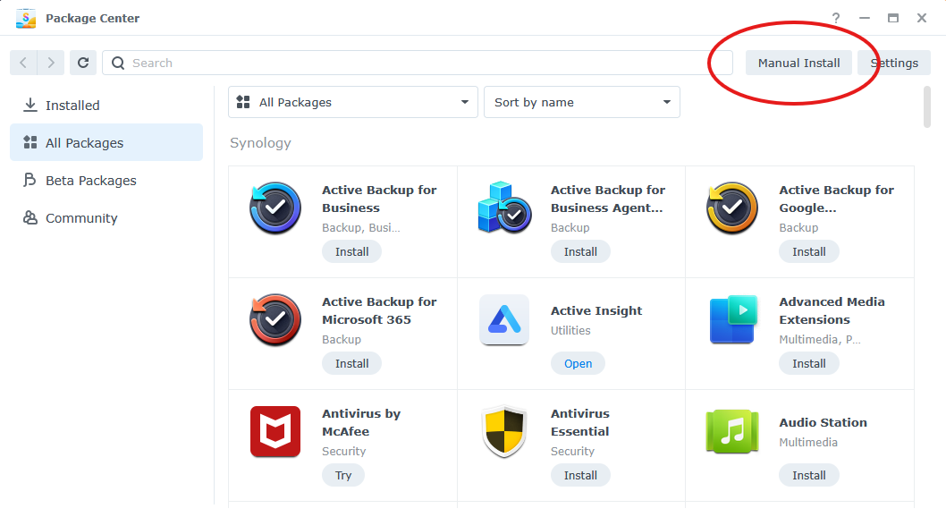
Package Center → Manual Install
Browse to the current SadlerACME .spk package, select it, and choose Next.

2. Accept the third-party package warning
DSM displays its standard warning for packages that are not verified by Synology. Review the warning and choose Agree to continue installing SadlerACME.
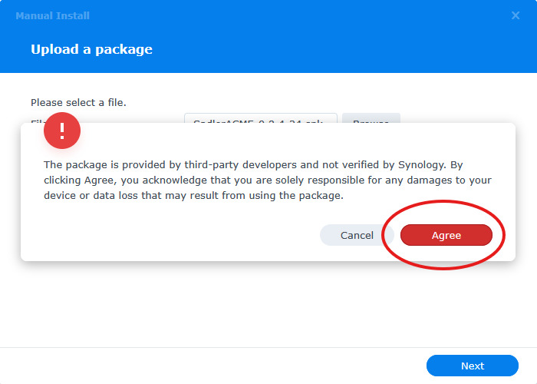
DSM third-party package acknowledgement
Public beta
SadlerACME is currently distributed as a public beta. Maintain normal NAS backups and keep an alternative way to access DSM while evaluating the package.

3. Confirm and complete installation
Review the package details. Leave Run after installation selected if you want SadlerACME to open immediately, then choose Done.
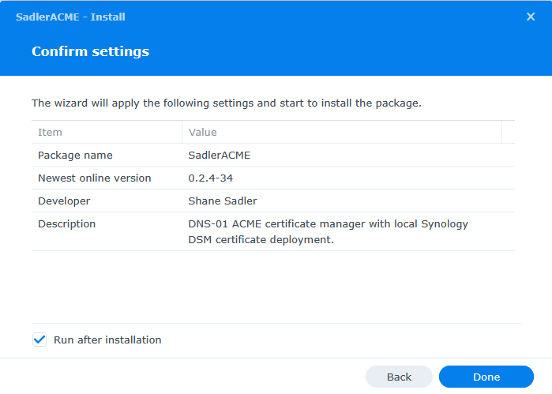
Confirm the package and complete installation
After installation, SadlerACME appears under Installed packages in Package Center and can also be opened from DSM’s application menu.
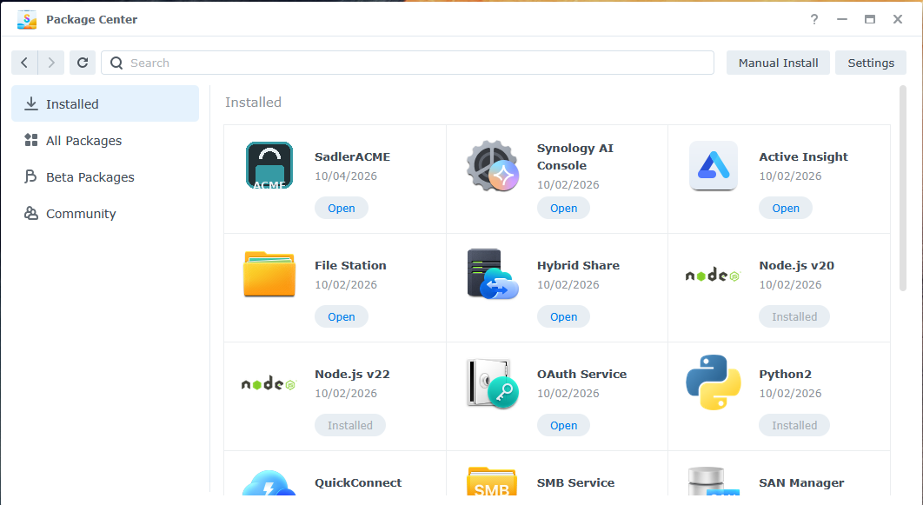
SadlerACME shown in Package Center after installation

4. First launch and Dashboard
On a fresh browser session, SadlerACME opens on the Dashboard. The Dashboard summarizes certificate health, DSM deployment state, renewal status, worker state and Cloudflare configuration.
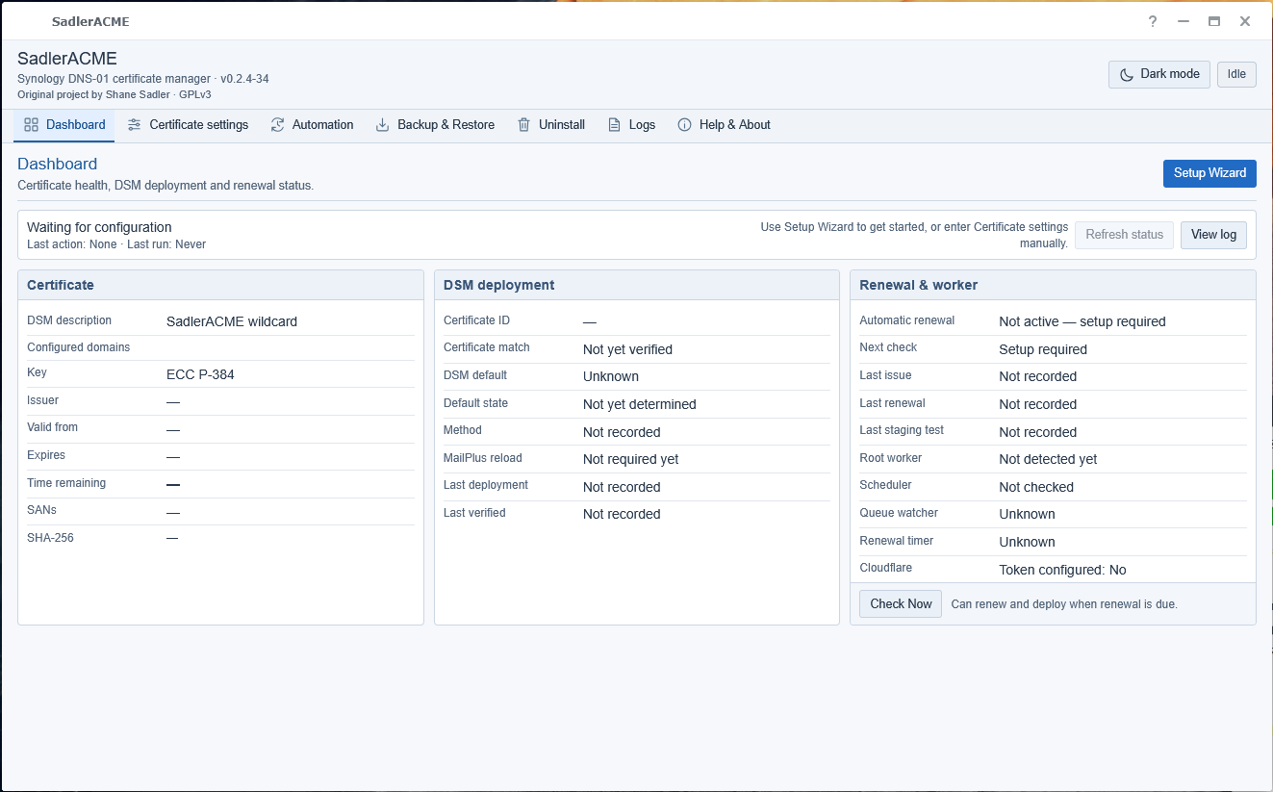
Dashboard — overall certificate, deployment and renewal status
Recommended starting point
Use Setup Wizard for the easiest guided setup. The wizard is available from both Dashboard and Certificate settings and does not start automatically.

5. Certificate settings
Certificate settings lets you configure SadlerACME directly without the wizard. Enter one DNS name per line. Wildcards such as *.example.com and additional SANs can be included on the same certificate.
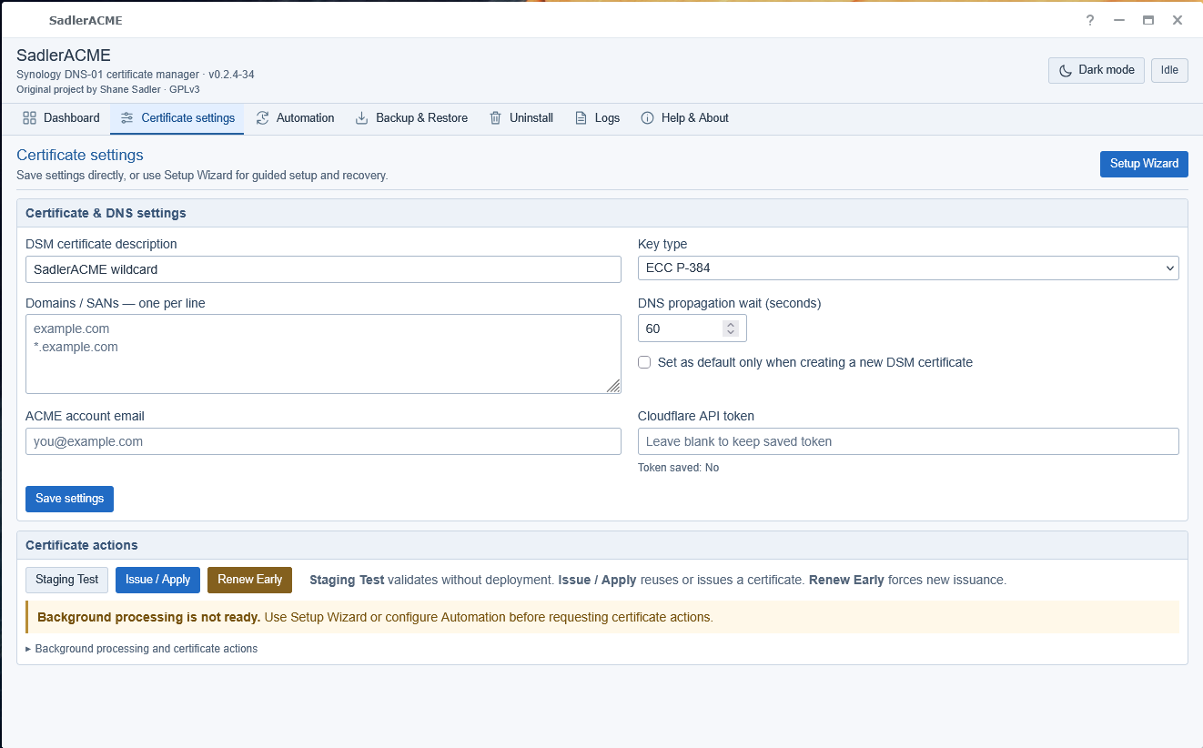
Certificate settings — wildcard and multi-domain configuration
The Cloudflare API token is used for DNS-01 validation. Recovery backups do not contain the token, so it must be re-entered when restoring on a new installation.
Certificate actions are deliberately separate from Save settings: Staging Test validates without deployment, Issue / Apply obtains or reuses a production certificate, and Renew Early forces a new issuance when required.

6. Automation
SadlerACME uses DSM Task Scheduler integration and background helpers so certificate checks can continue after a restart. The Automation page shows background-processing status, automatic-renewal settings and the expected boot-up task.
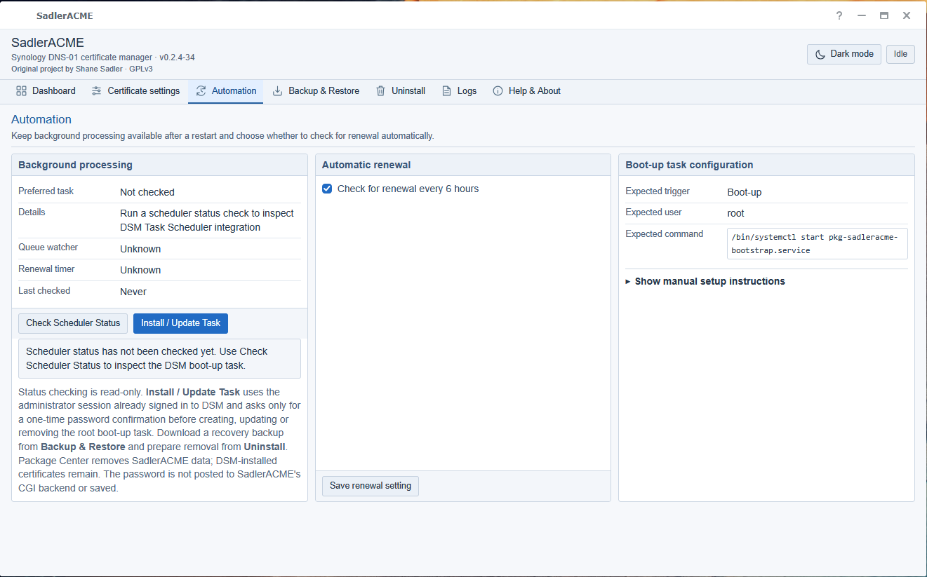
Automation — background processing, renewal interval and boot-up task
Check Scheduler Status is read-only. Installing or updating the DSM task may require administrator approval. The DSM administrator password is sent directly to DSM for approval and is not stored by SadlerACME.

7. Backup & Restore
Backup & Restore creates a recovery copy containing certificate keys, ACME recovery data and certificate settings when available. Keep the downloaded file private because it can contain private keys.
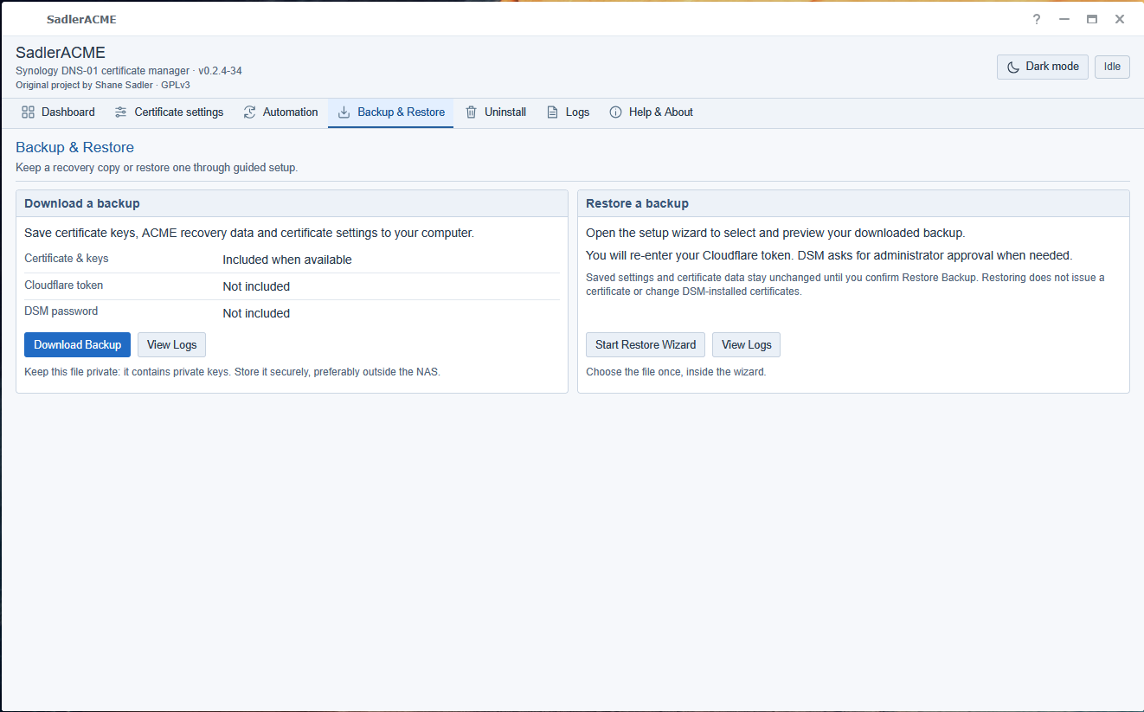
Backup & Restore — download a recovery backup or start the restore wizard
Not included in a recovery backup
The Cloudflare API token and DSM administrator password are deliberately excluded. They must be supplied again when required.

8. Prepare for uninstall
Use SadlerACME’s Uninstall page before removing the package from Package Center. Preparation stops the background helpers and renewal processing, handles pending work, and removes SadlerACME’s recognised DSM Task Scheduler entries.
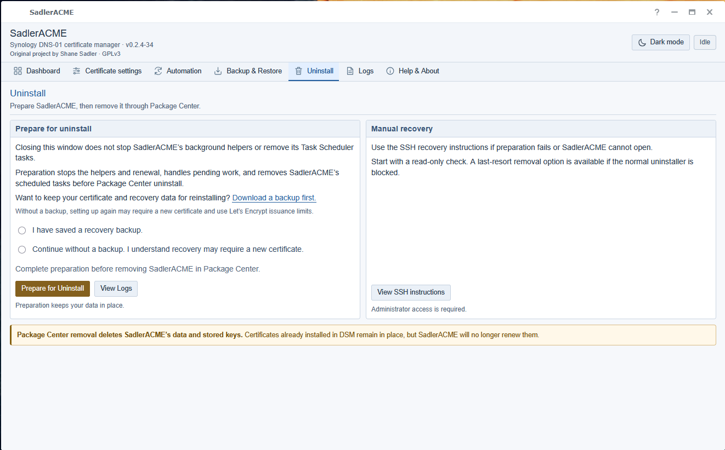
Uninstall — prepare background processing before Package Center removal
Download a recovery backup first if you may reinstall later. Certificates already installed in DSM remain in place after package removal, but SadlerACME will no longer renew them.
If normal preparation cannot complete, use the built-in manual recovery / SSH guidance rather than deleting individual scheduler entries and assuming all background processing has been removed.

9. Logs
The Logs page shows certificate operations and background processing. The viewer can be filtered, copied, paused and cleared. Long logs scroll inside the viewer so the toolbar remains accessible.
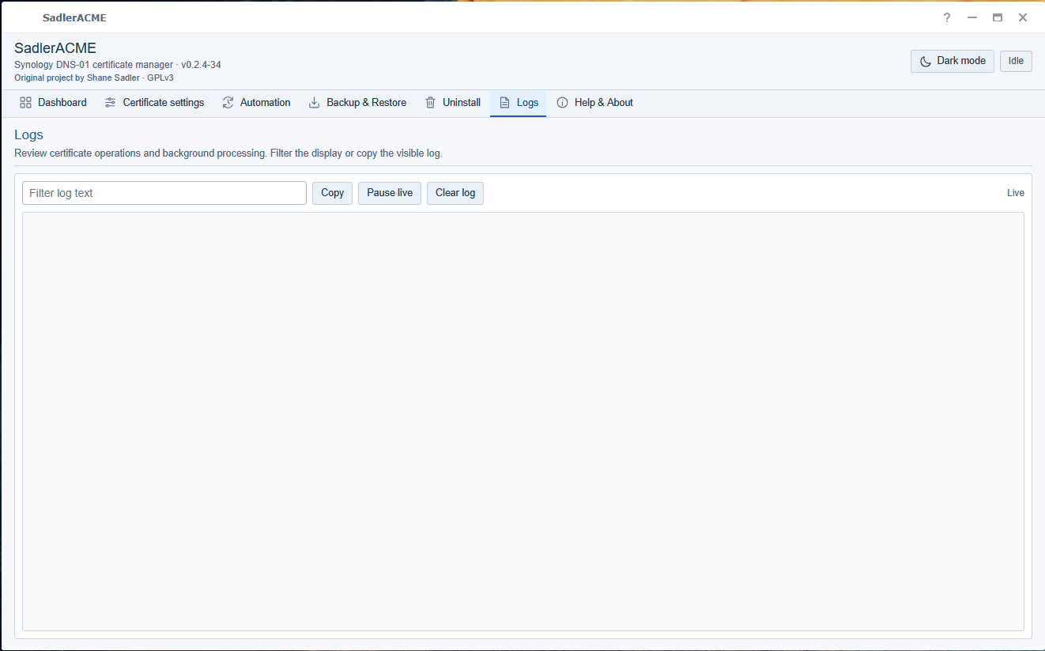
Logs — operational and background-processing information
When reporting a problem, include the relevant SadlerACME log output but remove or avoid sharing credentials, private keys, recovery backups and other sensitive material.

10. Help & About
Help & About provides the built-in QuickStart, setup and everyday-use guidance, recovery/manual-removal instructions, licensing information and project credits.
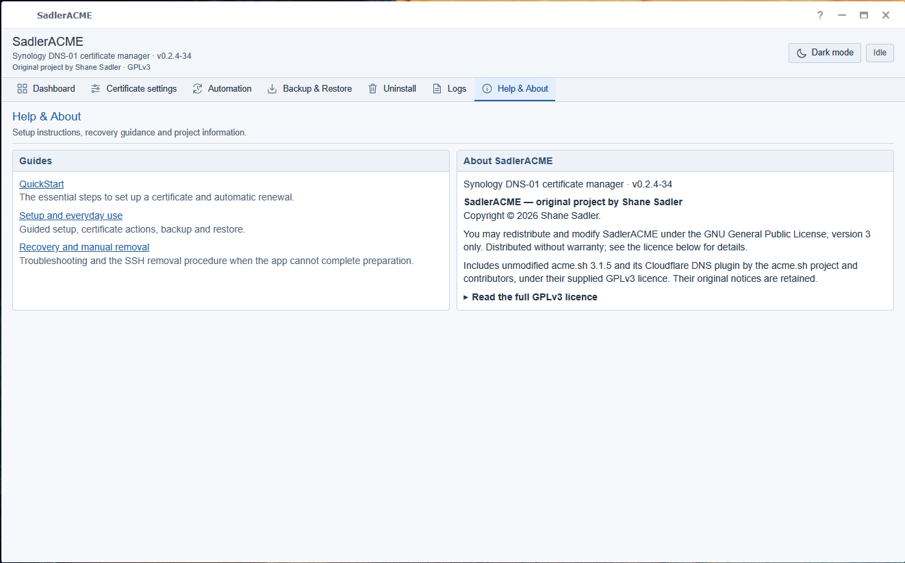
Help & About — built-in guides, licensing and project information
The application includes unmodified acme.sh and its Cloudflare DNS plugin under their supplied GPLv3 licence. SadlerACME itself is distributed under GPLv3 and retains the project credit for Shane Sadler.

Where to go next
For normal setup, return to Dashboard and choose Setup Wizard. The QuickStart guide covers the complete guided workflow, while Recovery and manual removal covers troubleshooting and the SSH recovery procedure if the application cannot complete preparation.

