Shane Sarnac
CSCI 3202
PS 2

1) Write a Program to play the game of SIM with eight points (labeled A-H) in which the computer competes against a user.

To accomplish this task, I first developed an implementation for the SIM game in which two human players could compete against each other while displaying the edges claimed by each player and the remaining edges that each player could choose. In the background of the program, the SIM game keeps four lists, one for each player, one for all the edges claimed, and one containing all of the nodes in the game.
Once a game could be played between two human players, I worked to modify the game so that an AI player could take the place of the second human. The AI player, called SimAI in the program, begins by looking at every edge it owns and counts how many times each particular node appears in its set of edges, storing the count in a dictionary to track how often a particular node is used. Then it uses its list of claimed edges and the list of all the claimed edges to determine which edges remain. From these edges, the SimAI builds a list tracking the “weight” of each edge, where the weight represents the sum of the total number of times each node in the edge is already used in the SimAI’s edge list. From this weight list, the SimAI randomly picks an edge with the smallest weight.
In theory, a triangle is more likely to happen when a particular node is used more frequently within a player’s set of edges. Therefore, by selecting edges with the least used nodes, the SimAI should perform reasonably well in defending against a human opponent. In practice, however, the strategy doesn’t work very well because the SimAI will sometimes pick edges that will form a triangle when non-triangle forming edges remain available. Additionally, because this is primarily a defense-based strategy, the AI does not typically leave options open that enables a human user to lose by accident. As a result, more often than not this strategy either produces a loss for the AI or a scratch game.
Relevant Code for Part 1:
class SimAI:
my_edges = []
opponents_edges = []
node_list = []
node_overlap = {}

def __init__(self, nodes):
self.node_list = nodes
for node in self.node_list:
self.node_overlap[node] = 0

def countNodeOverlap(self):
for node in self.node_list:
self.node_overlap[node] = 0
for edge in self.my_edges:
(node1, node2) = edge.getEdge()
self.node_overlap[node1] += 1
self.node_overlap[node2] += 1

def buildEdgeWeightTree(self, remaining):
weighted_edges = []
for edge in remaining:
(node1, node2) = edge.getEdge()
weight = self.node_overlap[node1] + self.node_overlap[node2]
weighted_edges.append((edge, weight))
return weighted_edges

def findBestEdge(self, remaining):
self.countNodeOverlap()
edge_weight_tree = self.buildEdgeWeightTree(remaining)
best_edge_weight = 100
best_edge = 0
for node in edge_weight_tree:
(edge, weight) = node
print("Edge: " + str(edge.getEdge()) + " Weight: " + str(weight))
if weight < best_edge_weight:
best_edge_weight = weight
best_edge = edge
return best_edge

def chooseBestEdge(self, myedges, oppedges, remaining):
self.my_edges = myedges
self.opponents_edges = oppedges
return self.findBestEdge(remaining)
An example of game play (full game not shown):
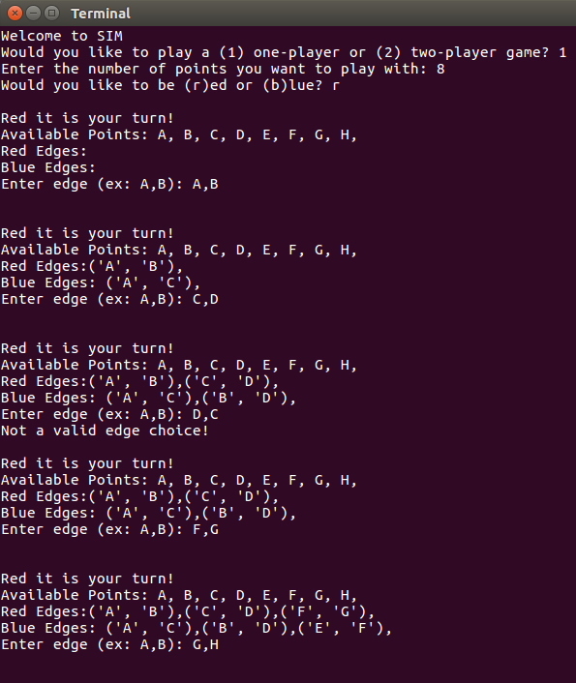
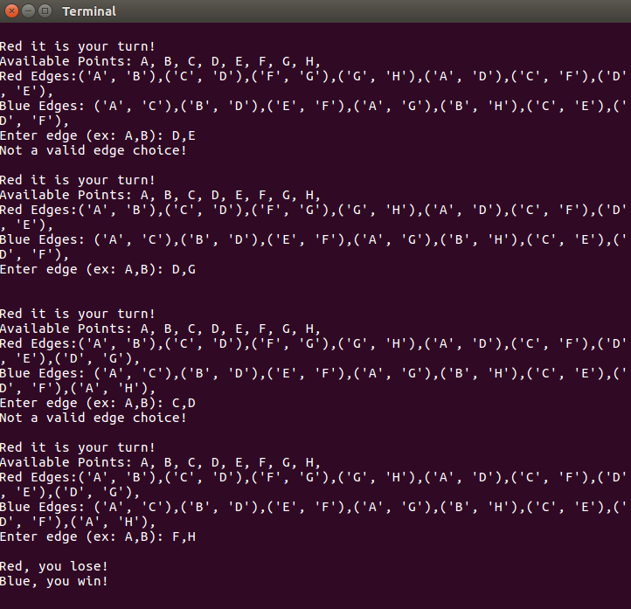
2) Construct a tree with a branching factor of 3 at each level, and 81 leaves. This tree will represent two complete MAX-MIN pairs of moves. The top level of the tree is MAX; the next level is MIN, and so on. The fifth level are the leaves of the tree, labeled with the following numbers, grouped in sets of 27, and reading from left to right:

837 259 538 257 948 632 495 172 246
147 842 578 246 956 102 453 927 317
956 401 345 123 734 432 827 193 273
(a) What is the overall value of this tree to MAX?

The overall value of this tree to MAX is 3.

(b) How many of these leaves actually have to be evaluated by an alpha-beta game search algorithm assuming that possible moves are examined from left to right?

From left to right, only 40 of the 81 nodes need to be examined by an alpha-beta game search algorithm. I did this by hand, which can be viewed in the P2Images folder in my CSCI-3202 repository on my github account for HW2.

(c) How many leaves have to be evaluated by alpha-beta assuming that moves are examined from right to left?

From right to left, only 46 of the 81 nodes need to be examined by an alpha-beta game search algorithm. I did this by hand, which can be viewed in the P2Images folder in my CSCI-3202 repository on my github account for HW2.

(d) Suppose the root player is MIN. Now how many of the 81 leaves have to be evaluated by an alpha-beta searcher if moves are examined from left to right?

By changing the order in which the players choose, this game results in a different evaluation result, giving a final value of 7 instead of 3. Using alpha-beta pruning, this can be accomplished by looking at only 43 of the 81 leaf nodes.
3) Sodoku Porblem
(a) Solve the following 4x4 Sodoku puzzle by hand

1 | 2 | 3 | 4
3 | 4 | 1 | 2
2 | 1 | 4 | 3
4 | 3 | 2 | 1

(b) part 1: Write the necessary statements of propositional logic to ensure that there is exactly one “3” in the fourth column of the puzzle.

(b) part 2: Write the necessary statements of propositional logic to derive the placement of a “3” in row 3, column 4; these statements should include starting constraints of the puzzle (e.g. “S144”, “S242”, and so on) and rules like the one you wrote in part 1 above. Finally show how you can use resolution, along with those statements to derive the truth of S343.

Before Resolution:
After First Resolution:
After Second Resolution:

