Shane Sarnac
CSCI 3202
Problem Set 4
Fall 2017

Problem 4.1
Output:
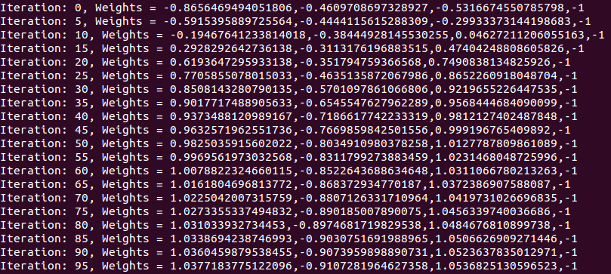
Note: The weights in the output given above are listed in the order: A, B, C, D. For this output, I let , which allowed the weights to normalize quickly. While these edge weights are approaching the theoretical solution of (1,-1,1,-1), the errors remain pretty high and consistent, even with many iterations.

Note also, that I tried running this program with various values, including 0.1 and 0.01 with similar results. However, while the relative magnitude is about the same for each weight, the magnitude of edge B is always slightly smaller than the magnitude of each A and C, which gives correct (albeit barely) results when rounding the output function.

Problem 4.2
Output:
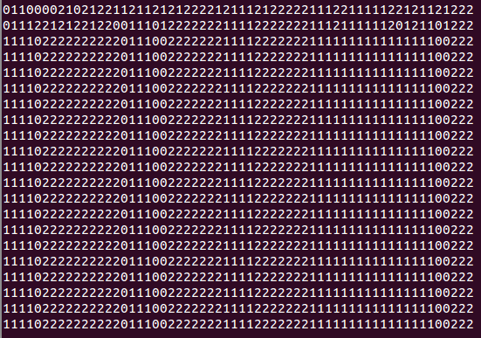
Note: Each line represents the city after 20 iterations for a total of 400 iterations. Note that the city becomes stable within the first 60 iterations. Consider the following which shows the city after 100 iterations, each line representing 5 iterations:
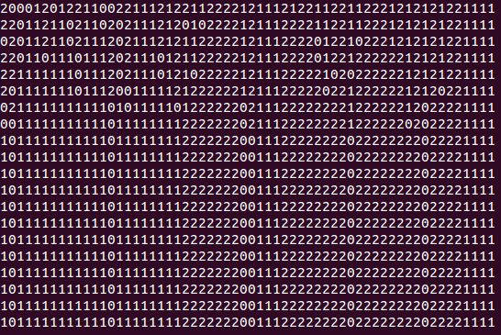
Much like the first output above, the city reaches a steady state within 60 iterations (albeit normalizing around 50 iterations). This shows that neighborhoods will form if it is assumed all people will want to have two neighbors be like them as the clusters are pretty clearly identifiable.
Problem 1 Code: perceptron.js

function Perceptron(iterations, printing_frequency) {
var data_set = [
[0, 0, 0, 1],
[1, 0, 0, 1],
[0, 1, 0, 1],
[0, 0, 1, 1],
[1, 1, 0, 1],
[0, 1, 1, 1],
[1, 0, 1, 1],
[1, 1, 1, 1]
];
var expected = [0, 0, 0, 0, 0, 0, 1, 1];
var nodes = [];
var node_weights = [];
var threshold = 0.5;
// Set initial edge weights
node_weights = defineRandomWeights(3);
node_weights = node_weights.concat(-1);
runSimulation(iterations, printing_frequency, data_set, expected, node_weights);
};

function runSimulation(iterations, printing_frequency, data_set, expected, node_weights) {
var sum, output, error;
for (var i = 0; i < iterations; i++) {
if (i % printing_frequency == 0) {
printWeights(i, node_weights);
}
for (var j = 0; j < data_set.length; j++) {
sum = calculateSum(data_set[j], node_weights);
output = outputFunction(sum);
error = calculateError(output, expected[j]);
if (i % printing_frequency == 0) {
//printResults(data_set[j], expected[j], output);
}
for (var k = 0; k < node_weights.length-1; k++) {
node_weights[k] = adjustWeight(sum, error, data_set[j][k], node_weights[k]);
}
/*console.log("edge_weights = " + node_weights + " (after) \n");*/
/*if (i == iterations-1) {
printResults(data_set[j], expected[j], output);
}*/
}
}
}
function adjustWeight(sum, error, node_value, node_weight) {
var alpha = 0.01;
var new_weight = node_weight + alpha * error * outputFunctionPrime(sum) * node_value;
return new_weight;
}

function calculateSum(node_values, node_weights) {
var sum = 0;
for (var i = 0; i < node_values.length; i++) {
sum += node_weights[i] * node_values[i];
}
return sum;
}

function sigmoidalFunction(x) {
return 1 / (1 + Math.exp(-x));
}

function outputFunction(sum) {
return sigmoidalFunction(sum);
}

function outputFunctionPrime(sum) {
return sigmoidalFunction(sum) * (1 - sigmoidalFunction(sum));
//return Math.exp(sum) / Math.pow(Math.exp(sum) + 1, 2);
}

function calculateError(output, expected) {
return expected - output;
}

function main() {
new Perceptron(10000, 500);
}
main()
Problem 2 Code: neighborhood.py

class House:
occupied = 0
def __init__(self, occ):
if occ < 0:
print("invalid occupant")
exit()
self.occupied = occ

def isOccupied(self):
return self.occupied != 0

def getOccupant(self):
return self.occupied

class Neighborhood:
total_ones = 0
total_twos = 0
total_empty = 0
neighborhood = []
empty = [] # holds the indices of empty homes in the neighborhood

def __init__(self, ones, twos, empty):
self.total_ones = ones
self.total_twos = twos
self.total_empty = empty
self.buildNeighborhood()
#self.printNeighborhood()

def buildNeighborhood(self):
ones_remaining = self.total_ones
twos_remaining = self.total_twos
empty_remaining = self.total_empty

while ones_remaining > 0 or twos_remaining > 0 or empty_remaining > 0:
occupant = randint(0,2)
if occupant == 2 and twos_remaining > 0:
self.neighborhood.append(House(occupant))
twos_remaining = twos_remaining - 1
elif occupant == 1 and ones_remaining > 0:
self.neighborhood.append(House(occupant))
ones_remaining = ones_remaining - 1
elif occupant == 0 and empty_remaining > 0:
self.neighborhood.append(House(occupant))
empty_remaining = empty_remaining - 1
self.empty.append(len(self.neighborhood)-1)
def printNeighborhood(self):
neighborhood_str = ""
zeroes_str = ""
for i in range(len(self.neighborhood)):
neighborhood_str += str(self.neighborhood[i].getOccupant())

for i in range(len(self.empty)):
zeroes_str += str(self.empty[i]) + ","
# print(neighborhood_str + " " + zeroes_str)
# print(neighborhood_str + "\n")
print(neighborhood_str)

def findDissatisfied(self):
neighborhood_size = len(self.neighborhood)
dissatisfied = [] # contains index of dissatisfied occupants
left_1 = 0
left_2 = 0
right_1 = 0
right_2 = 0

for i in range(len(self.neighborhood)):
preferred_neighbor_count = 0
left_2 = self.neighborhood[(i-2)%neighborhood_size].getOccupant()
left_1 = self.neighborhood[(i-1)%neighborhood_size].getOccupant()
occupant = self.neighborhood[i].getOccupant()
right_1 = self.neighborhood[(i+1)%neighborhood_size].getOccupant()
right_2 = self.neighborhood[(i+2)%neighborhood_size].getOccupant()

if occupant == left_2:
preferred_neighbor_count += 1
if occupant == left_1:
preferred_neighbor_count += 1
if occupant == right_1:
preferred_neighbor_count += 1
if occupant == right_2:
preferred_neighbor_count += 1

if preferred_neighbor_count < 2 and occupant != 0:
dissatisfied.append(i)
return dissatisfied

def moveDissatisified(self, dissatisfied):
if len(dissatisfied) == 0:
return
random_dissatisfied_index = dissatisfied[randint(0, len(dissatisfied)-1)]
random_empty_index = randint(0, len(self.empty)-1)

# get the unhappy resident from the neighborhood and make the home empty
unhappy_occupant = self.neighborhood[random_dissatisfied_index]
self.neighborhood[random_dissatisfied_index] = House(0)

# find a new empty home, move the resident into it,
# and store the the new empty home in the empty list
new_home = self.empty[random_empty_index]
self.neighborhood[new_home] = unhappy_occupant
self.empty[random_empty_index] = random_dissatisfied_index

def runSimulation(self, print_iter, max_iter):
for i in range(max_iter):
if i % print_iter == 0:
self.printNeighborhood()
dissatisfied = self.findDissatisfied()
self.moveDissatisified(dissatisfied)

def main():
neighborhood = Neighborhood(27, 27, 6)
neighborhood.runSimulation(5, 100)
main()

