Shane Sarnac
APPM 4650
Homework 3: Numerical Differentiation and Integration
- Use the most accurate three-point formula to determine each missing entry in the following table.
1.1 | 9.025013 | 17.7697
1.2 | 11.02318 | 22.1936
1.3 | 13.46374 | 27.1073
1.4 | 16.44465 | 32.5109

Explanation:
To determine the estimated values for at each , two different formulas, one for the end points and for middle points . Although the same general formula was used for each endpoint, the sign associated with the coefficients was actually the opposite of each other.
Thus for ,

Similarly for ,

Then for the two middle points, I used the following formulas

Note that the error bound for both end points is and at the mid points is for some unknown value of between and .
- Derive a five-point method for approximating by expanding the function in a fourth-order Taylor polynomial about . The result should be written in terms of evaluated at and . show that the error is .
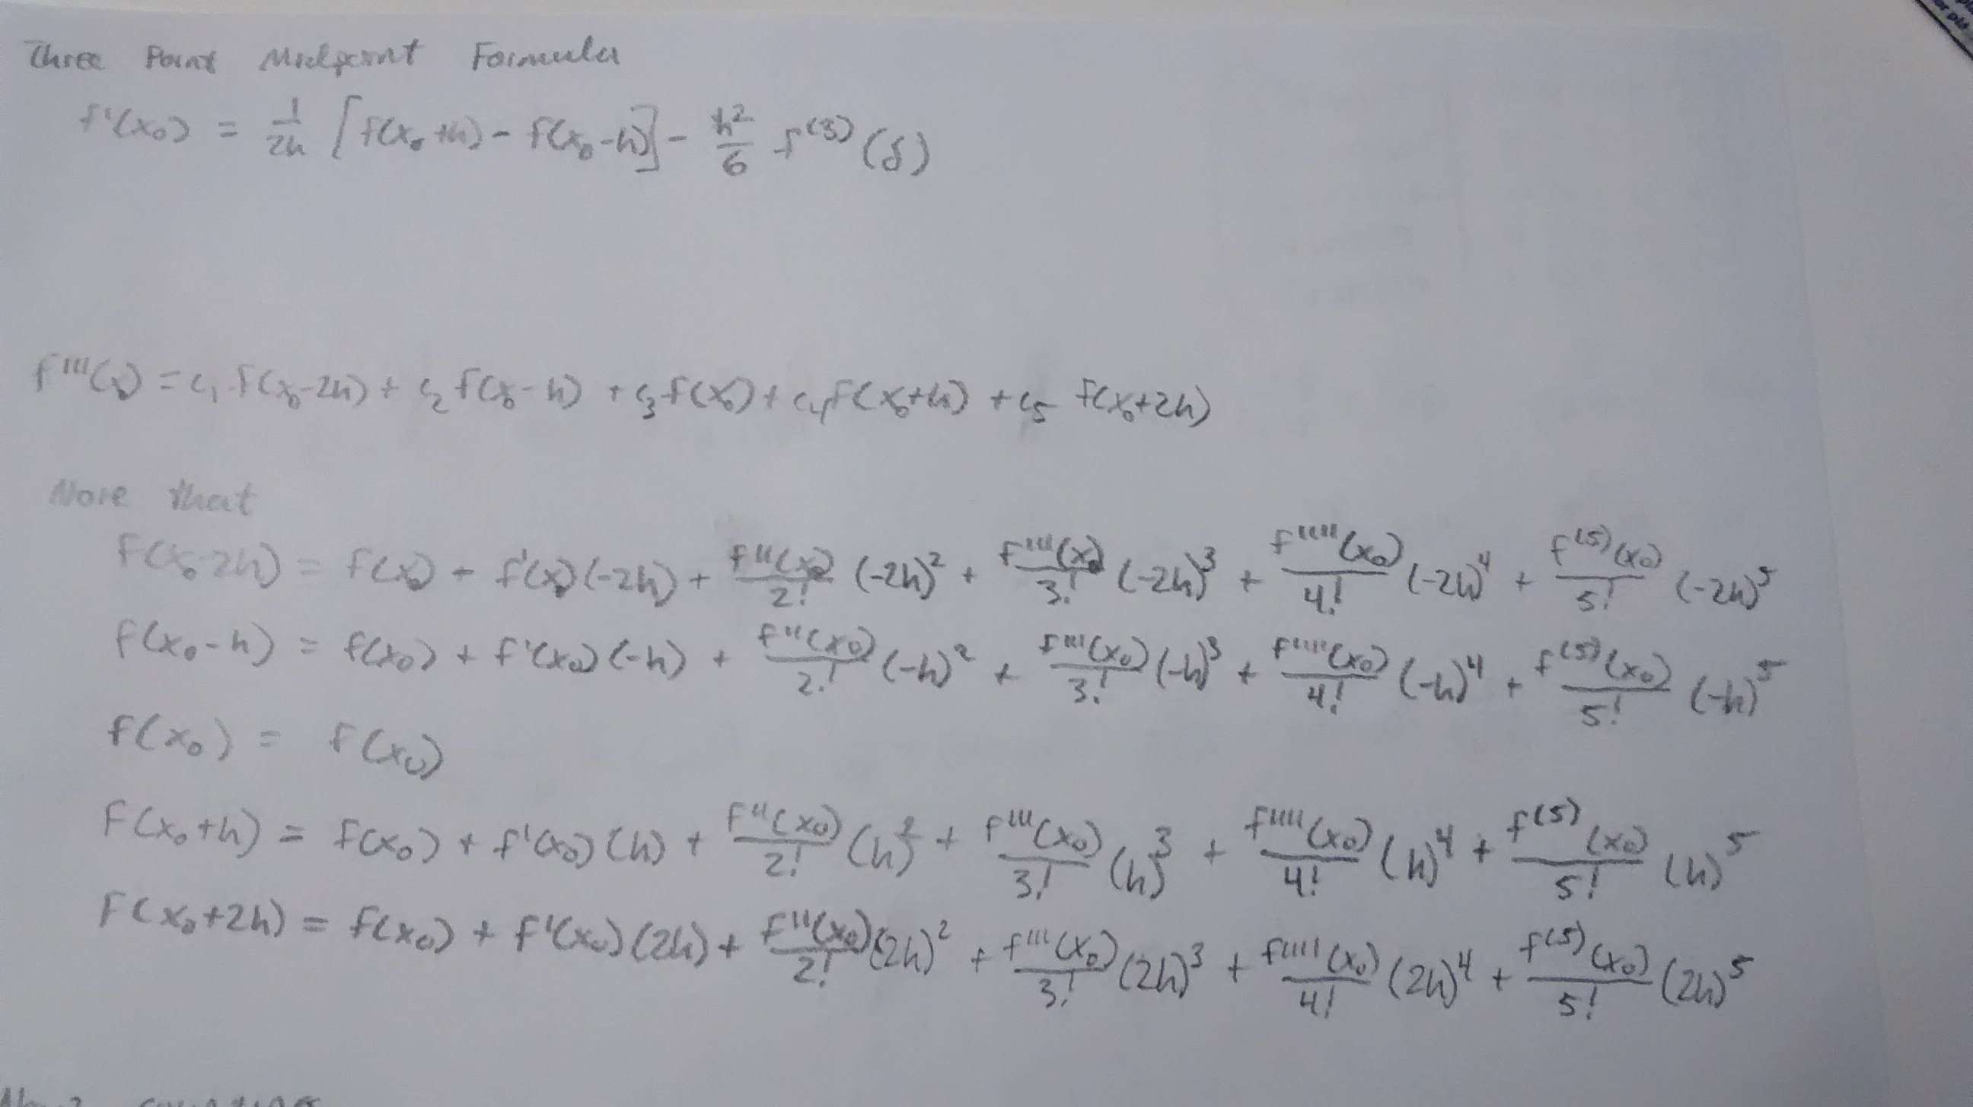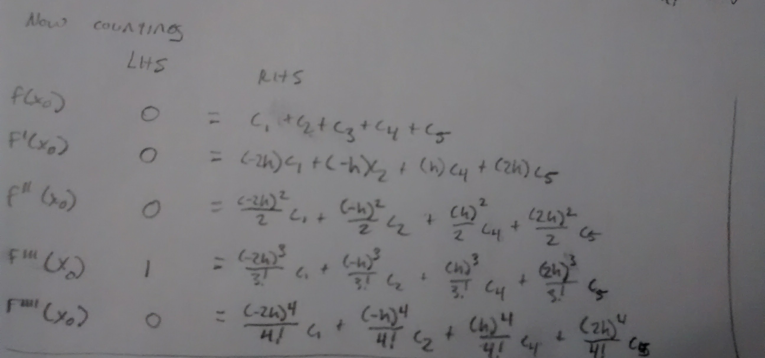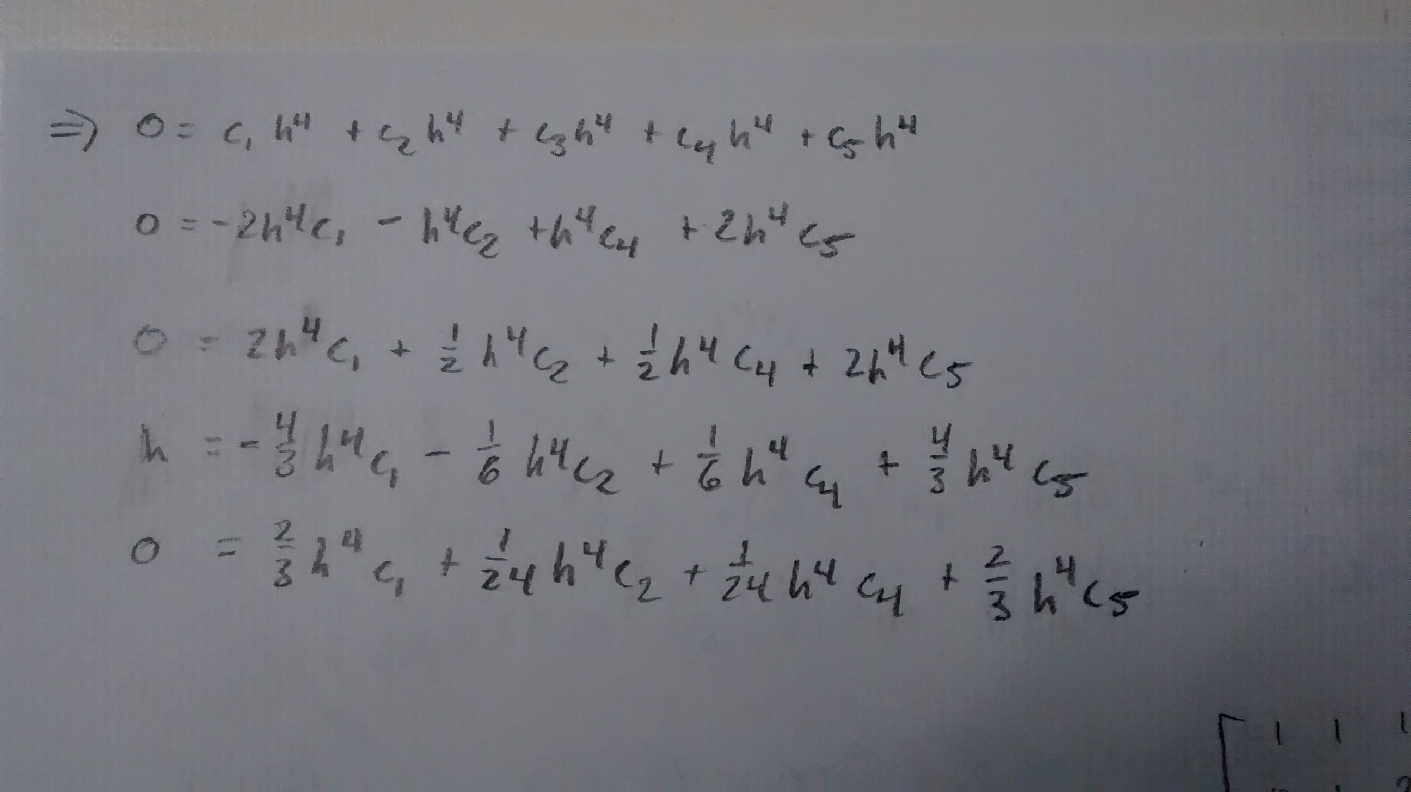

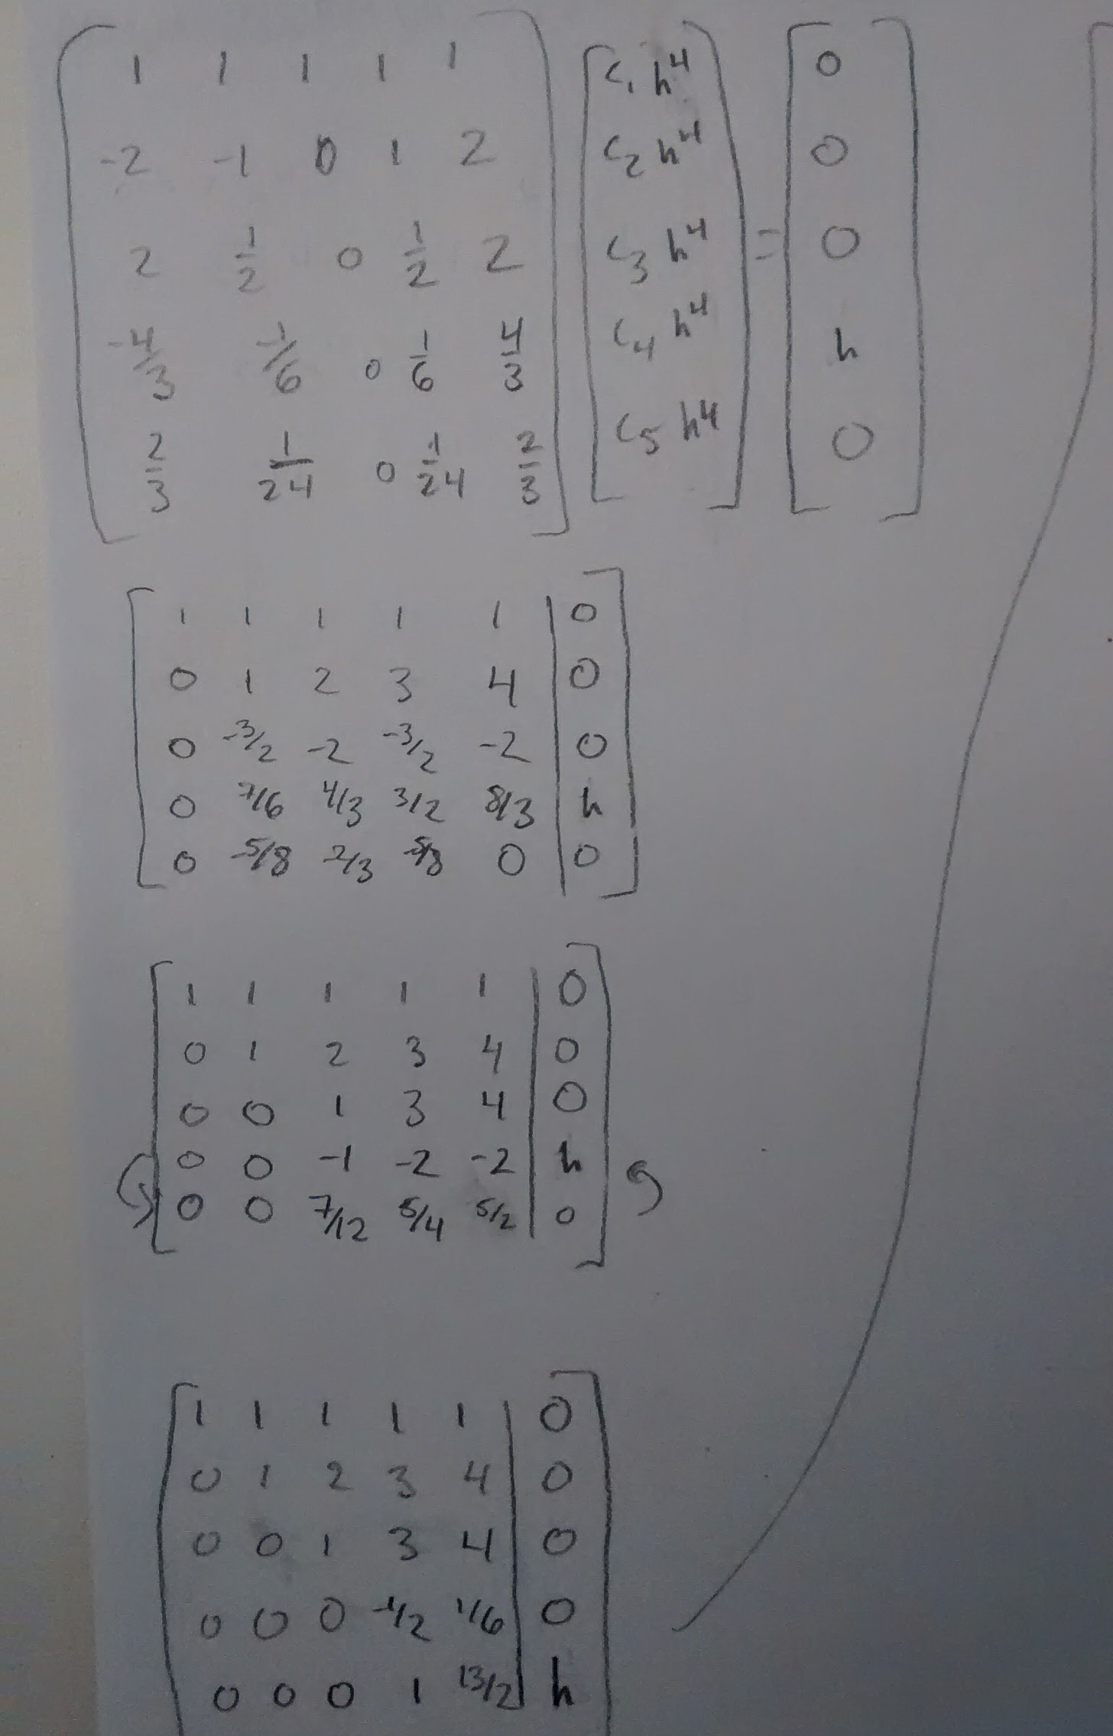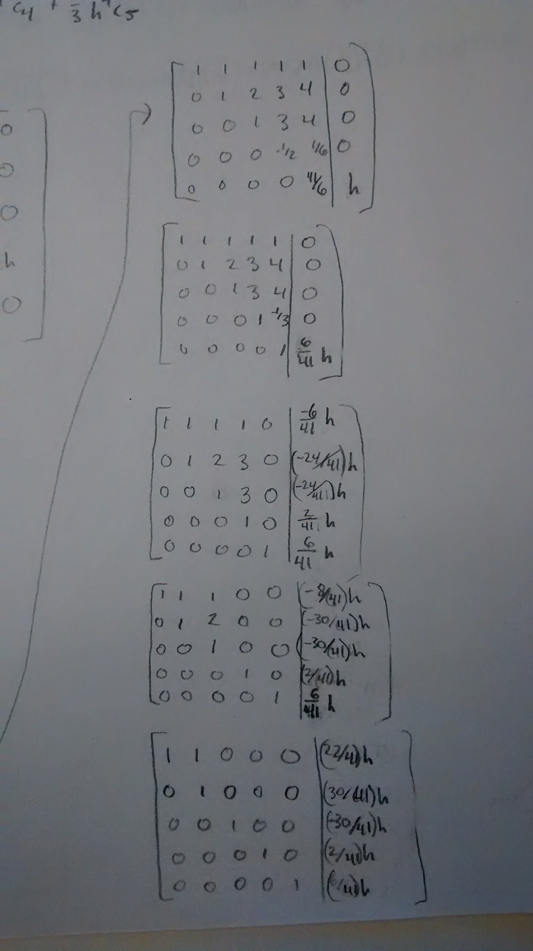
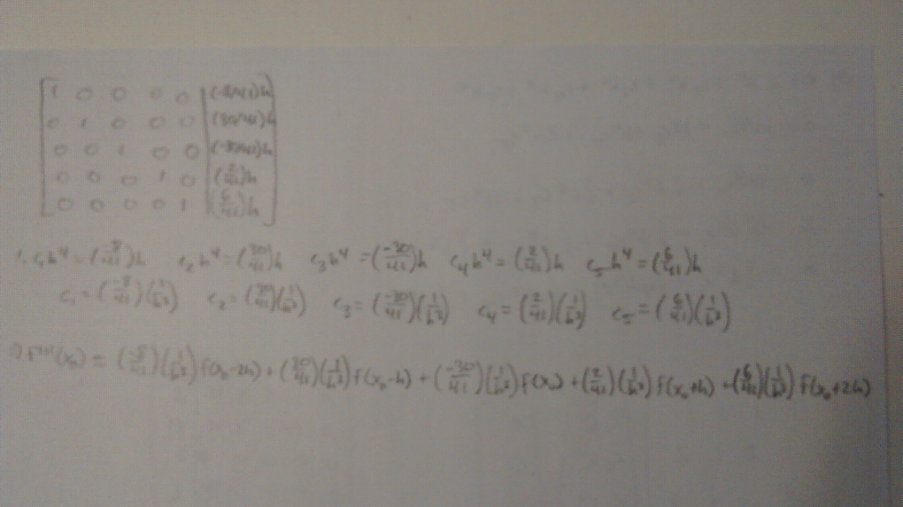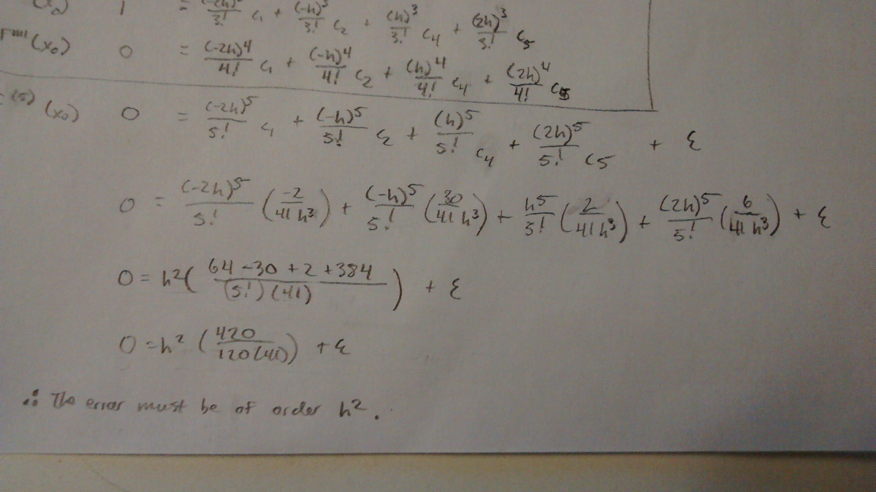
Final answer:
- Use Taylor series expansions to find three-point forward and backward expressions for . (Note: also attached in back if print-out is not legible)
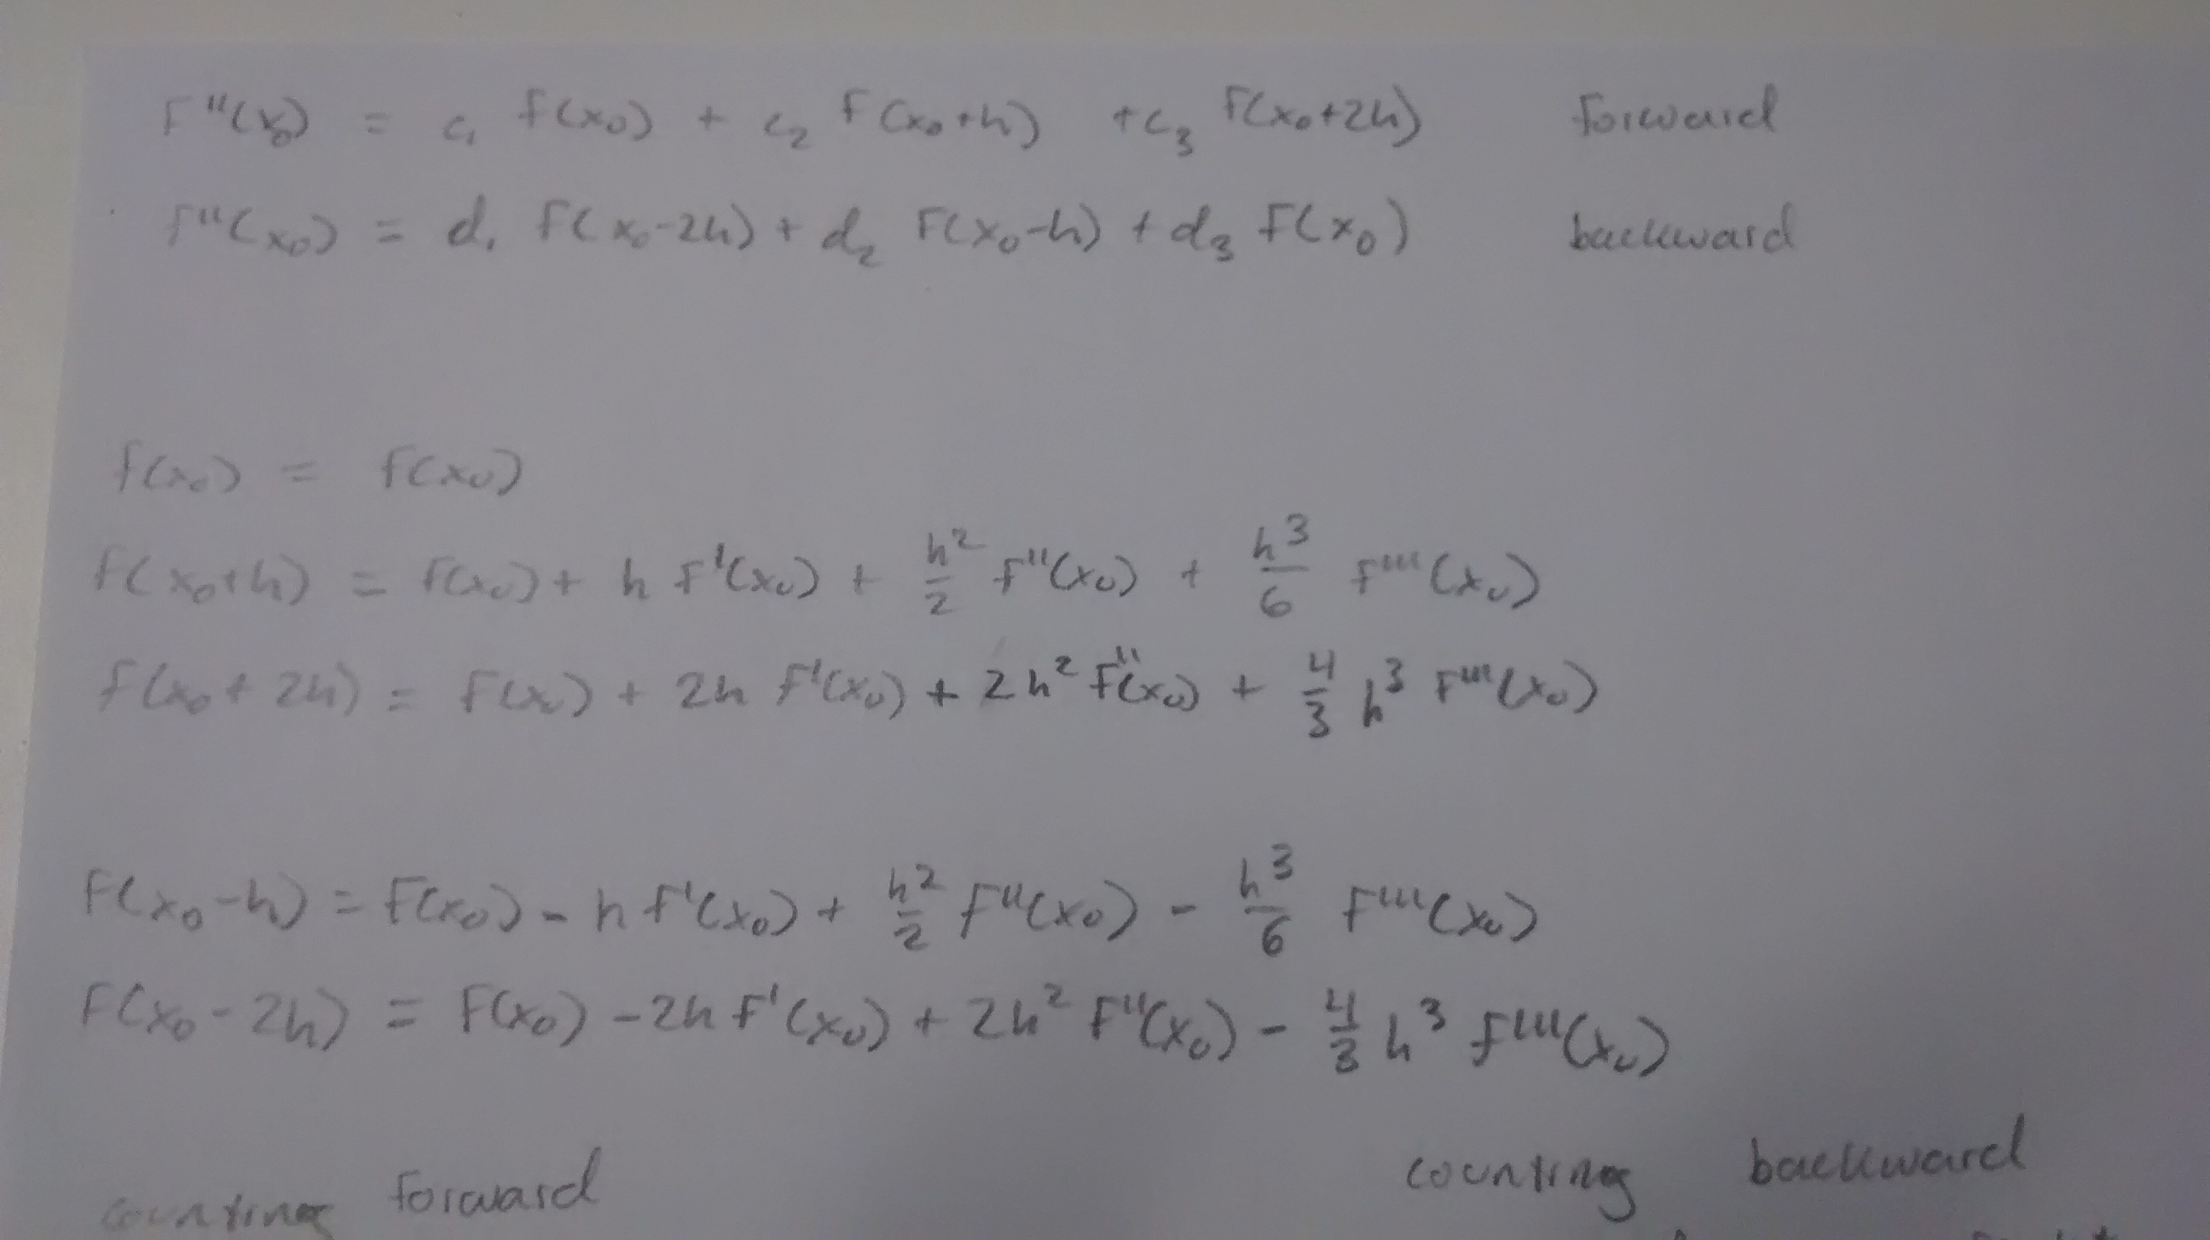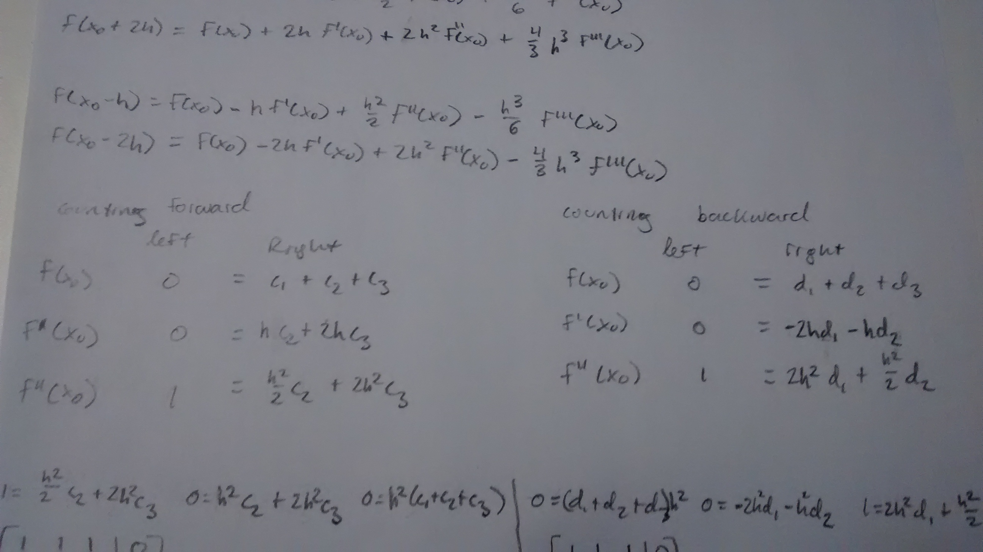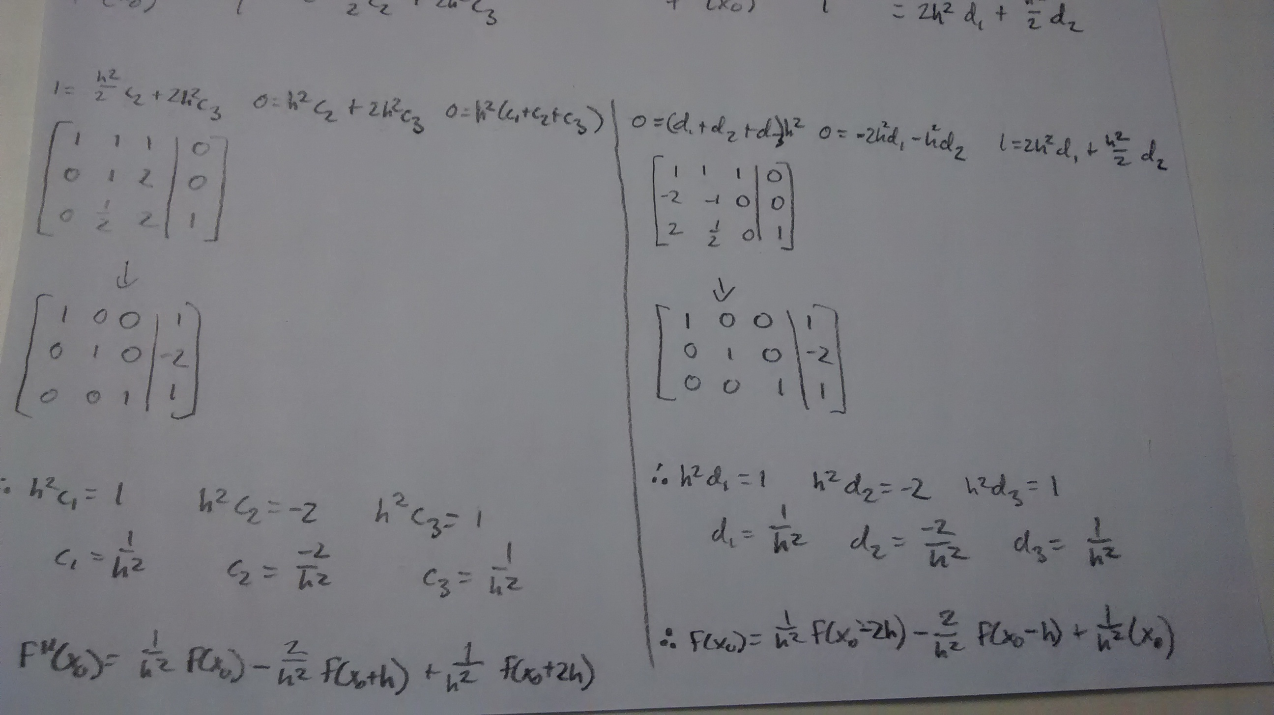

- Use Taylor series expansions to arrive at the expression

which we found in class using Lagrange polynomials.
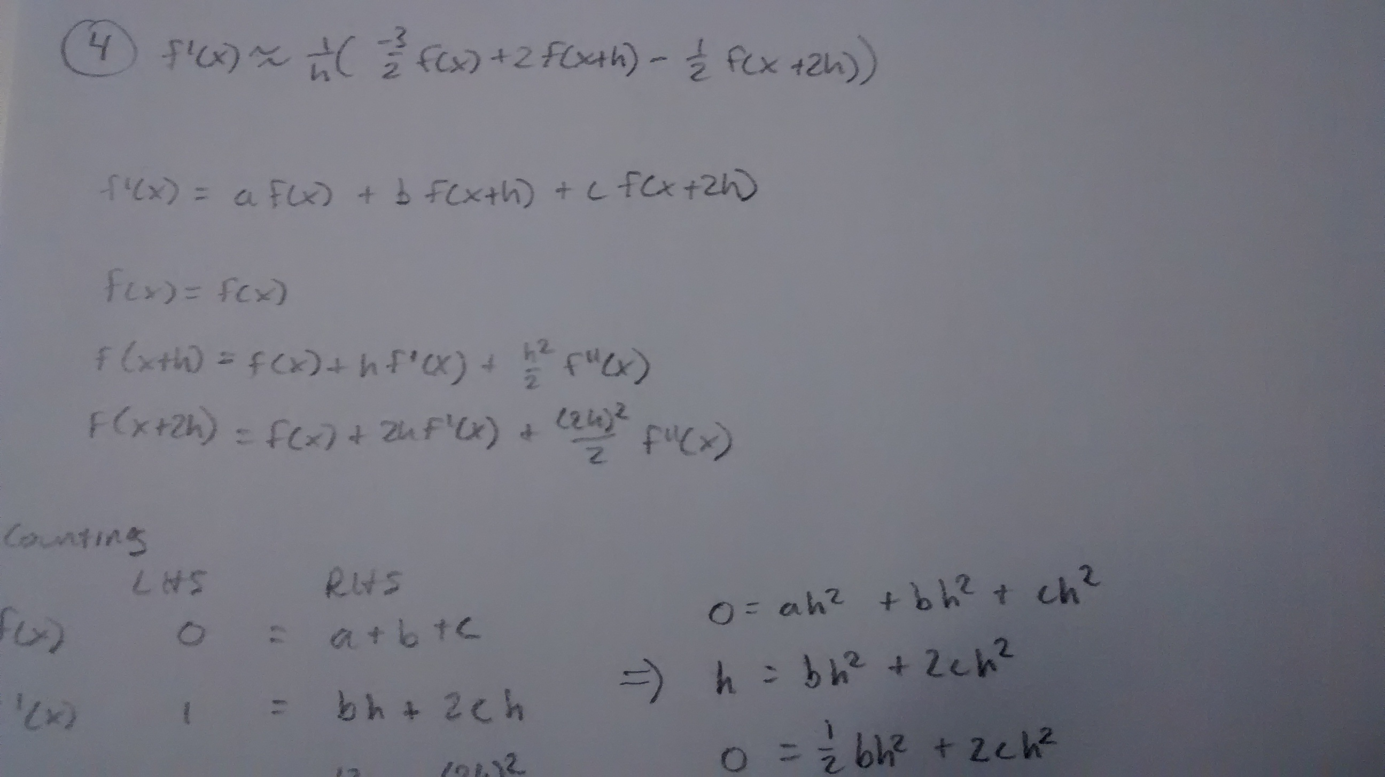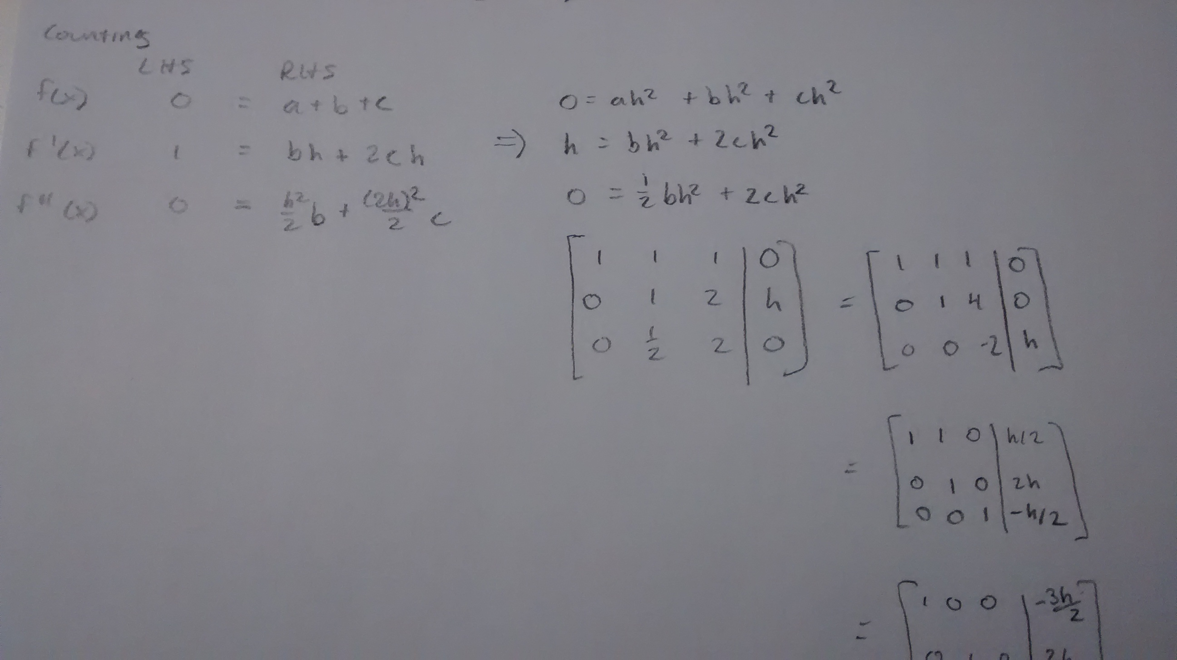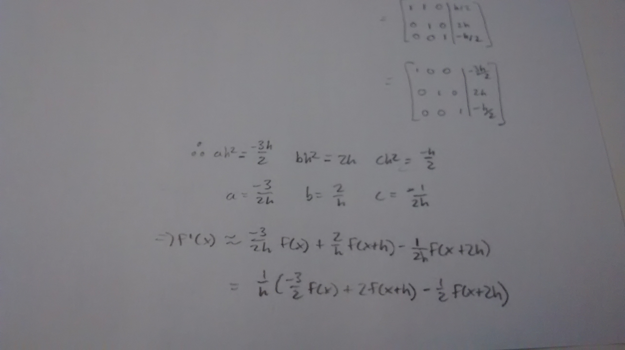
- Derive Simpson's Rule using
  - Lagrange polynomials
  - Taylor comparison

(a) Lagrange polynomials
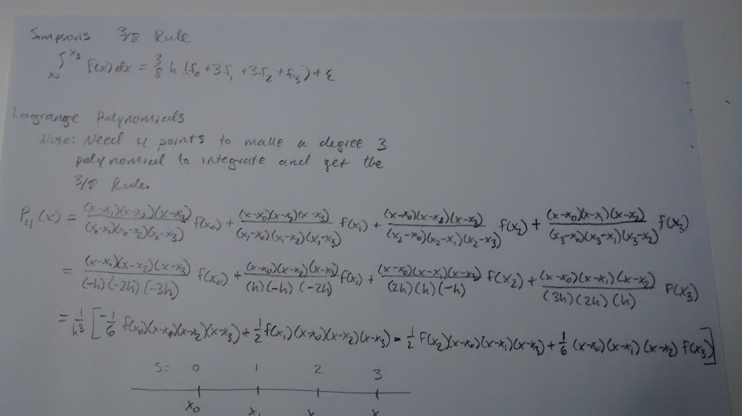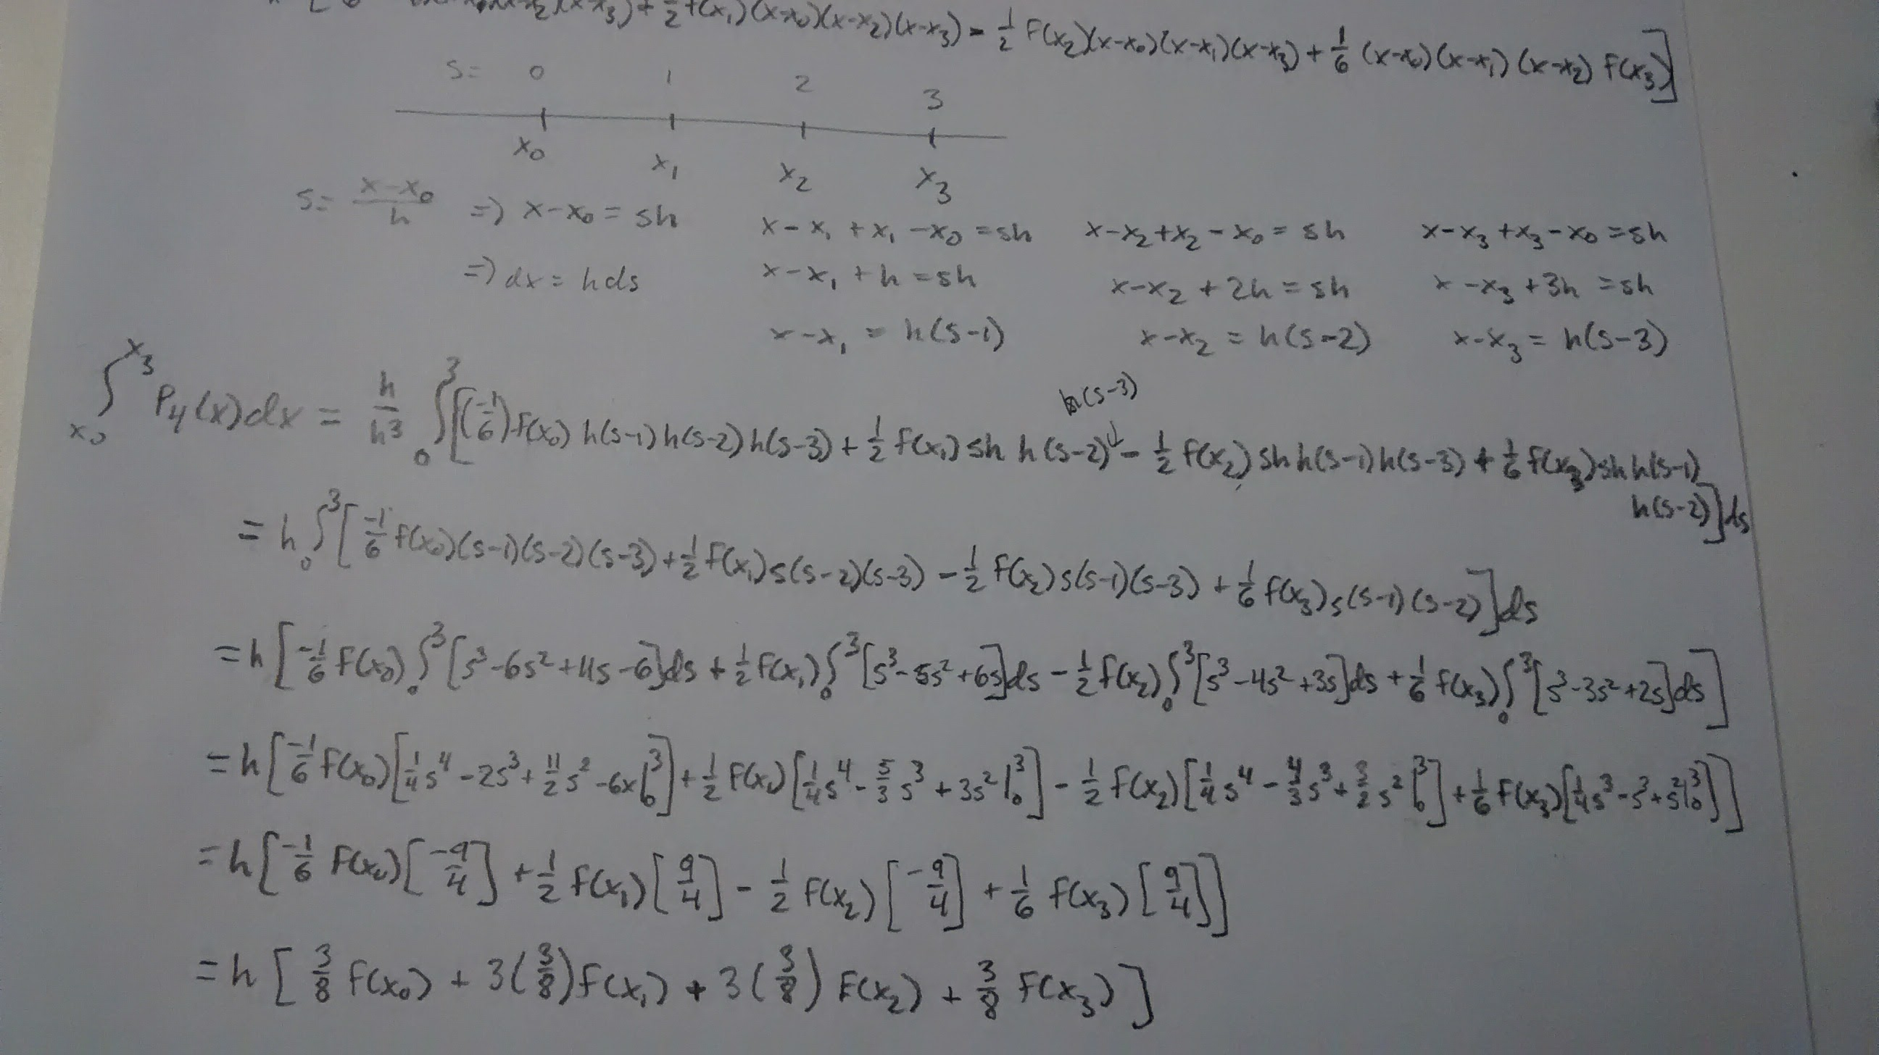Finally,

- Approximate the value of using the following methods with .
  - Composite Midpoint rule.
  - Composite Trapezoidal rule.
  - Composite Simpson's rule.

(a) Recall that the Composite Midpoint Rule is for . Using this expression, I found

(b) Recall that the Composite Trapezoidal Rule is for . Using this expression, I found

(c) Recall that the Simpson's Composite Rule is

Using this expression, I found

- Approximate the integral using Gaussian quadrature and compare your results to the exact values of the integral.
  - Use (b) Use
Solution
Note that, before performing the computer-based calculation, first consider the true value of the given integral.

With the known answer in mind, now consider the Gaussian quadrature. Recall that for Gaussian quadrature to work, the bounds on the integral must be between -1 and 1. To do this, we first apply the transformation which implies .
After simplifying, for our equation, we get .

(a) Using this, we can now find the Gaussian Quadrature for . Recall that the optimal values for are . Now we apply the algorithm:

Note that this result is off by from the exact answer, or .

(b) Now consider for . Recall that the optimal values for are with coefficients of as in the following:

Note that this result is off by

