Shane Sarnac
APPM 4650
Fall 2016
HW 1

- Use a tolerance of on the relative change of (specifically ) to find the root of using the Bisection, Fixed Point Iteration, Newton-Raphson, Secant, and False Position Methods. How many iterations are required for convergence using each method assuming you start with the same initial guess (es)?

Note: where applicable, and .

Method | Value of Convergence | Number of iterations
Bisection | -0.567143 | 55
Fixed Point | -0.567119 | 17
Newton | -0.567143 | 4
Secant | -0.567143 | 7
False Position | -0.567143 | 7

- Section 2.1 Material:
  - Use the Bisection method to find an approximation to within to the first positive value of x with .

Note that the number 0 is non-positive. Provided this, and looking at a plot of

I estimated that the root should be somewhere between 3 and 4.6, values that I used as my initial guesses. With these guesses, my bisection method required 20 iterations to reach the value of .
Iteration | Estimate
1 | 3.8
2 | 4.2
3 | 4.4
… | …
18 | 4.49341…
19 | 4.49341…
20 | 4.49341

  - Find an approximation to correct to within using the Bisection Algorithm. Hint: Don’t simply try to try to find the root of . Use another function with the same root.

Using the function and initial guesses of and , I found that the root, where , is approximately 2.9375, which required 4 iterations to reach.
Iteration | Estimate
1 | 2.5
2 | 2.75
3 | 2.875
4 | 2.9375

- Section 2.2 Material:
  - Use the fixed-point iteration method to determine the root(s) of . Your results should be accurate to within .

With and , the first discovered root is , discovered after two iterations, where the estimates of -4.89859e-16 and 3.07787e-15. However, no matter how I rearrange the formula ( i.e. ) , I am only able to achieve the single solution, regardless of the different values I choose. Graphically, there should be a total of 5 solutions, but the fixed-point iteration method limits the findable solutions to just the single solution.

- Section 2.3 Material:
  - The iteration equation for the Secant method can be written in the simpler form

Explain why, in general, this iteration method is likely to be less accurate than the algorithm given in Algorithm 2.4.

Recall that the iteration method given in Algorithm 2.4 is . The key difference between the two formulas is the order of the multiplication/subtraction instructions in the numerator. In the method given in Algorithm 2.4, the subtraction occurs first, followed by the multiplication, whereas the simplified equation performs the multiplication first, followed by the multiplication.
Performing the subtraction first reduces the potential for overflow when the multiplication is performed. In the reduced version of the algorithm, the magnitude of the multiplication of or could exceed the number of bytes allocated to store each number, causing overflow and thus losing accuracy. Algorithm 2.4 avoids this by subtracting the x values first, thus multiplying a small number by a potentially large number, reducing the chances of overflow.

  - Use Newton’s Method for this problem. Problems involving the amount of money required to pay off a mortgage over a fixed period of time involve the formula

known as an ordinary annuity equation. In this equation, A is the amount of the mortgage, P is the amount of each payment, and is the interest rate per pay period for the pay periods. Suppose that a 30 year home mortgage in the amount of $135,000 is needed and that the borrower can afford house payments of at most $1000 per month . What is the maximal interest rate the borrower can afford to pay?

Note that in the problem, it is given that , , and .
Therefore, the equation becomes . After rearranging to solve for zero, the equation simplifies to . Note that the derivative of this function is . Using this information and an initial guess of and , Newton’s method evaluates to an interest rate of after three iterations.

Iteration | Estimate
1 | 0.00740741
2 | 0.00676906
3 | 0.00674994

- In class we used Fixed Point Iteration to find the roots of . One of the more obvious choices to lead us to . Explore the convergence characteristics of relative to the magnitude of near each of the roots of . Also please include “spider web” graphs for several initial guesses to help support your conclusions.

Recall that when , there is at least one root near all the x values that satisfy the relationship. Here, . Therefore, there is a root near the interval . Recall that there is a root when , thus it is likely that any initial value in the indicated interval will converge to .
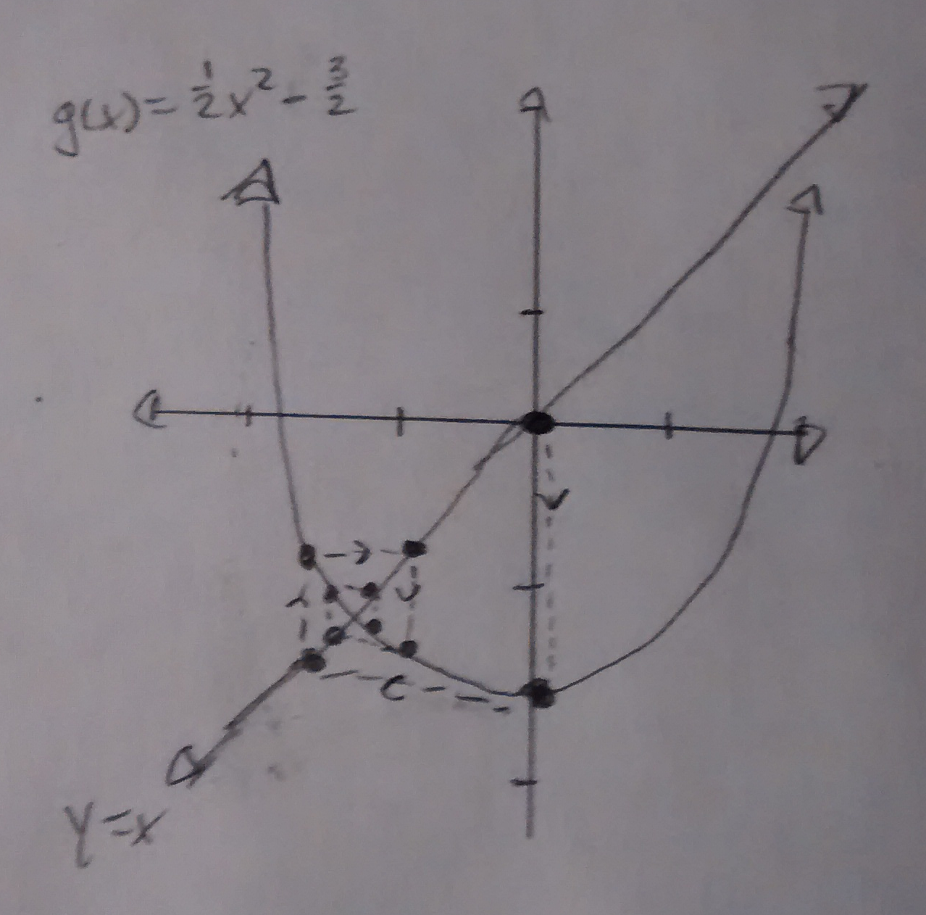

It appears that the prediction holds for values close to . Note that near the other root, , which indicates that values near 3 will not necessarily converge to 3.
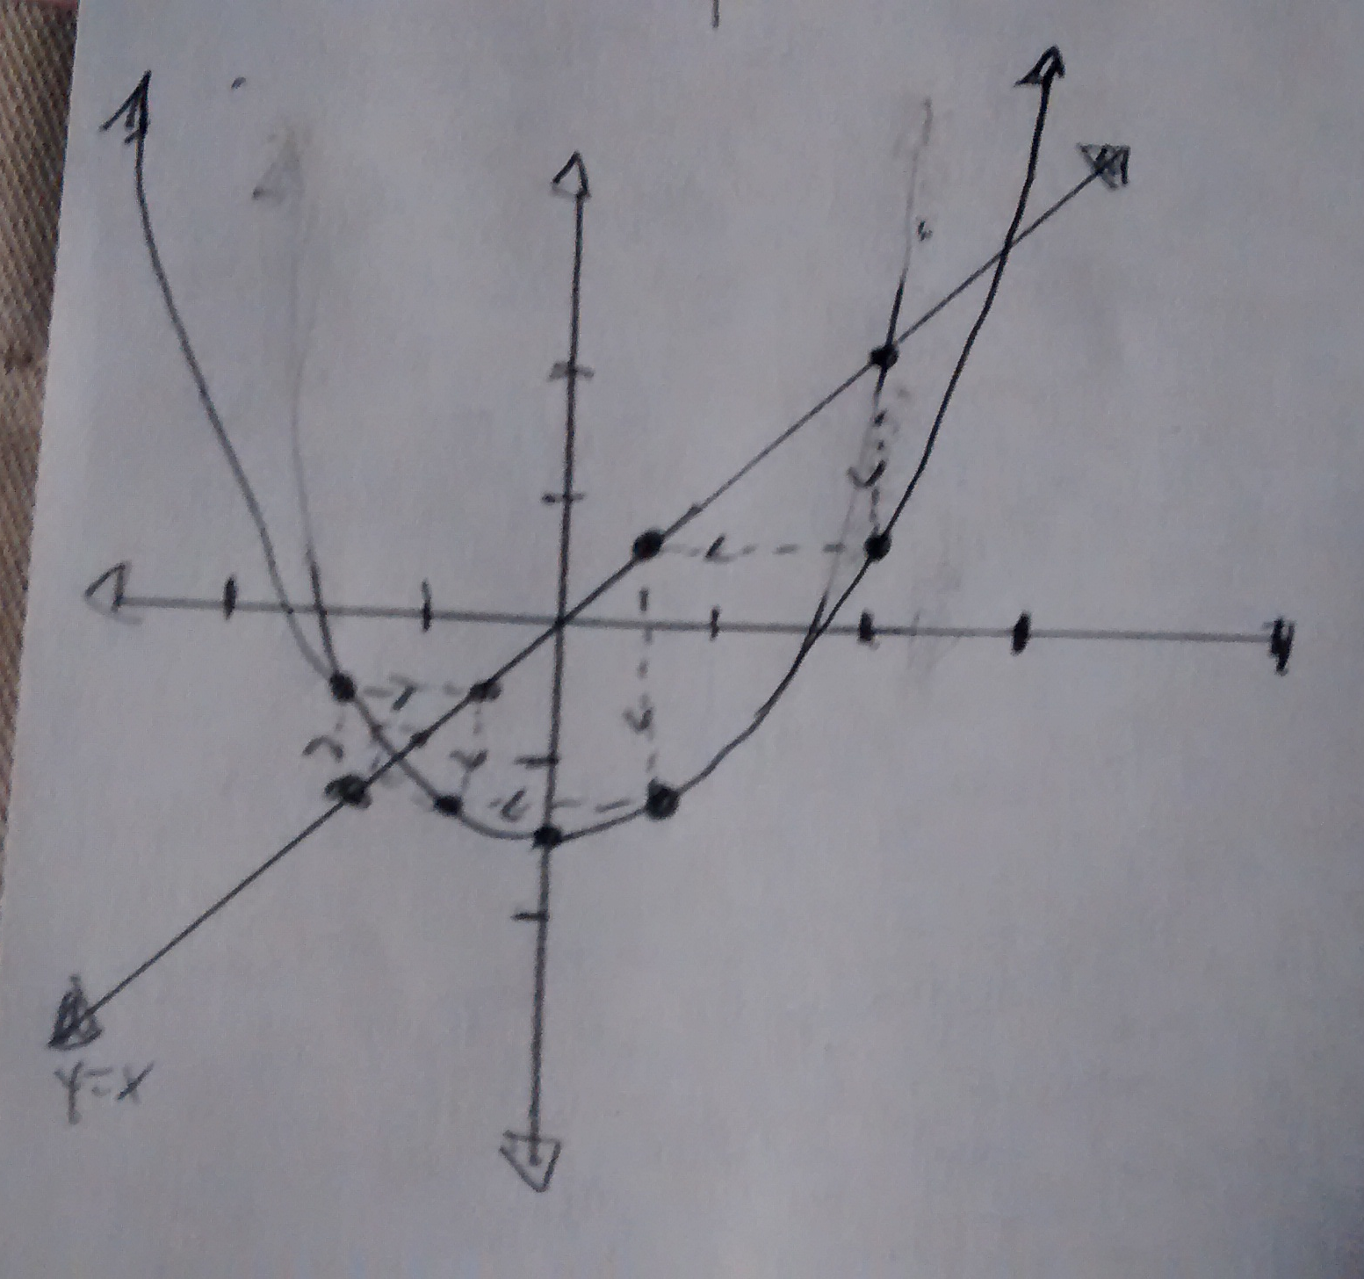

Notice that for a value near 3, the values still converge to , which supports the idea that there is no guarantee that the fixed point method with this function will converge to 3.

