Shane Sarnac
Brendan Boyd
Lucy Rieves
APPM 4660
Oil Production Analysis
Introduction
Oil production is critical for maintaining modern society but many express concerns about the longevity of oil reserves. This investigation aims to determine how long oil reserves will last by fitting a Gaussian curve to world oil production data recorded since 1857. To provide a practical range of dates, estimates of 2 trillion, 3 trillion, and 4 trillion barrels of total oil on Earth will be used.

Method
To solve this problem, the Gaussian or Normal curve will be used to approximate future world oil production. In general, this equation is given by

where denotes the total amount of oil theoretically accessible on Earth, denotes the date of the maximum rate of oil production, and denotes the characteristic width of the distribution.
To avoid overflow errors, the oil quantities will be adjusted by a factor of and time will be shifted such that year 0 corresponds to 2006, the year of the largest oil production in the given data set. As a result, the Gaussian equation can be fitted to the data by finding proper values of and to minimize the difference between the data and the curve for each value (least squares method).
Since the Gaussian curve is not a polynomial, finding good and values requires using the Taylor approximation method. In general, the solution is given by the following matrix system:

where

Results
Using this algorithm, the following table was generated:
2 Trillion | -2.920682 | 29.541248 | 2.700907 | 0.1350454 | -2.920682 (2003) | 70 (2076)
3 Trillion | 12.38289 | 38.25616 | 3.128298 | 0.1564149 | 12.38289 (2018) | 107 (2113)
4 Trillion | 25.28866 | 43.94112 | 3.63153 | 0.1815765 | 25.28866 (2031) | 133 (2139)

Additionally, the following plots were generated:
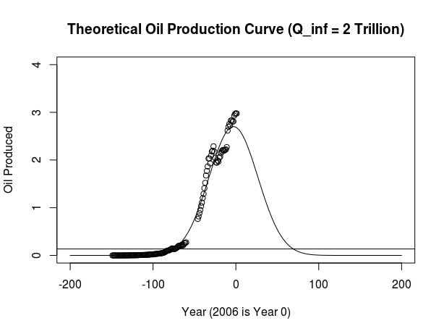

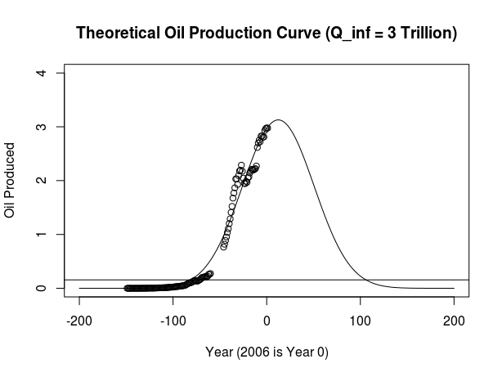

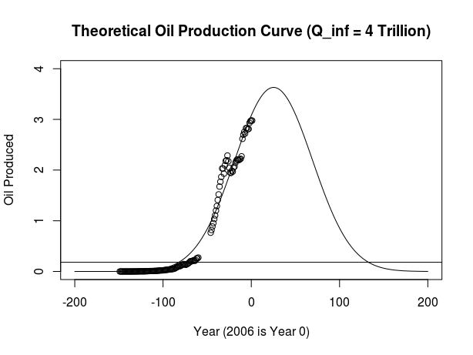

Conclusions
Based on these results, assuming that oil production continues to grow according to the Gaussian curve, it is likely that oil will become effectively used up by 2150, even with very generous assumptions of the total amount of oil on Earth. This highlights the need for increased investments in alternative energy sources, especially as human populations increase and much of that population lifts itself out of poverty.
Since this investigation assumes that oil production will continue to follow the Gaussian curve, it is possible that these results are skewed. This model assumes that humanity will continue without any kind of intervention and production continues as it is today. However, if humanity determines that oil production needs to be adjusted to maintain the longevity of the resource, it is likely that governments – international or local – will step in to protect the resource

