 RBE 501 – Robot Dynamics

Fall 2023 – Instructor: Andre Rosendo  
Homework 4

# **INSTRUCTIONS**

1. **Submit your solutions on a Zip file, with part of your answers in this word file (can be saved as a PDF if you prefer) and the other part as an .m file.** Use of computer software for calculations (e.g. MATLAB) is encouraged.
2. **Due date: Thursday Nov-9 at 3:59pm**

In the figure, the first frame is called {0} and is at the same plane as the table, the last is {ee} and is located between the tips of the gripper. The robot is at the Home Configuration

The other 4 frames in between are J1, J2, J3 and J4. The motor axis for J2, J3 and J4 is oriented in the -Y direction (Positive = Up).

X is in Red, Y in Green, Z in Blue

Using Solidworks and measurements from the real robot that you have at AK120:

1. Build an Slist for this robot at the Home Configuration. **(Zero points)**
2. Using IkinSpace.m, write below the angles that keep the robot at the same orientation as the base, but with a p = [0.15m, 0, 0.05m]. Angles in degrees. **(10 points)**

Theta1= 0 deg Theta2= 2.3741 deg Theta3= 12.2408 deg Theta4= 75.3851 deg

1. Using the new weight that you measured from the plastic links, update the material properties from those links on Solidworks to match those measured masses. Write below the new densities: **(20 points)**

Density for link 2 (between joint 2 and joint 3)= 0.89 kg per liter, material is pp copolymer

Density for link 3 (between joint 3 and joint 4)= 0.89 kg per liter, material is pp copolymer

1. Breaking your assembly in smaller link assemblies, find the cartesian position of the center of gravity for your 4 links. With this knowledge paste your Mlist below: **(20 points)**

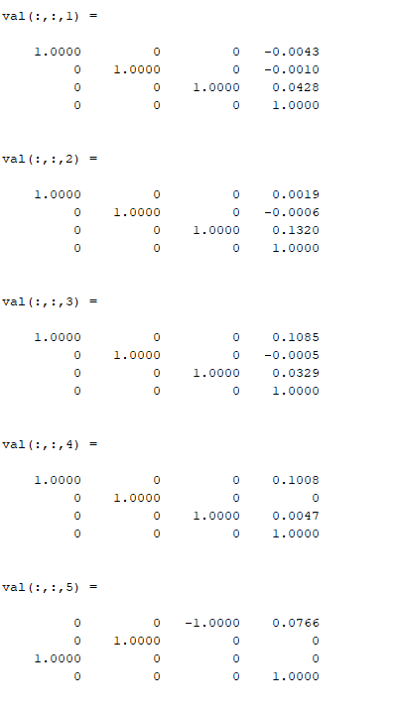

Unit: m

1. Paste below your four Spatial Inertia Matrices (G1, G2, G3 and G4): **(20 points)**

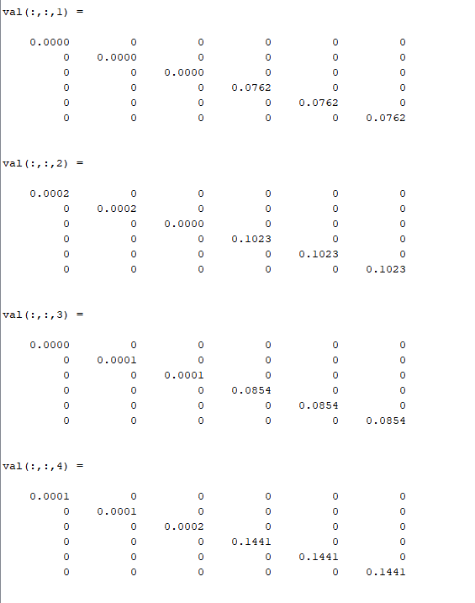

Unit: kg m^2

1. Assuming zero joint velocities and accelerations at the position found at (b), find the torques needed to lift a 10N block at the tip of the end effector (Hint: Use Ftip from your InverseDynamics.m). **(30 points)**

Tau1= 0 Tau2= -1.6671 Tau3= -1.2977 Tau4= 0.1331

Unit: N m