可见图，Encode价格数

we present a scheme of the visibility algorithm. In the upper zone we plot the first 20 values of a periodic series by using vertical bars (the data values are displayed above the plot). Considering this as a landscape, we link every bar (every point of the time series) with all those that can be seen from the top of the considered one (gray lines), obtaining the associated graph (shown in the lower part of the figure). In this graph, every node corresponds, in the same order, to series data, and two nodes are connected if visibility exists between the corresponding data, that is to say, if there is a straight line that connects the series data, provided that this ‘‘visibility line’’ does not intersect any intermediate data height.

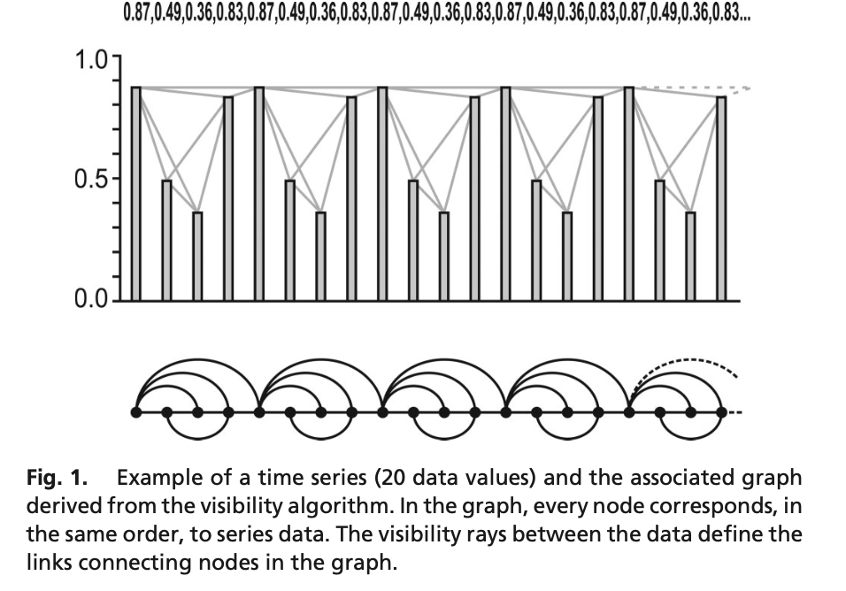

图表示学习：

图表示学习中，图的节点、边甚至整个子图都可以被转换成低维的、密集的向量表示；

降维：将图结构中的高维和复杂的信息转化为低维的向量，便于计算和分析。

数据兼容性：使图数据能够被传统的机器学习算法所处理。

揭示隐藏特征：通过学习，可以揭示节点间的隐含关系和图结构的深层特性。

嵌入的过程：节点嵌入、边嵌入、子图嵌入。

节点嵌入：每个节点被表示为一个向量，该向量捕捉了节点的位置、邻居节点和其在图中的角色；边嵌入：图中的边也可以被转换成向量形式，表示节点间的关系或连接强度；子图嵌入：整个子图（图中的一部分）可以被表示为一个向量，捕捉子图的整体特性。