**Microservices with Spring Boot 3 and Spring Cloud**

**Creating Microservices for account**

**Code:**

**Account Application:**

package com.cognizant.account;

import org.springframework.boot.SpringApplication;

import org.springframework.boot.autoconfigure.SpringBootApplication;

@SpringBootApplication

public class AccountApplication {

public static void main(String[] args) {

SpringApplication.run(AccountApplication.class, args);

}

}

**Account Controller:**

package com.cognizant.account.controller;

import org.springframework.web.bind.annotation.GetMapping;

import org.springframework.web.bind.annotation.PathVariable;

import org.springframework.web.bind.annotation.RequestMapping;

import org.springframework.web.bind.annotation.RestController;

import java.util.HashMap;

import java.util.Map;

@RestController

@RequestMapping("/accounts")

public class AccountController {

@GetMapping("/{accountId}")

public Map<String, Object> getAccount(@PathVariable("accountId") String accountId) {

Map<String, Object> details = new HashMap<>();

details.put("number", accountId);

details.put("type", "savings");

details.put("balance", 234343);

return details;

}

}

**Output:**

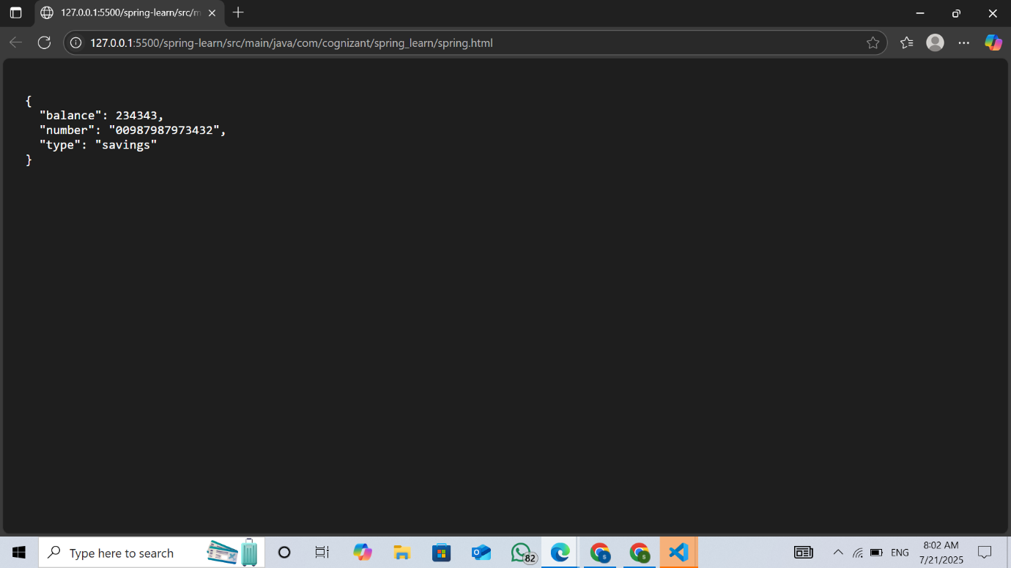

**Creating Microservices for loan**

**Code:**

**Loan Application:**

package com.cognizant.loan;

import org.springframework.boot.SpringApplication;

import org.springframework.boot.autoconfigure.SpringBootApplication;

@SpringBootApplication

public class LoanApplication {

public static void main(String[] args) {

SpringApplication.run(LoanApplication.class, args);

}

}

**Loan Controller:**

package com.cognizant.loan;

import org.springframework.boot.SpringApplication;

import org.springframework.boot.autoconfigure.SpringBootApplication;

@SpringBootApplication

public class LoanApplication {

public static void main(String[] args) {

SpringApplication.run(LoanApplication.class, args);

}

}

**Output:**

